Transmition Matching
Powertrain Technology

Callum Evans 1702660
HND/BSc(hons) Motorsport / Automotive Engineering

Table of Contents
1. Introduction 2
2. Methodology 2
3. Research 3
3.1 Tractive effort 3
3.2 Torque and Power 4
3.3 The dynamometer 4
4. Results/Calculations 5
5. Analysis and Results 7
6. Conclusion 10
7. List of Figures 10
8. Bibliography 11

Introduction

This report involves a Rolling Road session of a 2018 BMW S1000RR Sports bike. Data such as Torque, RPM and velocity will be obtained from the session with the bike in 5th gear. The gear ratios and weight of the motorcycle will be researched and used to calculate Drag, P-Drag, Torque at wheels, Wheel Power, Final Drive and Tractive effort. Graphs such as Torque and power curves and Tractive effort vs RPM will be drawn up and compared with manufacturers specifications and any differences will be discussed.

Methodology

- Roll BMW s1000rr onto the dyno rollers.
- Secure the front wheel to the brace with the use of a strong strap
- Place exhaust extractor onto the exhaust off the bike
- Turn on air flow fans and open the back door for ventilation
- Connect Dyno Data logger box to the OBD plug under the rear of the bike
- Put on safety goggles and ear protection
- Turn on the ignition of the bike and start the engine
- Allow the engine to idle and warm up
- Start the Dyno measuring programme and select the start button
- Slowly accelerate to 30mph while changing up the gears to 5th
- Hold bike at full throttle until the rev limiter is reached
- Allows the bike to run down and take a reading.
- Select neutral and turn off the bike
- Save the data collected into a file and name appropriate

Research

3.1 Tractive effort

Tractive effort is force required to haul a load. When tractive effort is equal to tractive resistance a bike will be either stationary or moving at a constant velocity. If the tractive effort becomes greater than the resistance the bike will accelerate until the tractive effort is again equal to the tractive resistance
Tractive effort is increased when engine torque is put through the rear wheel of a road bike. Therefore, the bike will accelerate due to the TE being greater than the TR. The bike will continue to gain speed until it reaches Vmax. This means that the TR is equal to the TE. (None, 2005)
Tractive resistance is increased when the air resistance becomes stronger and when bending and compressing of the tyre occurs. Also, gradient resistance can contribute to TR as the bike needs to overcome a proportion of its total mass as the bikes climbs a slope. TR is also affected by the inertia and drag in the drivetrain components of the bike. For example, an ‘o’ rings chain can cause more drag at high speed compared to a stock chain. Therefore, there is more Tractive effort needed to overcome the tractive resistance. (None, 2005)

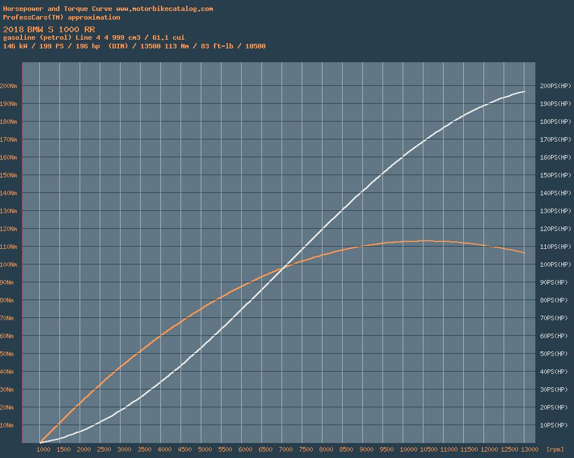
3.2 Torque and Power

(figure 1)
Torque is created by the engine of the bike when the crankshaft is turned along with the input shaft. This torque then goes through a gearbox and through and output shaft to drive the wheels
The graph above shows a torque and power curve of a BMW S1000RR found on a website called motorbikecatalog. This is what our dyno session results will be compared to. Torque is represented by the orange line and the white line is Brake horsepower. The graph shows that the max engine torque value is 113nm at 10500 rpm (school, 2019)

3.3 The dynamometer

A dynamometer is a device used for measuring the power and torque of a rotating object.
A dynamometer measures the amount of work done by an engine over a certain period. This can then be converted into a power figure. As the engine turns the drums that under the driving wheels, electromagnetic forces provide a braking effect to simulate load. This force is measure and used with the engine RPM to produce units of power. (Bonnier, 2008)

Results/Calculations

Transmission efficiency
$$n=\frac{Power at Wheels }{Power at Engine }$$

Torque at Wheels
$$T=Torque at Engine ×p ×f×n× η$$

Tractive Effort
$$TE=\frac{Torque at Wheels }{Rolling Radius R}$$

Differential Ratio
$$f=\frac{2π R N}{60 v n p}$$

Maximum Tractive Effort
$$TE=\frac{T×p×f×n×η}{R}$$

Speed Ratio
$$=\frac{Max Torque Engine Speed }{Max Power Engine Speed }$$

Theoretical intermediate gear ratios,
1st ratio = n1

2nd ratio = n1 x speed ratio

3rd ratio = n1 x speed ratio x speed ratio

4th ratio = n1 x speed ratio x speed ratio x speed ratio

5th ratio = n1 x speed ratio x speed ratio x speed ratio x speed ratio

Max Road speed achievable
$$P_{drag}=\frac{1}{2}ρC_{d}A{(V+V_{0})}^{2}.V$$

Max Road speed in all gears
$$v=\frac{2πRN}{60pfn}$$

Analysis and Results

(Figure 2)
The graph above shows the torque curve of the BMW S1000RR.
As the bike accelerates the engine speed increases. At 2000 rpm the engine is producing 200 newton meters or torque. The torque figure quickly increases to 600 nm at 4000 rpm. The torque steadily increases until the bike reaches the top of each rev range in 5th gear. Peak torque of 1000nm is seen at 10000rpm. After 11000 rpm the torque at the wheels decreases as the bike is reaching Vmax and its max RPM in 5th gear. The bike is not needing any more torque at 11000 rpm.
Compared to figure 1 and the torque values that were researched. The torque curve produced by the BMW during the dyno session is what was expected. The peak torque was 114 nm compared to the researched 113nm which is very close.
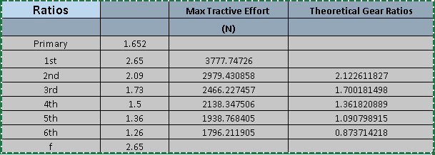
(Figure 3)
The table above shows gear ratios and theoretical gear ratios. It is noticed that the theoretical gear ratios, do not match up with the actual gear ratios. This is because the theoretical gear ratios are based on what rpm the peak power and torque occurs. Also, because 1st gear needs to be used to find the theoretical gear ratios then it is not possible to obtain the ratio for 1st gear.
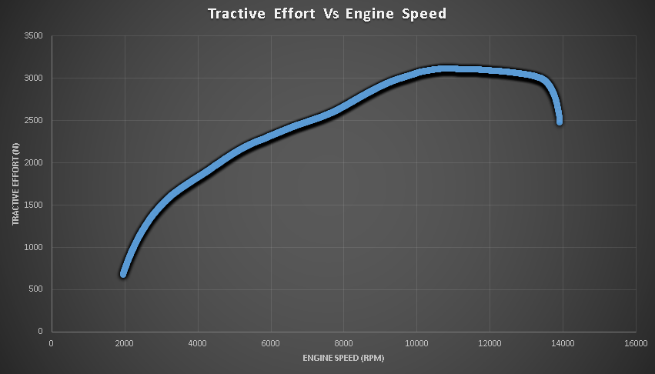
(Figure 4)
The graph above shows tractive effort (NM) vs engine speed (Rpm) obtained from when the bike was on the dyno accelerating in 5th gear at full throttle.
The graphs line constantly increases as the bike accelerates hard, during this phase the tractive effort is greater than the tractive resistance. This must be true for the bike to gain speed.
As the bike reaches 10500 rpm the tractive effort starts to decrease. This shows that the Tractive resistance is equal or greater than the tractive effort. This means the bike was no longer accelerating and was reaching its top speed of 180 mph. During test the bike was doing 274kmph at 14000 rpm. The large drop at the end of the line on the graph is the bike maybe reaching Vmax and the bike being very close to the rev limiter to protect the engine.

(Figure 5)
(Figure 6)

Figure 5 and figure 6 above show calculated P-Drag VS velocity at sea level and at 1000ft. It would be expected that the BMW would achieve a greater speed at 1000 ft because the air is less dense.
Figure 5 shows that the line on the graph is slightly steeper, meaning that the P-Drag is more significant where the air is denser. Figure 6 shows that the bike is traveling through less dense air, therefore the tractive resistance must be less than if the bike was at sea level. This means that the bike would have to overcome less TR and therefore achieve a higher Vmax. Air density at 1000ft is 1.112 p(kg/m^3) (tool, 2011)

Conclusion

To conclude this investigation of the BMW s1000rr Dyno session, the results obtained from the session are all very closely matching the researched specifications and the manufacturers specifications. For example, the recorded Max torque was 114.2 newton meters compared to the researched 113nm. This 1nm difference can be put down to testing conditions and slight calibration errors in the dyno. Also, BMW state that the bike should produce a max power of 143kw at 13000RPM. After running the dyno session, the BMW produced 149kw. This slight difference could also be due to the calibration differences of some dynos or different map settings.
Overall, the P-Drag calculations and tractive effort all resulted as expected.

List of Figures

- (Figure 1) Graph to show Torque and power curve of the S1000rr from (school, 2019)
- (Figure 2) Graph to show Torque vs engine speed, Graph produced in excel document
- (Figure 3) Table to show gear ratios, Produced in Excel document
- (Figure 4) Graph to show tractive effort vs engine speed, Graph produced in excel document
- (Figure 5) Graph to show P-Drag vs velocity at sea level, Graph produced in excel document
- (Figure 6) Graph to show P-Drag vs velocity at 1000ft, Graph produced in excel document

Bibliography
Bonnier. (2008, april 20th). Super street bikes/ dyno. Retrieved from Super street bikes: https://www.superstreetbike.com/dynamometer-tuning-explained-drum-roll#page-5
None. (2005, april 19). Tractive effort and Tractive Resistance . Retrieved from The car tech : http://www.thecartech.com/subjects/auto_eng/Tractive%20Effort.htm
school, R. (2019, april 19). 2019 BMW s1000rr Specs . Retrieved from Racing school Europe : https://racing-school-europe.com/2019-bmw-s1000rr.html
tool, E. (2011, april 20). Us Standard atmosphere . Retrieved from Engineering toolbox : https://www.engineeringtoolbox.com/standard-atmosphere-d_604.html

