Strategic Management (LCMB7003)
Strategic Analysis of Google Inc


Student name:
Student Number:
Lecturer:
Word count:
Submission Date:

Table of Contents
Introduction 3
Company’s background 3
The company’s mission and objectives 4
Macro environment analysis 4
PESTEL analysis 5
Micro-environmental analysis 7
Industry Life Cycle 7
Porter’s Five Forces Analysis 9
Internal analysis 13
Strategic resources and capabilities of Google 13
Google’s value chain analysis 14
Primary activities 14
Inbound logistics: 14
Support activities 15
VRIO analysis of Google 16
SWOT analysis of Google 18
Strategies for sustaining competitive advantage 19
Growth strategies 20
Green strategy and CSR of Google 22
Conclusion 24
Recommendation 25
References 26
Appendices 32
Appendix 1: Porter’s Generic Strategy 32

Introduction
Strategic management is concerned with the procedure of decision-making and planning those results in the evolvement of a robust strategy that can contribute to the attainment of organisational objectives (Wheelen et al., 2017). The purpose of designing the report is to accomplish a strategic analysis of the central issues encountered by Google Inc based on the given case study through the incorporation of relevant theories and models. The report will also demonstrate how Google has attained a competitive advantage by opting for strategic management. The report will encompass a succinct background of Google, macro and micro environment analysis of Google, internal analysis, strategies to sustain competitive edge, growth strategies, corporate social responsibility initiatives of the company and a succinct conclusion and recommendation.

Company’s background
Google is one of the oldest tech giants of Silicon Valley that offers a myriad of services and products, including online advertising, cloud computing, search engine technology, consumer electronics, artificial intelligence, computer software and so on. Google was founded in 1998 in California and offering unflinching services to consumers for around 24 years. As of January 2023, Google has around 178,234 employees (Google, 2023). Despite the shockwave sent by the recent pandemic on businesses, Google has managed to witness an increase in its annual revenue. As reported by Statista (2022), Google's revenue reached 279.8bn USD in the year 2022. As reported by Google (2023), the company owns around 70 offices pervaded in 50 nations.
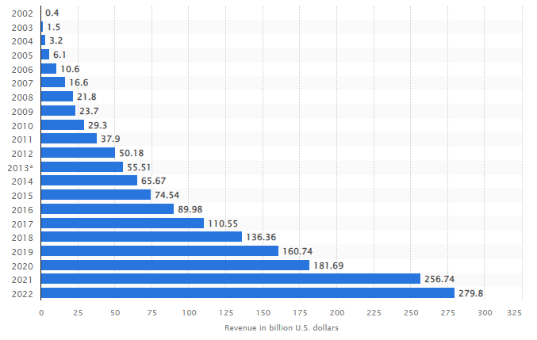
Figure 1: Annual Revenue of Google from 2002 to 2022
(Source: Statista, 2022)

The company’s mission and objectives
The mission of Google is to organise the information of the world and turn it useful and accessible universally. The salient objectives of Google are:
- To generate the best possible solutions to the questions (Chelliah and Swamy, 2018)
- To update algorithms consistently in order to provide updated information across the world

Macro environment analysis
The macro-environment scanning is regarded as the first step in carrying out strategic analysis and it seeks to explore the salient environmental elements that can impose considerable effectuations on the industry at large. Successful accomplishment of macro environment analysis can go a long way for a company to learn about probable opportunities and menaces that can impose considerable impact on business (Hamilton and Webster, 2018). To identify macro factors and their effectuation on Google, PESTEL Model has been applied below.

PESTEL analysis
External Drivers
Political | Positive | - Higher geopolitical influence of Google across the globe (Sun et al., 2019)  - Liberalisation of trade across the world
Political | Negative | - Criticisms across the world for monopoly  - Rising protectionism  - Frequent complaint received from indigenous players in countries like India (Thomas, 2020)  - Brexit in the UK and the Europe
Economic | Positive | - Stable nature of the economy of the United States  - GDP growth rate of the United States was nearly 5.67% compared to 2019 (Statista, 2022)
Economic | Negative | - Global recession caused by the pandemic  - High inflation and rising labour cost
Social | Positive | - Catering to the changing needs of the society (Baruh, Secinti and Cemalcilar, 2017)  - Rising world population and demand of technology
Social | Negative | - Amplifying privacy concerns among users(Baruh, Secinti and Cemalcilarm, 2017)  - Ad blocking trend among the users  - Failure to keep commitment regarding user data protection
Technological | Positive | - The consistent determination of Google in terms of staying ahead with technology  - Creating a robust smartphone operating system as well as web-browsing (Bisong, 2019)  - Google's tie-up with Android  - Advancement in Cloud and AI technology
Technological | Negative | - Failure to protect user data  - Lack of well-developed OS system for computer

Legal | Positive | - Greater commitment to address legal disputes  - Effective response to workplace discrimination, retaliation and abusive issues
Legal | Negative | - A spiral of recent laws pertaining to data privacy  - Legal action from both the EU and the UK for anti-competitive conduct  - Increasing embargo regarding data collection
Environmental | Positive | - Increasing commitment towards sustainability  - Growing dependence on sustainable energy in data centres (Singh and Misra, 2022)
Environmental | Negative | - Being accused of using large units of electricity (Singh and Misra, 2022)  - Increasing cost of upgrading infrastructure for sustainability

Micro-environmental analysis
A microenvironment can be explicated as the environment that subsists in a company and can impose considerable effectuations on the daily operation of a company. Salient elements of the micro environment include competitors, employees, suppliers, consumers and so on (Hamilton and Webster, 2018).

Industry Life Cycle
The term industry life cycle is defined as the development of a business or an industry depending on the phases of growth and decline. The four stages concerning the industry lifecycle encompass include an introduction, growth, adulthood or maturity and finally decline. As stated by Cantner et al. (2021), although the stages of the industry lifecycle remain the same for all industries, companies can stand in different positions within the industry life cycle. Google’s industry life cycle has been explicated below regarding its position in the software industry.
Introduction:
As stated by Cantner et al. (2021), in the introduction phase of the lifecycle model, a company or an industry remains in the infancy. At this stage, companies usually develop new products or services. At this phase, a company can emerge as a small entrepreneurial company that utilises R&D in order to develop innovative offerings. For instance, Google was founded in September 1997 (Shuen, 2018). During the initial days, some of the key products offered by the company include Images, Ness and AdWords.
Growth:
Like the introduction phase, the growth phase also necessitates a considerable amount of capital. The predominant goal of marketing efforts concerning the phase is to demarcate the offerings of a firm from rivals who are operating in the same industry. From 2003 to 2004, Google witnessed exponential growth on account of the launch of Gmail and Scholar (Şekerli and Akçetin, 2018). The momentum of growth continued with the launch acquisition of YouTube and the launch of Chrome in the year 2004. The growth phase of Google also witnessed the launch of Android in the year 2008.
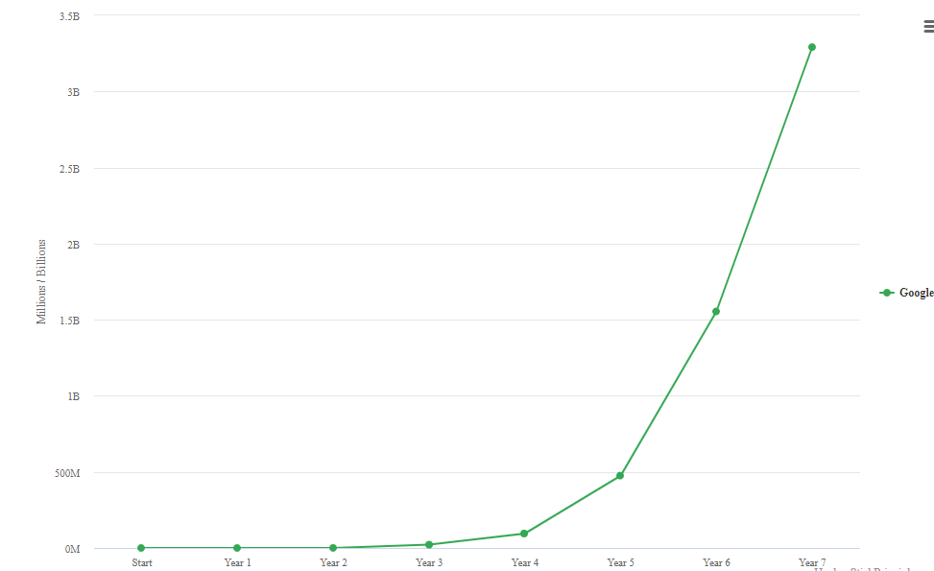
Figure 2: The Growth stage of Google
(Source: Şekerli and Akçetin, 2018)
Further, in the year 2012, the company launched the Glass prototype and it was available in the year 2014. Further, during the growth phase, the company has also emphasised projects in energy and health.
Maturity:
In the industry Life Cycle Model, the maturity phase commences with a shakeout phase. At this stage, companies witness slower growth and seek to emphasise cost reduction (Cantner et al., 2021)). As reported by CNBC (2023), Goole has been terminating free perks for employees as a measure of cost-cutting. Further, the company's tablet and laptop division witnessed a massive setback in recent times (Arstechnica, 2019).
Decline:
The capability of industry to support growth heralds the phase called decline. Decline raises questions regarding the justification of an already existing business model. For instance, as reported by Arstechnica (2019), Google Alo was closed in March 2019.

Porter’s Five Forces Analysis
First brought out by Michael Porter, the Five Forces Analysis is a highly beneficial tool for a business entity in terms of reviewing its strength concerning the market position. As stated by Isabelle et al. (2020), the five-force analysis works effectively while looking at the entire market sector. The central idea behind the model is that one of the essential aspects of ascertaining competitive advantage by a company is the overall attractiveness of the industry (Whittington et al., 2019). The Five Force Analysis of Google has been administered below:
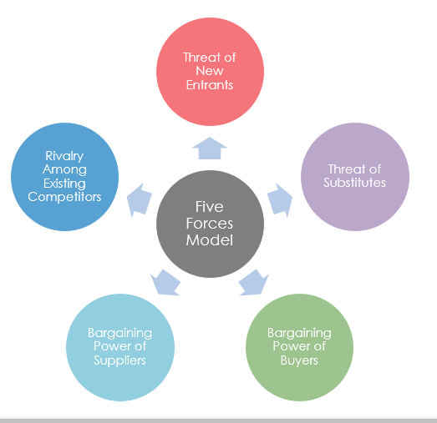
Figure 3: The Five Forces Analysis of Porter
(Source: Isabelle et al., 2020)
Suppliers’ power (Low)
As far as the suppliers’ power of bargaining is concerned, it has been observed that existing suppliers can exert low power on Google owing to the large size of the company. Further, as stated by Dolata (2017), unlike Apple, Google is a software company. In the realm of the software industry, traditional suppliers enjoy low power of bargaining. On the other hand, as argued by Shapiro (2019), one of the major reasons behind the low level of supplier power of Google is that the company has managed to develop most of its services in-house thanks to its possession of advanced technologies. Therefore, the role of the suppliers is limited in Google compared to any other software company operating in the industry.
Buyers’ power (Low)
As stated by Isabelle et al. (2020), buyers mainly impact the profitability of existing enterprises within the industry thanks to their ability to lower requirements and pricing in pursuit of offering higher service or product quality. There is a large number of users across the globe that depends solely on Google’s services and products. Some of the featured services offered by Google like Chrome, Gmail and Google Search comprise of huge market share compared to the rival brands. As far as digital advertising is concerned, as stated by Statista (2023), the company holds the highest market share in the world compared to its competitors. For instance, in the year 2021, the digital advertising revenue of Google was 209.5 billion USD. On the other hand, its closest rival Meta (Erstwhile Facebook) has managed to generate 114 billion USD only.
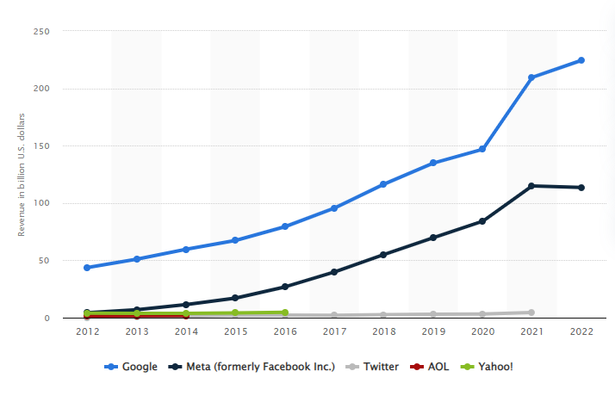
Figure 4: Digital advertising revenue of leading online companies
(Source: Statista, 2023)
New entry threat (Low)
Google has been encountering low risk from new entrants owing to its huge market share and global operation (Dolata, 2017). At present, only a limited number of companies like Apple, Amazon and Microsoft can challenge the supremacy of Google to some extent. For new players, it is far-fetched to match Google in terms of scale and size in the realm of cloud and digital advertising (Dolata, 2017). The necessity of huge capital investment and intensive competition has also discouraged new entrants to take entry into the software industry in numbers.
Product alternation threat (Moderate)
The threat emerging from product substitution is moderate on Google. Google is well known for consistent innovation and for enhancing its service or product quality. The predominant threat concerning substitution is emerging from four larger technology brands Microsoft, Amazon, Apple and Facebook. While Microsoft has been becoming one of the leading players in search, its market size is low compared to Google. In terms of the cloud, threats may come from Aszure and AWS which are proffering a range of substitute products (Dolata, 2017).
Competitive rivalry (Moderate to High)
The extent of competitive rivalry within the industry is high since competitors like Microsoft, Amazon has also been ramping up their effort in order to increase market share. Further, there are players like Salesforce and Oracle that are capturing market share gradually (Cusumano, Gawer and Yoffie, 2019). Further, in terms of a search engines, although Microsoft and Yahoo have been increasing their market share, Google is far ahead of them.
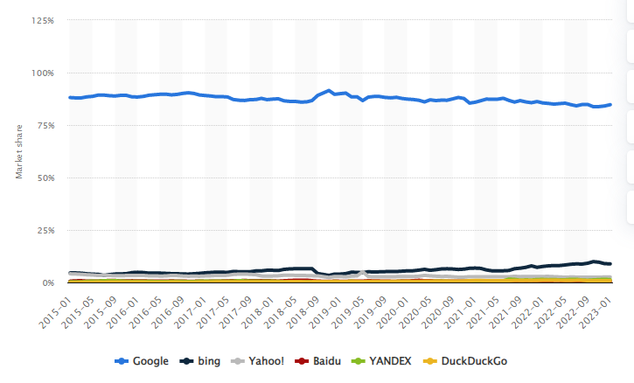
Figure 5: Desktop market share of leading search engine companies (2015-2023)
(Source: Statista, 2023)
However, as avouched by Statista (2023), the rivalry of capturing market share in the cloud sector is intense on account of the accelerated effort given by Microsoft and Amazon.

Internal analysis

Strategic resources and capabilities of Google
Depending on the Resource Based View (RBV), an organisation can ascertain long-term competitive advantage if its resources fulfil the following salient criteria:
Valuable resources:
Google is well known for its search engine. Thus, it is regarded as the most valuable resource of Google, running advertisements that generate 96% of the revenue of Google (Teece, 2018). Employees are also regarded as a highly valuable resource for the company and their effective contribution has facilitated Google to create a number of innovative tools and services.
Rare resources:
Google possesses a wider portfolio of patented technology. As reported by Google (2022), the company possesses more than 50,000 patent assets across the globe. For instance, in 2013, Google conferred a patent for a technology namely "Gaze Tracking System".
In-imitable resources:
Google does not offer detailed information about company infrastructure. However, it has been ideated by experts that Google servers are situated all over the globe (Teece, 2018). Therefore, it is far-fetched for the rivals to imitate the astounding success received by Google all over the globe.
Organisation for capturing value
One of the major setbacks of Google is that it has a very limited brick-and-mortar presence in the realm of consumer electronics (Teece, 2018). In this segment, companies like Apple and Samsung have been presenting a tough challenge to Google.

Google’s value chain analysis
A brainchild of Porter, the value chain is regarded as a series of interconnected procedures that a company carries out in pursuit of generating value for the consumers. As stated by Peng (2021), the value chain is a strategic management tool that elucidates the constellation of procedures that a company utilise in pursuit of making money.
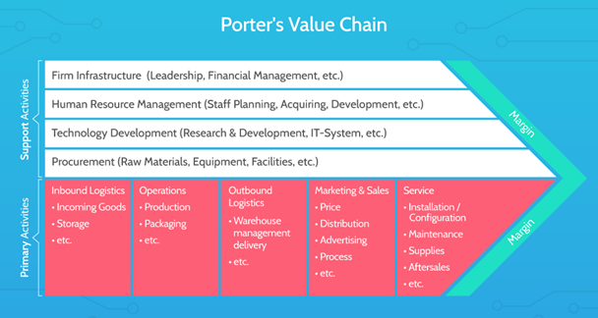
Figure 6: Porter’s value chain
(Source: Eling and Lehmann, 2018)

Primary activities

Inbound logistics:
As far as internet search is concerned, internet users of Google create a search on the search engine to fetch relevant information. The content generated by Google as a search result is predominantly created by organisational internet users and third-party providers. On account of the unique aspect of Google's business model, the company does not have to incur inbound logistics costs for its core business division (Teece, 2018). However, for Google TV, Chromecast, and Pixel, the company has to rely on third-party suppliers (Ibid, 2018).
Outbound logistics:
Google disperses a large aspect of its services via the internet. To offer smooth services round the clock, the tech giant has to depend on data centres that are located in different parts of the globe like Asia, Europe and America.
Operations:
Google has established 78 officers in more than 50 nations across the globe. However, as observed by Papadopoulos et al. (2017), technology has played a crucial role in Google to carry out its operation smoothly and value creation.
Marketing:
The marketing strategy of Google is dependent on the effective amalgamation of offline and online communications in pursuit of communicating the marketing message. Crucial elements of the marketing mix like events, experiences and advertising are extensively utilised by Google to run sales promotions (Papadopoulos et al., 2017). The ownership of the company in an eminent online marketing platforms has assisted Google to generate considerable revenue.

Support activities
Human resource management
For a long time, Google has set a remarkable record in terms of human resource management. However, in recent times, the company’s decision to lay off 12000 staff has generated negative effects effectuation on the employees’ minds (Google, 2023).
Technology
The core business model of Google is based on information technology. Google’s successful utilisation of data analytics, machine learning and artificial intelligence has assisted the company to maintain its supremacy in search engine operation (Madsen, 2022). Further, Google’s extensive innovation in the domain of security has also assisted the company to generate value.
Firm infrastructure
The computing infrastructure of Google is regarded as the largest and most exponentially sophisticated in the globe. The present infrastructure of the company is capable of providing services for both external (For example, Google Cloud Clients) and internal users (For instance, Gmail, Maps, Search and YouTube) (Google, 2023).
Procurement:
In Google Procure to Pay (P2P) teams remain responsible for owing and maintaining procurement systems and procedures. Further, fostering long-term contracts with suppliers has gone a long way for Google in terms of creating value by delivering products to consumers without any issue (Teece, 2018).

VRIO analysis of Google
Core competency | Valuable | Rare | Imitable | Organised | Competitive advantage
Brand image | Yes | Yes | Yes | Yes | Sustainable advantage
Product range | Yes | No | Yes | Yes | Medium to the long-term advantage
Research and development | Yes | Yes | No | Yes | Sustainable advantage
Customer loyalty | Yes | No | No | Yes | Temporary advantage
Financial position | Yes | Yes | No | Yes | Sustainable advantage

In the realm of the technology industry, brand image is considered a pivotal ingredient in ascertaining competitive advantage (Lynch, 2018). With its user-friendly and cutting-edge solutions, Google has become a part and parcel of people’s lives (Kim and Geum, 2020). Thus, an enhanced brand image has been translated into a long-term competitive edge for Google. Besides, the enhanced product range of Google encompasses Google Search, Google alerts, Google Books, Google Pay, Smartphones and other consumer appliances, various security tools, statistical tools and map-related products. Apart from that continuous dedication of Google to R&D has assisted the company to ensure a sustainable advantage in competitive rivalry. Although rival companies like Microsoft and Yahoo have launched their search engine, Google still champions this regard. As averred by Papadopoulos et al. (2017), in the context of the technology industry, consumer loyalty is dependent on a number of elements, including accessibility, services and pricing and so on. When it comes to the context of convenience, quality and accessibility, Google’s products are much ahead of its rivals. In FY 2022, Google's revenue was worth 279.8bn USD which was around 256bn USD in the previous year (Statista, 2022). Despite, the rippling outcomes effectuated by the pandemic, Google has emboldened its financial position. It has assisted Google to invest more in developing new technology.
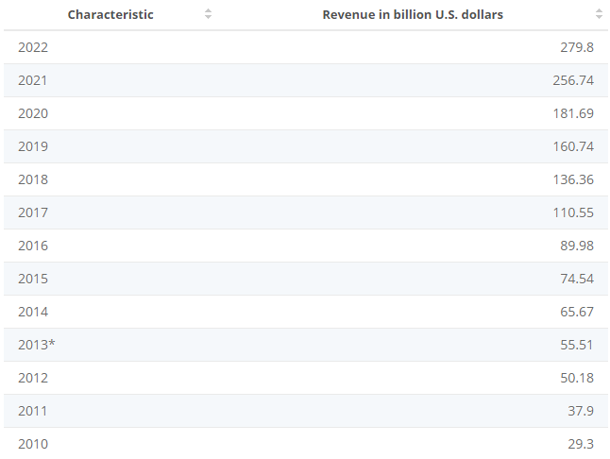
Figure 7: Annual Revenue of Google from 2002 to 2022
(Source: Statista, 2022)

SWOT analysis of Google
Strengths | Weaknesses
- One of the major merits of Google is that it has been continuing to remain a stalwart in search engines (Teece, 2018)  - Google possesses the capability of generating huge user traffic and it has conferred an unparalleled edge on Google  - The company has a large volume of market share and as of July 2020 Google's market share has reached 86.86% (Statista, 2022)  - Google is considered the most valuable brand in the globe that comes just after Apple (Forbes, 2022)  - As stated by Mostaghel et al. (2022), adaptability has conferred a greater strength on Google and thanks to Android technologies, it has managed to compete effectively with Apple | - In recent years, Google has attracted criticisms across the world for violating consumers’ privacy and in Europe it has to incur a 56bn USD ad fine for privacy violations (Mostaghel et al., 2022)  - The company has been encountering declining ad revenue and it has witnessed a decline of 1.6% during the fourth quarter of 2022 (Statista, 2022)  - As stated by Teece (2018), in pursuit of maintaining its supremacy in the search engine, Google has resorted to unfair business practices by thwarting the entry of new players into the industry  - Although Google has garnered enough popularity in the android platform, it has been encountering weaknesses in OS development provision
Opportunities | Threats
- Google has the opportunity to develop OS for PC to compete effectively with Apple's Mac  - Google can diversify its revenue streams rather than depending solely on advertisements  - The company can invest a lion's share in Google Pay in order to develop it further and thus diversify revenue streams | - Emerging technologies like Robotics, data analytics and AI-based tools can affect the dominance of Google in terms of search engine  - Intensification of competition with Amazon, Apple, and Facebook has resulted in the erosion of Google's revenue

Strategies for sustaining competitive advantage
Among the business-level strategies, Porter's Generic Strategy is frequently applied by strategists in order to assess whether or not a company can retain a competitive edge. These generic strategies are distinguished as differentiation, cost leadership, the differentiation focus and cost focus (See Appendix 1). As far as Porter's Generic Strategy is concerned, Google has predominantly accrued a differentiation strategy. However, cost leadership is also evident in a few instances. As stated by Celikyay et al. (2022), in Generic Strategy, differentiation suggests making one or more products special or unique compared to the substitutes available in the marketplace. By garnering technological innovation to a wider extent, Google has managed to set itself apart from its nearing rivals like Amazon, Apple and Microsoft. Apart from offering the fastest search engines, Google products are launched to cater to the requirement of a wider audience segment. As stated by Celikyay et al. (2022), thanks to its outstanding algorithms, Google has managed to ensure a sharp edge in the competition.
As stated by Firoz Suleman, Rashidirad and Firoz Suleman (2019), in the technology industry, differentiation plays a crucial role to offer superior customer experience. Thanks to its most popular search engine Google has managed to capture a huge market share. Apart from a search engine, Google is also ahead of its competitors in terms of web browsers. Google Chrome has earned the reputation of being the fastest browser in the market. Thanks to its quick load time and simple interface, it has emerged as the most installed web browser in a short span. Besides, differentiation is also evident in Gmail because it is regarded as the most popular email service evolved and operated by Google technology. In both developed and developing countries, Gmail has become the first choice for small and medium-sized business entities (Firoz Suleman, Rashidirad and Firoz Suleman, 2019). Besides, differentiation is also evident in the android platform. It is regarded as one of the biggest projects having versions for TV, tablet and mobile devices (Ibid, 2019). Android possesses a large number of applications that one can access and download from Google's app store namely Play Store. Further, as far as content watching is concerned, YouTube has emerged as the second-most utilised search engine in the globe and the first-ever online video-watching service.
Based on Porter's Generic Strategy, cost leadership suggests the act of minimising costs borne analogising with value to a client or consumer (Celikyay et al., 2022). In order to access Google Chrome, Google Drive, and YouTube (except premium), Maps users are not required to pay any amount. Moreover, the cloud-operated storage service of Google namely Google Drive facilitates one to offer 15 GB of storage for free of cost (Google, 2022). Moreover, products like Google Doc and Google Sheets has been gaining immense popularity since they are free. On the other hand, users have to pay for accessing MS Word and MS Excel.

Growth strategies
Ansoff Matrix emphasises four predominant strategies, including market diversification, product development, market penetration and market development (Reillier and Reillier, 2017). Brands can opt for one or more strategies in order to grow their market sales, market share and revenue. In a long term, these strategies can play a leading role for a company to foster growth and market share.
Market penetration:
Market penetration strategy has explained the tactics taken by marketers to accelerate the sales of available products in those markets where a company maintains an active presence. As a part of its market penetration strategy, Google was offering its existing products outside the United States (Levy, 2021). The prime objective behind the market penetration strategy is to ensure amplified advertising revenue in those nations where it maintains an active presence.
Product development:
When a firm launches a brand new product in a market where it already operates, a product development strategy happens (Whittington et al., 2019). As far as the development of the new product is concerned, it has been observed that Google's organisational culture encourages employees to innovate and accept new ways of accomplishing things (Levy, 2021). As a part of its product development strategy, the tech giant has been continuing to develop new products, including mobile applications, Pixel devices and cloud services and so on.
Market development:
Aside from market penetration and product development, Google also utilises a market development strategy. The salient objective of undertaking market development is to sell the remaining product into a new market (Barney. and Hesterly, 2018). For instance, starting from search engines to browsers to various apps, Google has been utilising this strategy. Further, Google has adopted this strategy to sell pixel devices in new countries (Teece, 2018). Earlier, the sale of pixel products was limited to a few states only. Nowadays, the company has been increasing the sale of pixel phones in new markets across the globe.
Diversification:
The concept of diversification is connected to the proceedings of setting up a presence by a company in a new marketplace with completely new offerings (Barney. and Hesterly, 2018). As far as Google's diversification strategy is concerned, the tech giant has opted for diversification to a small extent while making Android phones, chrome books and watches. This kind of diversification has worked greatly in Google's favour since the company has managed to increase revenue while mitigating its reliance on advertisements that continue to remain a viable source of Google's revenue. As observed by Reillier and Reillier (2017), diversification remains a core business tactic for Google since it has abetted the company to set a footprint in a new market while retaining subsisting consumers. Diversification has assisted Google in terms of creating a pool of dependable user base.
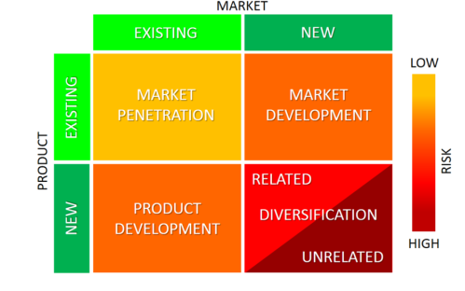
Figure 8: Ansoff matrix
(Source: Reillier and Reillier, 2017)

Green Strategy and CSR of Google
For Goggle sustainable business practices continues to remain at the core of its strategic choice. The company has unified their practices, product and partnership around a single mission in pursuit of fostering sustainability to a massive extent. Google has organised information about the planet and made it actionable with the assistance of technology so that the company can impose more positive implications for people, profit and the planet. Google has taken a pledge of ascertaining carbon-free operations by 2030 (Kusyk, 2021). Further, the multinational company has been implementing change at the systematic level by collaborating with the policymakers and government in order to achieve carbon-free energy. Further, the company has started a platform namely environmental insights explorer that makes valuable data available to around 3,000 cities in pursuit of mitigating carbon emissions (Wu et al., 2018). Further, in order to ascertain clean transportation, Google has offered a shuttle in the Bay Area of California.
CSR strategy of Google:
Carroll’s CSR Pyramid elongates the definition of corporate social responsibility by utilising the shape of the pyramid in pursuit of depicting the cruciality of each of the dimensions of CSR. It intends to assist companies in terms of acclimatising their business-related activities so that their activities not only generate profit but also become legally compliant, ethical and socially responsible (Kusyk, 2021). The CSR strategy of Google has been discussed below by following Carroll's Pyramid Framework.
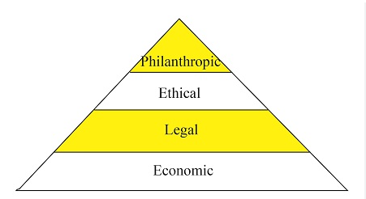
Figure 9: CSR Pyramid
(Source: Kusyk, 2021)
Economic responsibilities:
As ostensible from the CSR Pyramid, business profitability is regarded as the basement of a pyramid on which rests of the activities associated with business rest. As argued by Kusyk (2021), firms possess a greater economic responsibility towards society. Google has fostered the unification of its various practices, products and partnership in order to fulfil a single target of fostering sustainability to a large extent (Wu et al., 2018). By organising information concerning the planet and making it implementable with the assistance of technology, the company has managed to operate in such a way that it can make a profit without affecting the community.
Legal responsibilities:
Companies must bear legal responsibilities while operating nationally, regionally and internationally and locally. This rule of law set up the way an organisation needs to carry out their business practices fairly. Google has faced a number of legal challenges and controversies for infringing the laws of various nations. Moreover, the company has also been subjected to adverse criticism for mishandling consumer data. For instance, as reported by Nature (2019), Google and a prominent healthcare organisation in the United States have been subjected to controversy for jeopardising the privacy protection of service users. Further, as reported by Reuters (2022), owing to misleading users regarding data collection, Google has to pay a hefty fine in Australia.
Ethical responsibilities:
As stated by Kusyk (2021), as an integral part of Alphabet, Google has an unflinching commitment towards ethical conduct. The company has also demonstrated a greater commitment to paying respect to workers and ascertaining a safe working environment for all. However, followed by the incident of Damore Memo, there are allegations of gender stereotypes and biases in Google CNBC, 2023).
Philanthropic responsibilities:
Philanthropic responsibility talks about voluntary responsibilities that can go beyond the common expectations of society. Every year Google invests a lion's share in philanthropic activities. For instance, as reported by Philanthropynewsdigest (2022), Google has committed to providing $20 million to enhance the scope of computer education. Further, the tech giant has incorporated philanthropic initiatives in order to extend necessary support to local communities in developing nations.

Conclusion
Google has remained a stalwart in the technology industry thanks to the incorporation and effective application of business-level and corporate-level strategy. The macro-environment analysis makes it clear that Google has been facing some challenges due to rising protectionism in China. Further, growing privacy concerns have also imposed negative effects on Google. Moreover, thanks to advanced technology, Google can ascertain considerable growth in future. Based on the application of Porter's Five Force Analysis, it is evident that the tech giant is in a favourable competitive position owing to low supplier power, low consumer power, and low new entry threat. Further, the findings gleaned from the report also assert that competitive rivalry is not intensive on Google. Based on the SWOT analysis, some of the crucial strength factors of the company encompass having a sharp edge in search engine products, having impressive market share and adaptability and so on. Some of the weaknesses of the company include violation of consumer rights, soliciting unfair business activities and weaknesses in dealing with privacy issues. Google's business-level strategy is differentiation and cost leadership. Concerning corporate strategy, it has been observed that Google has mainly focussed on diversification. However, the company has also embraced the rest of the strategies to some extent. Summing up, to ascertain long-term sustainability and retail brand image, Google needs to be more responsible in handling consumers' data.

Recommendation
As evident from the report, giving a fig to local rules and regulations has been working against Google. Therefore, it is recommended that the company needs to update its user consent and privacy regulations in order to thwart unauthorised access to user data. Further, it is also recommended that Google should let the users opt out of sharing their data. Further, informing users that the company is exponentially serious about data regulation can embolden the corporate image of the brand.
Further, after elucidating the corporate strategy of Google, it has been observed that the company has failed to leverage the entire benefit of diversification since it is still dependent on ad revenue. Therefore, it is suggested that Google needs to concentrate more on unrelated diversification in pursuit of curtailing its dependence on Ad revenue. For instance, as a part of its commitment towards sustainability, Google set up the production of clean energy-led vehicles in order to generate revenue from new sources.
Finally, Google can opt for regenerative leadership in order to make further breakthrough in terms of complying with legal and ethical aspects. Regenerative leaders are capable to bring significant changes in the systems of a company and mitigate mechanistic way of carrying out things. It can assist the leaders of Google to respond to employee issues more proactively while keeping a vigilant eye on sustainable practices and targets.

References
Arstechnica. (2019) Google's constant product shutdowns are damaging its brand, Ars Technica. Available at: https://arstechnica.com/gadgets/2019/04/googles-constant-product-shutdowns-are-damaging-its-brand/#:~:text=Google's%20laptop%20and%20tablet%20division,shut%20down%20on%20March%2013. (Accessed: April 18, 2023).
Barney, J.B. and Hesterly, W.S., (2018). Strategic management and competitive advantage: Concepts and cases. Pearson Higher Ed.
Baruh, L., Secinti, E. and Cemalcilar, Z., (2017). Online privacy concerns and privacy management: A meta-analytical review. Journal of Communication, 67(1), pp.26-53.
BBC. (2022) Google faces €25bn legal action in UK and the EU, BBC News. BBC. Available at: https://www.bbc.com/news/technology-62891769 (Accessed: March 24, 2023).
Bianchi, T. (2023) Global Search Engine Desktop Market Share 2023, Statista. Available at: https://www.statista.com/statistics/216573/worldwide-market-share-of-search-engines/ (Accessed: March 31, 2023).
Bianchi, T. (2023) Google revenue 2002-2022, Statista. Available at: https://www.statista.com/statistics/266206/googles-annual-global-revenue/#:~:text=Google's%20revenue%20is%20largely%20made,of%201%2C392%20billion%20U.S.%20dollars. (Accessed: March 24, 2023).
Bisong, E., (2019). Building machine learning and deep learning models on Google cloud platform (pp. 59-64). Berkeley, CA: Apress.
Cantner, U., Cunningham, J.A., Lehmann, E.E. and Menter, M., (2021). Entrepreneurial ecosystems: A dynamic lifecycle model. Small Business Economics, 57, pp.407-423.
Celikyay, M., Sonmez Cakir, F. and Adıguzel, Z., (2022). Effects of supplier orientation and competitive strategies on ICT firms’ performance. Journal of Asia Business Studies.
Chelliah, J. and Swamy, Y., (2018). Deception and lies in business strategy. Journal of Business Strategy, 39(6), pp.36-42.
CNBC (2023) Google to cut down on employee laptops, services and staplers for 'multi-year' savings, CNBC. Available at: https://www.cnbc.com/2023/04/03/google-to-cut-down-on-employee-laptops-services-and-staplers-to-save.html (Accessed: April 18, 2023).
CNBC (2023) Google to lay off 12,000 people - read the memo CEO Sundar Pichai sent to staff, CNBC.. Available at: https://www.cnbc.com/2023/01/20/google-to-lay-off-12000-people-memo-from-ceo-sundar-pichai-says.html (Accessed: April 18, 2023).
Cusumano, M.A., Gawer, A. and Yoffie, D.B., (2019). The business of platforms: Strategy in the age of digital competition, innovation, and power (Vol. 320). New York: Harper Business.
Dolata, U.,(2017). Apple, Amazon, Google, Facebook, Microsoft: market concentration-competition-innovation strategies (No. 2017-01). SOI Discussion Paper.
Eling, M. and Lehmann, M., (2018). The impact of digitalization on the insurance value chain and the insurability of risks. The Geneva papers on risk and insurance-issues and practice, 43, pp.359-396.
Firoz Suleman, M., Rashidirad, M. and Firoz Suleman, S., (2019). The applicability of Porter's generic strategies in pure online firms: A case study approach. Strategic Change, 28(3), pp.167-176.
Forbes. (2020). The 2020 world's most valuable brands (no date) Forbes. Forbes Magazine. Available at: https://www.forbes.com/the-worlds-most-valuable-brands/#3f83178d119c (Accessed: April 18, 2023).
Google. (2023) Google. Available at: https://www.google.com/patents/licensing/#:~:text=Google's%20technical%20innovations%20and%20diverse,so%20do%20their%20patent%20needs. (Accessed: April 18, 2023).
Google. (2023). Browse a list of Google's office locations (no date) Google. Available at: https://about.google/locations/ (Accessed: March 24, 2023).
Google. (2023). Google's vision and mission. Google Docs. Google. Available at: https://docs.google.com/document/preview?hgd=1&id=1kRYwyq6ypHxvRWaNWHFro3U8MEtOmepgi3UGrTLyCis#:~:text=Mission%3A%20%22Google's%20mission%20is%20to,and%20provide%20navigation%20and%20communication. (Accessed: March 24, 2023).
Habib, A. and Hasan, M.M., (2017). Firm life cycle, corporate risk‐taking and investor sentiment. Accounting & Finance, 57(2), pp.465-497.
Hamilton, L. and Webster, P., (2018). The international business environment. Oxford University Press.
Isabelle, D., Horak, K., McKinnon, S. and Palumbo, C., (2020). Is Porter's Five Forces Framework Still Relevant? A study of the capital/labour intensity continuum via mining and IT industries. Technology Innovation Management Review, 10(6).
Kim, M. and Geum, Y., (2020). Predicting patent transactions using patent-based machine learning techniques. IEEE Access, 8, pp.188833-188843.
Kusyk, S., (2021). Carroll's CSR Pyramid: An Empirical Investigation of SME CSR Orientation. Journal of Leadership, Accountability and Ethics, 18(4), pp.100-115.
Levy, S., (2021). In the plex: How Google thinks, works, and shapes our lives. Simon & Schuster.
Lynch, R.L., (2018). Strategic Management. Harlow, England.
Madsen, D.Ø., (2022). Value, Rarity, Imitability, Organization (VRIO) Analysis. In Encyclopedia of Tourism Management and Marketing (pp. 668-671). Edward Elgar Publishing.
Marketline. (2023). Google Inc. Revolutionary business model needs to evolve--market line case study. Available at: https://store.marketline.com/report/google-inc-revolutionary-business-model-needs-to-evolve/ (Accessed: March 24, 2023).
Mostaghel, R., Oghazi, P., Parida, V. and Sohrabpour, V., (2022). Digitalization driven retail business model innovation: Evaluation of past and avenues for future research trends. Journal of Business Research, 146, pp.134-145.
Nature. (2019) Google Health-Data scandal spooks researchers, Nature News. Nature Publishing Group. Available at: https://www.nature.com/articles/d41586-019-03574-5 (Accessed: April 18, 2023).
O'Neill, A. (2023) United States - gross domestic product (GDP) growth rate 2027, Statista. Available at: https://www.statista.com/statistics/263614/gross-domestic-product-gdp-growth-rate-in-the-united-states/ (Accessed: March 24, 2023).
Papadopoulos, T., Gunasekaran, A., Dubey, R., Altay, N., Childe, S.J. and Fosso-Wamba, S., (2017). The role of Big Data in explaining disaster resilience in supply chains for sustainability. Journal of Cleaner Production, 142, pp.1108-1118.
Peng, M.W., (2021). Global strategy. Cengage learning.
Philanthropynewsdigest. (2022). Google commits $20 million to expand computer science education (no date). Available at: https://philanthropynewsdigest.org/news/google-commits-20-million-to-expand-computer-science-education (Accessed: April 18, 2023).
Reillier, L.C. and Reillier, B., (2017). Platform strategy: How to unlock the power of communities and networks to grow your business. Taylor & Francis.
Reuters. (2022) Australian court orders Google to pay $43 million for misleading users. Thomson Reuters. Available at: https://www.reuters.com/technology/google-pay-427-mln-penalties-misleading-users-australian-watchdog-2022-08-12/#:~:text=O)%20Google%20unit%20was%20ordered,of%20their%20personal%20location%20data. (Accessed: April 18, 2023).
Searchengineland (2023) Google Search, network, and YouTube revenue all fell in Q4 2022, Search Engine Land. Available at: https://searchengineland.com/google-search-network-and-youtube-revenue-all-fell-in-q4-2022-392611#:~:text=Overall%2C%20Google%20ad%20revenue%20fell,%25%20and%207.0%25%2C%20respectively. (Accessed: April 18, 2023).
Şekerli, E.B. and Akçetin, E., (2018). Diversification Strategy in Internet Industry: Case of Google Inc. Afyon Kocatepe Üniversitesi Sosyal Bilimler Dergisi, 20(3), pp.271-289.
Shapiro, C., (2019). Protecting competition in the American economy: Merger control, tech titans, labor markets. Journal of Economic Perspectives, 33(3), pp.69-93.
Shuen, A., (2018). Web 2.0: A Strategy Guide: Business thinking and strategies behind successful Web 2.0 implementations. O'Reilly Media.
Singh, K. and Misra, M., (2022). The evolving path of CSR: toward business and society relationship. Journal of Economic and Administrative Sciences, 38(2), pp.304-332.
Statista (2023) Google revenue 2002-2022, Statista. Available at: https://www.statista.com/statistics/266206/googles-annual-global-revenue/ (Accessed: April 18, 2023).
Statista. (2023) Digital advertising revenue of leading online companies 2022, Statista. Available at: https://www.statista.com/statistics/205352/digital-advertising-revenue-of-leading-online-companies/#:~:text=Digital%20advertising%20revenue%20of%20leading%20online%20companies%202012%2D2022&text=In%202021%2C%20Facebook%20earned%20over,dollars%20through%20digital%20advertising%20channels. (Accessed: March 31, 2023).
Sun, Z., Xu, R., Du, W., Wang, L. and Lu, D., (2019). High-resolution urban land mapping in China from sentinel 1A/2 imagery based on Google Earth Engine. Remote Sensing, 11(7), p.752.
Teece, D.J., (2018). Business models and dynamic capabilities. Long range planning, 51(1), pp.40-49.
Teece, D.J., (2018). Business models and dynamic capabilities. Long range planning, 51(1), pp.40-49.
Thomas, K.S. (2020) Google faces a dilemma in its biggest market: India, The Week. The Week. Available at: https://www.theweek.in/news/biz-tech/2020/10/07/google-faces-a-dilemma-in-its-biggest-market-india.html (Accessed: March 24, 2023).
Wheelen, T.L., Hunger, J.D., Hoffman, A.N. and Bamford, C.E., (2017). Strategic management and business policy (Vol. 55). Boston: pearson.
Whittington, R., Angwin, D., Regner, P., Johnson, G., Scholes, K. and Koleva, P., (2019). Exploring strategy, text and cases. Pearson Education.
Wu, W., Liu, Y., Chin, T. and Zhu, W., (2018). Will green CSR enhance innovation? A perspective of public visibility and firm transparency. International journal of environmental research and public health, 15(2), p.268.

Appendices

Appendix 1: Porter’s Generic Strategy
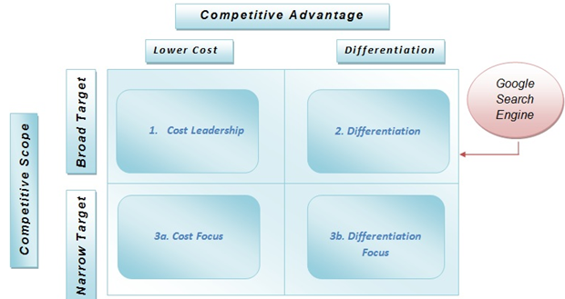
(Source: Celikya et al., 2022)

