
Skills for the Workplace
Module Assignment Submission
Student Name: | Lianne Davies
Student Number: | 1917783
Module No: | BMSK6003
Module Title: | Leading and Implementing Change in the Workplace

Statement of Confirmation of Authenticity
By the act of making this submission, the student declares that this is the work of the student named above. The work has not, in whole or in part, been knowingly presented elsewhere for assessment, or where assessment has been built on a previous assessment, this has been identified. Where materials have been used from other sources it has been properly acknowledged. If this statement is untrue, the student acknowledges that an assessment offence has been committed.
Attention is drawn to the plagiarism and unfair practice policies of both the University and of ILM.
Permission for ILM to use this script
ILM uses learners’ submissions – on an anonymous basis – for assessment standardisation. By submitting, both the centre and the learner agree that ILM may use this script on condition that identifying information is removed. However, if you are unwilling to allow ILM to use this script, please refuse by ticking the box: □
Table of Contents
1. Introduction 2
2.0 Critically analyse the current forces for change in the organisations micro and macro environment that can impact workplace culture and capability 2
2.1 What is Change in the workplace? 2
2.2 Micro-Environment and Macro-Environment 3
2.3 PEST Analysis 4
2.4 Porters Five Forces 6
2.5 SWOT Analysis 8
2.6 Stakeholders Analysis 9
2.7 Change Curve 10
3.0 Critically analyse the nature of change and evaluate complex concepts relating to leadership in relation to change management. 12
3.1 Change Theory Kotter’s 8 Step Model of Change 12
3.2 Generating – Urgency, Build Guiding team and develop a Plan 13
3.3 Consolidating - Communicate for Buy-in, Empower Action and Create Short Term Wins 14
3.4 Anchoring – Don’t Let up, and Make change stick 15
6.0 Conclusion 15
References 17
Appendix A 18
Appendix B 18
Appendix C 19
Appendix D 20
Appendix E 20
Appendix F 21
Appendix G 22
Appendix H 23
Appendix I 23
Appendix J 24
Appendix K 24

Introduction
This report will critically analyse change for an organisation, the first section will look at different forms of change and what change is in the workplace, using the Burke Litwin Model of Organizational Performance and Change as an example of transformational leadership and transactional. Using an example of change that happened due to the Covid 19 pandemic and how working from home effected a lot of individuals but not all, and how the hotel industry was prominently affected by the pandemic and had to shut their businesses down, Whitbread PLC, (2022a) who own premier inn kept 39 hotels open to help and support the front-line workers. Then the report will look at the micro and macro environment and what is needed to monitor the areas, such as PESTLE, Porters Five Forces and SWOT. Briefly going over the stakeholders and the importance of communicating certain things to them. And looking at the change curve and how it relates to the feelings employees may have when a change happens, and how important it is for leaders to be aware of hoe their employees are feeling towards the change. The next section will look at Kotter’s 8 step model of change, the model is a simple top-down model that can help the transition of change. The model is very similar to Lewin’ Model of change. The model is then used for organisational change of returning to work after the covid 19 pandemic. Student A is a manager in Premier Inn, used this model to make the transition of returning to work easier for their team. Concluding that Kotter’s model was unsuccessful as not all steps were completed, the student did learn bout themselves in the process.

2.0 Critically analyse the current forces for change in the organisations micro and macro environment that can impact workplace culture and capability

2.1 What is Change in the workplace?
“Change is the law of nature. We can observe change in every walk of our life be it is business, profession, or personal life.”
Sourced from (Warner Burke, 2008)
Change in the workplace is fast becoming the norm with the world evolving and changing daily. There are many forms of change that exists for an organisation, two examples are transformational, transactional. Burke Litwin Model of Organizational Performance and Change see Appendix A shows the different factors of change and categorize them regarding importance. The model displays the factors that are more important on the top section (transformational) and less important on the bottom section (transactional). Holten & Brenner, (2015) found that research on organizational change found that positive behaviours towards change happen if management is capable of change, is hands on, communicative, and is understood to be honest. Managers are an important factor for change, enabling the success of organizational change and influencing the level to which individuals welcome the change. This suggests that a competent strong leader or manager will be able to successfully implement change, being involved and communicating every step will help making the journey easier for their employees.
Change can come in all shapes and sizes and be influenced by many things, such as climate change, culture, positive or negative changes in the economy, advances in technology, and internal environmental changes such as change in management, changes in procedures and even personal life situations can affect change within the workplace. A recent example of change that affected the whole world was the Covid 19 pandemic. Almost all organisations big and small were affected, with some having to close their businesses for good, and others having to make immediate changes such as working from home for example. The most prominent change was to our Mental Health. Da et al., (2022) wrote about a study completed in the UK about anxiety disorder, the study found that anxiety in individuals during the pandemic reached 24%, compared to pre-pandemic of 13%, the research also found that covid affected everyday lives of individuals causing loneliness and decreased mental health. These figures suggest that covid played a negative role in the way individuals felt about their professional and personal lives. The lifestyle changes during the pandemic were immediate and having to adapt to working from home can be difficult for some, but not so difficult for others. Dubey & Tripathi (2020) study was based on how individuals felt having to work from home during the pandemic, the study was completed by analysing twitter activities that were posted on social media. Using the results of 100,000 tweets that were analysed, they found that 73.10% of tweets were positive towards working from home compared to the 26.10% which were negative. To ensure of a more detailed analysis of the 100,000 tweets, the emotional intelligence associated with them were analysed. A total of eight emotions were assessed which were fear, joy, anticipation, anger, disgust, sadness, surprise, and trust. See Appendix B. The results showed that most of the tweets were based on three emotions Trust, Anticipation and Joy. These figures suggest that working from home was seen as a positive activity. This can be for many reasons, for example, having an organisation make the transition easier would help employees adapt to working from home a lot simpler and with minimal stress. Communication can also be a factor, having an organisation communicate with their home working staff can help with the isolation of working from home. The Leisure and tourism sector took a big hit during the pandemic, with most hotel chains in the UK having to close their businesses and staff were either made redundant, let go or furloughed. Whitbread PLC, (2022a) kept open 39 hotels within the UK to support NHS staff and other front-line workers, this meant that 39 hotels were able to keep their staff working to ensure the key workers were being looked after and supported. A list of what Whitbread did during the Covid 19 pandemic can be found in Appendix C.
There are many other forces of change within an organisation. The next section of this report will look at micro-environment and macro-environment and how both cover internal and external factors of change for an organisation.

2.2 Micro-Environment and Macro-Environment
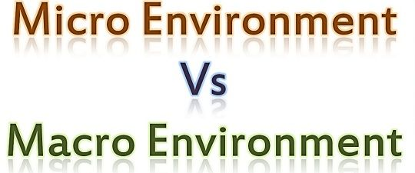
Sourced from (Surbhi S, 2018)
An organisation environment is commonly made up of various macro- and micro-environments. Micro- Environment is known as internal factors that can influence the day-to-day activities and performance of an organisation, such as suppliers, competitors, customers and even the public. Macro-Environment is the external factors which can impact the organisations decision making and overall performance, such as economic, technological, natural, and political to name a few. Singh et al., (2021) wrote that the macro-environment contains factors that are difficult to be in control of, and this is because it is outside the control of the organisation, and PEST (political, economic, socio-cultural, and technological) is typically used for the macroenvironment. They also described micro-environment as Customers, rivals, suppliers, and creditors. This shows that the macro-environment is an uncontrollable force and using the PEST analysis can bring more attention to them. Dalirazar & Sabzi, (2020) said that managers do not have any influence in external factors, a PESTLE review will help to set up strategies and focus on their internal assets and plans. Applying this model in evaluating the external environment, is the best way to assess external risks. This shows management have no control over external forces, but being aware of them can help be proactive, enabling them to put plans in place and protect them from uncontrollable forces.

2.3 PEST Analysis
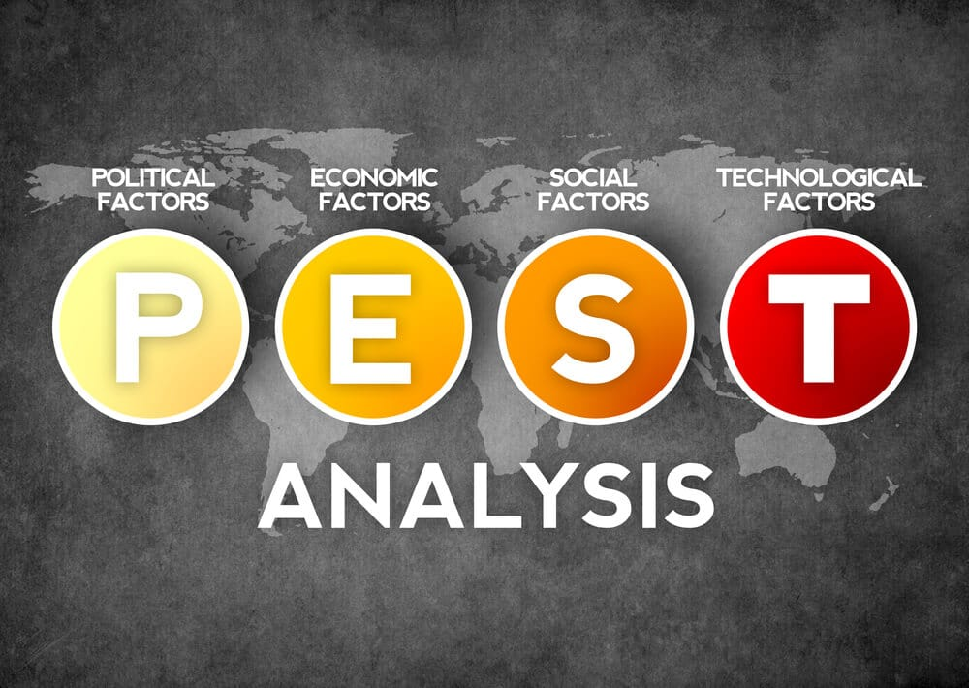
Sourced from (Kiesha Frue, 2020)

PEST is an acronym for four areas of change: political, economic, social, and technological. A PEST analysis is an influential tool that’s widely used, it helps to identify the changes and the effects of the macro environment that can and will affect the present and future of an organisation. According to (Rastogi & Trivedi, 2016) many other variations have been used over time Appendix D, for example PESTLE (Political, Economic, Social, Technological, Legal and Environment) White, (2021) described PEST analysis as being used to assess the external and macro environment elements that can influence an organisation, these are political, economic, social, and technological. It can aid organisations in forecasting how worth while or successful a business plan will be regarding revenue and profit. This shows how important PEST analysis is to the future of an organisation. Carruthers, (2009) said that to help the PEST analysis, the organisations environment is split up into macro-environment, this comprises of the external elements that can affect how the organisation operates but is out of their control. These suggest that PEST is generally used within an organisation to monitor the changes, planned or unplanned that can happen on the outside of the organisation and that’s out of their control. Voiculet et al., (2010) concluded that an organisation must be alert to any action from the external environment and must constantly adapt to it. If an organisation is aware of what is going externally, the also have the opportunity to put plans in place to stay ahead of the competition.
An example of change that can and will affect the future of an organisation is ‘Climate Change,’ this is a global problem and without immediate action the future of our planet is at stake. Whitbread PLC owns over 840 Premier Inn hotels largely in the UK and most recently Europe, they understand that change is needed, and they have a responsibility to their people. Whitbread have a sustainability programme in place called ‘Force for Good,’ and the aim of this programme is to create a beneficial influence for all stakeholders and the world. See Appendix F for Whitbread’s ‘Forces for good’ pledge.
Below is an example of a PESTEL analysis completed by Student A who works as a team leader for Premier Inn hotels.
Political | The UK hotel industry depends heavily on legislations created by the government.  The most recent change in legislation that has impacted the hotel industry is the COVID-19 pandemic. Due to the covid 19 regulations the public have been advised to stay at home and travel bans all around the world were put in place. The hotel industry lost millions due to loss of sales. (See Appendix I)  Low taxes have helped Premier Inn Hotel to sustain the covid-19 impact.
Economic | Economic factors affecting the hotel business are costs of utility, costs of labour, rent, and business rates. The most recent change that’s affected the economy has been the increase in utility costs which is going to impact on the hotel to a big extent.
Social | Social factors are related to the customers ’needs, their expectations, and the services provided by us at Premier Inn. Customers’ needs and expectations are forever growing and changing. We offer the 100% Money back Guarantee (see Appendix G) if our customers are not happy with our product and service.
Technological | Technological has a big influence on marketing and advertising. The way people communicate is ever changing. Premier inn has an online service, for easy booking. All Premier Inns have Wi-Fi available.
Environmental | Global climate change can have a consequential effect on Premier Inns, ‘The forces for good’ program is a project that aims to make Premier Inns ecologically sustainable (see Appendix F).
Legal | National Living Wage and National Minimum Wage rates is a legal requirement that the government review yearly and must be adhered to, for the latest government increase for wages (See Appendix H).

The PESTLE analysis is a tool used to monitor the external environment of an organisation, it helps to identify threats and opportunities due to outside influences. Another tool that can help monitor the external environment is Porter's 5 Forces, this model will help analyses an organisations competitive environment.

2.4 Porters Five Forces
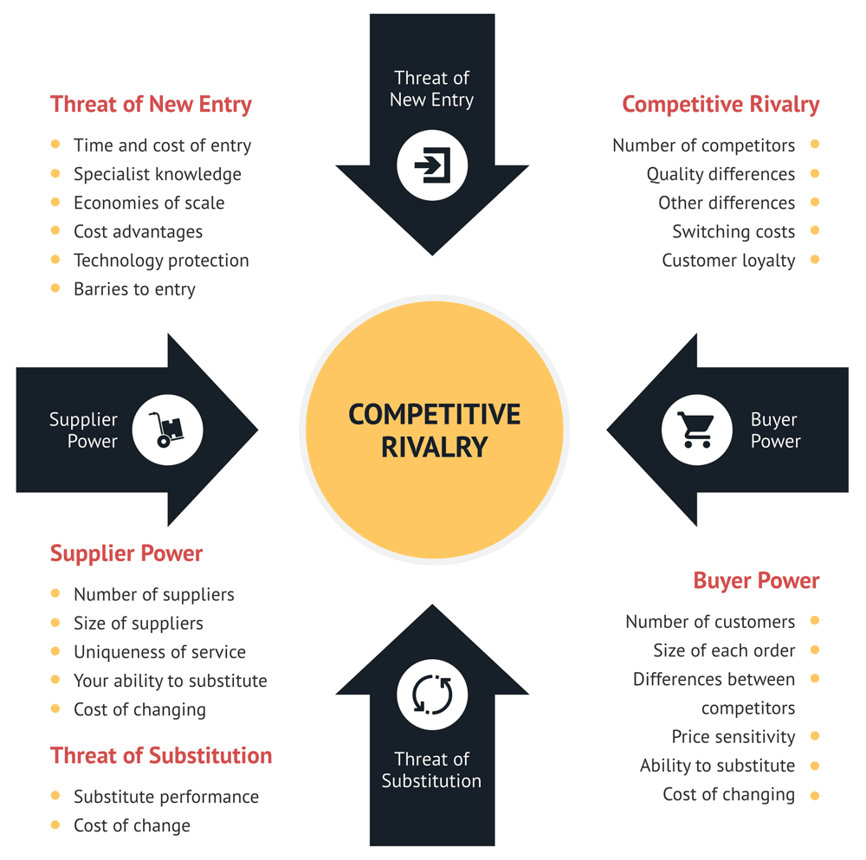
Sourced from (Heubel, 2021)
The above model is ‘Porters Five Forces’ it was created by Professor Michael Porter in the late 1970’s as a tool to help businesses assess the competitive market. He believed there are five forces that can determine the intensity of the market.
The five forces are.
- Threat of new entry - new entrants in an industry can bring new dimensions and the craving to gain a share in the market.
- Competitive Rivalry – The force looks at how intense the current competition is in the marketplace
- Buyer Power - This force analyses to what length the buyers (customers) can put pressure on a company.
- Supplier Power - This force analyses how much power and control suppliers have over businesses.
- Threat of substitution – this force analyses the existence of products that are similar or the same, which increase the chance of customers switching company’s
According to (Bruijl, 2018) The five forces model is an influential tool that is straightforward to use, it can help with identifying certain capabilities that are in line with a particular business situation by looking from the outside-in. This suggests that this tool can be used for the macro-environment, looking at external areas that can help increase profitability. (Isabelle et al., 2020) paper argued that the Porters five forces framework is no longer suitable as it doesn’t meet the needs of functioning in the 21st century and could possibly lead to unsound decision- making. This implies that maybe the Porter’s model is out of date and would not work in this ever-changing environment, and the decisions made will be unsuccessful. (Göral, 2015) said that with the combined weight of porters five forces, organizations can succeed with the right position in the environment shaped by the forces. The model has the capacity to persist in spite of the competition forces and use them to their advantage to be in the correct position. This shows the model has the ability to help an organisation monitor the environment and stay in the best position to improve their advantage within the market.
Below is an example of a completed Porter’s five forces model for Premier Inn by Student A.
Threat of new entry – As the hotel industry is growing at a rapid rate and new hotels are popping up everywhere, the threat of new entry is HIGH.
Competitive Rivalry – Competition is high, Premier Inn’s main competitors are other budget hotel chains such as Travelodge and Holiday Inn.
Buyer Power – The power buyers have is moderate, with a lot of competition amongst the hotel’s costs become competitive, and buyers can choose where to stay based on low prices.
Supplier Power – The power suppliers have is low, with the hotel industry being so large there are no shortages of suppliers.
Threat of substitution – The threat of substitution is high, with the development of technology the advancement of substitute products such as Airbnb, Teams and Zoom is decreasing the need to travel and book hotel rooms.
Porter’s Five forces is a great tool for monitoring the competitive market for the macro-environment. Another tool that can monitor the external and internal environment is a SWOT analysis.

2.5 SWOT Analysis
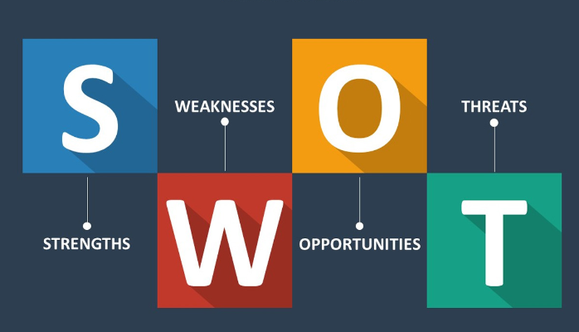
Sourced from (Shaw, 2017)
A SWOT analysis is used as an evaluation model, it looks at internal factors, strengths and weaknesses and external factors, opportunities and threats which are beyond the control of an organisation. The SWOT model is not designed to give results, it’s designed to help understand where the organisation currently stands, and how to start moving the organisation in a better direction. Helms & Nixon, (2010) wrote that the SWOT model has been used by many practitioners, market researchers and is a popular tool used regularly for business marketing and strategy students. They said the tool is used to assess a possible course of action and complicated decision situations, using internal and external issues as a starting point in creating a plan of action. It can be put together swiftly and can be used as a brain storming exercise collecting different perspectives. This suggests that SWOT has been used by many, and for the same outcome, looking at where the company is in the present and where they need to go for the future, and making the difficult decision to action. It also implied that the model is simple to use and can be used as a group exercise to get different perspectives. Swot has been used for many years and by many researchers who have examined this model for its strengths and weaknesses (Strategic Direction; Bradford, 2015) found that.
“SWOT can be compared to a photograph, rather than a moving image. Perhaps that is where its greatest weakness lies: it is a snapshot of a point in time. Because the environment is constantly changing and new strategies also have an effect on internal strengths and weaknesses, environmental scanning is needed regularly to update analysis.”
This implies that once a SWOT analysis is completed, no other work is done to assess these areas going forward, in this ever-changing environment it’s important to be proactive and continually monitor the analysis after completion to ensure its updated regularly and actioned if needed.
A SWOT analysis consists of four areas, two areas are for the micro-environment and two are for the macro-environment.
Micro-environment
- Strengths – Are what an organisation does well.
- Weakness – Is what an organisation doesn’t do well.
Macro- environment
- Opportunities- Are what opportunities are available externally.
- Threats – external threats could impact negatively.
Below is a SWOT analysis from Whitbread PLC, the information was sourced from (MarketLine, 2022)
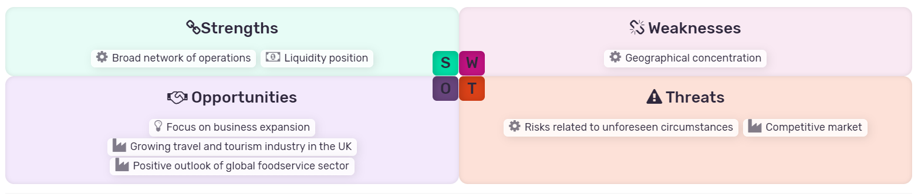
See Appendix E for a full break down of the SWOT Analysis.
It is important for the hotel industry to monitor the micro-environment, using the SWOT analysis can be a successful way monitor and assess any changes that can and will affect the business. Being aware of any changes in the micro-environment will enable an organisation to put plans in place to enable any change to be introduced successfully.

2.6 Stakeholders Analysis
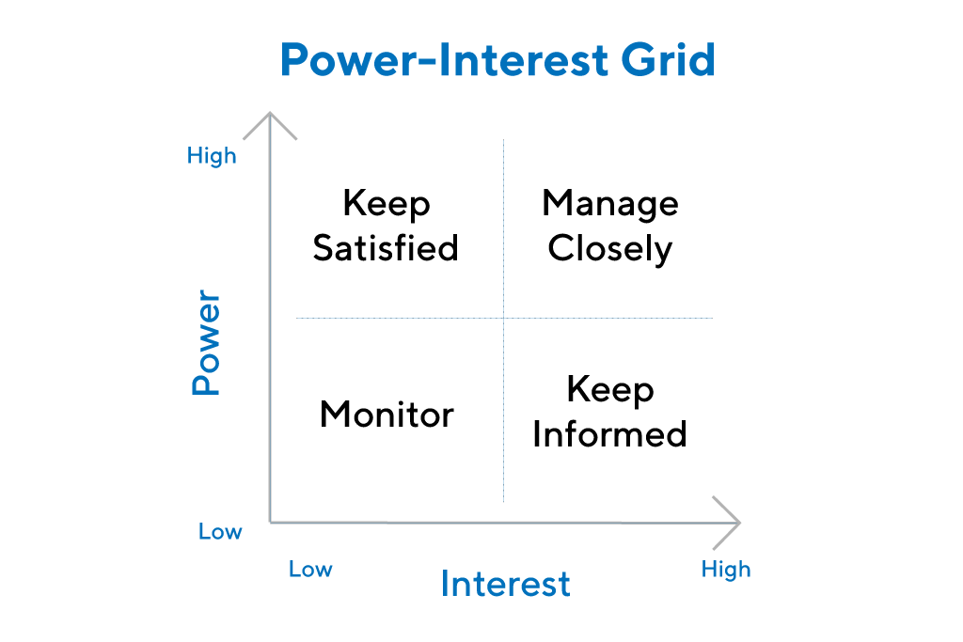
Sourced from (ProductPlan, 2018)
The purpose of a stakeholder analysis is to summarise the key stakeholders and what their needs are for the business or organisation. It is important to have a clear understanding of each stakeholder as this will help identify and prioritize the people who may be affected by the business or organisation. These people range from CEO’s, managers, staff, and customers. Maguire et al., (2012) described a stakeholder’s analysis as ‘a range of tools for the identification and descriptions of stakeholders’ based on their traits, interconnections, and their common interest, and Mok et al. (2017) paper considers the analysis as a necessary part of stakeholder management that helps to identify stakeholders and their interests, evaluates stakeholders' interactions, and measures their influences. These show that the analysis is important in identifying who the stakeholders are and how they can influence an organisation by their associations with them.
Stephens, (2005) said the relationship of a stakeholder and an organisation is important in developing the reaction to stakeholder pressures. Suggesting that building and maintaining relationships with an organisation’s stakeholder is important in helping to communicate with them. This is especially important when a change is about to take place, certain stakeholders will need and want to be involved, and others may not need to be told.
Examples of stakeholders for Premier Inn completed by student A.
Stakeholders | Relationship | Position on grid
Whitbread PLC | Whitbread owns Premier Inn | High Power/ High Interest
Employees | Works for Premier Inn | Low Power/ High Interest
Customers | Stay in Premier Inns | Low Power/ Low Interest
Suppliers | supplier of goods | Low Power/ High interest
Government | Taxes - corporate and income | High Power/ High Interest

2.7 Change Curve
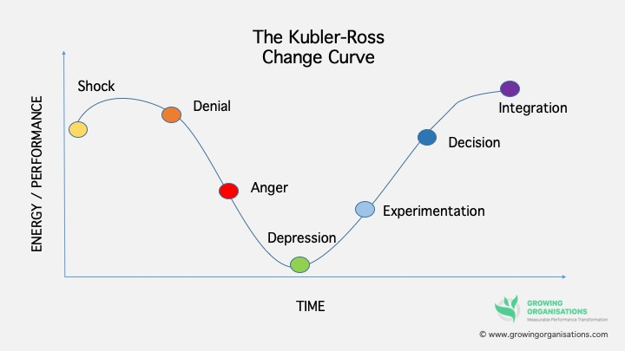
Sourced from (Francis, 2020)

Change is an inescapable part of life, and there is no getting away from it. If change is well planned, mapped out and organised, it can create positive results. But even if the planning is all thought out, change can be hard to integrate, accept and appreciate. The Change Curve model was originally developed by Elisabeth Kubler-Ross in the 1960’s to help explain the steps in the grieving process. However, the model has been used as a way of helping people process and understand their reactions to change, either negative or positive.
The stages are:
- Shock – Hearing of change for the first time can cause a feeling of shock and surprise.
- Denial – Disbelief that change is happening
- Anger – Not happy with the change.
- Depression – Feeling low, and unhappy with the change.
- Experimentation – Engaging in the new.
- Decision – Feeling more positive and learning to accept the new changes.
- Integration – Changes accepted.
(Williams & Braddock, 2019) said that the model is broadly used to manage Change or a crisis, mainly in larger organisations where employees encounter unexpected news, generally related to significant restructuring. By comprehending oneself and other’s reaction to change, can help understand where a person is on the Change Curve model. This suggests that having an understanding of how people will react to big changes, using the model to assess where people are in their process. Lynch, (2019) said its important to remember that all individuals are different, and move through change at different rates, and without cautious management some may remain at the depression stage and not move on. This suggests that if management doesn’t manage and support their employees through all the stages, they could get bogged down at the depression stage and not recover. This can cause a negative impact on an organisation especially if they are going through a major change.

3.0 Critically analyse the nature of change and evaluate complex concepts relating to leadership in relation to change management.

3.1 Change Theory Kotter’s 8 Step Model of Change
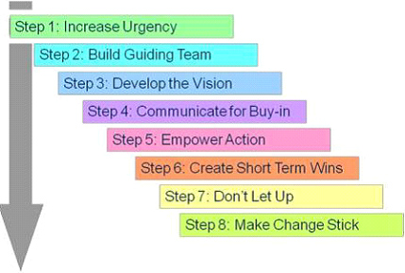

Sourced From (Juneja, 2019)
The Kotter’s 8 Step Model of Change was first introduced by John Kotter in his book ‘Leading Change’. The model was created to help leaders achieve organisational change successfully. The model is designed to prepare employees for a change, not to catch them off guard, and support them on every step of the journey.
Kotter’s model has 8 steps.
Generating
- Increase urgency – Create a feeling of haste towards change.
- Build Guiding team – Create an alliance.
- Develop the Vision – Create a game plan.
Consolidating
- Communicate for Buy-in – Present and communicate the game plan for change.
- Empower Action – encourage employees by removing barriers
- Create Short Term Wins – Create short term goals.
Anchoring
- Don’t Let up – Continuous improvement.
- Make Change stick – Ensure the new change stays in place.
Varkey & Antonio, (2010) Kotter’s 8-step model for change management is widely used in the business field and is a complete sequence of steps that puts attention on people and their feelings toward change. This suggests that the model is used in most genres of business, and the model’s steps don’t just focus on change but on how people feel about the change. Laig & Abocejo, (2021) paper said that the 8-step process in leading change to enable an organisation to be successful in this ever-changing world. An said it’s regarded as an emergent process when change is inevitable in the organisation. This implies that the model is still considered as a up and coming when change is necessary to the success of an organisation. As the environment changes it can bring new ways to do things. Appelbaum et al., (2012) concluded that the primary problems people face while implementing Kotter’s eight steps are not due to planning, formation, culture, or systems, but about the changing behaviour of people. This suggests that the issues that rises in the model are not due to the work that’s involved but hoe people perceive and deal with the change. Aldemir, (2010) said Kotter gives an 8-step model for leading change and puts leadership at the heart of the model. These steps can be split into three sections which are generating, consolidating, and anchoring, these 3 areas have similarities with Lewin’s model of change. This implies that leaders have an important role in the model and are responsible for being both coach, mentor, and counsellor to their employees, and it also implies that the model is like the Kurt Lewin’s model of change (See Appendix J). Kurt Lewin’s Model of change is a simple but effective method, it has 3 stages compared to Kotter’s 8 steps, but the concept is similar. Below is a table to show the similarities between Kotter’s and Lewin’s change models.
Kotter's | Lewin's | Similarities
Generating - Steps 1-3 | Unfreezing - Stage 1 | Creating the right environment for change
Consolidating - Steps 4-6 | Change - Stage 2 | Implement the change
Anchoring - Steps 7-8 | Refreeze - Stage3 | Adapt and accept the change

Harrison et al., (2021) said Kotter and Lewin’s models, underline the central theories of involving people in change from the beginning, supporting their feelings about change and supporting change with effect communication and behaviours. This shows that both models have an interest in ensuring their employees are cared for during the change process, being open, honest, and supportive through the process will help the change implemented succeed. Calder, (2013) suggested Kotter goes into a lot of detail in the Unfreezing stage. Both Lewin and Kotter see the significance in decreasing the resistance and arranging people to support the change in full before commencing on changing anything. This shows that both models see an importance in ensuring staff are open to change, and the importance of having a team available to provide support.
The next part of this report will use Kotter’s 8 step model in a change from student A’s workplace.
.

3.2 Generating – Urgency, Build Guiding team and develop a Plan

As the covid 19 pandemic winds down, Premier Inns are now back to working order with additional changes in place. According to (Nadkar, 2020) Whitbread lost over 6000 employees due to the pandemic, with some being let go, some volunteered to leave admin moved to homeworking and the rest were furloughed. The changes needed to reopen and work as normal were communicated to all team members, Furloughed staff returned to their normal duties with the housekeeping team being re- trained in Covid cleans, reception staff continue with social distancing, and extra cleaning in all areas for the safety of both staff and customers (see Appendix K). Returning to work was the biggest change for all, staff had been at home for a long time and adjusting to being back in work can affect individuals in different ways.
Student A is a manager for Premier Inn, to ensure the transition of when staff return to work was smooth, Student A had Team meetings via Teams with all team members to; 1. Check in - Well-being, 2. Explain what will happen going forward, 3. Maintain relationships, and 4. Create an open dialog for best practices for returning to work. Student A’s main priority was to communicate and support the team through the change, involving the team in creating a plan will ensure cooperation. (Wang & Li, 2022) paper found that research had conveyed that capable leaders can motivate individuals to seek better organizational performance, help organisations manage challenges, and help to reveal future business directions.
The 1st 3 steps of Kotter’s model has been followed, Student A has been in contact with the team before their return to work to discuss their return, Key members are on board for returning and are excited, and discussions on strategy took place. According to Student A the only downside to this was not all team members were available for team meetings and may have missed the information being shared. Generating complete

3.3 Consolidating - Communicate for Buy-in, Empower Action and Create Short Term Wins
The team has returned to work, and now student A can share the plan of action with them, housekeeping workload has been reduced to ensure staff are eased back into it, extra training is provided for ‘Clean Protect’ and social distancing. According to (Jensen et al., 2018) Transformational leaders’ have the expertise to deliver values and increase mission power among employees is because of their communication of the vision. Suggesting a transformational leader will have the knowledge and experience to communicate the vision to keep employees engaged. Once training was complete and staff were back to work, student A started monitoring all teams to ensure no barriers were present and if so remove them, a common problem that arose was ‘people’ and the resistance to change. Karaxha, (2019) said there are many reasons for an employee or employees to have resistance to change, they are all different, and depends on their individual personality. This suggests that resistance can be due to the values and beliefs of people and their own view of things. Richesin, (2011) said individuals will differ in their competence, and desire to adapt to change. Suggesting people may have low emotional intelligence and engagement in change.
Steps 4 & 5 of Kotter’s model has been followed, Student A Delivered the plan of action to the team and monitored progress for any problems the team might have. Student A found that even though the team were communicated to face-to-face team meetings, letters of information and notice boards around the building they still had their reservations. Student A had one to one, open and honest communication with the individuals who were still having issues and seemed to iron out the problems.
Step 6 was not completed, due to the unseen future concerning covid student A didn’t have the resources to create short term goals.

3.4 Anchoring – Don’t Let up, and Make change stick
Student A has been monitoring the return of the team and communicating with them often to ensure they are happy, as things are still uncertain with the pandemic. Men, (2014) said that communication ability, standards, styles, and channels of a leader can influence the attitude of employees and behaviours. Suggesting that a strong experienced leader with clear communication skills will have more of a reaction from their employees. Staff are following covid guidelines to ensure their own safety and the safety of the guests. Student A’s aim is to create a culture of change, Student A has regular meetings with each department to ensure things are running smoothly, using this opportunity to resolve any conflict by listening to what the team have to say, answer questions, and engage in discussions. This links to transformational leadership, Barling et al., (2000) paper said that leaders who know how to manage their own emotions, have self-control, and delays own satisfaction can be role models to their employees, which creates trust and regard for the leader. This suggests that leaders with high emotional intelligence can build a strong culture around relationships and trust.
The last steps 7 & 8 are being implemented and will be a continuous process, as we adapt to post covid.
Student A found Kotter’s model of change easy to follow and implement even though it wasn’t completed (step 6), student A has always tried to maintain relationships with the team members which aided in the transition of returning back to the workplace. Student A compared both Lewin’s model of change and Kotter’s model, student A found Kotter’s model more informative, but strict with no room to go back or change anything, where Lewin’s model could be moulded to fit the return-to-work scenario. Student A enjoyed using Kotter’s model as it helped in their own personal development, knowing what type of leader they are, has helped them gain a better perspective.

6.0 Conclusion
This report has shown that many factors go into monitoring the micro and macro environment, the SWOT and PESTLE are essential tools to ensure these areas are monitored and actioned, Porters five forces will also help stay on the competitive market. The research in this report shows that Kotter’s model was unsuccessful in a workplace change as step 6 create short term wins was not implemented, however the student found the model engaging and learned something about themselves in the process. The student compared both models and concluded it would be easier to implement Lewin’s’ model of change due to the simplicity and it’s not as ridged as Kotter’s. However, the importance in delivering change is in the leader, and how they move their team through any change, large or small. A leader will create trust, employees who trust their leader will follow.

References

Aldemir, E. (2010). Models and Tools of Change Management: Kotter’s 8 Steps Change Model. 1–12. https://www.researchgate.net/profile/Enis-Aldemir/publication/338345322_Models_and_Tools_of_Change_Management_Kotter’s_8_Steps_Change_Model/links/5e0e456ca6fdcc2837527e36/Models-and-Tools-of-Change-Management-Kotters-8-Steps-Change-Model.pdf
AlManei, M., Salonitis, K., & Tsinopoulos, C. (2018). A conceptual lean implementation framework based on change management theory. Procedia CIRP, 72, 1160–1165. https://doi.org/10.1016/j.procir.2018.03.141
Appelbaum, S. H., Habashy, S., Malo, J., & Shafiq, H. (2012). Back to the future: revisiting Kotter’s 1996 change model. Journal of Management Development, 31(8), 764–782. https://doi.org/10.1108/02621711211253231
Barling, J., Slater, F., & Kevin Kelloway, E. (2000). Transformational leadership and emotional intelligence: an exploratory study. Leadership & Organization Development Journal, 21(3), 157–161. https://doi.org/10.1108/01437730010325040
Boone, J. B. (2012). Improving Employee Engagement: Making the Case for Planned Organizational Change Using the Burke-Litwin Model of Organizational Performance and Change. Information Management and Business Review, 4(7), 402–408. https://doi.org/10.22610/imbr.v4i7.994
Bruijl, G. H. Th. (2018). The relevance of porter’s five forces in today’s innovative and changing business environment. SSRN Electronic Journal, 1(1), 1–23. Researchgate. https://doi.org/10.2139/ssrn.3192207
Calder, A. (2013). Organizational Change: Models for Successfully Implementing Change. In DigitalCommons@USU (pp. 1–20). Utah State University. https://digitalcommons.usu.edu/cgi/viewcontent.cgi?article=1142&context=honors
Carruthers, H. (2009). Using PEST analysis to improve business performance. In Practice, 31(1), 37–39. https://doi.org/10.1136/inpract.31.1.37
Da, S., Fladmark, S. F., Wara, I., Christensen, M., & Innstrand, S. T. (2022). To Change or Not to Change: A Study of Workplace Change during the COVID-19 Pandemic. International Journal of Environmental Research and Public Health, 19(4), 1982. https://doi.org/10.3390/ijerph19041982
Dalirazar, S., & Sabzi, Z. (2020). Strategic analysis of barriers and solutions to development of sustainable buildings using PESTLE technique. International Journal of Construction Management, 12(8), 1–30. https://doi.org/10.1080/15623599.2020.1854931
Dubey, A. D., & Tripathi, S. (2020). Analysing the Sentiments towards Work-From-Home Experience during COVID-19 Pandemic. Journal of Innovation Management, 8(1), 13–19. https://doi.org/10.24840/2183-0606_008.001_0003
Francis, L. (2020, October 18). Where Are You On The Change Curve? Growing Organisation. https://growingorganisations.com/where-are-you-on-the-change-curve/
Göral, R. (2015). Competitive Analysis of the Hotel Industry in Konya by Using Porter’s Five Forces Model. European Journal of Economics and Business Studies, 3(1), 106. https://doi.org/10.26417/ejes.v3i1.p106-115
GOV.UK. (2021, October 27). Minimum wage rates for 2022. GOV.UK. https://www.gov.uk/government/publications/minimum-wage-rates-for-2022
Helms, M. M., & Nixon, J. (2010). Exploring SWOT analysis – where are we now? Journal of Strategy and Management, 3(3), 215–251. https://www.proquest.com/docview/758229537/fulltext/FE4CF420658F442CPQ/1?accountid=130472
Heubel, M. (2021, January 22). Porter’s Five Forces Analysis: Definition, Model & Examples Explained. Consulterce. https://consulterce.com/five-forces-analysis/
Holten, A.-L., & Brenner, S. O. (2015). Leadership style and the process of organizational change. Leadership & Organization Development Journal, 36(1), 2–16. https://doi.org/10.1108/lodj-11-2012-0155
INOMICS. (2020). Microeconomics & Macroeconomics | Definitions, Differences and Uses. Www.youtube.com. https://www.youtube.com/watch?v=nJbWj_kHCJQ
Isabelle, D., Horak, K., McKinnon, S., & Palumbo, C. (2020). Is Porter’s Five Forces Framework Still Relevant? A study of the capital/labour intensity continuum via mining and IT industries. Technology Innovation Management Review, 10(6). https://www.timreview.ca/article/1366
Jensen, U. T., Moynihan, D. P., & Salomonsen, H. H. (2018). Communicating the Vision: How Face-to-Face Dialogue Facilitates Transformational Leadership. Public Administration Review, 78(3), 350–361. https://doi.org/10.1111/puar.12922
Juneja, P. (2019). Kotter’s 8 step Model of Change. Managementstudyguide.com. https://www.managementstudyguide.com/kotters-8-step-model-of-change.htm
Karaxha, H. (2019). Methods for Dealing with Resistance to Change. Baltic Journal of Real Estate Economics and Construction Management, 7(1), 290–299. https://doi.org/10.2478/bjreecm-2019-0018
Kiesha Frue. (2020, September 13). Understanding Pest Analysis with Definitions and Examples. PESTLE Analysis. https://pestleanalysis.com/pest-analysis/
Laig, R. B. D., & Abocejo, F. T. (2021). Change Management Process in a Mining Company: Kotter’s 8-Step Change Model. Journal of Management, Economics, and Industrial Organization, 5(3), 31–50. https://doi.org/10.31039/jomeino.2021.5.3.3
Lynch, M. (2019). Incident Background. In icheme (pp. 2–6). https://www.icheme.org/media/12344/paper-2.pdf
Maguire, B., Potts, J., & Fletcher, S. (2012). The role of stakeholders in the marine planning process—Stakeholder analysis within the Solent, United Kingdom. Marine Policy, 36(1), 246–257. https://doi.org/10.1016/j.marpol.2011.05.012
Marketline. (2022). Whitbread PLC. Uwtsd.ac.uk. https://advantage-marketline-com.ezproxy.uwtsd.ac.uk/Company/Profile/whitbread-plc?swot
Mok, K. Y. Shen, G. Q. & Yang, R. J. (2017) Addressing stakeholder complexity and major pitfalls in large cultural building projects. International Journal of Project Management, 35(3), 463–478. https://doi.org/10.1016/j.ijproman.2016.12.009
Premier Inn. (2021). CleanProtect. Www.premierinn.com. https://www.premierinn.com/gb/en/why/cleanliness.html
Premier Inn. (2022). Good Night Guarantee. Www.premierinn.com. https://www.premierinn.com/gb/en/sleep/good-night-guarantee.html
Principles of Management. (2019). Planning and Executing Change Effectively. Github.io. https://saylordotorg.github.io/text_principles-of-management-v1.1/s11-05-planning-and-executing-change-.html
ProductPlan. (2018). What is Stakeholder Analysis? | Definition and Overview. Productplan.com. https://www.productplan.com/glossary/stakeholder-analysis/
RASTOGI, I., & TRIVEDI, D. . M. K. (2016). PESTLE TECHNIQUE – A TOOL TO IDENTIFY EXTERNAL RISKS IN CONSTRUCTION PROJECTS. International Research Journal of Engineering and Technology (IRJET), 03(01), 384–388. https://d1wqtxts1xzle7.cloudfront.net/54685520/IRJET-V3I165-with-cover-page-v2.pdf?Expires=1661726974&Signature=DDlweCUm~yVJnkeJEvxNZOKxYUezAM8IB4GGTpcQn0aWTnhLXDYwWDzcLdk-ULtOT3LlsC3H8z82q6t0sPekQAcYQN0cGe-ffV2ZQXJGNOb5feJvWN3FEveIecTV13WtD~AZ1EcrJ56tlmg2L97-0R5QPCTyH0TgADMmSUl5Eefo7MctLnYyT9PywyAdQhIFM4gHWMYHDoUo2CoM44JRGB-ulCOg6fynAcqKPGgr89P3vZOGJfZ5s7iSlWZFsDEqZ3zX~yzsZmrb6GXJN4IvlVRM4HxvQ9jNVPorX28O2o7CfoxM82po1cdjxRAj4I0QZIJ8QQ~2A0oH-32bF1SJWA__&Key-Pair-Id=APKAJLOHF5GGSLRBV4ZA
Richesin, A. (2011). Assessing the Implementation of a Non-profit Organizational Change Initiative Using Kotter’ s (1995) 8 Step Change Model. https://dc.etsu.edu/cgi/viewcontent.cgi?article=1014&context=honors
Shaw, J. (2017, January 13). How to Complete a Personal SWOT Analysis. Medium; Thrive Global. https://medium.com/thrive-global/how-to-complete-a-personal-swot-analysis-2f8769aebd5e
Singh, R., Sarangal, R. K., & Singh, G. (2021). The Impact of Micro and Macro Environment on Entrepreneurial Success: Case of J&K MSMEs. FIIB Business Review, 11(1), 231971452110618. https://doi.org/10.1177/23197145211061809
Strategic Direction; Bradford. (2015). Is SWOT analysis still fit for purpose? Strategic Direction, 31(4), 13–15. https://doi.org/10.1108/sd-02-2015-0024
Surbhi S. (2018). Difference Between Micro and Macro Environment (with Comparison Chart) - Key Differences. Key Differences. https://keydifferences.com/difference-between-micro-internal-and-macro-external-environment.html
Thomsen, P. (2021, April 30). Hospitality sector loses £80.8bn of sales in 12 months of COVID-19 - UKHospitality. Ukhospitality.org.uk. https://www.ukhospitality.org.uk/news/563270/Hospitality-sector-loses-80.8bn-of-sales-in-12-months-of-COVID-19.htm
Varkey, P., & Antonio, K. (2010). Change Management for Effective Quality Improvement: A Primer. American Journal of Medical Quality, 25(4), 268–273. https://doi.org/10.1177/1062860610361625
Voiculet, A., Belu, N., Parpandel, Denisa Elena, & Rizea, Ionela Carmen. (2010). The impact of external environment on organizational development strategy - Munich Personal RePEc Archive. Uni-Muenchen.de. https://doi.org/https://mpra.ub.uni-muenchen.de/26303/1/MPRA_paper_26303.pdf
Wang, Y., & Li, M. (2022). Leadership, creativity, and recovery from crisis in rural tourism. ASIA PACIFIC JOURNAL of TOURISM RESEARCH, 6(27), 652–670. https://doi.org/https://doi.org/10.1080/10941665.2022.2106145
Warner Burke, W. (2008). Organization change: Theory and practice. (2nd edition) by burke W. Warner. Personnel Psychology, 61(4), 942–946. https://doi.org/10.1111/j.1744-6570.2008.00134_6.x
Whitbread PLC. (2022). Our strategy and targets. Whitbread PLC. https://www.whitbread.co.uk/sustainability/our-strategy-targets/
Whitbread PLC. (2022a). COVID-19. Whitbread PLC. https://www.whitbread.co.uk/about-us/covid-19/
White, S. K. (2021). What is a PEST analysis? Preparing your business for external impacts. Trade Journal. ProQuest Central. https://www-proquest-com.ezproxy.uwtsd.ac.uk/trade-journals/what-is-pest-analysis-preparing-your-business/docview/2515480659/se-2?accountid=130472
Williams, M., & Braddock, M. (2019). AI Case Studies: Potential for Human Health, Space Exploration and Colonisation and a Proposed Superimposition of the Kubler-Ross Change Curve on the Hype Cycle. Studia Humana, 8(1), 3–18. https://doi.org/10.2478/sh-2019-0001

Appendix A

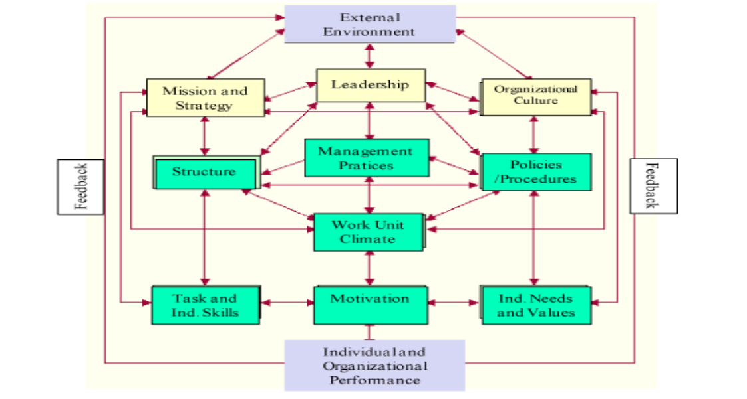
Sourced from (Boone, 2012)

Appendix B
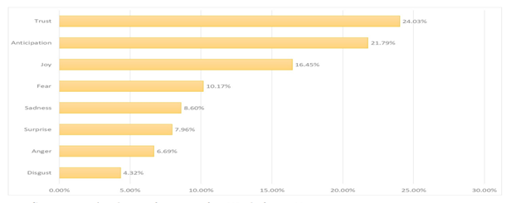Sourced from (Dubey & Tripathi, 2020)

Appendix C

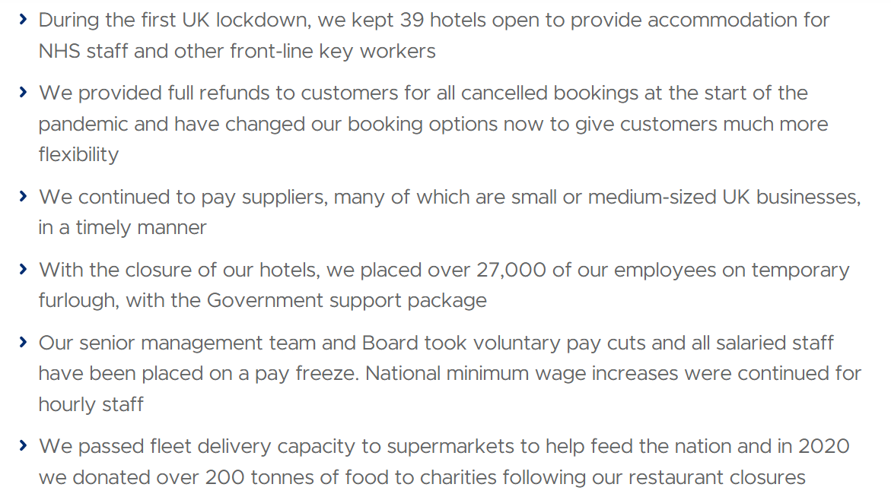
Sourced from (Whitbread PLC, 2022a)

Appendix D
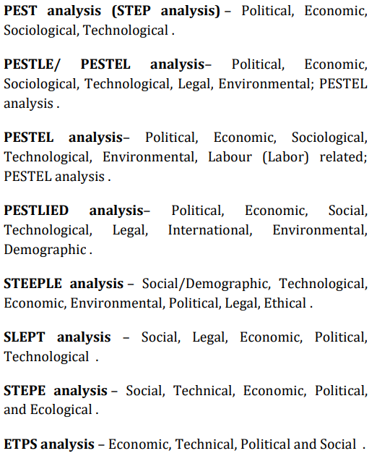
Sourced from (Rastogi & Trivedi, 2016)

Appendix E
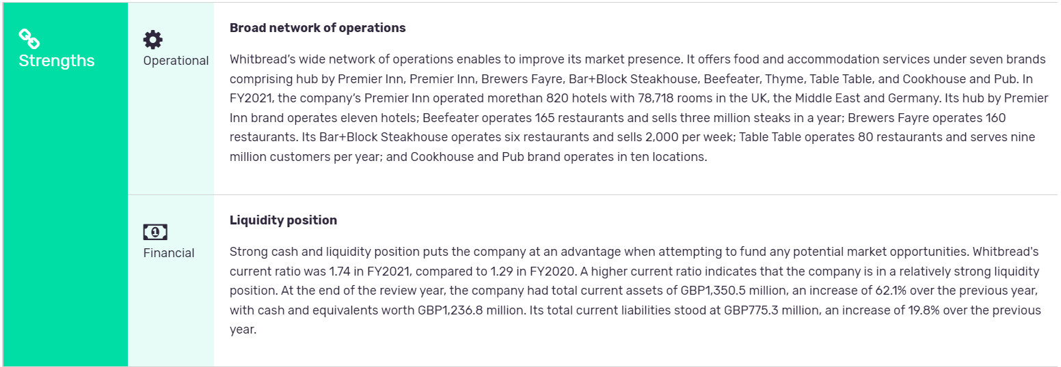
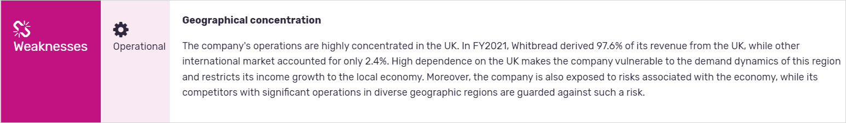
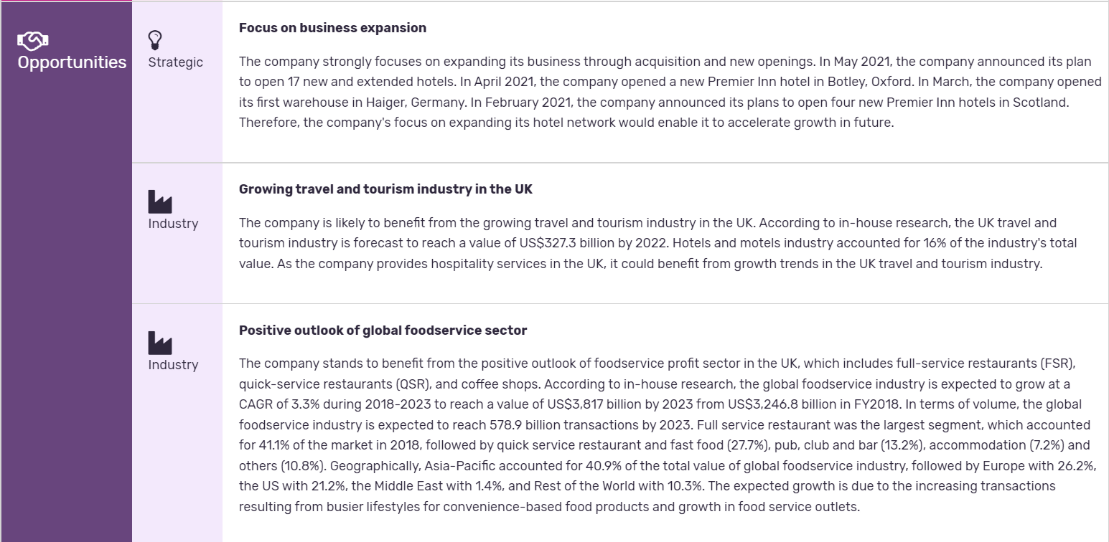
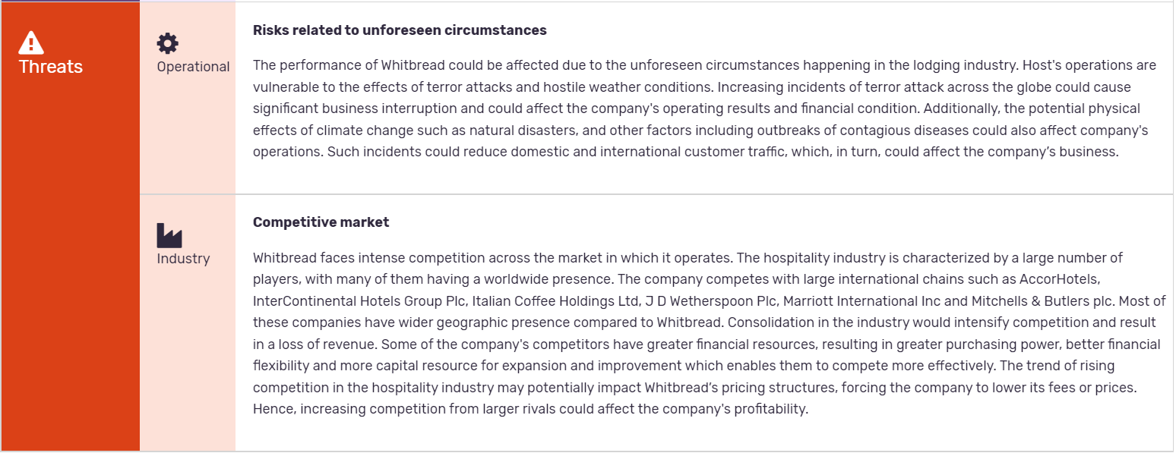

Appendix F

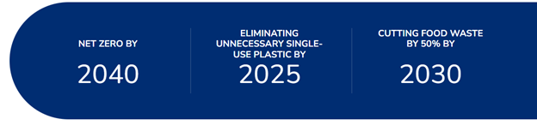
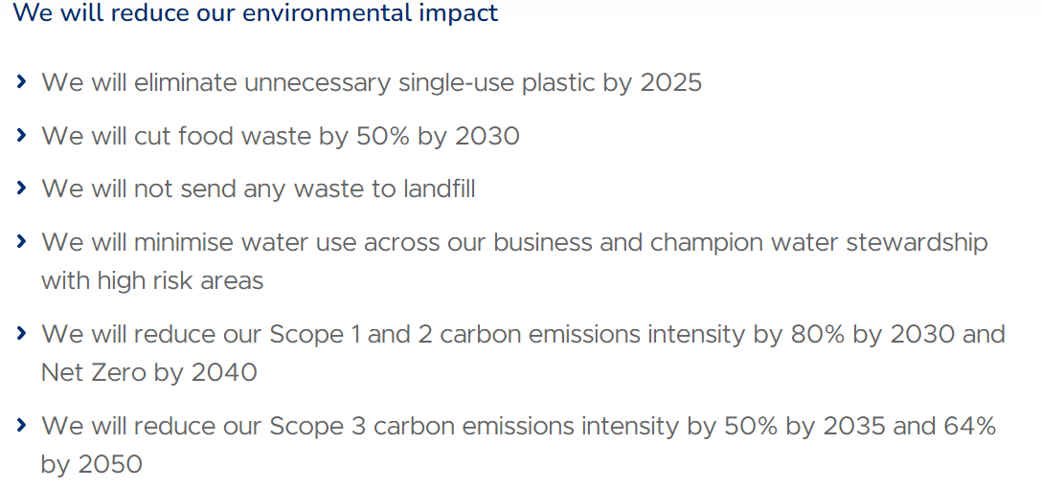
Sourced from (Whitbread PLC, 2022)

Appendix G
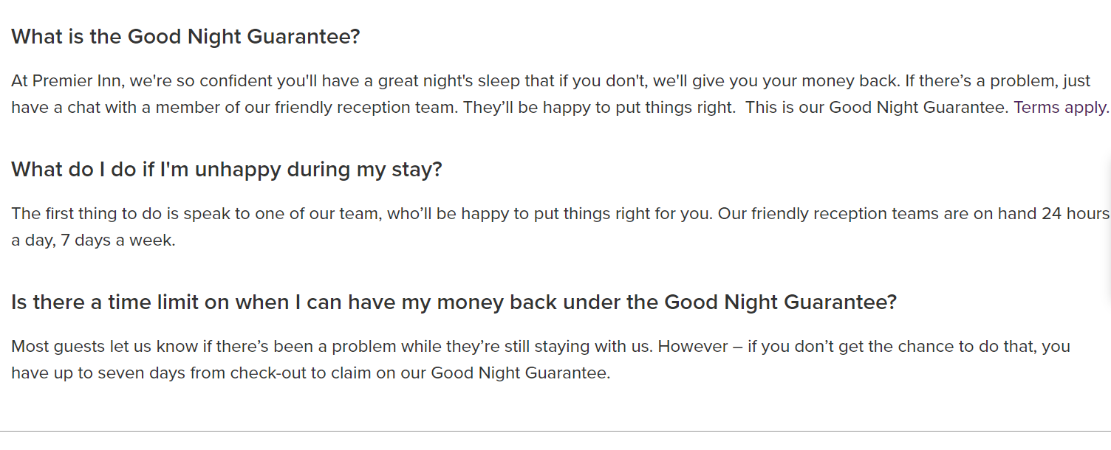
Sourced from (Premier Inn, 2022)

Appendix H

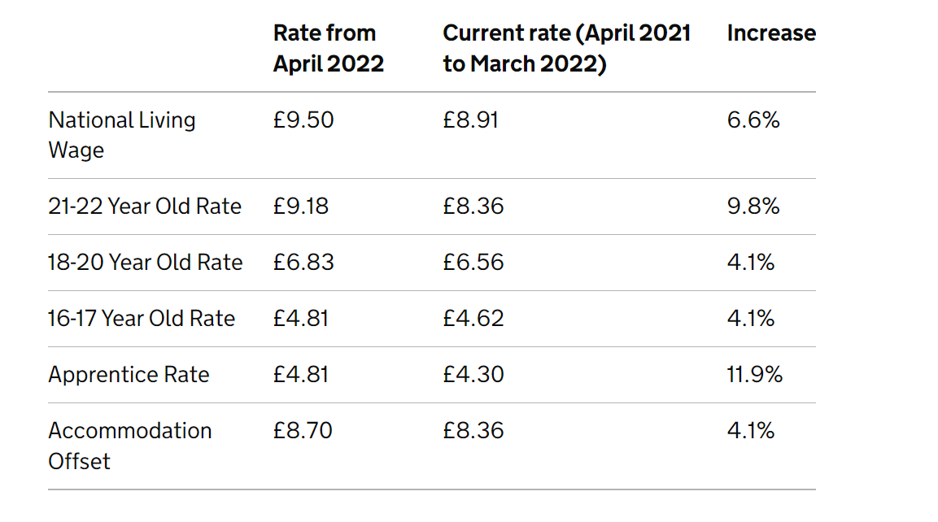
Sourced from (GOV.UK, 2021)

Appendix I

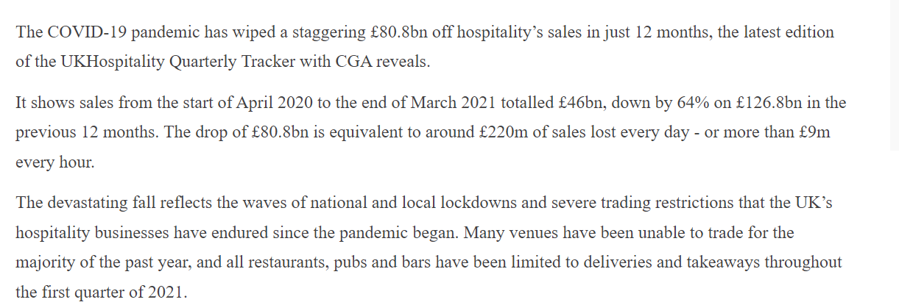
Sourced from (Thomsen, 2021)

Appendix J
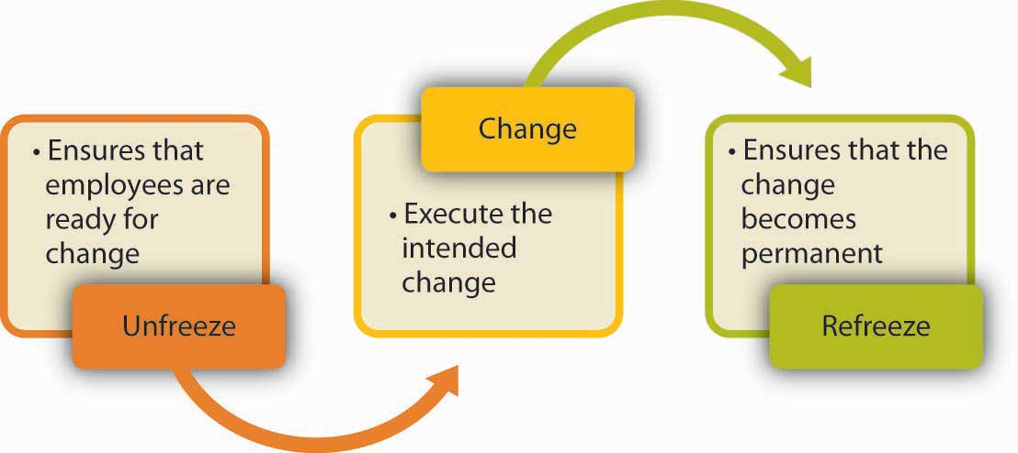
Sourced from (Principles of Management, 2019)

Appendix K

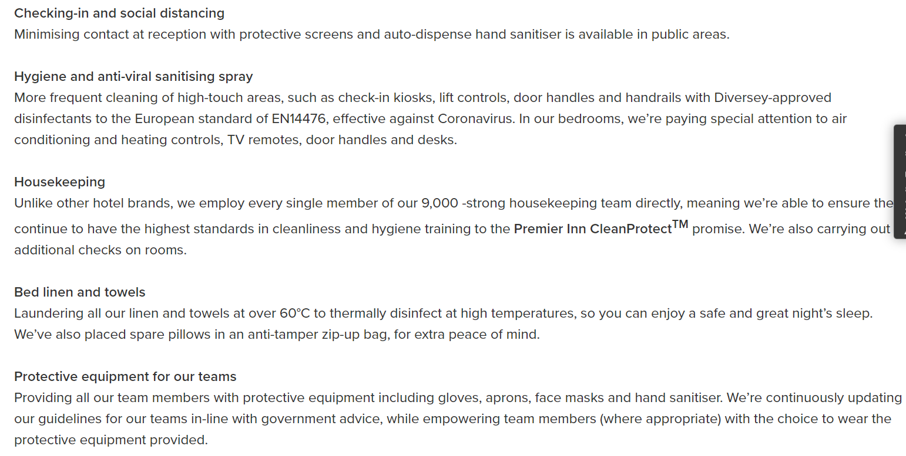
Sourced from (Premier Inn, 2021)

