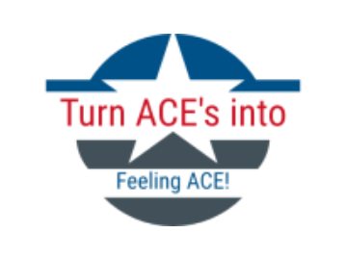
Our service aims to support children with Adverse Childhood Experiences, ACE’s, in order to help them to:-
- Be children!
- Help them with their situation!
- Help prepare them for their future!
- Allow them to enjoy their life now!
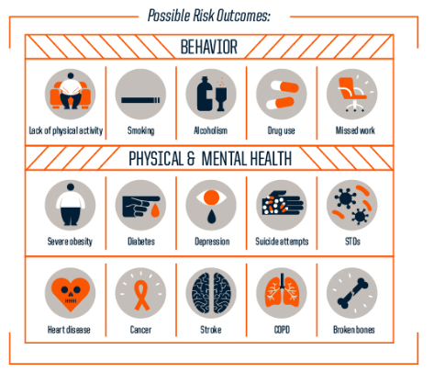
Facts about ACE’s
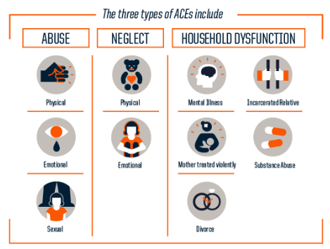
The NHS Wales (2015) found that for every one hundred adults in Wales, forty seven of them have suffered at least one ACE during their childhood and fourteen have suffered four or more. The Robert Wood Johnson Foundation (2013) have described the three main types of ACE’s and are as pictured below.

These ACE’s can have a huge impact on a child’s life, Joining Forces for Children (2019) found that ACE’s can cause toxic stress which they described as ‘prolonged activation of the body’s stress response to frequent intense situations/events.’ For example, witnessing domestic violence within the home or experiencing chronic neglect. If this type of stress is not properly addressed, it can lead to long-term behavioural issues, health complications and other diseases in which ACE’s can cause, these are shown below.

Robert Wood Johnson Foundation (2013)

Who are we?
We are an enthusiastic, hardworking and well trained team who all work together in order to ensure that all of the children are supported. Currently, we only have 2 Turn ACE’s into Feeling Ace services within the South Wales area. However, we hope to expand and reach as many disadvantaged areas in order to help other children. The Turn ACE’s into feeling ACE is a service aimed at those who live in disadvantaged areas in Wales and works closely with schools, health visitors and social workers. Our service will aim to provide a space for any young person aged 3 to 18 who is currently in education and suffering or has suffered with ACE’s. We split these children into groups by age in order to allow them to carry out activities suitable to their age.
How do we help?
We put on 2 hour sessions 2 days a week for children in order for children to:-
- Talk to our trained staff if they need
- Do homework
- Have access to computers and internet
- Play some games
- Make friends
- Give our older children help with creating CV’s
- Providing them with nutritious snacks
During school holidays, we also take our children on days out to places like the park, soft play areas, theme parks and zoos. We have even take the older children on what we call a little holiday break, last year we went to Cardiff and stayed in the Urdd Camp for 2 nights. We have booked to go to the Urdd Camp in Llangranog in which our children are very much looking forward to. We do these trips because children may not have had a chance to do these things within their family homes. We are able to these trips as we rely on charity as well as a grant from the Welsh Government in which we receive yearly.

Wikepedia (2019)
123RF (2019)


Who do we work with?
At Turn ACE’s into feeling ACE take a multi-agency approach as we feel this benefits the children and helps us improve our service keeping in close contact with other services. The agencies that we work closely with are:-
- Schools
- Team Around the Family (TAF)
- TAF often refer children to our team if they feel our help is necessary
- Swansea Council (2018) inform that they have an holistic way of working with the whole family of children aged 0-11
- Around 40% of our younger children are referred to us by the TAF programme
- Flying Start Programmes
- Swansea Council (2018) explain that Flying Start is quality childcare for 2 to 3 year olds
- Around 30% of our younger children are referred to us by the Flying Start programme
- Health visitors
- School nurses
- Play workers
- Social workers
- Youth organisations
- Youth workers
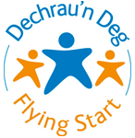
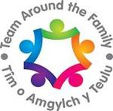Swansea Council (2018)
Welsh Government (2019)
Person Centred Planning (PCP)
Our service heavily relies upon PCP in order to work as we intended it. O’Brien & O’Brien (2000, p20) explains that PCP allows professionals to find out what works well for individual pupils and what does not work well, it allows them to find what they need to support the individual as well as to find out what the pupil wants for the future and what they will do to ensure that. PCP originally began out of a passionate concern to support people with developmental disabilities in discovering and contributing their gifts. It moved from segregating and controlling vulnerable groups of people to giving them the experience of participation. Booth (2014) says that PCP aims to empower disadvantaged children and describes this as a process in which individuals who lack power can become more powerful.
What are the principles of PCP?
According to Mercer (2003) the principles are
- Having a community presence
- Having choice and control
- Being competent
- Having respect
- Building relationships
- Being able to share ordinary places and valued activities with others
- Having freedom to make decisions
- Having opportunities to engage in meaningful, functional activities with whatever level of assistance required
We aim to include these fully within our services by allowing the children to choose what activities they would like to do that session, whether it be drawing or playing a game like Monopoly. We allow them to do things independently and only give help when they require it and giving them the freedom to build friendships through the service. We use Person Centred Planning by ensuring that the child is at the centre of all that we do. The Helen Sanderson Associates (2019) explains that ‘by working this way, we can make sure that people are truly listened to and are kept at the heart of all decision-making.’ We use a child centred approach to ensure that all of the child’s needs and wants are met and we base this off of the Welsh Government’s 7 Core Aims.
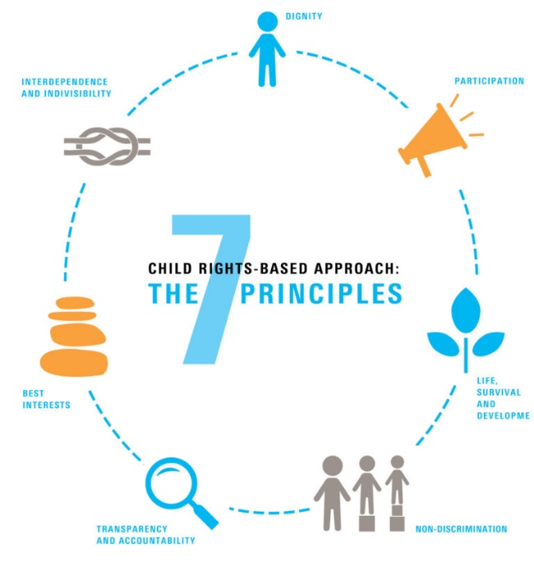

UNICEF (2019

Social Inclusion
The World Bank (2019) described social inclusion as ‘the process of improving the terms on which individuals and groups take part in society- improving the ability, opportunity, and dignity of those disadvantaged on the basis of their identity.’ At Turn ACE’s into Feeling ACE we aim to be socially inclusive by giving our disadvantaged children not equality but equity. We give them the help that they need so that they are not further disadvantaged by their ACE’s, we want to give them the best life they can live regardless of anything that has gone on in their life in which typically would set them back.
Location: Swansea Comprehensive School
When: Tuesday and Thursday 4pm until 6pm (unless told otherwise)
Contact number: 01792 654321
Email address: swanseacomprehensive@sch.co.uk
Reference List
Booth, J. (2014) Lecture 6 - Empowerment and Social Change SJSI6017. University of Wales Trinity Saint David. Unpublished.
Helen Sanderson Associates (2019). Person-Centred Practices. [Online]. Helen Sanderson Associates. Available at http://helensandersonassociates.co.uk/person-centred-practice/ (accessed 02/04/2019)
Joining Forces for Children (2019). What are ACE’s? [Online]. Joining Forces for Children. Available at http://www.joiningforcesforchildren.org/what-are-aces/ (accessed 28/03/2019)
Mercer, M. (2003) Person Centered Planning. Helping People with Disabilities Achieve Personal Outcomes. Illinois: High Tide Press
NHS Wales (2015). Adverse Childhood Experiences on health-harming behaviours in the Welsh adult population. [Online]. Public Health Wales NHS Trust. Available at http://www2.nphs.wales.nhs.uk:8080/PRIDDocs.nsf/7c21215d6d0c613e80256f490030c05a/d488a3852491bc1d80257f370038919e/$FILE/ACE%20Report%20FINAL%20(E).pdf (accessed 28/03/2019)
O’Brien, J. & O’Brien, C.L. (2000). A Little Book About Person Centred Planning. Ontario: Inclusion Press
Robert Wood Johnson Foundation (2013). Truth about ACE’s. [Online] Robert Wood Johnson Foundation. Available at https://www.rwjf.org/en/library/infographics/the-truth-about-aces.html#/embed (accessed 28/03/2019)
Swansea Council (2018). Quality Childcare for 2 to 3 year olds. [Online]. City and County of Swansea. Available at https://www.swansea.gov.uk/article/8915/Quality-childcare-for-2-to-3-year-olds (accessed 02/04/2019)
Swansea Council (2018). Team Around the Family. [Online]. City and County of Swansea. Available at https://www.swansea.gov.uk/taf (accessed 02/04/2019)
The Welsh Government (2019). Welcome to Cardiff Flying Start. [Online]. Flying Start Cardiff. Available at https://www.flyingstartcardiff.co.uk/ (accessed 02/04/2019)
The World Bank. (2019). Social Inclusion. [Online]. The World Bank Group. Available at https://www.worldbank.org/en/topic/social-inclusion (accessed 02/03/2019)
Picture Reference List
123RF (2019). Illustration of Kids on a Camping Trip. 123RF Limited 2005-2019. Available at https://www.123rf.com/photo_12325600_illustration-of-kids-on-a-camping-trip.html (accessed 02/04/2019)
Joining Forces for Children (2019). What are ACE’s? [Online]. Joining Forces for Children. Available at http://www.joiningforcesforchildren.org/what-are-aces/ (accessed 28/03/2019)
Robert Wood Johnson Foundation (2013). Truth about ACE’s. [Online] Robert Wood Johnson Foundation. Available at https://www.rwjf.org/en/library/infographics/the-truth-about-aces.html#/embed (accessed 28/03/2019)
Swansea Council (2018). Team Around the Family. [Online]. City and County of Swansea. Available at https://www.swansea.gov.uk/taf (accessed 02/04/2019)
UNICEF (2019). A Child Rights-Based Approach. [Online]. UNICEF. Available at https://www.unicef.org.uk/child-friendly-cities/child-rights-based-approach/ (accessed 02/04/2019)
Wikepedia (2019). Urdd Gobaith Cymru. Wikepedia. Available at https://en.wikipedia.org/wiki/Urdd_Gobaith_Cymru (accessed 02/04/2019)

