
Database Design and Implementation for MedAssist Clinic
A Relational Database Management System for Patient, Doctor, Appointment, Treatment, and Feedback Management
Module Name: Databases and Application Development
Module Code: ACCA5026
Assessment: Part A – Database Design and Implementation
Case Study: MedAssist Clinic
Student Name: Cornelia Dobre
Student ID: 2333752

Table of Contents
1. Introduction 6
1.1 Background 6
1.2 Problem Statement 6
1.3 Aim 6
1.4 Objectives 6
2. Database Design 7
2.1 Requirement Analysis 7
2.2 Entity Identification 7
2.3 Relationship Analysis 8
2.4 Entity Relationship Diagram (ERD) 8
2.5 Database Normalization 9
First Normal Form (1NF) 9
Second Normal Form (2NF) 10
Third Normal Form (3NF) 10
2.6 Database Constraints 10
3. Database Implementation 11
3.1 Database Creation 11
3.2 Constraint Implementation 13
3.3 Sample Data Population 14
3.4 CRUD Stored Procedures 15
3.5 Trigger Implementation 17
3.6 SQL Functions 18
3.7 Database Testing 19
4. Stored Procedures and Transactional Scenario 21
4.1 Stored Procedures 21
4.2 Transaction Handling 21
4.3 Practical Transaction Scenario 21
4.4 Importance of Transaction Handling 22
5. Performance Tuning Enhancement 23
5.1 Performance Issues 23
5.2 Secondary Indexes 23
5.3 Query Optimization 23
5.4 Performance Improvement 24
6. Conclusion and Reflection 24
6.1 Conclusion 24
6.2 Reflection 25
References 26
Appendix 29
Complete SQL Script 29
ERD 29
Additional Screenshots 29

List of Figures
Figure 1 . Entity Relationship Diagram (ERD) of the MedAssist Clinic Database 10
Figure 2 SQL Code for Creating the Users Table 13
Figure 3 Appointments Table 13
Figure 4 Treatments Table 14
Figure 5 Constraints Implement 15
Figure 6 INSERT statements 16
Figure 7 Execution of Patient CRUD Stored Procedures 17
Figure 8 Execution of Doctor CRUD Stored Procedures 18
Figure 9 Execution of Appointment CRUD Stored Procedures 18
Figure 10 Trigger Execution and Audit_Log Output 19
Figure 11 SQL Functions and Execution Output 20
Figure 12 Transaction Handling Using COMMIT and ROLLBACK 23
Figure 13 Query Optimization Using Secondary Indexes 25

1. Introduction

1.1 Background
MedAssist Clinic is a private health clinic in the United Kingdom. The clinic provides outpatient medical services such as general consultation, health check, refer to specialists. Providing quality health care to registered patients through the cooperation of doctors, specialists and administrative staff. Records, appointments, treatments and feedback is currently managed manuelly, which can be time consuming and prone to error. The clinic receives a lot of patients and it is very important to have an efficient database system to run the business efficiently. The computerised database will enable the timely storage, updating and retrieval of information which will improve the accuracy and security of medical records.

1.2 Problem Statement
The current manual system has several operational challenges to the clinic. There is a risk of duplication of patient information, record keeping can become cumbersome and appointments can be delayed or clash. Treatment history and patient feedback is also less consistent. Therefore, MedAssist Clinic must have the secure and centrally managed relational database to improve data management, daily operation and data consistency.

1.3 Aim
This project aims to create and develop a secure relational database system for MedAssist Clinic to facilitate patient management, appointment scheduling, treatment documentation, and feedback management.

1.4 Objectives
The objectives of this project are to:
- Design a relational database based on the clinic requirements.
- Create an Entity Relationship Diagram (ERD).
- Normalize the database to Third Normal Form (3NF).
- Implement tables with appropriate constraints.
- Develop stored procedures for CRUD operations.
- Create triggers and SQL functions to support database operations.
- Improve query performance by implementing suitable indexes.

2. Database Design

2.1 Requirement Analysis
MedAssist Clinic database was developed to support the clinic every day. All patient information, doctors' profiles, departments, appointments, treatments, and patient feedback are collected in a single central data repository. Patients can register and make appointments with the doctors available. Doctors are allocated to a ward and they note the treatment following each consultation. Creating an appointment connects one patient with one doctor, and creates a complete medical record. Patients also can voice their opinions after their visit to improve health care services. This Database eliminates manual work, improves document management, and stores information accurately and securely. Furthermore, it enables faster data retrieval, scheduling, and efficient healthcare management for both providers and users [1].

2.2 Entity Identification
The MedAssist Clinic database consists of eight primary entities, which contain different information. The Users entity contains information about users' logins, including administrators, doctors and patients. Stores information about medical departments in the clinic. Doctors include some personal information as well as doctor information. Patient information, contact and registration data are stored by patients. Records of appointments made appointments to doctors. Diagnosis, medicines and treatment notes after appointment in treatments store. Patient ratings and comments about the health services received are kept via the feedback function. Finally, triggers capture significant changes to the database in the Audit_Log entity. This, together, provides a comprehensive and well organized database which allows MedAssist Clinic to perform daily operations.
Table 1 Entity Description
Entity | Description
Users | Stores login details for administrators, doctors, and patients.
Departments | Stores department information such as department name, location, and contact details.
Doctors | Stores doctor information including qualifications, specialization, availability, and department.
Patients | Stores patient personal information, contact details, and registration records.
Appointments | Stores appointment details between patients and doctors.
Treatments | Stores diagnosis, prescribed medicines, and treatment notes.
Feedback | Stores patient ratings and comments after appointments.
Audit_Log | Stores audit records created automatically by database triggers.

2.3 Relationship Analysis
Primary and foreign keys are used to establish data integrity among the entities in the MedAssist Clinic database. Many doctors may belong to a single department, but a single doctor can belong to only one department. Many appointments are managed by a doctor and each appointment is assigned to one doctor. Likewise, a patient may have several appointments, and each appointment has a single patient. Each appointment will have one treatment record with the diagnosis and prescribed medication. Patients can provide feedback following their appointments and each feedback is related to a single patient. The appointment table connects to doctors and doctors receive feedback as each appointment specifies the doctor that provided the consultation. These relationships minimize data redundancy and ensure data integrity [2].

2.4 Entity Relationship Diagram (ERD)
The Entity Relationship Diagram (ERD) for the MedAssist Clinic database is shown in figure 1. The ERD displays the structure of the database, including all the entities, attributes, primary keys (PK), foreign keys (FK), and the relationships among entities. There will be a primary key in each table to uniquely identify each record, and there will be foreign keys to link to other related tables to ensure referential integrity. The relationships describe the flow of data between components. For instance, a department may have numerous doctors, a doctor may have numerous appointments, as well as a patient might have a number of appointments. Every appointment is associated with a treatment, and individual patients can provide more than one feedback record. The cardinalities reduce data duplication, ensure consistency, and adhere to a normalized Third Normal Form (3NF) database design [12].
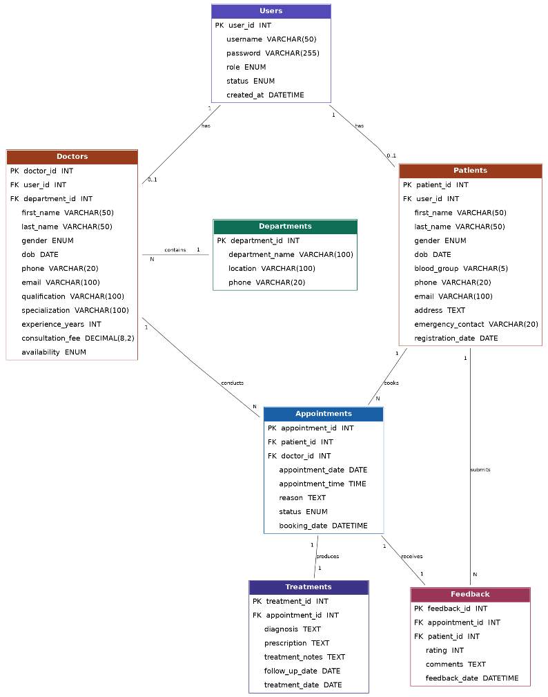
Figure 1 . Entity Relationship Diagram (ERD) of the MedAssist Clinic Database

2.5 Database Normalization
The database design was optimized through normalization to ensure efficient data storage and minimizing data redundancy. The MedAssist Clinic data base is designed in Third Normal Form (3NF) to ensure data integrity and easier database maintenance [30].

First Normal Form (1NF)
The database is in its 1st Normal Form as each table has a primary key and each column holds only one value. No repeating groups or multiple values are stored in a single field. For example, the Patients table contains one phone number, one email address and one blood group for each patient. Likewise, there is one appointment date and one appointment time in each appointment record [21].

Second Normal Form (2NF)
The database is in Second Normal Form (2NF) if all non-key attributes are dependent on the entire primary key. Each table contains one primary key and all of the related data is stored in the appropriate table. For example, doctor qualifications and specialization are stored only in the Doctors table, while patient details are stored only in the Patients table. This eliminates partial dependency and maintains the data structure [13].

Third Normal Form (3NF)
The database is in Third Normal Form (3NF), where no non-key attribute is dependent upon another non-key attribute. The data is divided into several tables, connected with each other in the form of foreign keys. For example, the Department information is not duplicated for each doctor record, but rather it exists in the Departments table. Likewise, the treatments are stored in the Treatments table and are linked to appointments through the use of the foreign key appointment_id. This design will prevent data duplication, consistency and efficient data maintenance [3].

2.6 Database Constraints
Database constraints have been used to ensure data accuracy, consistency and integrity for the MedAssist Clinic database. These constraints prevent the storage of invalid data, and keep all relationships valid [31].
A Primary Key (PK) is a field that ensures that every row in a table is unique. Each entity (Users, Doctors, Patients, Appointments, Treatments, and Feedback, etc.) has a primary key to make each record unique.
The Foreign Key (FK) is used to establish relationships between tables and ensure referential integrity. For instance, the doctor_id and patient_id columns in the Appointments table are used to link appointments to the appropriate doctor and patient. This ensures that orphan records and relationships are avoided [22].
The UNIQUE constraint is used to prevent duplicate values. In this database, the username field (Users table) and the email field (Doctors and Patients table) are unique and will not allow duplicate entries to be added to the database.
The CHECK constraint validates the data before it is inserted. For example, if you add a rating of 1 or 5 to the Rating field in the Feedback table, the rating will remain valid, but you will not be able to add a rating of 6.
The NOT NULL constraint ensures that other important data elements are not provided without any value. The values of the fields, such as names, appointment dates and usernames, need to be valid before an entry can be added to the database. These restrictions are used to help ensure data quality and reliability of database operations [14].

3. Database Implementation

3.1 Database Creation
The MedAssist Clinic database was designed with MySQL Workbench, guaranteeing a secure and organized environment for storing healthcare information. In the beginning a new database created named medassist_clinic_db and selected as the working database. All the tables, relationships, stored procedures, triggers, functions, and sample data for the project were stored here [23].
The Database was then created, and the required tables were designed based on the approved Entity Relationship Diagram (ERD). The process of creating a table was done in the logical order according to the database design to avoid foreign key dependency issues. The Users table was created first, because it holds the login credentials of both doctors and patients. The rest of the tables (Departments, Doctors, Patients, Appointments, Treatments, Feedback, and Audit_Log) were then created with their corresponding primary, foreign and data constraints. Each of these tables was appropriately linked and met the functional needs of the MedAssist Clinic database [4]. The SQL statement for creating the Users table is shown in figure 2.

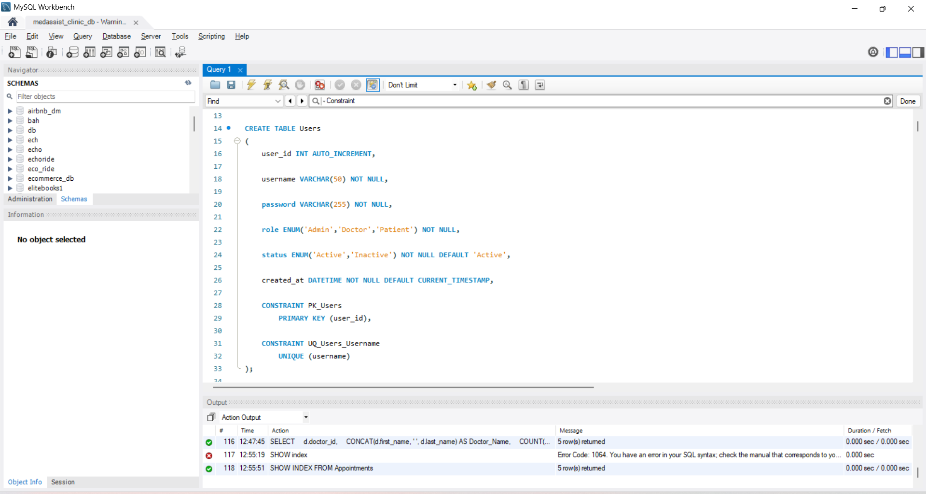
Figure 2 SQL Code for Creating the Users Table
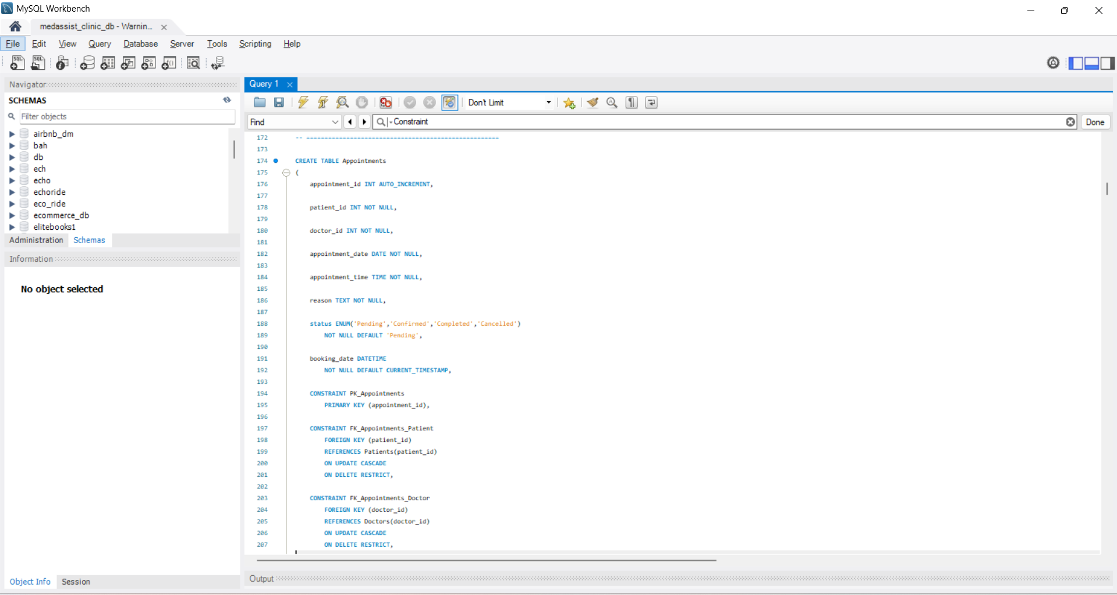
Figure 3 Appointments Table
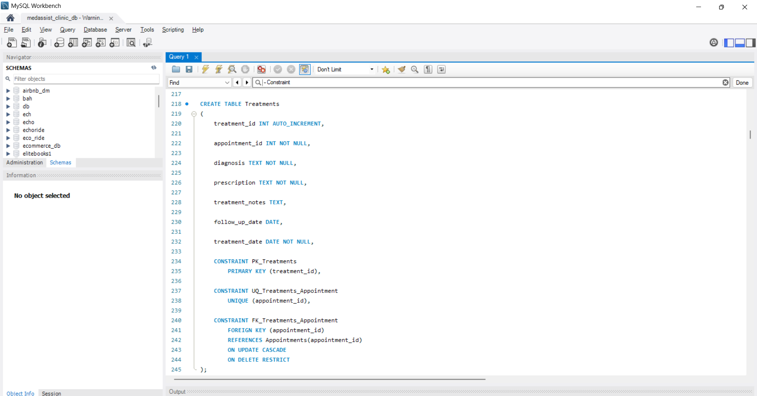
Figure 4 Treatments Table

3.2 Constraint Implementation
Preserving accurate, valid, and consistent information in the MedAssist Clinic database is made easier by the use of database constraints. These restrictions help ensure that data in different tables are linked up and that no invalid data is inserted into the database. Each table had a Primary Key (PK) constraint to uniquely identify each record. For example, user_id, doctor_id, patient_id and appointment_id ensure that no duplicate records exist for each of those entities in the tables [31]. Relationship between related tables was made using foreign key constraint and ensuring referential integrity. For instance, the Appointments table is related to the Doctors and Patients tables by foreign key, so only appointments that are for valid doctors and patients can be added to the Appointments table [15].
The UNIQUE constraint ensures that critical information such as username and email addresses are not repeated. CHECK constraint can be used to prevent the addition of invalid data to a table, such as preventing patient ratings from being added to the table that contain ratings in the range 1 to 5, but not 6 to 9. The NOT NULL constraint can prevent data from being inserted if any of the fields is not completed. The constraints implemented were tested with valid and invalid SQL statements, as the validation errors proved to be enough to cause the database to reject invalid data and preserve data integrity [29]. The SQL to create the constraints and the validation error that would occur should an invalid value be entered in the database table are shown in figure 5.
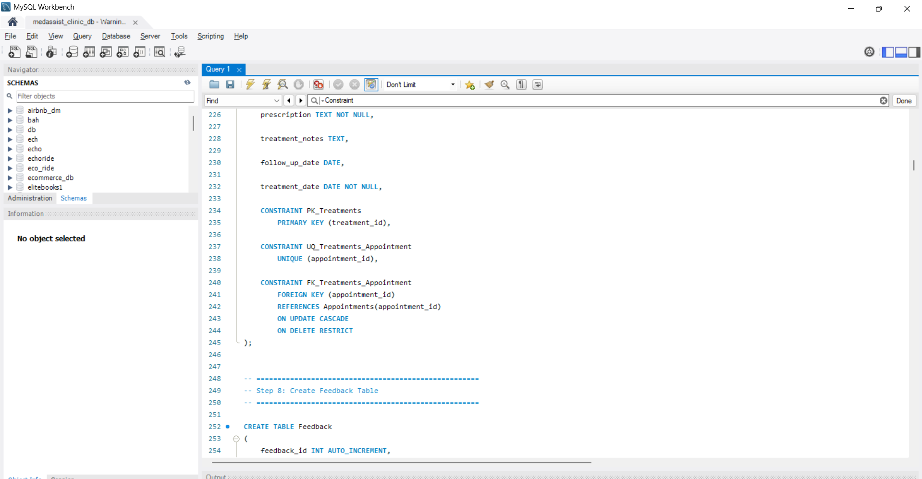
Figure 5 Constraints Implement

3.3 Sample Data Population
The database tables were developed, and sample data from the real world was inserted into the tables to simulate the operation of MedAssist Clinic on a day to day basis. Major tables (Users, Departments, Doctors, Patients, Appointments, Treatments and Feedback) have sample records added. Typical healthcare processes that are included in data are patient registration, doctor assignment, appointment scheduling, treatment documentation, and submission of patient feedback. Five medical departments, five doctors, ten patients, fifteen appointments, ten treatment records and ten feedback records were entered into the database for example. There are also role based access to the Users table for administration, doctor and patient accounts [5].
The sample data was also used to validate the database design and test all the implemented features. It was utilized to confirm inter-relationships of tables, to run CRUD stored procedures, test foreign key and check constraints, check triggers and SQL functions, as well as to show how to manage transactions with COMMIT and ROLLBACK. The realistic dataset also enabled query optimization and testing of indexes, as it contained enough records to evaluate performance. The SQL sentences for creating the database, inserting data into the database, and verifying that the data has been inserted into the appropriate tables are shown in figure 6 [24].
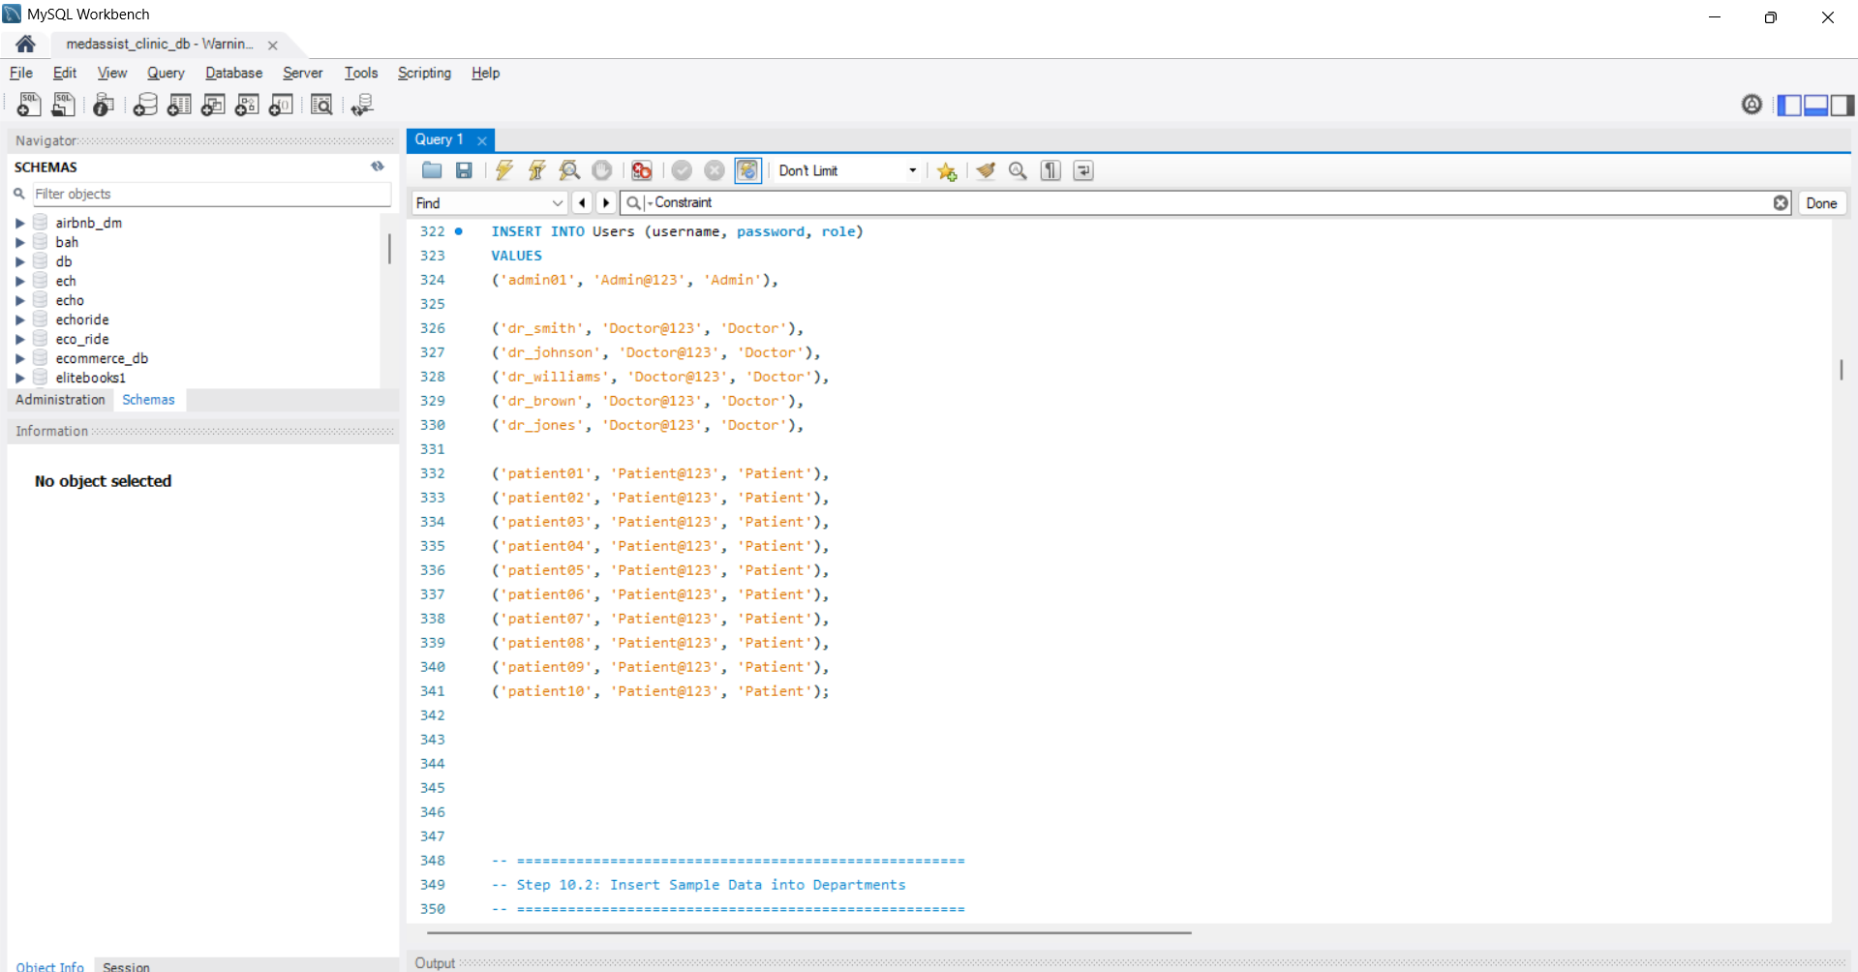
Figure 6 INSERT statements

3.4 CRUD Stored Procedures
The Create, Read, Update, Delete (CRUD) operations in the MedAssist Clinic database were developed using stored procedures. These procedures make database management easier, cut down on repeated SQL code, and ensure consistency of data in the database through the use of transaction handling with START TRANSACTION, COMMIT and ROLLBACK.
The AddPatient procedure adds a new patient record to the Patients table, subject to the validation of the patient's user account. The UpdatePatient procedure updates the phone number, email address, home address and emergency contact. The DeletePatient procedure will delete a patient record if no longer needed. The AddPatient, UpdatePatient, and DeletePatient procedures are executed along with their successful outputs as shown in figure 7.
Likewise the Doctors table store procedures AddDoctor, UpdateDoctor and DeleteDoctor will be used to add doctor, update doctor and delete doctor record with doctor detail, qualification, specialization, consultation fee, and availability. Figure 8 shows the successful implementation of these procedures and the results [6].
The BookAppointment, UpdateAppointment and CancelAppointment procedures are created to perform the appointment related operations, Schedule appointment, Update appointment information and canceling appointment when required. The results of the execution are shown in Figure 9 which shows that the records of appointments were created, updated and cancelled successfully. The stored procedures improved the integrity of the database, reduced manual SQL work, and provided a common standard for data from the clinics [16].
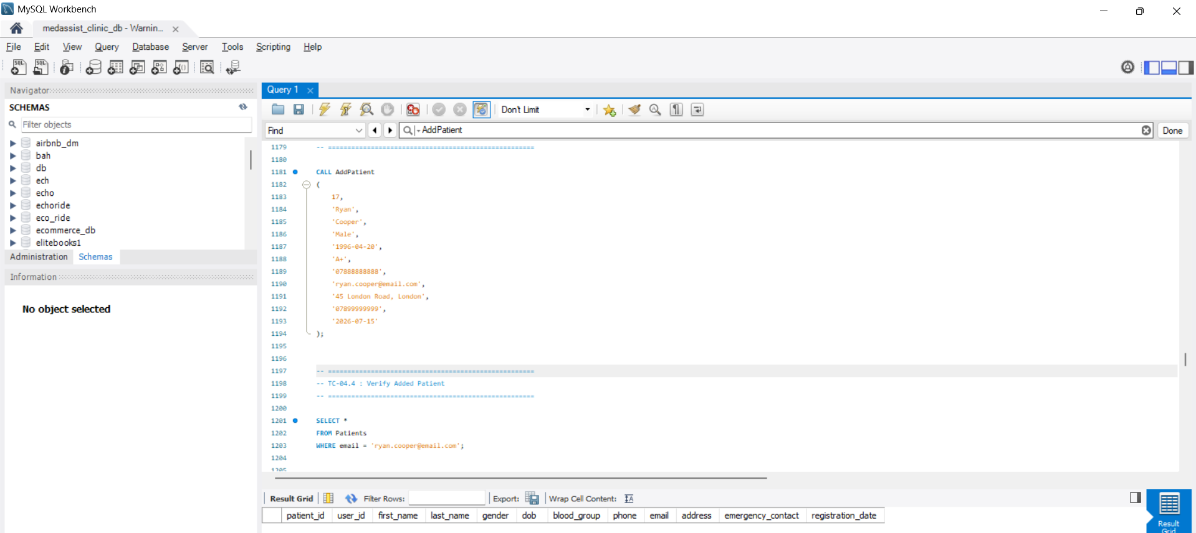
Figure 7 Execution of Patient CRUD Stored Procedures
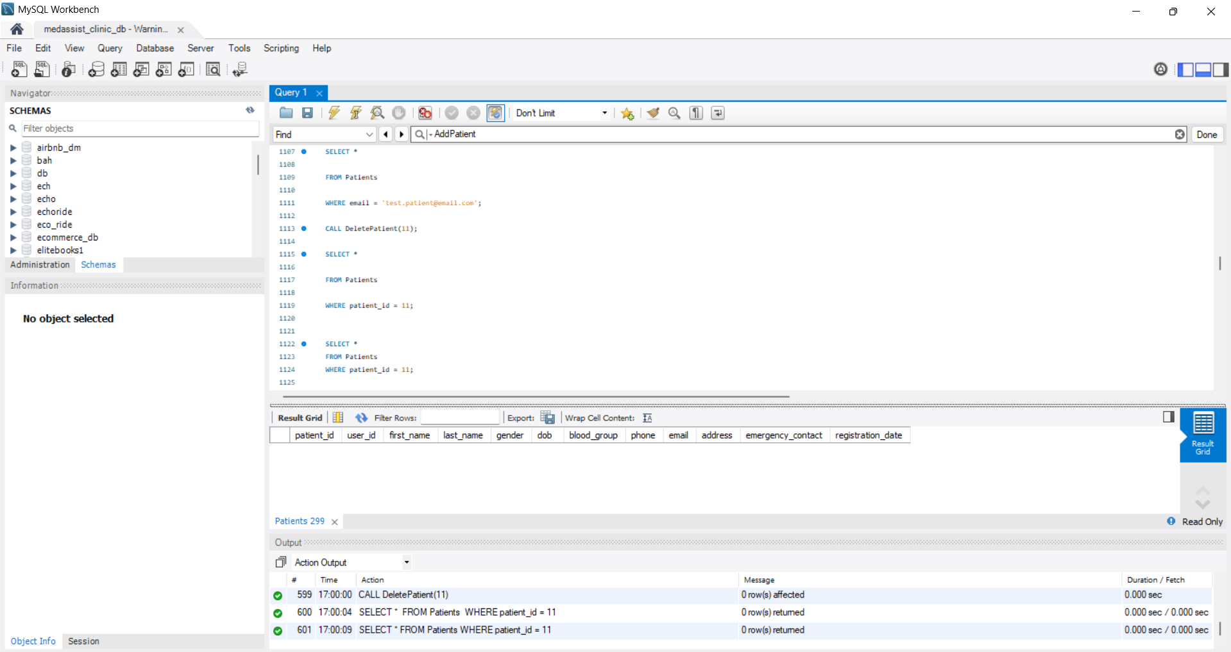

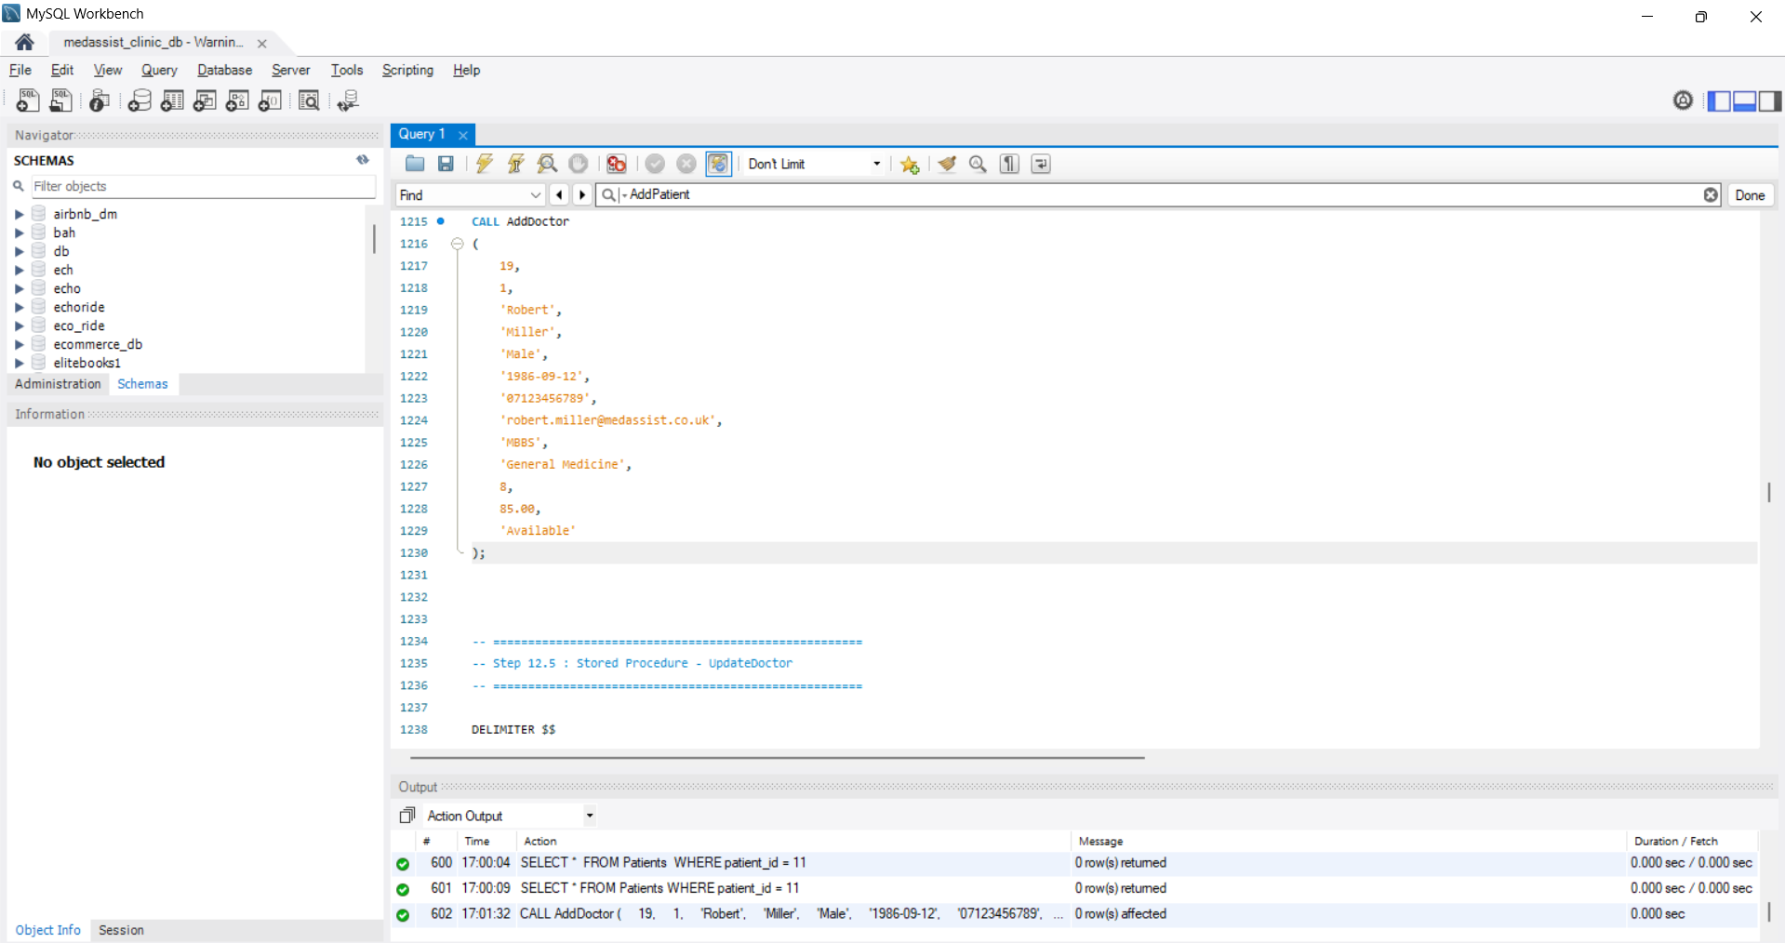
Figure 8 Execution of Doctor CRUD Stored Procedures

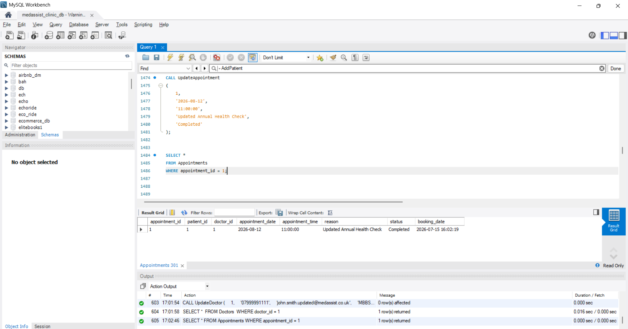
Figure 9 Execution of Appointment CRUD Stored Procedures

3.5 Trigger Implementation
Database triggers were designed to automatically track major changes in the MedAssist Clinic database. A new trigger, called AFTER UPDATE, was added to the Patients table to support auditing. This is a trigger that is used to track changes to the record history without the need to make changes by the database administrator. A trigger is then created which will automatically run when the information on a patient changes and will insert the information about the change into the Audit_Log table [25].
The Audit_Log table contains useful information, such as the table name, operation type, record ID, old value, new value, user who performed the operation and the time when the operation was performed. This gives an end to end audit trail for monitoring database activities and enhance accountability. The trigger also is used to guarantee data integrity, where all changes are made in a consistent way and can be accessed when necessary [17]. The trigger was tested by changing an email address of a patient in the Patients table. After the update was finished, the Audit_Log table was automatically updated with the associated audit record. The SQL statement that created the trigger is displayed in Figure 10 and the result set of the Audit_Log table is displayed to show that the auditing process was successful [32].

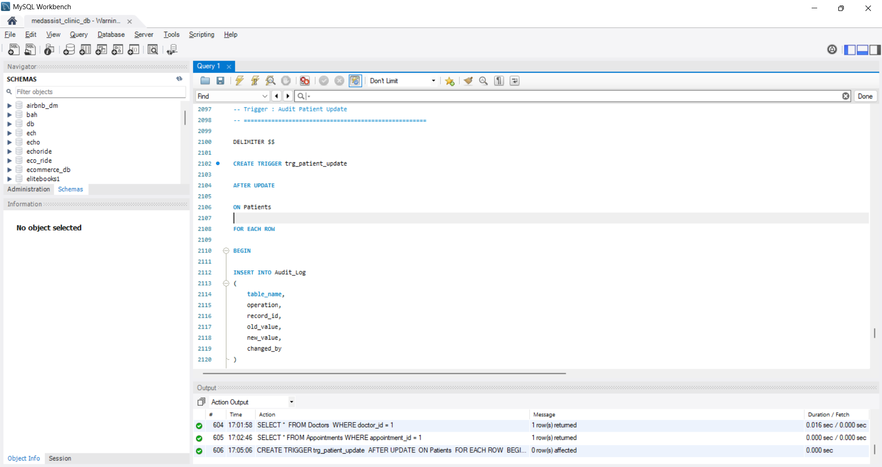
Figure 10 Trigger Execution and Audit_Log Output

3.6 SQL Functions
The MedAssist Clinic system required two user-defined SQL functions that are useful for data analysis and to ease frequent operations in the database. These functions provide helpful information, but do not require the need to make complex SQL queries whenever the function is invoked [7]. The GetDoctorAppointmentCount( ) function returns total number of appointments assigned to a selected doctor. It will associate the number of appointment records to the doctor_id that matches the doctor_id specified. This function will help to keep track of doctors workload and distribution of appointments in the clinic.
GetDoctorAverageRating($Doctor) returns the Average rating of a particular doctor based on the patients' feedback. It retrieves the ratings and returns the mean rating as a decimal number, from the feedback records that are stored in the Appointments table. This function is to enable the clinic to evaluate the quality of the healthcare service which is provided by a doctor based on the feedback from the patients. Both functions were tested with valid doctor_id's and the output matched what is stored in the database. These functions can improve the performance of the database, as they can include business logic and prevent duplicate SQL calls. The SQL code executed in Figure 11 and the result returned by the database are displayed that both functions executed correctly [26].
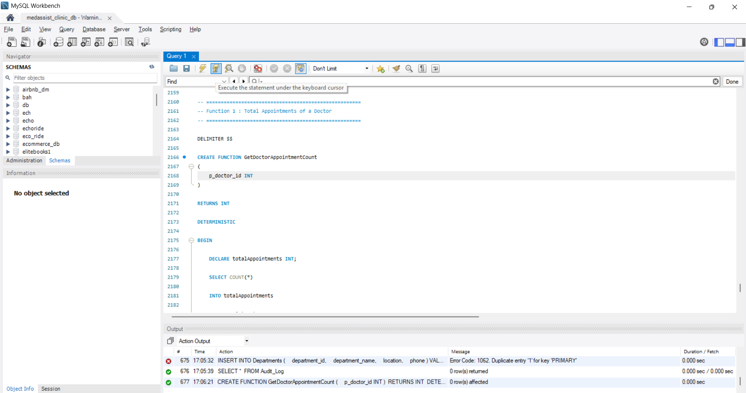
Figure 11 SQL Functions and Execution Output

3.7 Database Testing
The database was tested to ensure that all parts of MedAssist Clinic database worked and fulfilled the functional requirements of the system. The testing process consisted of testing of the database structure, data integrity, stored procedures, transaction handling, trigger and function execution, and query performance with indexes. All the tests were run by executing the SQL statements in MySQL Workbench and the results were checked to ensure desired results were achieved.
The first aim of database testing was to ensure that the features that have been added to a database are working properly in normal use. The tests also revealed that constraints were enforced, stored procedures executed without any errors to create, retrieve, update, or delete data, transactions ensured data consistency with COMMIT and ROLLBACK, triggers automatically tracked changes to the database, functions returned the proper value, and indexes improved query performance. All functional and technical requirements from the MedAssist Clinic scenario were met and no critical errors were found in the database [18].

Table 2 Database Testing Summary
Test Case | Description | Status
TC1 | Database Creation | Pass
TC2 | Sample Data Population | Pass
TC3 | Constraint Validation | Pass
TC4 | Patient CRUD Stored Procedures | Pass
TC5 | Doctor CRUD Stored Procedures | Pass
TC6 | Appointment CRUD Stored Procedures | Pass
TC7 | Transaction Handling (COMMIT & ROLLBACK) | Pass
TC8 | Trigger Implementation | Pass
TC9 | SQL Function Testing | Pass
TC10 | Index and Performance Testing | Pass

These tests successfully validated the reliability of the MedAssist Clinic database, its data integrity, and its ability to efficiently handle the necessary healthcare management operations [8].

4. Stored Procedures and Transactional Scenario

4.1 Stored Procedures
Common database operations were simplified using the stored procedures and they increase the efficiency of the MedAssist Clinic system. The procedures enable the database operations to be performed with a single command, rather than having to type the same SQL statements over and over. Specific stored procedures were created for appointments, doctors and patients. The procedures perform Create, Update, and Delete operations, and maintain consistency of the data through the use of transactions. Another advantage of stored procedures is that it increases the security of the database because the user has to perform a procedure and he won't be going to the tables directly. In addition, stored procedures have many other advantages in terms of reducing programming errors, reusability of the code and ease of maintenance for databases. This enhances the consistency, structure and administration of the MedAssist Clinic information system for daily activities [19].

4.2 Transaction Handling
The transaction feature was added to ensure that several database operations take place consistently and safely. The process begins with START TRANSACTION, which is used to start a transaction in the database. If all SQL statements are executed successfully, then the changes in the database are saved (or committed) permanently by the COMMIT statement. The ROLLBACK statement will reverse all changes made to the database in the transaction if the error occurs during the transaction. This way, no incomplete or incorrect records will be stored. Using transaction handling on stored procedures, the MedAssist Clinic database adhered to data integrity during the main operations (appointment scheduling, patient management, etc.) [27].

4.3 Practical Transaction Scenario
A practical scenario was developed to demonstrate the consistency of the data in the MedAssist Clinic database when arranging appointments. The transaction starts in the stored procedure with the START TRANSACTION statement. If booking is successful, then both patient record and doctor record is added (if exists) and an appointment is added to Appointments table [34]. If there are no errors, the COMMIT statement is executed, creating a permanent record of the new record in the database. A second test was conducted with an invalid patient id that does not match up to the foreign key constraint. There was an error with the data in the database and ROLLBACK was automatically called [33]. This will only cancel the entire transaction and no record will be saved of the appointment. The transaction is executed and the successful COMMIT message is returned, followed by the failed ROLLBACK message from the failed transaction as seen in Figure 12.
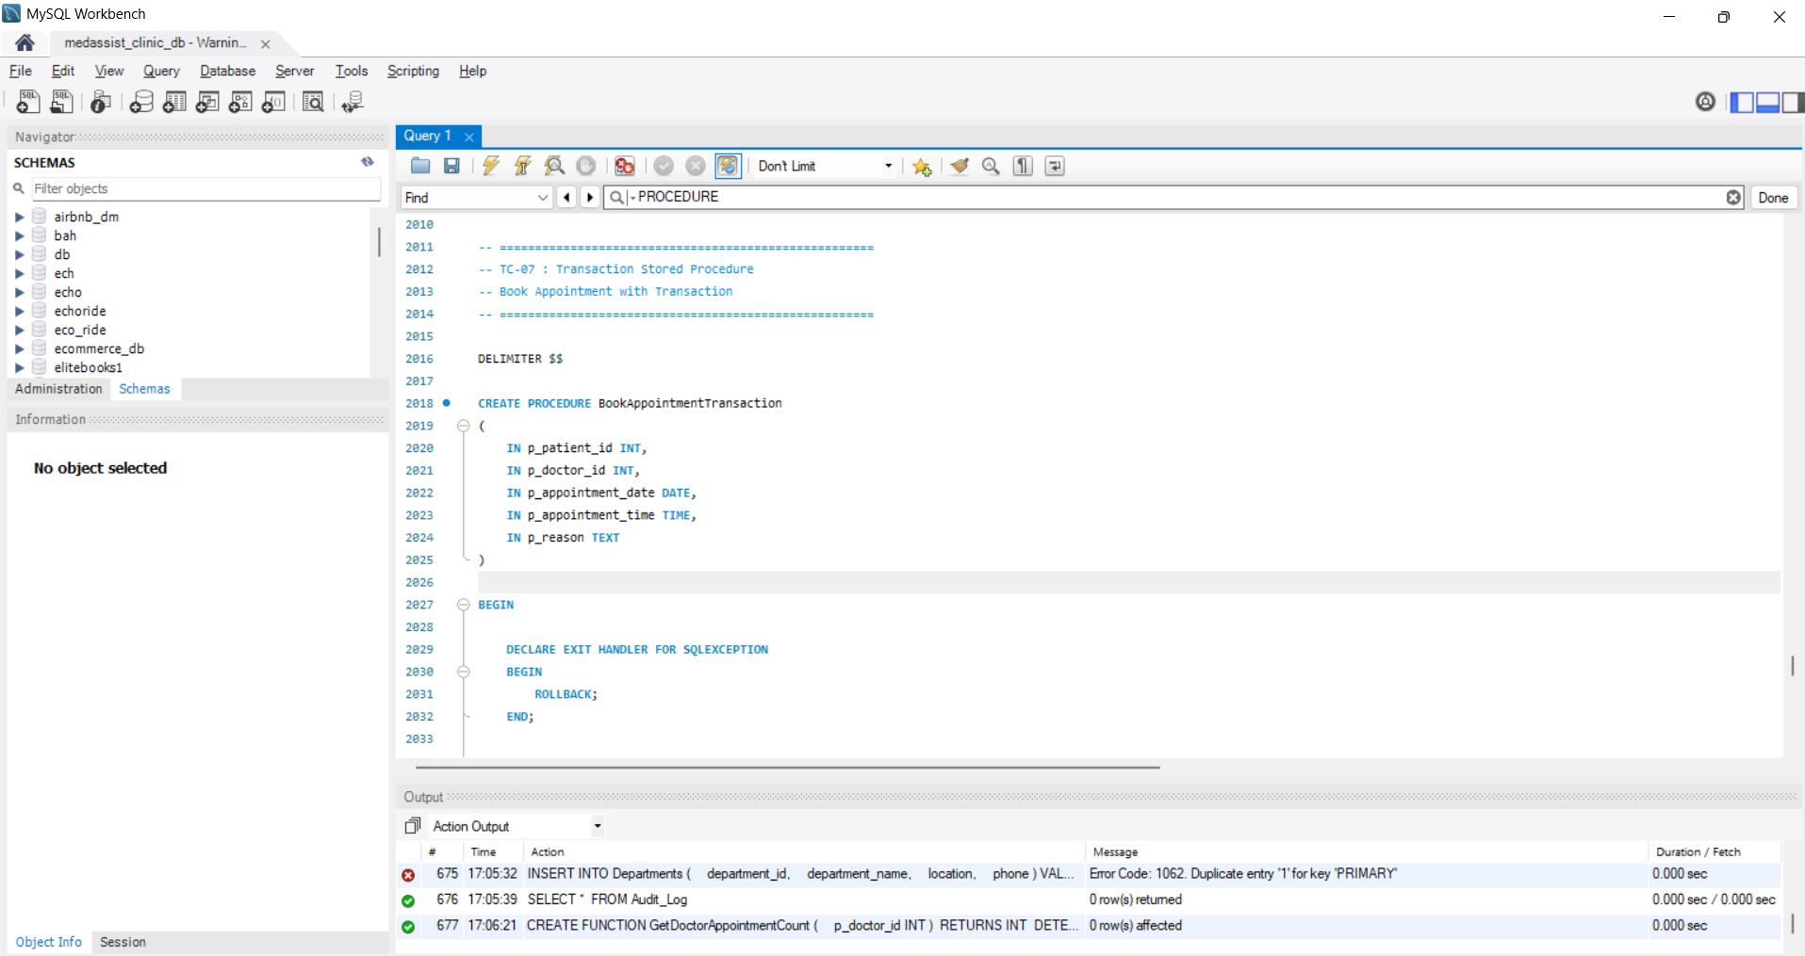
Figure 12 Transaction Handling Using COMMIT and ROLLBACK

4.4 Importance of Transaction Handling
Transaction handling is very important to ensure the reliability and accuracy of the MedAssist Clinic database. It guarantees a consistency of database operations as a single unit of work. The atomicity guarantees that either all operations are executed, or that all changes are reverted in case of an error. Consistency: The rules, constraints and relationships of the database are not violated before and after each transaction. Because invalid or incomplete data will not be saved by any failed transaction, data integrity is guaranteed. The ROLLBACK statement will take the database back to a previous valid state when an error is found. Safe and accurate completion of important tasks such as appointments and patient management ensures clinic database security, consistency and reliability [9].

5. Performance Tuning Enhancement

5.1 Performance Issues
As patients make use of the MedAssist Clinic, more patient information, appointments, treatments, and feedback will be entered into the database. Large tables are more time consuming to search, particularly if users are more often looking for doctor schedules, patient appointments, or treatment histories. A non-optimised SQL query will trawl the entire table for the data it is looking for and this will result in slower response time. There are regular operations, such as booking of appointments, patient management, and it is important to optimize system performance to ensure the smooth and speedy operation of the system [20].

5.2 Secondary Indexes
Secondary indexes were placed on columns that are often used in database searches and relationships. MySQL can locate records more quickly because these indexes allow it to skip the need to scan every row of a table [28].
Table 3 Secondary Indexes
Index | Purpose
doctor_id | Speeds up doctor appointment searches and joins.
patient_id | Improves patient record and appointment searches.
appointment_date | Supports faster appointment scheduling and date-based queries.
department_id | Improves searches for doctors within a department.
patient_id (Feedback) | Speeds up retrieval of patient feedback records.

5.3 Query Optimization
Query optimization was done using the EXPLAIN statement. MySQL had to traverse more rows than necessary to find the matching rows before building the indexes. After the indexes were generated the execution plan showed that the database was utilizing the index to obtain information efficiently. The SQL statements for creating the indexes, displaying them and checking for query optimisation are displayed in figure 13.
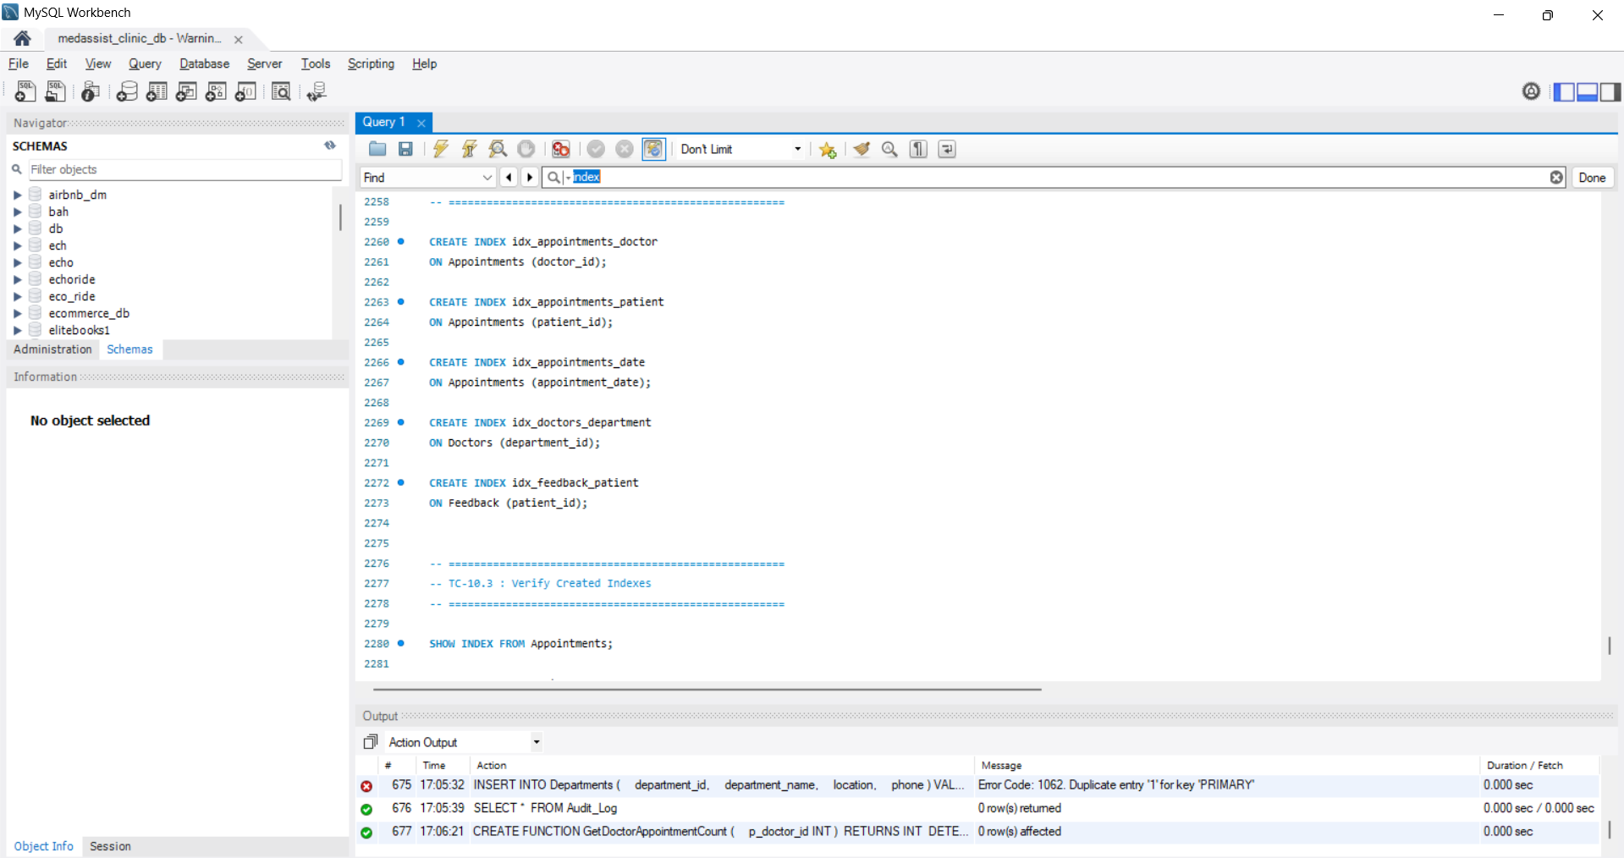
Figure 13 Query Optimization Using Secondary Indexes

5.4 Performance Improvement
The indexes applied simplified searches for common queries, and enhanced the efficiency of table joins between patients, doctors, appointments and feedback. Optimised query performance also equates to a more scalable system, because it can maintain the same performance when a large amount of data is inserted. The enhancements also guarantee that the MedAssist Clinic database runs smoothly and quickly as it supports daily healthcare operations [10].

6. Conclusion and Reflection

6.1 Conclusion
This project is one successful implementation of the given business requirements of MedAssist Clinic relational database. The design of an Entity Relationship Diagram (ERD) has been done to define the structure of the database and the relationship of all the entities. Data integrity and data redundancy were reduced by normalizing the database to Third Normal Form (3NF). To ensure the accuracy of the data, appropriate constraints were added, such as primary key constraints, foreign key constraints, unique constraints, check constraints and not null constraints. The following systems were enhanced: Stored procedures for CRUD operations, Triggers and SQL functions to provide database automation and reporting. ReliaData ensured reliable data processing with the use of COMMIT and ROLLBACK for transaction handling and secondary indexes for better query performance. Finally, the database is a reliable, structured and efficient tool for the operations of MedAssist Clinic.

6.2 Reflection
In this project, a few issues were encountered when designing relationships, writing stored procedures and managing transactions. Business requirements were identified and a step-by-step testing of all the database capabilities were performed to solve these issues. The project helped to improve my database design skills, database normalization, transaction, triggers, index, and SQL programming skills. Future enhancements to the system would include the use of role-based access control, appointment notifications, online patient registration, and advanced reporting features. The upgrades would make the database more secure, easier to use and more suitable for bigger healthcare providers.

References
- Ali, A., Naeem, S., Anam, S. and Ahmed, M.M., 2023. A state of art survey for big data processing and nosql database architecture. International Journal of Computing and Digital Systems, 14(1), pp.1-1.
- Amato, N.A.R., 2023. Mastering database normalization: A comprehensive exploration of normal forms. Researchgate.
- Azmat, H. and Huma, Z., 2025. Indexing Strategies in SQL: Enhancing Query Efficiency and Scalability. Baltic Journal of Multidisciplinary Research, 2(2), pp.130-138.
- Azzahra, Z.F. and Anggoro, A.D., 2022. Analisis teknik entity-relationship diagram dalam perancangan database sebuah literature review. Intech, 3(2), pp.70-74.
- Baig, M.S., Imran, A., Yasin, A.U., Butt, A.H. and Khan, M.I., 2022. Natural language to sql queries: A review. International Journal of Innovations in Science Technology, 4, pp.147-162.
- Basil, N.N., Ambe, S., Ekhator, C., Fonkem, E. and Nduma, B.N., 2022. Health records database and inherent security concerns: A review of the literature. Cureus, 14(10).
- Foufoulas, Y., Simitsis, A., Stamatogiannakis, L. and Ioannidis, Y., 2022. YeSQL: " you extend SQL" with rich and highly performant user-defined functions in relational databases. Proceedings of the VLDB Endowment, 15(10), pp.2270-2283.
- Gadde, H., 2024. AI-augmented database management systems for real-time data analytics. Revista de Inteligencia Artificial en Medicina, 15(1), pp.616-649.
- Gopalan, V., 2026. Deterministic Consistency Models for Cloud-Hosted Open Source Relational Databases Under Multi-Region Failover. International Journal of Humanities and Information Technology, 8(1), pp.46-58.
- Gupta, S., 2025. Snowflake vs RDBMS: Performance Tuning Techniques. Available at SSRN 6739438.
- Hardini, M., Agarwal, V., Apriani, D., Widjaya, I.A., Setiawaty, E. and Nurasiah, N., 2025. Application of database normalization in increasing data storage efficiency. International Transactions on Artificial Intelligence, 3(2), pp.201-211.
- Huang, H., Shen, B., Zhong, L. and Zhou, Y., 2023, January. Protecting data integrity of web applications with database constraints inferred from application code. In Proceedings of the 28th ACM International Conference on Architectural Support for Programming Languages and Operating Systems, Volume 2 (pp. 632-645).
- Iacob, I. and Mihălcescu, C., 2025. TRIGGERS IN ORACLE SQL: AUTOMATION AND INTEGRITY IN ECONOMIC DATABASE MANAGEMENT. Journal of Information Systems & Operations Management, 19(2), pp.246-259.
- Jangala, V.K., 2022. Relational and NoSQL databases in enterprise systems. International Journal of Contemporary Research in Multidisciplinary, 1(1), pp.125-131.
- Kanellis, K., Ding, C., Kroth, B., Müller, A., Curino, C. and Venkataraman, S., 2022. LlamaTune: sample-efficient DBMS configuration tuning. arXiv preprint arXiv:2203.05128.
- Khan, W., Kumar, T., Zhang, C., Raj, K., Roy, A.M. and Luo, B., 2023. SQL and NoSQL database software architecture performance analysis and assessments—a systematic literature review. Big Data and Cognitive Computing, 7(2), p.97.
- Kossmann, J., Papenbrock, T. and Naumann, F., 2022. Data dependencies for query optimization: a survey. The VLDB Journal, 31(1), pp.1-22.
- Kumar, R., Distributed Transaction Management for TIBCO and Java Micro-services Across Cloud Platforms.
- Kvet, M., 2023, November. Enhanced data locking to serve ACID transaction properties in the Oracle database. In 2023 34th Conference of Open Innovations Association (FRUCT) (pp. 73-80). IEEE.
- Liu, M., Luo, J., Li, L., Pan, X., Tan, S., Ji, W., Zhang, H., Tang, S., Liu, J., Wu, B. and Chen, Z., 2023. Design and development of a disease-specific clinical database system to increase the availability of hospital data in China. Health Information Science and Systems, 11(1), p.11.
- Nambiar, A. and Mundra, D., 2022. An overview of data warehouse and data lake in modern enterprise data management. Big data and cognitive computing, 6(4), p.132.
- Navarro, A., 2022. Fundamentals of transaction management in enterprise application architectures. IEEE Access, 10, pp.124305-124332.
- Omotunde, H. and Ahmed, M., 2023. A comprehensive review of security measures in database systems: Assessing authentication, access control, and beyond. Mesopotamian Journal of CyberSecurity, 3(1), pp.115-133.
- Panda, S.P., 2025. Relational, NoSQL, and Artificial Intelligence-Integrated Database Architectures: Foundations, Cloud Platforms, and Regulatory-Compliant Systems. Deep Science Publishing.
- Qin, B., Hui, B., Wang, L., Yang, M., Li, J., Li, B., Geng, R., Cao, R., Sun, J., Si, L. and Huang, F., 2022. A survey on text-to-sql parsing: Concepts, methods, and future directions. arXiv preprint arXiv:2208.13629.
- Ramu, V.B., 2023. Optimizing database performance: Strategies for efficient query execution and resource utilization. International Journal of Computer Trends and Technology, 71(7), pp.15-21.
- Rzaieva, S., Rzaiev, D., Kostyuk, Y., Hulak, H. and Shcheblanin, O., 2024. Methods of modeling database system security. Cybersecurity Providing in Information and Telecommunication Systems 2024, 3654, pp.384-390.
- Sakshi¹, S. and Sharma, A., 2025, May. Relational Database Performance Optimization Techniques. In Proceedings of the International Conference on Recent Advancement and Modernization in Sustainable Intelligent Technologies & Applications (RAMSITA-2025) (p. 112). Springer Nature.
- Shi, J., 2025. Optimizing secondary indexing for databases: learning-based benefit estimation and novel index framework design (Doctoral dissertation, Nanyang Technological University).
- Sichert, M. and Neumann, T., 2022. User-defined operators: Efficiently integrating custom algorithms into modern databases. Proceedings of the VLDB Endowment, 15(5), pp.1119-1131.
- Šušter, I. and Ranisavljević, T., 2023. Optimization of MySQL database. Journal of process management and new technologies, 11(1-2), pp.141-151.
- Taipalus, T., 2024. Vector database management systems: Fundamental concepts, use-cases, and current challenges. Cognitive Systems Research, 85, p.101216.
- Uzzaman, A., Jim, M.M.I., Nishat, N. and Nahar, J., 2024. Optimizing SQL databases for big data workloads: techniques and best practices. Academic Journal on Business Administration, Innovation & Sustainability, 4(3), pp.15-29.
- Yang, Z., 2025. Key Analysis in Relational Database (Doctoral dissertation, ResearchSpace@ Auckland).

Appendix

Complete SQL Script

ERD


