INTRODUCTION PHYSIOLOGY: BMHP5003, BSc: In Health and Social Care, Level: 5-part 2 Report
STUDENT: MONICA DORMER, ID: 1907095
LITERATURE: MUMTAZ - GOOLAM

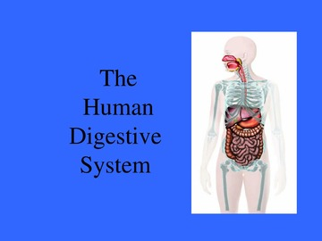

Digestive System
Public members are more likely to be aware of their digestive system because of what it does for the body.
Because of immediate response that lets you know you are hungry with gas where nature takes it, Couse, with bowel movement.
Aims of a description of these digestive systems and how it functions to show how the importance of keeping them in a good condition.
Elements of the digestive system consist of the gastrointestinal tract plus the accessory organs of digestion, (which are the tongue, salivary glands, pancreas that works with the gallbladder).
The digestion will include the breakdown of things you eat into small parts compressing them together until they can be distributed throughout the body.
This is a process that has several stages with the starting point being the mouth right through the body's intestine out through the anus which is then excreted. Refer: Parker, S. (2007) Digestive system and how it works, Accessed (09. 12. 2021)
Therefore, showing how it works to keep the body running smoothly to reduce complications.
However, looking at the function of the human body and what this will mean for the service users who will depend upon care received from services.
Explanation on the autonomy and that of the physiology of the digestive system.
Inflammatory bowel disease with these disease conditions is seriously inflamed these intestines or with another issue related. Ref: Parker, S. (2007) Stomach & Intestines are irritated & inflamed, Accessed: (17.09.2021)
CASE STUDY OF MS C, SMITH
This investigation is on an occurring problem, with her digestive system that needs to take a closer look based on a woman’s history by the uses of a question – air that will enable to build up a picture of the person, who is 59 years of age. This individual does not smoke she give up a year ago.
Her complete are of not feeling hungry sometimes unable to go to the toilet feeling bolted with pain in her stomach and most of the time unwell.
Displays no high blood pressure and has never had a heart attack or a stroke, as well as if any other family members that suffer from gastroenteritis also check her family’s history for any traces of those conditions.
some trouble with her cholesterol and exercise around three times a week with a healthy diet and have twelve units of wine per – week.
The health profession has asked MS, Smith to undertake a health question – air to determining
And to rule out other conditions which could be there, firstly, look at her background information.

ASSESSMENT REPORT
- Her symptoms are having abdominal cramps sometimes feeling unwell to vomit, feeling bolted, and unwell.
- At times she may not feel hungry, because of the build-up of? acid or it could be a virus of some kind? like stomach - bacteria.
- It is important to detect from an early stage to be able to have control of this condition.
- Therefore, some underlining problems with the immune system, will attack the body’s intestinal tissues.
- However, it also has a tendency which ulcerative colitis and Crohn’s disease that connect to families.
- Why the important to have background information on individuals beforehand to minimize our investigations for a better outcome.
- Therefore, details cause remains unclear, plus many causes which are long–term, normally start s from symptoms most common, with both condition they are abdominal pain, diarrheal, appetite loss, fever, intestinal bleeding, and some wight – loss.
- This ulcerative colitis, when inflamed plus ulceration can affect known the action of the rectum aside where it– times are known as proctitis, as, or part of all colons is fine.

Care plan (NCP)
Ms. Smith
- She will cut down on dairy products restricted herself from caffeine drink more water reduce alcohol and any fatty foods also when cooking tries more oven cooking to help to reduce oily foods for healthier eating.
- Bacteria of the stomach chemicals can lead to mercury arsenic or ingestion from poisonous species and mushrooms too.
- Therefore, treatments are symptomatic but just in case of bacterial and may be parasitic infection a course of antibiotics would be given.
- For gastroenteritis focus on non-acute care setting whiles making sure that she has the right nutrition balance which helps to maintain supporting the body functions.
- However, there will be a check on her progress to make sure that her treatment is working by two weeks, and if not then, then will be a review this may need more innovation from other treatments and may end up running for many more weeks.
- In the development, it shows that the lining entre can sore – like an ulcer sometimes causes blooding within the faces where it can be seen with the naked eye. Refer, Parker. S. Accessed (09.12.2021)
- LOWER DIGESTIVE TRACT DISORDERS: CROHN’S DISEASE
- That Crohn’s disease showed this inflammation, where ulceration could occur within the digestive tract, ranging from the mouth towards the anus, therefore, this also causes narrowing of the build-up within the intestine area where the large and the small meet.

FURTHER INFORMATION:
Layers of the small intestine wall within the stomach there are four layers, therefore the outer protective coat that is known as the serosa, where the next in - line.
Muscular, however, has an outline longitudinal with the inner - circular soft muscle tissue, connecting with the submucosa, which is a more relaxed layer that drives the vessels and that of those vessels with the nerves too.
However, with that terminal ileum the caecum, has often been affected. Accessed, the New England Journal of Medicine. (11.2021)
Gastroenteritis in the theory of the Medicine Net. com is when you have a built-up of acid that built up in the lining of the smock and can widen to the higher or lower part of the digestive system. Available at https://www.medicinenet.com Accessed, (11/2021)
A care plan is in place to help support the Gastroenteritis condition. As well as exercise this may be caused by what you eat has well has sleep, having a balanced lifestyle.
Has there are laws in place, to place individuals at the heart of care to have choices dignity, respect for information every step of the way regarding treatments, therefore vulnerable groups are protected by the mental capacity and disability act 2008, and the code of conduct which is for health and social care workers.
Those vulnerable groups are also children placing them at the front of safeguarding, every child matters, 2003 / chid act 2004 of this law young people for those that work in the adult sector. Refer, children act of (1989) Accessed 08.04.2022

This, fig 1 diagram gives the psychology and some guidelines on what is related to IBS understanding of why and what, these diseases of the digestive system with those that can give some direction on influence.

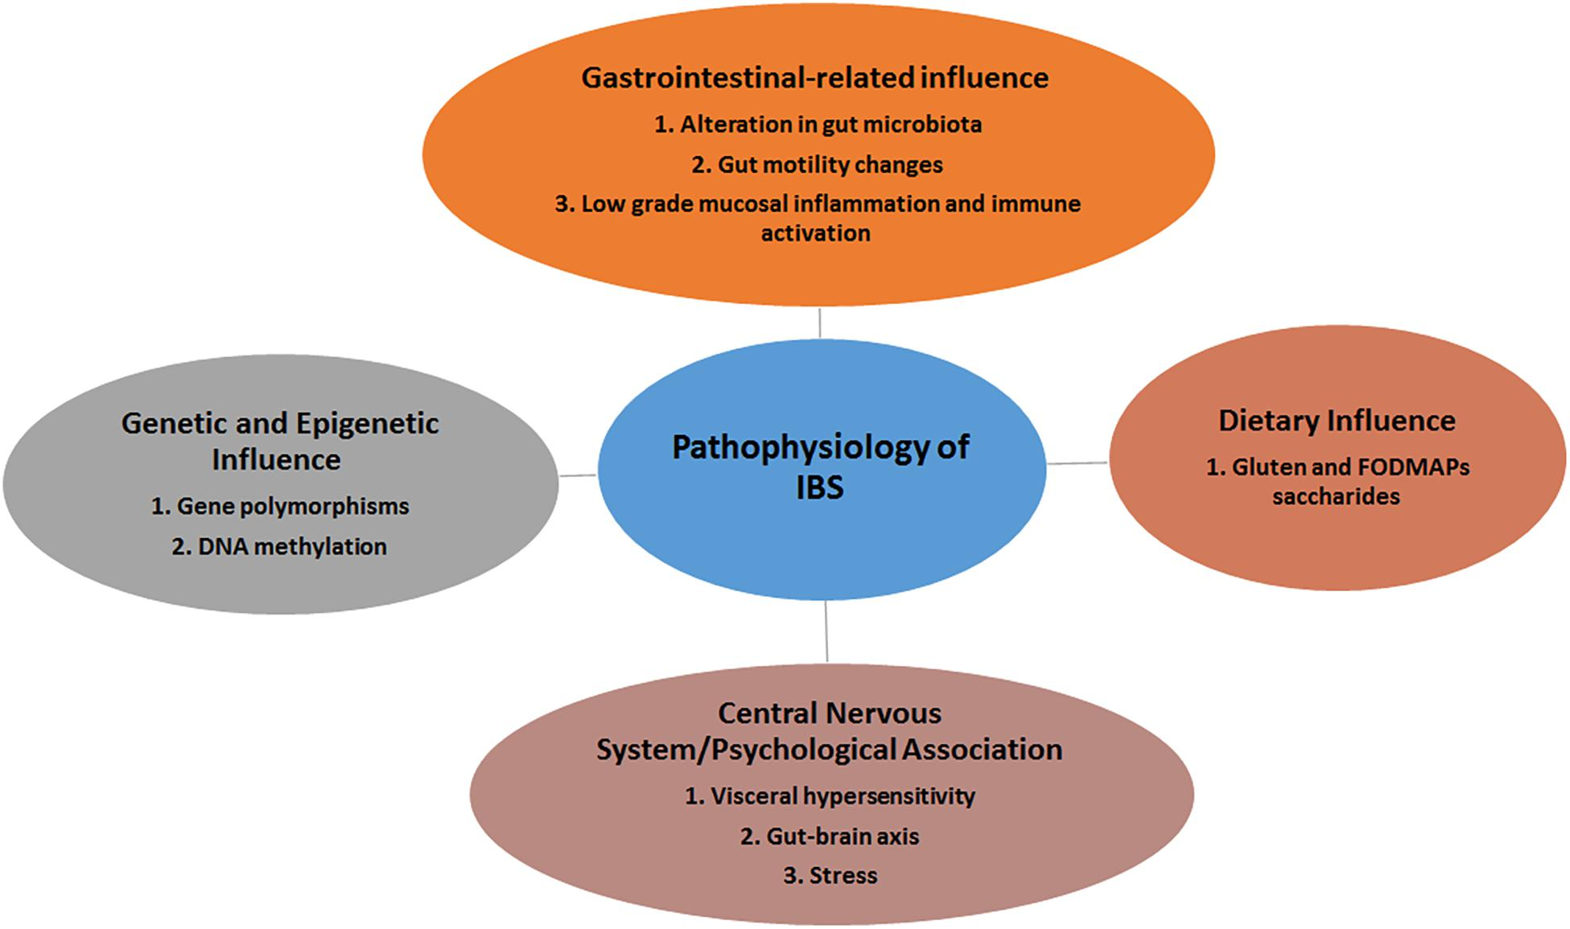
This Photo by Unknown Author is licensed under CC BY Bing’s picture
LIFESTYLE QUESTIONNAIRE
Introduction:

To help us focus on our Health Promotion activities in the practice, we would be grateful if you could fill in this short questionnaire of yours. (“LIFESTYLE 2.pdf - QUESTIONNAIRE”) - If you have already completed one on a previous visit after, please return this questionnaire to the receptionist.

Name MS Carol Smith……………………
Date of Birth 15 / 10/ 1962………………….

Do you smoke? |  | Yes | [ | ] No [x]
If yes, do you –
smokeless than one | cigarette/day |  | [ | ]
1 – 9 | cigarettes/day |  | [ | ]
10-19 | cigarettes/day |  | [ | ]
20-39 | cigarettes/day |  | [ | ]
more than forty | cigarettes/day |  | [ | ]
smoke a pipe |  |  | [ | ]
smoke cigars |  |  | [ | ]

If no, have you –

never smoked  given up smoking in the last year not smoked for more than 1 year |  |  | ( )  (x)
Do you have high blood pressure? |  |  |  | No | x | ]
Have you ever had a heart attack or suffered from angina? |  |  |  | No | x | ]

Have you ever had a stroke, “shock?
or any weakness down one side? Yes [] No [x]
Have any of the following – mother, father,
Or Sister, Brother ever had a heart – attack over the age of sixty, or under if yes at what age. Or if not then no problem YES () NO (X)

(hyperlipidemia)

………………………………………………………………………………………

Practice Use Only:
Health Education Smoking …N/A……….

BP 170…... / 72…...

Height 5 /4.5………….

Weight 10.5 Stone /66.67kg………….

MS, Smith has given her consent to take part in an investigation of the Digestive system.
In attendance, they will be a consent form available to sign beforehand for permission for her examination or referral. Ref: WebMD (19/08/2021)

This would be conducted by a consultant by the health providers who will arrange the appointment and your GP will give you a physical examination which the doctor will more likely diagnose gastroenteritis based on the symptoms.

However, in several similar cases, studies show the community that a rapid stool test may detect rotavirus and, or norovirus, although they are no quick fix testing that may show other viruses that cause gastroenteritis. Accessed: Viral gastroenteritis (16/Oct/2018) available at https://www.mayoclinic.org.uk (11/2021)
MS, C. Smith: status: Student at University full time, ay UWTSD (University of Wales Trinity Saint David) Not in work currently.

EXERCISE
Healthy exercise usually involves activity that lasts for at least 25 minutes, raises your pulse, and produces hard breathing. For younger people, this football might be running, cycling or sport, or walking for older people.

Do you take this type of exercise –

daily []
Three times weekly [x]
once weekly []
once monthly []
seldom []

I cannot take exercise because of my disability []

DIET
Please tick the one category which is closest to your usual eating pattern.

I eat no meat, fish, or dairy produce []
I eat no meat [x]

I eat a mixture including daily fruit and vegetables [] I eat a mixture including regular chips and fries [] I eat frozen meals (e.g., TV dinners) 3 or 4 times/week [] I eat snacks [x]
I eat a special medical diet []

Please specify …A balanced Diet with no red meat, fish sometimes chicken, veg, plate base foods with more homemade meals.……………………………………………………………………

ALCOHOL
Please tick the statement which most closely describes your usual alcohol intake. (1 unit is 1 glass of wine, ½ pint of beer, r a single measure of spirit.)

I never drink alcohol []
I drink less than 1 unit per day []
I drink between 1 and 2 units a day [x]
I drink between 3 and 6 units a day []
I drink between 7 and 9 units a day [] I drink more than 9 units a day on average []

Full-time student Health & Social care …………………………………………………………………………………….

Practice Use Only

Health Education Alcohol [N/A]
Alcohol Brief Intervention [N/A]

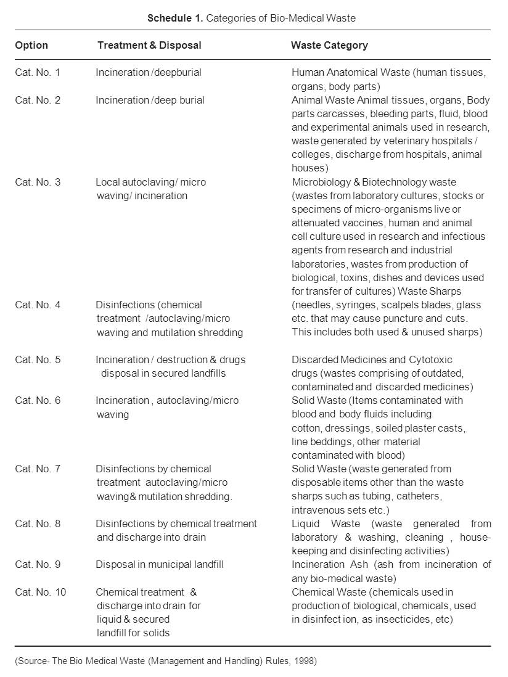
This Photo by Unknown Author is licensed under CC BY Bing’s picture

Client: MS Carol Smith (case ref no: S573917
D.O.B (15. 10. 62)
Care plan by: Dormer, RN
Date: 03/ 12 / 2021

Per - Assessment | DIAGNOSIS | OUTCOME | INTERVENTION | RATIONALE
Check weight height, Heart rate, colterol,  Abdominal cramp, BP test,  Alcohol levels, Conducted an  The investigation, Abnormal pain | Abnormal pain, Blood test  Ref: https://www.b.vic.gov  Better Health Channel  (11/2021) | The patient will maintain a healthy diet cut down on fats  most acidy foods,  mindful of alcohol.  Ranitidine 150mg, every morning | Stools for blood or viruses, inflammatory or disease,  Ultrasound, or TC  scans may help to diagnose a condition | Mental Health, feeling - low  Gastroenteritis, build-up of Toxins

RECOMMENDATION:
In my professional observation, all tests were conducted where ultrasound and CT scans which show that she had some abnormality and that she was advised. Ref: by Cardona, A. (2018)
For MS, SMITH is suffering from a condition called irritable bowel syndrome to undergo a treatment of a course of RELON, Ranitidine 150mg taken every morning.
To help reduce the build-up of acid, by support for the line of the stomach, this can be a short term as well has taken even longer, illness whiles keeping an eye on her recovery.
Gastroesophageal reflexes include acid which can travel towards the esophagus and can cause symptoms like heartburn which can become troublesome.
In some cases, there may be more going on like mental health issues which would add to her condition.
Therefore, an update to check if this is working out for this patient may lead to more investigation taken.
However, there are times when the medication does not agree with the patient’s system and may need to change to try another.
CONCLUSION:
MS, Smith to go ahead with the treatment of reducing the gas build-up of the above medication and monitor her condition.
Mental health has been high – lighted that she may be suffering from some depression and may need some medication for her mental health.
Advised her to keep taking her medication regularly and make sure she eats well; she also studies so this also keeps her mind active.
I have also recommended that she speak with a mental health advice support worker or a CPN nurse who will have a referral to be allocated for further support.
Which is to come back for a review within 2 – 4 mouth time to see if things have scaled-down this can become a lasting problem if do not take control of, and with infection control, she can also have an intolerant of some kind.

CONTENTS PAGE:
Front Cover…………………………………………………………………………………... Pp 01
Digestive System ...................………………………………………………………… Pp 02
Case Study of MS, C. Smith……………………………………………………………. Pp 02
Assessment Report…………….…………………………………………………………. Pp 03
Lower Digestive Tract Disorders Crohn Disease...…………………………... Pp 03
Further Information………………………………………………………………………...Pp 04
Pathophysiology of IBS…………………………………………………………………… Pp 05
Lifestyle Questionnaire…………………………………………………………… Pp,6,7& 8
Bio-Medical Waste……………………………………………………………………...... Pp10
Assessment ………………………………………………………………………………… pp 11
Recommendation & Conclusion…………………………………………………… Pp 12
Contents page………………………………………………………………………………. Pp 13
Reference List………………………………………………………………………………. Pp 14

REFERENCES LIST:
- Cardona. A, et - al (2018) T – Wave Abnormality as Electrocardiographic signature
- Parker, S. (2007) Publisher Kindersley, D. Stomach and small intestine, The Human Body: (2011), pp72 - 178 Available at https://www.bbc.co.uk?science?human?body (Accessed 06. March.2022)
- The Bio-Medical Waste Rules, (1998) Management and Handling Rules Available at http://www.igims.org?DataFile?waste%20management?BIO Accessed
- This picture is licensed under Author: Cc by Bings picture, online x2: Accessed (11/2021)
- The New England Journal of Medicine (NEJM) is a weekly general medical journal (2021), Available at https://www.nejm.org.uk, Accessed: (11 December 2021)
- Gastroenteritis Symptoms and Medicine- Net – Health & Medical information Produced, by the doctors, et – al, (1996 – 2021), Medical Ethics UK – Ltd Available at: https://www.medicinenet.com.gov Accessed 04.04.2022
- Gastroenteritis Better Health, Available at: https://www.betterhealth.vic.gov.uk Accessed (11/2021)
- Imaging Tests to help Diagnose Digestive problems – WebMD (19/08/2021) Available at: https://www.webmd.com Accessed 04.03.2022
- Stomach & Intestines are Irritated & Inflamed (17/09/2021), Accessed 2021)
- Safeguarding Vulnerable Groups Act (SVGA 2010) Available at: https://www.legislation.gov.uk
- UK Health Security Agency and Department of Health and Social Care, published (01 April 2022) Accessed 08 April 2022
- Viral gastroenteritis (16/Oct/2018) Available at: https://www.mayoclinic.org.uk Accessed (11 December 2021)

