Raluca Nicoleta Caruntu

Student Number: 2410738

BA (Hons) Leadership and Management Skills for the Workplace

Module: Managing Business Information

Module code: LCLM 5004

Assignment Title: Component 2

Individual report-

Information Systems Improvements

Business Case: Kalori Ltd. – Overcoming Operational Challenges

Table of Contents
- Introduction
  - Business Overview
  - Key Challenges
- Evaluation of Current Systems
  - Existing System Structure
  - Identified Inefficiencies
- Proposed Information System Solution
  - Overview of Recommended System
  - Justification and Benefits
- Implementation Plan
  - Key Implementation Stages
  - Risks and Considerations
- Critical Evaluation
  - Limitations and Challenges
  - Risk Mitigation
- Conclusion
- References

1. Introduction
Kalori Ltd. is a fast-growing consumer electronics retailer that operates through a network of physical stores alongside an increasingly important e-commerce platform. While the company has experienced strong growth in sales and customer demand, its internal information systems have not developed at the same pace. As a result, a gap has emerged between business expansion and operational capability. These challenges are particularly visible in areas such as inventory management, customer experience, and the quality of managerial decision-making.
One of the main issues faced by Kalori Ltd. is the reliance on manual processes and disconnected systems across different departments. Inventory data is not consistently updated across all channels, which means that products shown as available online may, in reality, be out of stock in physical locations. This creates a negative customer experience, often resulting in cancelled orders, refunds, and reduced trust in the brand. As highlighted by Laudon and Laudon (2022), organisations that lack integrated information systems often struggle to maintain accurate data and operational control, especially as they scale.
Another significant challenge is the fragmentation of customer data. Information is stored across multiple systems, making it difficult to build a complete view of each customer. This limits the company’s ability to deliver personalised marketing campaigns and reduces the effectiveness of customer service. According to Payne and Frow (2005), organisations that implement integrated Customer Relationship Management (CRM) systems are better able to understand customer needs and improve long-term relationships.
In addition to operational and customer-related challenges, Kalori Ltd. also faces limitations in its decision-making processes. This reduces the organisation’s ability to respond quickly to changes in demand or market conditions.
Overall, these issues highlight the need for a more integrated and scalable information system. Therefore, this report proposes the implementation of a unified system solution that aims to improve operational efficiency, enhance data management, and support more effective decision-making, ultimately enabling sustainable business growth.
2.Evaluation of Current Systems
The current information system environment at Kalori Ltd. can be described as fragmented and inefficient, mainly due to the use of disconnected systems across different departments. This lack of integration creates operational silos, where information is not shared effectively, leading to delays, duplication of work, and increased risk of human error. As noted by O’Brien and Marakas (2011), organisations that rely on isolated systems often experience inefficiencies that negatively impact productivity and decision-making.
A key weakness within Kalori Ltd. is the manual inventory management process , without real-time synchronisation. From a practical perspective, this issue directly affects customer satisfaction, as customers may purchase products online that are not available in reality. It also creates internal challenges, as managers struggle to balance overstock and understock situations. Monk and Wagner (2013) highlight that automated inventory systems significantly improve accuracy and provide better control over supply chain operations, particularly in multi-channel retail environments.
Another important limitation is the way customer data is currently handled. Customer information is stored across multiple systems, meaning there is no single, consistent view of the customer. This fragmentation reduces the company’s ability to understand customer behaviour and preferences. As a result, marketing campaigns are less targeted, and customer service teams cannot easily access relevant purchase history when dealing with complaints or queries. According to Buttle and Maklan (2019), effective CRM systems are essential for developing long-term customer relationships, as they allow organisations to personalise interactions and improve service quality.
In addition to operational inefficiencies, the organisation faces challenges in decision-making. Management currently relies on manually created spreadsheets. This limits the ability to identify trends, forecast demand, and respond quickly to changes in the market. Chen, Chiang and Storey (2012) argue that modern Business Intelligence (BI) systems enable organisations to transform raw data into actionable insights, improving both the speed and quality of decisions.
Finally, there are concerns related to data security and regulatory compliance. This is particularly important given the requirements of data protection regulations such as the General Data Protection Regulation (GDPR) (European Union, 2016).
Overall, the evaluation shows that the current systems are not suitable for a growing organisation like Kalori Ltd. The lack of integration, real-time data, and secure data management highlights the need for a more advanced and unified information system.
3. Proposed Information System Solution
Based on the issues identified in the previous section, it is clear that Kalori Ltd. requires a more integrated and scalable information system that can support its continued growth. Rather than implementing a single system in isolation, this report recommends the adoption of a Unified Retail Information System, which combines Enterprise Resource Planning (ERP), Customer Relationship Management (CRM), Inventory Management, and Business Intelligence (BI) tools within a cloud-based environment. This integrated approach ensures that data flows consistently across the organisation, reducing inefficiencies and improving overall performance.
The foundation of the proposed solution is the implementation of an ERP system, which will act as the central platform for managing core business operations such as finance, procurement, and supply chain activities. ERP systems are widely recognised for their ability to create a single source of truth, where all departments access the same accurate and up-to-date information. This is particularly important for Kalori Ltd., as it will eliminate the need for manual data transfer between departments and reduce the risk of errors. Davenport (1998) argues that ERP systems significantly improve organisational efficiency by standardising processes and improving data consistency across the business.
In addition to ERP, the implementation of a CRM system is essential to address the current issues related to fragmented customer data. A CRM platform will centralise all customer interactions, including purchase history, preferences, and support requests. This will allow the marketing team to develop more targeted campaigns and enable customer service representatives to respond more effectively to enquiries. From a strategic perspective, improving customer relationships can lead to higher retention rates and increased customer lifetime value. Payne and Frow (2005) highlight that organisations with well-integrated CRM systems are better positioned to create personalised customer experiences and build long-term loyalty.
Another critical component of the solution is the introduction of a real-time inventory management system. This system will synchronise stock levels across all physical stores and the online platform, ensuring that inventory data is accurate and consistent. By providing real-time visibility of stock, the company will be able to reduce order cancellations, improve fulfilment speed, and optimise stock levels across locations. This not only enhances customer satisfaction but also reduces costs associated with overstocking or stock shortages.
To further support decision-making, the implementation of Business Intelligence (BI) tools is recommended. BI systems will enable managers to access real-time dashboards and analytical reports, providing insights into sales performance, customer behaviour, and product demand. This will allow the organisation to make more informed decisions, improve forecasting accuracy, and identify opportunities for growth. According to Waller and Fawcett (2013), organisations that effectively use data analytics gain a competitive advantage by responding more quickly to market changes.
From a technological perspective, deploying these systems within a cloud-based infrastructure offers additional advantages. Cloud solutions provide scalability, allowing Kalori Ltd. to expand its operations without the need for significant hardware investment. They also support remote access, improved system reliability, and easier updates. Ross, Weill and Robertson (2006) emphasise that integrated and flexible IT architectures are key enablers of long-term business growth and digital transformation.
However, it is important to recognise that the implementation of such a system requires careful planning and investment. While the initial costs may be relatively high, the long-term benefits in terms of efficiency, cost reduction, and improved customer experience are likely to outweigh these expenses. In my view, the main value of this solution is not only in improving individual processes, but in creating a connected system where all parts of the organisation work together more effectively.
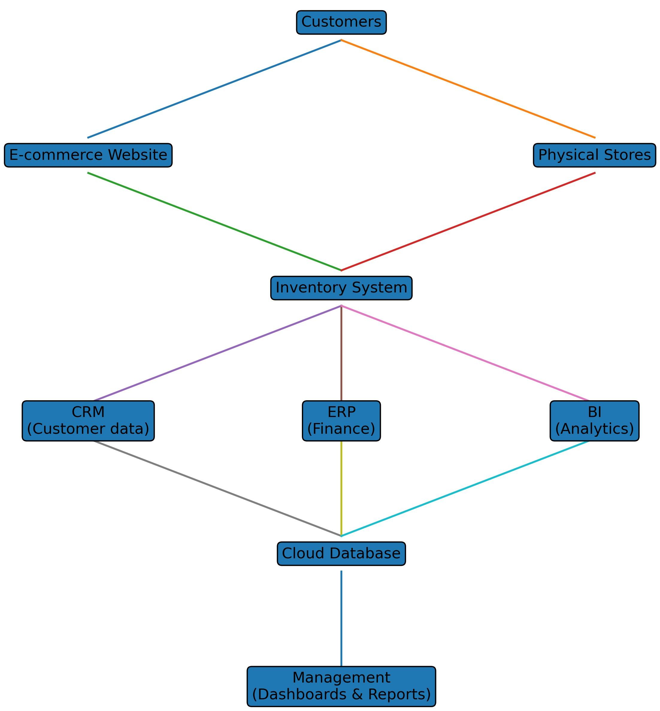
Overall, the proposed Unified Retail Information System provides a comprehensive and scalable solution that directly addresses the key challenges faced by Kalori Ltd. By integrating core business functions and improving data visibility, the organisation will be better equipped to operate efficiently, compete in the market, and support future growth.

4.Implementation Plan
The successful implementation of the proposed Unified Retail Information System requires a structured and well-managed approach. Given the scale of change involved, a phased implementation strategy is recommended, as this reduces risk and allows the organisation to adapt gradually rather than introducing all changes at once.
The first stage should focus on requirements analysis and system selection. This involves identifying the specific needs of each department, including inventory management, sales, customer service, and finance. It is important that key stakeholders from across the organisation are involved in this process, as their input will help ensure that the selected system supports real operational requirements. At this stage, Kalori Ltd. should also evaluate different vendors based on cost, functionality, scalability, and compatibility with existing systems.
The second stage involves data preparation and system integration. Before migrating data into the new system, existing data must be cleaned and standardised to ensure accuracy. Integration with the e-commerce platform and point-of-sale systems must also be carefully planned to enable real-time data updates.
The third stage is system configuration and testing. The new system should be configured to match the organisation’s processes, rather than forcing the business to fully adapt to the software. Pilot testing should be carried out in a limited number of stores or departments before full implementation.
Another critical element of the implementation process is employee training and change management. Introducing a new system often leads to resistance from staff, especially if they are used to existing processes. To address this, Kalori Ltd. should provide structured training programmes and ongoing support . According to Stair and Reynolds (2020), user adoption is one of the most important factors in determining the success of an information system.
The final stage involves deployment and continuous improvement. Once the system has been successfully implemented, performance should be monitored using key performance indicators such as inventory accuracy, order fulfilment time, and customer satisfaction. Feedback from users should also be collected to identify areas for improvement.
Despite the benefits of the proposed solution, several risks must be considered. These include implementation costs, potential technical issues, and employee resistance. There is also a risk that the system may not fully meet expectations if requirements are not clearly defined at the beginning. The use of recognised project management frameworks, such as those outlined by APM (2020), can help ensure that the implementation process is structured and controlled.
In my opinion, the most important factor in this implementation is not the technology itself, but how well the organisation manages the transition. Even the best systems can fail if employees are not properly trained or if processes are not aligned. Therefore, Kalori Ltd. must focus equally on technical implementation and organisational change to ensure long-term success.
5. Critical Evaluation
Although the proposed integrated information system offers clear advantages for Kalori Ltd., it is important to consider the potential limitations and challenges associated with its implementation. While systems such as ERP, CRM, and BI can significantly improve efficiency and data visibility, their success depends heavily on how they are introduced and managed within the organisation.
One of the main concerns is the high initial cost of implementation, which may place pressure on the company in the short term. However, this should be viewed as a long-term investment rather than an immediate expense, as improved efficiency and reduced operational errors are likely to generate financial benefits over time.
Another important issue is employee resistance to change. As highlighted by Ross, Weill and Robertson (2006), many digital transformation projects fail not because of the technology itself, but due to poor change management and lack of user adoption. For this reason, training and communication should be prioritised throughout the implementation process.
There are also technical risks associated with system integration. Migrating data from existing systems into a new platform can lead to errors or data loss if not managed carefully. Therefore, thorough testing and data validation are essential to ensure a smooth transition.
In addition, the increased reliance on digital systems raises concerns around data security and privacy. While modern systems often include advanced security features, they also create new risks, particularly if sensitive customer data is not properly protected. Ensuring compliance with regulations such as GDPR (European Union, 2016) is therefore a critical requirement.
Despite these challenges, the overall benefits of implementing an integrated system are likely to outweigh the risks. In my opinion, the key to success lies in balancing technological improvements with effective organisational change. Kalori Ltd. must not only invest in the right systems but also ensure that employees are supported throughout the transition.

6. Conclusion
In conclusion, Kalori Ltd. is currently facing a number of operational challenges that are directly linked to its outdated and fragmented information systems. While the company has achieved significant growth, its existing infrastructure has not kept pace with increasing business demands. As a result, issues such as inaccurate inventory data, inefficient customer management, and slow decision-making are limiting overall performance and reducing the company’s ability to compete effectively.
The evaluation of the current systems has clearly shown that the lack of integration between departments is a key weakness. Manual processes and disconnected data not only reduce efficiency but also increase the risk of errors and poor customer experience. This highlights the need for a more modern and coordinated approach to managing business information.
The proposed solution, based on the implementation of a Unified Retail Information System, provides a comprehensive way to address these challenges. By integrating ERP, CRM, inventory management, and business intelligence tools, Kalori Ltd. can create a single, reliable source of data across the organisation. This will improve operational efficiency, enhance customer experience, and support faster, more informed decision-making. In addition, the use of cloud-based technologies ensures that the system remains scalable and adaptable as the business continues to grow.
However, it is important to recognise that technology alone is not enough to guarantee success. The implementation process must be carefully managed, with a strong focus on employee training, data accuracy, and organisational change. Without proper adoption and support, even the most advanced systems may fail to deliver their expected benefits.
Overall, the findings of this report suggest that investing in an integrated information system is not simply an operational improvement, but a strategic necessity for Kalori Ltd. In my view, the company’s future success will depend not only on how effectively it adopts new technologies, but also on how well it aligns these systems with its business processes and long-term objectives.

References
Buttle, F. and Maklan, S. (2019) Customer Relationship Management. Routledge.
Chen, H., Chiang, R. and Storey, V. (2012) Business Intelligence and Analytics. MIS Quarterly.
Davenport, T.H. (1998) Enterprise Systems. Harvard Business Review.
European Union (2016) GDPR.
Laudon, K.C. and Laudon, J.P. (2022) Management Information Systems. Pearson.
Monk, E. and Wagner, B. (2013) ERP Concepts. Cengage.
O’Brien, J.A. and Marakas, G.M. (2011) MIS. McGraw-Hill.
Payne, A. and Frow, P. (2005) CRM Framework. Journal of Marketing.
Ross, J., Weill, P. and Robertson, D. (2006) Enterprise Architecture. HBS Press.
Stair, R. and Reynolds, G. (2020) Information Systems. Cengage.
Waller, M. and Fawcett, S. (2013) Big Data Analytics. JBL.
APM (2020) Body of Knowledge.
NIST (2024) Cybersecurity Framework.
OECD (2019) AI Principles.
Pearlson, K. et al. (2019) Managing Information Systems. Wiley.

