Ways of Thinking
Developing A Voice (Writing Portfolio)
Lecturer: Kylie Boon
IUMW 4005

Student Name: Tharsika a/p Prushotman
Student ID: 2334439
Programme: Professional Communication
Part 1: The Contemporary Human (Persuasive and Descriptive Writing)
Title: The World Shifts When We Do

" I think probably kindness is my number one attribute in a human being. I'll put it before any of the things like courage or bravery or generosity or anything else". These timeless words by one of my favourite authors, Roald Dahl, are virtues that I still stand by as a human being. (70 Roald Dahl quotes from his books and more - parade)

In our rapidly advancing modern society, we often overlook the fundamental quality that really characterises our existence within the broader human race. Kindness remains a guiding light that offers hope for creating a caring and peaceful world where all beings may thrive. In an ever more fragmented society, an altruistic gesture of love and benevolence towards an unfamiliar individual, a radiant smile that brightens someone's face like a beam of spring sunlight, and a profound sense of compassion for all of humanity are the qualities that deem an individual worthy of the title "human." Throughout the years, the development of people has been influenced by the practice of showing kindness towards one another, which has played a significant role in shaping our current state. In my opinion, kindness should not be motivated by self-interest or the gratification derived from assisting others. In order to improve the world, we must adopt kindness as a fundamental attitude and contribute to its betterment via individual acts of benevolence.
In the face of the challenges that mankind encounters on a daily basis in the contemporary world, kindness emerges as a potent force capable of overcoming even the most complex problems and nurturing significant ties between individuals. It transcends ethnic, financial, and cultural barriers, fostering unity among individuals through empathy and comprehension. Exhibiting compassion towards each other has the potential to propagate and inspire others to do the same, without any anticipation, resulting in a splendid garden teeming with benevolence and kindness. This garden then becomes a haven of positivity that may greatly benefit mankind.
The great Dalai Lama once said, " Be kind whenever possible; it is always possible." (Dalai Lama quotes - brainyquote) Kindness is not contingent upon deliberate consideration or delayed action, nor is it constrained by circumstances or convenience. It is instead a conscious decision that we must actively incorporate into our everyday lives and every endeavour. A little gesture of benevolence has the potential to have a significant impact and serve as a reminder of our collective human nature, especially in a society where social media and technology may often foster feelings of alienation.

Being compassionate does not imply weakness or naivety; the potency of kindness may even transform an adversary into an ally. Exhibiting kindness requires immense fortitude and bravery, particularly in a society characterised by pessimism, scepticism, and apathy. Exhibiting kindness requires significant resilience as it demands us to demonstrate our utmost strength while the world is in a state of extreme adversity. Through the combination of empathy and resilience, I am certain that individuals can triumph over their traumas and challenges.
To conclude, I would want to assert that kindness is the essence of modern individuals, the bond that unites us, and the beacon that directs us towards a favourable course. According to Roald Dahl, it exceeds daring, bravery, and charity, since it is the ultimate virtue. In a society where individuals strive for dominance over their fellow humans, adopting kindness is a significant gesture that has the potential to positively impact many lives and create a more interconnected and peaceful global community.
As Princess Diana once said, " Carry out a random act of kindness, with no expectation of reward, safe in the knowledge that one day someone might do the same for you" (Fowler, 13 of princess diana's most inspiring quotes 2021)

It is imperative that we make a conscious effort to exhibit kindness in all of our acts, ensuring that we create a positive atmosphere wherever we may be, and prioritise kindness as the primary characteristic of our human nature. By demonstrating compassion and doing acts of love, we have the ability to positively influence and improve the world.
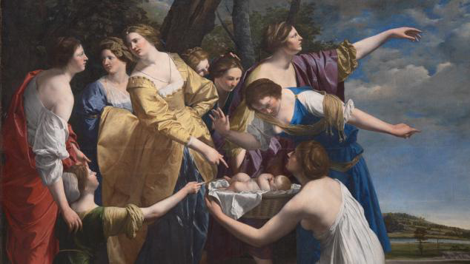

https://www.nationalgallery.org.uk/paintings/orazio-gentileschi-the-finding-of-moses

Part 2: Problem-Solving (Convergent Thinking and Expository Writing)
Title: Technology and Humanism: A Conversation Between Two Great Thinkers

Introduction :

During this hypothetical debate session, we will examine the influence of technology on humanism via the perspectives of two eminent intellectuals. Marshall McLuhan, a prominent Canadian media theorist, is well recognised for his research on the concept of the "Global Village" and the profound impact of technology on human communication. Albert Camus is a renowned French existentialist philosopher and writer known for his perspectives on mankind and the need of adopting humanism in contemporary society. Their contrasting perspectives on the matter illuminate the issues and difficulties that develop within the framework of modern people.

The Clash of Perspectives:

Marshall McLuhan initiates the conversation by asserting that technology has accelerated the breakdown of cultural borders, resulting in the formation of a global community where individuals are more interconnected than ever before. He also asserts that the rapid progress in technology has facilitated worldwide intercultural contact, hence bringing mankind closer together. McLuhan argues that the digital era has expanded the capacity for people to exchange beliefs, ideas, and moral attitudes that go beyond cultural and geographical limitations.
In contrast, Albert Camus expressed his apprehensions over the detrimental and dehumanising impacts of technology. He expressed his belief that technology has a significant impact on mankind, perhaps causing a sense of alienation amongst people and hindering them from living a genuine existence. Camus firmly asserts that although technology offers boundless resources and enjoyment, it also alters an individual's character, concealing their actual self and leading them to live an inauthentic existence. Camus often emphasises the need of humanity being vigilant in its use of technology, urging individuals to remain firmly rooted in their fundamental humanistic principles, including empathy, compassion, and authentic interpersonal relationships.
All-Inclusive Conversation:

During the course of the discussion, McLuhan also recognised the adverse aspects of technology. He argued that the information era has indeed reduced human productivity and is leading to a probable decline in critical thinking and profound contemplation. McLuhan emphasised the importance of human intelligence and responsibility in using technology, with the aim of augmenting human connections rather than completely replacing them.
Camus concurred with McLuhan's viewpoint, acknowledging the indisputable advantages that technology has bestowed upon civilisation. Nevertheless, he maintains that in order to enhance our humanity, we must wholeheartedly adopt our principles in the face of the ongoing technological progress in our society. Camus advocated for the active pursuit of true human connection rather than relying on technology, emphasising the need of empathy and compassion as fundamental aspects of our actual human life.

Conclusion :

During the hypothetical discourse between Marshall McLuhan and Albert Camus, we engaged in a profound collision of viewpoints about the influence of technology on humanism. McLuhan appreciates the immense potential of technology to foster connections among people, but Camus cautions against neglecting our inherent human traits. Their divergent perspectives highlight the intricacies of present-day human life in the digital age.
As we engage in the conversation between the two intellectuals, their discussion serves as a reminder to recognise the immense influence of technology in developing a more improved society. According to Camus, it is our responsibility as humans to motivate people to preserve our fundamental principles and establish significant relationships in the face of advancing technology. It is crucial to maintain a harmonious equilibrium between technical progress and humanistic principles in order to foster healthy personal development in a society heavily influenced by technology. Through the prudent use of technology and the embrace of our humanistic principles, we may mould a future that is characterised by a healthy coexistence of technology and values, therefore reaping the benefits of both realms.
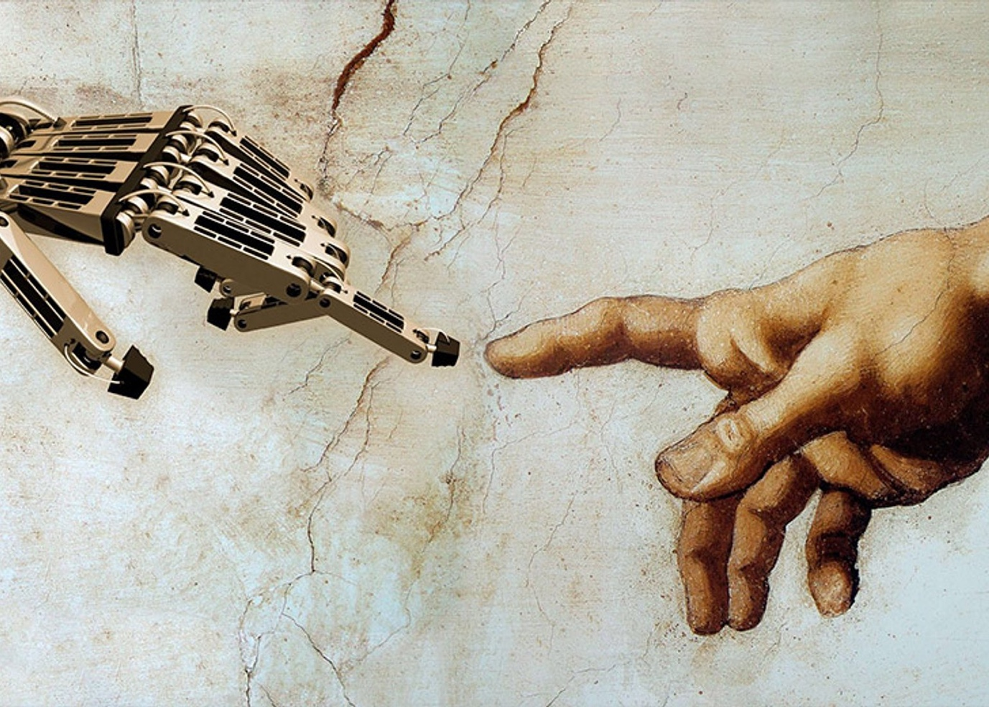


Albert Camus in Paris following the announcement that he had won the 1957 Nobel Prize for literature.
(AFP/Getty Images)


McLuhan leaning on television set on which his image appears, 1967

Part 3: Who am I ? ( Lateral Thinking and Narrative Writing)
Title: Unveiling the Essence of My Inner Strength.
The beauty of a woman is not in a facial mole, but true beauty in a woman is reflected in her soul. It is the caring that she lovingly gives, the passion she knows.” (40 of Audrey Hepburn’s best quotes on Love, life, beauty and more! - parade) This quotation from the timeless actress Audrey Hepburn serves as a constant reminder of the essential attributes that individuals should possess as they mature. As a female, I find it tough to live in the present day due to the pervasive inequity. However, even in the most difficult circumstances, there is always a guiding light that will accompany us throughout our lives. In order to alleviate feelings of sadness and distress, it is imperative that we discover the inner source of illumination that may provide us with solace and company.
Being a spiritual person, I always strive to discover positivity in my life, even when my surroundings are at their most unfavourable state. In my opinion, the essential goal in our lives is to discover and cultivate our inherent qualities. Discovering our most exceptional intrinsic attribute may withstand any circumstance or disagreement. Discovering our inherent qualities might be challenging in the absence of direction or experience. Having realised my inherent excellence, I am able to provide insights and wisdom that aided me in navigating even the most challenging periods of my existence.

You are welcome to challenge the recognition I have received or express disagreement with my views and guidance. It is OK to seek guidance from others or introspect when you encounter uncertainties in life. It is possible that you may never discover definitive answers, or you could. However, ultimately, you will always discover resolutions and insights on how to navigate the challenges you have encountered in your life. Returning to the pursuit of our inherent excellence, I believe the solution lies in delving into our innermost being, seeking insights that transcend our physical existence. Once you have reached that point, I think the solution is inside the essence of our physical being, known as the soul. An effective method to do this is by engaging in profound meditation and directing our attention only towards our inner selves, including our souls and physical bodies. Aristotle said, “Knowing yourself is the beginning of all wisdom.” (Williams, Real happiness starts with You 2015)


Discovering your distinctive attribute has the potential to profoundly transform your whole character, as well as your perspectives on the planet and the others in your vicinity. When you explore your own self, you will uncover the most fundamental essence of the universe: tranquilly. It is easier said than done. I am certain that a little amount of dedication and a strong desire to discover your inherent excellence has the potential to permanently transform your life. As Myles Munroe once said, “The greatest discovery in life is self-discovery. Until you find yourself, you will always be someone else. Become yourself .” (Myles Munroe quote: “The greatest discovery in life is self-discovery. until you find yourself you will always be someone else. Become yours...")

ESSAY WORD COUNT - 1789

References/ Citations.

- (No date) 70 Roald Dahl quotes from his books and more - parade. Available at: https://parade.com/1087241/alexandra-hurtado/roald-dahl-quotes/ (Accessed: 01 August 2023).
- Gentileschi, O. (no date) Orazio Gentileschi, the finding of moses, Orazio Gentileschi | The Finding of Moses | NG6684 | National Gallery, London. Available at: https://www.nationalgallery.org.uk/paintings/orazio-gentileschi-the-finding-of-moses (Accessed: 01 August 2023).
- (No date a) Dalai Lama quotes - brainyquote. Available at: https://www.brainyquote.com/authors/dalai-lama-quotes (Accessed: 01 August 2023).
- Fowler, D. (2021) 13 of princess diana’s most inspiring quotes, Grazia. Available at: https://graziadaily.co.uk/celebrity/news/princess-diana-quotes/ (Accessed: 01 August 2023).
- Understanding media (2023) Wikipedia. Available at: https://en.wikipedia.org/wiki/Understanding_Media (Accessed: 01 August 2023).
- Global Village (2023) Wikipedia. Available at: https://en.wikipedia.org/wiki/Global_village (Accessed: 01 August 2023).
- Albert Camus (2023) Wikipedia. Available at: https://en.wikipedia.org/wiki/Albert_Camus (Accessed: 01 August 2023).
- (No date a) 40 of Audrey Hepburn’s best quotes on Love, life, beauty and more! - parade. Available at: https://parade.com/977293/alexandra-hurtado/audrey-hepburn-quotes/ (Accessed: 01 August 2023).
- Williams, H. (2015) Real happiness starts with you, Holstee. Available at: https://www.holstee.com/blogs/mindful-matter/17408520-real-happiness-starts-with-you#:~:text=Aristotle%20once%20said%2C%20%E2%80%9CKnowing%20yourself,to%20get%20to%20know%20you%3F (Accessed: 01 August 2023).
- Myles Munroe quote: ‘The greatest discovery in life is self-discovery. until you find yourself you will always be someone else. become yourse...’ (no date) Quotefancy. Available at: https://quotefancy.com/quote/1537509/Myles-Munroe-The-greatest-discovery-in-life-is-self-discovery-Until-you-find-yourself-you (Accessed: 01 August 2023).
- Dignity (no date) BRAHMA KUMARIS UK. Available at: https://brahmakumaris.uk/ (Accessed: 01 August 2023).

