Student name: Emily Woodward
Student Number: 2219684
Module 5, assignment number: BMP7013F
Total Word count: 9492 words
Title - Can state-funded schools apply singing programs to empower and inspire confidence in adolescents?
Contents:
- Component 1. Plan: Project Portfolio page 2-13 (4548 words)
- Component 2. Evaluate: Project Report page 14-31 (4944 words)
- References: page 31-36
Appendix:
- Artefact - Teachers singing guide: page 37-54
- Artefact - YouTube video link: page 55

- Week one YouTube video speech and plan: page 56-60

Can state-funded schools apply singing programs to empower and inspire confidence in adolescents?
Component one
During this study I will create a series of weekly vocal programmes aimed at empowering and motivating state secondary school teachers to facilitate group singing sessions, underpinned by robust theoretical exploration. The ultimate goal is to cultivate confidence among adolescents and inspire them to use their voices with pride. My objective is to implement the findings of academic research by combining them with the most effective practical methods.
The artefact is to be used by secondary school curriculum teachers in a state school and will comprise a set of instructive lesson plan guides created to complement a series of YouTube videos. The videos will be accessible for students to see, engage with, and learn from, while the lesson plan will aid the teacher in facilitating the singing session.
The lessons will be a selection of fun and interactive vocal exercises for the adolescent changing voice, interactive rhythmic exercises which can be performed solo, in pairs or in groups, short singing challenges and group songs. The singing course content will be meticulously chosen, taking into account the vocal challenges that may arise throughout adolescent voice change (Gackle, 1991; Mckinney, 2005; Vennard, 1967; Abitbol et al.,1999; Barlow and Howard, 2002). Additionally, the lessons will be curated with the main goal of confidence whilst singing. The experience of self-consciousness, low confidence, and self-esteem problems (Sisk and Romeo, 2019; Rankin et al., 2004; Meena et al., 2018) resulting from significant psychological changes in the adolescent brain (Harris and Westermann, 2015; Gillibrand et al., 2016) will be highly relevant in the design of my artefact.
To facilitate the achievement of confident singing students, it is imperative to provide schools and instructors with the necessary resources and support to aid them. Given the scarcity of time, resources, and finances faced by schools and instructors (Solvason et al., 2023), it is imperative that this artefact be user-friendly and pleasurable for both the teacher and the student. To effectively engage the adolescent learner, the artefact must be exceptionally compelling. Thus, a study will be undertaken to enhance its design for sustained learning during adolescence, by investigating attention span and factors that excite teenagers' interests.
I hope to encourage the development of confident, less self-conscious adolescents who enjoy singing together and aren’t afraid of using their voice. I will do this by tailoring inclusive weekly short video lessons via YouTube to enable state secondary schools to implement singing into school life. Weekly new behaviours such as group singing, could have the potential to create new habits and new routines, consequently normalising singing. This in turn will lead to a feeling of pride, community and the feeling of being supported. However, effective delivery of these weekly sessions relies on the compliance and support of the already very stretched curriculum schoolteacher (Solvason et al., 2023)

Context
I am the owner of a theatre school where I teach over 300 children aged 4-18 how to sing, act and dance. The school’s ethos it to cultivate confident, happy, empathetic performers, with shared interests who are supportive of their peers regardless of background or talent. Interestingly, students I teach of primary age (4-11) generally express themselves with more confidence than my students who are of secondary school age (11+). Children I have taught from a young age who approach the transition to high school seem more self-conscious, less confident and embarrassed to sing in front of their peers. Previous studies of mine during my MA concluded that adolescents go through a time of mental and physical change which can be overwhelming and may lead to feelings of self-consciousness such as embarrassment and shame (Tangney & Tracy, 2014; Griffin, 2017; Somerville, 2013; Sweet, 2019). During my previous study it was clear from focus groups, interviews and questionnaires that when my participants attended primary school, singing was part of everyday life, it was accepted, and it was normalised. Yet when they transitioned to high school, they felt incredibly self-conscious about singing at their secondary state schools, with all 13 participants agreeing that the music and singing provision within their school was minimal and most definitely discouraged if one wanted to avoid being teased. However, all participants in my study said that they enjoyed singing in a group at theatre school and felt confident and happy singing in front of their friends. I found it hard to hear that at school, where they spend much of their young life, they felt they could not be themselves and couldn’t join singing clubs or plays for fear of judgement. Yet at my theatre school which they attend for just 3 hours a week, they can be unashamedly themselves.
Worrying is the notion that singing is limited to young children in primary school and not extended to high school students aged 11-18. Public financing for music and the arts in the UK has been substantially reduced (musiciansunion.org.uk, 2021). A study conducted by Birmingham City University suggest that funding reductions may lead to the total removal of A level music from the curriculum, with no expected new entries by 2033 (Whittaker, Conservatoire and Fautley, 2021). This suggests that the availability of music education will be restricted to individuals who have the financial means to purchase it independent of the classroom setting across the United Kingdom, making music and the arts an elitest activity. I strongly believe music education should be available to all, regardless of one’s socio-economic background. Singing requires no instrument other than your voice, so it is accessible to all, therefore without costly equipment, schools with limited resources and funds can still access and provide engaging lessons for all students. Implementation, celebration, and encouragement of singing in state secondary schools should be a collective responsibility of all teachers within the school, rather than being only entrusted to the underfunded music department. If singing in primary schools can be seen as fun and cool, surely this can be carried across to secondary education. Could the singing lessons I provide at my theatre school be implemented into state secondary schools to make singing cool again? Could a voice programme be implemented to foster happy, confident adolescents who are not afraid to use their voice?
In addition to my artistic career, I am a mother residing in a rural area of Norfolk. Locating state schools that offered music, theatre, and arts education for my children proved to be unattainable, which influenced my decision to send them to private schools which did provide such educational opportunities. The issue of inadequate creative programs in state schools initially captured my interest, prompting me to attempt to create singing programs that address this gap. This research study aims to a) develop the necessary materials to deliver my artefact, and b) clarify the underlying reasons for the persistent problem in state schools.

Study aims and objectives
This study aims to examine the physical and psychological difficulties and obstacles encountered by adolescent students. Furthermore, this study aims to analyse and pinpoint any possible challenges that secondary state schoolteachers may encounter when leading singing classes. These aims will aid in identifying an appropriate artefact that may support schoolteachers in their efforts to cultivate happy and self-assured adolescent pupils who are not hesitant to openly express themselves by using their voice. My objective is to create an artefact which engages a cohort of adolescent students inspiring them to sing, whilst cultivating confidence. One way I will be seeking to achieve my aims is by developing a comprehensive understanding of adolescent voices and changes in the adolescent brain that lead to feelings of self-consciousness The objective of my project is to create an artefact that stimulates and encourages the class instructor to embrace its usage because of its lucidity and user-friendliness.
- Identify appropriate vocal exercises, warm up games and songs for adolescent pupils by critically evaluating the physical and psychological changes in adolescents.
- Analyse the constraints and challenges that secondary state schools may face in providing arts programmes, and subsequently identify and critically evaluate effective solutions to these challenges through systematic investigation.
- Develop a prototype artefact that is ready for completion and applicable in module 6, via thorough exploration of optimal teaching methods designed to engage and inspire confident adolescent secondary school students.

Learning Outcomes:
Throughout this study I seek to enhance my awareness and understanding of the potential obstacles encountered by secondary school teachers delivering music and singing programmes in state schools, while also gaining a deeper insight into the psychology of adolescent students.
Methods:
As part of my artefact preparation, I intend to conduct a comprehensive literature review on the psychological changes that occur throughout adolescence and the measures that teachers may take to understand, support, and inspire them to sing with confidence in a group. The scope of my research will be multi-disciplinary using both ‘white’ literature and ‘grey’ literature (Lawurence, 2014), encompassing analysis of anatomy, voice pedagogy, psychology, literature relating to arts financing in schools, and best curricular teaching methods. Alongside my literature review methods, I want to draw on my own experience teaching adolescents (Breen, 2007). I am aware that many of them respond better to fast paced, engaging and interactive methods of teaching. I intend to utilise this knowledge in my research and concentrate on teaching methods that are most effective in extending the attention span of the adolescent pupils I desire to involve in my artefact. To facilitate the participation of a wide range of audiences, I will abstain from drawing any conclusions about a shared comprehension of the subject matter in my study (Onwuegbuzie, 2018).

As an inside researcher (Bell, 2005) predominately teaching adolescent students, I am acutely conscious of the fact that I originate from a position of bias that I must confront. I must be critical of the research and acknowledge the value of considering several perspectives and maintaining impartiality (Breen, 2007; Randolph, 2009; Bell, 2005). To mitigate bias, I plan to establish a stringent inclusion/exclusion criterion that will ensure my concentration on my research question, study aims, and objectives. I will gain fresh perspective and refine my study whilst gathering the information (Winter, 2022) which will lead to the creation of my artefact.

In previous studies for my MA I gravitated to a hermeneutic methodology, as I like it’s reflective nature of returning to the object of inquiry regularly and gaining deeper more meaningful clarification (Paterson and Higgs, 2005) whilst constantly building upon the knowledge gained. In my work and personal life, I am always looking to learn, gain understanding and clarification, often asking questions and reflecting on my own teaching experiences. The artefact I intend to produce, which seeks to enhance the confidence levels of adolescent state school pupils via group singing, may be most effectively addressed utilising a phenomenological approach. This approach involves analysing subjective experiences, focused on the individual experiences and setting aside personal expectations (Costely et al,. 2010).

Beginning any study can become all-consuming and overwhelming unless necessary planning is utilised. “Wandering” (Bell and Walters, 2018, p.23) around through the vast literature is time consuming and counterproductive. There is a time limit for every study and avoiding aimless wandering by implementing a plan is key to success.

I will begin my research using the University of Wales Trinity St David’s (UWTSD) online library and will use key words such as ‘funding in schools’, ‘music provision in state schools’, ‘adolescent’, ‘singing in school’, ‘teenage attention span’. I will then implement search filters to align with my stringent inclusion and exclusion criteria. My particular focus is on ‘music in UK schools’ with a restriction on publication dates to the past ten years. I will proceed to conduct similar searches using different keywords such as ‘adolescent singers’, ‘psychology and adolescence’, ‘confidence and adolescence’. In addition to UWTSD online library, I will employ Google Scholar and the Voice Study Centre library to locate literature pertinent to my research topic.

In my previous research projects throughout my MA, literature I have engaged with thus far has been a mixture of both qualitative and quantitative, depending on the particular subject. Quantitative research typically yields a definitive conclusion and outcome, typically expressed in numerical form and visually represented through graphs and charts (Bell, 2018); this is a genre of literature that I actively avoid for fear of confusion. However, I naturally find qualitative literature easier to understand and analyse as the information is often presented through language and personal narratives. Given that psychological changes and emotions could be consistent with qualitative literature, yet physiological alterations in the voice during adolescence may align with quantitative literature, I must remain receptive to both forms of analysis.

Many academics have studied the impact of voice change on the female adolescent and male adolescent concentrating on the physical changes during adolescent voice change. For the purpose of this research, adolescence is the developmental stage in which individuals transition from childhood to adulthood, it coincides with the onset of puberty (Sawyer et al., 2018). Puberty can often start at any age between 8 and 13 for females and 9 and 14 for males (NHS, 2022). Puberty is a developmental phase during which a child undergoes physiological and hormonal changes as they progress into adulthood (Rogol, Roemmich and Clark, 2002). It is important to acknowledge that while puberty occurs in young people universally, its duration and intensity differ across individuals (Tanner, 1981). Adolescence is characterised by significant changes in "all skeletal and muscular dimensions” (Tanner, 1981 pg. 43), including the larynx. As my artefact aims to identify appropriate vocal exercises and songs for adolescent singers, it is crucial I understand thoroughly what is happening internally during adolescent voice change, so I can then support my teaching with scientific evidence. Much of the research suggests that adolescents experiencing voice change can become inherently breathy, particularly female adolescent singers (McDonnel et al, 2011; Sweet, 2018; Gackle 1991). This is due to the ‘mutational chink’ which is where the vocal folds cannot fully close at the back of the glottis, meaning that air can continuously escape, leaving one’s voice sounding breathy, husky and hoarse (Sweet, 2018; Sweet, 2015; McKinney, 2005). It would therefore be appropriate for my artefact to adopt teaching strategies which may help to reduce breathiness, huskiness and hoarseness in the adolescent voice such as twang, semi-occluded vocal tract exercises (SOVTEs) and glottal onset’s. I will research these pedagogical methods focussing on experts in the field such as Estil, Titze, Obert, and Gackle.

Not only do adolescents face physical changes in their bodies which effect their voices, they also go through an array of different emotions, some of which they will not even be able to recognise or control (Sweet, 2019). The ‘invisible audience’ refers to the persistent feeling of being scrutinised among adolescents, which can result in diminished confidence and self-esteem (Somerville, 2013). I frequently receive requests for teaching singing to adolescent students, with the aim of enhancing their confidence. Confidence, as defined by the Oxford Learner's Dictionary, is the state of feeling certain about one's own capability to perform tasks that result in achievement (Oxfordlearnersdictionaries.com, 2023). Thus, having low confidence serves as the opposite, resulting in a sense of uncertainty in one's own capabilities and subsequent failure. Low confidence and low self-esteem are issues that regularly arise when looking at literature on adolescents (Griffin, 2017; Somerville, 2013; Sebastien et al., 2010). This is why it is so important to me to design an artefact that enhances a student’s confidence and doesn’t make them feel judged, or scrutinised. This is why my artefact will be utilised in a collective environment, where all participants are singing simultaneously, inside the same physical area, with specifically crafted songs tailored for adolescent students.

One challenge I may encounter is the aspiration to create something for adolescent school pupils, while recognising that its effectiveness depends on the schoolteachers’ readiness to utilise it and incorporate it according to its intended purpose. It is often acknowledged that music instruction in English state schools is neglected, even though it is mandated by law as part of the National Curriculum (Bath et al., 2020). To provide children from all backgrounds in England with the chance to learn how to sing, collaborate with others to create music, and advance in their musical development, the National Plan for Music Education (NPME) was established (Department for Education, 2011). There is a wealth of research that supports the positive impact of studying a musical instrument and learning to sing on specific cognitive skills (Bugaj & Brenner, 2011; Costa-Giomi, 2004; Pitts, 2014, 2017; Schellenberg, 2012; Standley, 2008; Tierney & Kraus, 2013). Moreover, studies indicate that music tuition in the curriculum leads to greater progress and enhanced academic performance (Hallam & Rogers, 2016). Surely that is the desire of any school, better grades and happier student? However, to teach music, a school needs the tools and funds. Teachers believe that schools do not value teaching the arts, and they also believe that they lack the resources and expertise necessary to teach subjects like music, theatre, and dance (Cooper, 2018). Hence, alongside creating an artefact that is exciting, engaging and educational for the students, I want to prioritise ease of use for the teacher. I want the teacher to feel supported and come away from each lesson feeling educated and more confident about delivering the next session.

My initial reading indicates a paucity of studies regarding the use of singing to boost confidence in adolescents. Therefore, my research will focus on developing a hypothesis on the most efficient and captivating methods to integrate singing participation for all students in state secondary schools to boost confidence levels.

I will aim to attain a thorough understanding of the facts via diligent examination of the academic literature. This approach is essential for attaining a thorough comprehension of the topic matter despite its complex and lengthy process. Through this approach I will then employ codes to classify certain data points that I deem to be significant. After that, I'll review my codes and consider how the various codes may be used to compile themes. Reviewing and refining the themes is an important step, similar to editing a paper. To then gain much needed clarity and accuracy I will name the themes and then once all data is organised, categorised and analysed, I will begin creating my artefact and writing my paper. This particular methodology I plan to adopt is based on Braun and Clarke’s (2006) six-step process, which I have found to be invaluable in my previous papers.

All relevant articles will be gathered using Mendeley as a comprehensive database, and each paper will be methodically categorised into several topics, themes and subcategories. Mendeley has demonstrated benefits in my prior research attempts. As part of my continuous research for this project, I will persist in using Mendeley as my primary database in addition to utilising Excel to manage my reference and citation lists, as it makes it easier to organise the material alphabetically.

Critical reflection

This study is meaningful to me because I teach many adolescent students each week who seem to be lacking in confidence. Students I teach 1:1 within a state school environment also exhibit anxiousness, embarrassment and even shame when attending their singing lessons. They openly express a desire to keep the door and windows of the practice room closed so nobody hears them, for fear of judgement. On top of these psychological struggles they experience, they are also contending with adolescent female and male voice change, which poses some vocal challenges, again leading to further insecurities and self-consciousness. In my theatre school teaching environment, my state school students regularly volunteer to sing solos and are fully engaged within my group singing class. This led me to wonder if the group singing classes I teach at my own theatre school can be replicated in a state school environment with everyone in a year group involved, not just those who take singing lessons or attend extra-curricular singing clubs. The question I kept asking myself was ‘can group singing be enjoyed by everyone in a state school and can it enhance the confidence of all students?’. I then asked myself ‘is it possible for state schools to deliver compulsory group singing classes whilst making them fun, engaging and educational?’. Due to my experience teaching adolescents, I was already aware of the challenges I may have to undertake gaining the trust from a cohort of them, however I wasn’t sure how I could gain the trust and be able to inspire the already stretched, over worked curriculum schoolteachers. I came across a lot of ‘white’ literature on teaching choirs in schools with students who were already singers, however finding scholarly literature on the field of teaching singing and the implementation of singing programmes in state schools for every single child was few and far between. Then, I was reminded of the BBC television series "The Choir," in which Gareth Malone took on the task of introducing music to state school adolescent pupils who had never sung before. Ultimately, the students' lives were made richer by music and choir participation; they also developed friendships, self-assurance, and social skills. Perhaps it was only successful due to the experiment being backed and broadcast by the BBC, extensive funding and it was led by a choir expert. However, I am optimistic that similar singing programmes can be implemented into schools with comparable results.

My development as a voice instructor and the development of my artefact will depend heavily on my ability to reflect, in order to make sense of what I have studied and determine the best course of action for me moving ahead. It appears that there are two primary methods to support the reflective process: reflection during activity (reflection in action) and reflection after action (reflection on action), (Schon, 1983). As stated by Bolton (2014, p. 6), the active practice of reflection (in action) may be likened to having a vigilant hawk that is prepared to seize any opportunity to use our acquired knowledge. Thanks to the accumulation of years of experience and further training, I have cultivated an enhanced level of confidence in my teaching skills. Hence, I now feel more proficient in implementing the strategy of reflection in action (Schon, 1983), such as when a pupil requires adjustment following a direction. Reflection on action appears post event, and raises questions like ‘what’, ‘who’, ‘where’, ‘when’ and ‘why’? (Bolton, 2014).

In previous studies I often favoured Borton’s model (1970) for reflection as it incorporates all the core skills of reflection and has a definitive end point. However, I know that teaching is more of a cyclical experience, where we are constantly learning, improving and adapting. This is why Kolb’s cycle (1984) of reflection is appealing for this project and for the creation of my artefact.

Concrete Experience: To inspire every child to sing, I knew I needed to produce vocal warmups and songs that were fun, inclusive, interactive and engaging. During my weekly group and 1:1 classes I observed the difference in interaction between the more tried and tested traditional warm up scales, arpeggios, SOVT’S, glides, (Titze, 2006; Estil, 2019; Hijleh and Pinto, 2021) whereby the students stand still with good posture (Chapman, 2017), versus interactive singing challenges and warm up songs I had viewed on TikTok, Instagram and YouTube. I noticed that all students I taught much preferred breathing exercises presented as ‘singing challenges’, ‘rhythmic games’ whereby they could move around the room, work in groups and not be stationary, harmony and pitch exercises disguised by the term ‘game’ or ‘challenge’.

Reflective Observation: Upon careful consideration, I observed that all the students actively participated and interacted more with the lively interactive vocal warmups. They seemed to spark joy and were something the students looked forward to doing in the class. In previous lessons, the more traditional warmups were seen as a necessity, something that needed to be done to protect the voice and maintain vocal control and flexibility (Smith and Stataloff, 2003; Stegman, 2003, Amir et al. 2005). This led me to consider that adolescent students might need fast paced, interactive more playful ways to learn enhancing the students’ experience. Something that initially would perhaps be seen as ‘childish’ and ‘uncool’ was surprisingly the activity most engaging to my students. Research indicates that actively engaging in the educational process increases student engagement, fosters a deeper comprehension of the subject matter being taught, and improves communication abilities (Blyznyuk and Kachak, 2024).

Abstract Conceptualisation: My reflective observation led me to research theories of interactive and playful learning in schools and in choirs. This was done with the intention of combining my research on interactive, fun choral teaching approaches, with what I had acquired about interactive teaching in a secondary school setting. I needed to also be mindful that students that attend my 1:1 classes and weekly singing groups at theatre school all chose to be there. They are all willing participants in the class. Of course, there are times I have to gently discipline the group due to over excited behaviour, but on the whole, tricky behaviour is not something I have to contend with. I knew I needed to also look at tried and tested methods used for gaining focus and respect from the students who display challenging behaviour. As my artefact is going to be for adolescent students but facilitated by teachers in schools, I knew I needed to research the inevitable problems faced by the class curriculum teacher in state secondary schools in the UK.

- Is group singing accessible to all adolescent pupils at a state school, and can it boost their confidence?
- Can the class curriculum teacher be inspired to confidently deliver singing programmes?

My singing programme hopes to positively answer these questions by combining the knowledge gained from vocal pedagogy, teaching practices and interactive learning methods to enhance student and teacher engagement, student focus and student confidence.

Active experimentation: With iterative reflection of my professional practice, I will refine and enhance my singing programme content by robustly applying my rigorous inclusion and exclusion criteria to ensure my artefact is engaging, educational and it is enhancing confidence via interactive singing challenges, singing games, warmups, interactive rhythmic activities, group and partner work. I will endeavour to create an artefact that can be easily implemented into the classroom or assembly hall through use of a laptop and a screen. I will create teaching guides for curriculum teachers who may have no music teaching experience and may have no piano, instruments or music facilities. These elements embody my initial aims and objectives by providing solutions to the issues encountered by schools and educators such as lack of music specific facilities, funds and teachers. Introducing singing into high schools on a daily or weekly basis might lead to the development of new routines and habits (Hawlader et al., 2022), consequently normalising singing. Students could thus be encouraged, not condemned, to sing in front of their classmates and feel proud of themselves. Consequently, this might result in an upsurge of self-assured, confident and contented adolescents who aren’t afraid to stand up and share their voices, “teach a child to use the voice with confidence, and that child will make music long after leaving your classroom!” (Phillips,1985, p.58).

Component 2
Much of my research during my MA has led to my fascination with the adolescent changing voice and the physiological changes that occur in the adolescent brain that contribute to emotions of self-consciousness. For centuries, adolescents have been negatively depicted, with philosophers such as Socrates and Aristotle characterising 'youth' as untrustworthy, impulsive, lacking self-restraint, rude, and exhibiting poor manners (cited by Sarah-Jayne Blakemore, 2019). This is not a true representation of what I personally experience when I’m teaching a new group of adolescent students, I experience something quite different. A vulnerability, a shyness, a desperation to succeed yet constantly fearing what others may think and a lack of confidence. In my group singing class, my regularly attending adolescent students have a meaningful experience with their classmates who share their interests (Tamplin and Lee, 2013). This enables them to experience joy when singing, devoid of shame or embarrassment. I try to exhibit empathy towards students lacking confidence and normalise the concept of making mistakes by sharing my personal experiences of “when I hit the wrong note” or “when I had a voice crack”. Recognising that their issues are not unique, alleviates their sense of judgement (Brené Brown, 2012).

Singing seems to be very much part of the primary school experience, with regular singing assemblies, performances and as a method to teaching languages, literacy and numeracy (Busse et al., 2021; Davis, 2017). There are evidential benefits for the interrelationship between music and academia such as behaviour, pronunciation skills, memory, and speaking skills (Busse, V et al., 2021). Teaching through singing is an enjoyable method of learning for students and teachers alike and promotes understanding and clarity of the subject matter (Davis, 2017). So why aren’t more secondary schools using music and singing to enhance students understanding in the classroom? Finding literature on singing in senior schools to educate the curriculum, is not quite as easy to find. There is a vast body of research for singing in primary schools, equally there are many websites, apps and teaching tools available for primary school teachers to help deliver singing. Yet the resources for secondary school teachers seems to be lacking. The notion that singing in schools is reserved exclusively for younger children and not for those aged 11-18 attending secondary school, is a huge concern of mine. In my previous research study, adolescent research participants all agreed that if they didn’t attend their weekend stage schools, they would never experience group singing, as it wasn’t something their state high schools actively encouraged, and it wasn’t on offer to them. In the United Kingdom, government support for music and the arts has been substantially reduced (musiciansunion.org.uk, 2021), which might lead to the curriculum's total removal of A level music, with no new courses expected by 2033 (Whittaker et al., 2021). This implies that only those who can afford to pay for it outside of the classroom will be able to receive music education in the UK. However, singing requires no expensive equipment, and almost everyone can do it. With the appropriate tools and training, teachers can therefore provide singing to students in schools giving them the opportunity to experience music and singing. Studies demonstrate that group singing can elevate mood and overall well-being by releasing feel-good neurochemicals (Pearce, Launay and Dunbar, 2015). I believe that everyone could benefit from a boost in mood and general well-being, especially adolescents who have the highest incidence of anxiety, which can lead to excessive worry (Zheluk et al., 2022).

I am not suggesting a cohort of secondary school students learn repetitive songs to help them remember dates in history, the periodic table or mathematical formulas. I am more interested in creating an artefact which supports the wellbeing and feelings of the adolescent students via singing. I want them to feel proud to be part of something that promotes fun, healthy singing for the adolescent. Pride is a self-conscious emotion, as it involves oneself (Tangney & Tracy, 2014), it is this sense of pride which will hopefully lead to confident, self-assured adolescent students at school, who are not afraid to use their voices to sing or speak, proving that adolescents are more than just disrespectful, careless and rebellious (Blakemore, 2019). To establish and develop my artefact an extensive literature review must be undertaken and reviewed using Nelsons reflective framework (see figure 1): know that, know how, know what (Nelson, 2022).

Figure 1
Figure 1, Nelson, R. (2022).

Figure 1 (Nelson, 2022)
Figure 1 (Nelson, 2022)

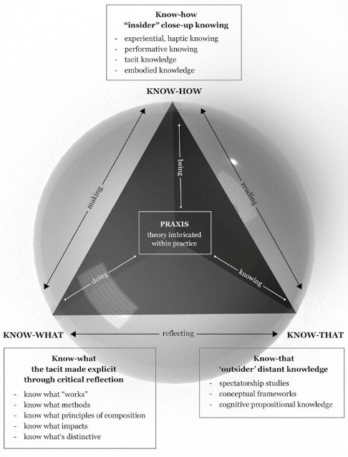

Figure 1 (Nelson, 2022)

Know that

As the principal teacher at my own theatre school and a freelance 1:1 teacher in both state secondary and private secondary schools, I am in the fortunate position to work amongst a wide demographic of adolescent students. I can see firsthand the music and singing opportunities my private school students receive, versus the stark opposite at the state school I work in. In state schools the uptake in A-level and GCSE music in the UK decreased by 43% between 2010 and 2023, and the number of hours of music tuition taught in schools has fallen by 36% (Cultural Learning Alliance, 2024). According to data compiled by the Cultural Learning Alliance, 42% of England's state-funded schools no longer enter any pupils for Music GCSE (CLA, 2024). This is a huge concern and asks the question why? Is it because the supply and implementation of music education in schools appears to be hindered by persistent underfunding (Bath et al., 2020)? Savage and Barnard (2019) claim that insufficient financing is the principal reason for the decrease in GCSE and A-level music enrolment. I argue that music can be taught without the use of instruments, high tech equipment and purpose-built studios or classrooms. Singing is accessible to the majority and has the ability to not only teach music, but also to teach empathy, compassion, confidence and enhance social interaction (Bodkin-Allen et al., 2019), and singing doesn’t require any instruments, therefore making it a cheap option for the underfunded state school.

Teaching methods: A significant portion of my own education at school was conducted through a passive teaching approach, this is when students remain seated at desks, taking notes and respond to questions when prompted (Diepreye et al., 2019). Lecturing is a passive method of teaching and is still widely used as a means to transferring knowledge from a teacher to a student (Diepreye et al., 2019). Personally, I find this way of learning complex and unenjoyable. Active learning is the complete opposite to passive learning (Sheryasi, 2017). Active learning is being involved in the learning process such as role playing, having discussions and debates, problem solving (Roberts, 2019), and maybe, even learning a song. I know I learn much better by doing, than just by listening, and I am engaged so much more in the learning process if I have been taught in an active approach. Incorporating this into my artefact is very important to me. Active teaching methods positively affect student focus, engagement and increase retention level (Diepreye et al., 2019). I want adolescent students to be able to get up and move around the space, alongside being seated for some aspects of the singing class. This suggests that the schools employing my artefact will require a substantial area, such as a hall, to facilitate the singing sessions, where benches or seats may be utilised alongside an open space for movement.

Psychological changes: My previous practice-based research suggests that the notion of singing and sharing one’s voice during adolescence at secondary school elicited feelings of worry, anxiousness and self-consciousness. Adolescence is characterised by heightened self-consciousness due to the maturation of the frontal lobe, resulting in intensified emotions and a perception of being judged by others (Somerville, 2013; Sung et al., 2021; Sebastien et al., 2010). Creating a culture in a school whereby singing is seen as normal and is done by everyone is probably the biggest challenge I faced whilst creating my artefact. My artefact is to begin being used in year 7, which is when students enter their new secondary school. The artefacts aim is to promote singing in schools as part of a weekly routine making singing habitual (Hawlader et al. (2022), therefore creating an environment where everyone feels accepted and less self-conscious.

Adolescent voice change: During my artefact creation, I was mindful of the physical and psychological changes that occur during adolescence. Adolescent voice change occurs in both male and females. The size of the larynx is equal in prepubescent boys and girls, the female larynx undergoes a growth rate of 38% while the male larynx increases by 65% throughout adolescence (Sweet, 2015). On average, the length of female vocal folds increase by 3-4 millimetres, whereas male vocal folds grow by approximately one centimetre (Sundberg, 1988). Adolescents' physiological growth of the chest and lungs throughout puberty improves their breathing capacity. Moreover, the vocal tract elongates as the larynx descends, and the face's resonators develop and lengthen. All these factors work together to affect phonation which causes both male and female voices to be lower pitched while speaking and singing (Weiss, 1950; Gackle, 1991; Sweet, 2015). Male adolescents can experience a loss of high notes and a breathy quality. They also can have trouble whilst trying to navigate their changing voice and can struggle with pitching (Henwood, 2023). Whilst female adolescents can experience insecurity of pitch, register breaks, huskiness and breathiness (Gackle, 2014; Sweet, 2018). It is therefore important that my artefact is specifically designed with the adolescent changing voice in mind, giving options and expert guidance to those experiencing difficulties and challenges in their voice. I will do this by incorporating vocal techniques and strategies such as twang and semi occluded vocal exercises (SOVT) to help students to sing clearly with easy phonation, which in turn will reduce breathiness, which seems to be an issue for both male and female adolescence experiencing voice change (Nix and Simpson, 2008; Andrade et al, 2014; Estill, 2005; Perta, Bae and Obert, 2020).

Know how

The challenge I have is that I am creating a resource not just for adolescents, but also for the teachers who will be conducting the singing sessions. The video is designed to captivate students, but the accompanying teaching guide must be straightforward and user-friendly.

From my years of teaching privately and in schools I am acutely aware from my own experience teaching in and out of schools, that a very small percentage of students and teachers in state schools can read sheet music. When I first started my adult choir back in 2017, I gained an influx of adult singers who couldn’t read music but loved to sing, which is why I decided to teach with lyrics rather than sheet music. I do this now with my under 18’s group singing class too. I have tried throughout the years to introduce sheet music in a group setting, but much of the class found the small musical notes and libretto challenging to read and they all seemed disengaged in the song learning process. This is why my artefact will utilise lyrics rather than musical notation (see figure 2), since I want for universal accessibility and equality among participants, easing feelings of self-consciousness for both the student and teacher (McGrew, 2015).

Since the COVID-19 pandemic, millions of adolescent students have engaged in online classes delivered in video format. Video style is crucial, as it may influence sustained attention in adolescents (Lackmann et al., 2021). Research indicates that a combination of infographic video content, which incorporates graphics, images, text and animations - with traditional lecture methods featuring a teacher, enhances cognitive and emotional engagement, thereby improving student performance (Lackmann et al., 2021). In my video artefact, I have integrated these video techniques (see figure 2) to provide the adolescent student with emotional engagement through the depiction of a teacher, and cognitive engagement through the incorporation of infographic video content (Lackmann et al., 2021).

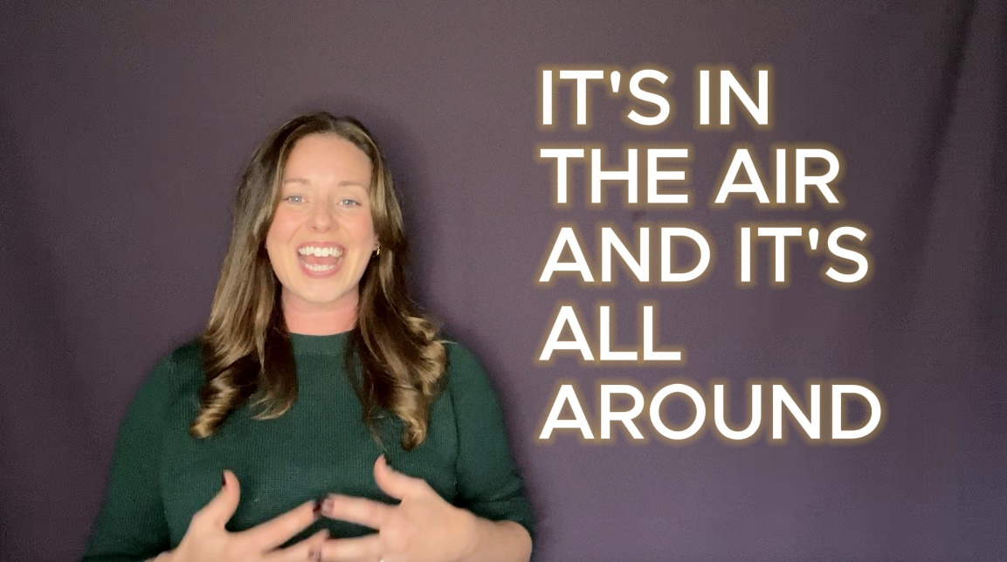

Figure 2 Artefact: YouTube Lyrics

I recognise that sustaining concentration during a cognitive task is essential for information processing (Hobbiss and Lavie, 2024). Due to adolescent's susceptibility to many distractions from external sources such as background noise, unforeseen movements, mobile devises, and internal factors like daydreaming (Hobbiss and Lavie, 2024), it is essential to reduce on-screen distractions. From best practice research and my own experience teaching this age group, I purposefully chose to present myself in a way that would not detract from the content, by filming my singing content against a plain purple background. I wore a simple top, natural hair, and makeup, and I used a ring light to enhance the video, keeping it interesting and appealing (see figure 3). This allowed me to attain the ideal balance between reducing distractions for online learning and producing content that looks professional and engaging.

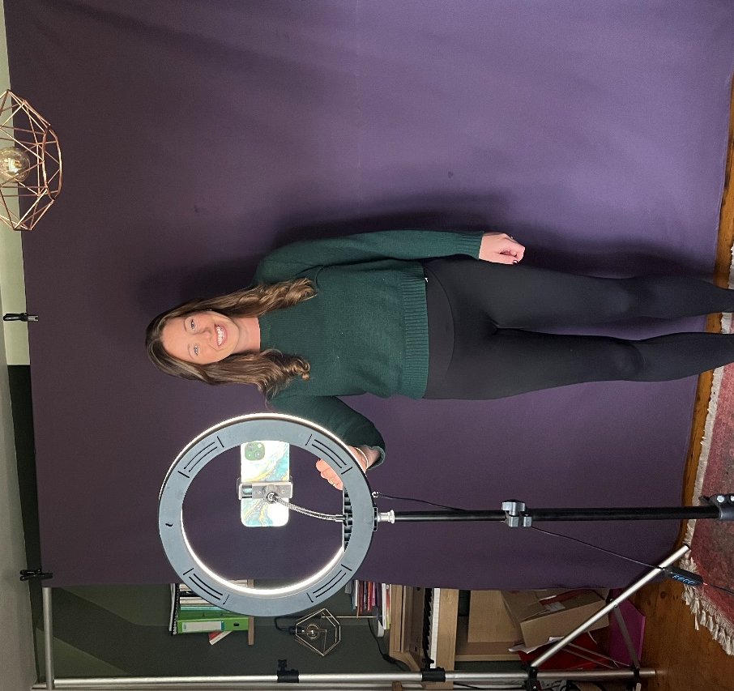

Figure 3: YouTube video set-up

The prevalence of social media usage among adolescents is clear (Zheluk et al., 2022), marked by a substantial rise in screen time and an accompanying decrease in television consumption (Orben, 2020). TikTok is predominantly favoured by adolescents; in 2020, 69% of its users were aged 13 to 24. Adolescent boys are more inclined to report usage of YouTube, whilst girls are more predisposed to utilise TikTok and Instagram (Zheluk et al., 2022). Social media platforms such as TikTok satisfy adolescents cognitive needs due to the nature of the short videos which gratify the adolescent’s short attention spans (Qin et al., 2022). My artefact includes YouTube videos, as YouTube is more accessible to a school environment and it’s use for “learning has considerably expanded” (Lange, 2019, p.6) but I have endeavoured to maintain the characteristics of TikTok to cater to the attention span requirements of the adolescent pupils. I have done this by keeping vocal exercises short and informative, using graphics, accessible fonts (see figure 4 and 5) and by adding variety to the singing session.

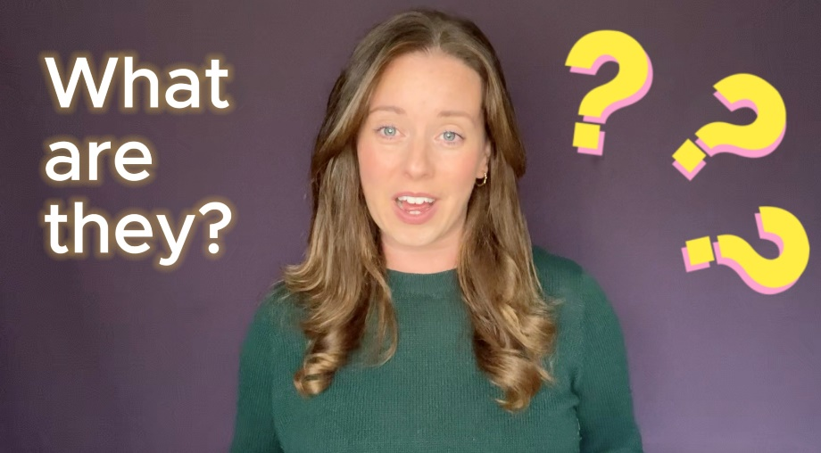
Figure 4: Artefact – YouTube Graphics

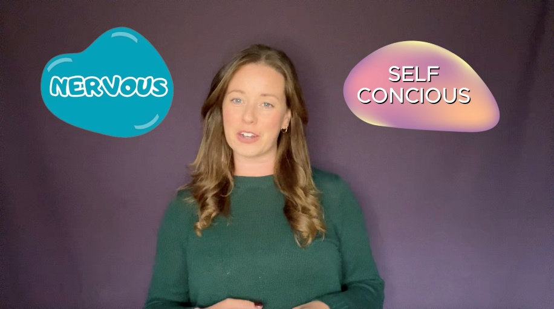
Figure 5: Artefact – YouTube fonts

Vocal exercises, singing challenges and rhythmic body percussion activities have been embedded into the video and teaching guides. However, traditional vocal warmups standing around a piano singing the C major scale to an ‘Ah’ have been avoided. Whilst traditional vocal exercises are useful for warming up the voice, they can take up to 20 minutes to achieve effectiveness, whereas less traditional vocal exercises such a SOVTs result in fatigue resistance and can benefit the singer in half the amount of time (Kang et al., 2019). I have tried to use a variety of both; however, my ‘traditional’ warmups have a twist to them to inspire and engage the adolescent. Choosing well-known songs adapted as vocal exercises may spark a feeling of familiarity, helping the adolescents to relax and enjoy the singing session (see figure 6).

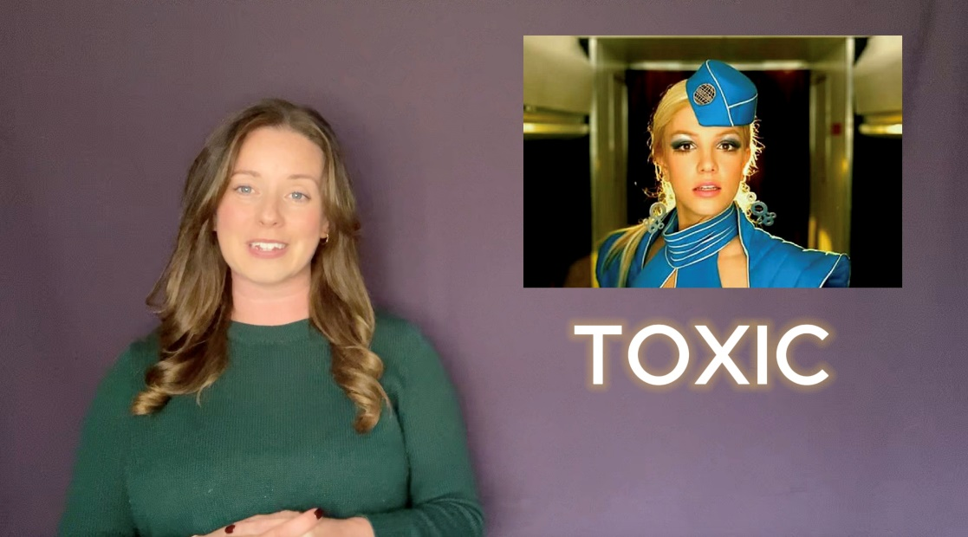
Figure 6: Artefact – Vocal exercises

Familiarity is enticing as it requires less cognitive work while acquiring new knowledge (Winet et al., 2023). Alongside curating the most effective vocal exercises and warm-ups for the adolescent student, I have researched the latest TikTok trends; TikTok trends consist of a compilation of viral short videos, usually to popular music. TikTok users express their creativity through multiple interpretations and subsequently upload their own videos, hence enhancing the trend's popularity (Jaudon, 2022). Vocal challenges are added to TikTok daily, which my targeted demographic is consuming. Bringing these challenges into the singing sessions could therefore be something that all students will find familiar and will hopefully engage in (see figure 7).
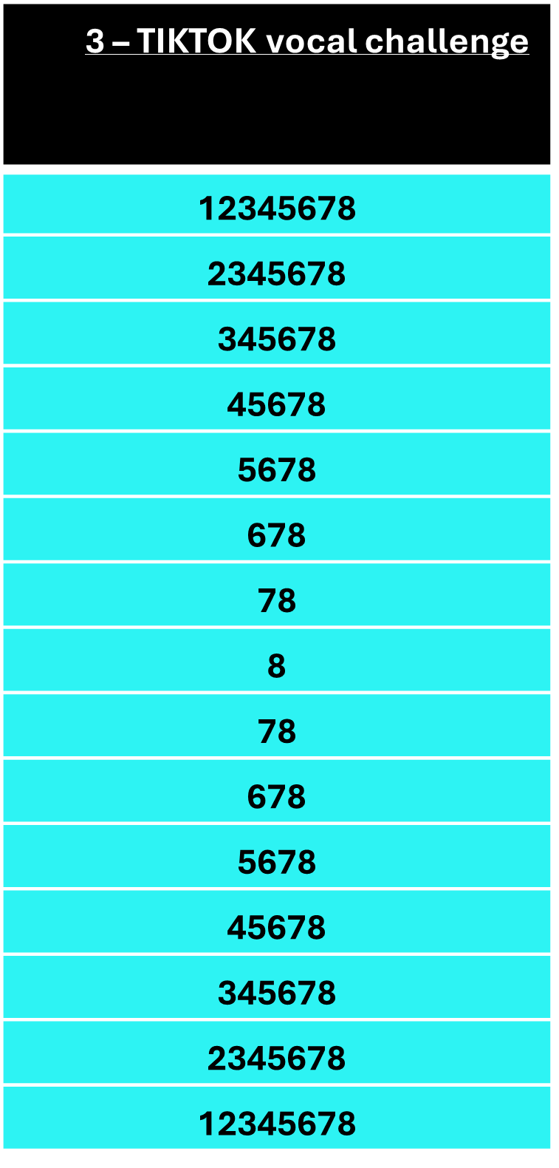
Figure 7 – Artefact: Teacher Guide - TikTok

Selecting the appropriate repertoire for the adolescent experiencing voice change is another challenge I faced when creating my artefact. I wanted to select songs that would gently exercise all areas of the voice (Gackle, 2014) giving options for low- and high-pitched singing. I needed the song choices to be popular amongst the school students to keep them interested, so I analysed the Spotify streaming chart, where most of its users are a predominately young adults and adolescents (Sukhanova, 2024). Amongst many new chart toppers, there was an array of older songs in the UK streaming chart, thanks to the resurgent TikTok viral trends. Having a variety of older and newer material potentially could interest both the students and the teachers delivering the sessions (see figure 8). My desire is for the singing sessions to be enjoyable for everyone involved.

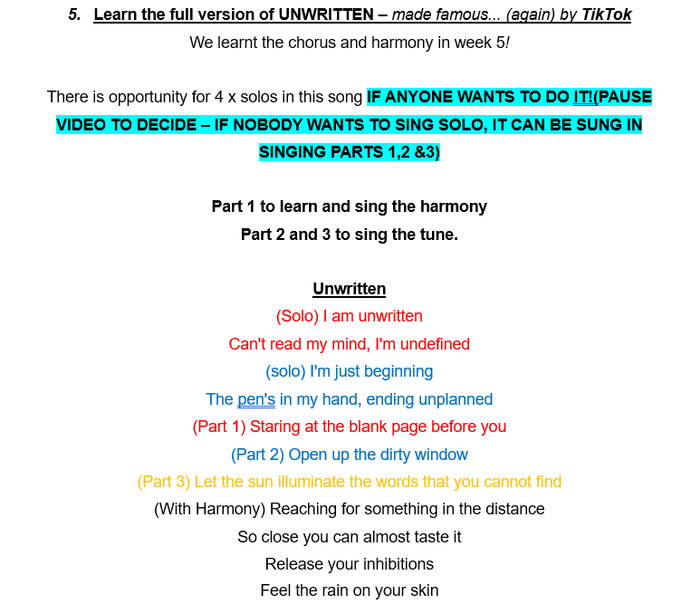

Figure 8 – Artefact: Teacher guide – made famous again by TikTok

Know What

The word that keeps coming up in the literature for adolescent’s going through voice changes is ‘breathiness’ (Sweet, 2015; Mckinney, 2005; Sweet, 2018; Gackle, 2014; McDonnell et al., 2011, Henwood, 2023). It's possible that adolescents will view this as a flaw or weakness (Sweet, 2019), which could then lead to feelings of self-consciousness such as embarrassment, shame and guilt (Muris, & Meesters, 2014). During my research I found there to be several teaching methods for the singing teacher to assist with a breathy singing quality; SOVT, twang and breath control, which I have embedded into my artefact in the form of singing exercises and challenges. I have also found that body percussion can help with memory, co-ordination, confidence and rhythm (Carretero-Martínez et al., 2014; Romero-Naranjo et al., 2014). The foundation of these pedagogical approaches is the concept of positive reinforcement within a supportive environment, designed to encourage students to explore new ideas without fear of judgement.
SOVT – semi occluded vocal tract exercises are used every day by me in my work as a singing teacher. Not only do I enjoy teaching them, but my students enjoy using them as an effect method for vocal warmups. For years, lip trills, humming, tongue trills, fricatives, and phonating via straws have been among the SOVT exercises used by a number of voice coaches, speech therapists, and singing instructors (Guzman et al., 2013). There are many benefits to utilising SOVT exercises, most importantly reducing any danger of injury to the vocal folds (Nix and Simpson, 2008), but also enhancing vocal quality, reducing breathiness, encouraging easy phonation (Laukkanen et al., 2008; Hijleh and Pinto, 2021; Andrade et al., 2014) and perhaps most pertinent to the self-conscious adolescent; SOVTEs can be performed virtually silently as “many SOVT’s mute the sound” (Hijleh and Pinto 2015, p. 340). This may appeal to the adolescent, as they are becoming more self-conscious and judgemental of themselves. Every singing session in my artefact begins the lesson with a series of SOVT exercises, to gently and quietly warm the voice up. My hypothesis is that this will gently ease students into the session without fear of voice breaks, breathiness and pitching issues (Gackle, 2014; Sweet, 2015) alleviating fears of embarrassment.

Breath control - Recognising that breath constitutes a singer's primary source of power, several teachers, me included, stress the need of breath control and support management (McCoy, 2014). Breath control refers to regulating subglottal pressure, glottal resistance, and airflow simultaneously (Vennard, 19676; Sundberg, 1987; Emmons, 1988). In teaching my students about vocal support, I align my explanation with Chapman's (2017) description, which proposes that vocal support entails applying various torso muscles to control breath flow during singing, thereby facilitating the regulation of air release through the vocal folds while generating sound. I have found that the use of imagery with my adolescent students has been helpful when teaching breath control. I instruct students to visualise the lungs as a balloon inflating during inhalation and deflating during exhalation. I encourage them to gradually regulate the release of air to prevent the balloon from deflating abruptly, which would leave the singer yearning for the next breath. Mental imagery serves as an excellent learning tool, and encouraging singing students to employ this technique may improve their comprehension of the session material (De Koning et al., 2013), so increasing their confidence and willingness to engage.

TWANG is energetic and expressive “loud and high-pitched singing” (Sundberg and Thalen, 2010, p. 654). When many of my singing students hear the word “twang” they routinely associate it with a very nasal quality. However, nasal twang and oral twang are quite different and both methods produce very different sounds (Steinhauer, Mary Mcdonald Klimek and Estill, 2017). Nasality is the term used to describe the low frequency content (200-300Hz) of sounds produced by the nose and mouth (Titze, 2001. p 520). To achieve this, the velum needs to be lowered, opening the passage to the posterior nasal cavity, known as the velopharyngeal port (Estill et al., 2019). This method is opposite to the formation of oral twang. In oral twang, the velum rises, resulting in sound production with a greater frequency range (2500-3500 Hz), which yields a vibrant and resonant tone (Titze, 2001). Twang is a strategy I have used in my singing studio, choirs and schools for years to positive effect. When students are struggling with volume, particularly with higher notes, adding twang usually helps to make the sound brighter, and louder (Sundberg and Thalen, 2010, p. 654). I have an exercise dedicated to twang quality in the artefact for a less breathy quality and to help encourage louder more confident sounding singing (see figure 9).

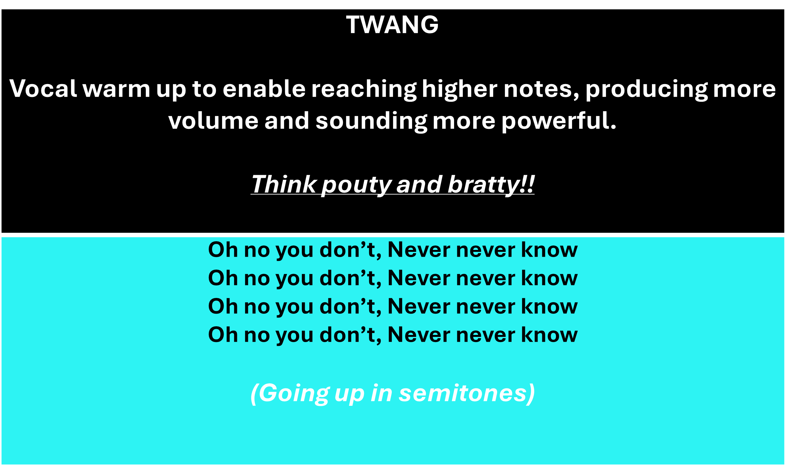

Figure 9 – Artefact: ‘Teacher guide’ - TWANG

Body percussion is a musical warm up I have used in choirs amongst children and adults alike for some time. I tend to use it as an ice breaker near the start of the class with older students, or to regain the attention of younger student’s part way through the class. It has multiple benefits to the learner, rhythmic and body awareness, precision, kinaesthetic learning, creativity and expression, memory and concentration to name a few (Romero-Naranjo et al., 2014). Beyond only creating beats, body percussion can lead to physical, mental and social improvements (Carretero-Martínez et al., 2014) whilst also improving rhythm, inspiring creativity, and enhancing the musical experience. We already know that school music departments are underfunded (Bath et al., 2020) and may not have access to percussion instruments. For these reasons, I used body percussion in my artefact (see figure 10) to help teach rhythm, but more importantly, to foster relationships among student groups, increase focus, and teach in a way that encourages participation and peer learning.
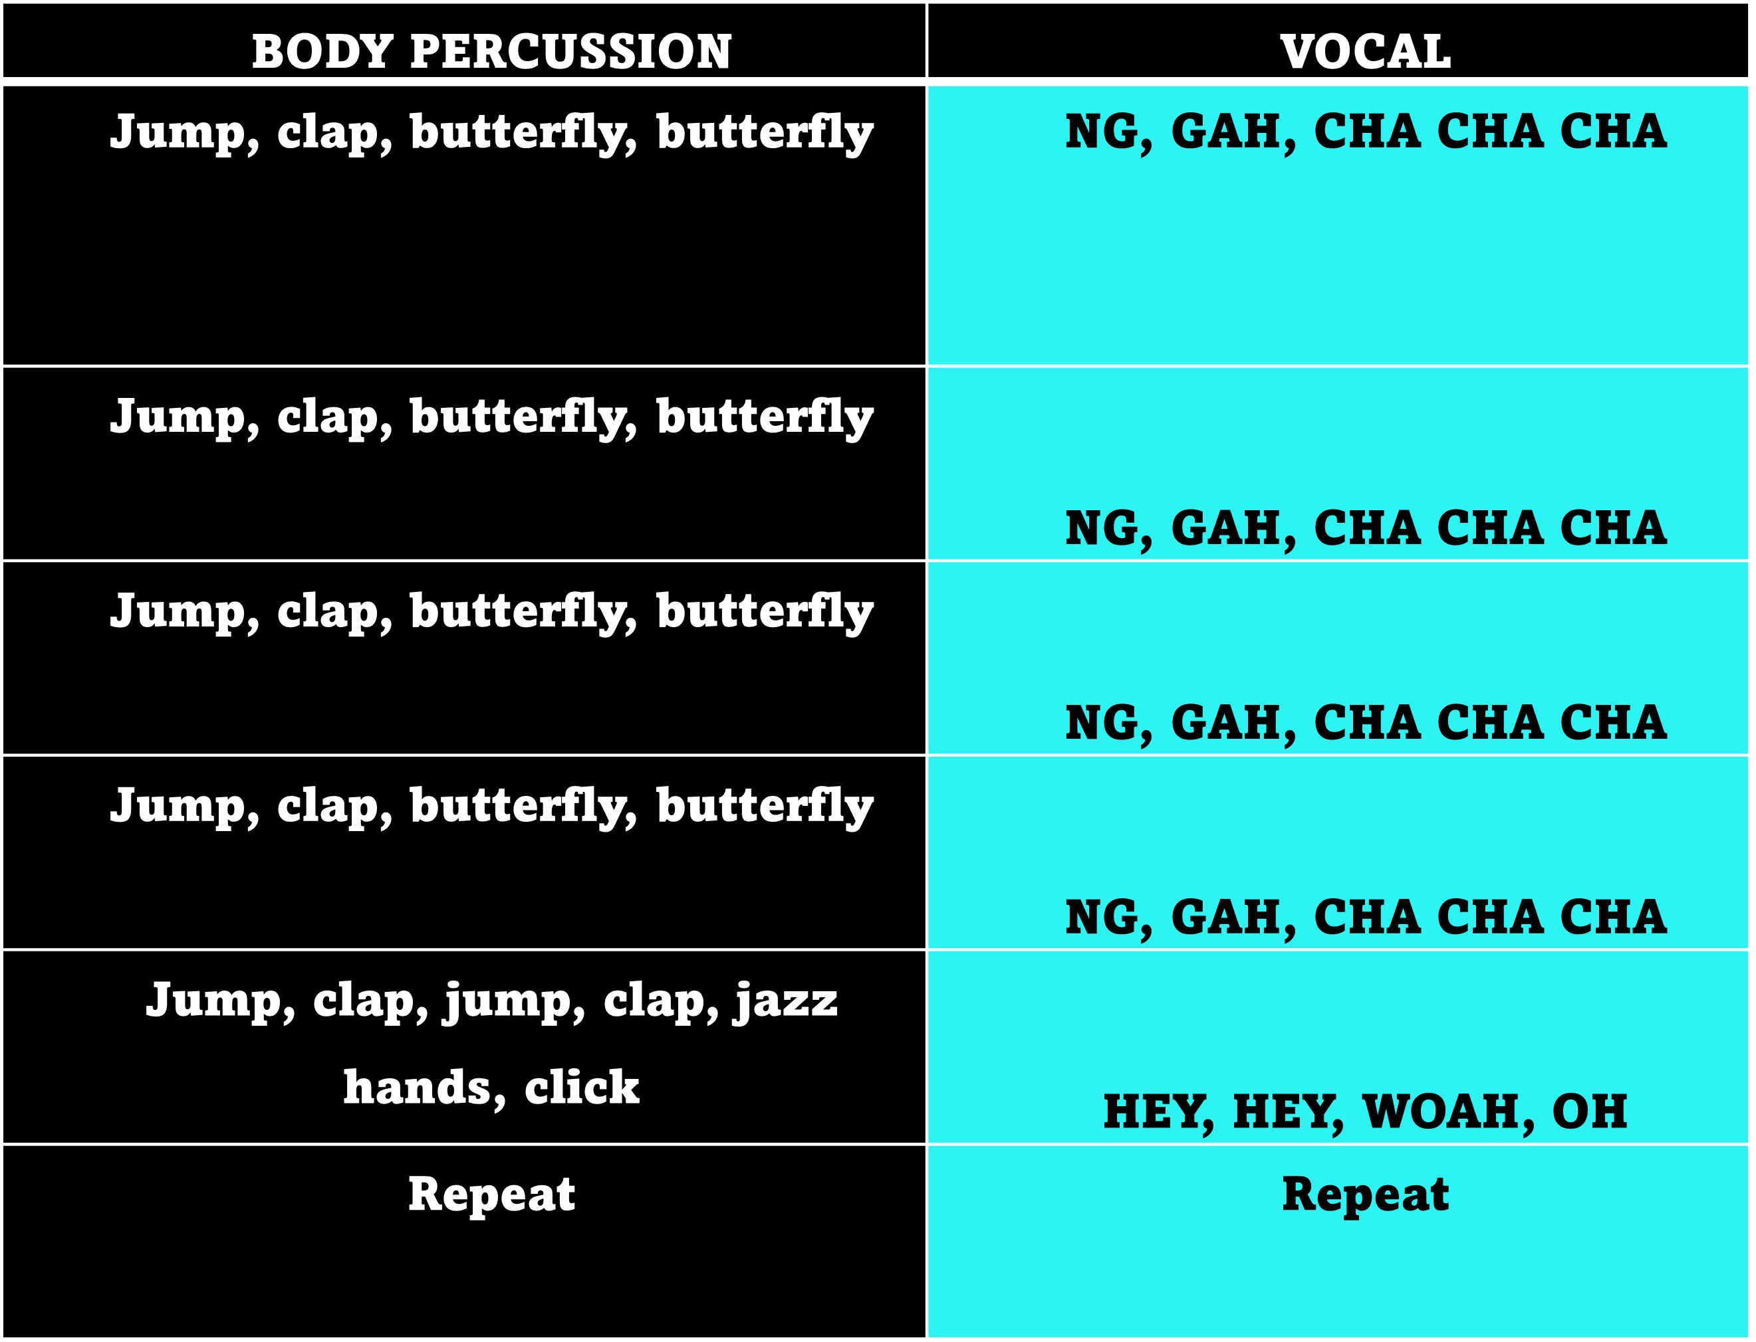

Figure 10 – Artefact: Teacher guide – Body Percussion

I have used the aforementioned vocal and musical training methods and approaches in addition to some of my favourite tried-and-tested vocal warm-ups. For example, I have adapted well-known musical passages from earlier songs to produce vocal warm-ups. In addition to this, I have included popular songs from the current Spotify charts. I've added body percussion, twang, and SOVT, as well as harmony options for both higher and lower pitched singing. Designing a singing program artefact that evokes familiarity (Winet et al., 2023), despite its newness, is uniquely innovative and considers both the adolescent learner and the adult teacher.
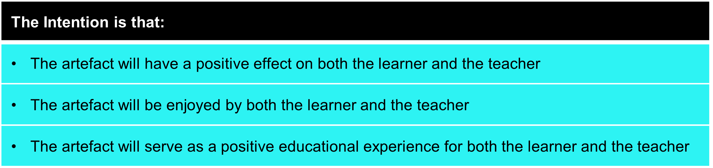

Positive reinforcement: It is imperative that all adolescent students who use my artefact, regardless of their level of experience or skill are included, creating an understanding community (Tamplin and Lee, 2013). In all exercises within my artefact, I have provided a variety of pitch alternatives and emphasised that students should only sing pitches that they are comfortable with. I've urged the teachers running the sessions to compliment students throughout the lesson rather than focussing on critique. Adolescents are more likely than adults to suffer anxiety and depression when they receive negative feedback, and they tend to expect minimal praise (Sebastien et al., 2010; Somerville, 2013). Singing sessions will be fun and inspiring using active teaching methods whereby the students and teachers can participate in a way which helps them to feel involved without fear of judgement (Sweet, 2019; Roberts, 2019). The sessions encourage positive reinforcement and praise from the teachers leading the class and avoid criticism (see figure 11). I want everyone involved to feel valued and confident.
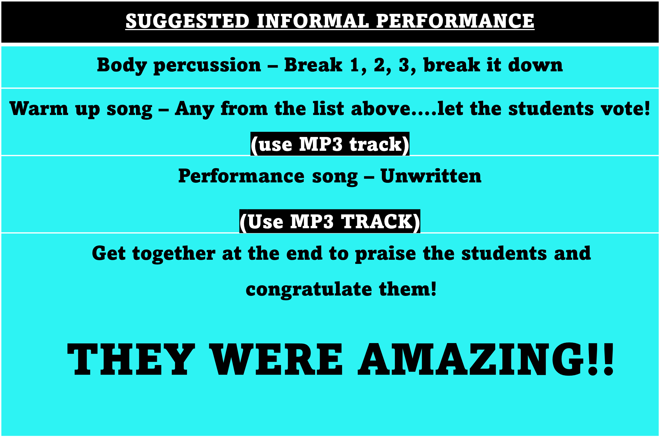

Figure 11- Artefact: Teacher guide - positive reinforcement

During the design phase of my artefact, I grew increasingly mindful of the time-consuming nature of content creation, including writing the teacher guides, composing vocal exercises, filming and editing. Hence, the instructional sessions and videos naturally evolved into a 7-week singing programme as opposed to an indefinite project with boundless videos and information. Based on my experience in a state school setting, I understand that a typical half term lasts 7 weeks; so, I envisioned the implementation of the singing programme at the commencement of a new term, culminating in an informal performance (see figure 12).

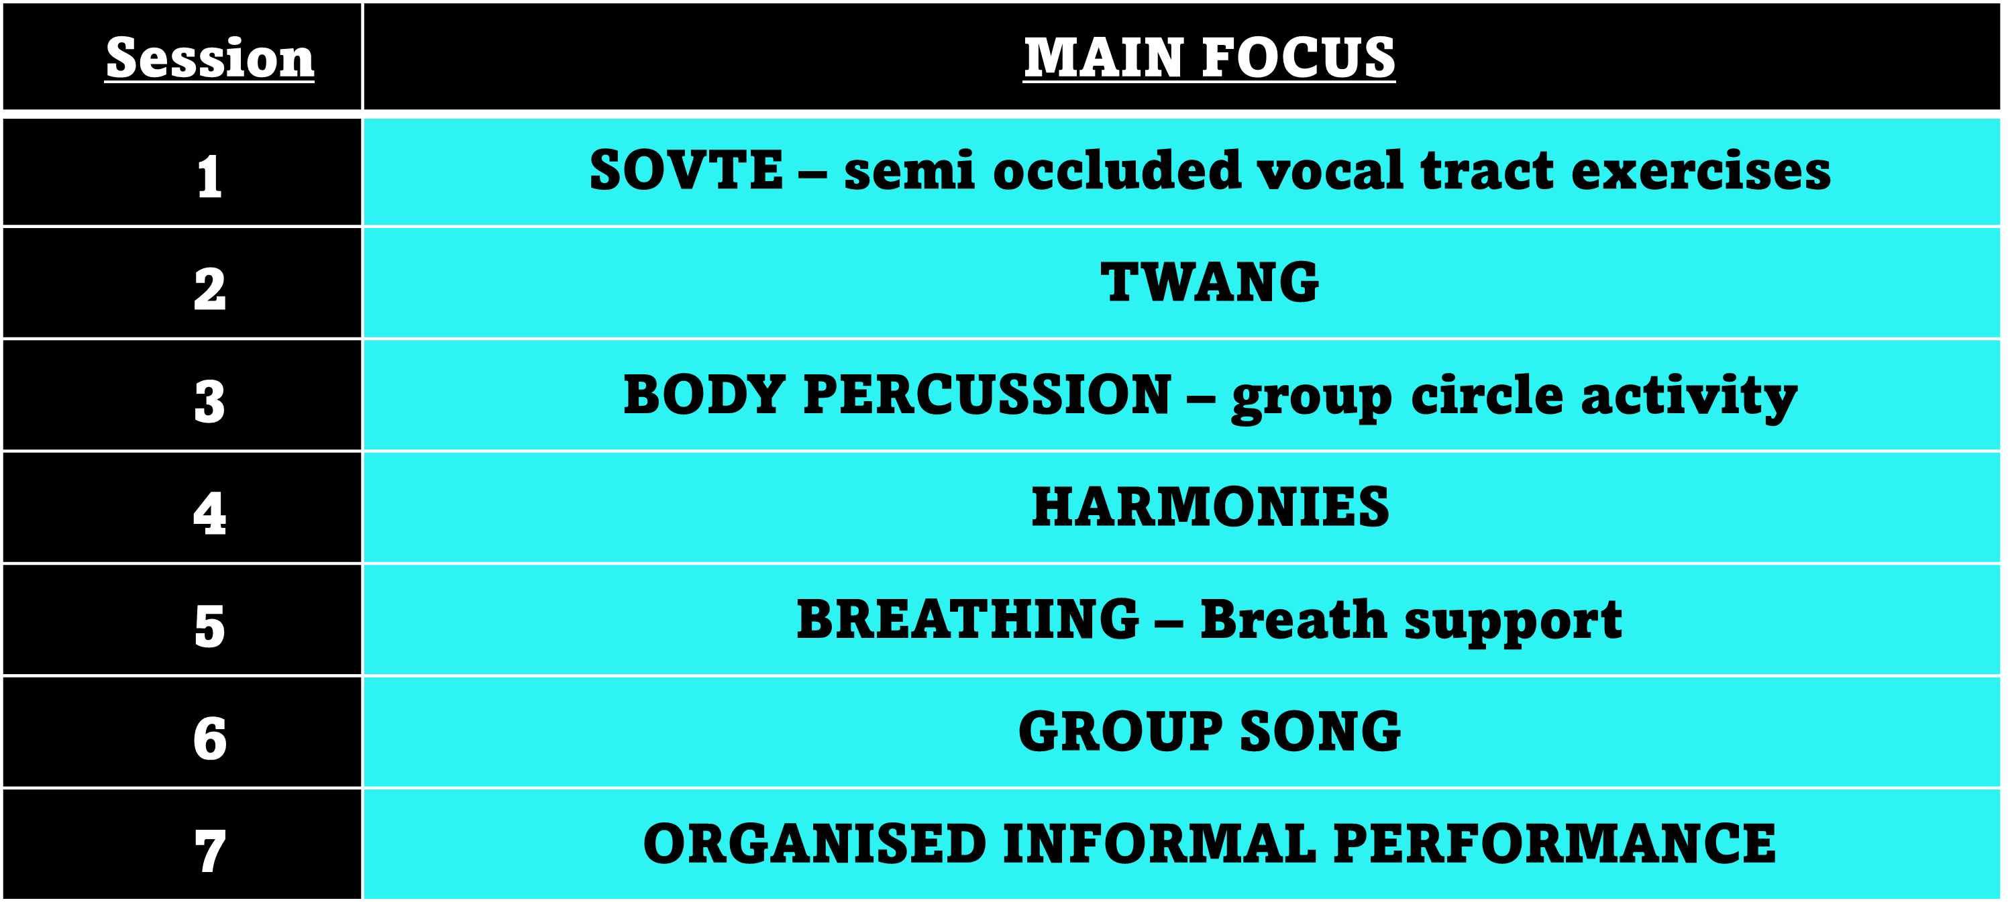

Figure 12 – Artefact: Teacher guide- 7-week plan.

Conclusion

The aim of my independent study was to create an artefact that could be used within state funded secondary schools to aid confidence in adolescent students. It is widely acknowledged that adolescents undergo significant mental and physical modifications, which can be stressful and may result in emotions of self-consciousness, including shame and embarrassment, ultimately leading to low levels of confidence (Tangney & Tracy, 2014; Griffin, 2017; Somerville, 2013; Sweet, 2019). I have seen these low confidence levels in my own students with many of my adolescent students sharing how they don’t sing at their secondary schools for fear of judgement, or quite simply because there isn’t any opportunity to sing. I have observed the beneficial impact of my own singing sessions with my adolescent pupils at my theatre school, which is what prompted my inquiry into finding out why such enjoyment and confidence building sessions via singing cannot be replicated in a state secondary school setting, or if it can, how it may be achieved.

Evidence suggests that singing is an effective way to learn, be creative and have fun in primary schools (Busse et al., 2021; Davis, 2017), yet this way of learning doesn’t follow suit in secondary education, with minimal singing programmes on offer to students due to music funding cuts and lack of time within the curriculum (musiciansunion.org.uk, 2021). My biggest hurdle during my research and artefact development was trying to produce something that would be easy to use for all teachers and was engaging whilst being advanced enough for the adolescent student. I am confident I have found the right equilibrium between user friendliness and suitability for the adolescent.

I am not technically minded, I don’t use ‘TikTok’, I rarely use ‘YouTube’ unless I need to learn how to do something, and I struggle using music apps to enable track creation such as ‘garage band’. 97% of adolescents use the internet daily and 95% of them have a smartphone (Zheluk et al., 2022). To a teenager or adolescent, I probably seem ancient and uncool, despite only being 34 years old. Thus, the idea of creating an artefact for use by adolescents who spend much of their time on social media and using smart phones felt daunting. I therefore decided to download TikTok to try and understand why it was so popular. Instantly I could appreciate why adolescents were addicted to the short video formats and challenges that were on offer to participate in. I even found myself taking part in vocal challenges to see if I too could accomplish them, however I did not post them for fear of judgement. Interestingly even I felt a wave of self-consciousness, consequently I started to appreciate the feelings of worry and embarrassment which adolescent students experience daily (Sweet, 2015). I was aware of the constraint that TikTok could not be used to create this specific artefact since it is not available on a laptop. However, YouTube can be shown on a school laptop that is connected to an interactive whiteboard, which is a feature that most schools offer, alternatively, it may be projected onto a screen in a school hall, reflecting my study’s aims and objectives by offering a viable solution to the problem. Hence, I have created a private YouTube channel which endeavours to include seven 15–30-minute singing sessions incorporating the much-loved TikTok feel. Alongside this, I have developed an easy-to-use teacher guide for the singing session facilitator. Introducing these weekly group singing sessions into high schools for adolescents, might potentially establish new routines and habits (Hawlader et al., 2022), which in turn may lead to confident adolescents who are not afraid to share their voices.

I am new to video editing, so looked at various apps and programmes alongside reviews highlighting ease of use, leading me to choose CapCut. I am sure like most things, editing becomes easier and quicker with practice, however, one 19-minute video took me 4 hours to make. Unfortunately, this meant I ran out of time to film and edit the other six planned singing sessions in the teacher guide. The editing experience enhanced my appreciation for the efforts of a social influencer who posts content regularly. They may either outsource or possess the time to directly design, film, and edit. Nonetheless, it is not viable for me presently whilst running a business and being a mother.

I am confident that the knowledge I have acquired during my research on diverse topics has been essential and advantageous for the advancement of my artefact. I am optimistic that my artefact could be implemented within state schools to inspire confidence in adolescent students, however one of the main contributing factors to the lack of music provision in state schools is under funding. Outsourcing video editing would incur significant costs, and this extra financial burden could deter schools from engaging in the singing programme. In the long term, a potential viable solution may be to enlist several schools to collectively share the expense. A modest monthly fee for access to instructional videos and plans may be attractive, supplemented by incentives like complimentary workshops to assure schools of their value for investment. This is something I plan to explore further and hope to initiate once my MA is complete.

References

Solvason, C., Allies, S., Hodgkins, A., Weston, R., & Malomo, M. (2023). ‘Occasionally there are moments of light’: the challenges of primary school teaching in England, and the factors that motivate teachers to stay in the profession. Education 3-13, 1–15. https://doi.org/10.1080/03004279.2023.2287547

Barlow, C.A. and Howard, D.M. (2002). Voice source changes of child and adolescent subjects undergoing singing training--a preliminary study. Logopedics Phoniatrics Vocology, 27(2), pp.66–73. doi:https://doi.org/10.1080/140154302760409284.

Bath, N., Daubney, A., Mackrill, D. and Spruce, G. (2020). The declining place of music education in schools in England. Children & Society, 34(5), pp.443–457. doi:https://doi.org/10.1111/chso.12386.

Bell, J. (2005). Doing Your Research Project: a Guide for first-time Researchers in education, health and social science. 4th ed. Berkshire: Open University Press.

Bell, J. and Waters, S. (2018). Doing Your Research Project : a Guide for first-time Researchers. 6th ed. Maidenhead: Mc Graw-Hill - Open University Press.

Busse, V., Hennies, C., Kreutz, G. and Roden, I. (2021). Learning grammar through singing? An intervention with EFL primary school learners. Learning and Instruction, 71, p.101372. doi:https://doi.org/10.1016/j.learninstruc.2020.101372.

Carretero-Martínez, A., Romero-Naranjo, F.J., Pons-Terrés, J.M. and Crespo-Colomino, N. (2014). Cognitive, Visual-spatial and Psychomotor Development in Students of Primary Education through the Body Percussion – BAPNE Method. Procedia - Social and Behavioral Sciences, 152, pp.1282–1287. doi:https://doi.org/10.1016/j.sbspro.2014.09.363.

Chapman, J.L. (2017). Singing and teaching singing : a holistic approach to classical voice. San Diego, Ca: Plural Publishing.

CLA (2024). CLA annual Report Card 2024 published today. [online] Cultural Learning Alliance. Available at: https://www.culturallearningalliance.org.uk/cla-report-card-published/.

Costley, C., Elliott, G. and Gibbs, P. (2010). Doing work based research: Approaches to enquiry for insider-researchers. London: Sage.

Davis, G.M. (2017). Songs in the young learner classroom: a critical review of evidence. ELT Journal, 71(4), p.ccw097. doi:https://doi.org/10.1093/elt/ccw097.

De Koning, B.B. and van der Schoot, M. (2013). Becoming Part of the Story! Refueling the Interest in Visualization Strategies for Reading Comprehension. Educational Psychology Review, 25(2), pp.261–287. doi:https://doi.org/10.1007/s10648-013-9222-6.

Freer, P.K. (2006). Hearing the Voices of Adolescent Boys in Choral Music: A Self-Story. Research Studies in Music Education, 27(1), pp.69–81. doi:10.1177/1321103x060270010501.

Gackle, L. (2014). Adolescent Girls’ Singing Development. The Oxford Handbook of Singing, pp.550–570. doi: https://doi.org/10.1093/oxfordhb/9780199660773.013.22.

Gillibrand, Lam, V., & O’Donnell, V.L. (2016). Developmental Psychology (2nd edition). Pearson.

GRD Journal for Engineering | Volume 2 | Issue 9 | August 2017 ISSN: 2455-5703 Active and Passive Learning: A Comparison Shreyasi Shubhendu Paul Assistant Professor Department of Information Technology SavitribaiPhule Pune University, PES’s Modern College of Engineering, Pune, Maharastra, India

Griffin, L., 2018. The Developing Teenage Brain. The Education Digest, 83(7), pp. 10-15.

Harris, & Westermann, G. (2015). A students’ guide to developmental psychology. Psychology Press. https://doi.org/10.4324/9781315867212
http://dx.doi.org/10.1016/j.peh.2015.09.003 2211-2669/© 2015 Elsevier Ltd. All rights reserved. T. Patston, M.S. Osborne / Performance Enhancement & Health 4 (2016) 42–49 43 and interpersonal aspects

Hobbiss, M.H. and Lavie, N. (2024). Sustained selective attention in adolescence: Cognitive development and predictors of distractibility at school. Journal of Experimental Child Psychology, [online] 238, p.105784. doi:https://doi.org/10.1016/j.jecp.2023.105784.

Jaudon, E. (2022). TikTok trends: How to find them and make them your own. [online] Bazaarvoice. Available at: https://www.bazaarvoice.com/blog/tiktok-trends-how-to/.

Kang, J. et al. (2019) ‘Comparing the Exposure-Response Relationships of Physiological and Traditional Vocal Warm-ups on Aerodynamic and Acoustic Parameters in Untrained Singers’, Journal of Voice, 33(4), pp. 420–428. Available at: https://doi.org/10.1016/j.jvoice.2017.12.019.

Lackmann, S., Léger, P.-M., Charland, P., Aubé, C. and Talbot, J. (2021). The Influence of Video Format on Engagement and Performance in Online Learning. Brain Sciences, 11(2), p.128. doi:https://doi.org/10.3390/brainsci11020128.

Laukkanen, A. M., Titze, I. R., Hoffman, H., & Finnegan, E. (2009). “Effects of a semioccluded vocal tract on laryngeal muscle activity and glottal adduction in a single female subject”. Folia Phoniatrica et Logopaedica, 60(6), 298–311. https://doi.org/10.1159/000170080

Lange, P. G. (2019). INTRODUCTION. In Thanks for Watching: An Anthropological Study of Video Sharing on YouTube (pp. 3–31). University Press of Colorado. http://www.jstor.org/stable/j.ctv2g5915d.4

Liebert, Robert M. ph.d. Effects of Television on Children and Adolescents. Journal of Developmental & Behavioral Pediatrics 7(1):p 43-48, February 1986. ‌

McCoy S. Your Voice: An Inside View. Princeton, NJ: Inside View Press;

Mccoy, S. (n.d.). Voice Pedagogy On Breathing and Support. In Journal of Singing (Vol. 70, Issue 3).

McGrew, E.D., 2015. Turning Toward Feeling. McGrew, Elizabeth D., "Turning Toward Feeling" (2015). SR & SC Masters Projects. Paper 2.
https://digitalcommons.wku.edu/srsc_sympres/2

Miller, S.A. (2022). Advanced Theory of Mind. Oxford University Press.
musiciansunion.org.uk. (2023). MU Outrage as Planned Cuts to Government Funding for Higher Education Arts and Music Confirmed. [online] Available at: https://musiciansunion.org.uk/news/mu-outrage-as-planned-cuts-to-government-funding-for-higher-education-arts-and-music-confirmed.

Muris, & Meesters, C. (2014). Small or big in the eyes of the other: on the developmental psychopathology of self-conscious emotions as shame, guilt, and pride. Clinical Child and Family Psychology Review, 17(1), 19–40. https://doi.org/10.1007/s10567-013-0137-z
Nelson, R. (2022). Practice as research in the arts (and beyond) : principles, processes, contexts, achievements. Cham: Palgrave Macmillan.

Pearce E, Launay J, DunbarRIM. 2015 The ice-breaker effect: singingmediates fast social bonding. R. Soc. open sci.2: 150221.http://dx.doi.org/10.1098/rsos.150221

Perta, K., Bae, Y. and Obert, K. (2021) “A pilot investigation of twang quality using magnetic resonance imaging,” Logopedics Phoniatrics Vocology, 46(2), pp. 77–85. Available at: https://doi.org/10.1080/14015439.2020.1757147.

Pinto, C., & Hijleh, K. (2021). “Realizing the Benefits of SOVTEs: A Reflection on the Research”. Journal of Singing, 77(3), pp.333-344. Available at: https://www.nats.org/_Library/JOS_On_Point/JOS_077_03_2021_333.pdf

Roberts, D. (2019). Higher education lectures: From passive to active learning via imagery? Active Learning in Higher Education, 20(1), 63-77. https://doi.org/10.1177/1469787417731198

Romero-Naranjo, A.A., Jauset-Berrocal, J.A., Romero-Naranjo, F.J. and Liendo-Cárdenas, A. (2014). Therapeutic Benefits of Body Percussion Using the BAPNE Method. Procedia - Social and Behavioral Sciences, 152, pp.1171–1177. doi:https://doi.org/10.1016/j.sbspro.2014.09.295.

Savage, J., & Barnard, D. (2019). The State of Play: A Review of Music Education in England 2019. Musicians' Union, Music Industries Association, Music for All, UK Music.

Smith, B. & Stataloff, R.T. (2003) choral pedagogy and vocal health journal of singing, 59, 233-240

Stegman, F.F. (2003) Choral warm ups: preparation to sing, listen and learn. Music educators journal, 89, 37-58.

Steinhauer, K., Mary Mcdonald Klimek and Estill,J. (2017). The Estill voice model: theory et translation. Pittsburgh Estill Voice International.

Sundberg, J., & Thalén, M. (2010). “What is “twang”?”. Journal of Voice, 24(6), 654–660. https://doi.org/10.1016/j.jvoice.2009.03.003.

Sukhanova, K. (2023). Spotify Statistics 2024: User Demographics, Growth Rate, and Revenue Breakdown. [online] The Tech Report. Available at: https://techreport.com/statistics/entertainment/spotify/.

Sweet, B. (2015). “The Adolescent Female Changing Voice”. Journal of Research in Music Education, 63(1), pp.70–88. Available at: https://doi.org/10.1177/0022429415570755.

Sweet, B. (2018). “Voice Change and Singing Experiences of Adolescent Females”. Journal of Research in Music Education, 66(2), pp.133–149. Available at: https://doi.org/10.1177/0022429418763790.

Sweet, B. (2019). Thinking Outside the Voice Box. Oxford University Press.

Tangney, J. P, & Tracy, J.L. (2014) Self-conscious emotions. In M.R.Leary, &J.P Tangney, Handbook of self and identity, second edition.

Tangney, Miller, R. S., Flicker, L., & Barlow, D. H. (1996). Are Shame, Guilt, and Embarrassment Distinct Emotions? Journal of Personality and Social Psychology, 70(6), 1256–1269. https://doi.org/10.1037/0022-3514.70.6.1256

TED2012. (2012, March). Berné brown. listening to shame [video]. TedTalks. Available from:https://www.ted.com/talks/brene_brown_listening_to_shame?utm_campaign=tedspread&utm_medium=referral&utm_source=tedcomshare

Titze, I. (2018). “Major Benefits of Semi-Occluded Vocal Tract Exercises”. Journal of Singing, 74(3), pp. 311-312. Available at: https://www.questia.com/library/journal/1P4-1985135567/major-benefits-of-semi-occluded-vocal-tract-exercises.

Titze, I.R. (2001). “Acoustic Interpretation of Resonant Voice”. Journal of Voice, 15(4), pp.519–528. Available at: https://doi.org/10.1016/s0892-1997(01)00052-2.

Whittaker, A., Conservatoire, R. and Fautley, M. (2021). A-level music decline and disadvantage attainment gaps. [online] Available at: https://bcuassets.blob.core.windows.net/docs/a-level-report-290621-pdf-132695100641559063.pdf.

Winet, Y.K. and O'Brien, E., 2023. Ending on a familiar note: Perceived endings motivate repeat consumption. Journal of Personality and Social Psychology, 124(4), p.707.

Zheluk AA, Anderson J, Dineen-Griffin S. Adolescent Anxiety and TikTok: An Exploratory Study. Cureus. 2022 Dec 14;14(12):e32530. doi: 10.7759/cureus.32530. PMID: 36654625; PMCID: PMC9840731

ARTEFACT PART 1
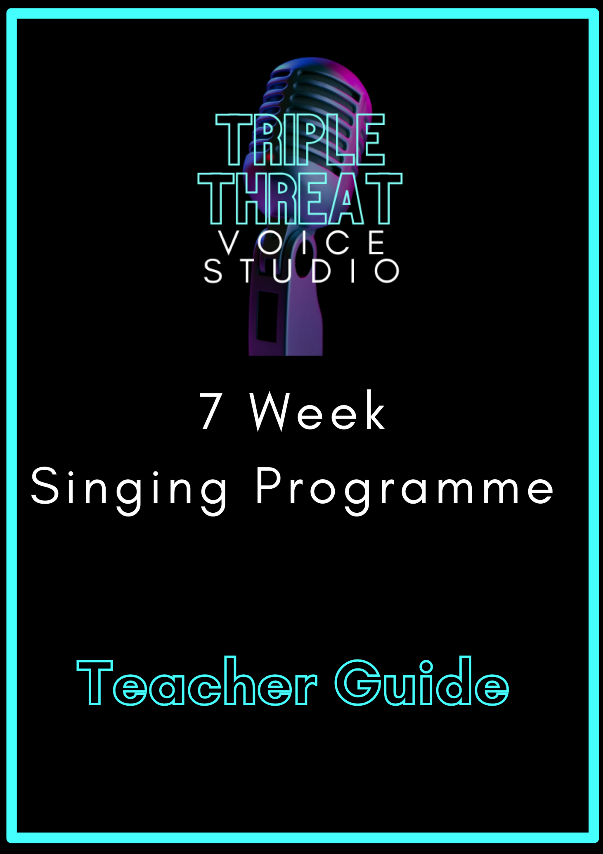

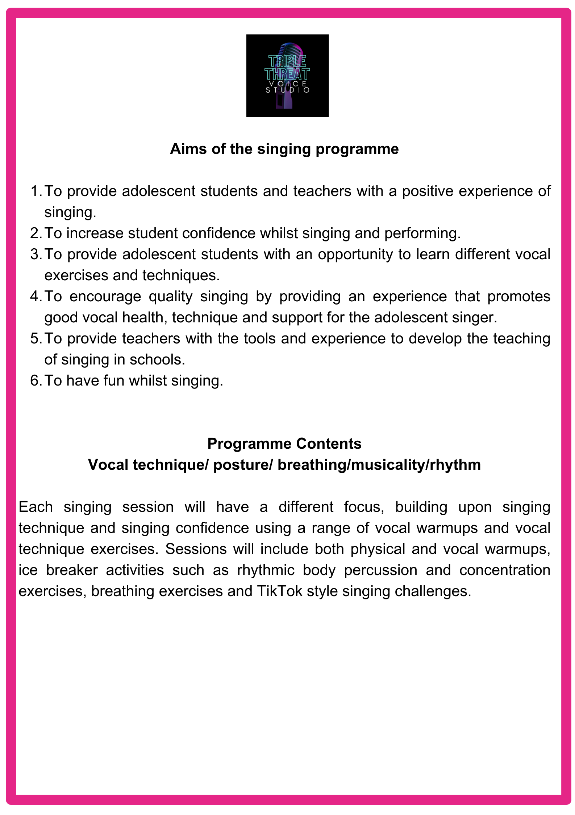

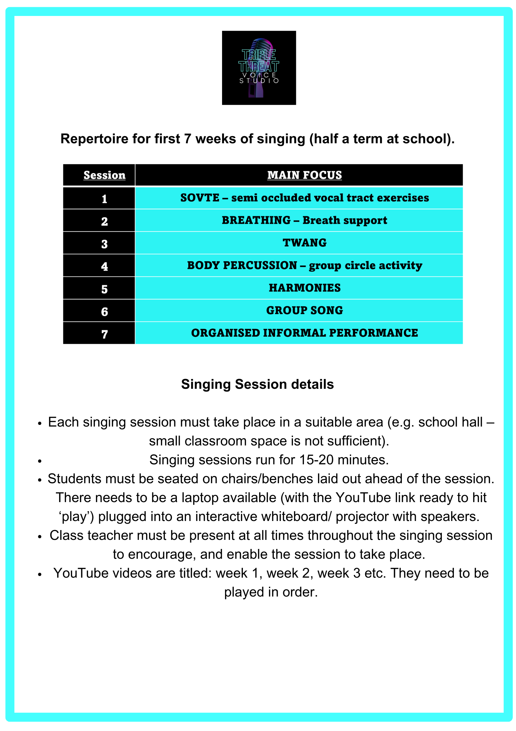

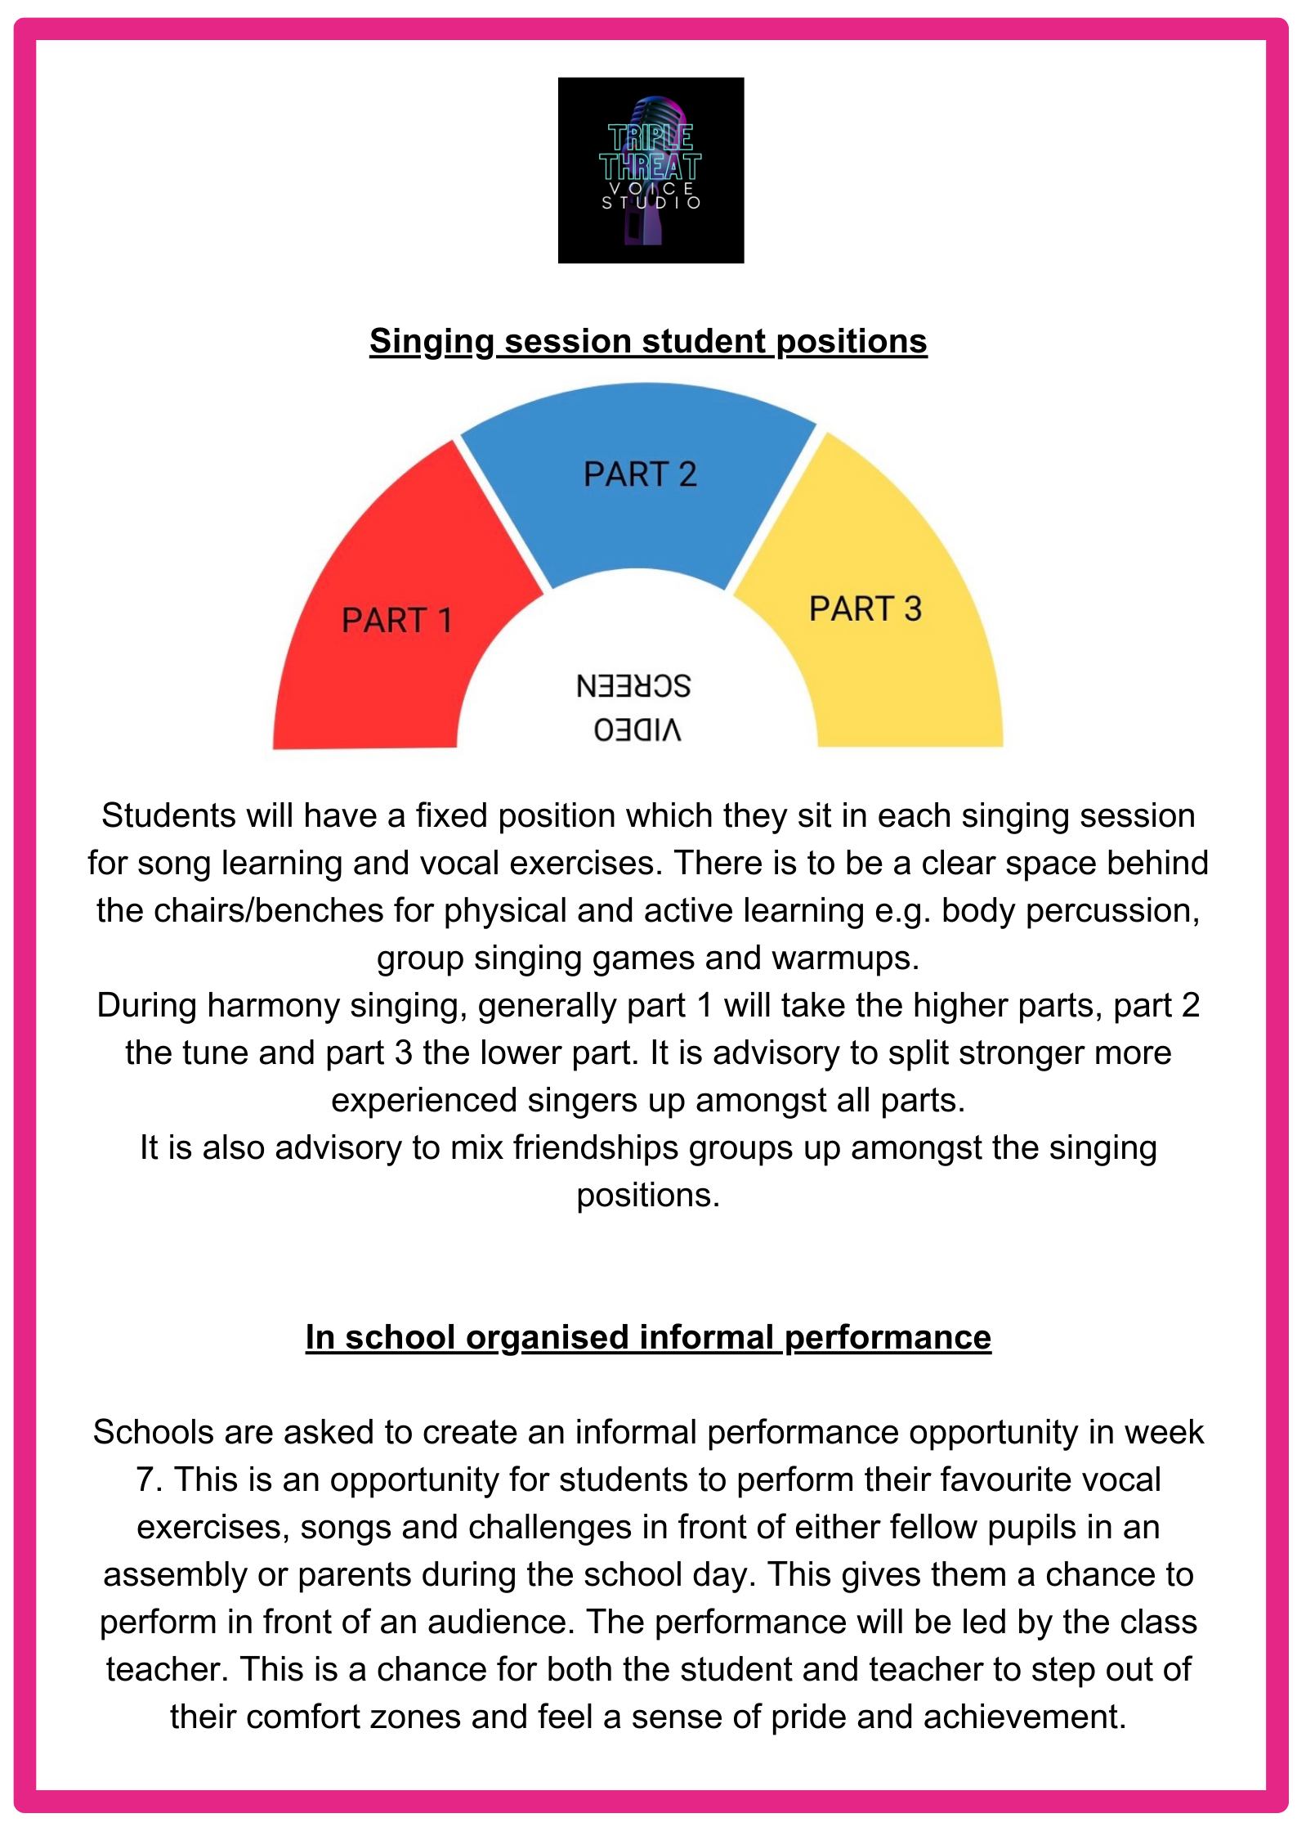

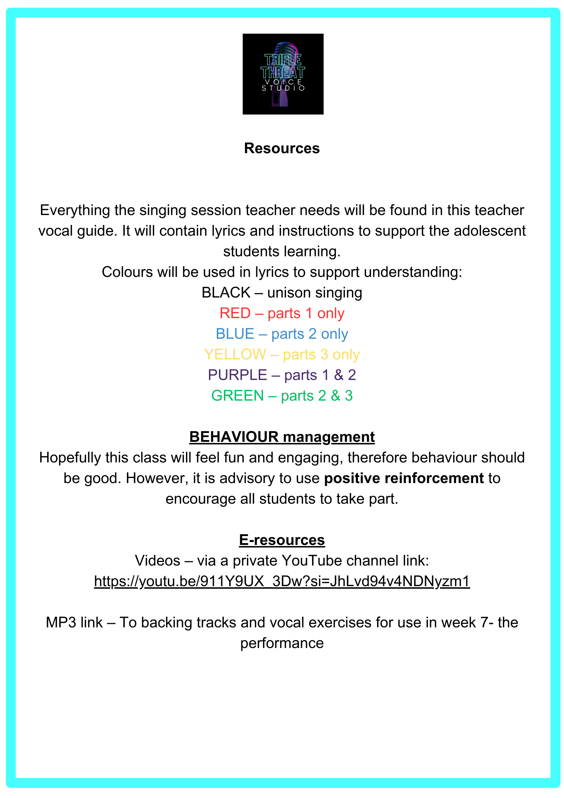

https://youtu.be/911Y9UX_3Dw?si=T0sDLK8tBBHicv_

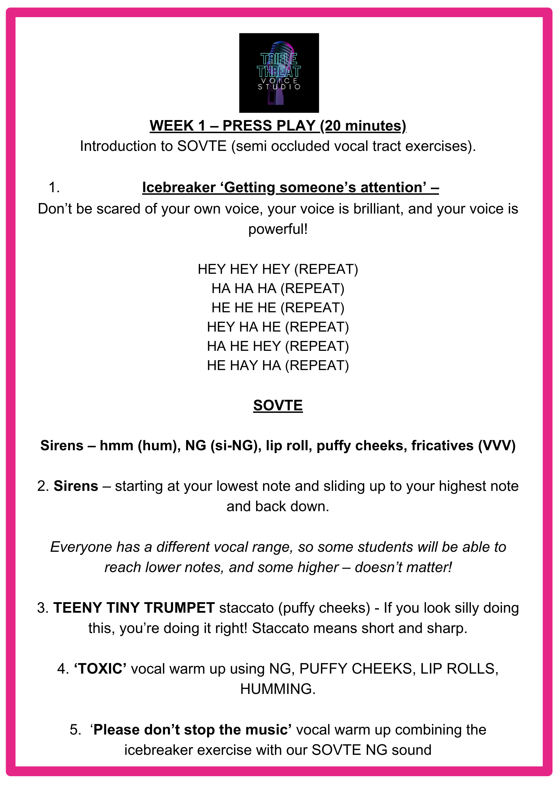

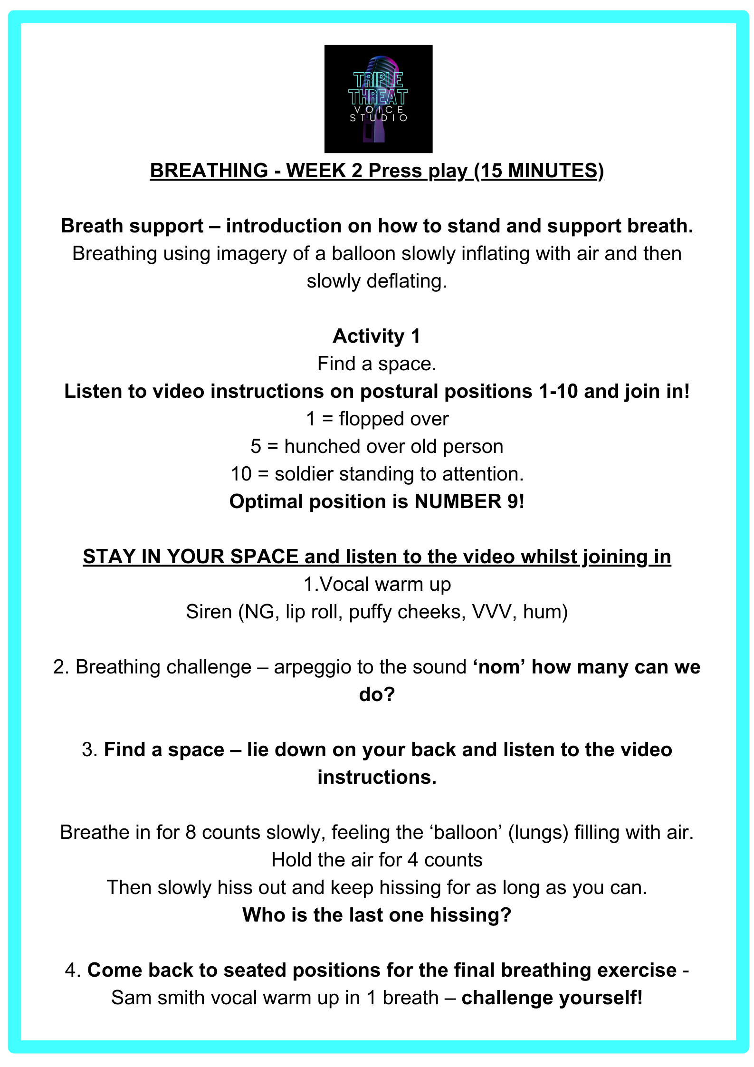

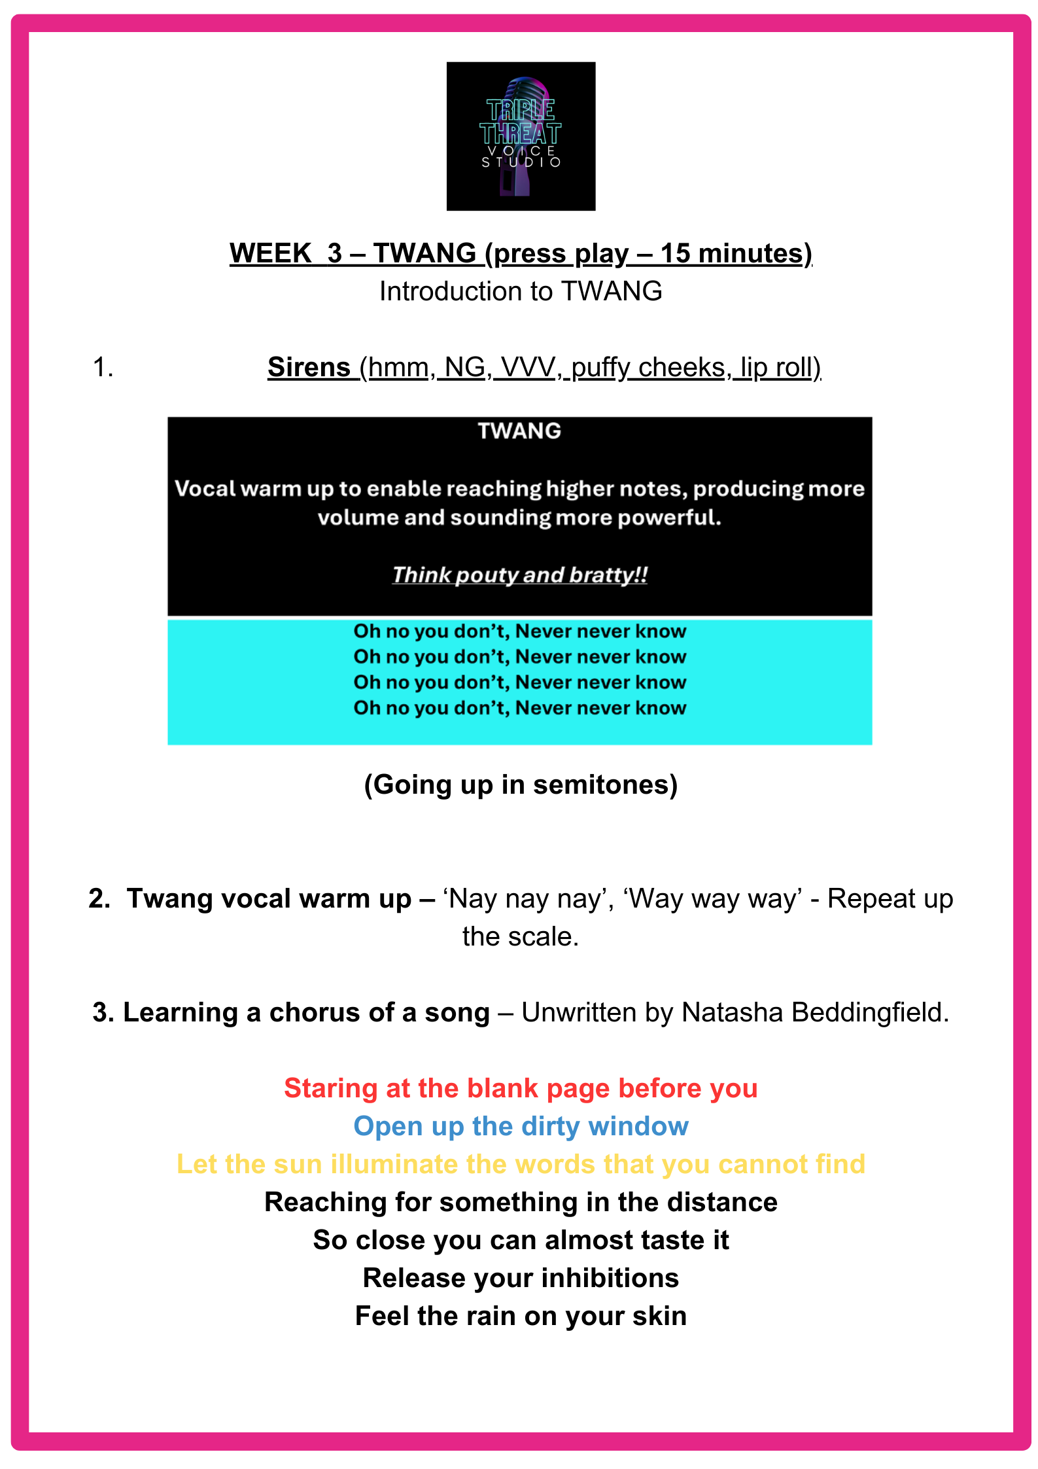

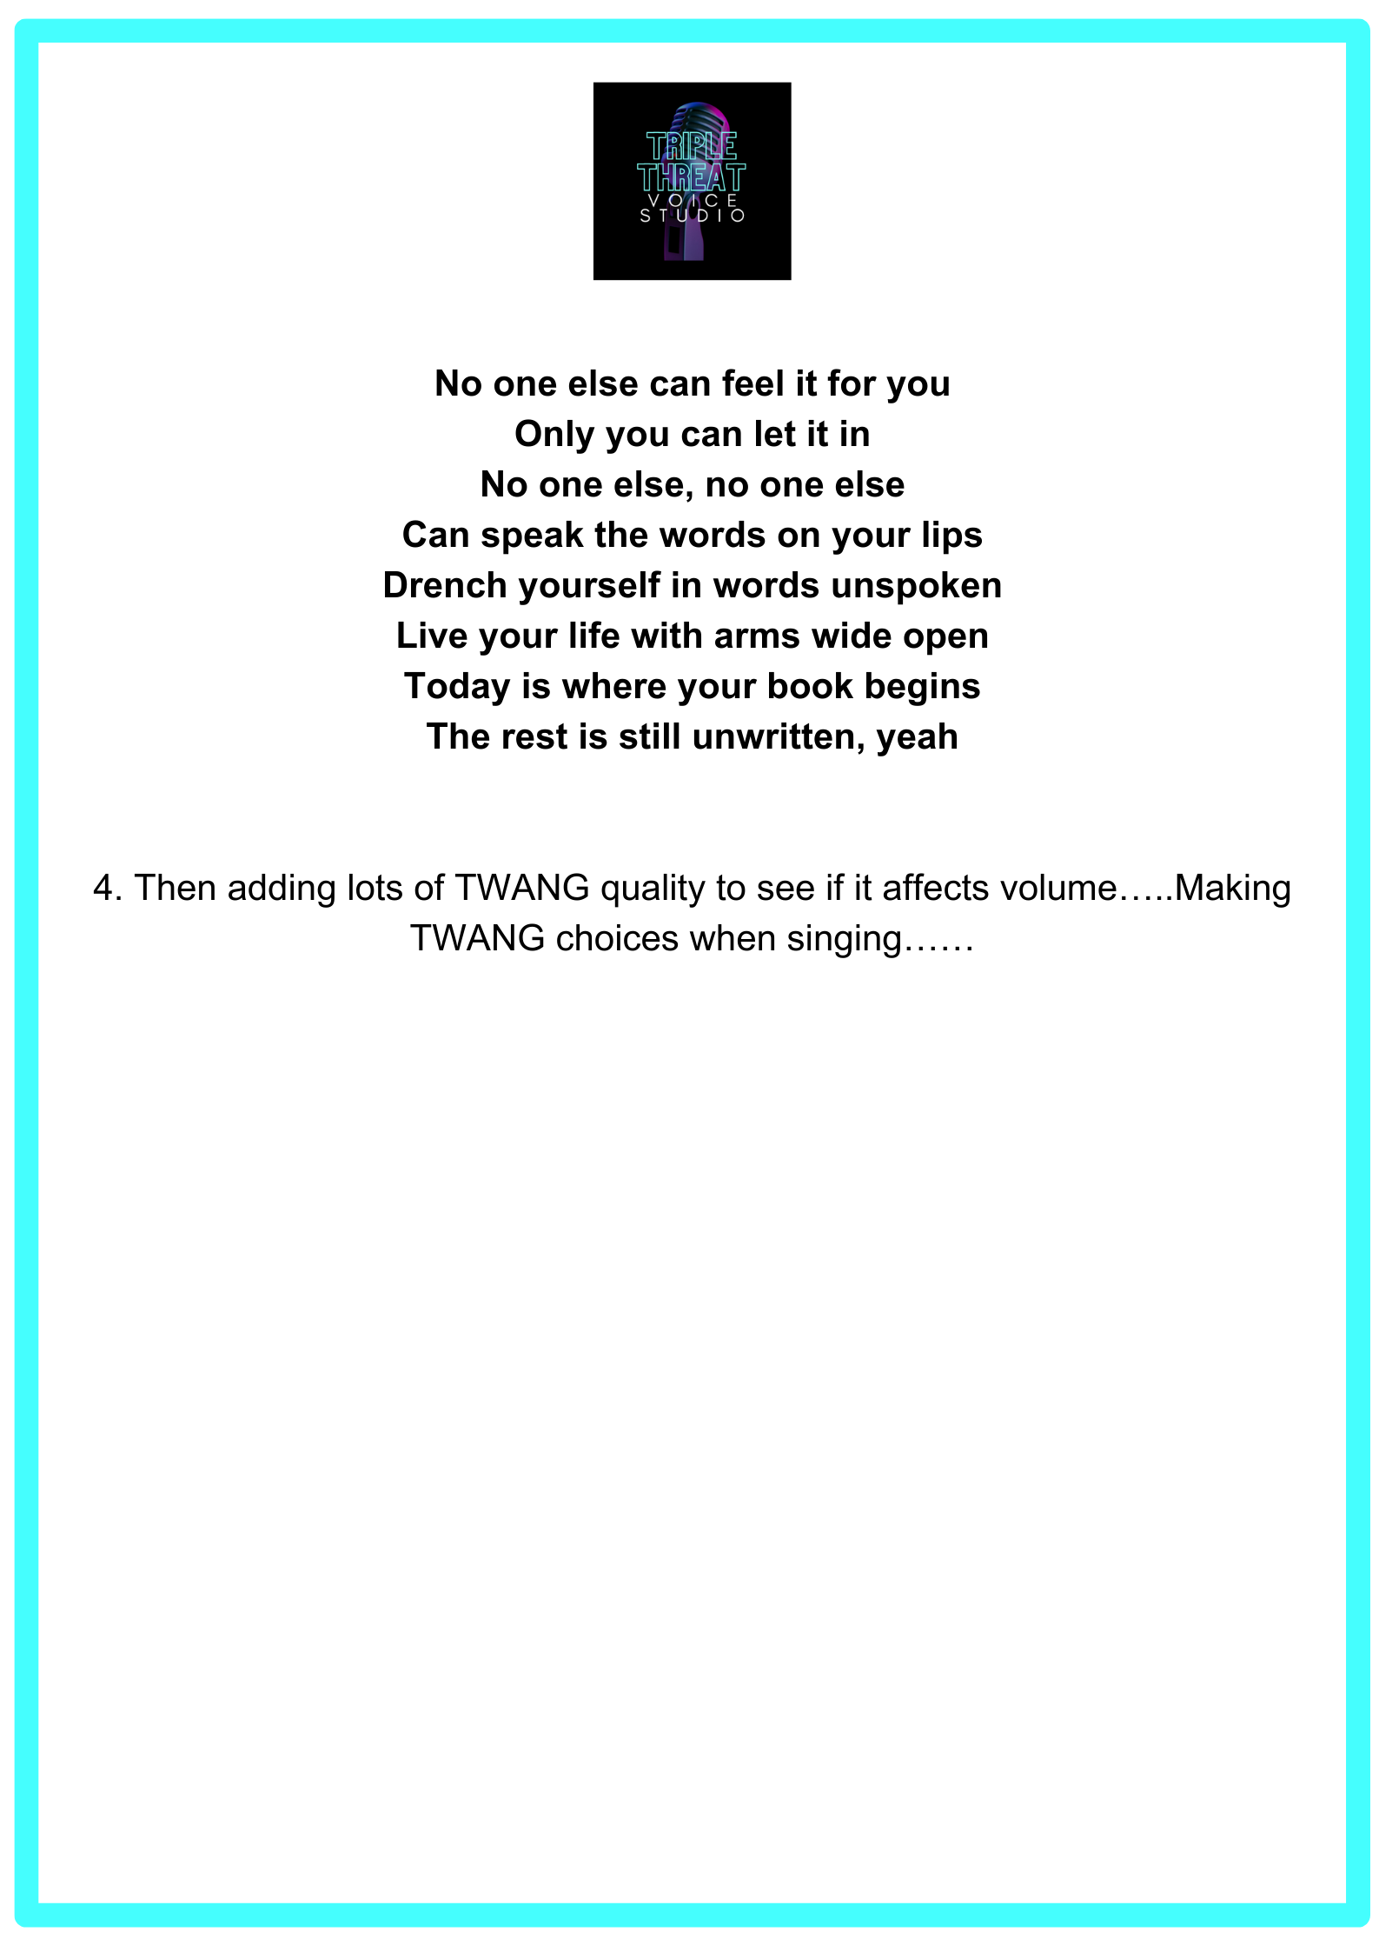

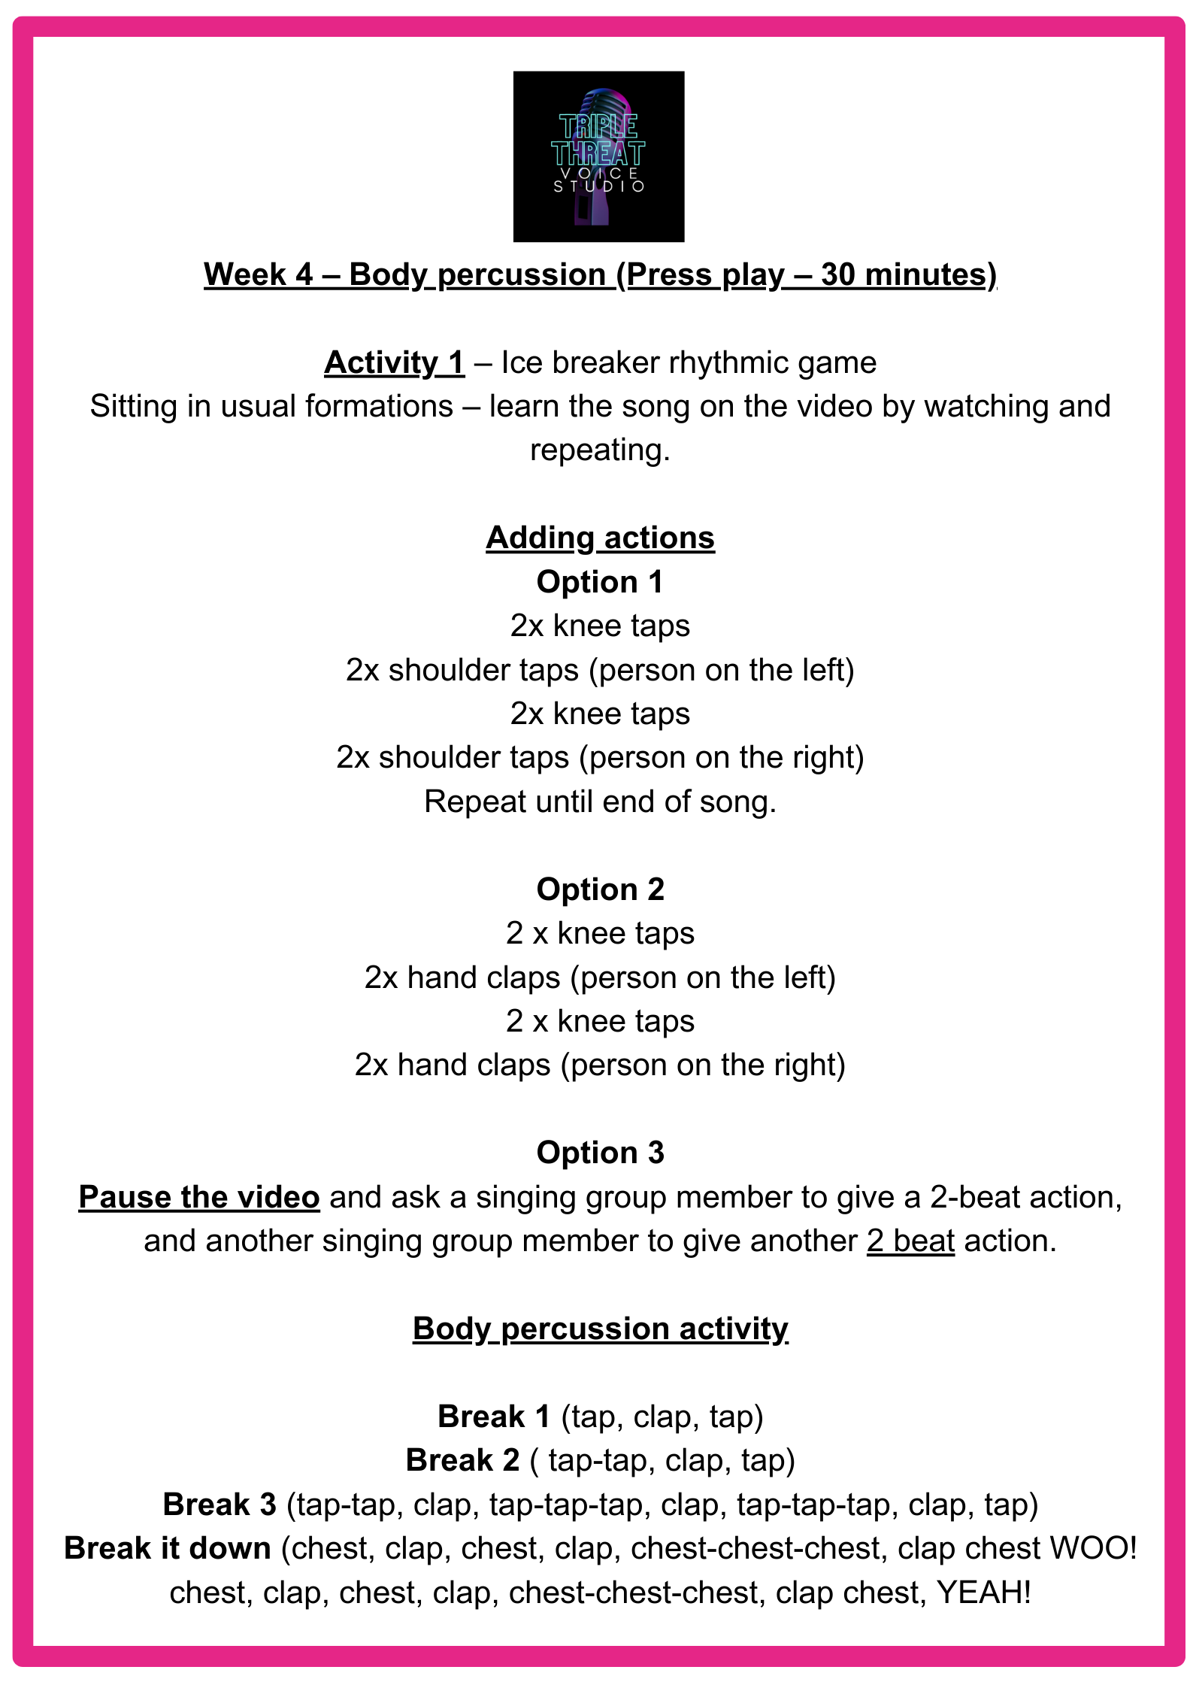

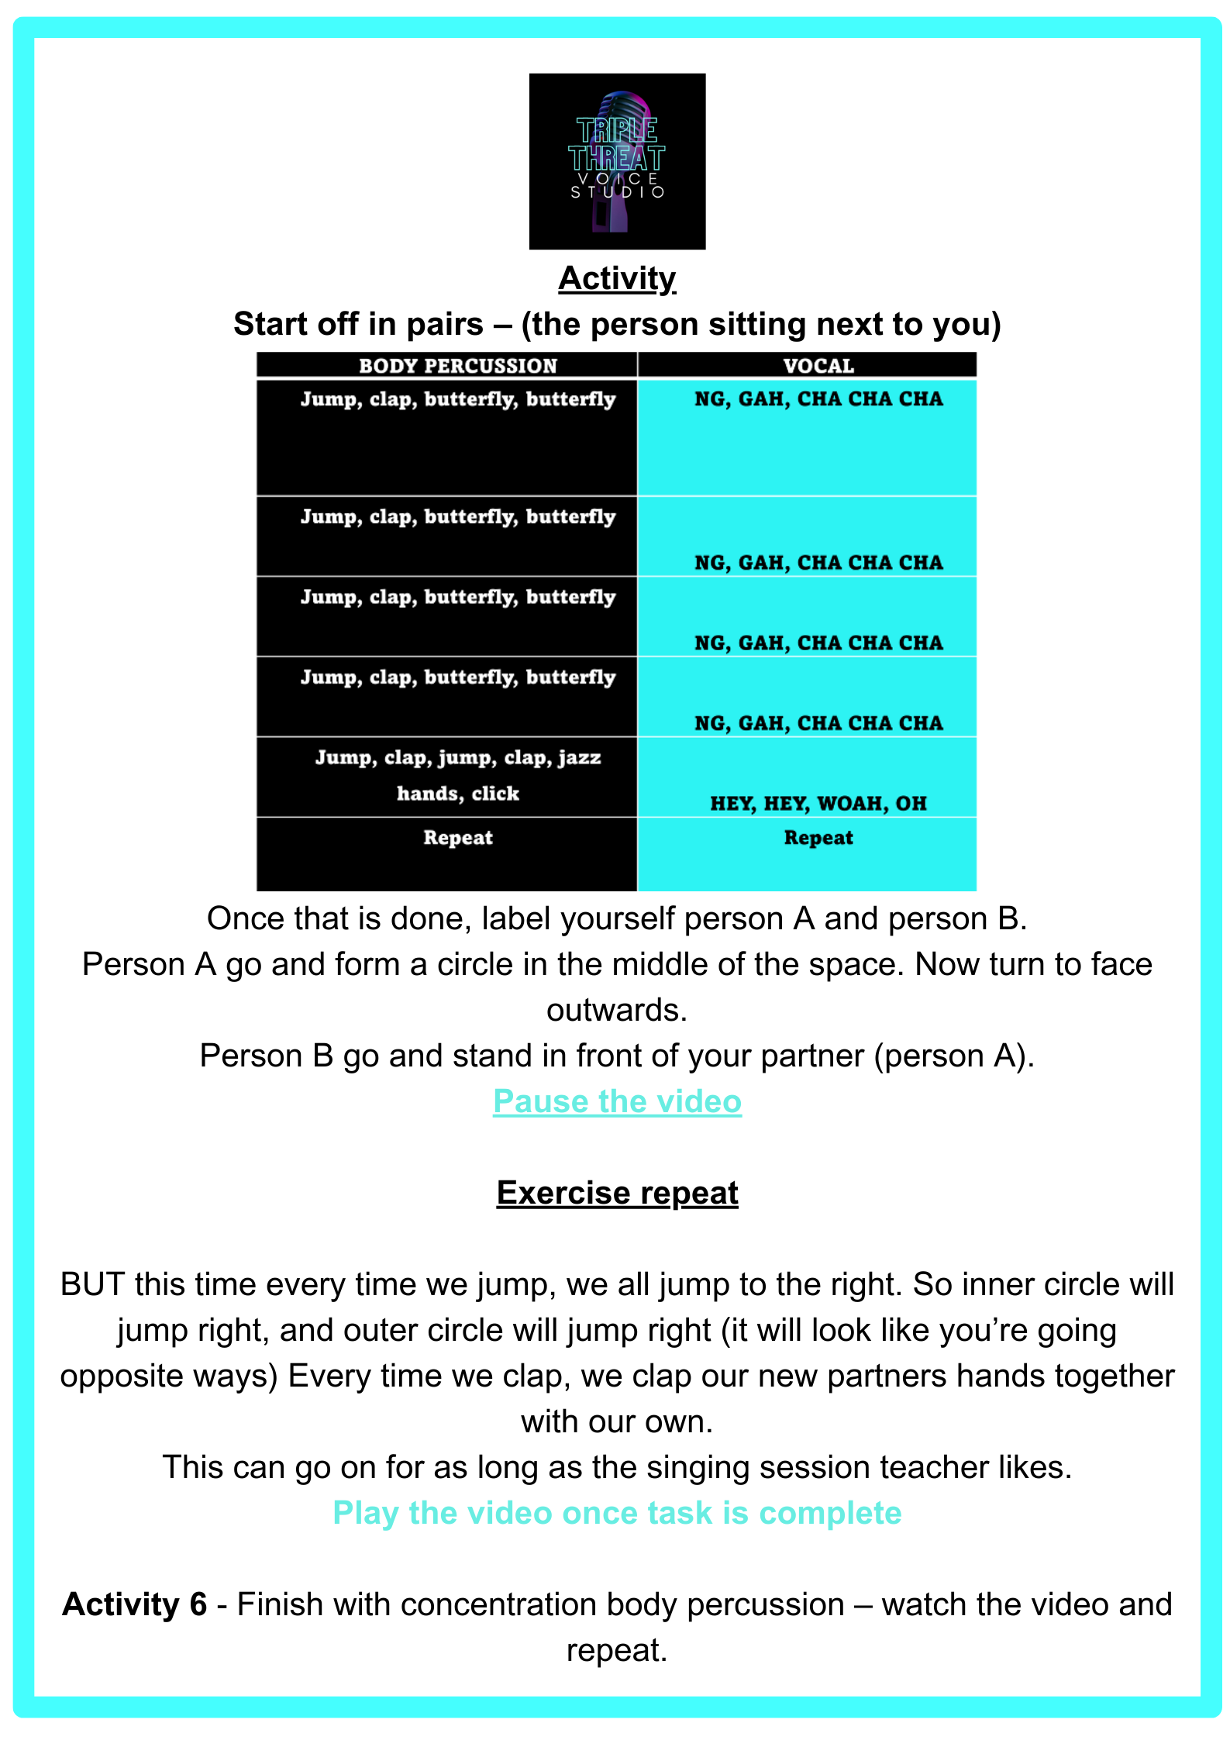

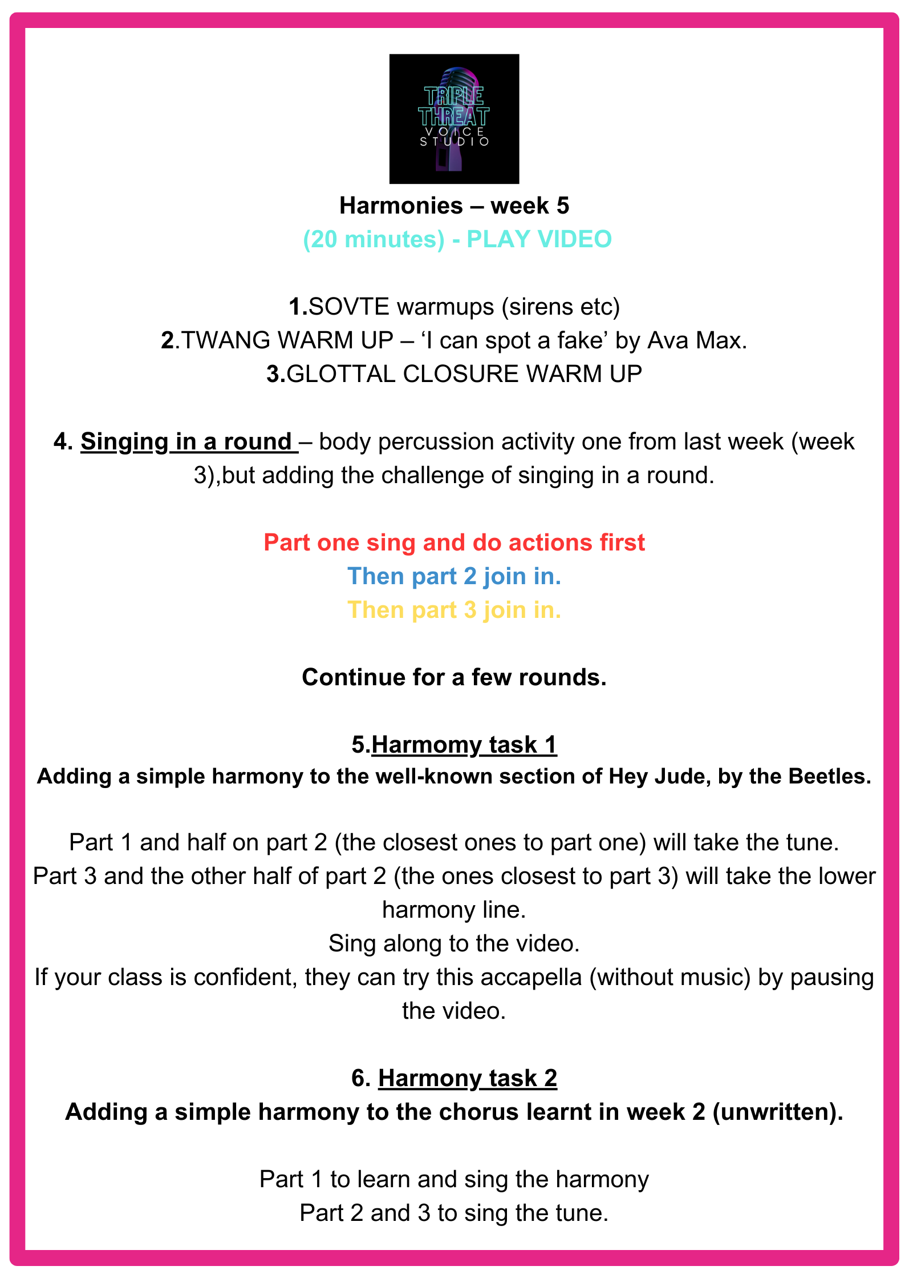

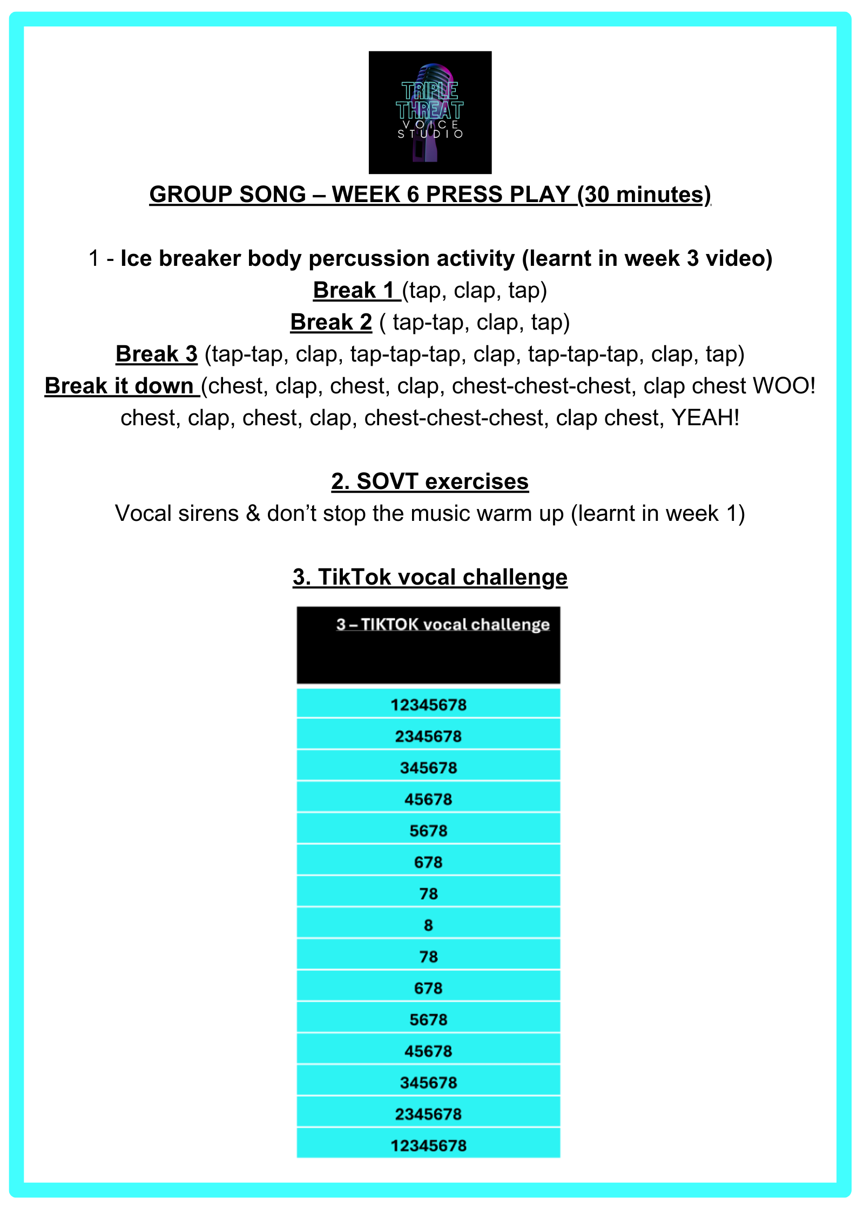

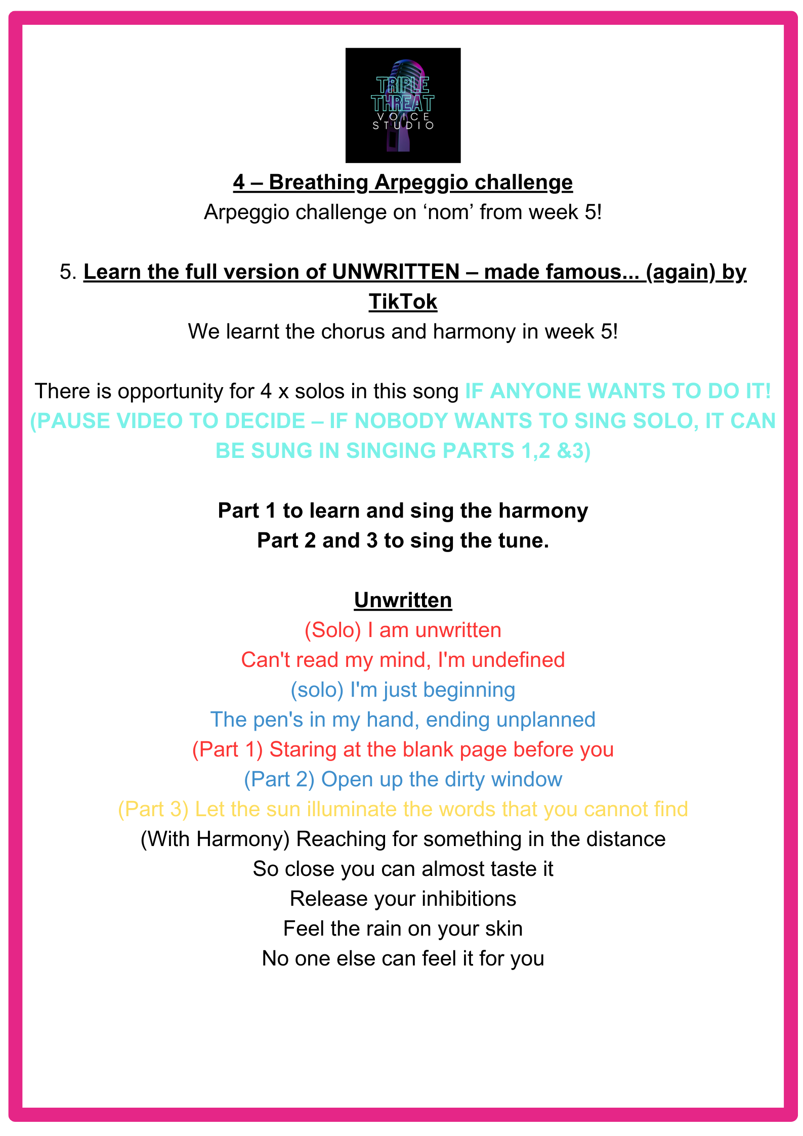

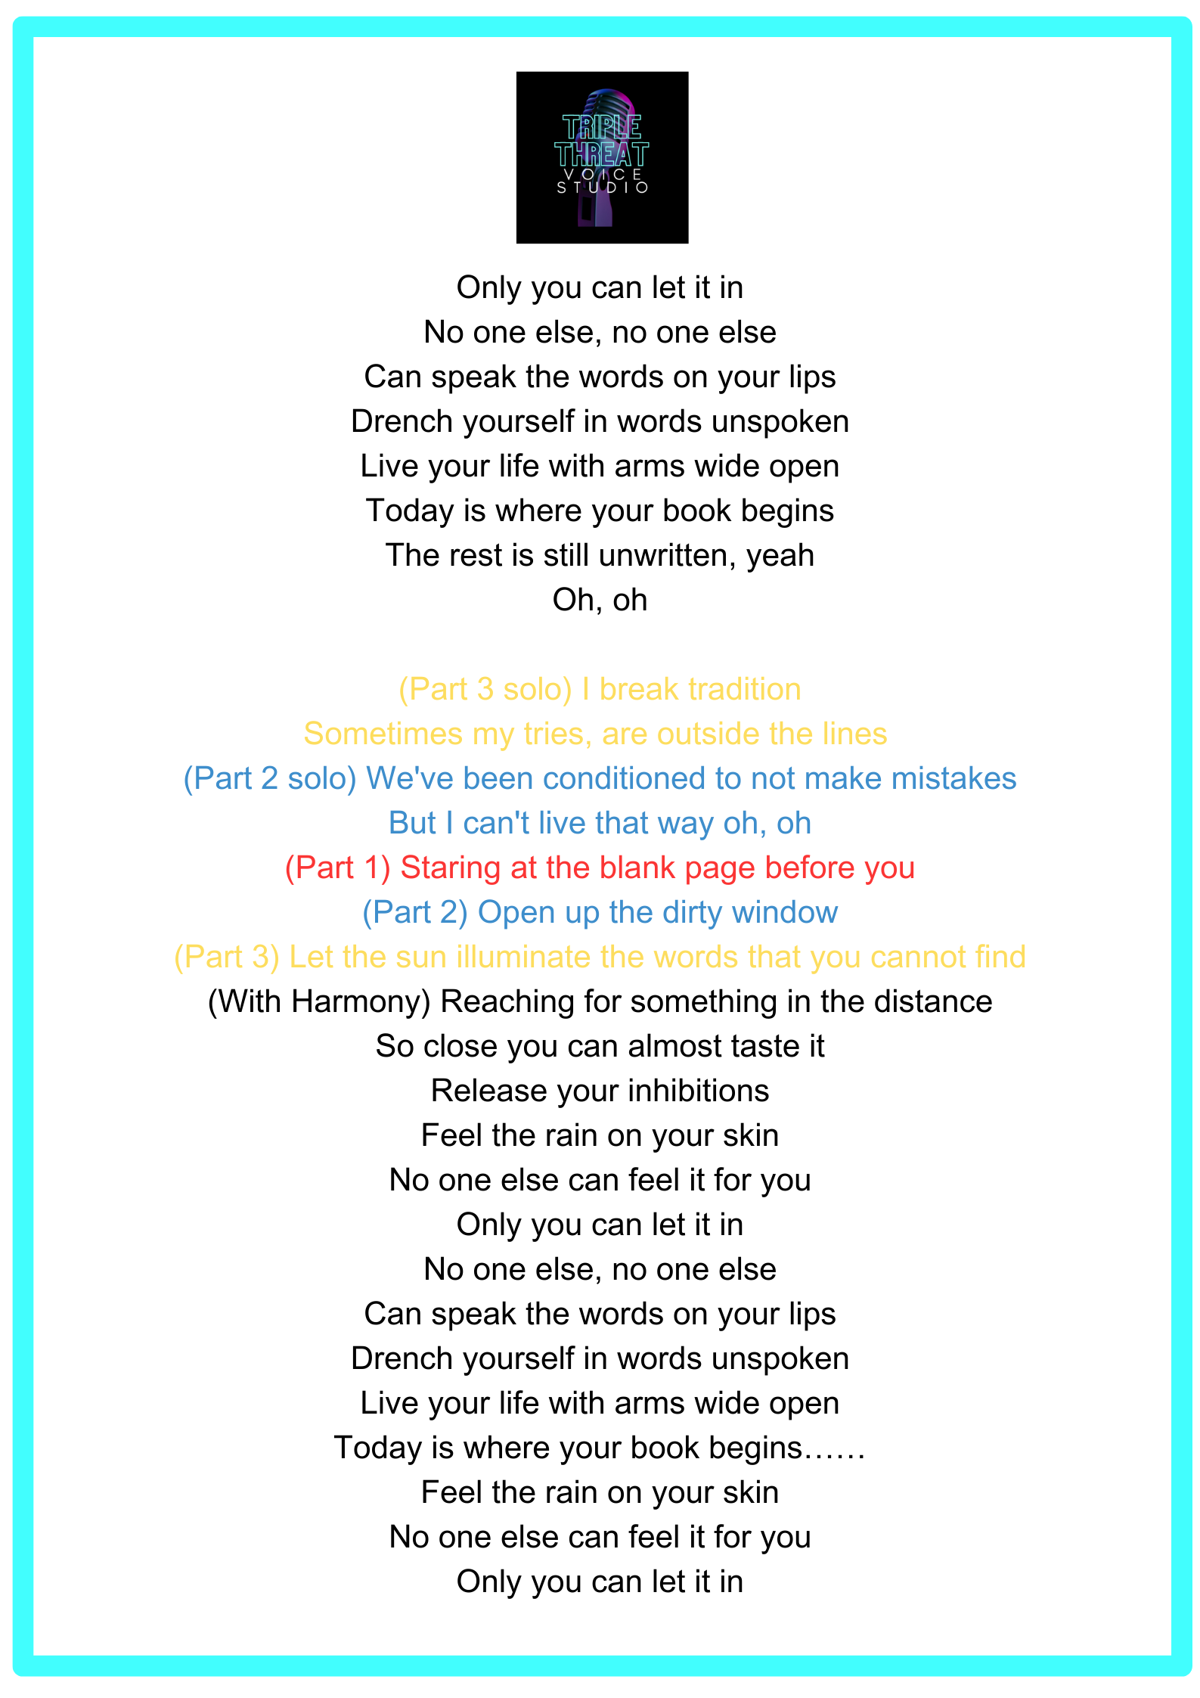

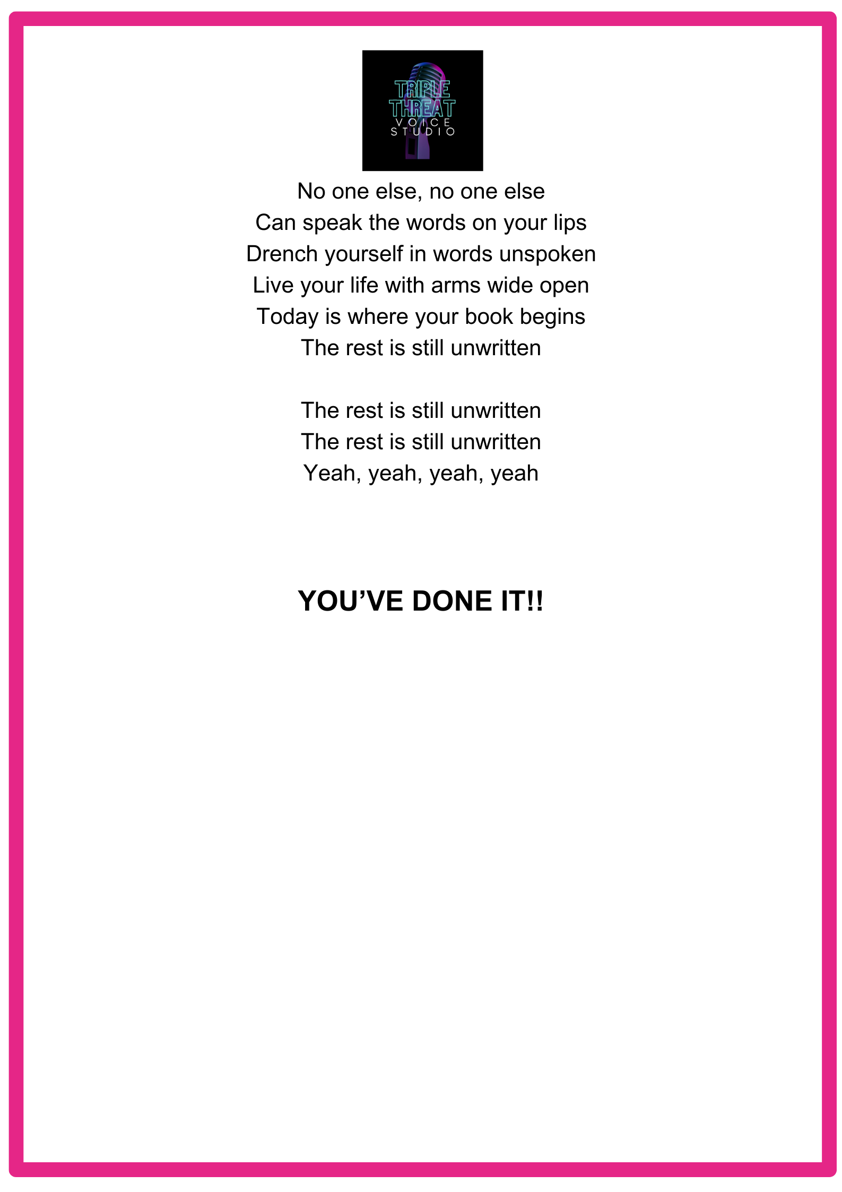

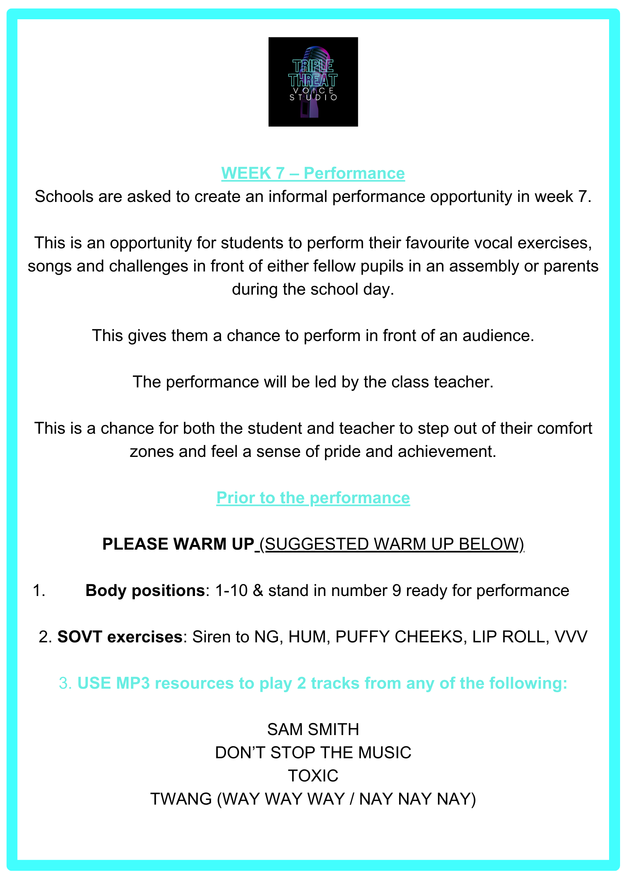

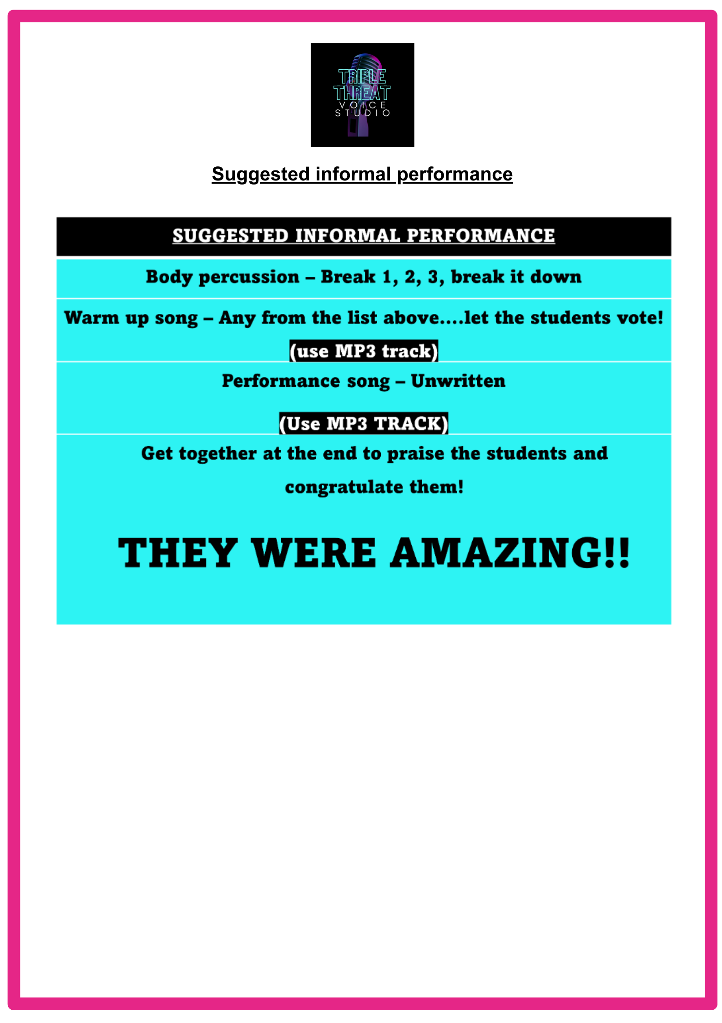

Artefact part 2

YouTube week 1 video link: https://youtu.be/911Y9UX_3Dw?si=JhLvd94v4NDNyzm1

Appendix

Week 1 YouTube video plan and speech

Do you ever feel nervous or self-conscious when you sing in front of others? Do you ever think, Gosh, I wish I could be a better singer, or sing louder, or have more control over my own voice? Or do you ever think….My voice doesn’t sound or feel right anymore…Or maybe your voice feels really tired and sore after singing for just 5 minutes and you think …Oh man, I’m loosing my voice”…..

I’ve got a secret for you…..You do have a good voice, and you deserve your voice to be heard!

My name’s Emily and I run Triple Threat voice studio. An online singing studio where we help transform, shy and self-consciousness secondary school students into confident and proud singers who enjoy singing together.

I’m not going to lie! I too was a self-conscious adolescent once upon a time shying away from singing or speaking in public. But I’m here to help show you how singing can enhance your confidence and bring joy to your senior school experience.

I know teenagers and adolescents can get a bad rep!! But I’ve been working with adolescents for over 13 years, and I know you guys are not the difficult, awkward, rude people that are stereotypically depicted on your TV screens.

If you can trust me over the next 6 weeks of singing sessions and really go for it in class, I promise you, you will start to enjoy singing, you will feel more connected to your year group and you will feel more confident singing at school.

In our week one singing session we will be learning about SOVTs……..I’m sure you’re thinking (words to appear on screen) WHAT ARE THEY?? Well SOVT stands for Semi-occluded vocal tract exercises…..This is when we partially close the vocal tract (which is a tube shaped cavity which helps sound to travel from the vocal folds in the larynx to the lips and nose, where it is converted into speech or…singing!) (insert diagram).
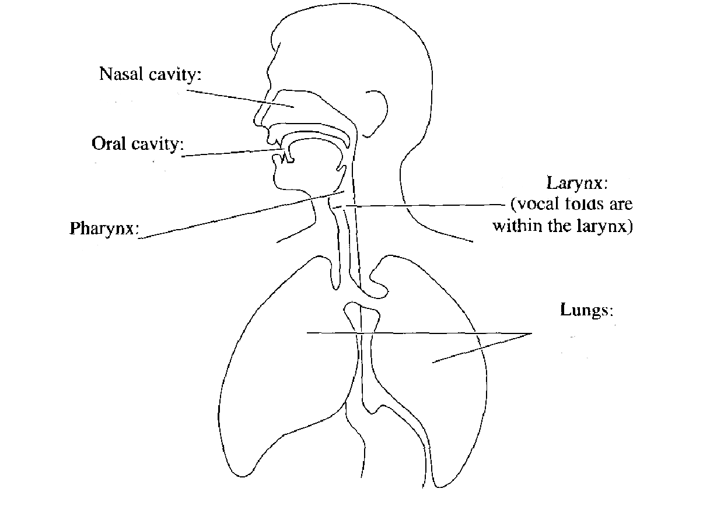

SOVTs are great because they help reduce breathiness in singing, reduce damage to the voice and encourage easy singing! So lets get started!

I want everyone to stand up with their feet shoulder width apart, hands down by your sides and look forwards. I know this feels weird and you’d probably prefer to stand with your arms crossed and with your weight in one hip…I get it…its waaaay comfier! BUT it isn’t great for singing. So, for now, I’m calling our singing position our number 9 position….and we will find out why it’s a number 9 in our second singing session. Before we get going with our SOVT’S lets wake those voices up….repeat after me

HEY HEY HEY (REPEAT)
HA HA HA (REPEAT)
HE HE HE (REPEAT)
HEY HA HE (REPEAT)
HA HE HEY (REPEAT)
HE HAY HA (REPEAT)

AMAZING!!

Now you’ve woken your voice up and ….perhaps the rest if the school….Lets start with a Siren.

This is where you find your lowest note and slide upto your highest note….like this (demo - eeee). Something to note here is that everyone has a different vocal range…some people can sing lower than others, some people can sing higher than others. It doesn’t matter if you can’t go high, or low! It doesn’t mean you’re a better or worse singer.

Let’s start with hmm (hum),
NG (si-NG),
lip roll, (if you cant , hum)
puffy cheeks, (use thump as a straw)
fricatives (VVV)

What I love about sirens is your voice is not like a piano - you don’t have individual keys. Your voice can slide and glide, so doing sirens can warm every part of the voice up smoothly.

Amazing – well done!

Next exercise is the TEENY TINY TRUMPET - which is like your puffy cheek exercise you did earlier, but this time we are staccato, so our notes are short and sharp. – To help, take your thumb and pretend it is the mouthpiece of a trumpet. Repeat after me

Br. Br br br br repeat x8 (….. If you look silly doing this, you’re doing it right!)

Lets try another vocal warm up using some SOVTs ….some of you may recognise this song…..

Let’s listen to the warmup

‘TOXIC’ vocal warm up using NG, PUFFY CHEEKS, LIP ROLLS, HUMMING.

NG…….(nice and scoopy, sliding)
Puffy – (repeat with that trumpet quality we spoke about earlier)
Lip roll – (if you can’t hum)
Hum

(Staccato) nom nom nom nom,
nom nom nom nom,
nom nom nom nom,
nom nom nom nom
Nahhhh (open the space and legato which means smoothly)

(Staccato) nom nom nom nom,
nom nom nom nom,
nom nom nom nom,
nom nom nom nom
Nahhhh (open the space and legato which means smoothly)

SI-NG (SIREN)

Too high can’t come down……its in the air and it’s all around……..can you feel me now… (nice and easy, nice and freely)

Then we it Repeat 3 times! LETS GO!

How do you feel? Let’s stick with the pop song warm up theme…..

Please don’t stop the music by Rhianna– This is created by Lara at Voxtape studios and I love using this one with my senior school students as it has a lovely SOVT section, it’s a challenge so listen up!

HA HA HA
Don’t stop the
HEY HEY HEY HEY
A E I O
OOH OOH OOH
Don’t stop the
HEY HEY HEY HEY
A E I O
MUSIC MUSIC
1234 Please don’t stop the music music
LAIDIDADI
DADIDAH
NG – AH
NG – AH
NG-AH
NG – AH
NG – AH

That’s it guys! Week one complete!

I hope you enjoyed learning about SOVT exercises. I’ll see you next time for our singing session on Breathing and breath support to help you sing louder, more securely and for longer without gasping for air! See you then!

