Student Name: Prashant Kumar J Sharma
Student ID Number: 2333800
Master's in business administration in International Business
Subject: Dissertation Proposal
Topic: Exploring AI Technology in Samsung’s Products Globally:
“A Comparative Analysis with Apple’s Intelligence”
Submission Date: 14 -03-2025

Table of Contents
1. Introduction 1
1.1 Background 2
1.2 Problem Statement and Rationale 2
1.3 Aim, objectives, and Research Question 3
2. Literature Review 3
2.1 Role of AI Technologies in enhancing user experiences and Functionality of consumers' electronic firms 4
2.2 Impact of AI-Integrated Consumer Electronics products and devices on Purchasing Decisions and Brand Loyalty 5
2.3 Research Gap 5
3. Research Methodology 5
3.1 Research Philosophy and Approach 6
3.2 Research Design, Method, and Strategy 6
3.3 Data Collection Method 8
3.4 Time Horizon 8
3.5 Data Analysis Method 8
3.6 Research Ethics 9
4. Resources and Planning 9
4.1 Gantt Chart 9
Conclusion 9
References 10

1. Introduction

1.1 Background
In the current era, artificial intelligence is revolutionising consumers' electronics as it enhances the experiences of the customers by providing features like voice assistant, smart home integrational, and personalized recommendations (Chintalapati and Pandey, 2022). Both Samsung and Apple have infused artificial intelligence throughout their product ecosystems to improve user experiences and stay competitive (Temprano, 2024). Samsung's approach to artificial intelligence involves smartphones, home appliances, and IoT devices while providing personalization and automation (Marr, 2024). The Samsung company is using the Galaxy AI feature in its smartphones which is making the devices more automatic, efficient, and personalised (Samsung, 2025).
On the other hand, Apple introduced Apple Intelligence in 2024 to enhance Siri's capabilities and user personalization (Apple Inc, 2025). Thus, this study will conduct a comparative analysis which will identify variations between the companies concerning their AI integration strategies, consumer adoption patterns, and the implications on their competitive standings in the global market.

1.2 Problem Statement and Rationale
Artificial intelligence (AI) is becoming an essential component of consumer electronics because it improves user experience alongside automation and personalization functions (Chintalapati and Pandey, 2022). Through their roles as leading technology companies Samsung and Apple utilize AI across several product functionalities starting with voice assistants and continuing to photography features, predictive text processing, and smart home connections (Temprano, 2024). However, Samsung faces challenges in using AI technologies accurately due to data security risks and difficulties in device compatibility (Prabhu and Bhat, 2020). This is affecting the usage of AI in Samsung products at the international level. Along with this, there is limited information available related to the use of AI technologies in Samsung products globally by comparing it with Apple’s intelligence in prior studies. Thus, this dissertation evaluates and compares the AI functions Samsung applies globally to its products while comparing them to Apple's AI system implementations. A thorough understanding of these differences enables the determination of how AI benefits competitive advantages and customer satisfaction and shapes future technological developments within the smartphone and electronic sectors.

1.3 Aim, objectives, and Research Question

Aim
This research will majorly be aimed to analyse and compare the integration of AI technologies in Samsung and Apple products globally by assessing the innovation, adoption, and competitiveness of both firms.

Objectives
- To examine the role of artificial intelligence technology in improving functionality and user experience for Samsung products around the world, which has been compared to Apple's innovations using AI.
- To analyse the influence of AI-integrated technology products and devices of Samsung as well as Apple on consumer purchasing decisions and brand loyalty.
- To evaluate the impact of AI advancements on Samsung’s competitive position relative to Apple in terms of innovation, user experience, and brand differentiation.
- To evaluate the issues faced by Samsung and Apple companies in adopting AI technologies at the global level.
Research Question
How are AI technologies used in Samsung’s products globally by comparing it with Apple’s intelligence?

2. Literature Review
In this section, the authors’ viewpoints have been critically analyzed in the context of analyzing the use of AI technologies in Samsung’s global products with Apple’s intelligence.

2.1 Role of AI Technologies in enhancing user experiences and Functionality of consumers' electronic firms
According to Syu, et al., (2023), artificial intelligence has made these devices more personal, intuitive, and efficient with the application of artificial intelligence in consumer electronics. AI technologies can help the firms to learn about user behavior, optimize performance to the user and automatic tasks related to user experience on different platforms like smartphones or home appliances. On the contrary, Inavolu, (2024) stated that AI-driven features such as voice assistants, predictive analytics, and smart automation allow devices to anticipate user needs and adapt accordingly. In smartphones, AI enhances photography, language translation, and battery optimization, while in smart home appliances, it improves energy efficiency and convenience.
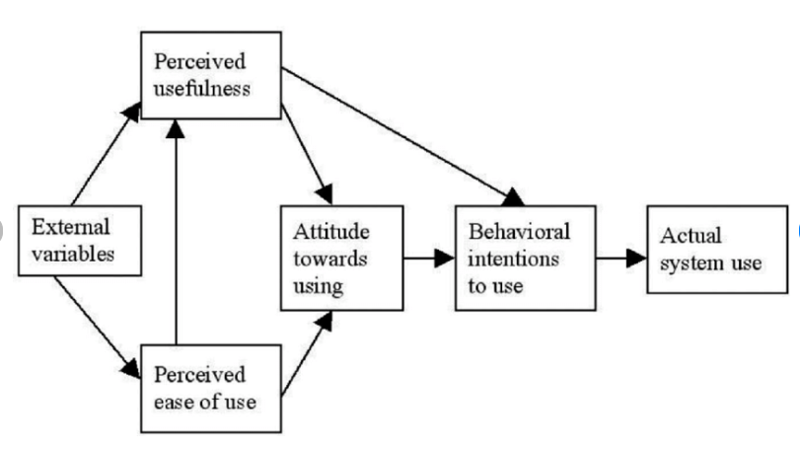
Figure 1: Technology Acceptance Model
Source: (Goh and Wen, 2021)
It can be observed from the above image that the technology acceptance model (tam) is a suitable theoretical framework to explain AI adoption, as it highlights perceived usefulness and ease of use as key factors influencing consumer acceptance (Goh and Wen, 2021). When AI improves usability and personalization, it fosters positive consumer engagement and brand loyalty. Moreover, AI's role in enhancing security, such as facial recognition and anomaly detection is also effective in strengthening trust in technology (Ramachandran, 2024). As AI continues to evolve, its integration in consumer electronics can drive innovation, reshape user expectations, and enhance competitive advantages for firms.

2.2 Impact of AI-Integrated Consumer Electronics products and devices on Purchasing Decisions and Brand Loyalty
As per the opinion of Chandrakumar, (2024), AI-integrated consumer electronics products play a very influential role in influencing consumer buying intention and brand loyalty by affecting user experiences, personalisation, and conveniences. In recent times, consumers are inclined to buy AI-supported equipment which is effective in offering seamless interaction, adaptive learning, and enhanced security. On the other hand, Wamba-Taguimdje, et al., (2020) stated that although AI improves the brand value of the consumer's electronic firms in front of the customers it creates issues related to data confidentiality and other security matters. Along with this, Lăzăroiu, et al., (2020) stated that consumer decision-making theory is effective in observing the ease of use, perceiving value, and building trust in the consumers while making the buying decision. It helps in observing that AI technologies are affecting the trust, ease of use and value of the consumers for using consumer electronic goods.

2.3 Research Gap
Previous studies such as (Syu, et al., 2023) and (Ramachandran, 2024) are effective in highlighting the use of AI technologies in products and services related to consumer electronics firms. However, the previous studies have been limited in giving the deep learning related to the effect of AI technologies on Samsung’s products globally by comparing it with Apple's intelligence. Thus, this research will help in aiding this gap in the preceding studies by providing deep learning into the same.

3. Research Methodology
In this section, the method and procedure will be found that will choose to collect, interpret, and Analyse the information.

3.1 Research Philosophy and Approach
Pragmatism philosophy seeks to understand experience, behaviors, and perceptive approaches in the available data (Pervin and Mokhtar, 2022). This research philosophy will consider subjective meanings and objective reasoning and will go deep into the existing information patterns. It will help in understanding user experiences, attitudes and adoption patterns of AI integration in Samsung’s consumer electronics. Furthermore, the abductive research approach starts from specific observations and builds material that is becoming increasingly broad and theoretical (Casula, et al., 2021). By applying AI adoption challenges in Samsung smartphones through an abductive approach to combining existing theories with real-world data, a correct context is obtained for its application. This study uses secondary sources and primary secondary data to find and test the trends and test the hypothesis regarding the effect of AI on consumer decisions, and brand loyalty to help further understand the role of AI on buying behaviors.

3.2 Research Design, Method, and Strategy

Figure 2: Saunders Research Onion Framework
Source: (Inspired By: Gamage, 2025)
Saunders’ research onion framework will be applied to structure the method for data collection, analysis and interpretation of this study (Gamage, 2025). It uses both secondary and primary data, and it adopts a mixed method design with an abductive approach under a pragmatism philosophy. The research uses content and descriptive analysis to examine the effectiveness of consumer perceptions of AI in Samsung and Apple smartphones. In this study, the role of AI in improving functionality, bettering user experience and improving competitive edge of a brand with reference to the global market. This analysis is made based on quantitative and qualitative data from industry reports, academic journals, articles, surveys and official company sources.
The approach to this study will be a survey-based approach where primary data will be collected from 40-50 customers of mobile industry to examine the consumer perceptions of AI in Samsung, Apple smartphones or Any Other smartphones. In the survey, significant trends in AI driven devices, smart assistants, user experience and AI innovations as well as AI competition will be analysed. Findings from industry reports, academic studies and official company sources will be supplemented into the findings for a proper analysis of AI’s impact on consumer preference and brand competitiveness.

3.3 Data Collection Method
The data collection methods used in this study will be both primary and secondary to make a comprehensive analysis of AI integration in Samsung and Apple smartphones. A survey of 40-50 customers will be conducted to collect firsthand approach to how consumers perceived AI-based features, how they contribute to the user experience, and factors that affect brand loyalty and buying behaviors. Academic journals, industry reports, company websites and online publications will be used as secondary source of data for knowledge of the industry trend, market competition and AI strategies. By combining both methods, the study’s reliability and depth increase, and findings are supported by credible academic and industry sources to make a comparative analysis of Samsung and Apple’s AI innovations.

3.4 Time Horizon
Data is gathered in a cross-sectional time horizon at a particular present moment (Dew-Becker and Giglio, 2023). However, this study, based on mixed methods, will be relevant and useful for deep analysis of AI technology in Samsung and Apple products. This will allow for comparison of AI features, user adoption and market impact across existing reports, online websites and industry analysis at a certain point of time.

3.5 Data Analysis Method
Both content analysis and descriptive statistical methods will be used to examine AI integration in Samsung and Apple smartphones for this study. Qualitative data will be content analyses, from academic articles, industry reports, online sources and company documents, to consider key patterns, themes, insights, around adoption of AI (Khoa et al., 2023). At the same time, descriptive statistical methods will be applied to examine primary survey data to the extent of a quantitative assessment of how consumer perceptions on AI-driven features, user experience and brand competition. This research will combine methods to provide a comprehensive comparative AI strategy study of Samsung and Apple to cater global product development, positioning on the market and engagement with the consumers.

3.6 Research Ethics
In terms of primary and secondary research, this study strictly follows the ethical considerations, ensuring credibility, accuracy and fairness in data collection and analysis (Rubenbauer and Haddaway, 2020). Ethical guidelines will be followed in the primary research conducted through surveys by obtaining informed consent, anonymity of participants, and confidentiality of data. The objective will be to collect all responses and Analyse them objectively without any manipulation or misrepresentation of findings.
Only credible and peer reviewed sources including academic journals, industry report are going to be used for secondary research. All information will be cited and referenced properly according to academic integrity and avoid plagiarism. The secondary data will be critically assessed for possible bias and findings will be interpreted objectively to ensure fairness. Moreover, data privacy laws will be strictly adhered to, no confidential or restricted information will be used. This ethical approach ensures that the study is reliable, transparent and unbiased in terms of insights about AI adoption in Samsung and Apple smartphones.

4. Resources and Planning

4.1 Gantt Chart
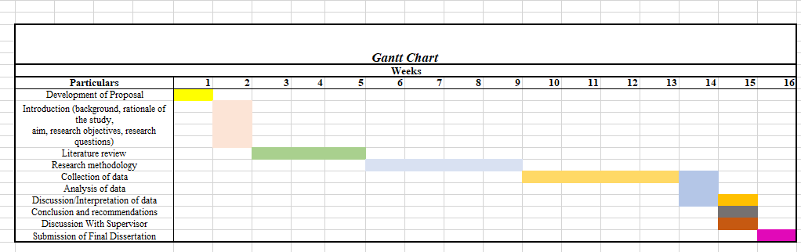
Figure 3: Timeline (Gantt chart)

Conclusion:

To conclude, this dissertation proposal outlines a research study that will conduct a comparative analysis of AI technologies in Samsung and Apple products globally.
The research will investigate the role of AI in enhancing user experience and functionality, its impact on consumer purchasing decisions and brand loyalty, and its effects on the companies’ competitive positions.
Through primary and secondary data collection and rigorous analysis, this study aims to provide valuable insights into the adoption, innovation, and implications of AI in the consumer electronics industry.

References
Apple Inc. (2025) Introducing Apple Intelligence, the personal intelligence system that puts powerful generative models at the core of iPhone, iPad, and Mac. [Online]. Available at: https://www.apple.com/in/newsroom/2024/06/introducing-apple-intelligence-for-iphone-ipad-and-mac/. [Accessed on: 12.03.2025].
Casula, M., Rangarajan, N. and Shields, P. (2021) The potential of working hypotheses for deductive exploratory research. Quality & Quantity, 55(5), pp.1703-1725. Available at: https://doi.org/10.1007/s11135-020-01072-9
Chandrakumar, H. (2024) The Use of AI-Driven Personalization for Enhancing the Customer Experience for Gen-Z. Open Journal of Business and Management, 12(6), pp.4472-4481. Available at: https://doi.org/10.4236/ojbm.2024.126225
Chintalapati, S. and Pandey, S.K. (2022) Artificial intelligence in marketing: A systematic literature review. International Journal of Market Research, 64(1), pp.38-68. Available at: https://doi.org/10.1177/14707853211018428
Dew-Becker, I. and Giglio, S. (2023) Cross-sectional uncertainty and the business cycle: evidence from 40 years of options data. American Economic Journal: Macroeconomics, 15(2), pp.65-96. Available at: https://www.nber.org/system/files/working_papers/w27864/w27864.pdf
Gamage, A.N. (2025) Research Design, Philosophy, and Quantitative Approaches in Scientific Research Methodology. Sch J Eng Tech, 2, pp.91-103. Available at: https://doi.org/10.36347/sjet.2025.v13i02.004
Goh, E. and Wen, J. (2021) Applying the technology acceptance model to understand hospitality management students’ intentions to use electronic discussion boards as a learning tool. Journal of Teaching in Travel & Tourism, 21(2), pp.142-154. Available at: https://doi.org/10.1080/15313220.2020.1768621
Gusenbauer, M. and Haddaway, N.R. (2020) Which academic search systems are suitable for systematic reviews or meta‐analyses? Evaluating retrieval qualities of Google Scholar, PubMed, and 26 other resources. Research synthesis methods, 11(2), pp.181-217. Available at: https://doi.org/10.1002/jrsm.1378
Prabhu, S. and Bhat, S. (2020). Application of Artificial Intelligence in Samsung–A Case Study. International Journal of Case Studies in Business, IT, and Education (IJCSBE), 4(2), pp.280-292. Available at: http://dx.doi.org/10.47992/IJCSBE.2581.6942.0096
Inavolu, S.M. (2024) Exploring AI-driven customer service: Evolution, architectures, opportunities, challenges and future directions. International Journal of Engineering and Advanced Technology, 13(3), pp.156-163. Available at: https://pdfs.semanticscholar.org/3744/60e2bcaaa2ff6785a452242d6524311556a6.pdf
Khoa, B.T., Hung, B.P. and Hejsalem-Brahmi, M. (2023) Qualitative research in social sciences: data collection, data analysis and report writing. International Journal of Public Sector Performance Management, 12(1-2), pp.187-209. Available at: https://doi.org/10.1504/IJPSPM.2023.132247
Lăzăroiu, G., Neguriţă, O., Grecu, I., Grecu, G. and Mitran, P.C. (2020) Consumers’ decision-making process on social commerce platforms: Online trust, perceived risk, and purchase intentions. Frontiers in psychology, 11, p.890. Available at: https://doi.org/10.3389/fpsyg.2020.00890
Marr, B. (2024) 4 Smartphones Leading the AI Revolution. [Online]. Available at: https://www.forbes.com/sites/bernardmarr/2024/11/11/4-smartphone-with-the-best-artificial-intelligence/. [Accessed on: 12.03.2025].
Pervin, N. and Mokhtar, M. (2022) The interpretivist research paradigm: A subjective notion of a social context. International Journal of Academic Research in Progressive Education and Development, 11(2), pp.419-428. Available at: http://dx.doi.org/10.6007/IJARPED/v11-i2/12938
Ramachandran, K.K. (2024) The role of artificial intelligence in enhancing financial data security. International Journal of Artificial Intelligence & Applications (IJAIAP), 3(1), pp.1-13. Available at: https://iaeme.com/Home/issue/IJAIAP?Volume=3&Issue=1
Samsung, (2025) A true AI companion is here. [Online]. Available at: https://www.samsung.com/us/galaxy-ai/#:~:text=The%20future%20of%20health%2C%20now,building%20block%20toward%20better%20habits. [Accessed on: 12.03.2025].
Syu, J.H., Lin, J.C.W., Srivastava, G. and Yu, K. (2023) A comprehensive survey on artificial intelligence empowered edge computing on consumer electronics. IEEE Transactions on Consumer Electronics, 69(4), pp.1023-1034. Available at: https://doi.org/10.1109/TCE.2023.3318150
Temprano, D. (2024) Future Market Blueprints: Harnessing Artificial Intelligence in a World Wired for Wonder. Northwestern Journal of International Law & Business 44(3). p.531. Available at: https://scholarlycommons.law.northwestern.edu/cgi/viewcontent.cgi?article=1909&context=njilb
Wamba-Taguimdje, S.L., Wamba, S.F., Kamdjoug, J.R.K. and Wanko, C.E.T. (2020) Influence of artificial intelligence (AI) on firm performance: the business value of AI-based transformation projects. Business process management journal, 26(7), pp.1893-1924. Available at: 10.1108/BPMJ-10-2019-0411

