Planning and Delivering an International Meeting/Event
Technology and Innovation: Use of Augmented and Virtual Reality in Hospitality

Student: Monica Roman
Student id: 2128507
Module: BMIH6007 International Meetings Management
Lecturer: Kathryn Flynn

Executive Summary
The Countryside Dream Retreat Hotel has decided to participate at The National Travel and Tourism Fair 2024 in Bucharest to showcase its innovative, immersive guest experiences. Based on Augmented and Virtual Reality technology these experiences will allow future guests to take virtual tours of the hotel and surrounding areas, choose their room in real-time during the booking process, live an immersive experience as a farmer in Romania’s countryside in early 1900s’. This report will analyse the planning, delivering and post-event evaluation according to present theories and frameworks, and using the Events Management Body of Knowledge model (EMBOK). After a thorough market research, careful planning and assessment of the benefits of participating in such an event (O’Toole, 2011), the hotel representatives have agreed that The National Travel Fair will provide the hotel with the necessary audience to showcase this innovative and immersive technology. Online research conducted by resort owners and the tech company that provided the AR/VR experience, established that there are no other hospitality companies offering this type of adventure, thus creating a competitive advantage. According to Porter (2004), this competitive advantage gives a company sustainable success, profitability and the means to achieve higher performance. The Romexpo National Travel Fair 2024 meets all the criteria that will allow the hotel to successfully present its innovation to the right target market, as hoteliers, tour operators and other hospitality representatives will be there (Romexpo, 2024). Using Its top-notch equipment and elaborate technological arrangements, The Countryside Dream Retreat is prepared to be in the spotlight with its compelling presentation of AI and AR (Marshall, 2020). The aim is to promote itself, target new customers and travel agencies by introducing this new and unique offering created to enhance guest experience. The aim is to capitalise on this innovation, and attract new guests, both domestic and international for future bookings and create partnerships with local and international travel agents. The report will show how the 50th edition of the National Tourism Fair is the best option for The Countryside Dream Retreat Hotel to present this technological innovation that could even revolutionise hospitality. Romexpo hall has clear logistic advantages and practicalities, both international and domestic hospitality companies and experts, travel agencies, tour operators and visitors that are present at the event could open new opportunities for The Countryside Hotel. It will hold true relevance and effectiveness so that hand in hand, future tourism trends and hospitality industry developments will change for the better.

Contents
Executive Summary 1
Introduction 4
The Event Cycle 4
Event Concept 6
Aim and Objectives 8
Event Operations 8
Event Budget 11
Industry Trends/Issues/Impacts 13
Cultural and Situational Considerations 14
Conclusion 16
References 17

Introduction
The proposed event, "Innovating Hospitality: Use of Augmented and Virtual Reality in Hospitality," represents the highlight of the show at the upcoming National Travel and Tourism Fair 2024, in Bucharest, Romania. As discussed in the presentation, the event aims to showcase cutting-edge applications of Artificial Intelligence and Augmented/Virtual Reality technologies within the hospitality industry (Marshall, 2020), which includes creating a hotel environment using the combined front-end interface of these technologies to provide mesmerising guest experiences. The choice of the event goes along with the growing significance of digital development in the tourism area. Law et al. (2014) state that consumer behaviour in hospitality has changed in recent years due to technological innovations. This field now depends to a great extent on the advancements in IT and interactive techniques (Brown, 2020) in order to attract young, tech-wise travellers. "Innovating Hospitality" seeks to furnish a new standard of implementing these technologies: guests would be able to enjoy live demonstrations and interact with the hosts in order to appreciate their use in making customised services and experiences fruitful. Bucharest, an international city that is known for its historic flavour, beautiful architecture and vibrant life is popular with the residents and tourists for its modernist art and technology, lending itself to the perfect backdrop for the setting of this story. Romexpo Hall is the stage for this annual Tourism Fair which has recently attracted international companies who want to bring visitors to Romania (Romexpo, 2024). Romexpo has the perfect infrastructure and facilities to host such an event that would bring benefits and facilitate new connections to all participating businesses, including the Countryside Dream Retreat.

The Event Cycle
According to Getz (1991, 2005) an event is “an opportunity for leisure, social or cultural experience outside the normal range of choices or beyond everyday experience”. There are different types of events, from small, informal family reunions to major national or international events that attract huge numbers of people and involve different stakeholders (Bowdin et al., 2011). To be successful, each event requires careful planning and a team of people with particular skills to make it happen. The Event Cycle is a comprehensive framework that outlines the various phases an event undergoes from its inception through to its completion and post-event analysis. This model is crucial for ensuring that each phase of the event is methodically planned and executed to optimise success.
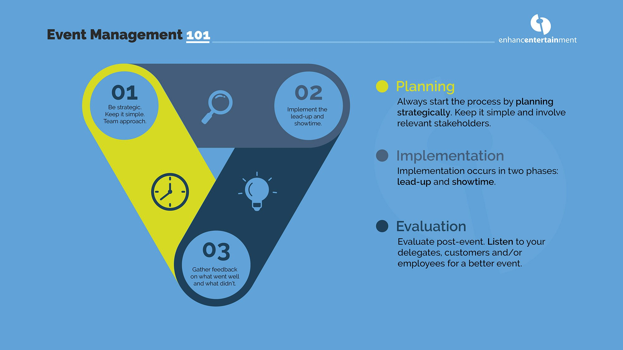
Fig. 1 (Enhance Entertainment, 2024 – Event cycle)
For this particular meeting the Event Cycle will be applied as follows:
- Planning: Conceptualisation of the event's theme and objectives centered around innovative technologies. Detailed scheduling, resource allocation, marketing and technology integration specific to VR and augmented reality demonstrations.
- Execution: Actual hosting of the event where technologies are showcased to visitors and delegates (Patel and Jacobson, 2022).
- Post-Event: Wrapping up the event with a review of the setups and initial feedback collection.
This application of the Event Cycle ensures a structured approach, allowing for a thorough evaluation of the technology's appeal and functionality within the hospitality industry.

Event Concept
The core theme of this event, hosted by The Countryside Dream Retreat hotel at the National travel and tourism fair, revolves around "Innovating Guest Experience through AI and Augmented Reality." This theme underscores the hotel's commitment to integrating cutting-edge technologies to enhance guest interaction (Hughes, 2021) and service delivery. As described in the presentation, the hotel wants to introduce a unique immersive experience for guests through AR and VR technology. The venue is Romexpo Hall, the biggest exhibition center in Bucharest. 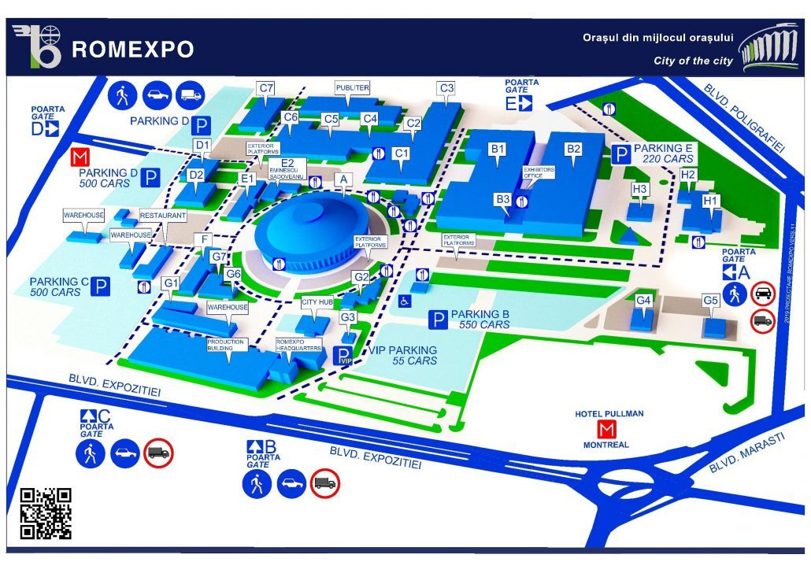 Fig. 2 Romexpo Hall (Romexpo, 2024)

The venue (Romexpo, 2024) has great infrastructure with over 100,000 square meters available, conference rooms, parking and catering facilities, being very well linked to the city. Delegates attending the event will embark on an immersive journey through the potential future of hospitality (Thompson and Chen, 2020). The experience will begin with a personalised AI-driven reception, where facial recognition technology will be used not only to check in guests but also to customise recommendations for the fair itinerary based on their preferences. Following this, guests will be guided through a series of augmented reality setups:
- Virtual Room Selection: Guests can use VR goggles to virtually explore different rooms and amenities the hotel offers, choosing their preferences in real time.
- AI Concierge Services: Through interactive kiosks, guests will interact with an AI concierge that provides information, takes requests, and offers personalised tourism advice based on predictive analytics.
- Augmented Reality Experiences: As showcased in the presentation, the highlight of the event, the immersive part is offering the hotel guests the opportunity to see how daily life on a farm was back in the 1900s’. The Countryside Retreat is set in a beautiful landscape and was a working farm. Owners of the hotel have decided to allow guests to experience this way of life by collecting from local and national archives videos and photographs showcasing life in the countryside. Using QR codes, guests will be able to immerse themselves in the reality of countryside life. Children will be able to use VR kits as well to live the life of a farmer’s child and do all the daily chores that were required of them: feed animals, clean the stables, collect fruits and vegetables from the garden, milking cows, etc. Delegates will also experience augmented tours of local attractions, previewing excursions and experiences offered by the hotel.
The day will conclude with a panel discussion on the integration of these technologies in traditional hotel settings, featuring industry experts and technology developers. This itinerary not only highlights the event's innovative theme but also directly engages delegates, offering them a first-hand look at how these technologies can transform guest experiences. Throughout this event, the seamless integration of AI and augmented reality aims to showcase the hotel's forefront position in adopting technological advancements (Li, 2021), thereby enhancing its appeal to tech-savvy travellers and stakeholders in the tourism and hospitality sectors.

Aim and Objectives
Aim:
The aim is to create competitive advantage (Porter, 2011) and increase international bookings by 15%, offering unique experiences for guests. By showcasing cutting-edge AI and AR/VR technologies in the hospitality industry through a dynamic and interactive experience at the international tourism fair enhances visibility and fosters industry-wide innovation (Marshall, 2020).
Objectives:
- Specific: To attract at least 500 visitors to the stall and 50 industry delegates, ensuring they engage with the technological showcase.
- Measurable: To receive a 90% approval rating from participant feedback surveys regarding the experiential, educational value and technological innovation of the event.
- Achievable: To secure partnerships with at least one leading technology company specialising in AI and AR to feature their latest products (Morrison and Anderson, 2021).
- Relevant: To strengthen the hotel's brand as a pioneer in integrating technology in hospitality, aligning with its long-term strategic goals.
- Time-bound: To accomplish these objectives within the timeframe of the tourism fair and the following year.

Event Operations
The creation and delivery of this event was based on the EMBOK model (EMBOK, 2005) that supplies one with all the information and skills necessary to organise an event. The three dimensions of the model: domains, phases and processes help structure the whole process from initial idea, delivery and post event activities. 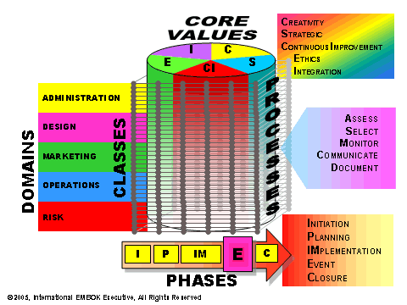
EMBOK model (EMBOK, 2005)
The successful delivery of an event centered around advanced technological displays, such as AI and AR, demands careful planning, good marketing and a team with a diverse set of skills (Getz and Page, 2019). As a large-scale event, The National Travel Fair 2024 will get important media coverage. According to Bladen et.al (2023) “media coverage of an event can shape how that event is perceived, with positive and negative implications for how those events are managed”. The hotel will market this event through its website, using social media channels, email marketing for established guests and stakeholders. The local council and the tech company that produced the software and AR/VR experiences will also market the event on their channels to achieve more coverage. Printed flyers and brochures of the hotel and the innovative technology will also be distributed locally and at the National Fair, hotel staff at the event personally advertising the experiences to the participants at the fair. Van der Wagen (2010) notes that events staff needs to be carefully selected and trained to be able to provide quality customer service.

Category | Details
Skills Required | - Technical Experts: Skilled in the operation and troubleshooting of VR and AR systems for smooth presentation and interaction.  - Hotel representatives: Capable to assist guests, answer questions, and ensure a positive experience (Wan der Wagen, 2010). Able to oversee logistics from conception to completion. Possess marketing skills to promote the event to the target demographic through digital and traditional channels.
Resources Needed | - Technological Equipment: High-specification computers, server, VR/ AR headsets, interactive display, loudspeakers and reliable internet.  - Software: Custom software for AI and VR/AR applications in hospitality.  - Physical Setup: Modular stands and booths adaptable to different technologies.  - Security: Enhanced measures to protect equipment and ensure participant safety.
Logistical Support | - Venue Coordination: Ensures the venue supports the technical needs of AI and AR technologies.  - Transport and Accommodation: Manages transport of equipment and staff, and arranges accommodation/meals.  - Schedule Management: Optimises showcase timing for maximum engagement, setup/ breakdown.  - Feedback Collection: Uses digital platforms for real-time feedback and attendee satisfaction metrics.

Effective event operations for a technology-driven tourism fair focusing on AI and AR/VR require meticulous planning and precise execution (Fox et al., 2014). The core operations encompass several key areas:
Technical Setup and Support: A robust technical infrastructure is paramount: high-performance computing systems, AR interfaces, and reliable Wi-Fi connectivity to support the interactive technologies. Technical experts must be on-site to demonstrate, manage systems, ensuring they are operational and troubleshoot promptly.
Staffing: The Fair’s event managers will coordinate the flow of activities and ensure adherence to the schedule (Brown, 2020) and security staff oversees safety of participants and equipment. The event will need a small team comprising of IT specialists to manage technological aspects and demonstrations, while hotel representatives deal with queries, assist attendees and enhance their experience.
Logistics: Coordinating logistics involves ensuring that all equipment and materials are transported safely to the venue, setting up the event space efficiently, and managing the flow of attendees. This also includes arranging accommodation and transport for IT and hotel staff.
Post-Event Activities: A debrief session is necessary to gather feedback, analyse the success of the event, and identify areas for improvement. This feedback is invaluable for refining future events.

Event Budget

Category | Details | Cost (Euro) | Income (Euro)
Income Sources

Sponsorships | Technology company and local council | - | €15,000
Merchandise Sales | Local produce and souvenirs | - | €3,000
External partnership investment | International partner investment | - | €20,000
Expenditures

Venue Rental | Event space rental | €4,000 | -
Technology Setup | AR/VR sets, computers, software licenses | €10,000 | -
Marketing | Digital and traditional advertising | €1,500 | -
Staffing | Event staff, technical support | €2,000 | -
Logistics | Transport, accommodation, food services | €1,500 | -
Miscellaneous | Contingency fund | €5,000 | -
Total |  | €24,000 | €38,000

Financial Strategy:
- Costs: The major expenditures include venue rental and technological setup, crucial for facilitating an AI and AR-intensive event. Staffing costs cover salaries for hotel staff and technical experts, transportation, accommodation and meals.
- Funding Sources: Primary funding is sourced through sponsorships from IT technology company, benefiting from exposure at the event (Turner and Freier, 2019), external partner investment, local council sponsorship.
- Income Generation: Sale of local produce and merchandise to connect brand to local traditions.

Industry Trends/Issues/Impacts
The events industry is currently experiencing a transformation driven by digital technology. Torabi Farsani et al. (2016) note that “innovation and product development are keys to success”. AR and AI are leading trends, streamlining operations, enhancing guest experiences through immersive and personalised interactions (Brown, 2020 and Hughes, 2021). However, environmental sustainability is also becoming a significant concern, with stakeholders demanding greener event solutions.
SWOT Analysis:
SWOT and PESTEL analysis have been performed in order to establish the internal and external factors that could influence the hotel’s participation at the fair and asses the benefits of this.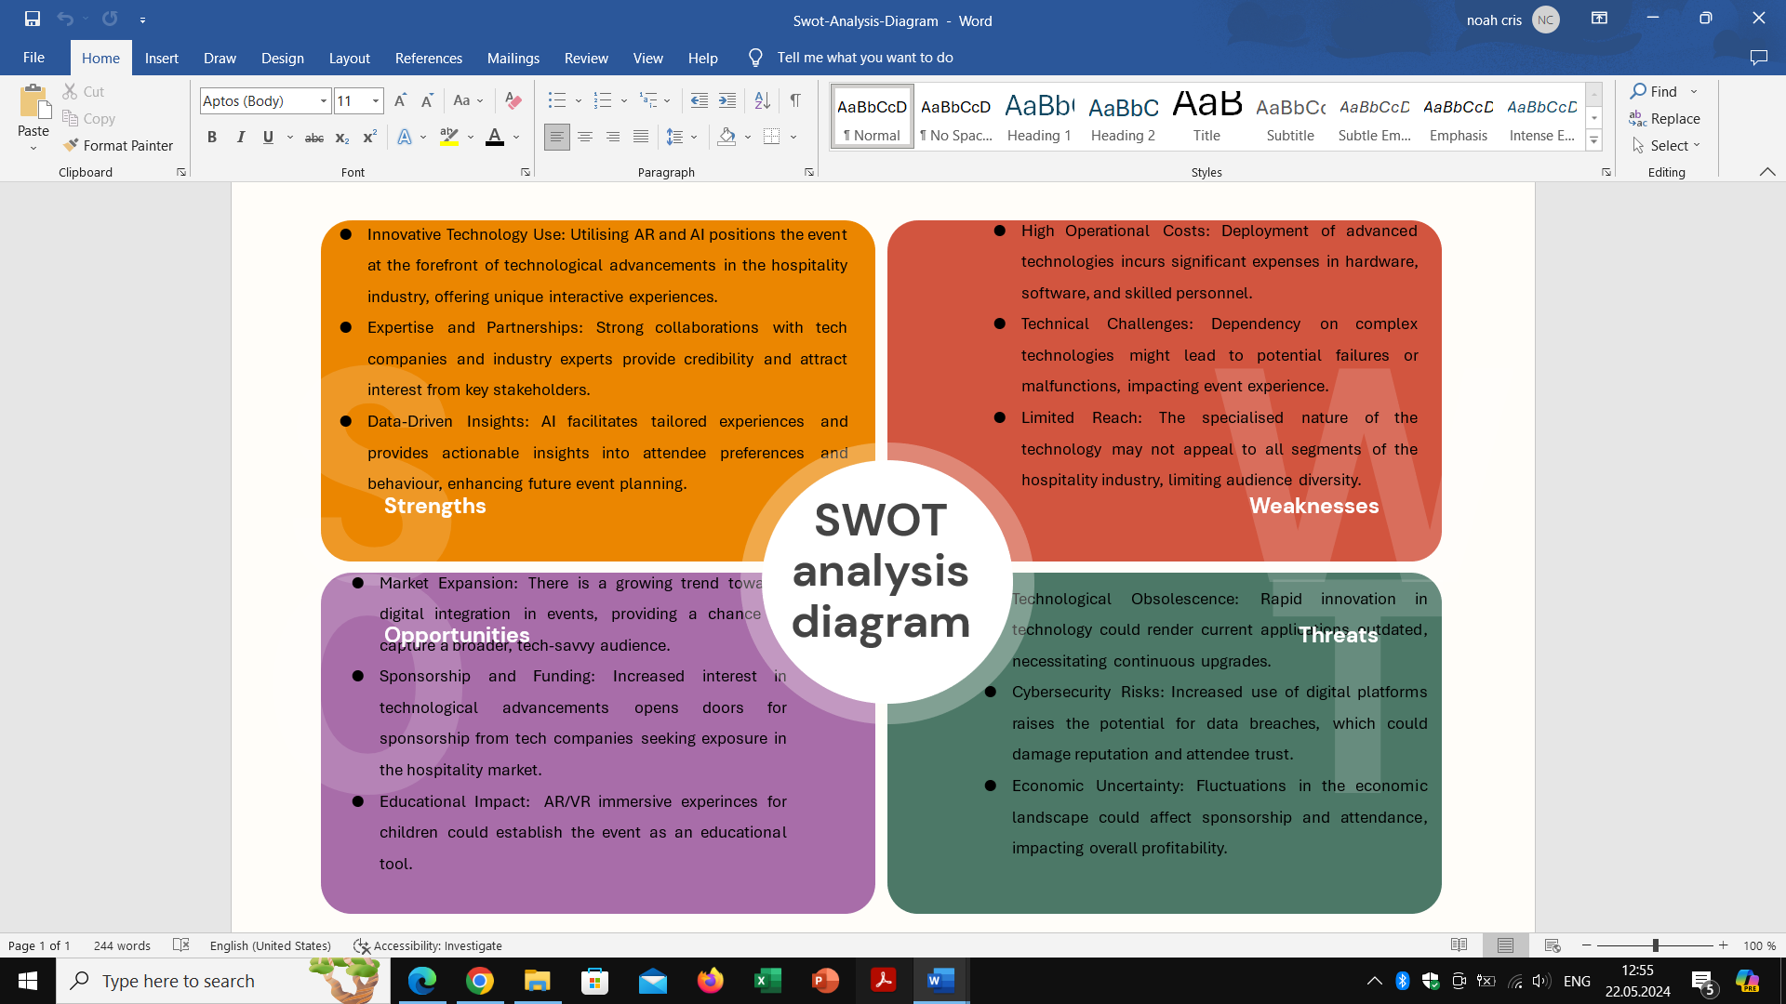

PESTLE Analysis:
Political: Compliance with international data protection laws, tax rise for tourism companies, political instability in the area due to Russia-Ukraine conflict.
Economic: Budget Sensitivity: Economic downturns could decrease industry spending on events, affecting ticket sales and sponsorship.
Social: Changing Consumer Preferences: A shift towards more immersive and interactive event experiences aligns well with the event's use of AR and AI.
Technological: Advancements in AR and AI: Leveraging the latest developments can provide a competitive edge but requires continuous learning and adaptation.
Legal: Intellectual Property Rights: Ensuring that all digital content and software used adhere to IP laws is critical to avoid legal challenges (Gupta, 2022).
Environmental: Sustainability Concerns: Reducing the carbon footprint of tech-heavy events is essential, demanding eco-friendly practices in event logistics and management.

Cultural and Situational Considerations
Cultural and situational factors play a crucial role in the planning and execution of international events (Bowdin et al., 2011), especially when introducing sophisticated technologies like AI and AR. Understanding and respecting cultural diversity is paramount to ensure inclusivity and accessibility.

Category | Factor | Description
Cultural Factors | Language Barriers | Multilingual support in AR and AI applications can help bridge communication gaps, making content accessible to a global audience.
 | Cultural Sensitivity | Content and interactions facilitated by AI should be culturally appropriate. Customisation features allowing for cultural preferences can enhance the user experience.
 | Technology Adoption | Varying levels of familiarity and comfort with technology across cultures must be considered to avoid alienating attendees.
Situational Factors | Location Accessibility | The choice of location should consider political stability, infrastructure for technology deployment, and ease of access for international attendees (Marshall, 2020).
 | Economic Climate | Economic factors in the host country can influence budgeting, pricing strategies, and overall event affordability.
 | Local Regulations | Understanding local regulations regarding technology use, data protection, and public gatherings will aid compliance and smooth operation.

Conclusion
The National Travel and Tourism Fair 2024 featuring technology and innovation in hospitality definitely creates the right pathway for The Countryside Dream Retreat to capitalise on its innovative AR and VR immersive experiences. This event not only displays the newest technological inventions, but also addresses how these tools can make both guest engagement and operations more powerful in real time as well. Visitors and participants at Romexpo Hall are able to experience the sheer practicality of all these technologies with skilled technicians demonstrating and explaining how experiences were created. The event's theme together with its strategic location and focus on delivering enriching technological experiences gives the hotel the opportunity to showcase its innovative idea, attract possible investors, strengthen the brand image and increase number of domestic and international bookings. This event can become a landmark of integrating technology in tourism and set a benchmark of excellence in services. This might motivate tourism organisations to adopt similar approaches, thereby raising the standards of the services rendered to tourists across the globe.

References
- Anderson, C. (2020) Smart hotels: Technology's role in the future of hotel management. Journal of Hospitality and Tourism Management, 45, pp.109-121.
- Bladen, C. et.al (2022) Events Management: An Introduction (3rd ed.). Routledge. Available at: https://doi.org/10.4324/9781003102878 (Accessed: 13 May 2024).
- Berridge, G. (2006) Events Design and Experience (1st ed.). Routledge. https://doi.org/10.4324/9780080468112 (Accessed: 13 May 2024).
- Bowdin et al. (2011) Events Management. Routledge: Oxford. (Events Management Series). Available at: https://search-ebscohost-com.ezproxy.uwtsd.ac.uk/login.aspx?direct=true&db=nlebk&AN=459613&site=ehost-live (Accessed: 13 May 2024).
- Brown, L. (2020) Virtual reality and augmented reality in tourism: A patrolling view of the literature. Journal of Travel Research, 59(3), pp.523-539.
- Events Management Body of Knowledge (2024) EMBOK model. Available at: https://www.embok.org/index.php/embok-model (Accessed: 14 May 2024).
- Enhance Entertainment (2024) Event Management. Available at: https://enhancentertainment.com.au/blog/event-management-101-run-like-pro-3-easy-steps/ (Accessed: 14 May 2024).
- Events Industry Council (2024) CIC Final Report. Available at: https://insights.eventscouncil.org/Portals/0/Documents/Article%20Body/CIC_Final_Report_Executive_Summary.pdf (Accessed: 05 May 2024).
- Eventbrite (2024) Event life-cycle. Available at: https://www.eventbrite.co.uk/blog/event-life-cycle-ds00/ (Accessed:13 May 2024).
- Fenich G. (2019) Meetings, expositions, events, & conventions: An introduction to the industry. Pearson.
- Fox, D. et al. (2014) Doing events research: from theory to practice. Routledge: Oxford.
- Getz, D. (2005) Event management and Event tourism. Cognizant Communication Corporation.
- Getz, D. and Page, S. (2019) Event studies: theory, research and policy for planned events. 3rd Edition. Routledge: Oxford.
- Gupta, S. (2022) Artificial intelligence in hospitality: Applications, implications, and future perspectives. Journal of Hospitality and Tourism Management, 48, pp.209-219.
- Hughes, L. (2021) The digital guest experience: Personalization through AI and data analytics. Tourism Management Perspectives, 39, pp.100856.
- Kennedy, D. (2020) Data-driven decision making in hotel management: Insights from AI applications. Cornell Hospitality Quarterly, 61(2), pp.123-138.
- Knani, M., Echchakoui S. and Ladhari, R. (2022) Artificial intelligence in tourism and hospitality: Bibliometric analysis and research agenda. International Journal of Hospitality Management. Volume 107. Available at: https://doi.org/10.1016/j.ijhm.2022.103317 (Accessed: 15 May 2024).
- Law, R., Buhalis, D., & Cobanoglu, C. (2014) Progress on information and communication technologies in hospitality and tourism. International Journal of Contemporary Hospitality Management, 26(5), 727–750. https://doi.org/10.1108/IJCHM-08-2013-0367.
- Law, R., Leung, D., & Chan, I. C. C. (2020) Progression and development of information and communication technology research in hospitality and tourism: state-of-the-art review. International Journal of Contemporary Hospitality Management, 32(2), 511–534. https://doi.org/10.1108/IJCHM-07-2018-0586.
- Li, J. (2021) Artificial intelligence in tourism: Opportunities and challenges. Tourism Management Perspectives, 39, pp.100835.
- Marshall, P. (2020) AR/VR trends in tourism: Disruption or revolution? Journal of Vacation Marketing, 26(1), pp.43-58.
- Morrison, A. and Anderson, D. (2021) Augmented reality and its future in hospitality marketing. Journal of Marketing Management, 37(7-8), pp.749-771.
- O’Neill, T. and Smith, A. (2019) Augmented reality in hotel spaces: Consumer expectations and experiences. International Journal of Contemporary Hospitality Management, 31(9), pp.3551-3569.
- O’Toole, W. (2011) Events feasibility and development: from strategy to operations. Elsevier: Oxford.
- Parapanos, D., & Michopoulou, E. (2023) Innovative Mobile Technology in Hotels and the Use of Gamification. Tourism Planning & Development, 20(2), 162–187. https://doi.org/10.1080/21568316.2022.2107563.
- Patel, H. and Jacobson, M. (2022) The impact of augmented reality in hospitality management: An overview of current trends. International Journal of Hospitality Management, 97, pp.103105.
- Porter, M.E. (2004) Competitive advantage: Creating and sustaining superior performance. Free Press.
- Rogers, T. and Wynn-Moylan, P. (2022) Conferences and conventions: a global industry. 4th Edition. Routledge: Oxford
- Romexpo (2024) Infrastructure. Available at: https://www.romexpo.ro/en/infrastructura/ (Accessed: 04 May 2024).
- Sharma, R. (2021) Leveraging artificial intelligence for enhanced guest services in luxury hotels. Tourism Management, 84, pp.104273.
- Singh, A. and Kaur, P. (2021) The role of artificial intelligence in enhancing customer experience in the hotel industry. Journal of Hospitality and Tourism Technology, 12(1), pp.179-194.
- Smith, A. (2012) Events and urban regeneration: the strategic use of events to revitalise cities. Routledge: Oxford
- Tan, G.W.et al. (2018) The interactive mobile social media advertising: An imminent approach to advertise tourism products and services? Telematics and Informatics, 35(8), 2270–2288. https://doi.org/10.1016/j.tele.2018.09.005
- Targul de Turism al Romaniei (2024) De ce sa fii expozant. Available at: DE CE SA FII EXPOZANT - Thttps://www.targuldeturism.ro/en/de-ce-sa-fii-expozant/ARGUL DE TURISM (Accessed: 30 April 2024).
- Torabi Farsani, N., et al. (2016) Measurement of satisfaction with ICT services implementation and innovation in restaurants (Case Study: Isfahan, Iran). Journal of Travel & Tourism Marketing, 33(2), 250–262. https://doi.org/10.1080/10548408.2015.1050540.
- Turner, M.J. and Freier, D. (2019) Enhancing hotel experiences through technology: Perspectives from the millennial generation. Tourism Review, 74(4), pp.808-822.
- Van der Wagen, L. and White, L. (2010) Events Management for tourism, cultural, business and sporting events. 4th edn. Pearson Australia. Available at: https://books.google.co.uk/books?id=zQfiBAAAQBAJ&pg=PR5&source=gbs_selected_pages&cad=1#v=onepage&q&f=false (Accessed: 14 May 2024).
- Walters, G., and Samuels, J. (2022) Cybersecurity in hospitality: Protecting guest data in an era of digital transformation. Journal of Hospitality and Tourism Technology, 13(1), pp.25-41.
- Zhang, H. (2020) The integration of AI in tourism and hospitality: A strategic perspective. Annals of Tourism Research, 83, pp.103006.

