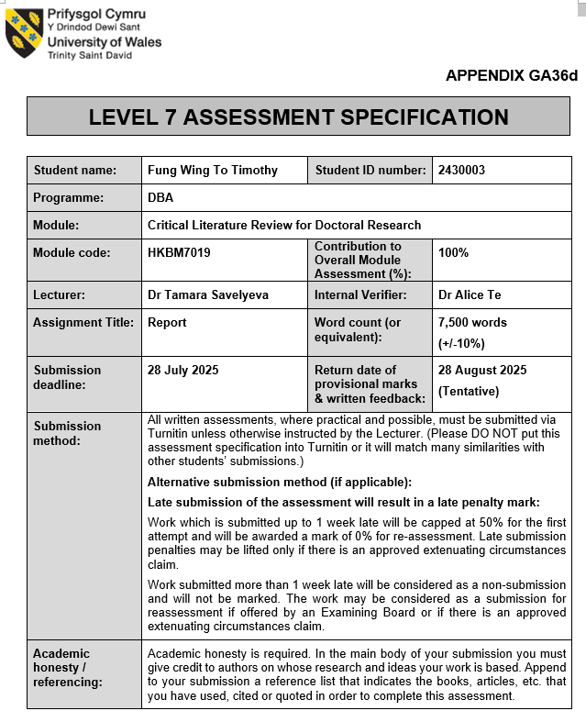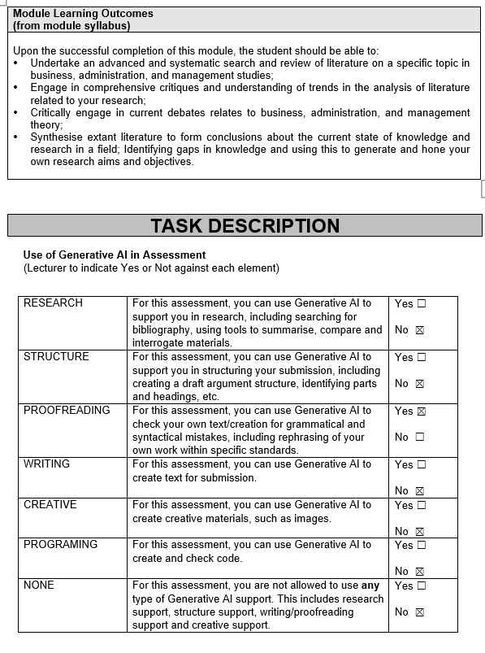

Table of Contents
1. Abstract 4
2. Literature review 6
2.1 Theme Park: Universal Studio 8
2.2 Economic benefit: 10
2.3 Stakeholder 10
2.3.1 Employee 10
2.3.2 Local Merchant 11
2.3.3 Government 12
2.3.4 Tourist 12
2.4 Opposing Economic benefits impact the argument of Scholars 13
2.5 Social benefit: 14
2.6 Hong Kong Local resident 14
2.7 Employee 15
2.8 Local Merchant 16
2.9 Tourist 16
2.10 Opposing Social benefits impact the argument of Scholars 17
2.11 Research Question and Conceptual Framework 19
2.12 Research methodology 21
2.14 Data Collection and Analysis 24
2.15 Research Limitation 24
2.16 Conclusion 24
Reference List 25
3. Annotated Bibliography 30

Research Title: Evaluating the economic and social benefit of establishing universal studio in Hong Kong

1. Abstract
Research Problem
Since the COVID-19 pandemic, all regions have been fully opened up. Hong Kong is facing increasingly fierce regional competition as a global tourism hub. Residents are reluctant to stay in Hong Kong for consumption. Foreign tourists have gradually lost interest in travelling to Hong Kong, resulting in the closure of Hong Kong's catering and retail industries, a decline in people's living standards, an increase in unemployment, and an economic recession, which has caused a severe situation in local economic development, leading to economic and social problems.

Research Purpose and Importance
This study explores the transformation opportunities brought by the proposed new theme park "Universal Studios" in Hong Kong to the tourism and entertainment industry and conducts a strategic investment evaluation, aiming to contribute economic and social benefits to Hong Kong through the plan, and improve local economic and social problems. In addition, as a Financial Center, foreign investors may lose interest in investing in Hong Kong, resulting in a decline in local value. The primary objective of this study is to evaluate the social and economic benefits of setting up Universal Studios in Hong Kong, revitalize the local economy, and turn challenges into opportunities, thereby enhancing the significance and research value of this study.

Research Aim
The primary aim of this literature review is to evaluate the social and economic benefits of establishing Universal Studios in Hong Kong, focusing on the potential to revitalise the local economy, enhance tourism, create employment opportunities for residents, and improve the quality of life for residents. This evaluation will provide stakeholders, including government officials, local businesses, and community members, with insights into the feasibility and implications of the project, as well as the development plan that enhances tourism competitiveness and produces multi-factor effects, thereby adding importance and research value to this study.

Research Gap
Despite existing studies on the economic impacts of theme parks globally, there is a lack of focused research specifically examining the implications of establishing Universal Studios in the unique context of Hong Kong. Most existing literature does not adequately address the intersection of social benefits and economic revitalisation in a post-recession environment. Additionally, there is a lack of exploration of stakeholder perspectives, such as those of residents and businesses, which are crucial for understanding the comprehensive impact of such a development.

Research Question
What are the economic and social benefit of establishing universal studio in Hong Kong?

Between the economic and social benefit of establishing universal studio in Hong Kong, which benefit has a significant impact?

Methodology
In this study, the data collect to evaluate the social and economic benefits of establishing Universal Studios in Hong Kong via interviews, qualitative research, and case studies. Face-to-face interviews and focus groups will be used to gather participants' concerns, expectations, and recommendations by Case study research approach. The target respondent is Hong Kong citizen and tourist. Secondary literature data will be used to provide a foundation for further empirical research results and make proposals for future research plans. The study aims to contribute to the social and economic benefits of all stakeholders.

Limitation
The study assesses the economic and community benefits of construction in Hong Kong. However, it faces challenges in calculating the actual return on investment due to a lack of accurate data, reliance on qualitative methods, and insufficient quantitative data, which limit its comprehensiveness.

Keyword: Theme Park, Job creation, Local Merchant, Social Benefit, Economic Benefit, Stakeholder

2. Literature review
Introduction
Research problem:
COVID-19 has caused significant damage to the economies of all parts of the world, particularly in the tourism, retail, and hotel industries. Starting from 2023, tourists from around the world resumed travel. The economies of places slowly began to recover. Hong Kong's economy and tourism industry did not benefit from it, but instead declined rapidly. This is because Hong Kong people chose to travel abroad for revenge consumption after customs clearance, opting to go to traditional destinations that Hong Kong people typically prefer, such as Japan, and Thailand. In recent years, Hong Kong residents have become accustomed to spending in the north and are less inclined to spend locally.
Free travelers are unwilling to stay, local or foreign consumers choose to shop online. This problem has a significant impact on the business of local physical store retailers. Hotels, tourism and overall economic development are also severely impacted. The economic recession has caused internal problems in Hong Kong, resulting in rising unemployment, economic recession, corporate inflation, and a decline in people's living standards; as for the external situation, due to Hong Kong's status as a financial center, the wave of bankruptcies and layoffs. The economic environment has deteriorated, which has also deterred foreign investors. The entire real economy has been significantly impacted, and society and the economy have also been severely affected.

High rent restrictions on the local business environment, which is difficult for local merchants to stimulate local consumption by reducing prices alone, and it is even more difficult to attract tourists. The existing local cultural industries, such as museums and old-style theme parks like Ocean Park and Disneyland, have a relatively declining attractiveness in their operating models. It is difficult to rely solely on the above-mentioned old industries to revive the economy.

Universal Studios is an example of a thriving local economy that has continued to develop by relying on theme parks. Its business volume has increased on average year over year, which Osaka, Japan, and Sentosa in Singapore, have a significant business volume. Osaka, Japan, is the second-largest city in the world, and its turnover is sufficient to stabilize the regional economy.
In terms of economic benefits, the government has increased taxes due to the rise in tourism and the number of tourists and boosts the local GDP, tourism creates employment opportunities and reduces unemployment.

In terms of the social benefit, which can also drive the benefits of nearby businesses: such as the hotel industry, retail, taxi industry, and construction industry; local citizens also have more choices due to the addition of theme parks, absorbing the culture of different parks and benefiting from the experience value, significantly increasing the local social and economic benefits.

Research Purpose and Importance
Drawing on the successful case of Universal Studios, this study evaluates the feasibility of a new theme park in Hong Kong, the economic and social benefits to stakeholders, and proposes solutions to solve the shortage of tourists and maintain Hong Kong's status as a Financial Center based on the research results. Therefore, this study is of great significance to Hong Kong's future social stability and economic stimulus

Research Gap
In terms of research gap, there is a lack of research on the construction of Universal Studios in Hong Kong in the past. Moreover, research on the intersection of a community and economic benefits after an economic recession is scarce. Additionally, there is a lack of research from the stakeholders' perspective. Therefore, the results of this study will increase the research value.

Research Aim: The primary goal of this research is to assess the impact of Universal Studios Hong Kong on the local community and economy. The research will focus on relevant stakeholders, including the government, Hong Kong citizens, competitors, employees of related industries, and foreign tourists.

Scholar’s argument
On the contrary, according to previous studies, the cost of establishing new projects is substantial, and the construction process also causes environmental problems (Li and Liu, 2019), such as air pollution, traffic congestion, and the impact of construction site selection on people's livelihood. In addition, some scholars have highlighted the challenges of return on investment, a topic that is a matter of controversy.

2.1 Theme Park: Universal Studio
Global Market Insights predicts a 5.5% annual growth in the global theme park market, reaching $132.5 billion by 2032 (GMI, 2024). Japan's National Tourism Organisation ranks theme parks among the top three tourist destinations, highlighting their significant contribution to a region's tourism industry.

Since Disneyland's opening in 2005, Hong Kong has not established any new international theme parks. However, Shenzhen is set to have Legoland, and Beijing and Shanghai have already established large international theme parks. To compete with other city clusters, Hong Kong should develop "Universal Studios Hong Kong" and use its soft power to effectively tell its story.

Universal Studios, a renowned theme park in Japan, was built in 2001, following the development of Singapore's "Singapore Special Economic Zone" and Beijing's "Singapore Special Economic Zone" in 2011. The park has gained popularity since 2014 with the addition of Harry Potter land, surpassing Tokyo Disneyland. The cost of building the park, which cost 2.3 billion yen, has been praised by the Japanese, who have praised it for its strong Western influence and global influence.

Revenue:
Universal Studios' parent company reported a decrease in visitor and revenue in the last three months of 2024 compared to 2023, but the revenue of its international theme parks increased, with Universal Studios Japan and Beijing contributing to a 0.1% increase in revenue to US$2.374 billion. (Niles, 2025).

Hollywood Universal Studios Tourism Statistics
Hollywood Universal Studios attracted 9.66 million visitors in 2023(Fig.1), 15% increase from the 9.1 million recorded in 2019. The number of visitors fell to 1.3 million in 2020 due to the pandemic, but rebounded from 5.5 million to 8.4 million from 2021 to 2022. The number reached 9.66 million in 2023, surpassing the previous record and increasing by 15% over 2022(Road Genius,2024).

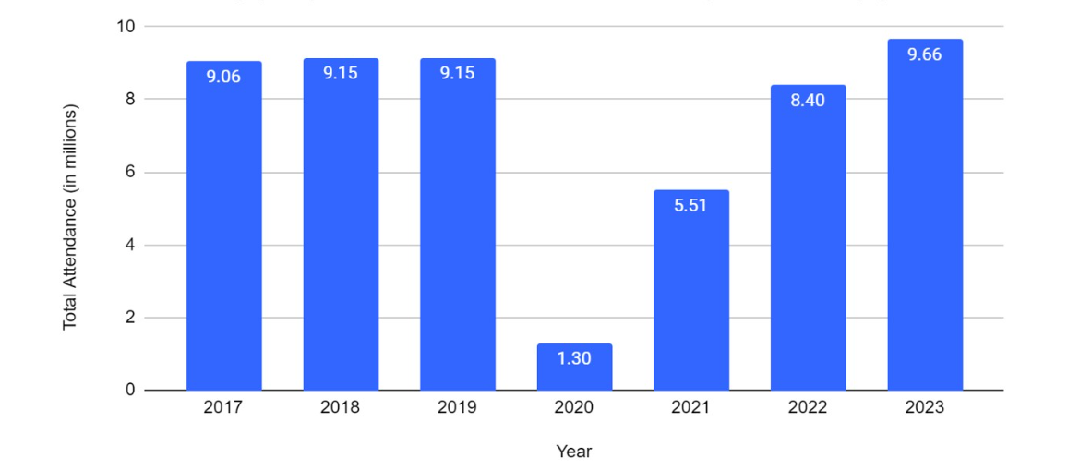
Fig.1 Number of people visit Universal Studios Hollywood Source from Road Genius(2024)

Comcast predicts Universal Studios theme park revenue will rise 18.6% in 2022 and $8.95 billion in 2023(Fig2), a four-fold increase from $2.09 billion before the pandemic. Ordinary ticket price: VIP experience tickets range from $109 to $379.
The average family dining expenses are $60 per month, while parking fees are $17. Hotel prices range from $75 to $400, depending on the number of tourists and location (Road Genius,2024).

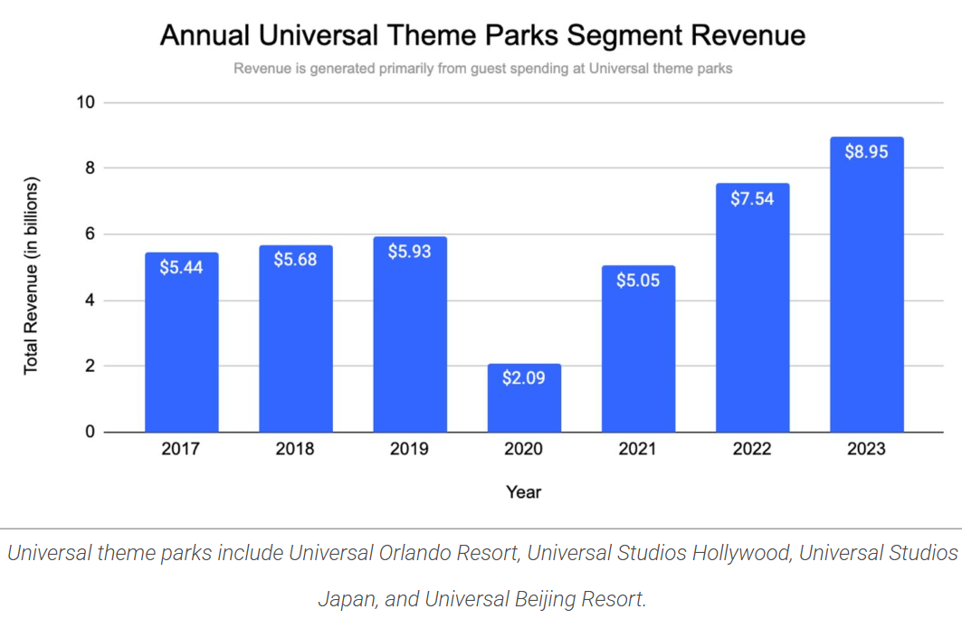
Fig.2 Visitors spend in Universal Studios Hollywood Source from Road Genius(2024)

2.2 Economic benefit:
Economic benefits refer to the return on investment or financial value gained or lost by a project or policy for a business, government, or the public after a decision is made (Spacey, 2018), which can involve a country, a business, or a city (Schaltegger et al., 2017). Common types of economic benefits include job creation, tax revenue, quality of life, productivity, property value, efficiency, and social capital (Scandizzo, 2021).

2.3 Stakeholder
Stakeholders define the business and organisational management approach that creates multiple benefits for different persons or groups, such as governments, civil society, suppliers, customers, and employees. (Schaltegger et al., 2019). Phillips et al. (2003) clearly stated the implications of stakeholder theory, believing that the focus should be on the normative theory of corporate social responsibility or business ethics. In contrast, Ibrahim et al. (2023) view stakeholder theory as a foundational framework for understanding and management, extending into other areas such as sustainability and corporate social responsibility and mentioned that the role of stakeholders in formulating and implementing different strategies and decision-making processes is significant.

In this study, we mainly explore the stakeholders of Universal Studios, including the government, Hong Kong residents, Tourists, Employees, and related merchants.

2.3.1 Employee
Job Creation:
Chen(2025) studied how Theme parks increase job creation for employees. The establishment of Universal Studios can create extra job positions, which include direct job headcounts in the theme park and indirectly positions in the related industries of hospitality, retail, and transportation
Direct Employment: The establishment of Universal Studios creates internal job positions in the park, the major administration position included in entertainment, operations, maintenance, and management, which provide stable employment opportunities.
Indirect Employment: The indirect employment included different sectors, such as:
Hospitality: Hotels, accommodation services, and management experience increase demand, and other industries, including housekeeping and food services, are also in demand.
Retail: Local shops and malls benefit from increased foot traffic, leading to hiring in retail management, sales, and customer service.
Transportation: Increased visitor numbers, combined with some public services, create different job opportunities, such as taxis and ride-sharing services.

2.3.2 Local Merchant
Economic development
Zhang et al. (2021) highlight Universal Studios' successful marketing strategies for Japan during the COVID-19 economic recession, providing an investment value example for other businesses. Hong Kong's Theme Park benefits citizens and tourists, and the government plays a significant role in the project's development, including infrastructure policy, site selection, transportation planning, and hotel construction. These projects have shown favourable returns and economic benefits, particularly in supporting Osaka, Japan's economy during the severe COVID period. Universal Studios' tenacity in supporting the entire economy during the COVID-19 pandemic demonstrates its operating ability.

Construction: When the government develops theme park infrastructure and transportation planning, it creates a large number of jobs, reducing the unemployment rate.

Hotel: The development of Universal Studios' hotel facilities enhances the park's visibility and attracts tourists to stay and spend money, which is undoubtedly a boost to Hong Kong's tourism industry. Additionally, hotel construction increases the demand for work positions, which include both permanent and temporary employees, thereby directly creating employment opportunities after the hotel's completion. Moreover, the hotel can also cooperate with foreign consortiums to strengthen investment cooperation opportunities between the government and international investors (Li et al., 2018).

Retail trading: As the number of tourists increases, it benefits retailers and shops around the theme parks, accelerating the pace of economic recovery. The Kowloon City retail business experienced positive growth when the Kai Tak stadium hosted events or concerts. Sung (2021) agreed that the joint operation of enterprises from different countries can internationalise the business and diversify business development.

Catering service: The increased foot traffic in parks could lead to increased sales and the construction of more dining venues, benefiting restaurants and cafés. Retail establishments may use the surge of travellers seeking souvenirs and regional merchandise.

Service Providers: Local tour service, transportation services, increased demand from Theme Park visitors.

2.3.3 Government
A government refers to a system or group of people that governs an organised community (usually a country), typically composed of legislative, executive, and judicial branches, as well as the mechanisms that implement organisational policies, make decisions, and execute these policies. In some countries, the government possesses a constitution, which is a statement regarding its governing principles and philosophy (Fasenfest,2010).

Tax Revenue
The investment generates tax revenue for the government, which can be allocated to public services and infrastructure. Heo & Lee (2009) studied the theme park industry and found a positive relationship with effective strategy in revenue management planning.

Direct Tax Contributions: The creation of Universal Studios produces primary tax income via below factors:
The park generates corporate profit will contribute to the tax income.

Sales Taxes: When visitors increase their spending, it benefits tax revenue for governments.

Employment Taxes: Creating jobs can increase employee income and, in turn, boost tax revenue in the park and related industries.

Reinvestment in public services: When the government receives more tax revenue, it can invest more in public services, which contribute to improving the quality of life of citizens, such as education, healthcare, and community facilities.

2.3.4 Tourist
Tourism growth:
Milman and Tasci (2018) found that customers feel satisfaction differently based on personal status, including gender, age group, family customers, couple customers, and older customers, who have different experiences, which affect their satisfaction and loyalty. Universal Studios attracts both domestic and foreign tourists, thereby increasing Hong Kong's overall tourism revenue. This can increase consumption in hotels, restaurants and other attractions.
Increased number of tourists: Universal Studios attracts both domestic and foreign tourists, which enhances Hong Kong's appeal as a tourist destination and improves the overall tourist experience, thereby drawing a large number of visitors.
Increased consumption: Visitors who visit Universal Studios spend more on various services, including:

Accommodation: Hotel occupancy and revenue increase.

Catering: Increased opportunities for tourists to choose restaurants in or near the park, thereby promoting sales in the catering industry.

Improve the quality of competitors' services: Ocean Park and Disney are Universal Studios' main competitors. Under healthy competition, the improvement of services in each park or the introduction of discounts to increase attractiveness will benefit tourists. Barnes et al. (2016) discovered that some customer loyalty stems from old memories and experiences, even though the theme park has undergone restructuring, which does not influence the customer's perception.

2.4 Opposing Economic benefits impact the argument of Scholars
Universal Studios' investment in Hong Kong can offer various benefits. Conversely, there are also potential negative economic impacts argument by scholars to consider:
Job stability and quality: Most jobs in theme park construction and operation are temporary, seasonal, or part-time, which can lead to economic instability for workers and significantly impact employee well-being. Milman & Dickson (2014) disputed that part-time employees have negative experiences and reduced performance.
Employment inequality: There are differences in employment opportunities, and certain groups (such as religion or nationality) face barriers to employment opportunities, leading to social tension and unfairness.
Wolcott (2021) argued that employment inequality leads to the loss of low-skilled employees, reduced loyalty, and low demand.
Over-reliance on tourism: The local economy is overly dependent on tourism. When a recession or special events cause the economy to lose balance and the number of tourists suddenly decreases significantly, it has a negative impact on all stakeholders, including those related to epidemics or social conflicts.
Competitive pressure: Local small businesses struggle to compete with large theme park operators, resulting in small-scale profit losses, business closures, reduced competitiveness, and a loss of employment opportunities. Soewarno et al. (2020) claimed that pressure from competitors will lead to vicious competition among small firm businesses, resulting in bankruptcies and increased unemployment.
Profit repatriation: The profits of theme parks need to be repatriated to the parent company. Investment decision-making and management rights belong to the parent company, and the subsidiary is restricted in economic development decisions. The Hong Kong government has no objection. Parnreiter et al. (2024) defended the master company's profit repatriation policy, which generates profits, and examined the unfair development under this policy.

2.5 Social benefit:
Social benefit defined as a government or organization that carries out policy or projects that benefit for society and people involved in project (Resnik,2018). In this study, the biggest beneficiaries of the proposal of establishing Hong Kong Universal Studio are stakeholders, including Hong Kong citizen, employee, local merchant and tourist.

2.6 Hong Kong Local resident
Quality of Life:
Sung (2021) found that Customers can also deepen their experience and understanding of different cultures, thereby improving their quality of life. The park offers local families additional theme park options, attracting them to stay in Hong Kong for consumption, and thereby enhancing the overall quality of life by creating a new tourist attraction that integrates entertainment, dining, and leisure. Low-income families can enjoy the facilities of Universal Studios without having to travel out of town and can also save on transportation costs.

Cultural exchange:
Chang & Pang (2018) examined Universal Studios Singapore and China's efforts to promote cultural exchange through attractions, community events, and educational programs. They found that these activities foster social cohesion and community participation, fostering a sense of belonging and pride among residents. They also suggested that organizations could set up team building programs in the park to allow employees from different nationalities to participate in cultural exchanges and team chemistry.

Accessibility: Parks can offer ticket discounts, special promotions or community days for holidays or special days (such as local birthday discounts, Halloween or Christmas). These special events can further enhance the experience for both residents and tourists. Ryan et al. (2010) investigated the relationship between exceptional experiences and customer loyalty, which included ticket prices as a factor.

2.7 Employee
Employment Opportunities:
Chen (2025) stated that building Theme parks increases job creation and reduces the unemployment rate.

Direct Employment: The Park creates direct job opportunities across various industries, including: Transportation, Hotel, Construction, Retail, and Catering

Attractions and entertainment:
Responsible for operating amusement facilities, role-playing and live performances. Theme parks can regularly invite singers to hold concerts in the park as an attraction to increase the number of stage and technical personnel employed.
Compared with physical fireworks, drone fireworks shows are more environmentally friendly and can also reduce costs, create more employment opportunities for professional technicians, and make greater contributions to society. Tafere et al. (2021) studied the growth of the tourism industry and believed that the growth of the tourism industry has a positive impact on the creation of employment demand.

Catering services: There is a great demand for jobs in restaurants, cafes, and snack stands in the park. A large number of job openings have increased job opportunities for catering staff.

Maintenance work, customer service and security: responsible for ensuring that the park remains safe and clean, and there is an excellent demand for plant maintenance personnel and efficient operation staff. Ryan et al. (2010) measured customer loyalty, which included rest area size, park cleanliness and safety.

Skill Development: Universal Studios offers training and development opportunities for employees, focusing on customer service, management, and technical skills. This enhances professionalism, career development, and employability, leading to higher productivity. Kiss (2004) suggests partnership planning between employment and education can boost economic growth and tourism development.

Indirect job creation: As Central Park is built to accommodate the growing number of visitors, this investment will bring employment opportunities to the surrounding areas, and the demand for positions in different industries will also increase, such as hotels, catering, transportation services, and guides and drivers in the local tourism industry. This chain reaction can significantly promote the development of the local job market.

2.8 Local Merchant
Businesses around the park usually welcome more tourists, thus promoting the growth of the local economy.

Increased business opportunities: Local businesses near Universal Studios benefit from the arrival of park visitors, including hotels, shopping malls and restaurants. This can lead to higher sales in the relevant industries, creating business opportunities to attract new investors or generate start-up opportunities. For example, Hong Kong Disneyland can drive hotel accommodation, shopping malls and catering industries in Tung Chung District. Ocean Park can also drive demand for restaurants and hotels in Ap Lei Chau, Hong Kong Island. Zerjav (2021) stated that cooperative operation will be better than a sole proprietorship, which can increase value creation and project value.

Retail stores: The Park can attract tourists with souvenirs of cartoon characters and local products in the park, increasing retail sales.

Service providers: Guides of local travel agencies, drivers of transportation services such as taxis, special line transportation and other corporate investors can also increase investment and development.

Community development: With the development of theme parks, not only has the overall economic development of the area increased, but also the vitality and momentum of Hong Kong's development have increased.

2.9 Tourist
Cultural exchange: Universal Studios can promote cultural exchange by presenting diversified stories and local themes that resonate with local tourists, thereby deepening the understanding of themes launched by international audiences in different regions. This approach increases tourists' experiences and promotes cultural understanding and appreciation.

Community participation:
Lee & Lambert (2005) studied the relationship between service quality and customer satisfaction and loyalty, which is both direct and indirect, depending on the waiting time for entry or the theme park game. Theme parks attract citizens from different regions to interact through events, festivals and promotions, creating a sense of participation and pride for local tourists. The interaction fosters a connection between the park and its residents. In recent years, due to the international success of the Hong Kong movie "Kowloon Wall City", the Tourism House has specially created theme exhibitions at Hong Kong International Airport and shopping malls to promote local Hong Kong movies and local community culture for tourists.

Enhance public awareness:
Spinks et al. (2005) believe that the theme park level influences customers' satisfaction with the experience, as the theme park always offers new promotions for its target customer group. By hosting local cultural and traditional activities, the park helps increase public awareness of Hong Kong's unique identity and encourages tourists and residents to appreciate the region's history and traditions. For example, famous Hong Kong movie stars include Bruce Lee, Jackie Chan, and Chow Yun-fat, whose fame and past film works are quite prominent on the international stage. In addition to featuring special areas dedicated to famous American movies, Universal Studios Hong Kong can also create a dedicated area for Hong Kong movies to attract and satisfy different types of tourists, thereby increasing tourists' satisfaction and emotional well-being.

2.10 Opposing Social benefits impact the argument of Scholars
While Universal Studios' investment in Hong Kong can offer various benefits. Conversely, there are also potential negative social benefits impacts argument by scholars to consider:
Impact on the cost of living of residents:
The development of Universal Studios will push up the cost of living in the surrounding areas. The rents of commercial and residential properties will rise sharply, forcing them to move out. This will residential structure and weaken community ties. Lee & Lambert (2005) questioned the products of theme parks. In order to cater to the popular characters of theme parks, the lack of novelty in products leads to customer loss.
Transportation issues: The planning and construction of tourist attractions will lead to road closures and diversions, which will directly affect the travel of nearby residents. In the long run, the price of park tickets will rise. The increase in transportation prices will increase the transportation costs of nearby residents; at the same time, during peak seasons, the park is crowded with people, and traffic congestion directly affects the lives of the original residents. Wondifraw (2007) believes that backward transportation and facilities will reduce the attractiveness and revisit rate of tourists.

Waiting a long time can negatively impact a brand's image.
Li (2010) argued that most theme parks lack attention to and test customer behaviour during physical waiting time, which can lead to the customer having a negative brand image of the theme park.
Seasonal fluctuations: Although tourism can promote economic development, it can also lead to instability. The decrease in tourist numbers during the off-season puts local businesses at risk of financial loss and increases the unemployment rate.
Resident migration: Park construction occupies land, forcing original residents or businesses to relocate, causing social unrest and leading to the loss of community ties. Huang et al. (2023) pointed out that new development areas have a significant negative impact on low-income people.
Overcrowding: The increase in the number of tourists leads to overcrowding near the park, which affects the original quality of life for nearby residents. Traffic congestion, noise, and reduced loyalty due to a decreased visitor experience and satisfaction have been identified as key issues. Fu et al. (2017) argued that self-congruity has a significant impact on loyalty.
Loss of local culture: Universal Studios is an original concept that brings together global entertainment themes, which is being built in Hong Kong. Zhang et al. (2021) argued that the company accommodates tourists for commercial reasons, and the products and services launched will lead to the commercialization of local culture, thereby weakening its tradition and authenticity.
Social Stratification
Employment opportunities are dominated by certain ethnic groups, leading to greater economic inequality within the community. Hong Kong has established minimum wage regulations, which leads to unfair treatment of individuals of different nationalities, languages and educational backgrounds. Williams et al. (2022) studied the demand for meaningful work and found that there is a moderate stratification between high and low levels of job role complexity.

2.11 Research Question and Conceptual Framework
The constructs of theme park in evaluating the benefit of social and economic have been confirmed (Milman et al., 2010).which conceptual framework will adapted in this study to evaluating the economic and social benefits of establishing Universal Studios in Hong Kong. This study framework focuses on key stakeholders, including the government, tourists, employees, local businesses, and residents to explore the reason and how to new theme park effect on social and economic benefits(Fig.3-6).

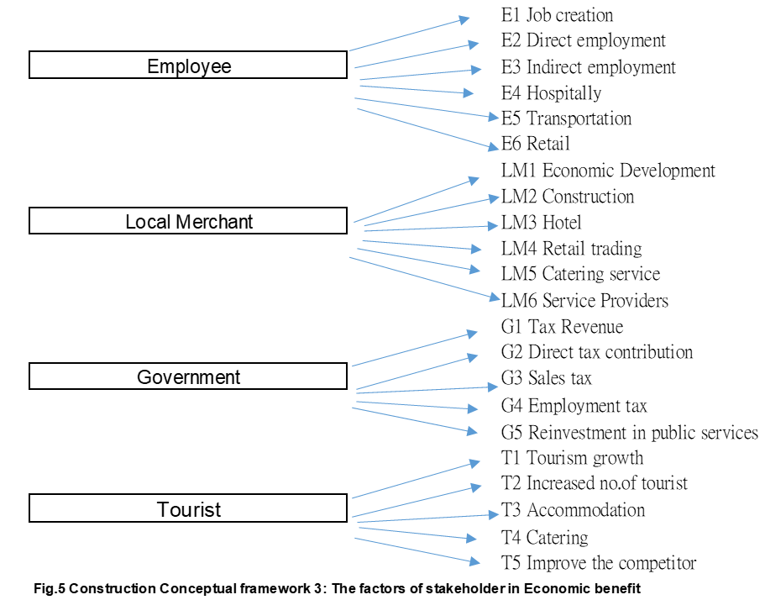

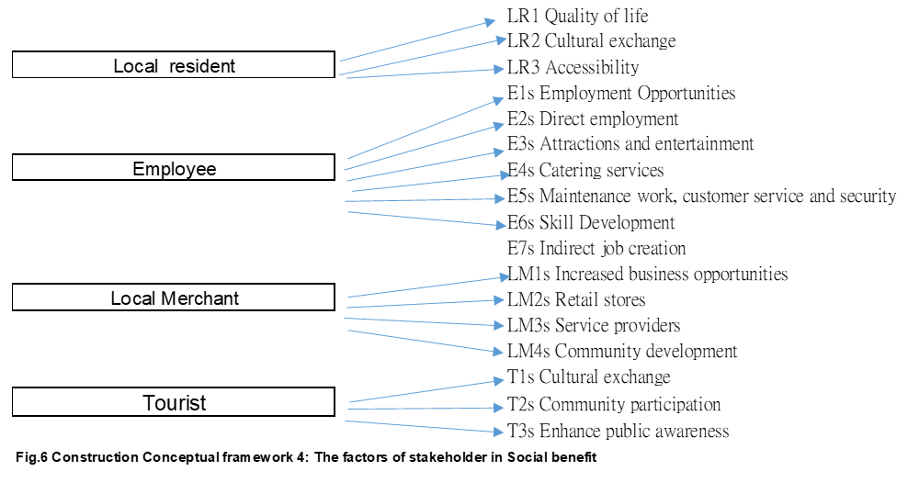

2.12 Research methodology
Research Philosophy
Ontology is a philosophical discipline that examines the nature and attributes of entities(Fig.7), emphasising the structure and interrelations, which grounded on mathematics (Nasution, 2018).
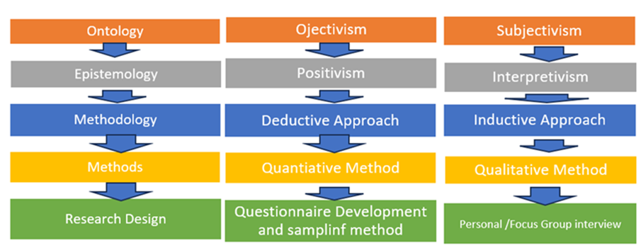
The Ontology contains two types Subjectivism and Objectivism.
Subjectivism and Objectivism are research philosophies and epistemology approaches that evaluate the economic and social benefits of establishing a universal studio in Hong Kong. Subjectivism posits that reality is influenced by human beliefs and actions, and Objectivism assesses scientific outcomes through experience, evidence, observation, measurement, and judgment (Wright et al., 2013). The study focuses on multi-stakeholder analysis.
This study assesses the economic and social benefits of establishing a universal studio in Hong Kong, using a subjectivist ontology of research philosophy and the epistemology of Interpretivism (Neuman, 2006), which focuses on the multi-stakeholders involved in establishing a Hong Kong universal studio.
The article from Milman et al.(2010)and Li and Liu(2019)used objective ontology and review method to identified the contribution from Theme park for benefit of social and economic, and new public project for social benefit which are finding were identified; this study will adapt its variables to evaluating the economic and social benefit of establishing universal studio in Hong Kong.
Epistemology
Epistemology is a philosophical field that examines the categories, sources, boundaries, and values of knowledge, including moral concerns, factual information, value judgements, restrictions, social effects, and personal importance (Stein, 2018).
Epistemology encompasses two categories:
Positivism employs existing scientific theories to analyse facts (Lincoln et al., 2011), while Interpretivism leverages observation and experience to assess social systems inductively (Flick, 2014).
This research will employ interpretive epistemology to examine the variables that affect the benefits of various stakeholders in social and economic contexts, investigating the proposed findings through theoretical and qualitative analyses (Denzin & Lincoln, 2005).

2.13 Research Approach
The inductive method involves observing and experimenting with assumptions (Bryman, 2008), using empirical experience to gather materials and assess the believability (Saunders et al., 2019). Qualitative approaches use brief questionnaires to understand subjective interpretations of individuals or focus groups, utilizing in-depth cognitive sensitivity and focused surveys to synthesize meanings and construct new viewpoints and ideas (Creswell, 2014). Both methods help in understanding and assessing the believability of specific facts (Merriam, 2009).
This study employs an inductive approach with a qualitative method to evaluate the economic and social benefits of establishing a universal studio in Hong Kong. This research employed descriptive and reliability testing to measure reliability, and the qualitative data from the focus group were used for cognitive sensitivity testing. The pros are saving time and money. Moreover, large sample sizes are used to test theories (Neuman, 2006) and to elucidate and address research problems (Kothari, 2007).
Research Design
This research utilized an actual questionnaire to enable the examination of sample sizes and qualitative methodologies via focus groups, using objective questionnaire responses from participants (Kamper, 2020).
Questionnaire Development and Measurement table
The focus group survey will consist of seven customised questions in English and Chinese, derived from measurement items, and three inquiries about personal information. The respondents are Hong Kong citizens and tourists, who can respond from a personal viewpoint. The questionnaire was used for pilot testing, formal sampling, and a half-hour face-to-face focus group interview.
Content Validity
The questionnaire was created using variable measurement table items from Milman et al.(2010) and Li and Liu(2019) to ensure its validity and reliability through the identification and publication of its questions.

Pilot testing
A pilot test used a qualitative method to collect primary data through face to face interview. The target respondents are 20 of the Hong Kong citizens and tourists

  - Sampling Method, Sample Size and Respondents
This research employs a voluntary sampling method (Murairwa,2015),with a minimum sample size of 60, which formula N>50+8(m), where m refers to the number of independent variables by Tabbachnick & Fidell( 2019), using qualitative methods like face-to-face interviews or focus groups for primary data collection.

Target Respondents
The participants included both males and females, aged between 18 and 70 years, including Hong Kong citizen and visitors (Kamper, 2020).

2.14 Data Collection and Analysis
Case study analysis
Case study approach refers to recording the interviewee’s experience and memory of a case, allowing the researchers to understand in detail the impact, feeling and cognition of the case on the interviewee (Priya,2020).
In this study, the research method employs qualitative method for data collection, and Case Study analysis primary data, aiming to conduct a comprehensive evaluation of the social and economic benefits of establishing Universal Studios in Hong Kong, and response the research question. The qualitative method were employed via face-to-face interviews and focus groups with multi-stakeholders to collect participants' concerns and expectations, and via Case Study analyses the data, last step via the research result provide the recommendations.
Additionally, this study employs secondary literature data as a research method to lay the foundation for further empirical research results and make deeper proposals for future research plans. It is hoped that this study will contribute to the social and economic benefits of all stakeholders in Hong Kong.

2.15 Research Limitation
This study estimates the economic and community benefits that the construction will bring to Hong Kong. There is a lack of accurate data to calculate the return on investment in the economic benefit forecast, and difficult to calculate the actual return on investment from the economic benefit. Furthermore, this study only employs qualitative methods, lacks quantitative methods, which is not comprehensive, and the amount of data is insufficient.

2.16 Conclusion
In conclude, this study contributes to literature by evaluating the economic and social benefits of establishing HK Universal Studios, and makes more effective recommendations and contributions to project stakeholders via research methods and result. The structure of this review is introduction, next section summarizes the stakeholder’s benefits in economic and social when establishing universal studio in Hong Kong; and scholar’s argument on related research topic. The last section conclusion.

Reference List
Barnes, S. J., Mattsson, J., & Sorensen, F. (2016). ‘Remembered experiences and revisit intentions: A longitudinal study of safari park visitors’. Tourism Management, 57, 286 294

Bryman.A (2008)’ Social Research Methods’. Oxford University Press, London UK

Chang, T. C., and Pang, J. (2018). ‘Between universal spaces and unique places: Heritage in Universal Studios Singapore’. In Theming Asia (pp. 66-84). Routledge.

Chen.Y(2025) ‘Analysis of the Marketing Strategy of Universal Studios Beijing under the Cross Cultural Background’. Advances in Economics management and political sciences 184(1):45
DOI: 10.54254/2754-1169/184/2025.BL23226

Creswell, J. (2014) ‘Research design: qualitative, quantitative, and mixed methods approaches’. Thousand Oaks, California: SAGE Publications, Inc

Denzin, N., & Lincoln, Y. (2005) ‘The Discipline and Practice of Qualitative Research’. In The Sage Handbook of Qualitative Research (3rd ed., 1-32). Thousand Oaks, CA: Sage Publications.

Fasenfest,D.(2010) “Government, Governing, and Governance”, Critical Sociology 36(6) 771-774

Fei, W., Zhang, Z., & Deng, Q. (2021, October). ‘Universal pictures’ SWOT analysis and 4Ps & 4Cs marketing strategies in the post-COVID-19 era’. 2021 International Conference on Public Relations and Social Sciences (ICPRSS 2021) (pp. 494-500). Atlantis Press.

Flick, U. (2014) ‘An introduction to qualitative research’. SAGE Publications: London

Fu, X., Kang, J., & Tasci, A.D.A. (2017). ‘Self-congruity and flow as antecedents of attitude and loyalty towards a theme park brand’. Journal of Travel & Tourism Marketing, 34(9): 1261-1273.

Heo, C.Y. and Lee,S.(2009) ‘Application of revenue management practices to theme park industry’. International journal of hospitality management, Vol 28 (3)

Huang,Y.,Li,V.J., and Wang,D.(2023) ‘New town development and housing affordability: A case study in Hong Kong’. Sage Journals Vol 51(3)

Ibrahim,Y., Ahmed, M. M., & Nayel, M. T. (2023). ‘The impact of corporate social responsibility practices on employees’ engagement: The mediating role of organizational identification’. Global Business and Organizational Excellence.

Kamper,S.J (2020) ‘Types of Research Questions: Descriptive, Predictive, or Causal”. Journal of Orthopaedic & Sports Physical Therapy. Vol 50 (8) (413-469) https://doi.org/10.2519/jospt.2020.0703

Kiss,A. (2004) ‘Is community-based ecotourism a good use of biodiversity conservation funds?’ Trend in Ecology & Evolution,19(5),232-237

Kothari, C. R. (2007) ‘Research Methodology: Methods and Techniques”. New Delhi: New Age international (P) limited, publishers.

Lee, W. & Lambert, C.U. (2005). ‘The effect of waiting time and affective reactions on customers’ evaluation of service quality in a cafeteria’. Journal of Foodservice Business Research, 8 (2), 19-37.

Li,S and Liu,L(2019) ‘Social Benefit Evaluation of Passive Design of Green Buildings’, E3S Web of Conferences 118, 03047. Doi.org/10.1051/e3sconf/201911803047

Li,T.,Liu,J.,and Zhu,H.(2018) ‘The international investment in theme parks: Spatial distribution and decision-making mechanism, an empirical study for China’ Tourism management, Vol 67, 342-350

Li, W. L. (2010). ‘ Impact of waiting time on tourists satisfaction in a theme park: An empirical investigation’. Industrial Engineering and Engineering Management (434-437).

Lincoln.YS, Lynham. SA & Guba.EG (2011) ‘Paradigmatic controversies, contradictions, and emerging confluences’. The SAGE Handbook of qualitative research, SAGE, London UK

Mahajan et al(2023) ‘Stakeholder theory’, Journal of Business Research 166 ,114104

Merriam, S. B. (2009) ‘Qualitative Research: A Guide to Design and Implementation’. San Francisco, CA: John Wiley & Sons

Milman,A.,& Dickson,D.(2014) ‘Employment characteristics and retention predictors among hourly employees in large US theme parks and attractions’. International Journal of Contemporary Hospitality management, Vol 26 (3):447-469

Milman,A., Okumus,F & Dickson,D.(2010) ‘The contribution of theme parks and attractions to the social and economic sustainability of destinations, Worldwide Hospitality and Tourism Themes 2(3):338-345
DOI:10.1108/17554211011052249

Milman, A., & Tasci, A. D. (2018). ‘Exploring the experiential and sociodemographic drivers of satisfaction and loyalty in the theme park context’. Journal of Destination Marketing & Management, 8, 385-395.

Nasution,M.K.M.(2018) ‘Ontology’. IOP Publishing Ltd. Journal of Physicscial: Conference Series. Vol 1116, Issue 2

Neuman,W.L.(2006) “Social Research Methods:Qualitative and Quantitative Approaches.6 ed”.USA:Pearson International Edition

Niles,R.(2025) ‘Universal's theme parks report lower revenue, earnings in 2024’.Theme park insider. Available at: https://www.themeparkinsider.com/flume/202501/10693/(Accessed: 22 July,2025)

Parnreiter,C.,.Steinwarder,L. & Kolhoff,K.(2024) ‘Uneven development through profit repatriation: How capitalism’s class and geographical antagonisms intertwine.’ Antipode vol.56(6),2343-2367

Phillips, R., Freeman, R. E., & Wicks, A. C. (2003). ‘What stakeholder theory is not’. Business Ethics Quarterly, 13(4), 479–502.

Priya,A.(2020) ‘Case study methodology of qualitative research: key attributes and navigating the conundrums in its application’. Sage Journals. Vol 70(1)

Resnik,D.B.(2018) ‘Examining the social benefits principle in research with human participants’. Health Care Anal. Vol 26(1)

Road Genius(2024) ‘Universal Studios Hollywood Tourism Statistics’. Road Genius. Available at: https://roadgenius.com/statistics/tourism/usa/universal-studios-hollywood/ (Accessed: 22 July,2025)

Ryan, C., Yeh (Sam) Shih, S., & Tzung-Cheng, H. (2010). ‘Theme parks and a structural equation model of determinants of visitor satisfaction -Janfusan Fancyworld, Taiwan”. Journal of Vacation Marketing, 16(3), 185-199.

Saunders,M.N.K., Lewis,P. ,& Thornhill ,A. (2019) "Research Methods for Business Students" Chapter 4: Understanding research philosophy and approaches to theory development. Research Methods for Business Students (128-171)

Scandizzo,P.L.(2021) ‘ Impact and cost–benefit analysis: a unifying approach’. Journal of Economic Structures vol 10

Schaltegger, S., Horisch, J., & Freeman, R. E. (2017). ‘Business cases for sustainability: A stakeholder theory perspective’. Sage journals, 32(3), 191–212.

Soewarno,N.,Tjahjadi,B.,& Perma-Tanadia,D.(2020) “Competitive pressure and business performance in East Java Batik industry”,Journal of Asian finance economic and business 7(12):329-336

Spinks, W., Lawley, M., & Richins, H. (2005). ‘Satisfaction with Sunshine Coast tourist attractions: the influence of individual visitor characteristics’. Journal of Tourism Studies, 16(1), 12-24.

Stein, N.( 2018) ‘Definition and the Epistemology of Natural Kinds in Aristotle’. Metaphysics, 1(1): 33–51, DOI: https://doi.org/10.5334/met.8

Sung, N. C. (2021) ‘The Glocalization of Shanghai Disneyland’. Routledge

Tabachnick, B. G., & Fidell, L. S. (2019). “Using Multivariate Statistics (7th ed.).” New York: Pearson Publishers.

Williams,M.,Gifford,J.,and Zhou,Y.(2022) ‘Social stratification in meaningful work: Occupational class disparities in the United Kingdom’. The British Journal of Sociology, Vol73(3):563-553

Wolcott,E.L.(2021) ‘Employment inequality: Why do the low-skilled work less now?’ Journal of monetary economics. Vol 118,161-177

Wondifraw,T.(2007) ‘Community-based ecotourism impact: The case of Adaba-Dodola protected forest.” MA thesis, Bale zone, Oromo, Addis Ababa University

Wright, J. C., Grandjean, P. T., & McWhite, C. (2013) ‘The meta-ethical grounding of our moral beliefs: Evidence for meta-ethical pluralism’. Philosophical Psychology, 336–361.

Zerjav,V (2021) ‘Why do business organizations participate in projects? Toward a typology of project value domains’ Sage journals. Vol 52(3)

Zhang,Z.,Liang,Z.,and Bao,J.(2021) ‘From theme park to cultural tourism town: Disneyization turning of tourism space in China’,Regional Sustainability ,2, 156-163

3. Annotated Bibliography

Acquah, I. S. K., Baah, C., Agyabeng-Mensah, Y., & Afum, E. (2023). ‘Green procurement and green innovation for green organizational legitimacy and access to green finance: The mediating role of total quality management’. Global Business and Organizational Excellence, 42(3), 24–41.
This article examined the relationship between green industry, green finance and quality management, and further studied the pros and cons of stakeholders' managers, which reference value of learn in the social benefits of stakeholders in this study.

Barnes, S. J., Mattsson, J., & Sorensen, F. (2016). ‘Remembered experiences and revisit intentions: A longitudinal study of safari park visitors’. Tourism Management, 57, 286 294
The article examined customer revisitation from memory and psychological perspectives, revealing that long-term memory significantly influences experiential emotions and makes customers more likely to revisit, which provides valuable insights into tourist loyalty in this study.

Bryman.A (2008)’ Social Research Methods’. Oxford University Press, London UK
This book explained research method on social science, which was data collecting skills for public, and using qualitative research method to collecting the data, which contribute for scholars and right to apply in this study.

Chang, T. C., and Pang, J. (2018). ‘Between universal spaces and unique places: Heritage in Universal Studios Singapore’. In Theming Asia (pp. 66-84). Routledge.
Universal Studios research on Singapore's cultural heritage suggests integrating local culture into Hong Kong Universal studios, but scholars question if uniqueness is exploited. The information right to apply on social benefit competitor in this study

Chen.Y(2025) ‘Analysis of the Marketing Strategy of Universal Studios Beijing under the Cross Cultural Background’. Advances in Economics management and political sciences 184(1):45
DOI: 10.54254/2754-1169/184/2025.BL23226
The article explores Beijing's Universal Studios and its marketing strategy, revealing that achieving unique success alone is challenging. It suggests that collaborating with local businesses is crucial for success. The information right to apply exploring how catering and retail industries can collaborate with local business groups to contribute to the economy and achieve success in this study

Choi ,E. K. C., Zhao, J., Joung, H. , and Suh, E. (2014) ‘Conceptual Framework for the Relationships among Job-Training Satisfaction, Job Satisfaction, and Turnover Intention in Foodservice Operations’. Journal of Culinary Science & Technology, 20(5):11-15
This article explained how to design the conceptual framework for the relationship between variables, which helpful to apply on construct my research framework application in this study

Creswell, J. (2014) ‘Research design : qualitative, quantitative, and mixed methods approaches’. Thousand Oaks, California: SAGE Publications, Inc
This book explained research method included mix method, which can compare the approach for different collection method. Specially on qualitative research method skills, which contribute to apply in this study.

Denzin, N., & Lincoln, Y. (2005) ‘The Discipline and Practice of Qualitative Research’. In The Sage Handbook of Qualitative Research (3rd ed., 1-32). Thousand Oaks, CA: Sage Publications.
This book explained research method on basic concept and practicing the qualitative research method to collecting the data, which contribute for scholars, and the above article is fit to apply in this study.

Fasenfest,D.(2010) “Government, Governing, and Governance”, Critical Sociology 36(6) 771-774
This article outlines defined government and governance, which can contribute to other scholars and article journals, which can apply the reference value of study a new theme park.

Fei, W., Zhang, Z., and Deng, Q. (2021, October). ‘Universal pictures’ SWOT analysis and 4Ps & 4Cs marketing strategies in the post-COVID-19 era’. 2021 International Conference on Public Relations and Social Sciences (ICPRSS 2021) (pp. 494-500). Atlantis Press.
The article confirmed Universal Studios' use of the SWOT method in marketing strategy, enhancing its streaming platform. The information right to apply on social benefit attract tourists and contribute to the economic benefit in this study

Flick, U. (2014) ‘An introduction to qualitative research’. SAGE Publications: London
This book explained research method on basic concept and using qualitative research method to collecting the data, which contribute for scholars, and the above article is fit to apply in this study.

Fu, X., Kang, J., & Tasci, A.D.A. (2017). Self-congruity and flow as antecedents of attitude and loyalty towards a theme park brand. Journal of Travel & Tourism Marketing, 34(9): 1261-1273.
The article confirmed Self-congruity and loyalty is significant factor for theme park brand, which contribute to understand the traveller and apply in this study

Heo, C.Y. and Lee,S.(2009) ‘Application of revenue management practices to theme park industry’. International journal of hospitality management, Vol 28 (3)
This article explained the relationship between revenue management and theme park development, which benefit for understanding the good revenue management skills can be keep the health development. The information helpful for the part of economic benefit in this study.

Huang,Y.,Li,V.J., and Wang,D.(2023) ‘New town development and housing affordability: A case study in Hong Kong’. Sage Journals Vol 51(3)
This article point out when new land development projects are launched, low-income people are the passive party and are ignored by the government. The information right to apply on social impact in this study

Ibrahim,Y., Ahmed, M. M., & Nayel, M. T. (2023). ‘The impact of corporate social responsibility practices on employees’ engagement: The mediating role of organizational identification’. Global Business and Organizational Excellence.
The article highlights the significance of corporate social responsibility in enhancing stakeholder engagement and provides a comprehensive analysis of this concept, making it an ideal reference for understanding the definition of stakeholders in study a new theme park.

Kamper,S.J (2020) ‘Types of Research Questions: Descriptive, Predictive, or Causal”. Journal of Orthopaedic & Sports Physical Therapy. Vol 50 (8) (413-469) https://doi.org/10.2519/jospt.2020.0703
This article explained research method on design on type of the research question, and some skills for adapted the content measurement with research method, which helpful to apply on research question application in this study.

Kiss,A. (2004) ‘Is community-based ecotourism a good use of biodiversity conservation funds?’ Trend in Ecology & Evolution,19(5),232-237
This article shown that employment and education is benefit for employee and the importance. The information right to apply on social benefit advance in this study

Kothari, C. R. (2007) ‘Research Methodology: Methods and Techniques”. New Delhi: New Age international (P) limited, publishers.
This book explained research method shown that techniques and skills , which good practice to apply in this study.

Lee, W. & Lambert, C.U. (2005). ‘The effect of waiting time and affective reactions on customers’ evaluation of service quality in a cafeteria’. Journal of Foodservice Business Research, 8 (2), 19-37.
The article confirmed that factors such as waiting time, emotional response, satisfaction, and service quality significantly influence satisfaction, which related results
providing reference value in this research.

Li,S and Liu,L(2019) ‘Social Benefit Evaluation of Passive Design of Green Buildings’, E3S Web of Conferences 118, 03047. Doi.org/10.1051/e3sconf/201911803047
This article examined and confirmed that the new development has contribution for social benefit from environment factors for stakeholders.
, which suitable for reference in study a new theme park.

Li,T.,Liu,J.,and Zhu,H.(2018) ‘The international investment in theme parks: Spatial distribution and decision-making mechanism, an empirical study for China’ Tourism management, Vol 67, 342-350
This article explained the theme park development in China, which along with globalization and expand the international trading, which benefit for country development and tourism investment. The information helpful for the part of economic benefit in this study.

Li, W. L. (2010). ‘ Impact of waiting time on tourists satisfaction in a theme park: An empirical investigation’. Industrial Engineering and Engineering Management (434-437).
The article confirmed that customer service waiting time, information, and environment significantly impact traveller satisfaction, which valuable reference for application in this study.

Lincoln.YS, Lynham. SA & Guba.EG (2011) ‘Paradigmatic controversies, contradictions, and emerging confluences’. The SAGE Handbook of qualitative research, SAGE, London UK
This book explained research method on how to use qualitative research method to collecting the data, which valuable reference for application in this study.

Mahajan et al(2023) ‘Stakeholder theory’, Journal of Business Research 166 ,114104
This article provides a comprehensive definition of stakeholders and their application in business management and ethics, serving as a valuable reference for scholars and article journals.
This study stakeholder theory and apply to business, which valuable in this study.

Merriam, S. B. (2009) “Qualitative Research: A Guide to Design and Implementation”. San Francisco, CA: John Wiley & Sons.
This book explained research method on qualitative skills, since basic to design and implementation, which contribute to apply in this study

Milman,A.,& Dickson,D.(2014) ‘Employment characteristics and retention predictors among hourly employees in large US theme parks and attractions’. International Journal of Contemporary Hospitality management, Vol 26 (3):447-469
This article explained the loyalty issue of part time employee, which helpful to understanding career situation, and how to influence the economic benefit in this study.

Milman,A., Okumus,F & Dickson,D.(2010) ‘The contribution of theme parks and attractions to the social and economic sustainability of destinations, Worldwide Hospitality and Tourism Themes 2(3):338-345
DOI:10.1108/17554211011052249
This article examined and confirmed the theme park have contribution for social and economic sustainability for stakeholders, which can apply the reference value of study a new theme park.

Milman, A., & Tasci, A. D. (2018). ‘Exploring the experiential and sociodemographic drivers of satisfaction and loyalty in the theme park context’. Journal of Destination Marketing & Management, 8, 385-395.
The article explores the relationship between satisfaction and loyalty in theme parks, particularly for overnight visitors. It reveals that the experience of feeling significantly impacts loyalty.
The study suggests applying that a new theme park should focus on understanding the factors influencing tourists' stay, increasing consumption, and enhancing economic welfare, thus enhancing the overall experience.

Nasution,M.K.M.(2018) ‘Ontology’. IOP Publishing Ltd. Journal of Physicscial: Conference Series. Vol 1116, Issue 2
This article explained Ontology approach to contribute for scholars, and the above article is exactly the research method to use in this study.

Neuman,W.L.(2006) “Social Research Methods:Qualitative and Quantitative Approaches.6 ed”.USA:Pearson International Edition
This article explained research methodology theory and measurement to contribute for scholars, and the above article is exactly the research method to use in this study.

Nissen,M.A.(2015) ‘Social Workers and the Sociological Sense of Social Problems: Balancing Objectivism, Subjectivism, and Social Construction’. Uniwersytet Lodzki, Wydzial Ekonomiczno-Socjologiczny, Instytut Socjol.
This article explained research methodology theory, approach and measurement to contribute for scholars, and the above article is exactly the research method to apply in this study.

Padgett ,D.(2008) ‘Qualitative methods in social work research”. Los Angels
This book explained research method on qualitative method skills, which contribute to apply in this study.

Parnreiter,C.,.Steinwarder,L. & Kolhoff,K.(2024) ‘Uneven development through profit repatriation: How capitalism’s class and geographical antagonisms intertwine.’ Antipode vol.56(6),2343-2367
This article explained When a joint venture makes a profit, it must be transferred to the parent company, and the government has no power to intervene, which creates an imbalance of interests. The information right to apply the negative of economic benefit in this study

Phillips, R., Freeman, R. E., & Wicks, A. C. (2003). ‘What stakeholder theory is not’. Business Ethics Quarterly, 13(4), 479–502.
This article examined stakeholder theory, which value is to apply it to business responsibility for detailed analysis. This study apply for this study to provide a reference for the definition of stakeholders in this study.

Road genius(2024) ‘Universal Studios Hollywood Tourism Statistics’. Road Genius. Available at: https://roadgenius.com/statistics/tourism/usa/universal-studios-hollywood/ (Accessed: 22 July,2025)
The website provide a statistics data of Universal studio, which useful for this study

Ryan, C., Yeh (Sam) Shih, S., & Tzung-Cheng, H. (2010). ‘Theme parks and a structural equation model of determinants of visitor satisfaction -Janfusan Fancyworld, Taiwan”. Journal of Vacation Marketing, 16(3), 185-199.
The article highlights the importance of physical park facilities, crowding, rides, and ticket prices in enhancing satisfaction and loyalty among tourists, which fit to this study on social benefit part.

Saunders,M.N.K., Lewis,P. ,& Thornhill ,A. (2019) "Research Methods for Business Students" Chapter 4: Understanding research philosophy and approaches to theory development. Research Methods for Business Students (128-171)
This book explained research methodology theory and measurement to contribute for scholars, and the above article is exactly the research method to use in this study.

Scandizzo,P.L.(2021) ‘ Impact and cost–benefit analysis: a unifying approach’. Journal of Economic Structures vol 10
The article proposes a unified method for assessing the cost, benefit, and contribution of large investment projects, particularly for multi-stakeholder projects, which result was contribute for this research.

Schaltegger, S., Horisch, J., & Freeman, R. E. (2017). ‘Business cases for sustainability: A stakeholder theory perspective’. Sage journals, 32(3), 191–212.
This article outlines how to create business cases via corporate sustainability and CSR to explore from the multi stakeholders, which right to determine the potential benefits of constructing a new theme park for stakeholders in this study.

Spinks, W., Lawley, M., & Richins, H. (2005). ‘Satisfaction with Sunshine Coast tourist attractions: the influence of individual visitor characteristics’. Journal of Tourism Studies, 16(1), 12-24.
The article highlights the importance of considering tourists' satisfaction in tourist attractions and implementing tailored marketing strategies, which result providing reference value in this study.

Stein, N.( 2018) ‘Definition and the Epistemology of Natural Kinds in Aristotle’. Metaphysics, 1(1): 33–51, DOI: https://doi.org/10.5334/met.8
This article explained definition of research method to contribute for scholars, and the above article is exactly to apply in this study.

Soewarno,N.,Tjahjadi,B.,& Perma-Tanadia,D.(2020) “Competitive pressure and business performance in East Java Batik industry”,Journal of Asian finance economic and business 7(12):329-336
This article confirmed the positive relationship between competitive pressure and business performance .The information reflect the negative of economic benefit in this study

Sung, N. C. (2021) ‘The Glocalization of Shanghai Disneyland’. Routledge
The book explored the influence of Chinese and local culture on the investment and market potential of Shanghai Universal Studios, highlighting the similarities between the two major Chinese cities, Shanghai and Hong Kong, which align with the economic benefits of constructing a new theme park in this study.

Tabachnick, B. G., & Fidell, L. S. (2019). “Using Multivariate Statistics (7th ed.).” New York: Pearson Publishers.
This book explained the formula for calculate the number of respondents for research design and data collection skills and research rule for methodology, which contribute to apply in this study

Williams,M.,Gifford,J.,and Zhou,Y.(2022) ‘Social stratification in meaningful work: Occupational class disparities in the United Kingdom’. The British Journal of Sociology, Vol73(3):563-553
This article studied social stratification and class level impact the job opportunities and unfair situation, which reflect on social impact issue and apply in this study

Wolcott,E.L.(2021) ‘Employment inequality: Why do the low-skilled work less now?’ Journal of monetary economics. Vol 118,161-177
This article explained the low skills working less demanding situation, which direct relationship from employment inequality problem, which helpful to understanding career situation of low skill working influence the economic benefit in this study.

Wondifraw,T.(2007) ‘Community-based ecotourism impact: The case of Adaba-Dodola protected forest.” MA thesis, Bale zone, Oromo, Addis Ababa University
This article explored that insufficient facilities and planned transportation issues reduce tourists' willingness to visit again. The information right to apply on social impact in this study

Wright, J. C., Grandjean, P. T., & McWhite, C. (2013) ‘The meta-ethical grounding of our moral beliefs: Evidence for meta-ethical pluralism’. Philosophical Psychology, 336–361.
This article explained research ethical theory to contribute for scholars, and the above article is exactly the research method to use in this study.

Zerjav,V (2021) ‘Why do business organizations participate in projects? Toward a typology of project value domains’ Sage journals. Vol 52(3)
This article explain the benefits of working with international organizations to develop large-scale projects, The information right to apply on local Merchants of social benefit part in this study

Zhang,Z.,Liang,Z.,and Bao,J.(2021) ‘From theme park to cultural tourism town: Disneyization turning of tourism space in China’,Regional Sustainability ,2, 156-163
This article studied the cultural tourism town and China regional sustainability, which confirmed the relationship is significant, which just right for the cultural issue with tourist in in this study.

