The Palace at Knossos

In this piece of work I will be accessing how materiality can be of assistance to archaeologists in helping them to better understand rituals and where they took place, during which I will be paying particular attention to the Palace of Knossos on Crete and the rituals the Minoans carried out there. Unfortunately, there is a distinct lack of information regarding any precise step by step guide to the rituals and any recordings of the rituals that took place in Knossos have either been lost to the ages, are unreadable, or never truly existed at all. However, there exists a plethora of archaeological evidence that has been unearthed which allows one to have a small window into the ritual practices of Knossos and take a fairly well educated guess based on objects and buildings found on site.

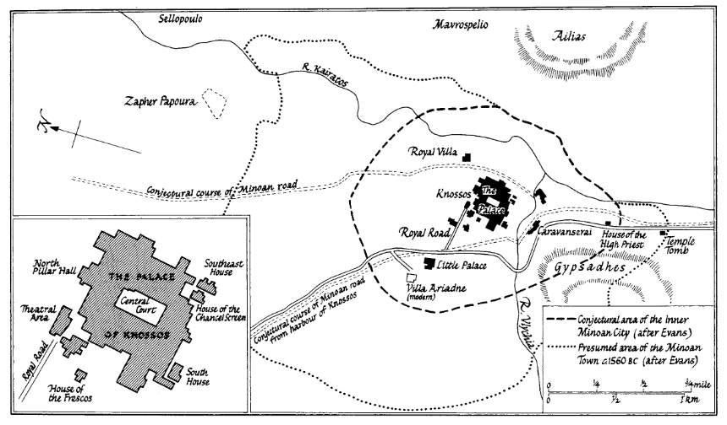
Fig.1 Plan of Knossos after Schoep 2010: 236

Rituals in Minoan Society

Ritual and Politics seemed to have gone hand in hand at Knossos. Rituals helped form a bridge between the political and the religious side of Minoan Society noted in the location of the rituals. If a ritual was performed in a political venue, such as the houses of high-status elites, it brought the ceremonial and religious aspect of society to the fore in a political place. And vice versa, if political actions took place in those buildings that held religious significance, the building may well impact or even direct the way political power was used.

Certain performance types were often associated with particular rituals. For example, dancing has been linked to rituals and ceremonies involving fertility cycles. Other ceremonies involved large groups of people, as can be evidenced from the size of the Central Court at Knossos, the large gatherings of people shown on the various frescos found in the Palace, and the storage of ritual equipment such as ‘rhyta’ (pouring vessels with two openings) in the Palace ‘Treasuries’, which were intended for distribution during communal ceremonies.

The Palace at Knossos

The Palace at Knossos was located on Kephala Hill. This may have held special significance to the Minoans, as it was believed to be the ancestral home of the first settlers on the island. This implies that the location had some form of religious importance for the Minoans, and the placement of the Palace here would have held special significance in the rituals performed.

It has been suggested by modern scholars that the construction of the Palace was a ritual in itself, demanding particular attention to the factors of time and place. If this is indeed the case, then it would have allowed the constructors to participate in their ritual obligations while performing their regular tasks. This link between ritual and Minoan Architecture suggests that as the construction involved a large number of participants, so too did the rituals involved. This would have been most obvious during construction, but may also have been re-enacted through other later rites of renewal.

Functional Palace Architecture

It has been observed that the architecture of the Palaces on Minoan Crete was functional as well as decorative. This can be clearly seen by the fact that, despite extensive modification and reconstruction throughout its lifetime, the Palace at Knossos retained both its location and its orientation. Schoep notes that in Near Eastern culture, only buildings of ritual importance, such as temples, remained in the same place and location, as those aspects were sacred. Driessen observes that as these features remained unchanged, it suggests that the rituals being performed during the first construction of the complex were still being performed when the remodelling took place. The importance of this functional architecture has been noted especially in the Central Court, where even the dimensions of the room (a ratio of 2:1) seem to have been designed with particular rites in mind. This suggests that these rituals were so important that they dictated the very design of the building they were to be performed in.

During the remodelling of the Palace in the middle of the third millennium BC, enclosed Courts were added, possibly to manipulate the ritual space for exclusive performances. This made certain rituals accessible only to a select few, a further link between religion and politics as mentioned above, and suggests that they were “spatially and temporally controlled by a particular social group”.

The Court Buildings

It is generally believed by modern scholars that the Court Buildings were the main venue of religious activity since the Early Bronze Age. Their earliest usage was as a venue for the “consumption of food and drink by groups of differing size and composition”, a practice that continued throughout their period of use. However, they were used for more than just feasting. The Palace was both a communal and a cult centre, and would have been “tied in with specific belief systems and cosmologies”. Through continued performance of rituals at this site, especially those of communal feasting, the sense of tradition and community would have strengthened within the society, lending the site even greater significance.

The Central Court

The Central Court was an area of particular significance to the Minoans at Knossos. This can be evidenced by the fact that even when the surrounding buildings were undergoing reconstruction, repair work, or even just lying in ruins following natural disasters, the Central Court was still kept fully operational at all times. Its importance is further indicated by the architectural design mentioned above, as the layout of the Court seems to have been dictated by the requirements of certain rituals and ceremonies. However, the function of this Central Court is still under debate, as Driessen notes:

“Did it serve as the arena for the (in)famous Bull Games so frequently depicted in Minoan Art? Or should we imagine more peaceful ceremonies taking place in the Court: feasts, ritualised warfare… dances, sacrifices, or simply astronomical observations?... I suspect that [the rituals] were perhaps largely ecstatic, maybe drug-induced, and most likely involved larger groups”

There does seem to be some agreement among modern scholars that the most likely rituals performed in this space involved dancing and feasting. The material evidence for this comes from the so-called ‘Miniature Frescos’ found at Knossos, which show “large groups dancing or standing in grand open places”. Special attention has been paid by archaeologists to the ‘Sacked Grove and Dance Fresco’ and the ‘Miniature Temple Fresco’. In both of these, a group of performers are observed by a larger group. The urban setting of the Frescos has led modern scholars to identify their location as the Central Court and West Wing of the Palace.

The layout of the Central Court is also symbolic of feasting rituals. The presence of several ‘hearths’ in the Court is an indication that early rituals there involved the subdivision of the larger group into smaller units that would feast together, possibly family units. Later rituals seem to have changed to incorporate larger units feasting together, as evidenced from the large-scale deposition of drinking sets that have been associated with communal feasting.

Temple Repositories

The Temple Repositories in the Palace at Knossos are possibly the most famous deposit found in Minoan Archaeology. They are located on the West Side of the Central Court, and are identified as the East and West Repositories, both of which contained a great variety of material objects, which have been able to inform archaeologists about the rituals that may have been performed at Knossos. Many of the objects found are cult-related, leading the excavators to interpret them as the remains of a shrine that was located nearby in the West Wing of the Palace. The deposit seems to indicate that a carefully planned ‘destruction’ ritual took place here, where the objects were deliberately chosen for disposal. Some of the objects were purposefully broken, either at the time of their placing, or previously in preparation for the ritual. Several other similar but smaller deposits were also found in other places throughout the West Wing, which suggests that this portion of the palace was set aside for ritual disposal of objects. However these other deposits were made up of only broken pottery, whereas the Temple Repositories contained a wider variety of objects. It is clear that this was a deliberate deposit, rather than simply debris that had been swept aside, as the types of objects and their significance in Minoan Culture suggest that they had been chosen specifically for this purpose and had been planned carefully in advance.

The objects found in each of the repositories are slightly different. Hatzaki tells us that the East Repository contained:

“faience fragments, seashells and faience seashells, faience cufo, female figures in faience (including the famous Snake Goddess Torso), dresses in faience… and arms of figurines and a figurine head… Other finds recovered… included administrative paraphernalia… faience beads, ivory objects, a marble cross, stone libation tablets, two stone hammers, antlers, fish vertebrae and carbonised cereals.”
Hatzaki then goes on to inform us of the contents of the West Repository:

“Apart from the lower body of the ‘Snake Goddess’ figurine, they are reported as gold foil, carbonised matter, a rock crystal disk with petals, and bronze (a handle and possibly hinges for boxes).”
As mentioned above, many of the items found in these Repositories were ritually broken, suggesting that they were part of a deliberate destruction ritual. This has been interpreted by archaeologists in two possible ways. Firstly, that it was a “conspicuous demonstration of power, emphasising the Palace’s ability to ‘kill’… intentionally a unique assemblage of luxurious objects”. This does seem likely, if you combine the presence of these broken luxurious objects with the architectural modifications that were designed to limit access in a potential show of power. The second possible purpose for this destruction ritual was that it was a Foundation Deposit, to celebrate the completion of a building. They were common practice in Minoan Crete, but were also found in non-elite contexts. Hatzaki tells us that “such deposits… are associated with a handful of ceramic vessels… set either below or near the base of a wall.” If this is indeed a Foundation Deposit, then its size and contents seem appropriate for a building of this level of monumentality and importance. The deposit could have been placed at the start or at the conclusion of the building’s construction.

The deliberate fracturing of certain objects may also have another meaning. Several arms of figurines were found in the East Repository, and have been interpreted by archaeologists as being a metaphor for human sacrifice. We know that human sacrifice formed part of some of the rituals performed at Knossos, thanks to the osteological evidence that has been uncovered at the site.

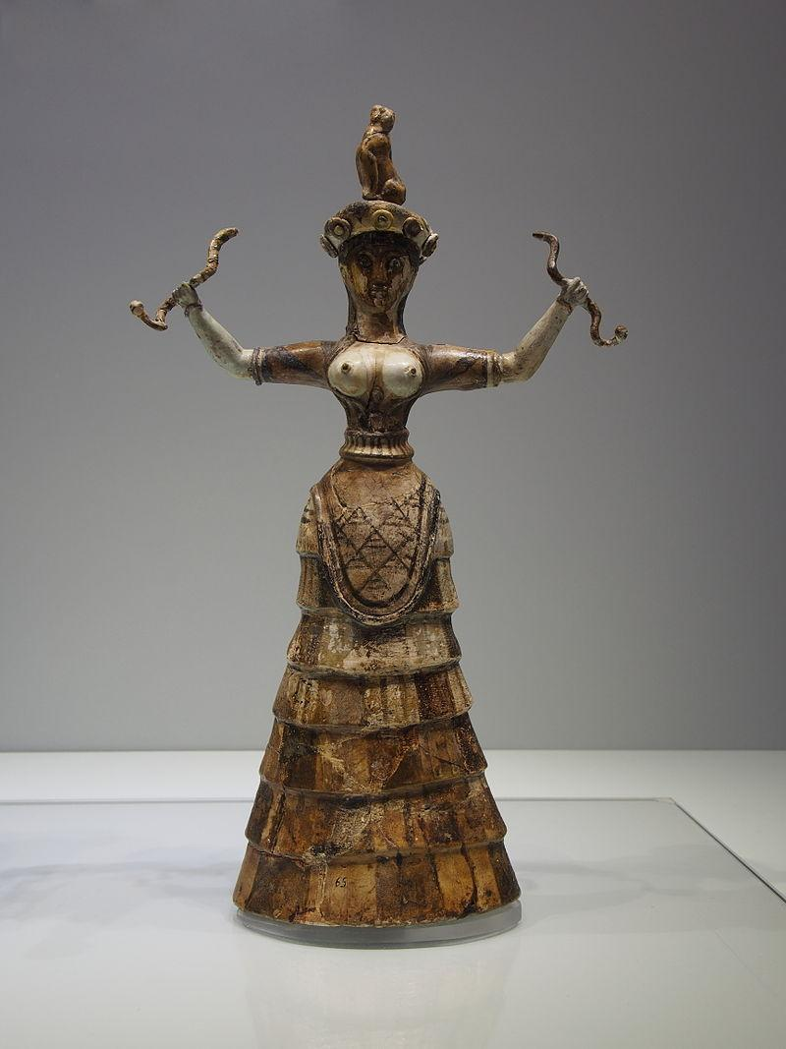
Fig. 2 Snake Goddess after Wikipedia.org 2017a

The ‘Snake Goddess’ (See Fig. 2) was an important figure in Minoan Religion according to Sir Arthur Evans, the original excavator of Knossos. Evans is often criticized for his interpretations of the artefacts, as he may have been influenced by the theories of matriarchal societies that were at the forefront of society during his time. Evans saw her as one aspect of a “Great Mother Nature Goddess”, who was central to his idea of the Minoan Religion, as she embodied fertility and motherhood, as well as holding dominion over the earth, sky and underworld. However, more modern scholars are inclined to discard this idea of a matriarchal society as a “modern myth” in favour of other societies at the time which were “theocracies with male kings and armies.” The inclusion of the broken ‘Snake Goddess’ statue in this Repository may hold significance, as she was deliberately fractured and separated between the two Repositories. In the East Repository, the head of the ‘Snake Goddess’ was discovered at the bottom of the deposit, which shows that it was among the first items put there by the ritual performers. This could be an indication of her spiritual involvement in the ritual, or that the shrine that this assemblage was once part of was dedicated to her. The next items to be deposited were the broken arms and other ‘fairly complete’ figurines. If this was a metaphor for human sacrifice, as previously discussed, then it may suggest that human sacrifice was once performed in connection with the ‘Snake Goddess’, or with the destruction ritual itself. After these figurines had been placed in the Repository, they were covered with faience cups, which could hint at a feasting or libation aspect to this ritual.

Another part of the deposit that poses special significance to understanding the ritual performed here are the over 6000 marine shells that were found in the Repositories. Hatzaki suggests that this is an indication of the participation of a very large group of people, if not in person, then symbolically. It is also important to note that 480 of these were ritually decorated with red, green and black paint, possible to denote members of the society that were special in some way, perhaps those who physically took part in the ritual. These markings have been understood to signify age, gender or rank differentiations.

The Vat Room

The Vat Room was discovered to have a deposit of cult paraphernalia and luxury items, including ivory, shell, rock crystal, faience, frit and gold, as well as a variety of pottery. The deposit dates to MMIA-B, the beginning of the so-called ‘Old Palace Period’. Like the Temple Repositories, this deposit has been identified as either a Foundation Deposit, that marked a transition in the life of the building, or a disposal of ritual items. A ritual disposal seems more likely, due to the fragmentary nature of the finds, and the fact that a destroyed Shrine was also found in the Vat Room.

The Vat Room, along with other deposits in the West Wing, has provided archaeologists with a unique glimpse into some of the rituals performed by the various social groups at Knossos, and the material objects have helped to interpret how these rituals may have been performed.

The Throne Room

The Throne Room at Knossos may also have held ritual importance. The Throne itself is believed to have served more of a religious purpose than a political one, and may have been part of the ‘Re-Enactment of Epiphany’ Rituals performed by the High Priestess. This is further indicated by the iconography of Griffins, Palms and Altars found in the Wall-Paintings at Knossos, all of which were associated with rituals. In Minoan Religion, only goddesses were flanked by Griffins, and so the High Priestess would have been portraying the role of a goddess in such rituals. The Throne Room was also associated with the observation of the solstices and equinoxes, with particular ceremonies being performed at dawn on certain days of the year. It has also been discovered that there is a kitchen in the adjacent complex, which could be seen as evidence for ceremonial banqueting taking place in the Throne Room.

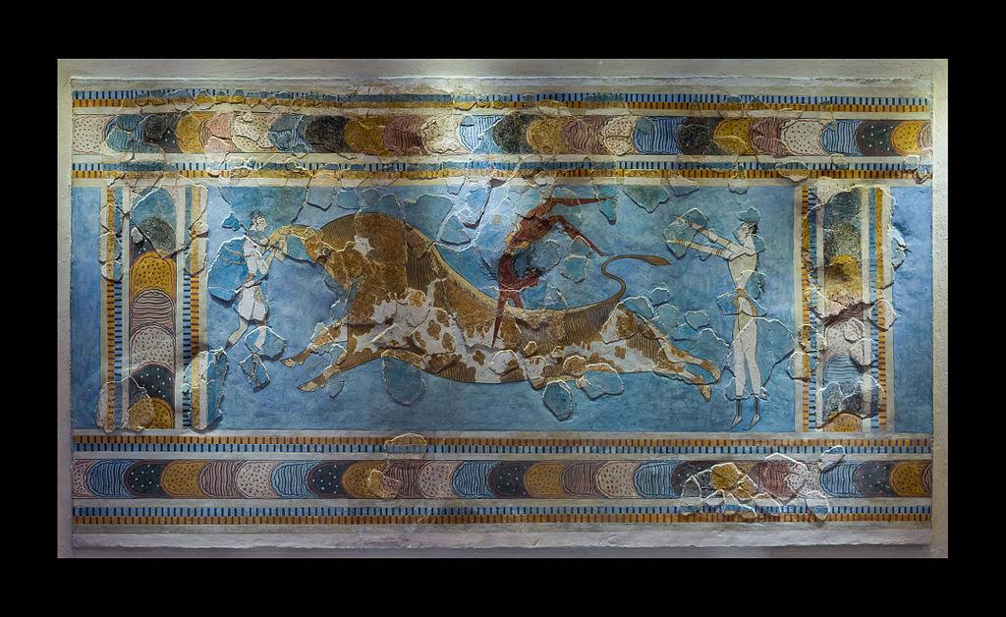
Fig. 3 Bull Leaping Fresco, after Wikipedia.org. 2017b

Bulls and Bull-Leaping

One of the most famous rituals performed in Minoan Society was ‘Bull-Leaping’. The main source of evidence for this practice comes from the Frescos found at several sites across Crete, the most famous of which are the ‘Taureador Frescos’ at Knossos, (See Fig 3.) as well as figurines made from bronze recovered at open-air sanctuaries, and the ivory figure found at Knossos. The bull held special significance for the Minoans, so much so that the Greek myth of King Minos and the Minotaur has been associated with the island of Crete and gave its name to the people we now know as the Minoans. The strong connections with Knossos, and the adornment of the Palace with depictions of bulls and bull-leaping, has led some archaeologists to believe that Knossos was the origin of the bull-leaping practice. It has been suggested that the act of bull-leaping was a ritual associated with the mythology of the Minoans. McInerney tells us that in one theory, put forward by J. Alexander MacGillivray, it is representative of a story told by the constellations:

“Orion confronts Taurus, composed of the Hyades and Pleiades (the seven sisters), while Perseus somersaults with both arms extended over the bull’s back to rescue Andromeda.”

Another artefact that has been linked ritualistically with Bulls is the Bull’s Head rhyton that was discovered at Knossos. It had been carved out of steatite, and decorated with gold, jasper, rock crystal and shells, making it too precious and heavy to have been used in anything but a ritual setting. It may have been used as a drinking vessel or to perform libations if a feast had followed a sacrifice, as it imitated the bull’s head and performed a re-enactment of the ritual bloodletting. However it is also possible that it was used as part of a sacrificial ritual and was used to hold blood from the sacrifices.

Conclusion

To conclude, from the archaeological evidence found at Knossos and around the Cyclades one can begin to see how closely tied to everything ritual was in Minoan society. Rituals existed and were used in a multitude of ways from architectural rituals used in the building of the Palace at Knossos to rituals, to performances and ceremonies held at the Palace itself. Feasting, dancing, bull leaping and destruction ceremonies all held an integral place in society. Ritual and politics were closely linked and often influenced one another, the famous throne room on Knossos was not intended for King Minos but rather for the High Priestess and rituals were performed within the throne room dedicated to the ‘Snake Goddess’. The venue for the ritual bore particular importance as it dictated the desired audience and effect which is why there existed rituals for all to see in the courtyard and rituals for select and privileged individuals held in private chambers with walls that permitted control of who could and could not bear witness to certain rituals. There is not much in the way of written accounts when it comes to the Minoans and most of what we know is only possible because of materiality which allows us to piece together, in this case, the rituals and ceremonies that took place and what objects and locations were involved in them.

Reference List

- Driessen, J. 2003. ‘Court Compounds of Minoan Crete: Royal Palaces or Ceremonial Centres?’ Athena Review. 3.3 p57-61

- Driessen, J. 2010. ‘Beyond the Collective… The Minoan Palace in Action.’ From the Foundations to the Legacy of Minoan Society. A Round Table in Honour of Professor Keith Branigan. Sheffield. Sheffield Centre for Aegean Archaeology (29th-31st Jan 2010) p1-32

- Hatzaki, E. 2009. ‘Structured Deposition as Ritual Action at Knossos’. Hesperia Supplements. 42 p19-30

- McInerney, J. 2011. ‘Bulls and Bull-Leaping in the Minoan World. Expedition. 53.3 p6-13

- Panagiotaki, M. 1999. The Central Palace Sanctuary at Knossos. BSA Supplementary Volume 31. London: British School at Athens

- Pelon, O. and Marinatos, N. 2005. ‘Aegean Religions’. In. Jones, L. (ed) Encyclopaedia of Religion. Detroit: Macmillan Reference USA. p37-44

- Schoep, I. 2010. ‘The Minoan Palace-Temple Reconsidered: A Critical Assessment of the Spatial Concentration of Political, Religious and Economic Power in Bronze Age Crete.’ Journal of Mediterranean Archaeology. 23.2 p219-244

- Schoep, I. 2011. ‘Bridging the Divide Between the ‘Prepalatial’ and the ‘Protopalatial’ Periods’. In Schoep, I., Tomkins, P. and Driessen, J. (eds) Back to the Beginning: Reassessing Social and Political Complexity of Crete During the Early and Middle Bronze Ages. Oxford: Oxbow Books. p403-428

- Shapland, A. 2013. ‘Jumping to Conclusions: Bull-Leaping in Minoan Crete. Society and Animals. 21.2 p197-207

- Wikipedia.org. ‘Bull Leaping Fresco’ 2017a. https://en.wikipedia.org/wiki/Bull-Leaping_Fresco#/media/File:Bull_leaping_minoan_fresco_archmus_Heraklion.jpg [Accessed 28th December 2017]

- Wikipedia.org. ‘Minoan Snake Goddess Figurines’ 2017b. https://en.wikipedia.org/wiki/Minoan_snake_goddess_figurines#/media/File:%CE%98%CE%B5%CE%AC_%CF%84%CF%89%CE%BD_%CE%8C%CF%86%CE%B5%CF%89%CE%BD_6393.JPG [Accessed: 28th December 2017]

Schoep 2010: 230
Schoep 2010: 230
Driessen 2010: 8
Driessen 2010: 14
Hatzaki 2009: 30
McInerney 2011: 7
Driessen 2010: 14
Schoep 2010: 231
Schoep 2010: 231
Driessen 2010: 15
Driessen 2010: 16
Driessen 2010: 19
Schoep 2010: 231
Schoep 2010: 231
Driessen 2003: 59
Driessen 2003: 60
Driessen 2003: 59
Driessen 2003: 60
Schoep 2010: 230
Schoep 2010: 231
Schoep 2010: 231
Schoep 2010: 231
Schoep 2011: 411
Driessen 2003: 60
Driessen 2010: 15
Driessen 2003: 60
Driessen 2003: 60
Driessen 2003: 60
Hatzaki 2009: 30
Hatzaki 2009: 30
Schoep 2011: 412
Schoep 2011: 413
Hatzaki 2009: 20
Hatzaki 2009: 20
Hatzaki 2009: 20
Hatzaki 2009: 20
Hatzaki 2009: 20
Hatzaki 2009: 22
Hatzaki 2009: 22
Hatzaki 2009: 21
Hatzaki 2009: 21
Hatzaki 2009: 27
Hatzaki 2009: 28
Hatzaki 2009: 28
Hatzaki 2009: 28
Hatzaki 2009: 29
Hatzaki 2009: 29
Pelon and Marinato 2005: 37
Pelon and Marinato 2005: 37
Pelon and Marinato 2005: 37
Pelon and Marinato 2005: 37
Pelon and Marinato 2005: 37
Hatzaki 2009: 26
Hatzaki 2009: 26
Hatzaki 2009: 26
Hatzaki 2009: 26
Hatzaki 2009: 26
Hatzaki 2009: 26-7
Hatzaki 2009: 27
Hatzaki 2009: 27
Panagiotaki 1999: 51
Schoep 2010: 231
Hatzaki 2009: 28
Panagiotaki 1999: 52
Panagiotaki 1999: 52
Hatzaki 2009: 29
Driessen 2003: 59
Driessen 2003: 59
Driessen 2003: 59
Pelon and Marinatos 2005: 39
Driessen 2003: 59
Driessen 2003: 59
Pelon and Marinatos 2005: 39
Shapland 2013: 198
Shapland 2013: 204
Shapland 2013: 203
Shapland 2013: 197
McInerney 2011: 7
Shapland 2013: 204
McInerney 2011: 9
McInerney 2011: 7
McInerney 2011: 8
McInerney 2011: 8

