Database Management Systems
Shape Up Gyms Database
Harry Byrne P133366
Abstract
To Improve a growing gym companies database system, with constraints, primary and secondary keys, then test it with queries.

Contents
Introduction 3
Task 1 3
Database Creation 3
Populating the Database 6
Check Constraints 9
Queries 10
Transaction Rollback 12
Task 2 13
Performance Tuning 13
Distributed Database Solution 13
References 14

Introduction
The task given was to help a gym company named shape up gyms upgrade their IT systems with a distributed database model as it has outgrown the systems it previously had in place. A subset of the current centralised relational database schema was provided with the column names and primary fields included.

Task 1

Database Creation

To show how the database was built, below is an entity relationship diagram of the completed database.
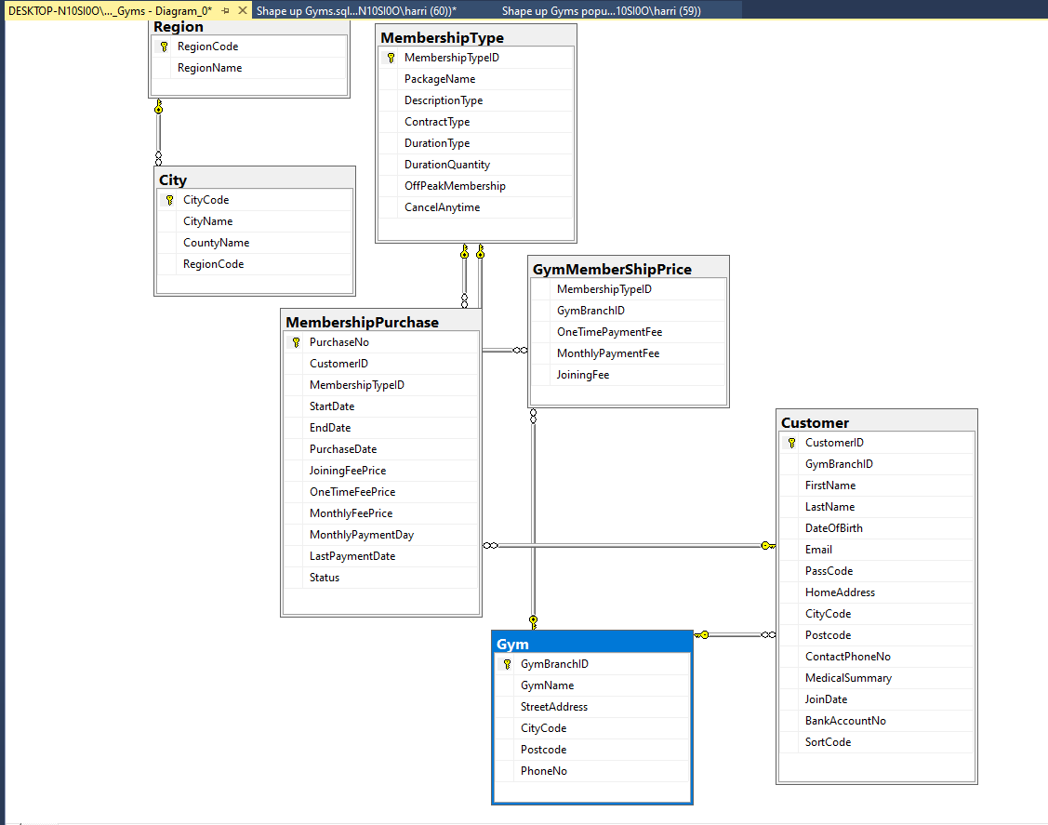

On the first table named Region, RegionCode was set as the primary Key.
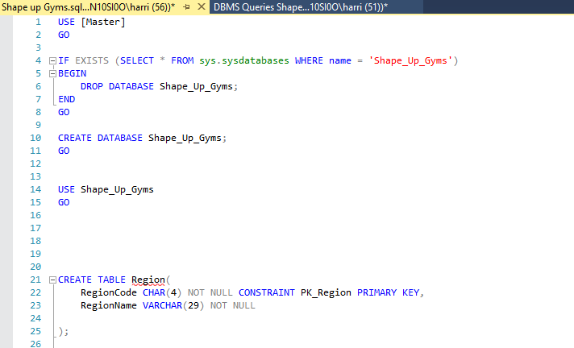

On the Second table named City, CityCode was set as the primary key with a constraint on the input of data to be only in the format of ‘C’, followed by 4 numbers. This table also has a foreign key of RegionCode from the Region table.
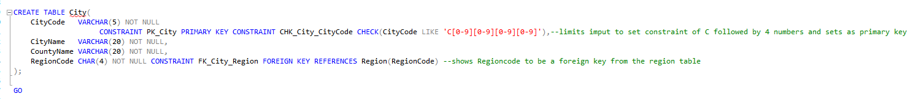
The next table name Gym has GymBranchID as it’s primary key, with a constraint of the input data to only be allowed starting with ‘G’ followed by 4 numbers. Whilst City Code should have been a foreign key, there were issues being flagged, so for the purpose of this example it was left alone. A second constraint was put on Postcode to limit the max length to be 8 characters or lower.
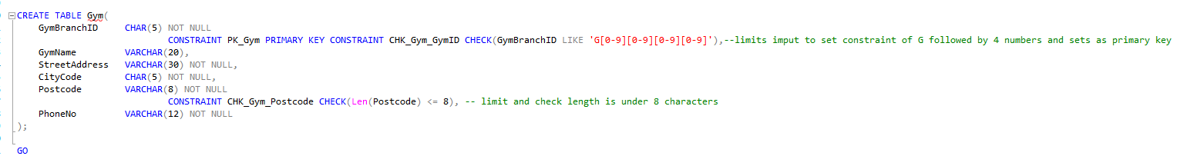

The next table is Membership which had MembershipTypeID set as the primary key with a constraint placed on the input to only allow ‘M’ followed by 4 digits. Whilst the brief said to use the word description, it appeared to be an SQL keyword, so was changed. There appeared to be an overlap of data from this table and MembershipPurchase, this was not corrected as it was deemed best to follow the task description.
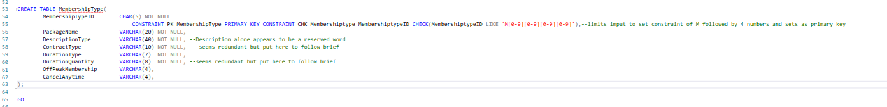

The following table was GymMembershipPrice, MembershipTypeID was set as foreign key from MembershipType, as was GymBranchID from Gym.
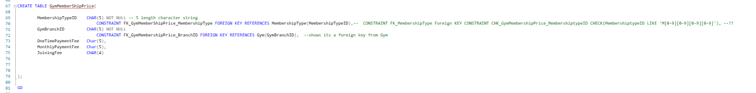

The next table was Customer. CustomerID was set as primary key with a check constraint of C folloed by 4 digits, DateOfBirth used the Date constraint set in SQL. Other constraints were set on PassCode, Postcode and SortCode to limit the amount of characters used to numbers wither chosen or used in the real world.
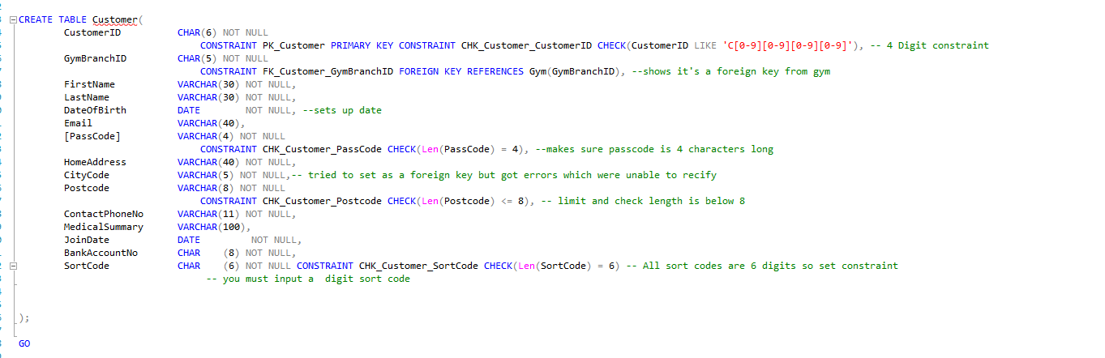

Next was MembershipPurchase table, with PurchaseNo set as primary key and a constraint of 4 digits only. There is a foreign key of CustomerID from the customer table.
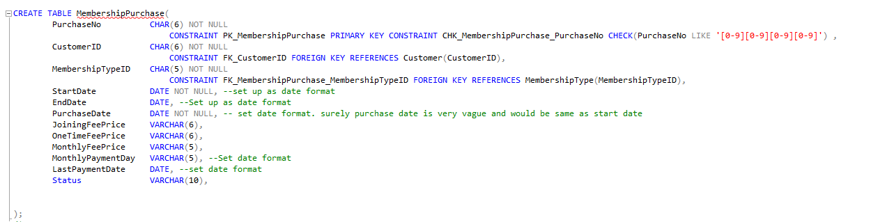

Populating the Database

This section involved inputting test data into the database so we could test the function and constraints. The inputted data code is followed by a results table run on each table to show how a user would see the data.

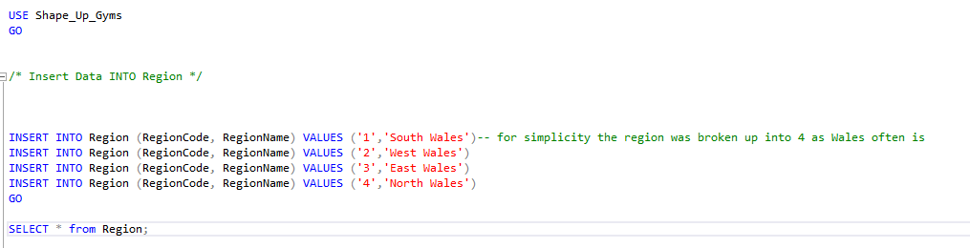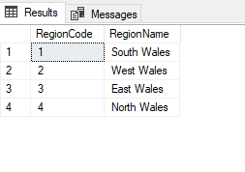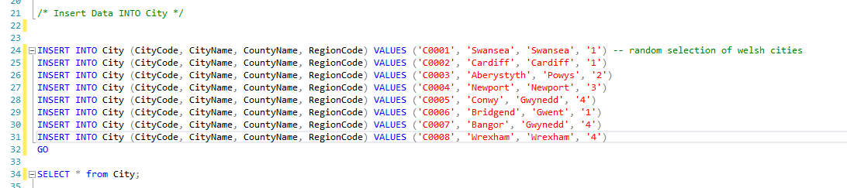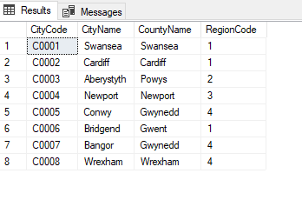
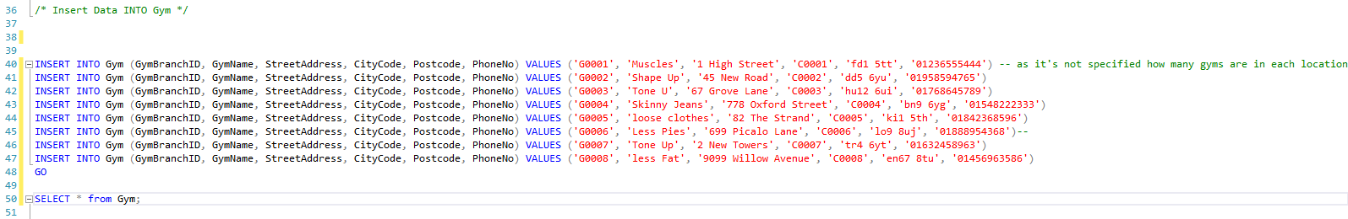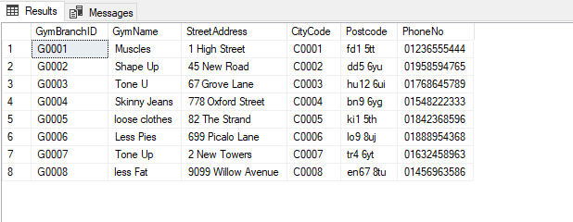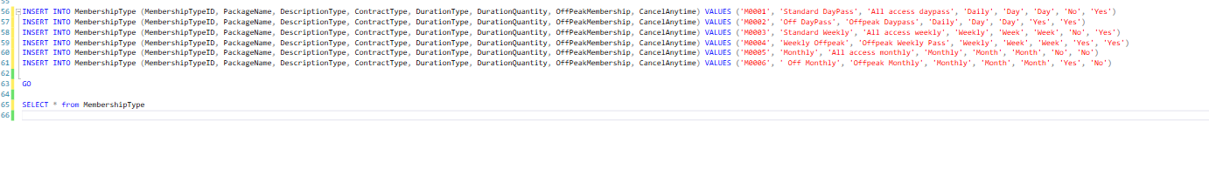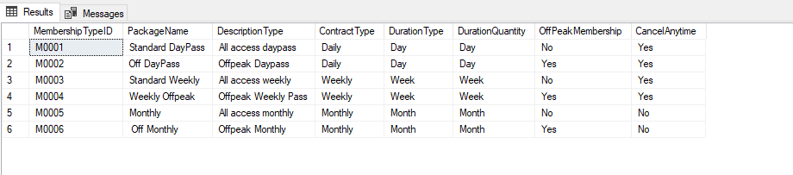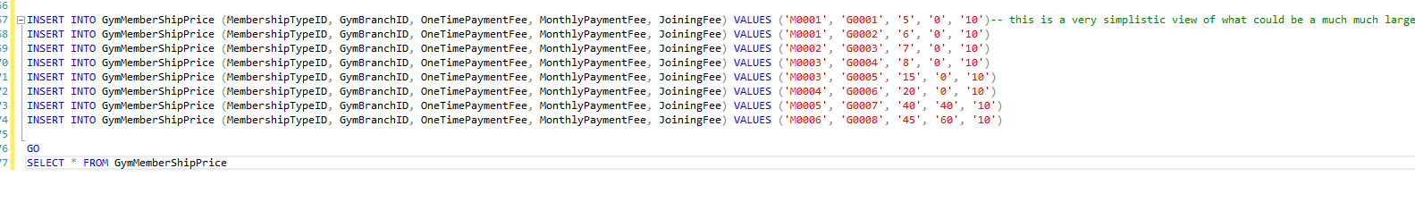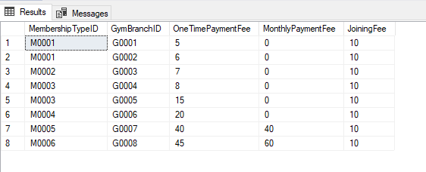

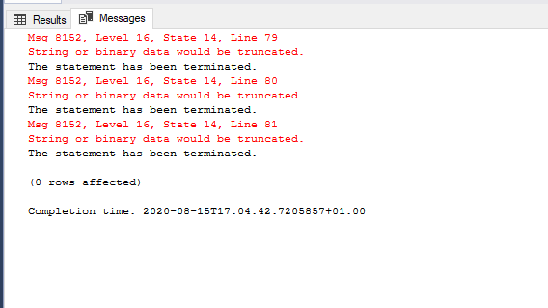
This is a problem the was discovered that was down to initially only inputting the date in a 6 digit format, a previous problem was discovered prior to this as the date was being inputted in a UK format while SQL reads dates in a US format.

Check Constraints

The first test was done on the city table with an incorrectly entered CityCode. As can be seen the constraint worked.
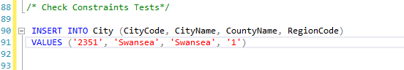

The second test was carried out on the gym table. An incorrect was entered. As can be seen the warning message of ‘String or binary data would be truncated’ is SQL server saying that inputted data is larger than allowed.
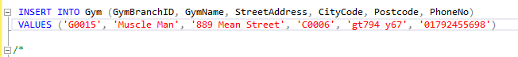
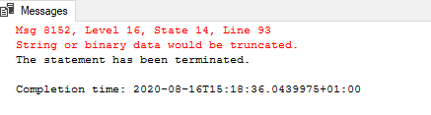
This following constraint test was carried out on the customer table. An incorrect customerID was entered.
This was picked up with the following message.

As these tests prove constraints stop bad data being inputted into the database. On reflection constraints should be put on the BankAccountNo also, as this in the UK is always an 8 Digit number

Queries

The first Query conducted that was deemed highly likely to be used within shape up gyms was one regarding finding customers names, bank details, their monthly payment day, and whether the account was still active. ‘The SELECT statement is used to select data from a database .The data returned is stored in a result table, called the result-set’ [1]. Following is a screenshot of that query. It was sorted in order of the payment day to make life easier for the user.
The table below is how the data was presented.
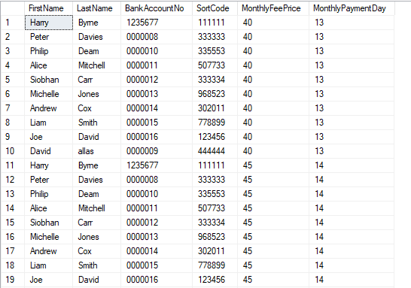
As can be seen there is an error of repetition here.. This query was deemed a fail.
To correct the query a WHERE statement was added as seen below.
This now shows the correct data sorted by monthly payment date. 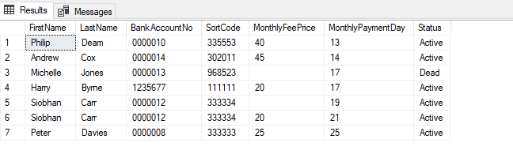
The next Query undertaken was to see what customers are using which gym.
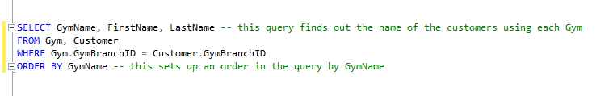
As can be see below, there table is correct since learning the mistake of not using the where statement.
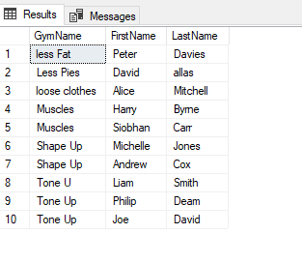

Transaction Rollback

The First part of the question asks to update a customers pay monthly membership and bank account details. This was done with the update statement as show below.
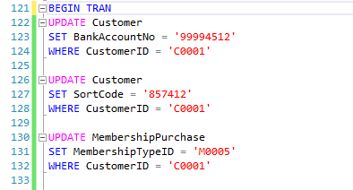
Following this, it is asked to rollback the transaction. This is as easy as simply putting the word ROLLBACK; at the end of the statement as BEGIN TRAN was put at the beginning of the code.
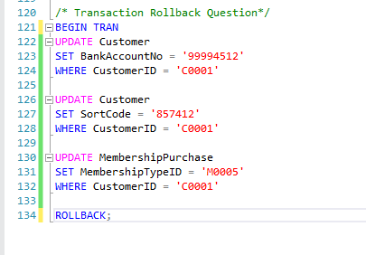

Task 2

Performance Tuning
Secondary indexes
‘An index is an on-disk structure associated with a table or view that speeds retrieval of rows from the table or view. An index contains keys built from one or more columns in the table or view. These keys are stored in a structure (B-tree) that enables SQL Server to find the row or rows associated with the key values quickly and efficiently’ [2]. Unfortunately during the task, there was no success in coding in SQL any secondary indexes.

Distributed Database Solution

There are 4 main types of fragmentation, vertical, horizontal, mixed and derived [3]. A suitable fragmentations schema is required. Through using the code below, it was found there was no fragmentation so it was deemed difficult to implement any schema for it.
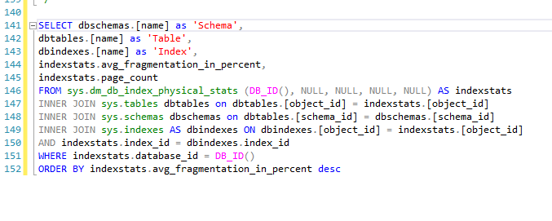
This code was found on Schnider Electric webpage[4].
The table below shows no fragmentation.
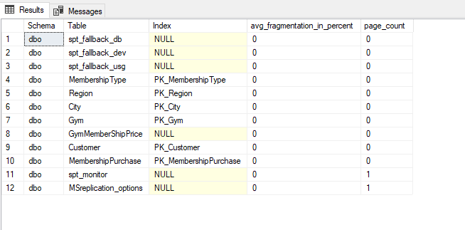

References
[1] “SQL SELECT Statement.” [Online]. Available: https://www.w3schools.com/sql/sql_select.asp. [Accessed: 16-Aug-2020].
[2] “Clustered and Nonclustered Indexes Described - SQL Server | Microsoft Docs.” [Online]. Available: https://docs.microsoft.com/en-us/sql/relational-databases/indexes/clustered-and-nonclustered-indexes-described?view=sql-server-ver15. [Accessed: 16-Aug-2020].
[3] T. Connolly and C. Begg, Database Systems: A Practical Approach to Design, Implementation, and Management: Global Edition. 2015.
[4] “How to Check Index Fragmentation on Indexes in a Database.” [Online]. Available: https://www.se.com/ww/en/faqs/FA234246/. [Accessed: 16-Aug-2020].

