Compare and contrast the expression or representation of the sky in two works of film, music,
art, architecture, celestial cartography or literature in their expression or representation of the sky.

This essay compares and contrasts the image of Earthrise from the Moon taken by the Apollo 8 space mission (Earthrise, Figure 1) with the poem “Lines Composed a Few Miles Above Tintern Abbey, On Revisiting the Banks of the Wye During a Tour, July 13, 1798,” (Tintern Abbey) as portrayals of the human relationship with Earth, sky and space. Earthrise is a photo taken by the Astronauts of the Apollo 8 mission in 1968. It features a skyscape where a vibrant, cloud-swirled Earth is viewed from the glowing, pitted surface of the moon, silhouetted by a black space-sky, which Cosgrove notes is composed of unexposed film. It has been described by Nature “as one of the most important and influential photographs in science, if not all of human history. Tintern Abbey is a celebrated poem by Wordsworth, a major figure in the Romantic movement at the start of the 19th century. I will consider in particular the passage below, described by Corn as “one of the best known” of Wordsworth’s poems.

And I have felt
A presence that disturbs me with the joy
Of elevated thoughts; a sense sublime
Of something far more deeply interfused,
Whose dwelling is the light of setting suns,
And the round ocean and the living air,
And the blue sky, and in the mind of man:
A motion and a spirit, that impels
All thinking things, all objects of all thought,
And rolls through all things.

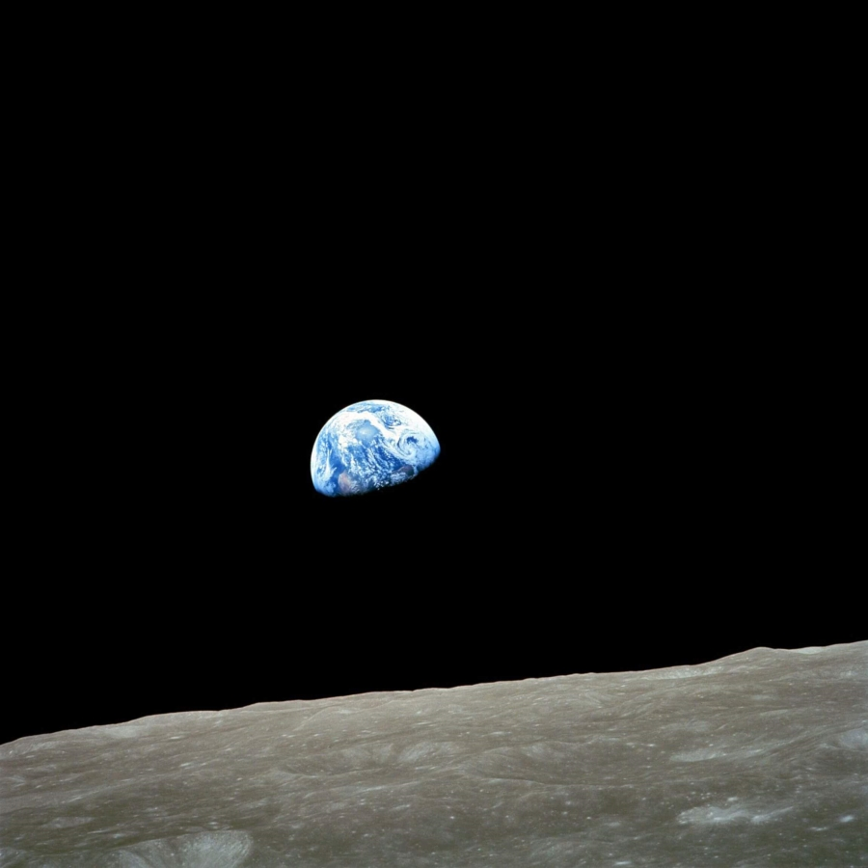

Figure 1 Earthrise (NASA AS8-14-2383). Apollo 8 photograph of Earth taken from lunar orbit, December 1968.

Context: Turning points

Wordsworth lived through the upheavals of the French and Industrial revolutions and attendant social shifts. Weinfield views him as confronting the “epistemological chasm and consonant religious crisis” provoked by the Enlightenment. Seamon describes Wordsworth and his peers as counteracting the Enlightenment’s focus on the intellect by seeking to restore the importance of intuition and feeling, emphasising human relationships with nature. Weinfield describes Tintern Abbey as “an argument that is directed at modernity and that continues to have a purchase on us.” Similarly, Cosgrove describes Earthrise as capturing “the Modernist technological faith that had launched the Apollo project ten years earlier and the gnawing sense of mistrust in that faith that was increasingly apparent in the closing years of the 1960s.” Paralleling Wordsworth and the Romantics, Heidegger and his contemporaries looked to relationships with environment and place as an alternative, although with a different orientation, as will be discussed later in this essay.
Contested Narratives

Kissane explains that for Wordsworth, the moon was a symbol of the imagination which, like Coleridge, he associated with moon-light and sun-set. Kissane explores Wordsworth’s poem, “A Night-Piece”, in which the sudden view of the moon shifts the tone of the nocturnal landscape from one of dullness to an “ecstatic sense of incomprehensibility”. This nocturnal view is inverted in the Earthrise shot, although as Lazier notes, only after the frame is shifted so that the lunar horizon appears at the bottom of the photo rather than vertically to one side (as it actually was) in order to meet the Earth-oriented expectations of viewers.
In considering the work of Cosgrove, Henry and Taylor observe that Earthrise is a “multivalent image”. Cosgrove charts 20th century representations of the globe/whole earth, identifying how these have drawn on a range of sacred, secular, colonial and imperial meanings relating to Christianity and empire since the time of the Emperor Constantine. He sees the US as “heir to a universalizing culture that is embodied in the Enlightenment principles of its constitutional philosophy.” Highlighting the Western cosmological imagery in the name Apollo, and its fittingness for the youthful male American astronauts on the mission, Cosgrove adds “NASA's Saturn rockets carried the imaginative vision of a modern superpower beyond the confines of Earth.” Earthrise was photographed on Christmas Eve and the Apollo Astronauts read the cosmogenic narrative from Genesis on Christmas morning.
Notwithstanding the above, Henry and Taylor posit that the Earthrise image “resists being narrated as merely conquered frontier and instead powerfully revealed earth’s agency as an autonomous, self-regulating biosphere.” Jasanoff notes that the planetary view removed the day to day environmental harms faced by billions of people, from polluted water to infectious diseases.”Cosgrove adds that it removes the centrality of “man” from the scene and opines that for green groups and agencies Earthrise and similar photos “represent a quasi-spiritual interconnectedness.” Apposite in this regard is Klein’s reference to Wordsworth’s insistence that “Nature generates response” and that “sympathy with speechless things is requisite to and generative of feeling for other people.” In emphasising relationships with nature and the non-human world without arguing for the primacy of humans, Tintern Abbey echoes spiritual perspectives found in traditions such as Hinduism and Buddhism, as well as those of indigenous peoples, which stand outside imperialist meanings given to Earthrise.

The sublime and the technological
According to Seamon, Wordsworth, along with contemporaries such as Blake and Goethe, was deeply concerned by the increasing development of technology and “a fledgling positivist science” believing that this was changing the way people perceived their world. Intellectuals in the middle of the 20th century such as Arendt and Heidegger expressed similar concerns. Acknowledging that Earthrise was the first time humanity was able to ”look down”, Micholoudis and Dann add: “Today, we are conscious of being constantly monitored from above…no longer do we navigate by the stars, but from them.” Lazier notes that Borman, the first astronaut of the Apollo 8 mission to view Earthrise, exclaimed “look at that picture over there!”- overlaying the vision before him with the wish to capture it on film, as many of us may confess to doing in far less dramatic circumstances. On the other hand, Earthrise and other photos also removed human imprints in cultural perceptions of the Earth. Lazier quotes Blumenberg’s reflection that there “were perhaps others like me who were momentarily astonished to see nothing of the net of latitude and longitude, nothing of the line of the equator, as every globe had impressed it in photographic memory.”
A differing perspective comes from Cosgrove’s discussion of the sublimity of the Apollo photos, portraying a world moved by “forces so balanced, intricate, and powerful that in their presence the only valid human responses were awe, wonder, and humility. Describing how “Wordsworth enfolds the sublime in the beautiful in “Tintern Abbey,” Weinfield posits that “the forms of experience are accessible to us, and, when invested with the sense of the numinous we call beauty, lift us beyond a sense of the world that would otherwise be merely static.” The Apollo astronauts were, of course, very far outside any sense of a static world and there were mind-bending aspects to their experience. Cosgrove describes how Michael Collins, an astronaut on the Apollo 11 mission reflected: “[Earth] seemed so small I could blot it out of the universe simply by raising my thumb…it suddenly struck me that that that tiny pea, pretty and blue, was the Earth…I didn’t feel like a giant, I felt very, very small.” Klein argues that this ability of nature, broadly understood, to “surprise, to disturb, to break in upon the reflective mind”, is what drew Wordsworth, albeit in far less visually dramatic settings. Helmreich describes Heidegger’s “vertiginous unmooring” at photographs of the Earth from space and Lazier quotes him as finding them “frightening” . This is unsurprising given his stance that “Mortals… receive the sky as sky. They leave to the sun and the moon their journey, to the stars their courses.” In contrast, Klein views Wordsworth’s poems as opening readers to our limited knowledge of both ourselves and the universe, as well as the “the fearsome pleasure of existence.” In this she quotes Potkay who describes Wordworth’s “empathic engagement with things that cannot reflect us, that on the contrary unmoor us from our sense of self or human exceptionality.” This emphasises Wordsworth’s willingness to be present to such experiences. Seamon argues that, while today there is general acceptance of the fact that all aspects of nature are integrally connected, Wordsworth suggests “a higher, less readily touched connection”. There are parallels to this in Helmreich’s suggestion that Earthrise may be “an icon in a more sacred sense”- a medium that “[embodies and transmits] the power of the photographed subject”. And so it may be that the disturbing joy expressed by Wordsworth in Tintern Abbey is evident not only in the light of setting suns but also in photographs of rising Earths.

Returning to Earth and Space

Sleeman quotes Michael Light, the photographer who assembled the NASA images for the 30th anniversary of the Moon landing: “Apollo’s path is circular. Humanity’s boldest and most audacious movement outward from its home found itself relentlessly looking in the opposite direction – back toward Earth.” Lazier identifies the “centripetal pull” of Earthrise on those who behold it, its beauty causing a wish to return. This raises the question of whether the bond of humans to our home plant is so strong that, when confronted with a view of it, the rest of space is obscured for us. As Chakrabarty highlights, when we look at the Earth in this way, “other planets, so to speak, are not in our field of view.” For Cosgrove, the sky in Earthrise suggests “complete isolation of terrestrial life in a black, sepulchral universe.” Such musings on our place in space tend towards what Blumenberg termed “astronoetics”, or the “the age-old tradition of contemplative reflection upon the cosmos, for which astronautics has been a recent aid” for those “who (prefer) to sail the seas of the stars by means of the seas of the mind” rather than physically visit. As Lazier acknowledges, for anyone other than the astronauts experiencing it, Earthrise is an astronoetic rather than astronautic adventure. In contrast, Henry and Taylor maintain an more astronautic perspective, viewing Earthrise and access to space as foreshadowing space art that enables humanity “to think environmentally about the worlds we yet dream of exploring.” For this task, imagination is deemed insufficient as the first form of sky art “did not enable viewers to envision themselves in space due to a lack of sufficient detail”. Different still, Wordsworth’s approach is rooted in Earth experiences that took him beyond the Earth, or at least beyond a sense of separation from what he saw. Seamon describes Tintern Abbey as “portraying a special moment in which awareness of landscape suddenly expands and immerses the person in a spiritual oneness with unified nature.” Likewise, Harris refers to the ideal Romantic state as being “such immersion in the atmosphere as to feel inseparably part of it.” Although markedly varying, all three approaches enable deeper consideration of what lies within and beyond the vistas of earthbound humanity.

Conclusion

This exploration of two very different media has revealed a number of common and contrasting themes concerning Earth and Sky, including the role of philosophy, technology, imperialism and conquest. It has also examined deeper opportunities to explore space without space travel, in which any sense of human appropriation or entitlement can be replaced by an openness to the wonder and fear of our existence within a wider cosmos. Further, Earthrise and ensuing space photos reveal a myriad of ways of responding when the small, beautiful planet of which we are a miniscule but integral part is reflected back to us. Whether Wordsworth would ever have countenanced voyages to the Moon is highly debatable, nevertheless poems such Tintern Abbey can inform consideration of an image that lies, perhaps, far beyond his wildest imaginings. Seamon emphasises that Wordsworth understood human relationships with nature not in the intellectual way that a modern ecologist or biologist might, but “experientially, through a heightened emotional contact”. Love for the Earth, Seamon concludes, does not come from intellectual understandings but from a heart-felt connection, an observation that can extend to the Moon-and beyond.

BIBLIOGRAPHY
Anonymous, ‘Earthrise at 50.’ Nature Vol. 564 (7736), (Dec. 2018), p. 301
Chakrabarty, Dilip, ‘Planetary Crises and the Difficulty of Being Modern’, Millennium: Journal of International Studies Vol. 46, No.3 (2018) 259–282
Corn, Alfred, ‘The Wordsworth Retrospective.’ The Hudson Review, Vol. 52, No.3, (1999), 359-78
Cosgrove, Dennis ‘Contested Global Visions: One-World, Whole-Earth, and the Apollo Space Photographs’, Annals of the Association of American Geographers, Vol. 84, No.2, (June 1994), pp.270-294
Harris, Alexandra, Weatherland; Writers and Artists under English Skies (London Thames & Hudson, 2015).
Helmreich, Stefan, ‘From Spaceship Earth to Google Ocean: Planetary Icons, Indexes, and Infrastructures’, Social Research, Vol.78, No.4, (Winter 2011), pp.1211-1243
Henry, Holly ; Taylor, Amanda, ‘Re-Thinking Apollo: Envisioning Environmentalism in Space.’, The Sociological Review, Vol.57(1_suppl), (May 2009), pp.190-203
Kissane, James ‘A Night-Piece: Wordsworth's Emblem of the Mind’, Modern Language Notes, Vol. 71, No. 3 (1956), pp. 183-186

Klein, Amelia ‘The Poetics of Susceptibility: Wordsworth and Ecological Thought’, Studies in Romanticism, Vol.58(1), (Spring 2019) pp.105-128,147, p113

Lazier, Benjamin, ‘Earthrise; or, The Globalization of the World Picture’, The American Historical Review, Vol. 116, No.3, (2011) pp.602-630

Michaloudis, Ioannis ; Dann, Bronwyn, ‘Aer( )sculpture: Inventing skies and micro-clouds into diaphanous sculptures made of the space technology nanomaterial silica aerogel’, Journal of Sol-Gel Science and Technology, Vol.84 No.3, (2017) pp.535-542

Seamon, David, ‘Emotional Experience of the Environment.’ American Behavioral Scientist 27.6 (1984): 757-70
Sleeman, Joy, ‘Land Art and the Moon Landing’, Journal of Visual Culture, Vol.8 No.3, (Dec. 2009) pp.299-328
Henry Weinfield, “These Beauteous Forms”: Tintern Abbey and the post-Enlightenment Religious Crisis, Religion and the Arts, 2002, Vol.6(3), pp.257-290

William Wordsworth, Lyrical Ballads with a few other Poems, Biggs & Cuttle Bristol 1978 [Hereafter Tintern Abbey]
Denis Cosgrove, ‘Contested Global Visions: One-World, Whole-Earth, and the Apollo Space Photographs’, Annals of the Association of American Geographers, Vol. 84, No.2, (June 1994), pp.270-294, p275 [Hereafter Cosgrove, Visions]
Anonymous, ‘Earthrise at 50.’ Nature, Vol. 564 (7736), (Dec 2018), p. 301
Alfred Corn, "The Wordsworth Retrospective." The Hudson Review Vol 52 No.3, (1999): pp.359-78, p363
Henry Weinfield, “These Beauteous Forms”: Tintern Abbey and the post-Enlightenment Religious Crisis, Religion and the Arts, 2002, Vol.6(3), pp.257-290, p261 [Hereafter: Weinfield, Beauteous Forms]
David Seamon, Emotional Experience of the Environment, American Behavioral Scientist, Vol.27(6), (July 1984) pp.757-770, p762 [Hereafter Seamon, Emotional Experience]
Weinfield, Beauteous forms, p265
Cosgrove, Visions p284
James Kissane, ‘A Night-Piece: Wordsworth's Emblem of the Mind’, Modern Language Notes, Vol. 71, No. 3 (1956), pp. 183-186 [Hereafter Kissane, A Night-Piece]
Kissane, A Night-Piece p185
Benjamin Lazier, ‘Earthrise; or, The Globalization of the World Picture’, The American Historical Review, Vol. 116(3), (2011) pp.602-630 p625 [Hereafter Lazier Earthrise Globalization]
Henry, Holly ; Taylor, Amanda, ‘Re-Thinking Apollo: Envisioning Environmentalism in Space.’, The Sociological Review, Vol.57(1_suppl), (May 2009), pp.190-203 p190 [Hereafter Henry and Taylor Apollo]
Cosgrove, Visions, p272
Cosgrove, Visions, p281
Cosgrove, Visions, p273
Cosgrove, Visions, p282
Henry and Taylor Apollo p191,
Sheila Jasanoff, “Image and Imagination: The Formation of Global Environmental Consciousness.” Changing the Atmosphere: Expert Knowledge and Environmental Governance. Eds. Clark A Miller and Paul Edwards. Cambridge, MA: MIT Press, 2001: 309–337, p.335 cited in Stefan Helmreich, ‘From Spaceship Earth to Google Ocean: Planetary Icons, Indexes, and Infrastructures’, Social Research, Vol.78 No.4, (Winter 2011), pp.1211-1243, p1215 [Hereafter Helmreich, Spaceship Earth]
Cosgrove, Visions pp286-287
Amelia, Klein, ‘The Poetics of Susceptibility: Wordsworth and Ecological Thought’, Studies in Romanticism, Vol.58(1), (Spring 2019) pp.105-128,147, p113 [Hereafter Klein, Poetics]
Seamon, Emotional experience p768
Lazier, Earthrise Globalisation, p604
Ioannis Michaloudis; Bronwyn Dann, ‘Aer( )sculpture: Inventing skies and micro-clouds into diaphanous sculptures made of the space technology nanomaterial silica aerogel’, Journal of Sol-Gel Science and Technology, Vol.84 No.3, (2017) pp.535-542 p536
Lazier, Earthrise Globalization p606
Lazier, Earthrise Globalization p623
Cosgrove, Visions, p289
Weinfield, Beauteous Forms p272
Cosgrove, Visions p285
Klein, Poetics p123, author’s own italics
Helmreich, Spaceship Earth p1216, Lazier Earthrise Globalization p609
Martin Heidegger, Building Dwelling Thinking, from Poetry, Language, Thought, translated by Albert Hofstadter, Harper Colophon Books, New York, 1971.
Klein, Poetics p 124
Adam Potkay, Wordsworth’s Ethics, John Hopkins University Press: Baltimore 2012, p97, in Klein, Poetics p114
Seamon, Emotional Experience p 765
Helmreich, Spaceship Earth p1216
Joy Sleeman, ‘Land Art and the Moon Landing’, Journal of Visual Culture, Vol.8 No.3, (Dec. 2009) pp.299-328
Lazier, Earthrise globalisation, p322
Dilip Chakrabarty, ‘Planetary Crises and the Difficulty of Being Modern’, Millennium: Journal of International Studies Vol. 46, No.3 (2018) 259–282 p263
Cosgrove, Contested Visions, p275
Lazier, Earthrise Globalisation p620
Lazier, Earthrise globalisation p630
Henry and Taylor, Apollo p195
Henry and Taylor, Apollo p196
Seamon, Emotional Experience, p764
Alexandra Harris, Weatherland; Writers and Artists under English Skies (London Thames & Hudson, 2015) p235
Seamon, Emotional Experience, p759
Seamon, Emotional Experience, p769

