Calorimetry Lab Report

Theodore Dunning - 2317700
Ordinance, Munitions and Explosive Engineering Course
UWTSD



May 2024
Dr Ewa Kazimierska
Contents
Introduction 3
Hypothesis’ and Variables 4
Method to measure the heat capacity of the calorimeter 4
Method to measure the heat capacity of the metal 4
Results 5
Measuring the heat capacity of the calorimeter: 5
5
Measuring the heat capacity of the metal: 6
Discussion 7
Conclusions 8
Appendix 9
Equipment 9
PPE 9
Equations 9
References 10

Introduction
Calorimetry is an experiment used to measure the heat transfer in a chemical or physical process [1]. Heat is easy to follow as the first law of thermodynamics states energy cannot be created or destroyed, it can only be transferred. This means the temperatures can be tracked to see how much energy is transferred from one object to the other. The objects need to be held within a well-insulated surrounding so the heat doesn’t transfer to other objects. To get the most accurate heat transfer results this experiment will be conducted using Styrofoam cups, as they are mostly made of air pockets that trap the transfer of heat, it is an amazing insulator [2]. In this cup there will be a thermometer and stirring rod, these will be poked through a Styrofoam lid so that the inner area of the cup is completely sealed. This will stop as much heat escaping as possible. The heat transfer will be from a heated metal object, to the water in the cup. Using the stirring rod to swirl the water will keep the temperature of the water even throughout the cup for the thermometer after the hot metal is introduced.

Once the hot piece of metal is taken out of the 60 degree water, the heat from the metal will start being transferred outwards instantly. To minimize the heat lost to surroundings while the metal is being moved from the hot water to the cup, it needs to be moved as quickly as safely possible. The metal will cool down in the water until it reaches an equilibrium point where both the water and metal are the same temperature. The results gathered will be used to work out the specific heat capacity of the calorimeter and after that can be used to find the specific heat capacity of the metal, this is the amount of energy needed to raise 1kg of a substance by 1 degree.
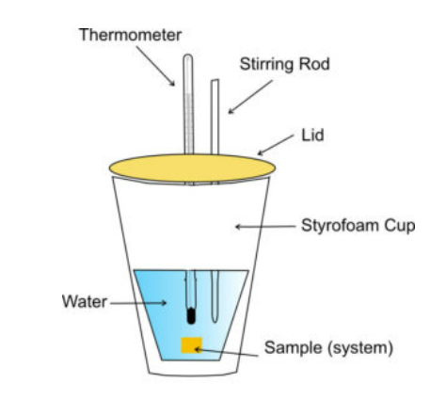

Figure 1, Simple Calorimeter setup [5]

Hypothesis’ and Variables
As the experiment is split into two halves, each one can have its own hypothesis and variables. Firstly, for the heat capacity of the calorimeter, the temperature will be raised to the equilibrium point and then stay at that temperature. The independent variable is the volume of water in the calorimeter, the dependent is the temperature of the water and the control variable is the temperature of the water added to the calorimeter.

For the second part, when the metal is added the water will heat up slower than the previous cup of water, eventually reaching its highest temperature before falling to its equilibrium point. The independent variable of this part is the metal being added to the water, the dependent is still the temperature of water in the calorimeter and finally, the control variable is the temperature of the metal before being added.

Method to measure the heat capacity of the calorimeter
- Add 50mL of water to the Styrofoam cup, close the lid with the stirring rod and thermometer inside.
- Add 50mL of water to the other beaker and start heating to 80 degrees using a Bunsen burner, once it has reached this temperature wait for it to cool down to 60 degrees.
- Measure the temperature in the Styrofoam cup, this is T(Cold).
- Add the hot water to the calorimeter and mix thoroughly while watching the thermometer, record the maximum temperature that it reaches, this is T(Hot).
- Calculate the heat capacity of the calorimeter, HC(Calorimeter).

Method to measure the heat capacity of the metal
- Weigh the metal object and record its mass as m(metal).
- Add water to a large beaker and start heating until its boiling, once it is add the metal and keep on the heat for 5 minutes. This brings the metal to the temperature of the water, but try to keep the metal away from the direct flame as this will heat it more than the water.
- Measure 30mL of water and add it to the empty calorimeter, measure it and record it as T(Cold)
- Record the temperature of the hot water once the metal has reached thermal equilibrium, record this as T(Max).
- Add the hot metal to the calorimeter using tongs. Try to be quick so that heat energy is not lost to the surroundings before being covered in the cup.
- Stir the water constantly and record the temperature every 10 seconds in a table of time against T(Water). Continue until the water has heated up and then cooled by at least 2 degrees.
- Calculate the specific heat of the metal using the equation below. Assuming the capacity of the water in the calorimeter was C(p water) = 4.186.

Results

Measuring the heat capacity of the calorimeter:

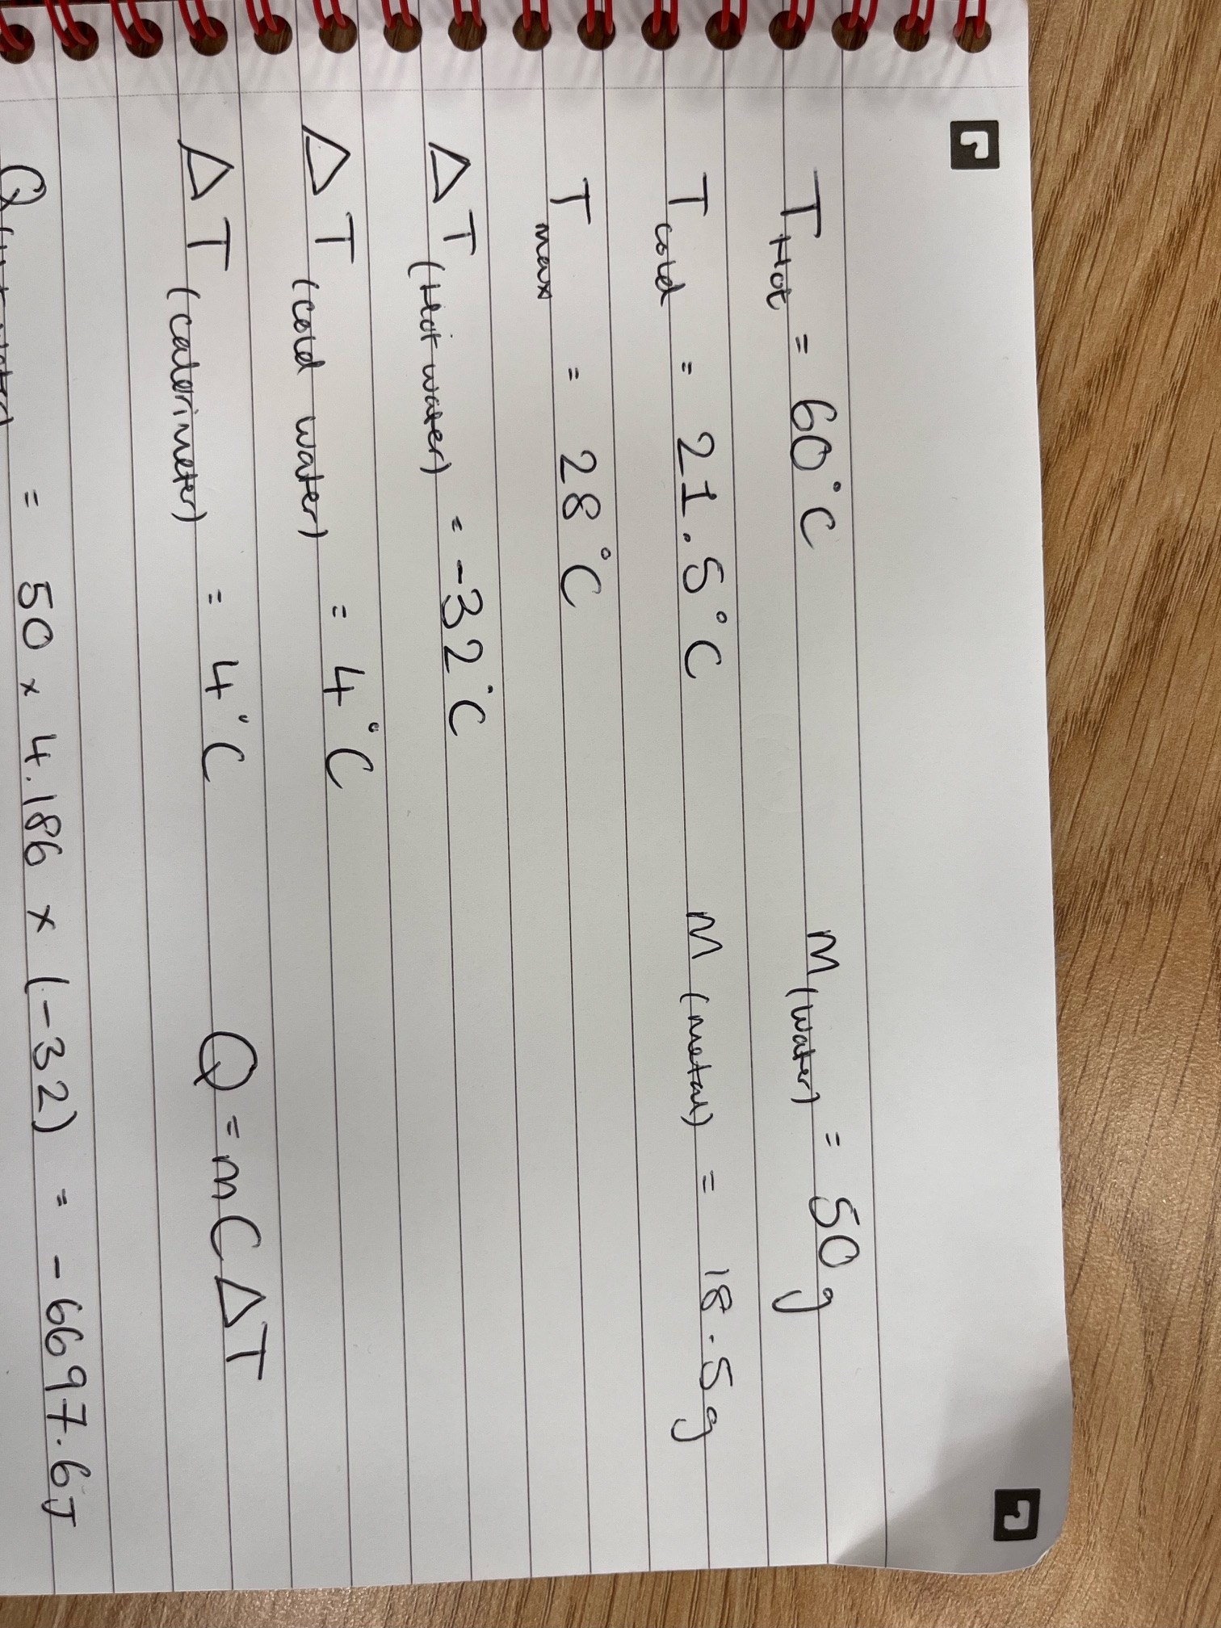

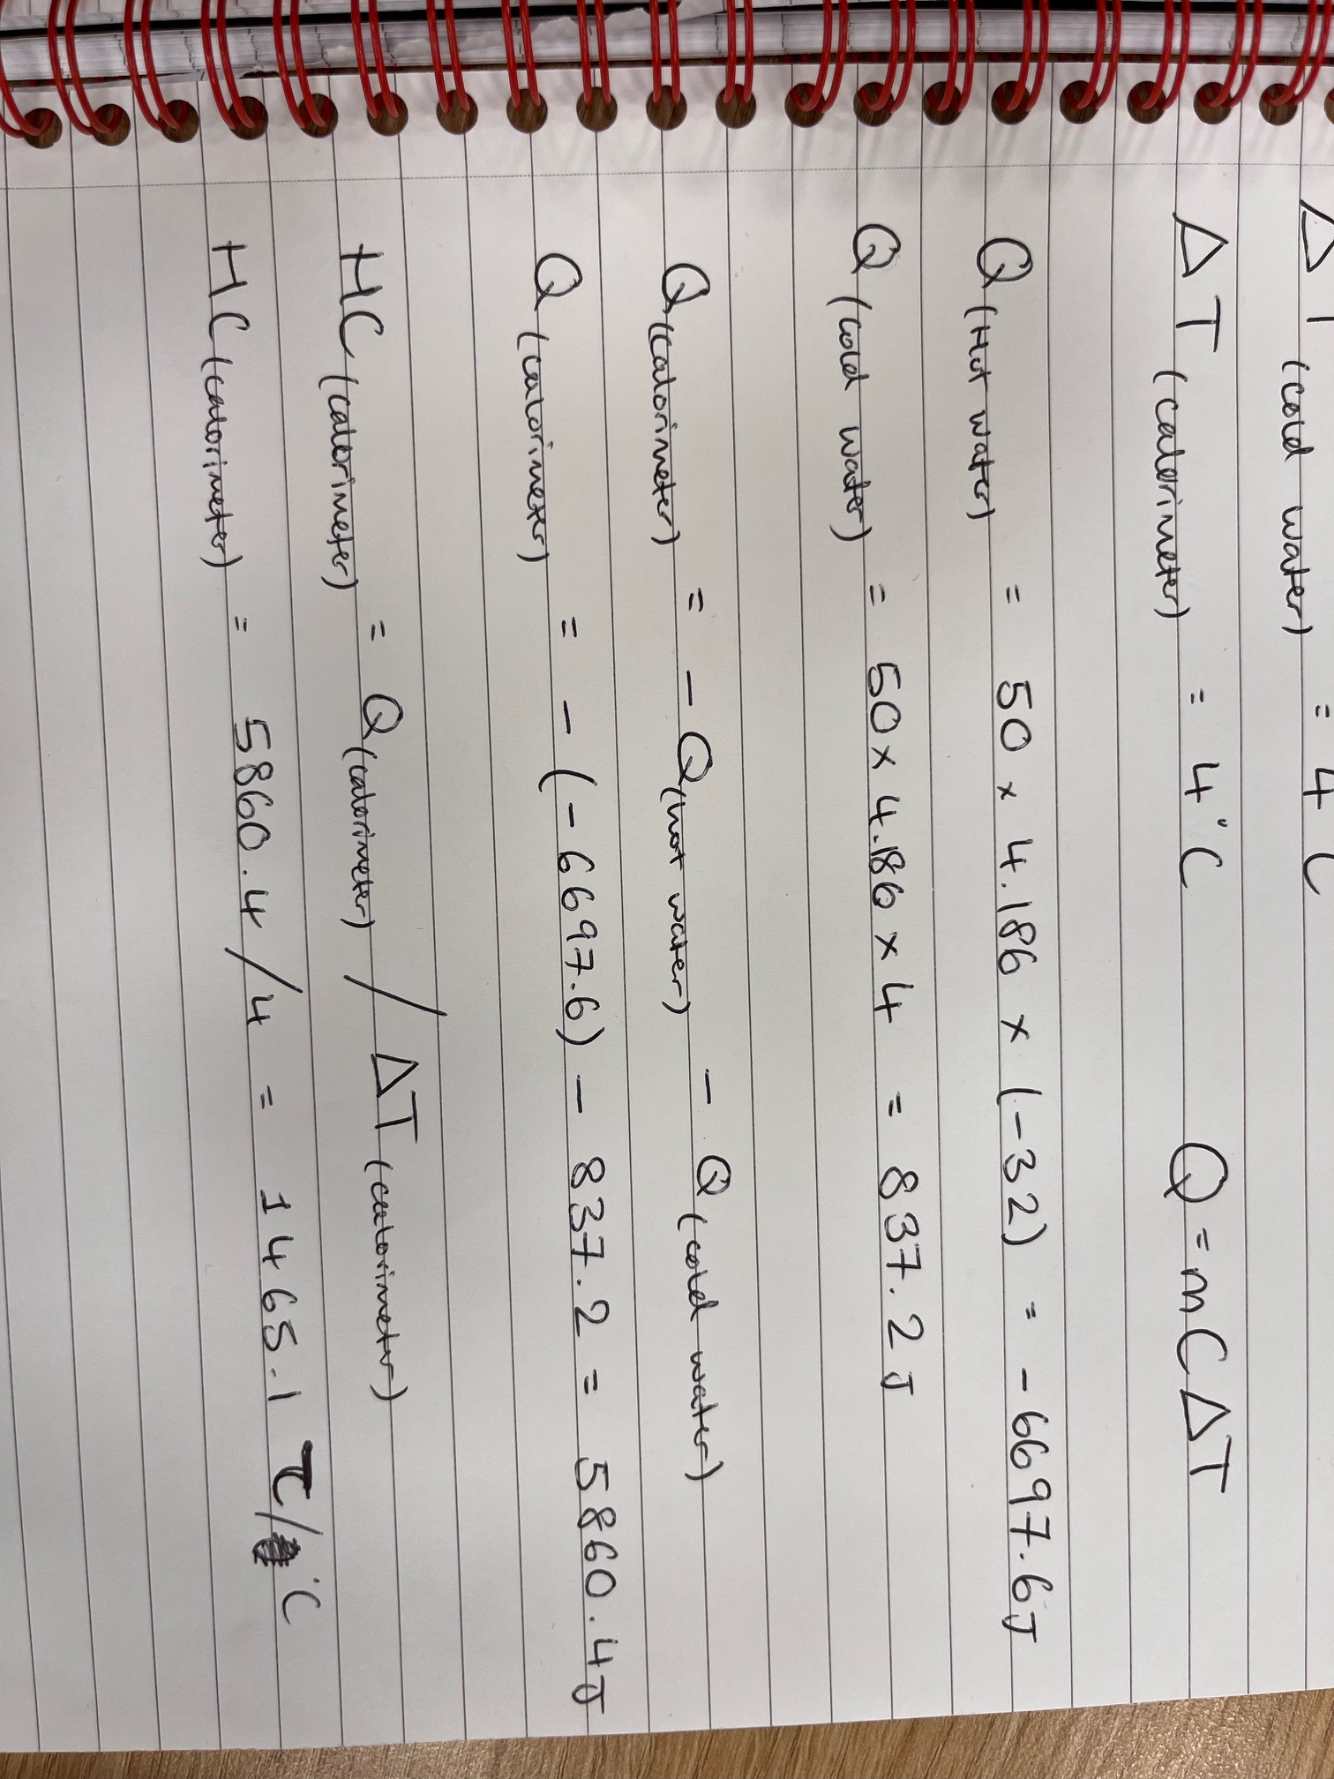

Measuring the heat capacity of the metal:

TIME | TEMPERATURE
10 | 26
20 | 27
30 | 27
40 | 28
50 | 28
60 | 28
70 | 28
80 | 28
90 | 28
100 | 27.5
110 | 27.5
120 | 27.5
130 | 27.5
140 | 27.5
150 | 27.5
160 | 27.5
170 | 27.5
180 | 27
190 | 27
200 | 27
300 | 27
600 | 26

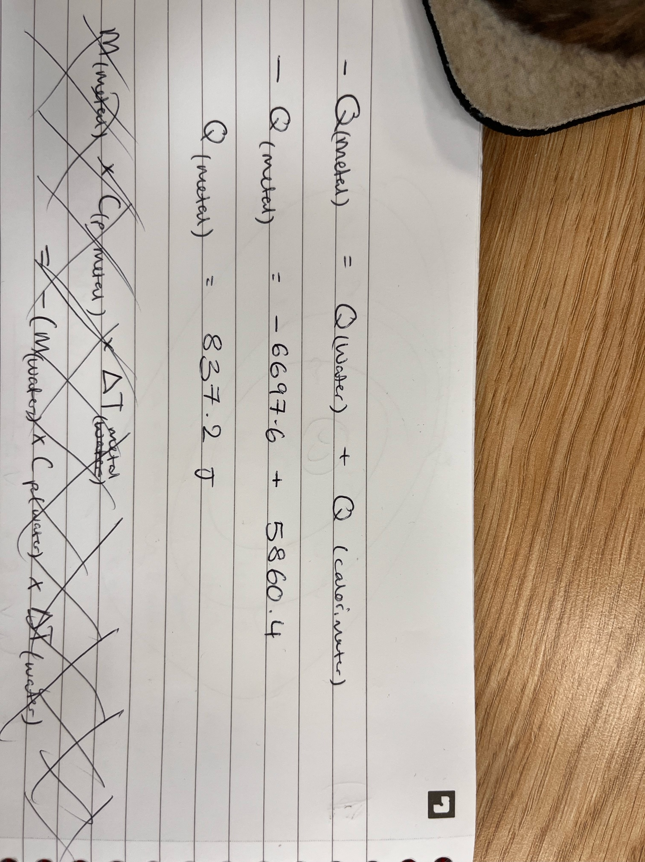
From the information in the table of results, it is clear the water heated up the most within the first 10 seconds after the metal was added. After 40 seconds it reached its highest temperature of 28 degrees and then slowly fell through to 26 where it stayed for over 10 minutes. This was the calorimeters equilibrium temperature.

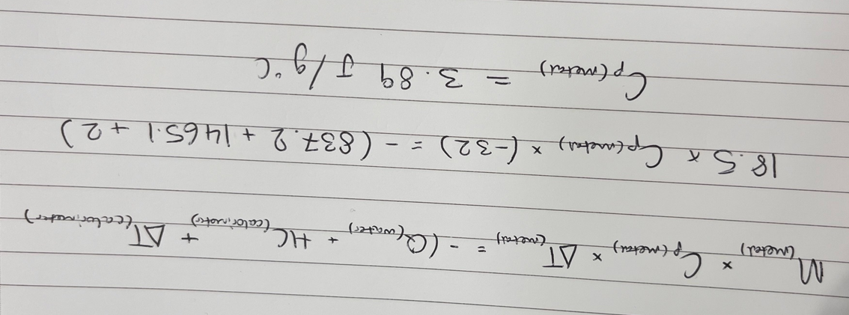

Discussion
Calorimeters are used in OME too, specifically bomb calorimeters are used to measure the heat capacity of solutions, enthalpy changes in reactions, and the heat formation of substances [3]. These can be used for fuel calorific determination, quality control in fuel production, food calorimetry, bio-energy research and many more practical experiments [6].

These devices have high-precision temperature sensors that get highly accurate readings while in a much better insulator environment compared to the Styrofoam cups used earlier. Furthermore, bomb calorimeters can act as a closed system from the start to finish of the reaction inside. An electrical fuse ignites the reactants while the lid is on, there is no opening of the system and subsequent loss of heat [4]. As shown in figure 2 (Below), the system uses minimal human input, apart from in setting up the system there is very little human error. The stirrer speed can be set and maintained, and the air jacket around the system stops the outer temperature of the system effecting the water temperature. The whole system is extremely controlled, this will help to receive consistent and accurate results. However, bomb calorimeters can suffer with incomplete combustion, sample size limitation and can be very time consuming, while also being quite expensive for all the right equipment.
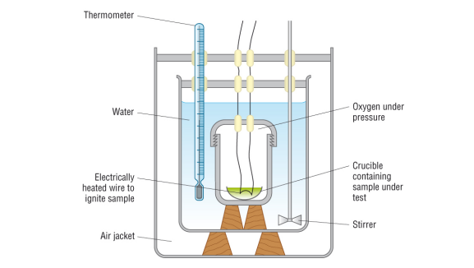

Figure 2, Diagram of a Bomb Calorimeter [4]

Overall the experiment was a success, the metal object heated the water above its original temperature and then it cooled down. It was very simple and could be improved in several areas. Firstly, the metal’s temperature was unknown, after leaving it in boiling water there was no certain way to tell it was at the right temperature internally. Following this once taking it out of the water and dropping it into the cup it would lose a significant amount of energy to the environment. Also, the stirring stick was difficult to move in the cup without piercing the walls, similarly the thermometer poked through multiple cups while trying to take readings. Lastly, as the room had open windows that created a draft that was further cooling down all of the instruments and calorimeter, this could have been fixed by closing the windows or getting wind breakers / more shelter around cup like for example, an air jacket.

Conclusions
Both hypotheses were accurate, the experiments went as planned and there were no major unexpected changes. The whole procedure should be repeated multiple more times so that any anomalous results could be removed and averages of the accurate results worked out. In the future the same experiment could be done in a bomb calorimeter to see how accurate the Styrofoam cup set-up was. Or a step between both options, upgrading the materials used around the cup to improve the insulation and consistency while still remaining somewhat cheap.

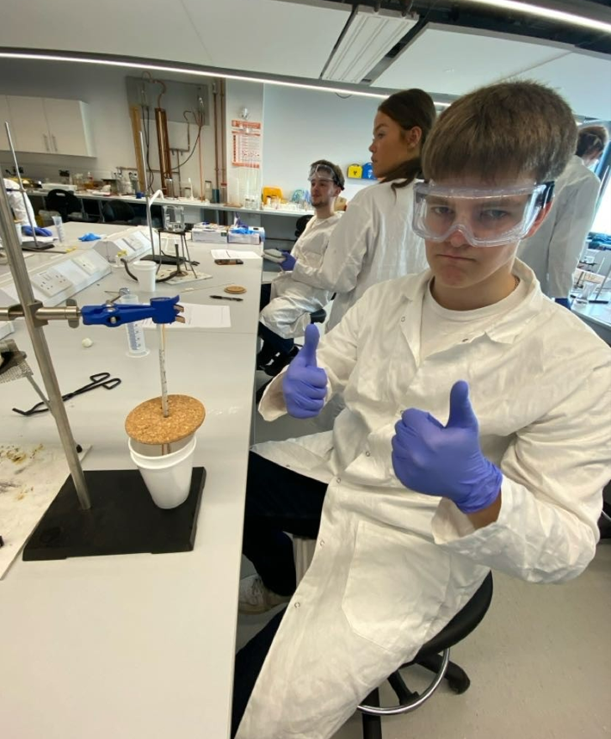

Figure 3, Setting up the experiment.

Appendix

Equipment
- 2x Styrofoam cup
- 1x Stand
- 1x Stand Clamp
- 1x Cork Lid
- 1x Thermometer
- 1x Stirring rod
- 1x Scissor tongs
- 1x Bunsen burner
- 1x Tripod
- 1x Heat mat
- 1x Measuring cylinder
- 2x Medium glass beakers

PPE
- Lab coat
- Goggles
- Gloves

Equations
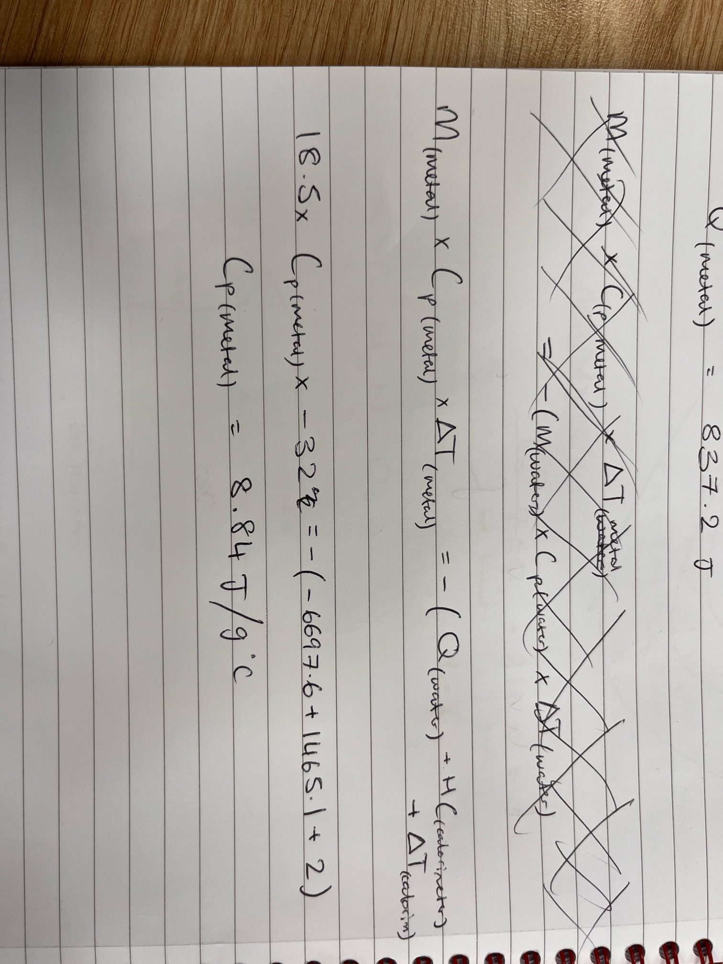

References
[1] J.Donnelly, N.Lapeyrouse, M.Rex. 10.2 calorimetry, Chemistry Fundamentals. Available at: https://pressbooks.online.ucf.edu/chemistryfundamentals/chapter/calorimetry/ (Accessed: 13 May 2024).
[2] Claire. Why is Styrofoam a Good Insulator? Sciencing Available at: Why Is Styrofoam a Good Insulator? | Sciencing (Accessed: 13 May 2024)
[3] Unknown Author. Bomb Calorimeter. StudySmarter. Available at: Bomb Calorimeter: Equation, Function & Use | StudySmarter (Accessed 14 May 2024)
[4] J.Melville, D.Gygi, E.Zhou. Bomb Calorimetry and Heat of Combustion. UC Berkely College of Chemistry. Available: calorimetry.pdf (berkeley.edu) (Accessed: 14 May 2024)
[6] H.Parinam. Bomb Calorimeter: Definition, Construction, Working, Uses, Advantages & Disadvantages. Mechanical Education. Avaliable: Bomb Calorimeter: Definition, Construction, Working, Uses, Advantages & Disadvantages - Mechanical Education (Accessed 14 May 2024)

