University of Wales Trinity Saint David
School of Engineering



Coursework Title:
Module Name & Code: Six Sigma Principles for Process Improvement – ACMA4004

Name: Luke Huzzey-Evans (2205835)
Date: 20/05/2024
Contents
1 Introduction 1
1.1 Aims 1
1.2 Objectives 1
2 Literature Review 2
3 Methodology 4
4 Conclusions 8
5 References 9

Figure 1- Annotated Metal Film Resistor Diagram 1
Figure 2 - Ishikawa/Fishbone Diagram 4

Introduction

Aims
Precision Electronic Solutions Cymru (PESC) stands as a respectable company in the manufacturing realm, specializing in crafting passive electronic components, notably Metal Film Resistors (MFRs), tailored to the exact needs of numerous large OEM companies. However, despite their seasoned expertise, PESC finds itself grappling with a pressing challenge: elevated defect rates leading to customer grievances and ballooning costs. In response, this report embarks on a strategic journey employing the DMAIC (Define, Measure, Analyse, Improve, Control) methodology of Six Sigma, meticulously aimed at enhancing their manufacturing process. With a laser focus on problem definition, metric establishment, root cause analysis, improvement blueprints, and stringent quality control mechanisms, this report endeavours to furnish a comprehensive roadmap toward operational excellence for PESC.

Objectives
In this report, we will explore the application of the Six Sigma DMAIC (Define, Measure, Analyse, Improve, Control) methodology to address the high defect rate issue at Precision Electronic Solutions Cymru (PESC), a manufacturer of passive electronic components. Our aim is to systematically improve the manufacturing process of Metal Film Resistors (MFRs) as seen in (Fig.1.) by identifying root causes of defects and implementing effective solutions.

Figure 1- Annotated Metal Film Resistor Diagram

Literature Review
Manufacturing industries constantly strive to enhance and achieve high product quality, optimize manufacturing processes, and reduce costs to remain competitive in today's dynamic marketplace. Six Sigma is a data-driven methodology, that offers a structured approach to achieving these goals by identifying and eliminating defects and variations in processes. This literature review explores the application of Six Sigma principles, particularly the DMAIC (Define, Measure, Analyse, Improve, Control) framework by improving manufacturing processes, focusing on their relevance, effectiveness, and key success factors.
The relevance of Six Sigma in Manufacturing is largely due to the fact that Six Sigma has gained widespread adoption throughout manufacturing industries due to its proven ability to drive continuous improvement and achieve measurable results. According to (Antony, 2005), Six Sigma emphasizes clear data-driven decision-making, process optimisation, and customer-centricity. Aligning well with the goals and challenges faced by manufacturing organizations past, present, and future. By systematically defining problems, measuring process performance, analysing root causes, implementing improvements, and establishing control mechanisms, this statement has been backed up by (Harry, 2000) who states that ‘’Six Sigma enables organizations to enhance their product quality, reduce defects, and improve operational efficiency’’.
The DMAIC framework serves as the cornerstone of Six Sigma methodology, providing a structured roadmap for process improvement initiatives. In their study, (Pyzdek, 2003) highlight the effectiveness of DMAIC in driving sustainable improvements by systematically addressing process inefficiencies and variability. By clearly defining project goals and scope (Define), measuring current process performance (Measure), analysing the root causes of defects (Analyse), implementing targeted improvement plans (Improve), and establishing quality control mechanisms (Control), organizations can achieve significant enhancements in product quality, customer satisfaction, and operational performance (Breyfogle III, 2003). Successful implementation of Six Sigma in manufacturing requires a combination of organizational commitment, leadership support, and employee engagement. According to (Kumar, 2006), leadership commitment is crucial for creating a culture of quality and driving organizational change. Senior management involvement in setting strategic goals, allocating resources, and providing direction is essential for sustaining Six Sigma initiatives in the long term. Additionally, employee involvement and empowerment is a vital factor for driving bottom-up improvement efforts, fostering innovation, and building a culture of continuous learning and improvement (Pande, 2000). Despite its numerous benefits, Six Sigma implementation in manufacturing is not without its challenges and limitations. According to (Chakravorty, 2010), resistance to change, lack of data availability, insufficient training and expertise are common barriers faced by many organizations Globally. In addition to this, the rigidity of Six Sigma methodologies may not always be suitable for highly dynamic or creative processes, requiring flexibility and adaptation to specific contexts (Davenport, 2008).

Methodology
To assess the current state of the manufacturing process at PESC, key performance metrics have been identified and measured. These include defect rates by which the number of defective MFRs per batch or per million units produced, likewise customer complaints can also be a strong metric to use based on the frequency and nature of complaints related to MFR quality, production yield defined be the percentage of defect-free MFRs produced in relation to total production, and the time taken to complete one production cycle from raw material input to finished goods output.
Root cause analysis aims to identify underlying factors contributing to defects in the manufacturing process. Two statistical or analytical tools that can be used for this purpose are Fishbone (Ishikawa) Diagram (Fig.2.), and Statistical Process Control.
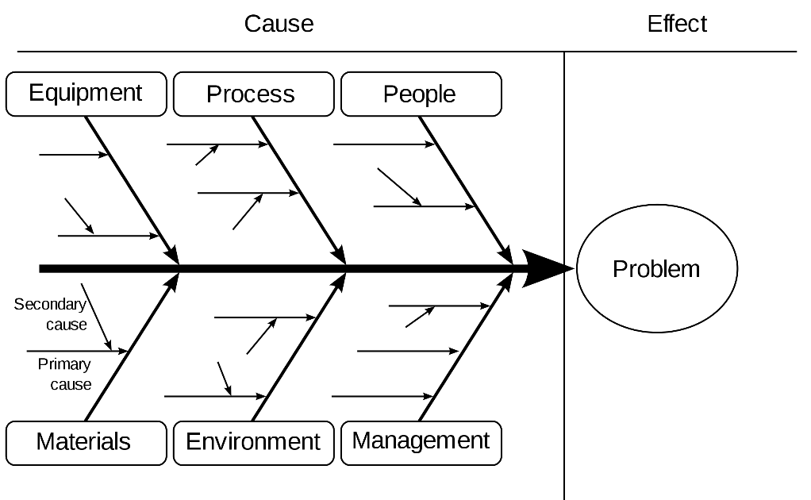
Figure 2 - Ishikawa/Fishbone Diagram
Ishikawa’s help visualize potential causes of defects by categorizing them into six main categories: People, Process, Equipment, Material, Measurement, and Environment. By systematically analysing each category, we can identify the root causes that are requiring attention.
Statistical Process Control (SPC) involves statistical analysis of process data to identify trends, patterns, and variations that may indicate potential causes of defects. Control charts, such as X-bar and R charts, these can help monitor process stability and identify any special causes of variation.
Based on root cause analysis, three potential improvement strategies to reduce defects in the manufacturing process are proposed:
- Process Optimization: Utilize lean principles to streamline the production process, minimize waste, and reduce variability. This may involve implementing standardized work procedures, optimizing equipment setup times, and improving material flow to eliminate bottlenecks.
- Training and Skill Development: Invest in employee training programs to enhance technical skills and promote a culture of quality and continuous improvement. Well-trained operators are better equipped to identify and address potential sources of defects, contributing to overall process reliability.
- Supplier Collaboration: Work closely with raw material suppliers to ensure the quality and consistency of inputs. Establishing stringent quality control measures at the supplier's end can help prevent defects from propagating into the manufacturing process, reducing rework and scrap.
To sustain improvements achieved through the DMAIC process, it is essential to establish control mechanisms for ongoing monitoring and maintenance of process performance. Specific control measures may include Standard Operating Procedures (SOPs) to document and communicate standardized work procedures, quality standards, and best practices to ensure consistency and repeatability in the manufacturing process. Regular audits and performance reviews can help verify compliance with SOPs and identify areas for further improvement, by using Quality Management Systems (QMS) and implementing a robust QMS, such as ISO 9001, to institutionalize quality management practices and facilitate continuous improvement efforts. Alongside regular internal audits and external certifications can provide independent validation of process effectiveness and adherence to quality standards. Process Monitoring and Auditing allowing regular monitoring of key performance metrics and conducting internal audits to verify compliance with established processes and identify areas for further improvement. By employing a continuous improvement culture at PESC and fostering a culture of continuous improvement through employee involvement, feedback mechanisms, and recognition of achievements will sustain these improvements.
From the overall analysis of the manufacturing process for Metal Film Resistors (MFRs) at PESC it has revealed several constraints that impact production efficiency and throughput. The identified constraints include significant changeover times at the Resistance Spot Welding, Spiralling, and Coating stages, as well as relatively long cycle times at the Spiralling stage. These constraints contribute to potential bottlenecks in the plant layout and material flow, ultimately affecting overall productivity and operational effectiveness. An effective problem statement for PESC's manufacturing process could be: "The current manufacturing process of Metal Film Resistors (MFRs) at PESC is plagued by high defect rates, leading to customer complaints and increased costs. The objective is to reduce defects and enhance product quality to meet customer requirements while optimizing operational efficiency and minimizing costs.’’ To address these constraints and improve production performance, several key improvements can be recommended based on exceptional evaluation of underlying concepts and principles, supported by qualitative and quantitative data interpretation.
There is an apparent need to optimise the Changeover Processes, to successfully implement this, lean manufacturing principles to streamline changeover procedures at bottleneck stages should be applied in areas such as the Resistance Spot Welding, Spiralling, and Coating. By utilizing techniques like Single-Minute Exchange of Die (SMED) to reduce changeover times, companies such as PESC can realize several benefits. Firstly, SMED allows for more efficient use of production time by minimizing downtime between product runs. This increased efficiency leads to higher overall productivity and throughput. Additionally, by separating internal and external setup tasks and converting them to parallel operations where possible, SMED helps streamline the changeover process, reducing the risk of errors and ensuring smoother transitions between production runs. Moreover, research shows that shorter changeover times will enable PESC to be more responsive to changing customer demands, allowing for greater flexibility in production scheduling and quicker adaptation to market trends. Overall, implementing SMED can result in significant cost savings, improved operational efficiency, and enhanced product quality and customer satisfaction.
To reduce Cycle Time, time-motion studies and value stream mapping should be conducted to identify opportunities for cycle time reduction, particularly at the Spiralling stage, another avenue that should be considered is to investigate potential process improvements, such as equipment upgrades, or workflow redesign, these can be achieved to enhance cycle time efficiency without compromising overall product quality.
Investment in Technology and Automation to explore the adoption of advanced manufacturing technologies, such as robotics or automated material handling systems, to minimize manual intervention and optimize production flow. Investment in predictive maintenance systems to ensure equipment reliability and reduce unplanned downtime, thereby mitigating the impact of constraints on overall production capacity. Using established and robust data collection and analysis systems to monitor key performance indicators (KPIs) related to production efficiency, changeover times, cycle times, and throughput will help utilize statistical process control (SPC) techniques to identify trends, patterns, and root causes of variability, enabling evidence-based decision-making and targeted interventions.
By implementing these recommendations, PESC can effectively address the identified constraints in their manufacturing process for MFRs, and therefore leading to significant improvements in operational efficiency, productivity, and overall competitiveness. Moreover, the application of evidence-based analysis and sound judgment ensures that the proposed interventions are both appropriate and valid in addressing the underlying challenges and achieving sustainable long-term growth and success.
However, it would be naive to disregard any possible challenges whilst actively introducing the forementioned recommendations provided, it's imperative to address the potential risks and resistance to change when implementing proposed improvements within an organization. This involves conducting a comprehensive risk assessment to identify and prioritize potential obstacles, ranging from technical challenges, resource constraints, and stakeholder resistance. It's essential to foster open communication and collaboration with all stakeholders, including employees, managers, and senior leadership, to gain their buy-in and support for the proposed changes. This can be achieved through regular meetings, town hall sessions, and one-on-one discussions to address concerns and solicit open and clear feedback. Moreover, developing a robust change management plan is critical to effectively managing the transition process. This plan should outline the clear objectives, define roles and responsibilities, establish a timeline for implementation, and detail strategies for communication and training. Providing training and development opportunities for employees is essential to equip them with the necessary skills and knowledge to adapt to new processes or technologies effectively. Additionally, conducting pilot tests or small-scale trials of the proposed improvements can help identify potential challenges and refine the implementation plan before a full-scale rollout. Offering incentives and recognition to employees who actively contribute to the success of the implementation process can help motivate participation and maintain momentum. Establishing mechanisms for continuous monitoring and feedback is also essential to track progress, identify areas for improvement, and address any unforeseen challenges or setbacks. Finally, developing contingency plans to mitigate risks and address unexpected issues is crucial for ensuring resilience and adaptability throughout the implementation process. By proactively addressing these factors, organizations such as PESC can increase the likelihood of a successful implementation period and achieve sustainable improvements in their operations.

Conclusions
In conclusion, the journey through the DMAIC methodology will be instrumental in Precision Electronic Solutions Cymru's (PESC) quest to mitigate their high defect rates in Metal Film Resistors (MFRs) manufacturing. By meticulously defining the problem, measuring performance metrics, conducting thorough root cause analysis, implementing tailored improvement strategies, and instituting robust control mechanisms, PESC will witness tangible enhancements in product quality, operational efficiency, and customer satisfaction. This structured approach not only can address the immediate challenges but will also lay a foundation for sustained success in the competitive market landscape. The emphasis on evidence-based analysis and continuous improvement will foster a culture of excellence within the organization, empowering employees to proactively identify and address issues while driving innovation and efficiency. The principles ingrained within the DMAIC framework should continue to guide PESC's endeavours, enabling the company to remain agile and responsive to evolving market dynamics. By embracing a mindset of continual improvement and leveraging the DMAIC methodology as a strategic tool, PESC is poised to navigate future challenges with confidence, cementing its position as a leader in the manufacturing industry.

References
Antony, J. &. B. R., 2005. Six Sigma in the UK service organizations: results from a pilot survey. Managerial Auditing Journal, pp. 184-194.
Breyfogle III, F. W. C. J. M. &. M. B., 2003. Implementing Six Sigma: Smarter Solutions Using Statistical Methods.. Austin, Texas: John Wiley & Sons.
Chakravorty, S. S. &. A. J. B., 2010. Diffusion of Six Sigma in manufacturing industries: an exploratory study. International Journal of Production Research, pp. 3925-3943.
Davenport, T. H., 2008. Why Six Sigma Is on the Downslope. [Online]
Available at: https://hbr.org/2008/01/why-six-sigma-is-on-the-downsl#:~:text=Companies%20really%20need%20a%20combination,mix%20should%20be%20even%20broader.
Harry, M. J. &. S. R., 2000. Six Sigma: The Breakthrough Management Strategy Revolutionizing the World's Top Corporations.. s.l.:Currency; Illustrated edition.
Kumar, M. A. J. &. S. R. K., 2006. Implementing the Six Sigma process in small and medium enterprises.. International Journal of Quality & Reliability Management, pp. 917-930..
Pande, P. S. N. R. P. &. C. R. R., 2000. The Six Sigma Way: How GE, Motorola, and Other Top Companies Are Honing Their Performance.. Illustrated ed. s.l.:McGraw-Hill Education.
Pyzdek, T. &. K. P. A., 2003. The Six Sigma Handbook.. 4th ed. s.l.:McGraw-Hill Education..

