

Name: - Meet Mukeshbhai Patel
Student-id: - 2241321
Module Code: - LCMB-7001
Module Name: - Marketing Assessment-1

Table of Contents
1. Introduction 3
2. Background of British Airways 3
2.1 Mission Statement 5
2.2 Vision Statement 5
3. Communication 6
3.1 Communication Model 6
4. Integrated Communication System 7
5. Promotional Strategies 8
5.1 Online strategies: 8
5.2 Offline strategies: 8
6. Branding & Brand Equity 9
7. keller’s Brand Equity Model 9
7.1 Advantages and Disadvantages of Brand Equity Model 10
8. Customer Journey 12
9. Customer Journey Map 13
9.1 Strength and Weakness of Customer Journey Map 15
10. Total Engagement Model 16
11. Recommendations 17
11.1 New Touchpoints 18
12. Conclusion 18
References 20

Introduction
British Airways is one of the famous airlines in the world. The aim of this report is to critically evaluate the customer journey for British Airways across the five stages of awareness, consideration, purchase, service delivery and after-sales. Customer journeys are important in modern marketing as they provide insights into the entire end-to-end experience that customers have with a company across multiple touchpoints and channels. Assessing and improving customer journeys can lead to higher customer satisfaction, loyalty and advocacy for brands. This report will analyse British Airways’ current customer journey strategies and touchpoints and provide recommendations for how the company can create more innovative marketing to improve the customer experience. The analysis will be supported by academic theory on customer journeys, touch points and relationship marketing.
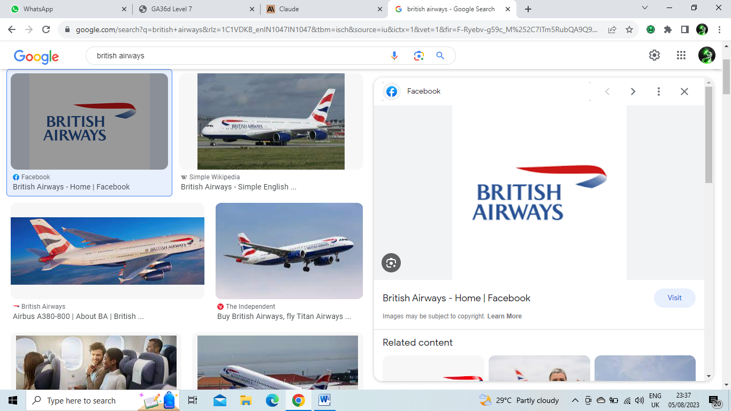

2. Background of British Airways
British Airways (BA) the United Kingdom’s flagship carries was formed in 1974 through by merging two largest airlines namely British Overseas Airways Corporation (BOAC) and British European Airways (BEA). Some key points about the history and background of British Airways:
- BOAC was founded in 1939 to operate long-haul services to the British colonies and Dependencies. It flew wartime routes during World War II and later expanded its global route network (Berenbak, 2022).
- BEA was established in 1946 to operate European and domestic routes. It was the biggest domestic airline in the UK throughout the 1960s and 1970s.
- The Civil Aviation Act of 1971 led to the merger of BOAC and BEA into British Airways in 1974. The airline was initially state-owned before being privatized in 1987(Berenbak, 2022).
- BA absorbed smaller UK airlines like British Caledonian and Dan-Air in the 1980s and 1990s to become the dominant airline in the UK.
- It is one of the world's largest international airlines, operating flights to over 200 destinations in more than 70 countries.
- Key hubs are London Heathrow and London Gatwick airports. BA is a founding member of the one world airline alliance.
- BA underwent a major rebranding in 1997, introducing a new image and livery with tail fins featuring global designs.
- The airline has faced financial challenges at times but remains one of the most prestigious legacy airlines globally. It continues to innovate, recently taking delivery of new fuel-efficient aircraft.
British Airways has a long and storied history as the UK's national airline, born out of the merger of BOAC and BEA in the 1970s and growing to become a top global carrier over the decades. It remains an aviation industry leader today (Berenbak, 2022).
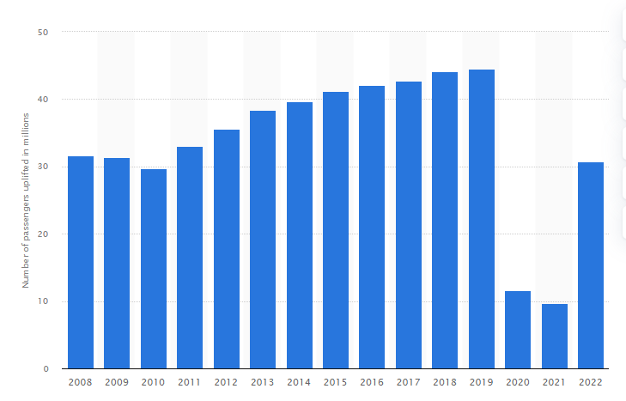
Figure 1: Graph showing Number of passengers uplifted by British Airways plc from 2008 to 2022 (in millions) (Berenbak & Lanser, 2020)

2.1 Mission Statement
British Airways as UK’s flag carrier aspires to be the most trusted and responsible airline, offering excellent value and service while connecting UK to the world. Safety and security are top priorities, and the airways strive to provide customers with a superb experience before, during and after each flight. Investing in employees and building a strong team environment also remain key focuses (Berenbak & Lanser, 2020). The company is committed to operating business in a sustainable and socially responsible way, utilizing advanced technologies and innovation to improve operations wherever possible. Strong global partnerships and alliances enable us to extend airways network reach. As a representative British brand, the company take pride in bringing the best of Britain to the world and enabling global access to Britain. The mission is to responsibly connect Britain with diverse global destinations, deliver an enjoyable customer experience, and reflect the finest values and service of our nation (Berenbak & Lanser, 2020).

2.2 Vision Statement
British Airways aspires to be the world's leading global premium airline group. The airlines achieve this statement by providing quality services to customers. The main vision is to establish long-term relationships with customers and invest in services and products to ensure that customers enjoy the best experience with British Airways (Bjermer, 2011).
British Airways sets the highest standards for safety, operational excellence, sustainability, and innovation in the airline industry. The company will develop people to reach their full potential and contribute their best to British Airways' success.
Looking ahead, the company aspire to connect Britain to the world in a responsible manner, promoting trade, tourism, and understanding between cultures. The company wants to represent the very best of British hospitality while bringing the best of the world to British shores (Bjermer, 2011).

3. Communication
British Airways defines communication as the effective and efficient transfer of information between all of employees of company and external stakeholders through a variety of channels. Effective communication is essential for us to build trust, foster collaboration, align strategy, manage operations, enhance customer service, convey our brand promise, and ultimately fulfil our mission.
The airways believe transparent, meaningful, and proactive communication enables better decision-making, problem-solving, and innovation at British Airways. Clear communication ensures employees understand vision, objectives, and values and are empowered to deliver brand promise (Heiets & Prakittachakul, 2020). Timely communication with customers keeps them informed and enhances their travel experience with us. The airways also maintain open channels of communication with investors, partners, suppliers and the media.
Overall, communication at British Airways entails listening attentively, responding promptly, addressing concerns, leveraging diverse mediums, and sharing relevant information across borders and roles (Heiets & Prakittachakul, 2020). The company communications aim to engage global audiences, support goals and strategies, and reflect high standards of service, integrity and professionalism. It is through considerate, constructive communication that the company will continue to build a world-class airline representing the very best of British.

3.1 Communication Model

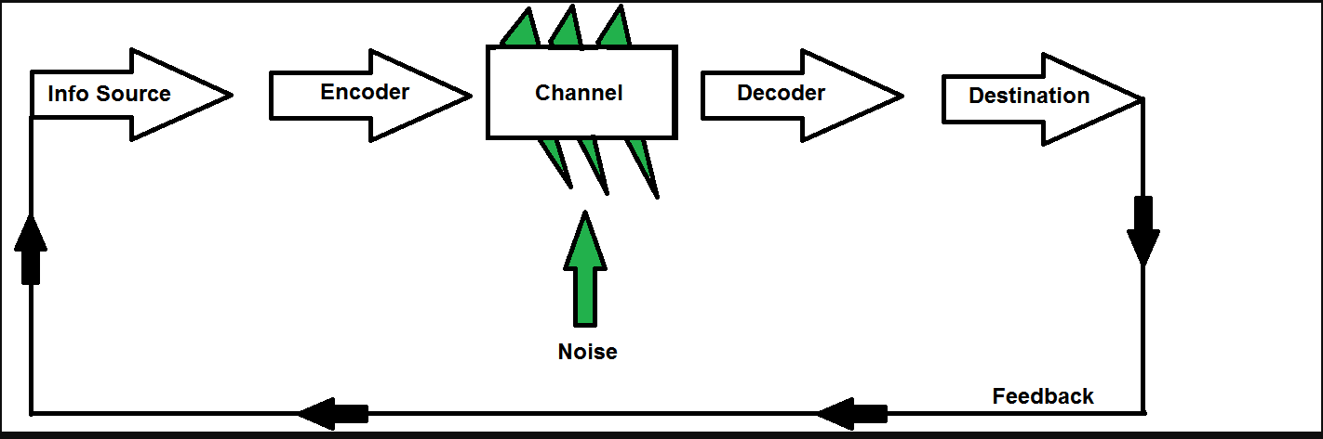
Figure 2: Claude Shannon and Warren Weaver’s macro model
At British Airways, effective communication requires clear senders and receivers exchanging meaningful messages through appropriate channels (Hutchinson, 2019).
- Senders: The senders of communication at British Airways include leadership, managers, employees, customers, investors, partners, media, regulatory agencies and other stakeholders. All have important messages to convey both within the organization and externally.
- Messages: The messages exchanged fulfil diverse purposes such as sharing information and ideas, providing guidance, establishing expectations, resolving issues, building relationships, promoting products and services, handling complaints, and managing operations. Messages aim to inform, instruct, persuade, inspire or convey other objectives.
- Channels: The channels that company utilize include verbal mediums like conversations, announcements, presentations; written forms like emails, reports, press releases; visual formats like videos, signage, ads; and digital platforms like the website, social media, apps. The channel is chosen based on the sender, receiver and message context.
- Receivers: The diverse receivers of communications at British Airways include workforce, customers, shareholders, partners, contractors, government agencies, interest groups and the general public. Careful targeting ensures messages reach intended receivers.
- Feedback loops allow for two-way communications and help improve messaging over time. Overall, The communications aim to create understanding between all senders and receivers.
This sender-message-channel-receiver model provides a useful framework for British Airways to analyse and optimize communications across the organization and with external stakeholders (Hutchinson, 2019). It emphasizes aligning components to communicate clearly, appropriately and effectively.

4. Integrated Communication System
The British airways define integrated marketing communication (IMC) as the strategic coordination of promotional messages and communications across all available channels. The goal is to build meaningful connections with customers and stakeholders through seamless, consistent, and engaging content (Meng, 2012).
The IMC involves aligning advertising, public relations, direct marketing, website content, social media interactions, internal communications, and other touchpoints to create a unified brand voice. Whether it is through traditional media or digital platforms, The Company wants to create transparent, valuable interactions that convert customers and create loyalty to British Airways.
Key elements of IMC strategy include understanding target audiences, defining campaign objectives, developing consistent messaging and visual identity, utilizing both traditional and digital media effectively, connecting multichannel content, amplifying core propositions, and measuring campaign impact(Meng, 2012).
At British Airways, integrated marketing communication enables us to effectively engage diverse audiences globally, build brand awareness, influence travel decisions, drive sales, and ultimately deliver exceptional customer experiences (Meng, 2012). The IMC aims to harmonize communications for clarity, consistency and connection with our brand.

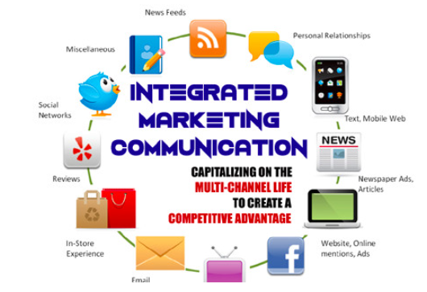
Figure 3: Integrated Marketing Communications

5. Promotional Strategies

5.1 Online strategies:
- Retargeting ads - Serving customized ads across platforms to people who previously visited BA's website or searched related topics. Helps keep BA top of mind.
- Content marketing - Creating and optimizing blog posts, guides, videos, etc. that offer valuable information searchers seek, while highlighting BA's services.
- Online PR - Seeking earned media exposure and backlinks through digital press releases, contributed articles and interview pitches (Prassl, 2021).
- Website optimization - Ensuring BA's website is mobile-friendly, user-centric and search engine optimized with relevant keywords.
- Review management - Proactively soliciting, monitoring and responding to customer reviews on sites like TripAdvisor and Trustpilot.

5.2 Offline strategies:
- Airport lounge marketing - Branding, brochures and sales materials strategically placed in British Airways lounges.
- In-flight advertising - Using in-flight magazines, menus, entertainment content etc. for subtle promotional messaging (Prassl, 2021).
- Partnerships - Teaming up with relevant brands in complementary industries like hotels, credit cards, rental cars and tourism boards for cross-promotion.
- Merchandise giveaways - Providing branded merchandise like bags, sleep masks, pins as free takeaways for travellers.
- Out-of-home ads - Placing large, attention-grabbing digital signage at transit points like subway stations.
- Experiential marketing - Having BA brand ambassadors interact with travellers at airports and city landmarks (Prassl, 2021).

6. Branding & Brand Equity
At British Airways, branding refers to the strategic process of developing and maintaining a distinctive brand identity that resonates with customers and stakeholders. The brand conveys attributes, heritage, ethos and service promise through visual components like classic logo and livery, as well as intangible associations customers have with airline. Branding permeates all customer touch points, from uniforms and cabin interiors to airport lounges, menus and digital interfaces (Ray, 2014). The aim of project is established British Airways brand personality across markets, balancing sophistication, charm and efficiency.
Brand equity represents the value and strength of the British Airways brand. It stems from building widespread brand awareness, loyalty and preference over years of great service. High equity translates into an edge over competitors, allowing us to justify price premiums, drive traffic, expand strategically and forge partnerships (Ray, 2014). The airways continuously monitor brand health to maintain equity. A compelling employer brand also helps us attract top talent globally. Responsible practices further build brand trust and goodwill. Overall, managing brand strategically and delivering an excellent British flying experience worldwide is key to sustaining brand equity, competitive advantage and future growth for British Airways (Ray, 2014).

7. Keller’s Brand Equity Model
British Airways aims to build substantial brand equity based on the pillars of salience, performance, imagery, judgments and feelings (Takebayashi, 2011).
Brand Salience
- High awareness and recognition of the British Airways (BA) brand globally
- Top-of-mind airline brand for travel from/to the UK
- Instant recall of BA's iconic assets like aircraft livery, London Heathrow terminals
Brand Performance
- Perception of BA flights consistently delivering on safety, service quality, reliability, punctuality
- Network connectivity to destinations across the UK and worldwide
- Seamless end-to-end travel experience, from booking to arrivals
- Elite airline status providing privileges and exclusive services
Brand Imagery
- Strong brand heritage as the flag carrier airline of the United Kingdom
- Brand imagery reflecting British charm, sophistication and world-class service
- Aircraft cabins, lounges and service evoking British elegance and refinement
- Consistent brand identity across physical and digital customer touchpoints
Brand Judgments
- High customer satisfaction and likelihood of recommendation for the brand
- Prestige associated with the British Airways brand name and flying experience
- Perception of good value for money, especially in premium cabins
- Trust in British Airways built over decades of operations
Brand Feelings
- Strong emotional connection and nostalgia for the brand amongst British customers
- Feelings of excitement and indulgence especially for first-time flyers
- Comfort and reassurance associated with the British Airways flight experience
- Sense of belonging to the British Airways community of travellers
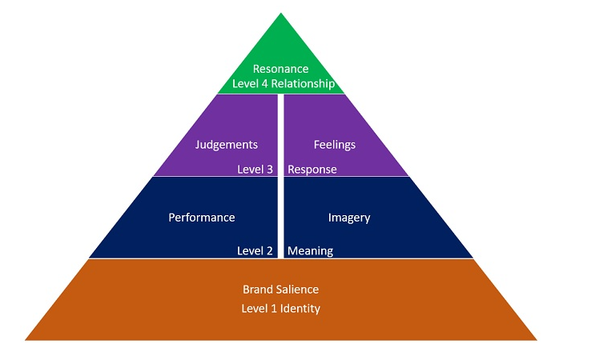
Figure 4: keller’s brand equity model
British Airways aims to build equity across all dimensions of brand knowledge, performance, imagery, judgments and feelings. By providing excellent air travel rooted in superior British service (Takebayashi, 2011), BA strengthens brand resonance and loyalty globally.

7.1 Advantages and Disadvantages of Brand Equity Model
Advantages:
- Provides a structured framework to evaluate and track brand equity over time across diverse dimensions.
- Identifies key brand building blocks that require investment and management.
- Highlights the importance of brand knowledge, awareness and image alongside functional performance.
- Focuses on crafting the customer's subjective perceptions and feelings towards the brand.
- Links brand building to customer experiences across touchpoints.
- Guides marketing strategy and actions required to build equity.
- Quantifies brand equity to justify investments and measure ROI.
- Keeps brand relevance and resonance at the core of business decisions.
Disadvantages:
- Can be complex for all employees to understand and apply in decisions.
- Challenging to select metrics and consistently measure subjective brand dimensions like feelings.
- Requires significant brand research across global markets.
- Model may need adaptation to capture industry and local nuances.
- Difficult to attribute brand equity specifically to marketing actions.
- Company culture and internal branding missing from the external model.
- Evolving digital landscape may warrant model updates over time.
Overall, leveraging a structured framework like Keller's model would provide British Airways strategic guidance on evaluating and strengthening its brand globally, despite needing customization and integration with internal branding efforts.

8. Customer Journey


Name: Michal
Age: 42
Occupation: Advertising Executive
Location: London, England
Bio: Michal is a busy advertising executive at a top London agency. He is married with two young kids. John travels frequently for business meetings with clients in New York, Paris and Milan. He appreciates efficiency and is loyal to brands that make his hectic life simpler.
Pre-Booking: John sees ads for British Airways' business class sale and is attracted by the convenient London Heathrow departure, premium amenities and mileage perks. He checks out BA reviews and brand reputation as he considers flight options for his NYC trip.
Booking: John books his roundtrip business class ticket directly on ba.com. The website is easy to navigate. He selects his seat and adds on an airport lounge pass. John receives his e-ticket confirmation promptly via email.
Pre-departure: In the week before flying, John receives a pre-flight email from British Airways highlighting airport information, cabin baggage guidance, and online check-in details.
Airport: On the day of departure, John arrives at Heathrow T5 early, checks in at a kiosk and drops his bag. He then proceeds to the BA Galleries lounge where he enjoys the upscale, refined British ambience.
Boarding: John boards the aircraft seamlessly using his mobile boarding pass. He is warmly welcomed at the door by a British Airways crew member.
In-flight: Settling into his lie-flat seat in business class, John is impressed by the fine details and amenities. An attentive flight attendant serves John a pre-departure drink and provides a menu for the onboard dining. Throughout the flight, John stays entertained with movies, Wi-Fi and workspace. Crew regularly check on John and fulfil any needs promptly.
Arrival: The flight lands smoothly at JFK. John breezes through immigration with his mobile passport details ready. He collects his luggage quickly at the priority carousel and clears customs, concluding his positive travel experience with British Airways.
John leaves feeling productive, rested and excited for his New York trip, eager to fly British Airways again soon.

9. Customer Journey Map
Customer Journey Map | Awarenes | Discover | Purchase | Use | Bond
Website |  | Advertisments |  | Frequent Flyer Program
Flight Stage |  | Receives in-flight service | Frequent Flyers
Social Media
Newspaper
Word of Mouth |  | Frequent Updation
Email | Regular Offers
Web Forums |  |  |  |  | Great Discount to Loyal Customers

Explanation:
Awareness Stage:
Customers first become aware of British Airways through channels like social media, news, and word of mouth. BA promotes its brand through online and offline marketing.
Discover Stage:
Customer explores BA website/app to view flight options, routes, and prices. The customer compare price of airlines with other airlines.
Purchase Stage:
Customer selects desired flight on BA and completes booking online, through app or via call centre and receives booking confirmation.
Use Stage:
Customer experiences the core BA product - the flight, Interacts with check-in, airport staff, and cabin crew. Flight experience shapes brand perception.
Bond Stage:
After the flight, BA seeks to continue relationship via Executive Club program, surveys, and promotions. Aims to make customer feel valued and build loyalty (Yilmaz, 2022).
Key Touchpoints:
Website, flight experience, social media are key customer touchpoints. Performance and service at these interactions determine customer satisfaction.
This map outlines the customer's journey from initial awareness to bonding with the brand after purchase. It helps identify key touchpoints BA can enhance to boost satisfaction (Yilmaz, 2022).

9.1 Strength and Weakness of Customer Journey Map
Strengths:
- Highlights key stages and touchpoints along customer journey with BA. Useful for identifying areas to focus improvement efforts.
- Captures both digital and in-person interactions. Includes pre-purchase online research and actual flight experience.
- Outlines customer emotions/needs at different stages. Helps empathize with the customer (Daniels, 2013).
- Visual format easy to digest. Can be used to align employees around the customer experience.
Weaknesses:
- Map may oversimplify complex customer journey for a global airline. More detailed maps may be needed for specific customer segments.
- Does not quantify pain points. Need supplementary research to identify biggest customer frustrations.
- Static snapshot. Customer journey evolves over time as preferences/expectations change. Requires updating (Daniels, 2013).
- Lacks insights from real BA customers. Should be supplemented with first-hand qualitative feedback.
- Focuses on individual passenger journey. Does not capture group/family travel

10. Total Engagement Model
Purpose
- Connect Britain to the world and bring the world closer to Britain
- Promote trade, tourism, and cultural exchange
- Represent the best of British service and hospitality
Big Idea
- To be the most trusted premium global airline
- Deliver outstanding British experiences and hospitality while flying
- Craft meaningful engagements that make customers feel valued
Strategic Narrative
- British Airways has proudly connected Britain with the world for over 100 years
- The commitment to service excellence reflects the very best of British hospitality
- The airways invest in people and deliver personal experiences customers love
- Ba makes flying quintessentially British wherever you are in the world
Engaged Actions
- Consistent brand touchpoints - uniforms, lounges, cabins reflecting brand
- Seamless digital experiences - app, website, automated notifications
- Responsiveness - addressing customer concerns promptly via all channels
- Loyalty programs - personalized rewards, exclusive events
- Quality training - investing in people to deliver brand promise
- Sustainable operations - carbon neutral flights, waste recycling
By linking British Airways' purpose to strategic narratives and engaged actions at each touchpoint, the total engagement model can help coordinate communications and experiences to build lasting customer engagement and advocacy (Dickinson et al., 1999).
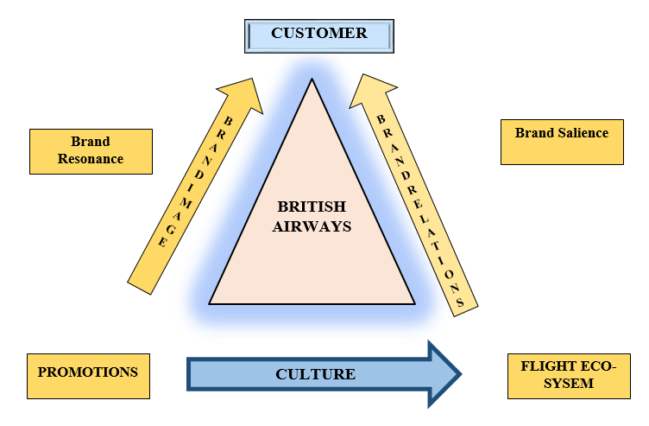
Figure 5: Total Engagement Model

11. Recommendations
- Leverage the brand equity model to conduct research identifying gaps in brand knowledge, performance, imagery, judgments and feelings across key customer segments. Address these gaps through targeted positioning and messaging.
- Build a consistent brand narrative and identity across all customer touchpoints including uniforms, amenities, digital interfaces, and advertising and employee interactions.
- Develop engaging and inspiring content for an integrated communications strategy covering traditional, digital and owned media platforms. Track performance rigorously.
- Design personalized customer experiences powered by data and technology to make travellers feel valued before, during and after each flight (Dickinson et al., 1999).
- Strengthen brand salience and visibility through sponsorships, partnerships and content collaborations with relevant media, personalities and brands.
- Highlight British Airways’ commitment to sustainability, community and inclusivity to connect with younger travellers on shared values.
- Create healthy employee culture and internal branding that reflects the external brand identity and empowers staff to deliver excellent British service.
- Regularly monitor brand health metrics and audit communications strategies to ensure messaging resonates across diverse audiences and markets.
- Build a user-focused digital ecosystem providing inspiration, rich information and frictionless customer service.

11.1 New Touchpoints
- Interactive airport displays - Digital/touchscreen displays at gates and lounges to provide flight info, destination content, entertainment and custom offers.
- Personalized in-flight portal - A customer portal accessible via onboard entertainment system with useful trip info, recommendations, miles status and more.
- Post-stay local tips - Emails with curated advice on dining, attractions, transport etc. at the destination after check-out.
- BA travel app - An app offering travel services, airport maps, booking integration, miles management, baggage tracking and virtual boarding passes.
- Partner co-branding - Co-branded credit cards, hotel rooms, rental cars that provide BA mileage rewards and status.
- Immersive virtual/augmented reality - Using VR and AR across websites, apps, lounges and onboard for deeper branded engagement.
- Biometric boarding - Options for secure, seamless biometric based check-in, bag drop and boarding to save time.
- BA content studio - Original digital content highlighting destinations, brands and experiences through engaging storytelling.
- Airport transfer partnerships - Providing seamless connections to hotel and transportation providers.
- Post-flight customer feedback - Seeking input and reviews via surveys, interviews, social media tagging.

12. Conclusion
To conclude, British Airways is one of the most famous airlines on the global market. The airline has a long history, which helps it create a good reputation in the market. Even though this airline faces various difficulties, it has offered excellent services to its clients for many years. For communication, the company prefers Claude Shannon and Warren Weaver’s macro model for transparent communication inside and outside the company with employees. The report also contains information about the customer journey map, which helps the airlines make changes where required to make British Airways one of the best airlines in the world.

References

- Berenbak, J. (2022). The “British Airways London Eye” the greatest observation wheel in the world (Das “British Airways London Eye” - der Welt größtes Riesenrad). Stahlbau, 71(4), 278–284. https://doi.org/10.1002/stab.200200830
- Berenbak, J., & Lanser, A. (2020). The structural design of the “British Airways London Eye” (Zum Tragwerksentwurf des “British Airways London Eye”). Stahlbau, 71(4), 285–288. https://doi.org/10.1002/stab.200200840
- Bjermer, L. (2011). Targeting small airways, a step further in asthma management. The Clinical Respiratory Journal, 5(3), 131–135. https://doi.org/10.1111/j.1752-699x.2011.00240.x
- Daniels, G. (2013). A Five-Step Model for “Unconventional Engagement.” Journal of Community Engagement and Scholarship, 6(1). https://doi.org/10.54656/xlnf7999
- Dickinson, M. H., Lehmann, F.-O., & Sane, S. P. (1999). Wing Rotation and the Aerodynamic Basis of Insect Flight. Science, 284(5422), 1954–1960. https://doi.org/10.1126/science.284.5422.1954
- Heiets, I., & Prakittachakul, V. (2020). Optimizing the Marketing Strategies of Qantas Airways and Thai Airways. Transnational Marketing Journal, 8(1), 95–124. https://doi.org/10.33182/tmj.v8i1.944
- Hutchinson, J. (2019). Michael Newman on New British Sculpture: A Report on the Third British Airways Lecture in Dublin. Circa, 26, 44. https://doi.org/10.2307/25557047
- Meng, X.-L. (2012). Enhanced security checks at airports: minimizing time to detection or probability of escape? Stat, 1(1), 42–52. https://doi.org/10.1002/sta4.6
- Prassl, J. (2021). To Strike, to Serve? Industrial Action at British Airways. British Airways plc v Unite the Union (Nos 1 and 2). Industrial Law Journal, 40(1), 82–91. https://doi.org/10.1093/indlaw/dwq031
- Ray, D. (2014). Airports Privatization in India: Airports Safety & Security Issues and Challenges. SSRN Electronic Journal. https://doi.org/10.2139/ssrn.2417203
- Takebayashi, M. (2011). EVALUATION OF ASIAN AIRPORTS AS GATEWAYS: APPLICATION OF NETWORK EQUILIBRIUM MODEL. Pacific Economic Review, 16(1), 64–82. https://doi.org/10.1111/j.1468-0106.2010.00535.x
- YILMAZ, R. (2022). Evaluation of organizational ethics in terms of businesses: The case of Virgin Atlantic Airways and British Airways. International Journal of Aeronautics and Astronautics, 3(2), 98–109. https://doi.org/10.55212/ijaa.1136269

