
Programme: BSc Cloud Computing
Module name: Cloud Computing Administration
Module code: ACCB6025

Aspire Retailers Cloud Management with Azure

Lecturer: Dr Khadija Hanga
Student: Cristian Bitca 2026078

2023

Contents
A. Guide the Aspire Retailers 3
B. Services analyse 5
C. Aspire Retailers’ costs 7
D. The uses of Azure Active Directory to configure different user accounts. 14
E. Azure Governing Strategy 15
F. Disaster recovery plan to the Aspire Retailers 18
References 20
Appendix 23
Figure 1. Going to the Azure Active Directory. 23
Figure 2. Select Users tab. 23
Figure 3. Selecting to see all users. 24
Figure 4. Create new user. 24
Figure 5. Fill user description. 25
Figure 6. First user created. 25
Figure 7. List of created users. 26
Figure 8. Going to Roles and administrators. 27
Figure 9. Creating new custom role. 27
Figure 10. Creating Normal user role. 28
Figure 11. List of our custom roles. 28
Figure 12. Assigned roles tab. 29
Figure 13. Add assignments. 30
Figure 14. Add Global User role to first user. 31
Figure 15. Add Normal User role to second user. 31
Figure 16. Global users list 32
Figure 17. Normal users list 32
Figure 18. Accessing Management groups 33
Figure 19. Creating a management group 33
Figure 20. Setting up Access control (IAM) 34
Figure 21. Adding role assignment to User 34
Figure 22. Adding reader role 35
Figure 23. Selecting members to the role 36
Figure 24. Adding our created user 36
Figure 25. Creating first resource group 37
Figure 26. Assigning name to our first group 37
Figure 27. List of resource groups 38
Figure 28. Going to Storage account 38
Figure 29. Searching on marketplace 39
Figure 30. Creating storage account 39
Figure 31. Selecting resource group 40
Figure 32. Setting up the Storage account name 40

- Guide the Aspire Retailers
Aspire Retailers, who happens to be a home improvement retailer, had been determined to be facing an exponential challenge regarding delivering a computing service in a timely fashion, most probably due to the management responsibility, which happens to be interacting with their on-premises datacenter. Thus, for an IT administrator, it had been extremely crucial here for providing with a prominent solution that would be allowing the company to acquire an immediate access to all computing services for supporting their needs more effectively (Tabrizchi and Kuchaki Rafsanjani 2020). While migrating to the cloud services, Aspire Retailers had been acquiring an immediate procurement in meeting their computing service needs. Based on the complete analysis being performed, the migration of Aspire Retailers towards the cloud services could deliver them with the following benefits:
- On-Demand Resource Provision: - The implementation of cloud solution had been beneficial for delivering with an instant provision of computing resources which would be beneficial for Aspire Retailers to leverage the cloud’s self-service for deploying their necessary resources rather than going through the time-consuming process of procuring hardware, software installation and configuration.
- Enhanced Deployment of Application: - The cloud services had been determined to be providing with a pre-build environment and application template which had been beneficial for simplifying the entire process of application deployment. With their complete migration to the cloud service, Aspire Retailers could be leveraging these templates for adding up new services, while reducing extreme time being spent on manual installation and configuration (Helo et al. 2021).
- Flexibility and Scalability: - In association with the On-premises data center, it sometimes become extremely difficult for scaling the infrastructure to meet peek demands of the organization. Thus, the installation of cloud solution could allow Aspire Retailers to easily accommodate increased website traffic during handling additional data storage requirements without putting ant limitations on physical infrastructure.
- Improved Reliability and System Security: - The majority of the Cloud service providers had been associated with investing heavy amounts for providing a robust security measures and infrastructure redundance, while providing high data security and availability. With their migration to the cloud solutions, Aspire Retailers could now easily leverage benefits from the enterprise-grade security feature like that of encryption, access control and threat detection without any burden of managing these aspects themselves (Hasan and Starly 2020).
Load Balancing had been determined as a critical feature that could significantly be utilized by nay organization for enhancing the overall performance, availability and scalability of applications and services within the cloud environment. Although, Aspire Retailers had been considering to move towards integrating cloud solutions for overcoming their desired challenges regarding proper management of their on-premises datacenter, thus, the implementation of Load Balancing could be of huge importance for the organization here. The process of Load Balancing generally involves with the proper distribution of overall network traffic across the multiple servers for optimizing proper resource utilization, which had also been associated with enhancing their response and prevent any overloading over a single server (Afzal and Kavitha 2019). With proper utilization of Load Balancing, Aspire Retailers could acquire the following advantages:
- High Availability: - Load Balancers generally acts as a single point of entry for the majority of incoming requests and further routes them towards the multiple servers. If in case, any one of the servers fails to comply by the network load, the Load Balancer automatically redirects the network traffic towards other healthy server while ensuring a continuous availability of services.
- Improved Performance: - Although the Load Balancers helps in automatically distributing the incoming network request to the available servers based on their predefined algorithms, this had been beneficial for better resource utilization while reducing extreme response times to ensure that no single server should become a bottleneck. With an even distribution of network load, the Aspire Retailer could deliver a faster service to their users (Kumar and Kumar 2019).
- Simplified Management: - The Load Balancers had also been determined to deliver with a centralized pair of control for managing and monitoring the traffic distribution. They happen to provide with session persistent, SSL Termination and traffic analysis, which would allow the IT admins to gain more insight into their performance and behavior. Thus, the IT team of Aspire Retailers could easily configure and adjust load balancing settings to meet their expected requirements.

- Services analyse
The implementation of the Cloud Computing had been determined to have revolutionized the way any business tends to manage their overall IT infrastructure, while offering a scalable, flexible and cost-effective services. Based on the complete analysis being conducted at the case study of Aspire Retailers, the overall management committee had finally decided to migrate their on-premises data center to the clous for enhancing their operations and further expand their services into a new market. For migrating towards the cloud services, a brief comparison among the three best selected Cloud service provider had been summarized below:

Microsoft Azure
Microsoft Azure had been recognized to be as one of the leading cloud service providers that had been associated with offering a comprehensive range of services and tools for meeting the diverse specification of any business organization (Sharma, Nigam and Sharma 2020). Based on the complete analysis being conducted at the case study of Aspire Retailers, the organization could acquire the following benefits from the Azure’s robust offerings:
- Infrastructure as s Service (IaaS): - The Azure helps to provide with a Virtual Machines that could considerably be provisioned to host entire of the website and additional video streaming services of Aspire Retailers. This would probably provide with an easy scalable and flexible capabilities for managing their computing resources.
- Platform as a Service (PaaS): - Azure’s PaaS services, like that of Azure App services and Azure Functions generally enables each developer of deploy and execute various application without allowing them to worry about underlying infrastructure. Thus, Aspire Retailer could leverage these services for streamlining their application development and deployment process (Palumbo et al. 2021).
- Data Storage and Analytics: - Azure had also been providing with different other kinds of storage options, like that of Blob storage, Azure SQL Database, which would allow Aspire Retailers to easily store and analyze their data with more efficiency. In addition to that, Azure could also provide with better data analytical services like that of Azure Data Lake analytics and Azure Databricks, thus enabling Aspire to gain valuable insight on their data.

Amazon Web Services
AWS also known as Amazon Web Service, had been identified as one of the prominent cloud providers that had been associated with offering a wide range of services and solution to the majority of organization. Based on the complete analysis being conducted at the case study of Aspire Retailers, the organization could acquire the following benefits from the AWS’s robust offerings:
- AWS Lambda: - The associated serverless computing services generally allows the developers for running code without managing any of the services. Thus, the Aspire Retailer could easily leverage AWS Lambda for dealing with event-driven as well as On-demand application components (Backes et al. 2019).
- Amazon Elastic Compute Cloud (EC2): - The Amazon Elastic Compute Cloud or the EC2 helps in providing with a scalable computing capacity in the form of virtual servers, which would sufficiently be enabling Aspire retailers to easily host their retail website and stream video applications.
- Amazon Simple Storage Services (S3): - Last, but not the least, the Amazon Simple Storage Service or S3 helps in providing with an object storage with high durability and availability. Thus, the Aspire Retailers here could sufficiently utilize the Amazon Simple Storage Services for storing as well as retrieving their application data alongside with other media files, respectively (Bai, Jhaney and Wells 2019).

Google Cloud Platform
GCP is another well-known cloud service provider with a comprehensive collection of services. Aspire Retailers may use the Google Compute Engine to build virtual machines as well as administer their cloud infrastructure. Google Cloud Functions, GCP's serverless service, enables event-driven creation of applications without the need for server administration (Bisong 2019). Based on the complete analysis being conducted at the case study of Aspire Retailers, the organization could acquire the following benefits from the GCP’s robust offerings:
- Google Cloud Function: - This serverless computing platform enables developers to create and deploy apps without having to worry about infrastructure maintenance. This would also be beneficial for allowing Aspire Retailers to sufficiently respond more efficiently to their user’s demands.
- Compute Engine: - In comparison of that of EC2 and VMs of Azure, the Compute Engine had also been associated with providing with a suitable VMs for hosting various applications, which would sufficiently be enabling Aspire retailers to easily host their retail website and stream video applications (Patil and Patil 2019).
- Google Cloud Storage: - Cloud Storage is ideal for hosting Aspire Retailer’s application information as well as multimedia files due to its outstanding reliability and durability. It also allows for efficient access to data and exchange.

- Aspire Retailers’ costs
In today's digital landscape as there is a paradigm shift of using the cloud services it has become very necessary to find and design the cloud services in such a way that they help in businesses seeking scalability, flexibility, and cost-efficiency. Aspire Retailers, like many other organizations can be very much benefitted by estimating the cloud spending so that they are able to make more informed decisions to optimize their cloud spending costs and are able to align the budget in such a way that they are able to meet with their computing requirements. The estimation process has different techniques so that they are able to configure, the tools like the Azure Pricing Calculator, based on that analysis they are able to implement the regular monitoring and perform the optimization of the cloud services (Mendu et al. 2022).
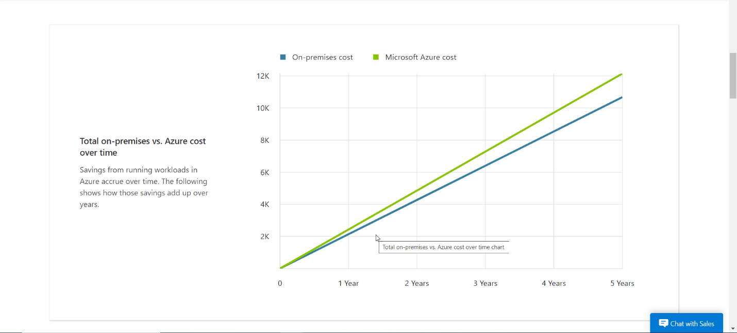
Figure 1: Graphical analysis of Cost overtime for VM1
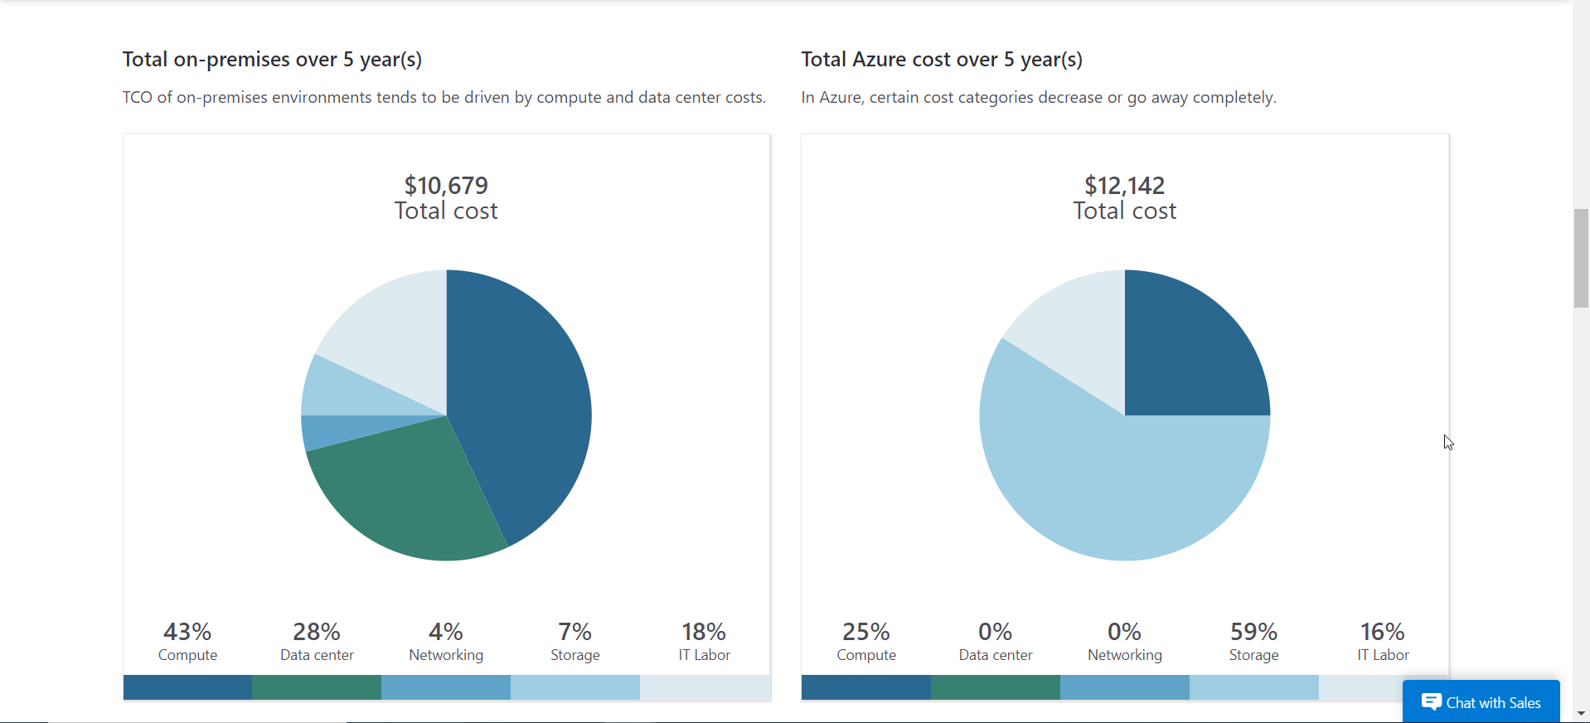
Figure 2: The overall cost representation
Therefore, the overall cost of VM1 over the tenure of 5 years is
Total On-Premise Cost | $10,679
Total Azure Cost | $12,142

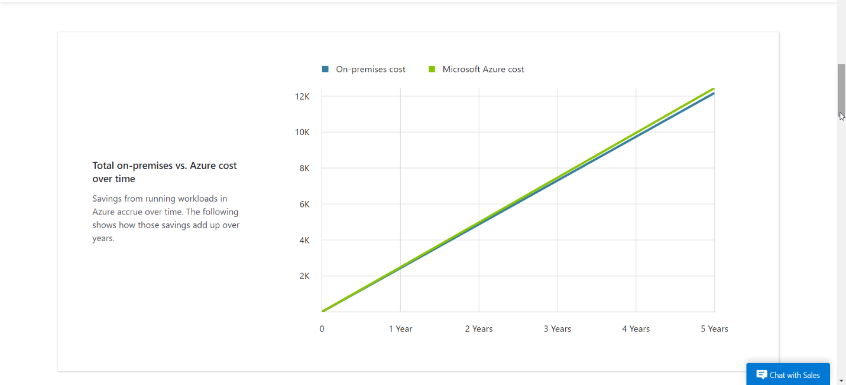
Figure 3: Graphical analysis of Cost overtime for VM2
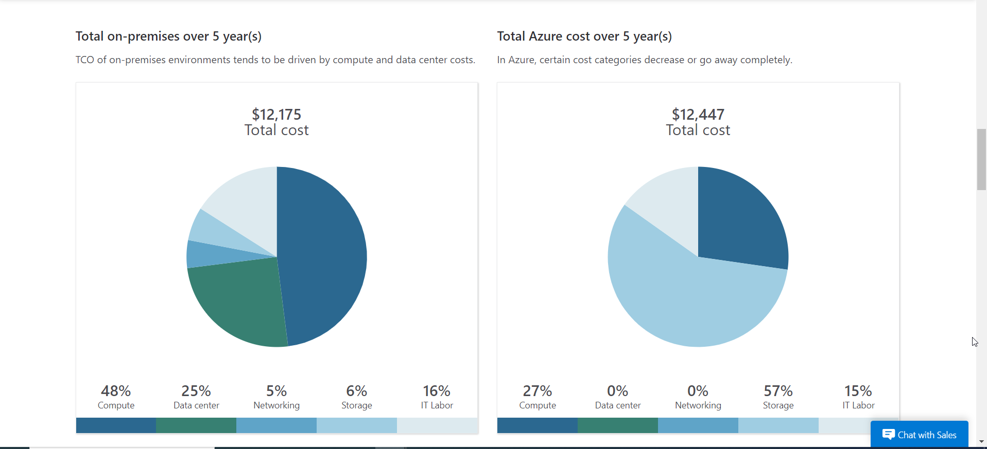
Figure 4: The overall cost representation
Therefore, the overall cost of VM2 over the tenure of 5 years is
Total On-Premise Cost | $12,175
Total Azure Cost | $12,447

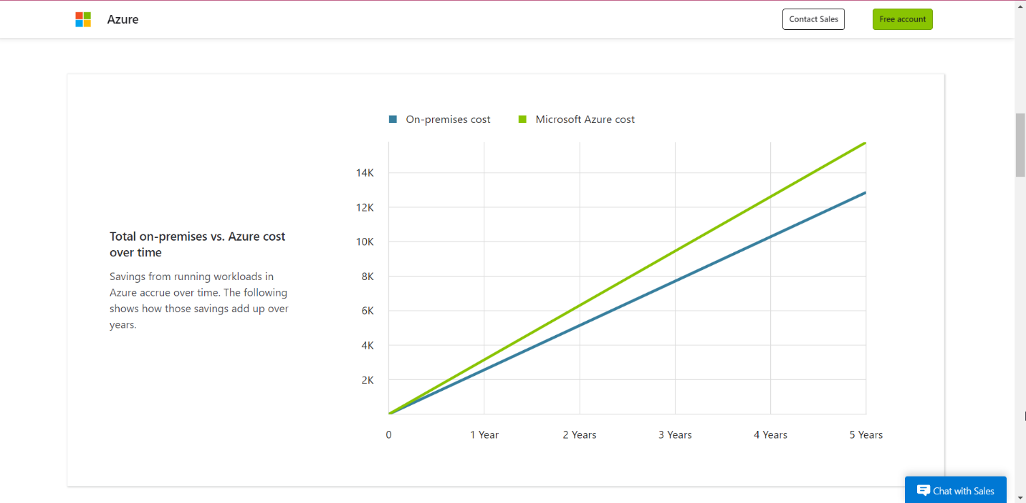
Figure 5: Graphical analysis of Cost overtime for VM3
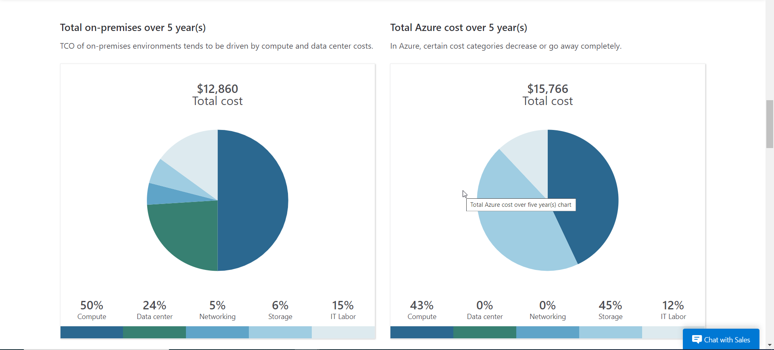
Figure 6: The overall cost representation
Therefore, the overall cost of VM3 over the tenure of 5 years is
Total On-Premise Cost | $12,860
Total Azure Cost | $15,766

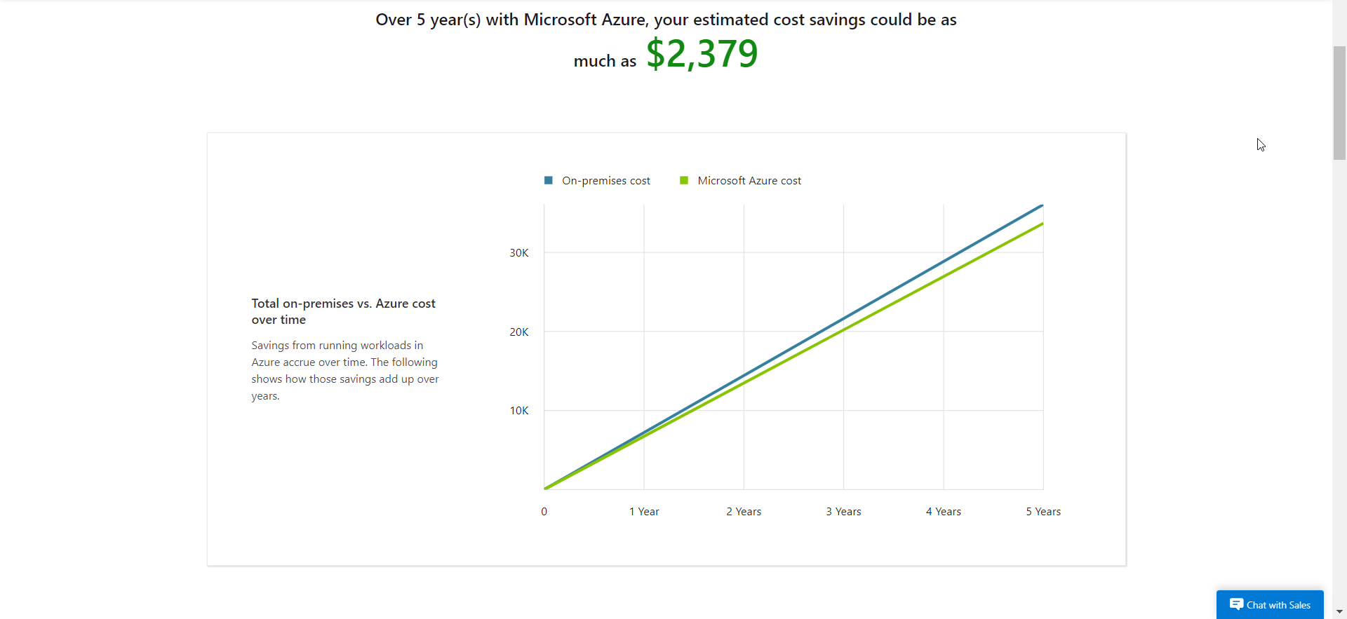
Figure 7: Graphical analysis of Cost overtime for VM4
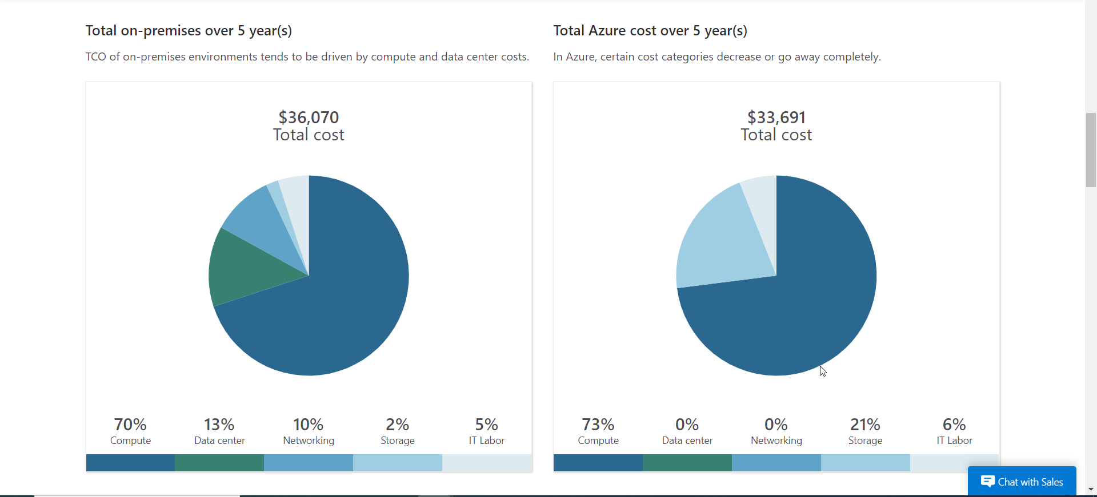
Figure 8: The overall cost representation
Therefore, the overall cost of VM4 over the tenure of 5 years is
Total On-Premise Cost | $36,070
Total Azure Cost | $33,691

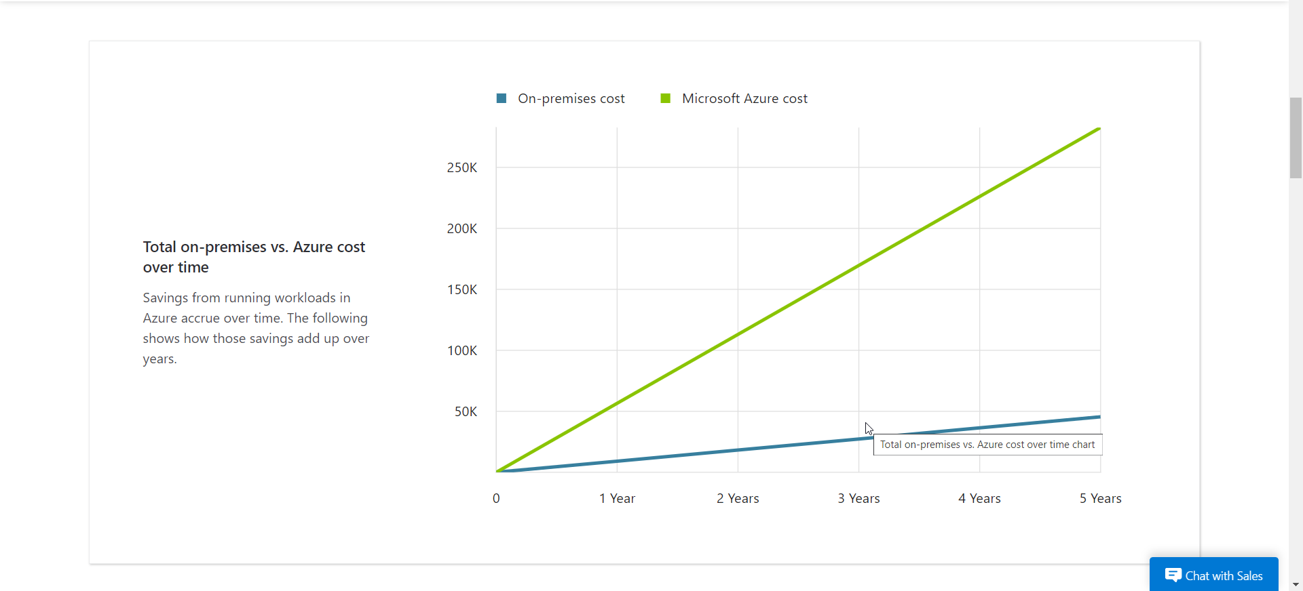
Figure 9: Graphical analysis of Cost overtime for VM5
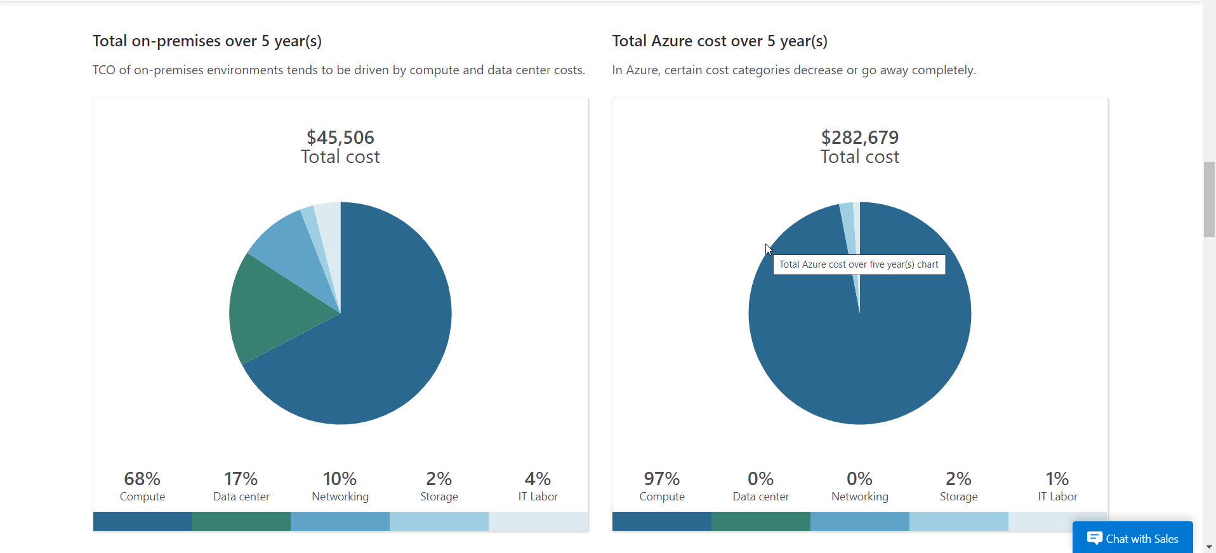
Figure 10: Approx Overall Cost Analysis
Due to the limitation of the website the exact cost of VM5 could not be calculated, so the overall cost of VM5 over the tenure of 5 years is
Total On-Premise Cost | $81,576
Total Azure Cost | $316,370

However, the cost estimation process is not one time process it requires a continuous monitoring and requires optimization that are very essential for maintaining the efficiency and the cost-effectiveness of the cloud environment. Aspire Retailers should design a dashboard system that is able to continuously evaluate the the cloud usage pattern which enables the user to identify the underutilized resources that needs to be either terminated or requires to be given attention so that the workload can be evenly be distributed. After this there can be proper implementation of the cost optimization strategies that could help to achieve the required objective. This is the process that requires the use of proper right VM instances, and is able to implementing the storage lifecycle policies so that they are able to perform the data retention and tiering in a proper way, thus using the reserved instances or selecting the proper savings plan it could be able to achieve the long-term commitments. With the help of proper monitoring and optimizing the cloud spending, Aspire Retailers can utilize the maximum portion of the computing resources effectively so that the costs are minimized, and the budget is well-managed.
Therefore, the total cost that is required to manage the cloud spending of the Aspire Retailers is calculated below
List of VM’s | Total On-Premise Cost | Total Azure Cost
VM1 | $10,679 | $12,142
VM2 | $12,175 | $12,447
VM3 | $12,860 | $15,766
VM4 | $36,070 | $33,691
VM5 | $81,576 | $316,370
Total | $153,360 | $390,416

In conclusion, the estimated cloud spending for Aspire Retailers has been calculated with the help of the TCO calculator, the overall cost has been calculated and is well supported with proper screenshots where it can be visibly seen that involvement of assessing the computing configurations and utilizing the tools like the Azure Pricing Calculator, through regular monitoring the user can optimize the practices. Through proper estimation of costs, Aspire Retailers is able to align the cloud spending with their estimated budget, so that they could make more informed decisions and optimize the costs so that they are able to meet the specific needs and achieve maximum efficiency and they could be easily benefitted from the using of the cloud services.

- The uses of Azure Active Directory to configure different user accounts.
In an Azure context, it offers a variety of tools and functionalities to establish and manage numerous user accounts. The following are some of the main ways that Azure AD is used to set up user accounts:
- Centralized User Management - You may centrally create and manage user accounts using Azure AD. Either directly within Azure AD or by synchronisation from an on-premises Active Directory infrastructure, user accounts may be created. As a result, user management across many apps and services is consolidated.
- Single Sign-On (SSO) - Users may easily and securely log in to several cloud-based and on-premises apps using Azure AD. Users may access various apps with just one authentication thanks to the integration of Azure Active Directory. User productivity is increased, and access control is made easier.
- Multi-Factor Authentication (MFA) - Multi-factor authentication is supported by Azure AD, which gives user accounts an additional degree of protection. By activating MFA, you may make it necessary for users to give extra verification in addition to their password, such as a phone call, SMS code, or biometric authentication. Security is improved and unauthorized access is protected as a result.
- Role-Based Access Control (RBAC) - Due to the integration between Azure AD and Azure RBAC, you may give users roles and permissions depending on their duties. Granular access control is made possible by RBAC, ensuring that users have the right permissions to complete their jobs while upholding the least privilege principle. As a result, access limits are enforced, and security is maintained across all Azure resources.
Creation of a user does not require much effort. Firstly, we have to go to the Azure Active Directory (Figure 1) and press on Users (Figure 2) on the left tab and we will be redirected to all users where we have to press on the left tab All users (preview) (Figure 3). Here we have to press on the New user button and select Create new user (Figure 4). Now we will be redirected to the user registration page where we have to fill Basic (Figure 5) tab with needed information. After finishing filling in we just have to press on Review + create button. So we got a message that our user were created (Figure 6). To create more users we have to follow the steps from above again, as you see now I have created 4 users in total, here you can see the list of created users (Figure 7). Now let’s assign roles, we have to create two custom roles, to do so, we have to go back to the Overview and select from the left tab Roles and administrators (Figure 8). Now as we are on the expected page, we have to click on New custom role button (Figure 9). Here we have to write the needed data, in my case, I created a Normal user role (Figure 10), after what we have just to add the needed permissions and go to review and create tab to finish. Same steps we have to do to create our Global role, here you can see list of our custom roles (Figure 11). Now we have to move to the Users page, select a user and click on the Assigned roles button (Figure 12). And here we just have to click on Add assignments button (Figure 13) and in the search bar of the Directory roles just type your role (Figure 14), in my case Global user. Same steps we have to do to add the Global user role for the second user (Figure 15) and Normal user roles to the other users. Now we can check how many and who are Global users by going again to (Figure 8) and just type our custom role in the search bar so here you can see how many and who are our Global users (Figure 16) and Normal users (Figure 17).
- Azure Governing Strategy
The Cloud Governance Strategy generally had been referred to the framework as well as practices that were conducted to put in place for effectively managing as well as securing the overall cloud resources within an organization (Al-Ruithe, Benkhelifa and Hameed 2019). This generally had been involving with the establishment of policies, procedure and controls for ensuring a proper access management, data protection, overall security and even cost optimization in Cloud environment. Based on the analysis being conducted at the implementation of Microsoft Azure, the following features and services would be availed by Aspire Retailers:
- Role-based Access Control (RBAC): - Aspire Retailer may give roles using users and groups, providing them particular access permissions according to their responsibilities, thanks to Azure's RBAC. By ensuring that users only have the essential access privileges, the least privilege principle lowers the possibility of resource abuse.
- Identity and Access Management (IAM): - Aspire Retailer would be able to establish centralized identity management and improve security by ensuring that only authorized users as well as devices have access to their cloud resources thanks to Azure's identity and access management (IAM) skills, which includes Azure Active Directory (Azure AD) as well as multi-factor authentication (Brandis et al. 2019).
- Azure Security Center: - The cloud environment used by Aspire Retailer is continuously monitored, threats are detected, and compliance is managed via Azure Security Centre. In order to proactively identify and address security threats, it provides information, vulnerability identification, and remedial recommendations. This promotes the safety of Azure assets and complies with legal requirements.
- Conditional Access Policies: - Aspire Retailer is given the ability to implement multi-factor authentication and impose access restrictions in accordance with contextual criteria like location of the user, device health, as well as risk levels by Azure's Conditional Access policies. This increases security by adding a further layer and ensuring regulated access to crucial cloud resources (Al-Ammary 2021).
Implementing a strong password policy is a critical policy that will help Aspire Retailers secure access to their cloud services. For Aspire Retailers to safeguard the accessibility to their cloud resources, it is essential to implement a strong password policy (Yıldırım and Mackie 2019). Sensitive information is safeguarded, unauthorized access is reduced, and industry standards are followed thanks to this approach. Aspire may greatly improve the security of their cloud environment by requiring passwords complexity, breathing out, history, and multi-factor authentication. Based on the complete analysis being conducted here, the following are the respective guidelines that could be included within the password Policy:
- Password Complexity: - This policy would be requiring their users to create a password that would meet specific complexity requirements, like that of a specific length, combination of both upper and lower letters, special characters, as well as numbers. This would be beneficial for ensuring that the password was harder to guess through any means of exploitation (Nifakos et al. 2021).
- Multi-Factor Authentication: - The Strong password policy also ensures to implement a multi-factor authentication as an additional layer of security for verifying their user’s identity. The services of Azure also tend to offer with the MFA capability which would allow the Aspire Retailers to easily to implement a second layer of security at their system logins.
- Account Lockout: - The implementation of Strong Password Policy would also ensure to setting suitable policies for account lockouts after a certain failed attempts to login to the system. This initiative had been beneficial for protecting the entire system here from the brute force attack and unauthorized access attempts (Hughes-Lartey et al. 2021).
- Role-Based Access Control: - The implementation of Strong Password Policy here also tends to apply the guideline for utilize the Azure RBAC for defining and assigning the roles with specific permissions to each user and group of users. This also ensures to implement the principles of least privilege, which would be subjected to grant the users with necessary access rights for conducting their tasks.
Aspire Retailers may greatly improve the safety of their cloud resources on Microsoft Azure by employing a strong password policy. This policy encourages secure authentication procedures, lowers the possibility of unauthorized access, and lessens the possible consequences of credential compromise. To maintain security, it's also essential to regularly check password usage as well as compliance with the policy (Zeadally et al. 2020).
By using Role-based Access Control, Identity and Access Management, and Conditional Access Policies, I have visualized the security strategy. First, we have I have created a simple user which will have the role assignment to read all our resource groups and storage account. Next step we will have to go to the Management groups (Figure 18), where we have to create a group that will contain our resource groups (Figure 19), we just have to press on Create button and follow the instructions. In the created group we will have on the left Access control (IAM) (Figure 20), here we just have to assign a role to our user by pressing on the Add button and Add role assignment (Figure 21), in the search bar we have to type Reader to find our role (Figure 22) and select it. In the next tab Members we have to press Select members and add our user (Figure 23) and (Figure 24). Once we are done, we will go back to Management groups and especially our group, and press on the left tab on Resource Groups and Create (Figure 25). I named my first group “Resource_group1” (Figure 26) and my second one “Resource_group2”, now we can see all our resource groups once created (Figure 27). Before creating a storage account, we have to Assign policy otherwise we will not be able to create it. After that, I choose the first resource group to create a storage account inside of it by selecting it and pressing on Create button (Figure 28). In the search bar, we have to type “Storage account” and select the first one (Figure 29), here we just have to press on Create button (Figure 30) and select our first group (Figure 31) and enter the Storage account name (Figure 32), after all those manipulations just go to the review and press on Create button. All those steps will help to secure the cloud resources within an organization.
- Disaster recovery plan to the Aspire Retailers
For Aspire Retailers to guarantee the continuation of their data and cloud applications, an adequate disaster recovery plan was essential. In the case of an unforeseen occurrence or system breakdown, a plan for disaster recovery defines the methods and tactics for restoring and recuperating operations (Ranchal et al. 2020). Here are a few ideas for a good disaster recovery plan:
- Identifying the Critical System and Data: - Aspire Retailers must begin by determining the crucial information, applications, and systems that need to be protected before developing a disaster recovery strategy. Customer information, commercial databases, a shopping website, as well as streaming video apps are all included in this. Setting these components in order of importance will guarantee effective catastrophe recovery.
- Defining the Recovery Objectives: - It is crucial to establish an adequate Recovery Time Objective (RTO) along with the Recovery Point Objective (RPO) for all of the systems. RTO outlines the maximum allowable downtime, whereas RPO outlines the maximum allowable data loss (Kamal et al. 2020). These goals aid in the selection of disaster recovery options that satisfy the requirements for each system's desired restoration time and data loss.
- Backups and Replication strategy: - Aspire Retailers should create an effective backup strategy that involves regular data backups from an off-site location to support its disaster recovery plan. They should also investigate data replication technologies that allow near real-time duplication to a separate data center or location, guaranteeing higher availability and reducing the likelihood of data loss in the case of a disaster.
- Automated Disaster Recovery Orchestration: - Aspire retailers may use Azure Site Recovery, a Microsoft Azure automation and orchestration service, to expedite and automate its disaster recovery process. Azure Site Recovery enables automatic copying, disaster recovery, and failback of virtual computers, apps, as well as information between primary and secondary locations, delivering efficient and dependable disaster recovery capabilities (Cheikhrouhou, Koubâa and Zarrad 2020).
- Regular Testing and Validating: - Regular catastrophe recovery drills are required to validate the plan's effectiveness. A coordinated reaction is ensured by including everyone with an interest, especially the IT team, application the owners, and business representatives. Any holes or weaknesses can be detected during testing, allowing essential improvements to be made to improve the plan's reliability as well as ensure preparedness for genuine crisis circumstances.
- Documented procedures and Communication Plans: - Aspire Retailers should record step-by-step protocols for disaster recovery, including the roles and duties of team members engaged, to guarantee a coordinated reaction during a crisis. There should also be clear escalation processes, ways to communicate, and emergency contact information. During crucial situations, this documentation reduces confusion and allows effective communication and action (Vinoth et al. 2022).
- Continuous Monitoring and Auditing: - Last, but the least, the Aspire Retailers should implement comprehensive monitoring and auditing procedures to ensure the success of their disaster recovery strategy. This involves regular evaluation of duplication rank, data integrity, and recovery system performance. Regularly examining logs and reports provides for the early detection of any anomalies or possible difficulties, allowing for immediate action to preserve the health and availability of disaster recovery infrastructure.

References
Afzal, S. and Kavitha, G., 2019. Load balancing in cloud computing–A hierarchical taxonomical classification. Journal of Cloud Computing, 8(1), p.22.
Al-Ammary, J., 2021. Assessing the readiness for cloud computing in higher education institutions in the kingdom of Bahrain: towards an education cloud computing strategy. International Journal of Managing Information Technology (IJMIT) Vol, 13.
Al-Ruithe, M., Benkhelifa, E. and Hameed, K., 2019. A systematic literature review of data governance and cloud data governance. Personal and Ubiquitous Computing, 23, pp.839-859.
Backes, J., Bayless, S., Cook, B., Dodge, C., Gacek, A., Hu, A.J., Kahsai, T., Kocik, B., Kotelnikov, E., Kukovec, J. and McLaughlin, S., 2019. Reachability analysis for AWS-based networks. In Computer Aided Verification: 31st International Conference, CAV 2019, New York City, NY, USA, July 15-18, 2019, Proceedings, Part II 31 (pp. 231-241). Springer International Publishing.
Bai, J., Jhaney, I. and Wells, J., 2019. Developing a reproducible microbiome data analysis pipeline using the Amazon web services cloud for a cancer research group: proof-of-concept study. JMIR medical informatics, 7(4), p.e14667.
Bisong, E., 2019. Building machine learning and deep learning models on Google cloud platform (pp. 59-64). Berkeley, CA: Apress.
Brandis, K., Dzombeta, S., Colomo-Palacios, R. and Stantchev, V., 2019. Governance, risk, and compliance in cloud scenarios. Applied Sciences, 9(2), p.320.
Cheikhrouhou, O., Koubâa, A. and Zarrad, A., 2020. A cloud based disaster management system. Journal of Sensor and Actuator Networks, 9(1), p.6.
Hasan, M. and Starly, B., 2020. Decentralized cloud manufacturing-as-a-service (CMaaS) platform architecture with configurable digital assets. Journal of manufacturing systems, 56, pp.157-174.
Helo, P., Hao, Y., Toshev, R. and Boldosova, V., 2021. Cloud manufacturing ecosystem analysis and design. Robotics and Computer-Integrated Manufacturing, 67, p.102050.
Hughes-Lartey, K., Li, M., Botchey, F.E. and Qin, Z., 2021. Human factor, a critical weak point in the information security of an organization's Internet of things. Heliyon, 7(3), p.e06522.
Kamal, M.A., Raza, H.W., Alam, M.M. and Mohd, M., 2020. Highlight the features of AWS, GCP and Microsoft Azure that have an impact when choosing a cloud service provider. Int. J. Recent Technol. Eng, 8(5), pp.4124-4232.
Kumar, P. and Kumar, R., 2019. Issues and challenges of load balancing techniques in cloud computing: A survey. ACM Computing Surveys (CSUR), 51(6), pp.1-35.
Mendu, M., Krishna, B., Sandeep, C.H., Padmaja, C. and Sultana, F., 2022, May. Creating and running apps on the hybrid cloud of Microsoft Azure. In AIP Conference Proceedings (Vol. 2418, No. 1, p. 020039). AIP Publishing LLC.
Nifakos, S., Chandramouli, K., Nikolaou, C.K., Papachristou, P., Koch, S., Panaousis, E. and Bonacina, S., 2021. Influence of human factors on cyber security within healthcare organisations: A systematic review. Sensors, 21(15), p.5119.
Palumbo, F., Aceto, G., Botta, A., Ciuonzo, D., Persico, V. and Pescapé, A., 2021. Characterization and analysis of cloud-to-user latency: The case of Azure and AWS. Computer Networks, 184, p.107693.
Patil, A. and Patil, D.R., 2019, February. An analysis report on green cloud computing current trends and future research challenges. In Proceedings of International Conference on Sustainable Computing in Science, Technology and Management (SUSCOM), Amity University Rajasthan, Jaipur-India.
Ranchal, R., Bastide, P., Wang, X., Gkoulalas-Divanis, A., Mehra, M., Bakthavachalam, S., Lei, H. and Mohindra, A., 2020. Disrupting healthcare silos: Addressing data volume, velocity and variety with a cloud-native healthcare data ingestion service. IEEE Journal of Biomedical and Health Informatics, 24(11), pp.3182-3188.
Sharma, V., Nigam, V. and Sharma, A.K., 2020. Cognitive analysis of deploying web applications on microsoft windows azure and amazon web services in global scenario. Materials Today: Proceedings.
Tabrizchi, H. and Kuchaki Rafsanjani, M., 2020. A survey on security challenges in cloud computing: issues, threats, and solutions. The journal of supercomputing, 76(12), pp.9493-9532.
Vinoth, S., Vemula, H.L., Haralayya, B., Mamgain, P., Hasan, M.F. and Naved, M., 2022. Application of cloud computing in banking and e-commerce and related security threats. Materials Today: Proceedings, 51, pp.2172-2175.
Yıldırım, M. and Mackie, I., 2019. Encouraging users to improve password security and memorability. International Journal of Information Security, 18, pp.741-759.
Zeadally, S., Siddiqui, F., Baig, Z. and Ibrahim, A., 2020. Smart healthcare: Challenges and potential solutions using internet of things (IoT) and big data analytics. PSU research review, 4(2), pp.149-168.

Appendix

Figure 1. Going to the Azure Active Directory.
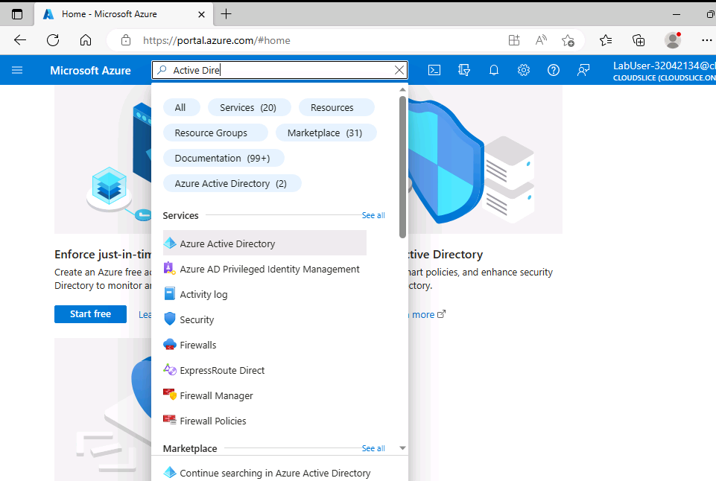

Figure 2. Select Users tab.
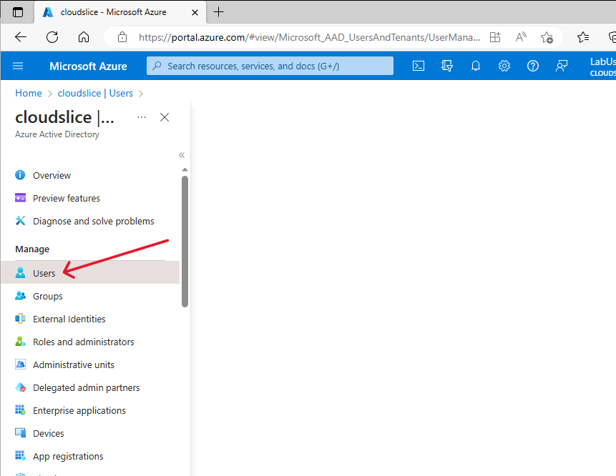

Figure 3. Selecting to see all users.
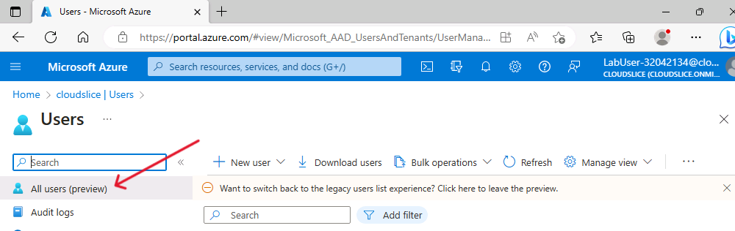

Figure 4. Create new user.
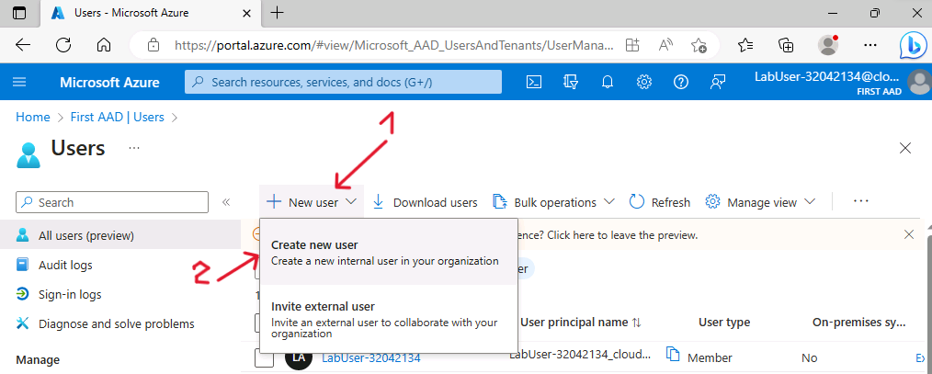

Figure 5. Fill user description.
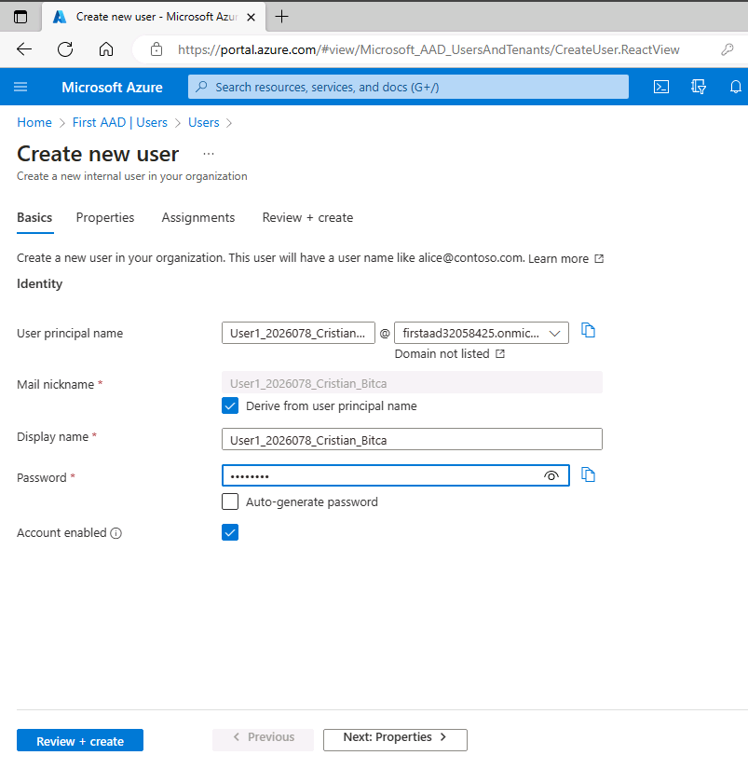

Figure 6. First user created.


Figure 7. List of created users.
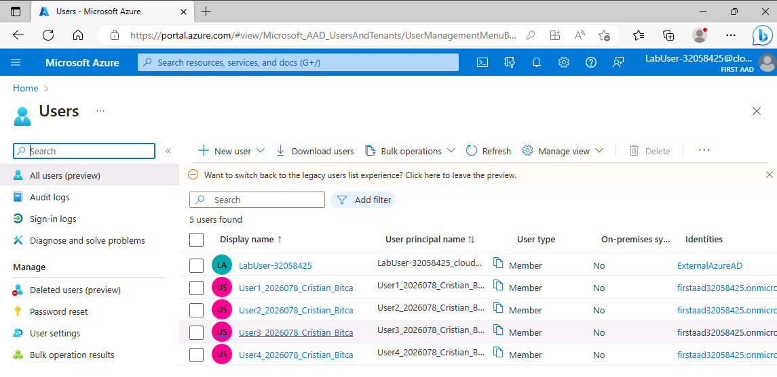

Figure 8. Going to Roles and administrators.
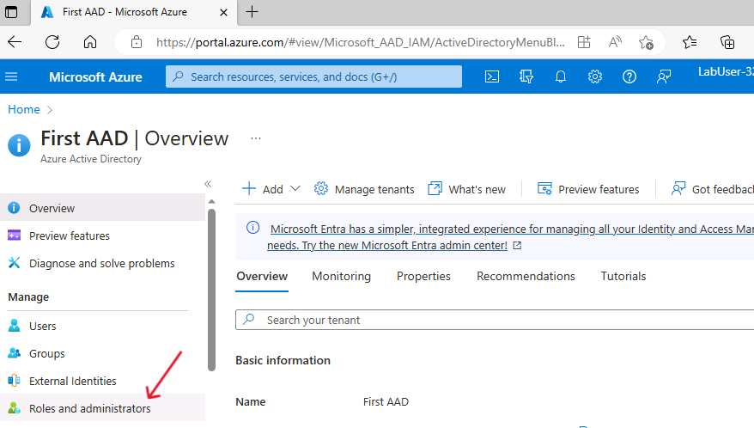

Figure 9. Creating new custom role.
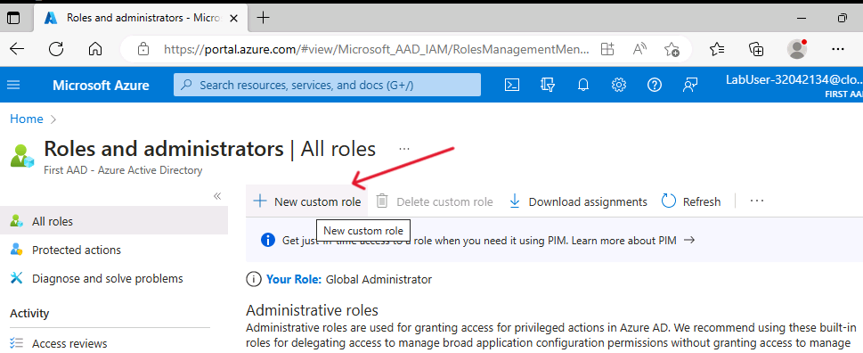

Figure 10. Creating Normal user role.
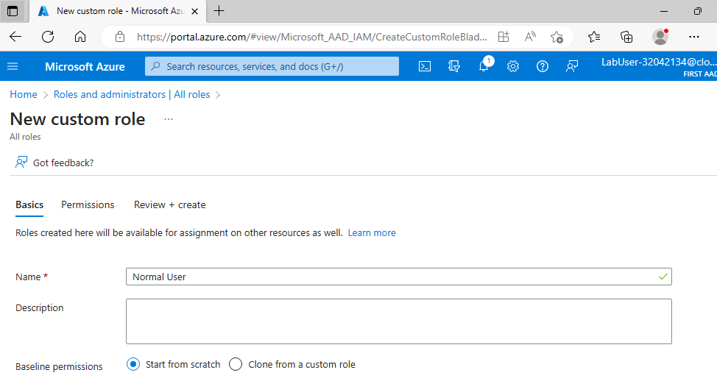

Figure 11. List of our custom roles.
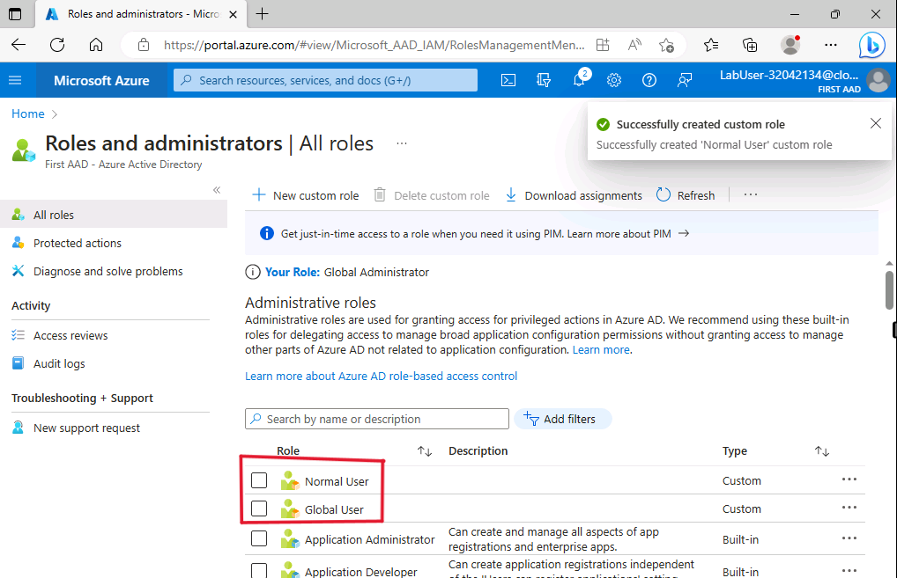

Figure 12. Assigned roles tab.
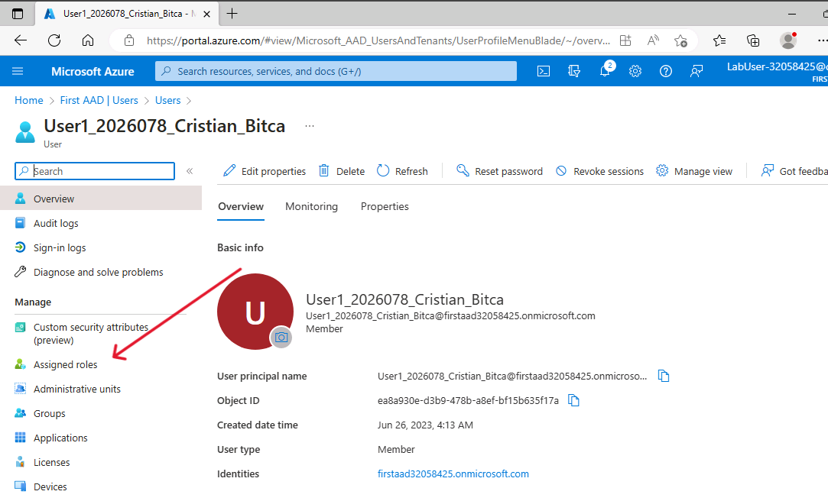

Figure 13. Add assignments.
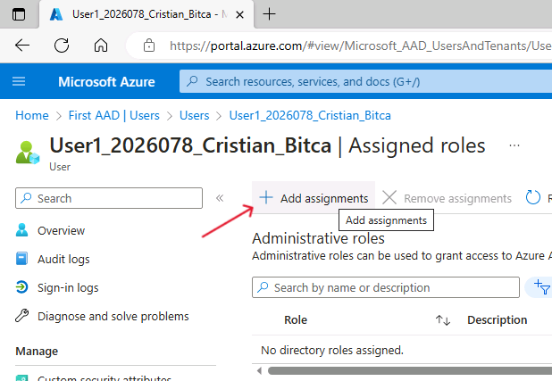

Figure 14. Add Global User role to first user.
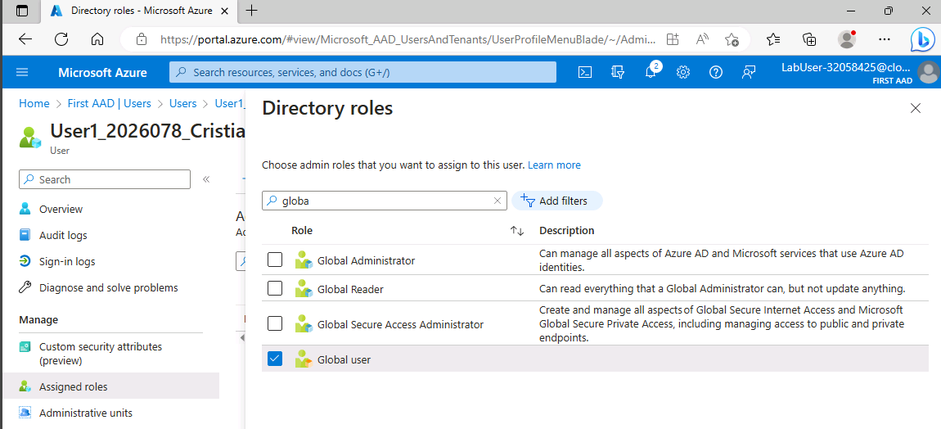

Figure 15. Add Normal User role to second user.
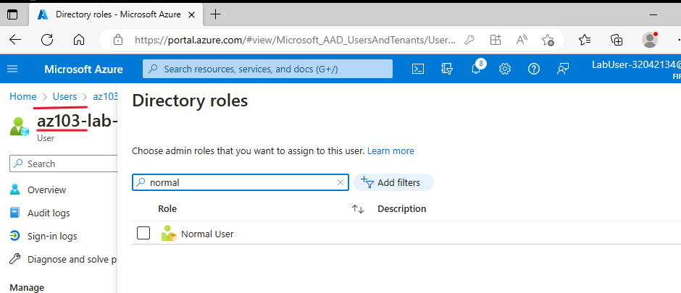

Figure 16. Global users list
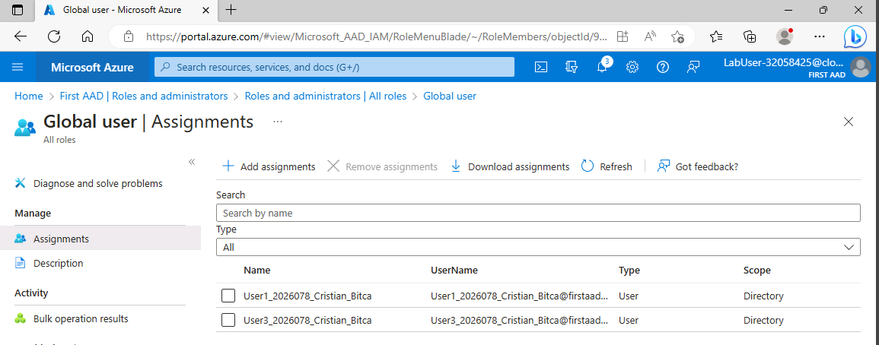

Figure 17. Normal users list
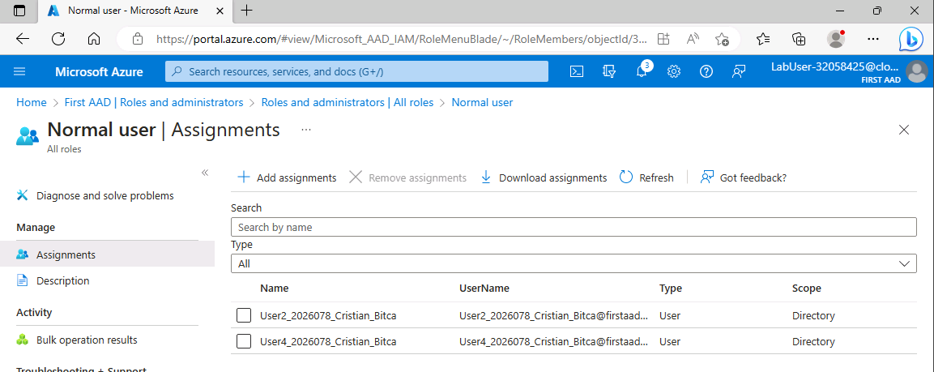

Figure 18. Accessing Management groups
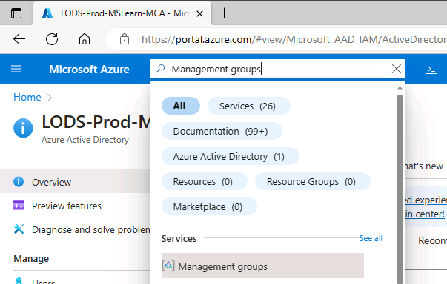

Figure 19. Creating a management group
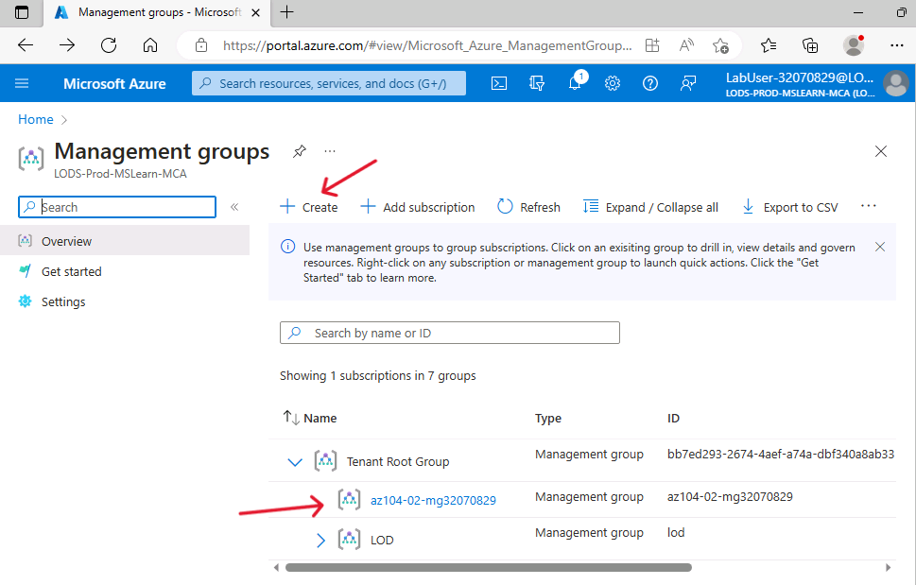

Figure 20. Setting up Access control (IAM)
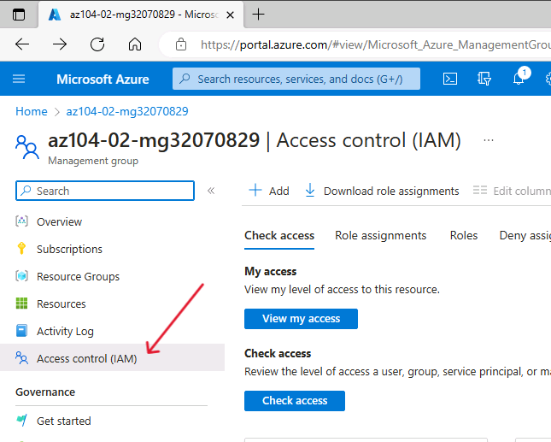

Figure 21. Adding role assignment to User
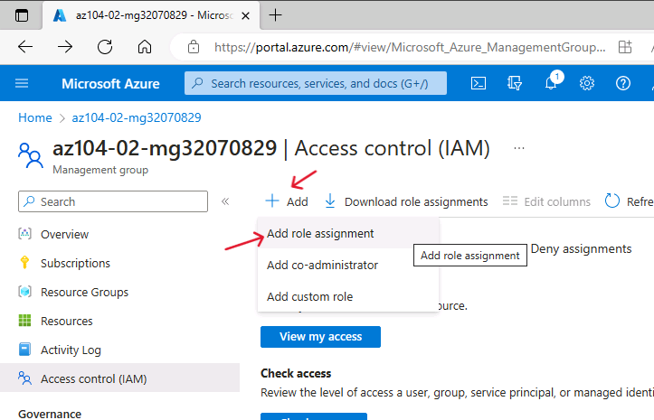

Figure 22. Adding reader role
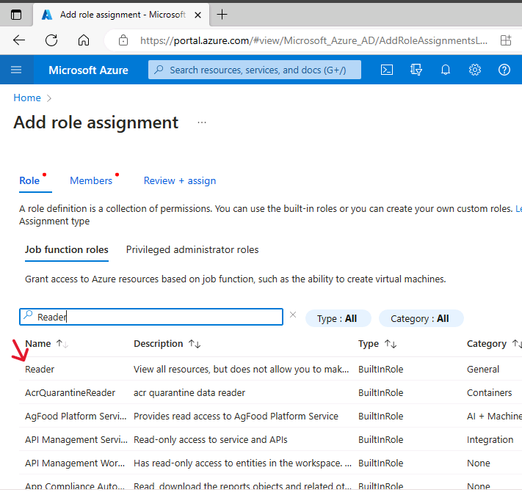

Figure 23. Selecting members to the role
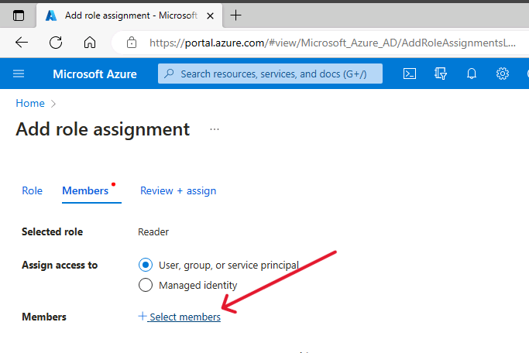

Figure 24. Adding our created user
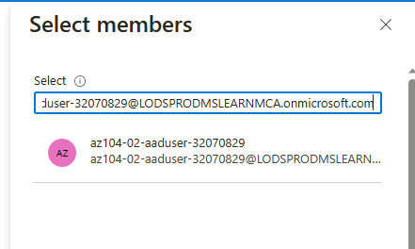

Figure 25. Creating first resource group
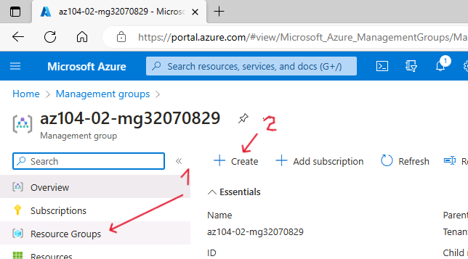

Figure 26. Assigning name to our first group
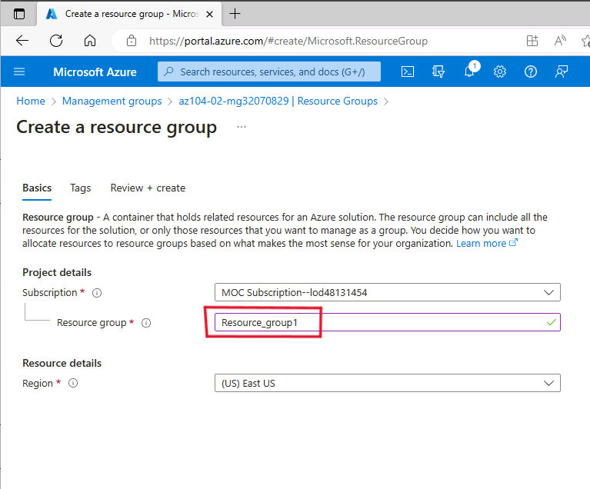

Figure 27. List of resource groups
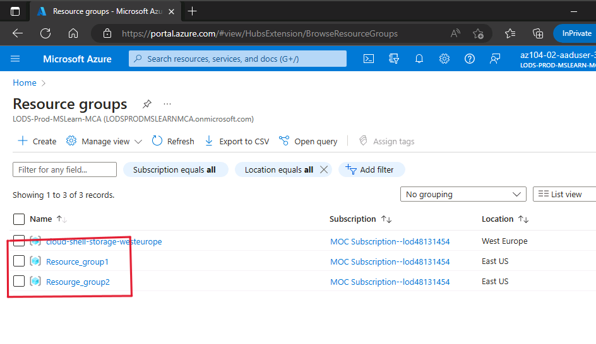

Figure 28. Going to Storage account
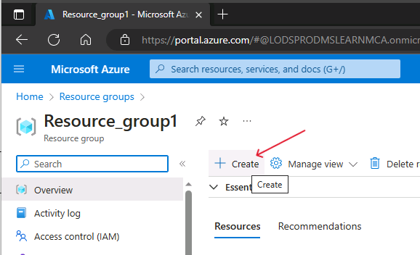

Figure 29. Searching on marketplace
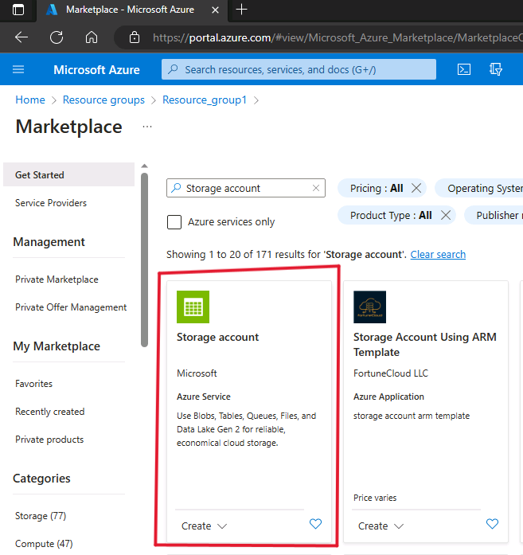

Figure 30. Creating storage account
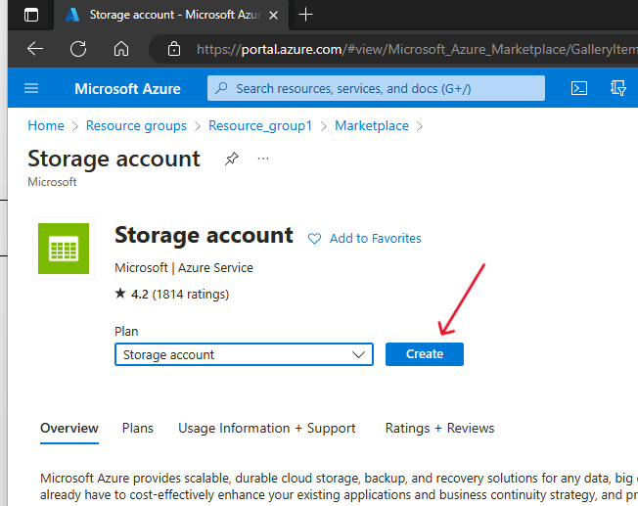

Figure 31. Selecting resource group
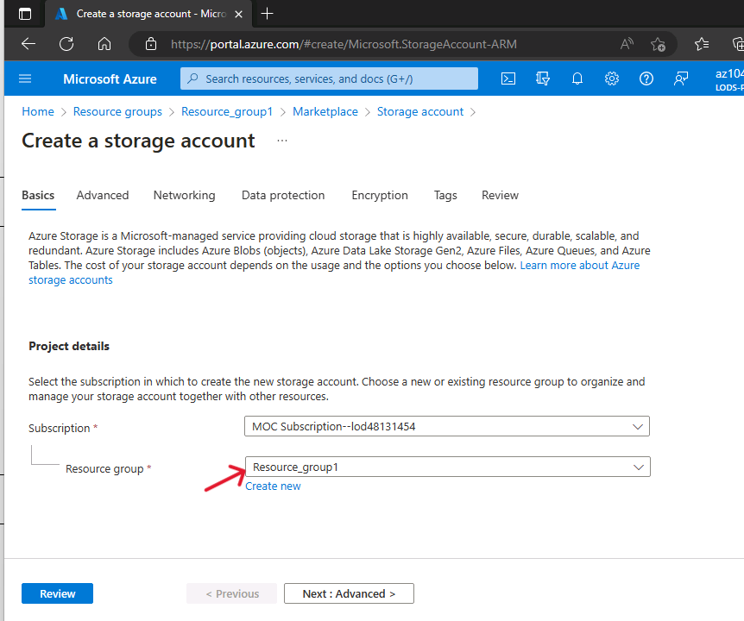

Figure 32. Setting up the Storage account name


