Student Name: Doreen Mckenzie

Student ID:1914130

Module code: BMSW 4005

Assignment Title: Portfolio of work

Tutor: Olubukola Adegbite

Contents

Page numbers
- Introduction
(4 -6) Curriculum Vitae
(7) National careers website quiz results
(8) Personal development cycle image
(9) Swot analysis
(10) Personnel Development Plan
(11-12-13) Assistant manager task
(14 - 15) Reflection
(16) References

Introduction
This is my personal portfolio, of which I have audited my own personal skills to prepare my self for further education and not only the world of work but a promising career of my own choosing. Nutrition is the area where my interests lie, and I have quite a keen thirst for knowledge in the nutrition field of study. I have recently applied to the University College Birmingham based on Summer row Birmingham to study food and nutrition FdSc full time. The duration of the course is two years starting September 2021. There is an option of progressing on to a third and final year after the initial two years of the foundation degree.
To qualify for this course, I first need to successfully complete my current studies. The entry requirements needed are access to higher education diploma 56-32 UCAS tariff points. The core modules in the first year will be culinary skills for nutrition, food manufacture, food science, Introduction to human anatomy and physiology, introduction to nutrition, public health, and nutrition. Core modules for second year consist of Contemporary eating practices, Food product design development, functional foods, nutraceuticals and legalities, nutrition in context, research for food and nutrition, with an option to choose one optional module in either Dietary research in culinary development, international nutrition, or sports nutrition.

Curriculum vitae
Doreen Mckenzie
Tel: 07767894778
Email: ital-dee@hotmail.co.uk
Personal Profile
I am experienced and enthusiastic committed to providing exemplary standards of customer service and cleaning. I always aim to instil a positive attitude amongst staff to ensure that operations are uninterrupted and continue to meet business targets. Highly focussed with a comprehensive knowledge of how to maintain a professional, effective, and courteous relationship with clients and colleagues whilst completing all individual duties with precision and efficiency.
Key Skills and Competencies
- Adherence and enforcement of all health and safety procedures in a working environment
- Ability to work independently and as part of a team
- Can work well in a busy and demanding environment
- Can communicate effectively
- Keen eye for details and a committed approach to all duties
- Adaptive to change and ability to multi-task
- Able to react quickly and effectively when dealing with challenging situations
- Ability to stay calm under pressure
- Enjoy updating skills and knowledge
Employment History
Now Careers agency – CSCS Cleaning operative August 2019 – September 2019
- working on construction sites cleaning up after labourers
Orion Cleaning – Cleaner November 2016 – September 2019
- Clean, stock and supply designated areas facility areas (dusting, sweeping, and vacuuming, mopping, cleaning etc)
- Notify management of occurring deficiencies or needs for repairs
- Check stock and maintain supply rooms
- Work as a team
- Follow all health and safety regulations
Gentle Hearts – Home care assistant May 2014 – December 2015
- Duties may include transporting clients to Doctors appointments
- Making beds, doing laundry, preparing meals, assisting clients with their medication, or running errands
- Light cleaning to maintain sanitary conditions in the home environment
- Aiding clients in bathing themselves
- Assisting clients in and out of the bath or shower
- Observe, monitor, and record clients physical and emotional wellbeing promptly and report any changes to senior staff
Women’s Help Centre – Volunteer March 2014 – March - 2016
- Assisting students during their ESOL lessons
- Developing structured learning plans for students to learn in class
- Offering one to one tuition to progress students English reading and writing skills
- Assisting and tutoring students in navigating ICT equipment
Education and Training
- Award in Food Safety in Catering – Level 2
- Health and safety in the Workplace – Level 2
- Functional Skills English – Level 2
- Adult Numeracy Mathematics – Entry Level 3 Level 2
- Nutritional Health – level 1
- Understanding Nutritional Health - Level 2
- ICT – Level 1
- Diploma for IT Users Level 2
- Developing Multimedia Products – Level 1
- Photography Techniques – Level 2
- Level 1 in Health and Safety in Construction
- Level 1 in Construction Skills Painting and Decorating
- Level 1 in Construction Skills Plastering
- Level 1 in Construction Skills Plumbing / CSCS Card

My Hobbies and Interests
In my spare time I ensure I remain proactive by keeping fit through swimming, walking and fitness classes. I also enjoy listening to music and spending time with my family and close friends.
References available on request

Identify Job of my choice
National Careers Quiz results
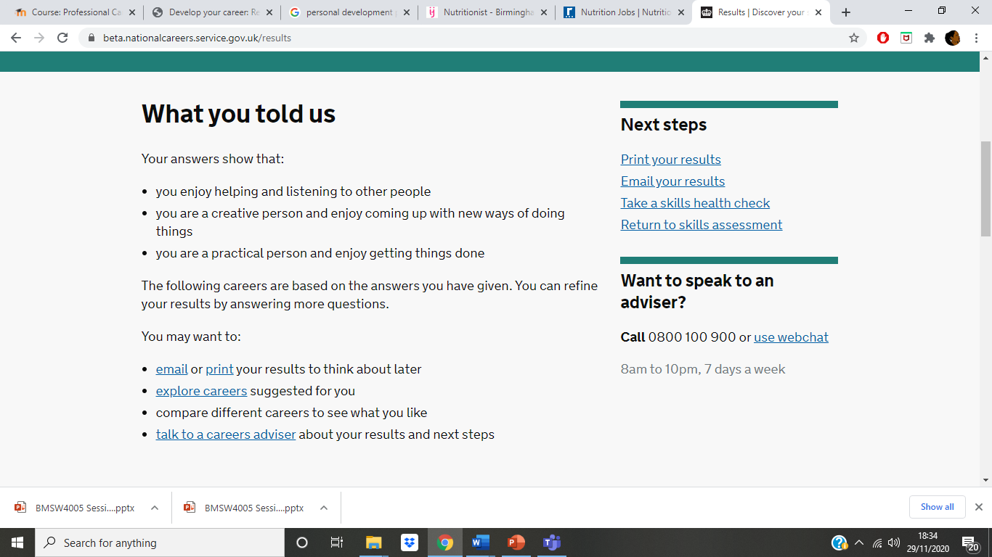
(service, 2020)
Made use of the national careers service online skills test by answering a series of questions my results stated that.
- I am a creative person I and I enjoy helping and listening to other people
- I am a creative person and enjoy coming up with new ways of doing things
- I am practical and enjoy getting things done
After answering more questions, it suggested a job in healthcare. My plan is to be a nutritionist, so I began a search of the career’s website for nutrition careers. At my present point in time, I am underqualified, the career website informed me that I will need a degree or post graduate qualification approved by the association of nutrition. Appropriate courses are. Food and nutrition, health promotion, public health, biochemistry, and physiology.

Personal Development Cycle
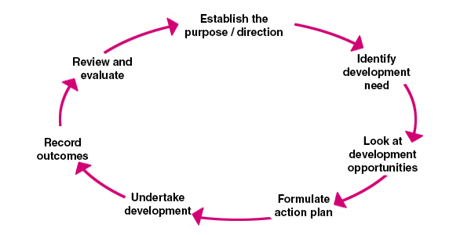
(CMI, 2020)
The personal development cycle helps to identify the steps I need to implement to get my careers goals in to action. It helps me to visualize my planning which is appropriate to my learning style as according to in class activities, I was identified as a visual learner.

 SWOT Analysis

Name Doreen Mckenzie Student ID1914130…

Strengths  Highly motivated in my career choice  Ability to work in a team  I am committed to my studies  Hardworking individual  Focused on my career choice  Disciplined to get work done  Dedicated to my studies and career development  Patient, friendly and empathic | Weaknesses  Can focus on detail too much  Lack confidence in public speaking  Biggest self-Critic  Hold back too much
Opportunities  Further education  Qualifications  Placements/Work experience  Currently in education, opportunity to continue, University in my chosen career path. Submitted application for food and nutrition course. | Threats  Time management  Pandemic causing lockdown  Economy  Distractions  Debts  Negative people

Personal Development Plan
What do I need to do | What will I do between gap in education | Time frame to get to desired outcome | How will I achieve my goals | Review  dates
By finishing my current studies and qualifying  Sign up for Food and Nutrition course at University College Birmingham | My plan to find either temporary work or a part time job that can fit in with studies later  In the meantime, do independent research on my chosen career studies Also do some short courses in holistic health | Food and Nutrition course starts in September 2021,  Two-year course ends 2023 however there is a choice to complete a third year | By having good time management skills and keeping focussed | January 2021

Summary
I am currently under qualified to be a nutritionist, but with successful completion of my current study and successful enrolment on to my chosen field of study. It will enable me to achieve my goals and potential. I will continue to establish my aims and objectives using a PDP as my tool.

Assistant Manager Task
As an assistant manager asked to access the learning and development training methods for the new employees, who are about to start in the organisation. It would be a good idea to firstly acquaint the new employees with the building lay outs and showing them where all the fire exit points are and where to meet in an emergency, plus who the first aiders are. The next step would be to familiarise themselves with the rest of the group and other staff members and what is expected of them. The rules and regulations and their job roles and further training guidelines.
There are several methods of training instructor led training, lectures, Management specific activities, role play, hands on training, e- learning, case studies or required reading activities. Coaching and mentoring, simulation employee training and group discussion activities. One exercise that employers like to use is called ice breakers This is carried out in the first meet up, so staff and colleagues can get to know one another.
For employees to learn about themselves and one another the Johari Window technique could be used. The Johari window was developed by psychologists Joseph Luft and Harrington Ingham in 1955. The purpose of the Johari window was to help individuals to be self aware and to learn about each other and understand one another. It is a useful tool to build on team relationships between different groups.

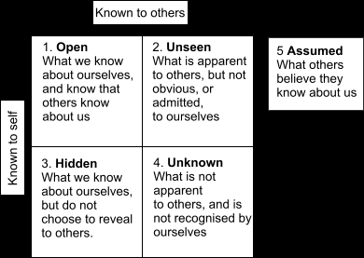
Example of Johari’s window (University of the West of England, 2020)

Employees can take part in activities that access their learning styles as part of their training and development. Visual, auditory, and tactile are the three type of styles of learning. Visual learners If you are a visual learner, you learn by reading or seeing pictures. You understand and remember things by sight. You can picture what you are learning in your head, and you learn best by using methods that are primarily visual. You like to see what you are learning Auditory learners learn by ear by listening and hearing, they may learn by reading aloud as they like to hear the word spoken, they tend to input the information by the way words are spoken. Not so easy with instructions that are written. Tactile learners like active learning. They are physical learners and remember by using their hands, find it hard to sit still and tend to gesticulate a lot. Learning styles have an impact on the way individuals absorb information and how they decipher it. Employees can also take part in a personality test to find out which of four learning style they match up with as in Activist, Theorist, Pragmatist and Reflector. These are the most preferred learning approaches. The Activist are individuals that like to be hands on and are open minded and love to experience new things. The Theorist likes to have an understanding of theories behind actions, Pragmatist need to put learning into effect to visualise, the reflector likes to observe and think. CPD continuous Professional Development is an ongoing process of updating skills and knowledge it is continuous. Employers understand it is essential to be invested in their employees, providing employees with training opportunities to update their skills and development, (example) Care providers in care homes, hospitals, and in the community provide their employees with training in manual handling. Manual handling educates staff on how to safely handle clients when lifting, which is very essential for the health and safety of all involved. That is just one example of the many types of training and how training can be relevant in the workplace. CPD should enable employees to keep up to date with personal and technical skills. Employability will be enhanced. PDP helps to develop competencies, working with others, team work not all about technical skills. Setting smart goals, Specific, Measurable, Achievable, Relevant, Time based. Smart goals will motivate employees helping to evaluate and make progress, it is important as a manager to set goals that are manageable for employees, so not to make employees lose interest by setting unrealistic goals. Assessing performance reviews for the purpose of receiving feedback, objectives and to evaluate. Staff can receive rewards, bonuses for hard work, which will encourage employees and boost staff morale. The company will benefit from it also

Employees can take part in various learning courses that are relevant to the type of work they are doing. On the job learning referred to as Job shadowing the employees can shadow more senior staff, so the employee will gain knowledge by watching the more senior staff in action and getting hands on training at the same time. All the training mentioned are relevant to employee development and learning skills. It is a good idea for employees to access their leaning styles so learning can be tailored better to suit the individual. The Johari window will encourage communication between groups, build trust within the team and employees own personal development.

Reflection of my experiences before and after the course

Before the start of the course, I was employed working two low skilled jobs until September of 2019. I was worked as a permanent office cleaner in the city centre and as a CSCS Cleaning operative cleaning up after labourers on building sites. The money was not too bad working as a CSCS cleaner but could be better. It was hard work, but I like being kept busy. The CSCS cleaning job informed me, they had plenty of permanent work. So, I left the other job, however a week after I left the job. The CSCS agency suddenly told me they had no work.
I always had dreams of having a successful career and nutrition is a subject close to my heart. From I was a young girl I was interested in which vitamins and mineral had particular effects on the body. But I did not quite know how to go about it as I did not have the qualifications. I believe I lacked the confidence to think that I could go to University especially when a family member laughed at me when I spoke about my aspirations some years back. I felt enthusiast when I was accepted to begin study at the University of Wales Trinity St David. The actual Birmingham campus just on the outskirts of town was easy to get to and my first thoughts that the building was quite decent, although it lacked an actual library and canteen and facilities to get hot water or heat food up. The classroom was decent and as I started my first day, I felt a little concerned as I wondered if I would be the only mature student in my group. Everything started off fine, my personality is very easy going, so, there is no problem with communicating to the rest of the group. However, I am uncomfortable with public speaking. The tutors were decent, and everything started off fine. Modules have been interesting and managed to get through the presentations in class. Unfortunately, due to the Covid 19 Pandemic, lessons ceased at the campus and everything moved online. In just a very short space of time. So, have found that the class really did not get to bond properly on the level we would have liked. Which has meant that even though we formed a WhatsApp group chat, there has been very little communication with one another. If we had been on campus, I believe we would have worked better together and helped one another with ideas when it came to our work. Although it is very understandable about the reasons why there are no physical classes. It is certainly not the same. Personally, it is more difficult I find it very distracting at home and from time to time the internet connection is very slow and freezes happen. These problems do occur when in the Microsoft teams, which can be very frustrating. My laptop may need renewing also. I have found studying at home more challenging than if we were on campus. I am a visual learner according to the learning style test we completed online, also an activist in the personality tests. I found the results to be quite interesting. I do get distracted easily by noises around me and I like to see what I am learning, being physically present and hands on in class. So, I can have a better understanding also I find I would prefer to have the paperwork in front of me, than everything always been on a computer screen as I like to turn pages especially in the case of assignment briefs. I find it awkward when I must keep flicking between computer screens on the laptop. I do not have a printer so I cannot print them. My most enjoyable lessons have been communication skills with Rebecca and Psychology with Mark. I have now been in contact with University College Birmingham to enrol onto food and nutrition and I have enjoyed my time with the University of Wales Trinity Saint David.

Works Cited
CMI, 2020. Personal Development Planning. [Online]
Available at: https://www.managers.org.uk/knowledge-and-insights/research/personal-development-planning/
[Accessed 28 November 2020].
David, U. o. W. T. S., 2020. Moodle. [Online]
Available at: https://moodle.uwtsd.ac.uk/course/view.php?id=5908
[Accessed 2020 September 2020].
Leicester, U. o., 2020. Honey and mumford learning styles. [Online]
Available at: www.2.le.ac.uk
[Accessed 28 November 2020].
Limited, N. A., 2011-2020. Free personality test. [Online]
Available at: https://www.16personalities.com/free-personality-test
[Accessed 28 November 2020].
Maund, A., 2016. Workplace learning and Development. In: J. E. Neugebauer, ed. Certificate in higher education: skills for the workplace. London: Sage Publications, pp. 340,341,342. 347.
planner, E., 2020. Whats your learning style. [Online]
Available at: http://www.educationplanner.org/students/self-assessments/learning-styles-quiz.shtml
[Accessed 28 November 2020].
service, N. c., 2020. Results. [Online]
Available at: https://beta.nationalcareers.service.gov.uk/results
[Accessed 29 November 2020].
templates, W., n.d. Personal development plan template. [Online]
Available at: https://www.wordstemplates.org/personal-development-plan-template/
[Accessed 26 November 2020].
University of the West of England, B., 2020. Johari’s Window. [Online]
Available at: http://learntech.uwe.ac.uk/communicationskills/Default.aspx?pageid=1377
[Accessed 28 November 2020].
University, T. O., 2020. Help Centre. [Online]
Available at: https://help.open.ac.uk/pdp
[Accessed 25 November 2020].

