BSc Applied Computing

Advanced Web Development

Assignment 1: Advanced Web Design
By Garin Llewelyn Rees

Contents

Introduction 2
Complex Data-Driven Web Application Report 3
Design Patterns 3
Server-Side Frameworks 4
Data Access Concepts 5
Data Transport Technologies 5
Database Technologies 6
Machine Learning 7
Advanced Web Application Design 8
Brief, Chosen Solution and Research Rivals 8
Personas 11
User Scenarios 11
Task Analysis 12
Mood board 15
Normilisation 16
Data Dictionary 17
Entity Relationship Diagram 18
Data Flow Diagram 19
Contents Plan 20
Sitemap 21
Application Flow Diagram 21
Visual Designs 22
Wireframes 35
References 45

Introduction

I must create a report that will explain in a simple format about data-driven web applications with key syntax, semantics, concepts and the principles of web programming too. Then I am required by the client to design a web application for a consumer review platform that is like TripAdvisor which must cover its purpose, audience, platform, strategy as well as functional and visual design of an advanced web application.

Complex Data-Driven Web Application Report

Design Patterns
Enterprise Design Patterns
The enterprise design patterns are standard framework designs that has the capabilities and the constraining principles that would help with all the integrated project teams that are developing, procuring and/or applying IT systems or services [1].

The benefits and features of enterprise design patterns cover the use of messaging which allows for the transfer of data frequently, instantly, reliably, and asynchronously by using customisable formats. It is a practical reaction to the problems for distributed systems and does not require both systems to be running at the same time, it forces developers to design components with high cohesion as well as low adhesion because of the slow remote application [2]. The use of file transfer is simple because no extra tools or integration packages are needed to use it and the integrators do not need any knowledge of the internals of the application, they deal with the transformations that are required for the application which makes them decoupled and can make changes without effecting the others [3].

The drawbacks and constraints of the enterprise design patterns is that messaging is has a complex programming model for it, there are problems with the sequencing and has limited platform support for it as well.
The file transfer that can be used usually its updates tend to occur infrequently and as a result the systems can get out of synchronization. Even though there is does not have extra tools or integration packages to be needed it causes developers having to do a lot of the work on their own [3].

MVC
The MVC stands for Model View Controller which is a design pattern that sets out that an application is made of a data model which is holds entities that will show an abstract look on system by defining the data with presentation information holds how data is displayed, control information executes reaction of the view to alter information as well as data between the models and view. [4]

The benefits and features that the MVC can provide is that more than one developer could work on the models, controllers and views at the same time. It allows for logical grouping of the related action for a controller together and the views for a model can be grouped too. The models can also have many views to them as well [4]. MVC allows you to change how the view reacts to the user without altering the presentation view and it has a class hierarchy which makes it easy to make new controllers based off others [5].

The drawbacks and constraints of the MVC is that the navigation of this framework design pattern can be complicated with the introduction of new layers of abstraction and requires users to adjust to the breakdown conditions for it. It requires the knowledge to be skilled in using the pattern on multiple technologies for it [4]. MVC has a high startup cost to use it and once an environment is created you need to train developers in the distinctions of the environment [6]. Partition-independence is one of MVC's features, but regrettably the partitioning indicates that web-applications are location-dependent, and this means that it is harder to use MVC design pattern [7].

User Interface Design Patterns
UI design patterns are explanations of the practices used for making user interface designs and they are often reusable resolutions for the common problems associated with these designing interfaces. The design patterns make up the structure for technical support although these design patterns only work for design stages in design projects [8].

The benefits and features of UI design patterns is that it has several patterns which define the interactions for large applications and mostly include Picture Manager, Canvas Plus Palette, Feature, Search and Browse which are smaller patterns that can support each other. There are Meta patterns which are patterns that can be applied to other patterns like mostly any content, document or list can be displayed in different ways and can switch between these alternative views. It offers a many workspaces patterns which would allow users to start the interface more than just once which can maintain many spaces like tabs for instances showing different pages on different sites [9].

The drawbacks and constraints of these UI design patterns is that because the patterns have their own structure to them it makes it hard to combine them with complex problem structures separately. The biggest problem with these patterns is that often there are many connections to the same problems causing cross-references or repetition. This cross referencing will reduce the readability of the explanations and the repeats will make it hard to keep them maintained [10]. These UI design patterns have little overlapping meaning there is no consistent structure and they do not set the context of where they should be used in the design process [11].

Server-Side Frameworks
Node.js
Node.js is an asynchronous event driven JavaScript runtime that is designed to build a network application that is scalable [12].

A comparison of other server-side frameworks shows that Node.js can work alongside with Express and MVC frameworks like Meteor as well as Derby which are popular to use for developers. There are also newer frameworks that come up every so often that will work alongside with Node.js as well [13]. Not to mention it can perform better than ASP.NET when it comes to having a multi-threaded built application to use [14].

CakePHP
CakePHP is an open source framework that uses PHP which is for developing, running and maintaining applications simply. This is based off MVC architecture which makes it powerful and understandable to get into which guarantee a separation of the business logic from the data and the presentation layers [15].

Where node.js is works well with many frameworks, PHP being a poplar scripting language would work well in the backend of applications like for Cake which help with agile, robust as well as secure back-ends for development with web applications better than Node.js [13]. CakePHP is also the cheaper option than ASP.NET is and it has the tools available to have better compatibility with known operating system out currently than ASP.NET as well [16].

APS.NET
ASP.NET is an open source framework that is cross-platform and high performing for building current, cloud-based, online connected applications [17].

A comparison of the frameworks illustrates that ASP.NET has a faster average response time than Cake PHP especially when it came to HTTP login requests that involve the security of the web pages. It also has a faster speed in uploading data and files to the server than CakePHP can do too [16]. ASP.NET is also when it comes to code readability is better than Node.js which means that the better the readability the faster to learn as well as faster to get into development. It also much easier to fix bugs and maintain the framework than Node.js does [14].

Data Access Concepts
REST
Representational State Transfer is an architectural style that is for distributed hypermedia which can provide a set of constraints that apply emphasis on the scalability of the component interactions, generality of interfaces, independent deployment of components and intermediary components to reduce interaction latency, enforce security, and encapsulate legacy systems [18].

The benefits and features that REST has is that it allows for all information on the main function of the data is to remain hidden within a sender making it so that assumptions can be prevented from happening on the data structure so that making client implementation simple. It also makes it so that users can have a simple and scalable data transfer that can be diminished [19].

The drawbacks and constraints of REST is that even though it can prevent assumption being made on the data structure it restricts the functioning of the recipient and makes it so that most of the processing load goes on the sender. There is also the simple and scalable property of a data transfer which loses out on the information hiding and would require for both the sender as well as the recipient to conceive of the data types used [19].

Micro-Service Architecture
Micro-service architecture, also known as micro-services, is a unique method to develop software that attempts to focus on the building of single function modules that have a well explained interface and operations. It can help to make scalable and testable software can be done weekly [20].

The benefits and features that micro-services have is that it is mostly used for business domains and they avoid the problems of traditional tiered architectures. It is suitable for providing smaller services, the smaller it is the more the benefits around interdependence increases. It can adapt other technologies faster and comprehend how these improvements would help. It is easier to deploy the micro-services which allow changes to a single service and deploy it independently from the system [21].

The drawbacks and constraints of micro-services is that even though it gets better as a service when is smaller the opposite goes for if it is bigger causing complexity to show with the increase in moving parts. It may be resilient but in must properly embrace the improved resilience which requires developers to understand the new sources of failure that distributed systems have to deal with, making maintenance recurring with new threats every day [21].

Data Transport Technologies
AJAX
AJAX is a set of programming techniques that approaches web programming to consistently update web pages inputted from the server without any need to refresh anything [22].

The benefits and features that AJAX has other than a good buffering as well as an improved user interaction is that it requires less bandwidth than you do for other applications because of the data that is needed is only requests and transfers. Queries can also work well with AJAX which take long to run but with AJAX it can request data can be done in the background whilst the user can continue with other actions on pages [23].

The drawback and constraints that come with AJAX is that navigating to previous actions on the page does not work as it is intended because the application occurs on a single page of the site and going back is outside of the applications capabilities, this could become confusing for users as well. It is the same when it comes to bookmarking pages with the single page application on it because it only takes address of the page the application is on and not the its state [23].

JSON
JavaScript Object Notation is small data-interchange format and is a text format that that a full independent language but also uses conventions which are like programmers that use languages like C#, Java, JavaScript, Pearl Python and so on [24].

The benefits and features of JSON is that it can circumvent a JavaScript’s same-source policy because if you import the JSON file it will allow you to access document that Java Script will stop users from viewing allowing for JSON to give unrestricted access. Another advantage of JSON is that its scripts are simpler and a little in line with the rest of the language for JavaScript than XML data does [25].

The drawbacks and constraints of JSON is that the formatting of the script is difficult to comprehend for users and it may be the same for XML but JSON has a complicated syntax view with different brackets and commas on the same line with no breaks in between at the end of the data snippets, which can lead to a complicated debugging process [25].

XML
Extensible Markup Language is a like HTML and is recommended with a W3C specification as a common purpose markup language. This means that different to the usual markup language it does not make defined for you, so programmers will have to define their own tags [26].

The benefits and features of XML is that it is the most understandable format to read for users and it has been used for a long time meaning that developers have become more accustomed to XML than any others as well as it holds more weight in developing applications or websites [25].

The drawbacks and constraints of XML is that it needs to have JavaScript so that data can be implemented into HTML pages is a length process and is not at all understandable when look at the script [25].

Database Technologies
Mongo
Mongo, also known as MongoDB, is an open source as well as a document database which is designed to make developing and scaling easier to do [27].

A comparison with Mongo against other database technologies shows that it is most suited for reliable, durable and read method cases for it use. Although it lacks in its availability, scalability and its write performance. Not to mention that it is stalled by its time to stabilize itself which is one of the reason for it not being available to everyone [28]. Mongo is also a much faster database than Cassandra is when it come to the reading, writing and deleting operations for a database, especially when it comes to the reading operation [29].

Neo4j
Neo4j is a well-known graphical database as well as a cypher query language and is written in Java programming language. It allows for it to be highly scalable not to mention schema free which is a NoSQL database [30].

A comparison against other databases found that Neo4j out performs when it comes predictable behaviour casing a low variance in the results than Cassandra can do. It is also faster than Cassandra when it comes to the workload processing because it deals with more than other databases do in terms of the amount of data. Not to mention that the dataset loading time is much lower by about two times than Cassandra does as well allowing for other functions to be executed with the increased time using the database [31].

Cassandra
Cassandra is a database that is distributed that comes from Apache and this makes it a scalable as well as it being designed to be able to manage large structured data amounts providing a high obtainability with no single point failures [32].

Cassandra compared to the other database technologies is considered a multi-purposeful database because of its configurable consistency properties that does lack that capability in its read performance but surpasses the others with it being only designed for large writing operation workloads [28].

Machine Learning
Machine learning is a term used in the field of artificial intelligence which means that it can give a computer the characteristic to learn without needing to be programmed to do [33].

The additional functionality that machine learning is capable of when integrated can be able to use image recognition, speech recognition, medical diagnosis, statistical arbitrage, learning associations, classification, prediction, extraction, regression and financial services [34]. Some examples of these being used are from:
- GE Power with advanced analytics to maintain and power of the business’s energy management calling it the internet of energy.
- Experian with the use of financial services to allow for faster and effective decision-making to be done.
- Infervision uses medical diagnosis which they trained and taught algorithms to augment the work of radiologists to allow them to diagnose cancer more accurately and efficiently [35].

Advanced Web Application Design

Brief, Chosen Solution and Research Rivals

I am required by the client to make design and develop a web application that allows for consumer reviews based on the topic of their company. The client is a games distribution company that supplies most of the games out in the market on an ecommerce system which also wants to have the option for users to be able to review the games that they are providing from their company. They want the functionality of the application to allow for:
- Administrator login
- New review topic creation or amendment
- User account creation and login
- User can post or amend review and score
- User can comment on another user’s review
- Search reviews and present results using several different views
- Admin user can moderate reviews and comments

The chosen solution that will be used to build this application is a CakePHP because it is a simple framework to use that I have worked on and with the use of Oven that makes the installation as well as the page design will save time developing. Another reason that I chose this framework is that there is a manual on the development with CakePHP which will make it easier than other frameworks researched. Not to mention that using phpMyAdmin database, which also comes along in CakePHP anyway and the oven sets it up too, will be a familiar technology to use.

The security decisions made were on passwords to be protected by encrypting it on the database. The legal decisions that were made for web application is that since it collect data from users that review on the site will be under the Data Protection Act that keeps users data up-to-date, used for only its purpose, complete, guarantee protection on the site and if used outside of the country. Copyright is another issue by collecting the images to populate the database and site, but this can be avoided by using copyright free sites or ask permission to use the images. I would need some help with expertise in CakePHP through a manual or an experienced developer with CakePHP to get complicated functions working.
Amazon - https://www.amazon.co.uk/
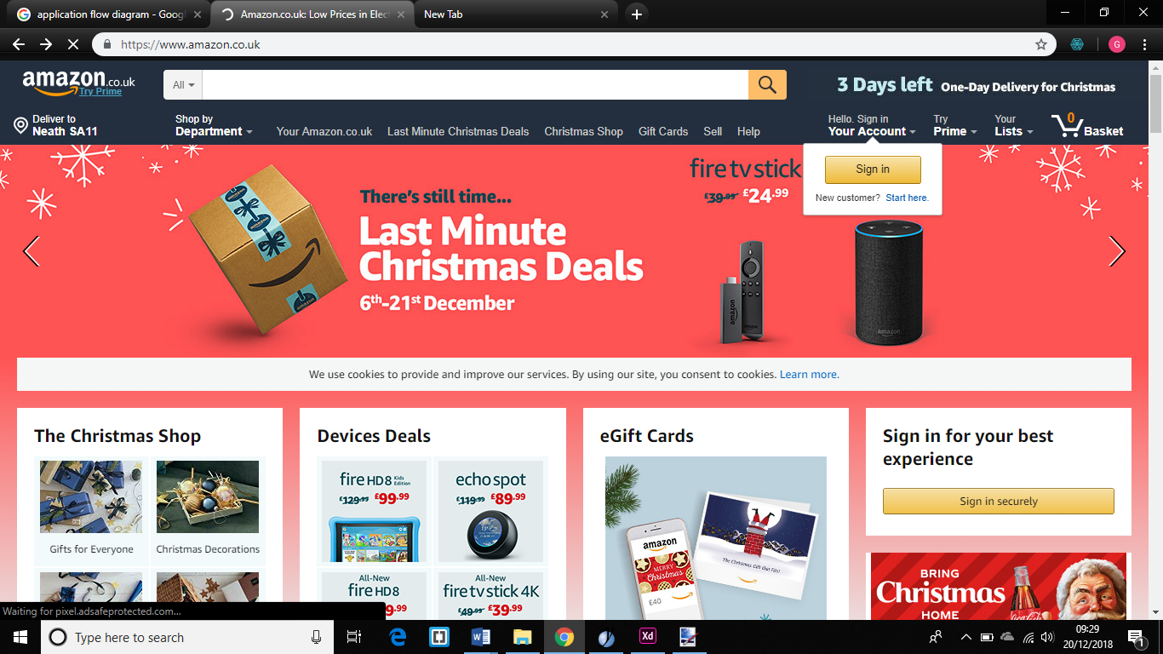
The Amazon site is a shop that allows the reviewing of their products and I want to use their review system of star ratings for the design of the site as well as the position of the navigation bar and basket.
Trustpilot - https://uk.trustpilot.com/
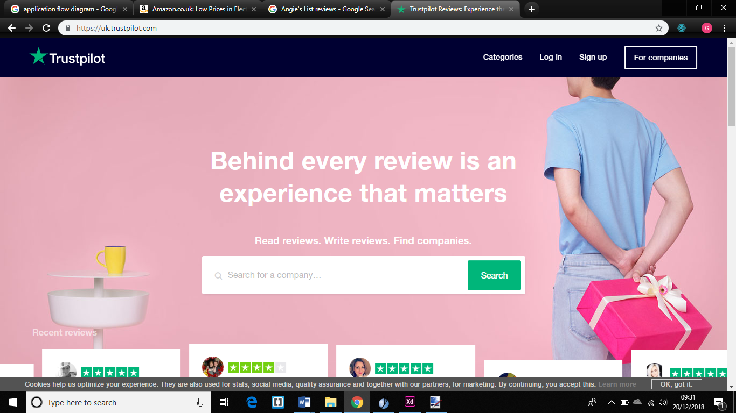
The contrasting that Trustpilot uses is something that I would want to implement into my design, but with a different sort of colour scheme. I would like the position of the sign in/sign up to be at the top right corner of the site in my design.

Capterra - https://www.capterra.com/
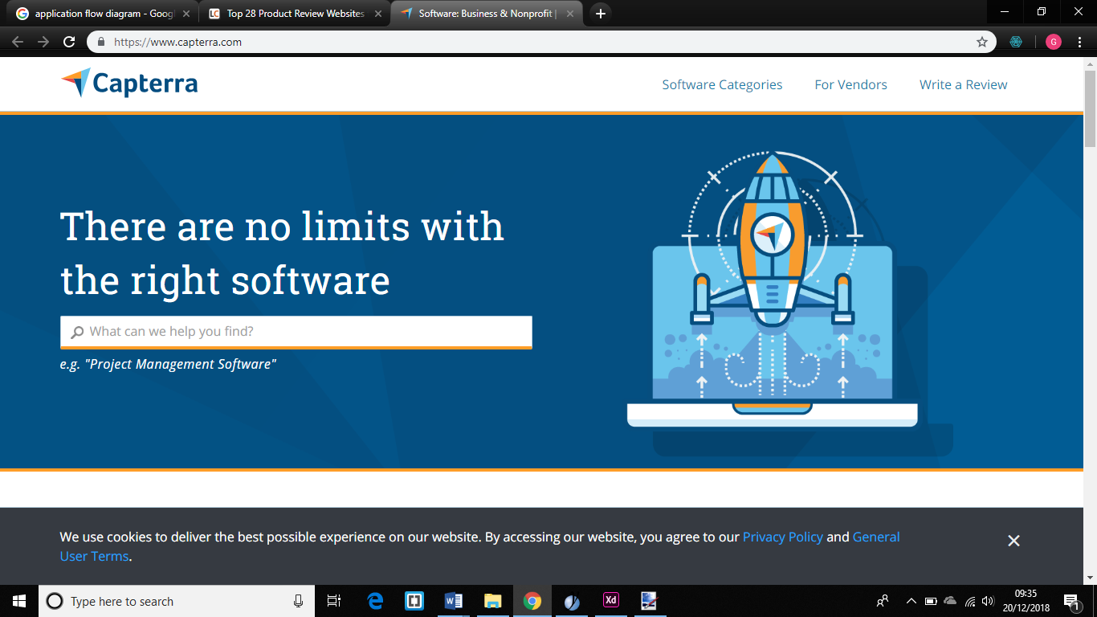
This is the Capterra site and it seems to have a simplistic as well as spacious view for the user and I want this to be implemented in a way to show that there is no clutter on the page than the other sites that I have looked at.

Personas
1st Persona
Sam Smith is a 30-year-old male that lives near Swansea and is one of the administrators on a website that allows users to review the products of the online shop. They are responsible with moderating the content and to add new items, images, descriptions which could then be reviewed on the site by users. He needs to login into the site to be able to add new items to the list of products as well as review the comments that have been made on the products to see if they are appropriate and lastly select the best reviews to display on the product page.

2nd Persona
Sarah Milligan is an 18-year-old female that lives and works in Newport area as a retail assistant and deals with stock and working on the tills. On her spare time, she plays on her games console at home playing a new game every day. She wants a few more games play over the next couple months since she will not have enough time to buy them personally from shops because she is going to be working overtime at her job at that time.

3rd Persona
Matthew Phillips is a 27-year-old male university student in Swansea as well as lives there in student accommodation. In his spare time after he has done his university work he plays games on his console and has bought a lot of games from the same online website that sells them to him. He has played a recent game that he bought from online shop and wants to give his review on the game for the website.

User Scenarios
1st User Scenario
Sam Smith has a backlog of review permission requests and new items to put onto the site. He needs to log into the site as an admin to be able to add new products to the database as well as judge the review requests that have been made on certain products and the same goes for the comments to see if they are appropriate to have on the site or not too.

2nd User Scenario
Sarah Milligan wants to buy a game from an online shop so that it does not affect the time on her work and searches for a site that would sell games. After she finds one she will look at the recommendations of the site as well as the other users on there to be able to make an informed decision on what games she can buy.

3rd User Scenario
Matthew Phillips has recently bought a game from the online shop and wants to login into it to be able to search for that product. After he finds the page that the game is one he will write a review on the game and giving it a rating too for the site.

Task Analysis
1st Task Analysis
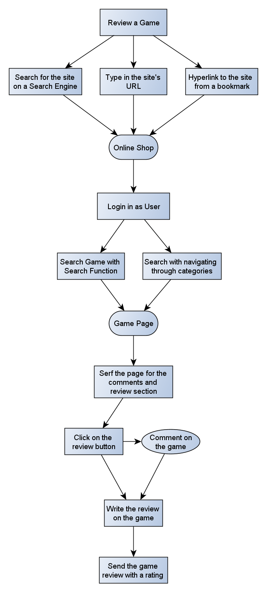

2nd Task Analysis
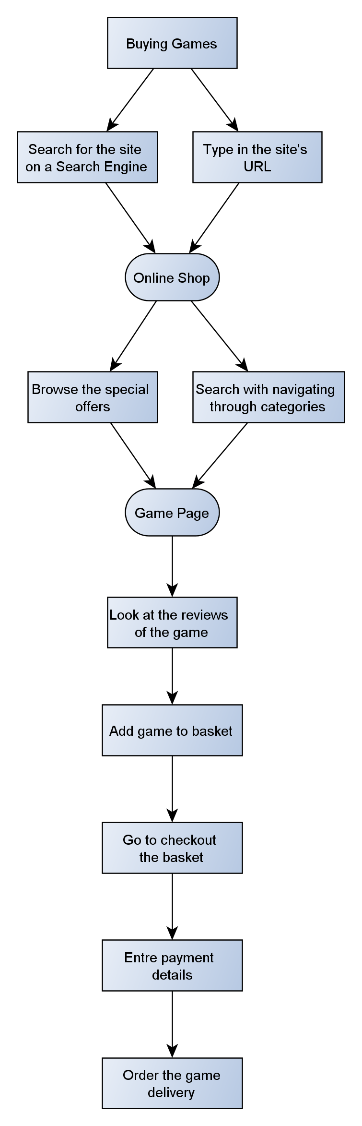

3rd Task Analysis
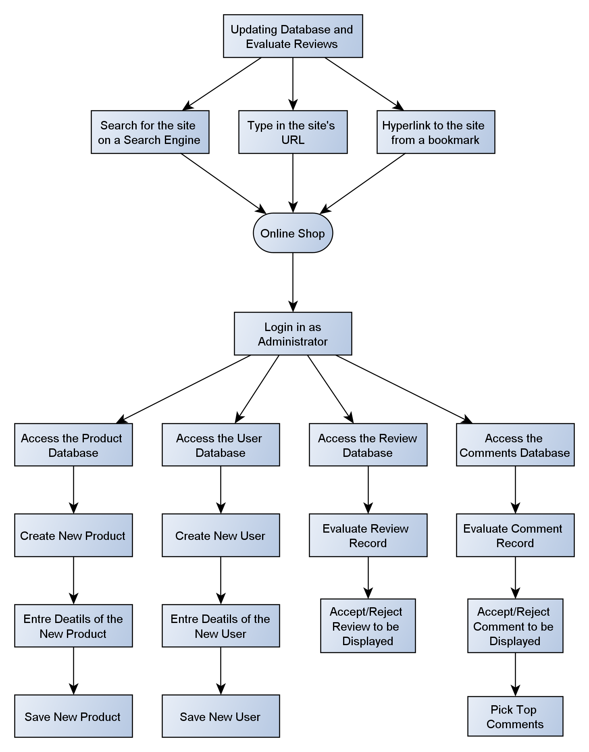

Mood board
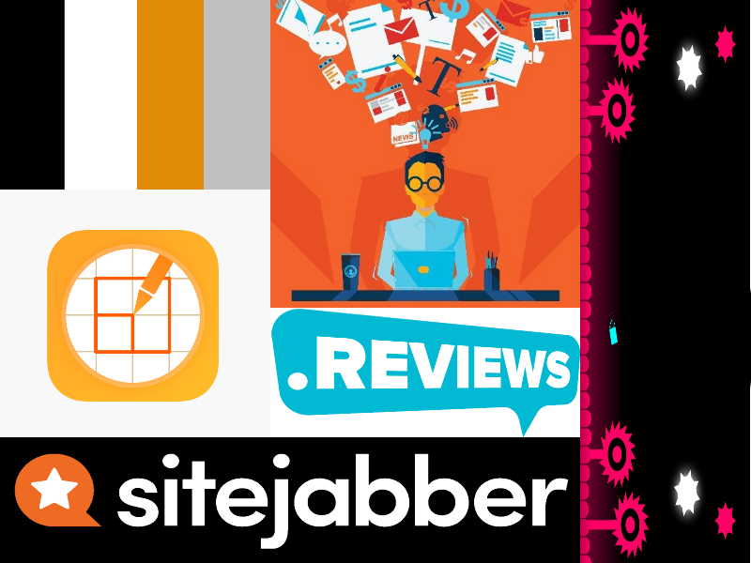

In this mood board I have chosen this colour scheme for the website because the emotion of orange symbolises both red and yellow, which represent passion and happiness, but when making the colour orange it would also represent fire that links to passion [36] [37]. Orange on its own psychologically can bring optimism, self-confidence and warmth for users within the design [38]. There is also the use of black, white and grey that match each other that contrast the site with the use of orange alongside it, which when one or more colours are used together would cancel each other out making other content on the page stand out [39]. The use of text I have chosen is relatively bold and contrasted well which is what I wanted for the theme of the site to be as well as it is having illustrative designs like in mood board that fills in the blank space in the colours.

Normilisation

Normilisation Stage | Attributes/Fields
Un-Normalised Form | OrderID, OrderDate, Total, UserID, CustName, CustAddress, CustTelephone, CustEmail, CustUsername, CustPassword, AdminID, AdminName, AdminAddress, AdminTelephone, AdminEmail, AdminUsername, AdminPassword, ProductName, Description, Price, Stock, BasketID, BasketListID, Quantity, CommentID, CommentDesc, CommentDate, ReviewID, ReviewDesc, ReviewRating
1st Normal Form | OrderID, OrderDate, Total, UserID, CustName, CustAddress, CustTelephone, CustEmail, CustUsername, CustPassword, AdminID, AdminName, AdminAddress, AdminTelephone, AdminEmail, AdminUsername, AdminPassword, BasketID, BasketListID, Quantity, CommentID, CommentDesc, CommentDate, ReviewID, ReviewDesc, ReviewRating, ReviewDate  OrderID, ProductID, ProductName, Description, Price, Stock
2nd Normal Form | OrderID, OrderDate, Total, UserID, CustName, CustAddress, CustTelephone, CustEmail, CustUsername, CustPassword, AdminID, AdminName, AdminAddress, AdminTelephone, AdminEmail, AdminUsername, AdminPassword, BasketID, BasketListID, Quantity, CommentID, CommentDesc, CommentDate, ReviewID, ReviewDesc, ReviewRating, ReviewDate  OrderID, ProductID  ProductID, ProductName, Description, Price, Stock
3rd Normal Form | OrderID, OrderDate, Total, UserID, BasketID  UserID, CustName, CustAddress, CustTelephone, CustEmail, CustUsername, CustPassword, CommentID, CommentDesc, CommentDate, ReviewID, ReviewDesc, ReviewRating, ReviewDate  AdminID, AdminName, AdminAddress, AdminTelephone, AdminEmail, AdminUsername, AdminPassword  BasketID  BasketListID, BasketID, ProductID, Quantity  ProductID, ProductName, Description, Price, Stock
4th Normal Form | OrderID, OrderDate, Total, UserID, BasketID  UserID, CustName, CustAddress, CustTelephone, CustEmail, CustUsername, CustPassword  CommentID, CommentDesc, CommentDate, UserID, ReviewID  ReviewID, ReviewDesc, ReviewRating, ReviewDate, UserID, ProductID  AdminID, AdminName, AdminAddress, AdminTelephone, AdminEmail, AdminUsername, AdminPassword  BasketID  BasketListID, BasketID, ProductID, Quantity  ProductID, ProductName, Description, Price, Stock

Data Dictionary

Orders | User | Admin | Basket | Basket List | Product | Comment | Review
- OrderID - PK  - OrderDate  - Total  - UserID - FK  - BasketID -FK | - UserID - PK  - CustName  - CustAddress  - CustTelephone  - CustEmail  - CustUsername  - CustPassword | - AdminID - PK  - AdminName  - AdminAddress  - AdminTelephone  - AdminEmail  - AdminUsername  - AdminPassword | - BasketID - PK | - BasketListID - PK  - Quantity  - BasketID - FK  - ProductID - FK | - ProductID - PK  - ProductName  - Description  - Price  - Stock | - CommentID - PK  - CommentDesc  - CommentDate  - UserID - FK  - ReviewID - FK | - ReviewID - PK  - ReviewDesc  - ReviewRating  - ReviewDate  - UserID - FK  - ProductID - FK

Entity Relationship Diagram
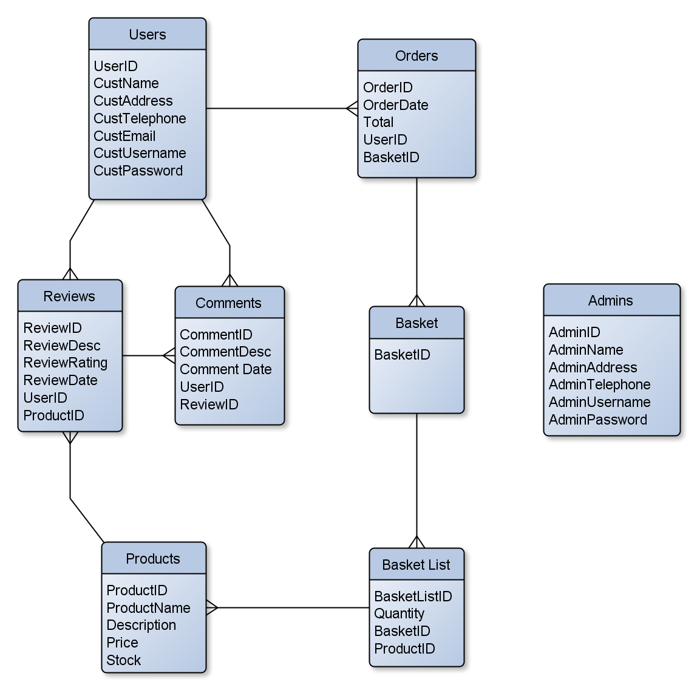

Data Flow Diagram
User Ordering
Level 0
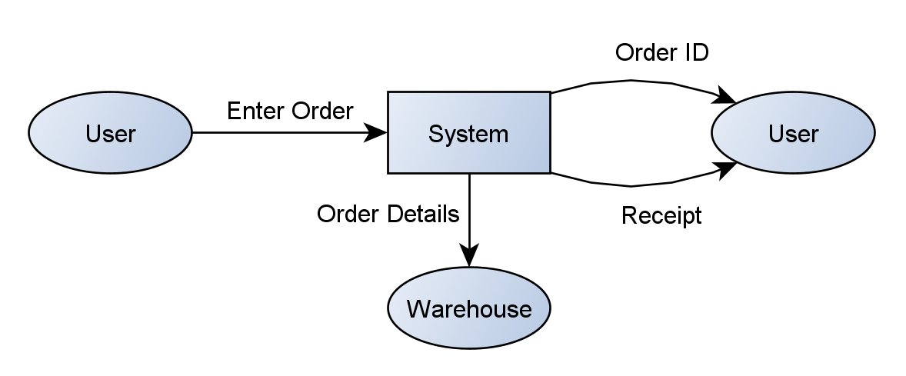
Level 1
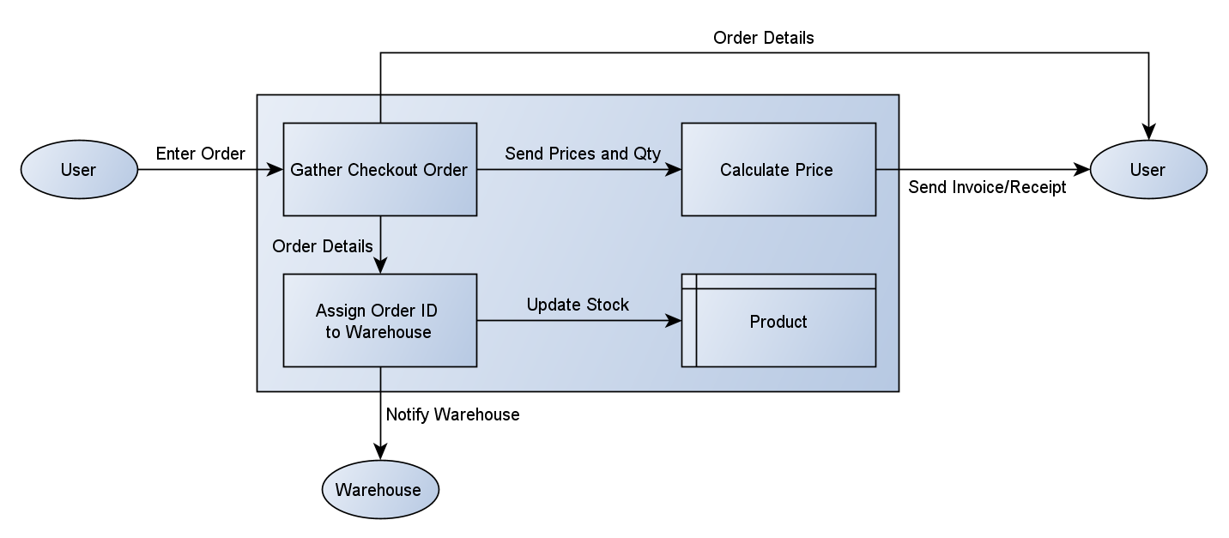
User Commenting and Reviewing
Level 0
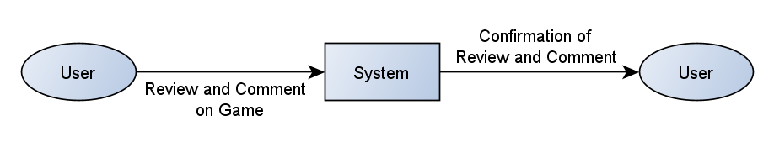
Level 1
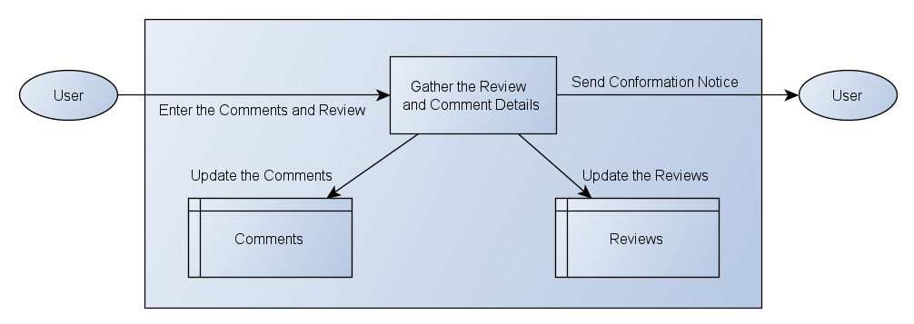

Contents Plan
Page | Contents
Home | - Latest news of products  - Special offers  - Recommendations  - Social network feed  - Logo  - Signup/login link  - Social network links  - Navigation panel  - Images of products  - Brief description of the company
About Us | - Company’s description  - Photos of founders
Games | - Link to the PlayStation, Xbox and PC Games pages
- PlayStation Games | - List of PlayStation Games with name, price, stock and link to the product page
- Xbox Games | - List of Xbox Games with name, price, stock and link to the product page
- PC Games | - List of PC Games with name, price, stock and link to the product page
Basket | - hold all the products that have been added by the user  - Contains the payment method  - Options to checkout or clear the basket
Login/Register | - Form to show the user and admin login methods  - Admin links to the management page  - User Links back to the home page
Contact Us | - Types of communication methods with the company e.g. phone number, email address and a message form
Product Page | - Product’s details, price and stock  - Buttons to add to basket or checkout

Sitemap
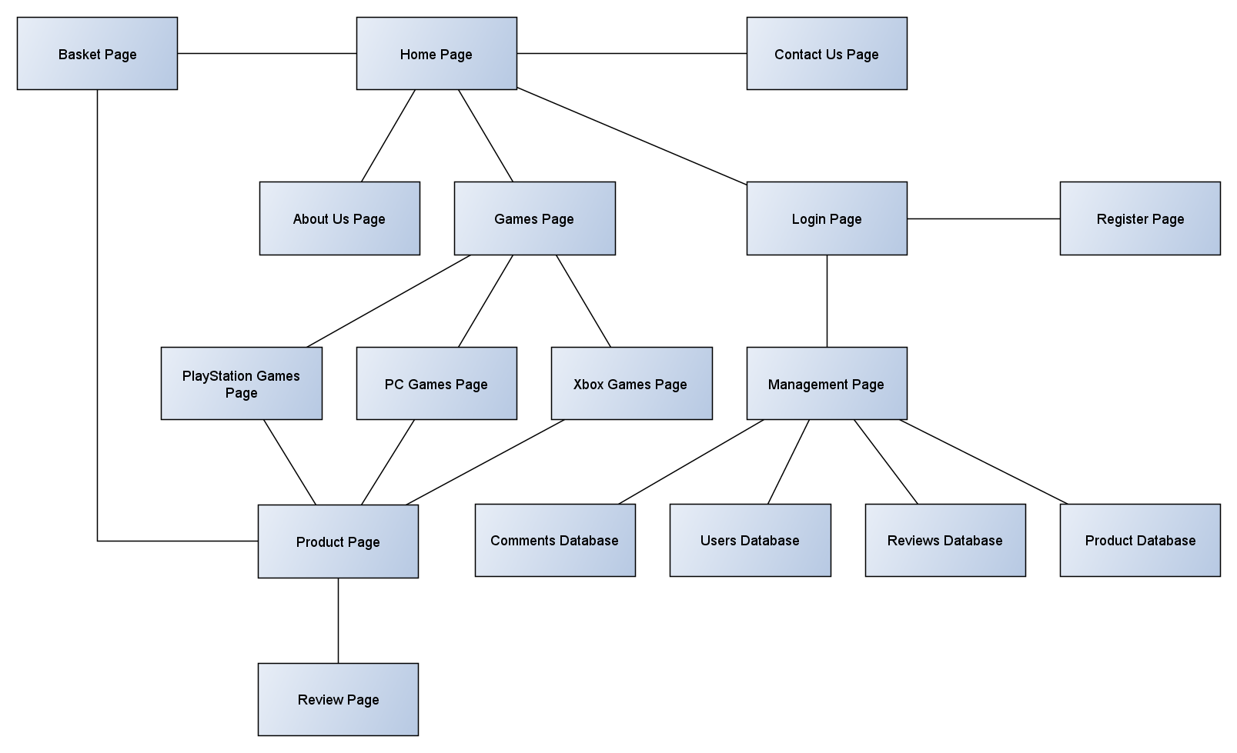

Application Flow Diagram
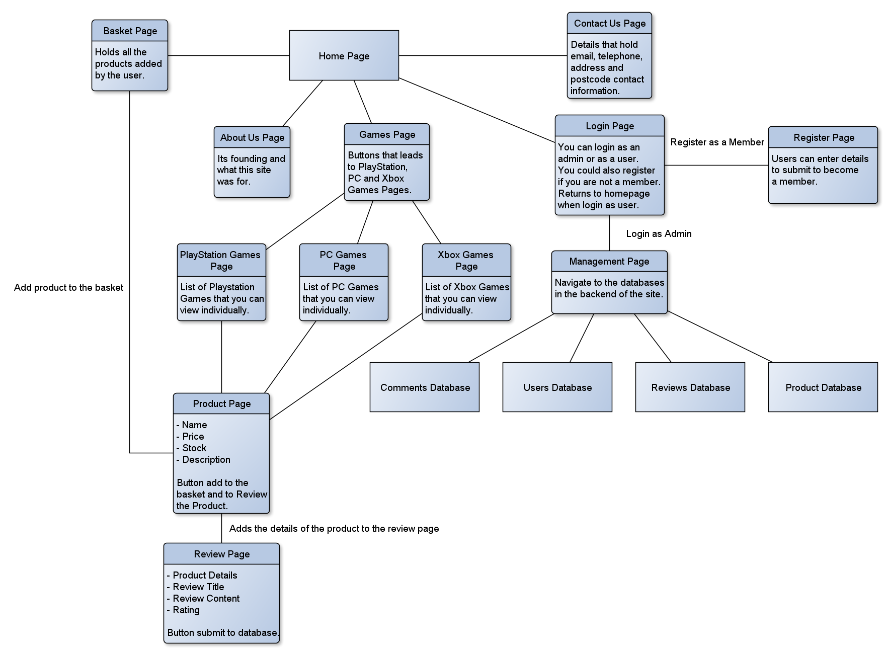

Visual Designs
Home Page
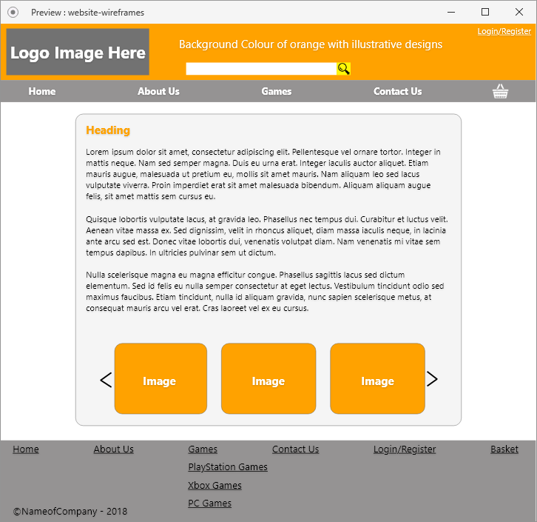
I made it so that the usability of the design was intact by making the pages have consistency throughout the web application with the colour scheme and the positioning of the functions too. I also made use of good spacing in the pages making it simple to comprehend by preventing clutter on the pages [40].
The method I have chosen to display the text in the designs has a differentiation in font and size this is because it would make up the typography of a text hierarchy which allows the user to see what the high form of information and lower forms of information are in the pages, like what is the header and what is the contents of that header [41].
I had spacing implemented to make it seem that there is space on the page to prevent the cluttering of the page this was because it made use of white spacing design principle and when blank spaces are it displays the content clearly [42].

About Us Page
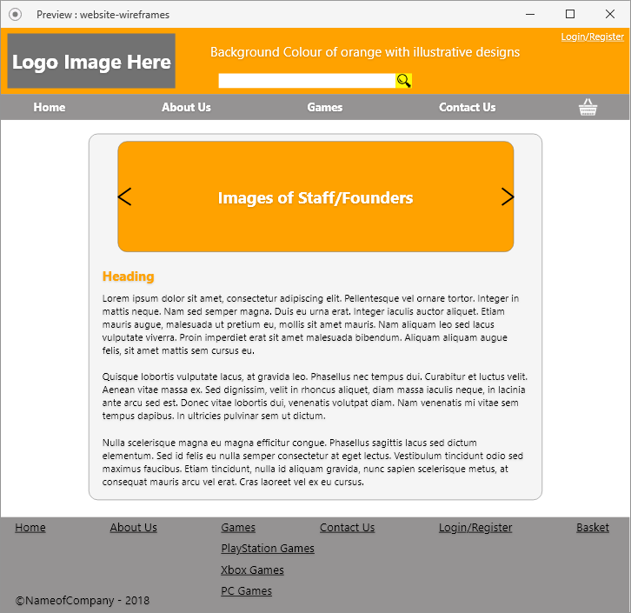

Contact Us Page
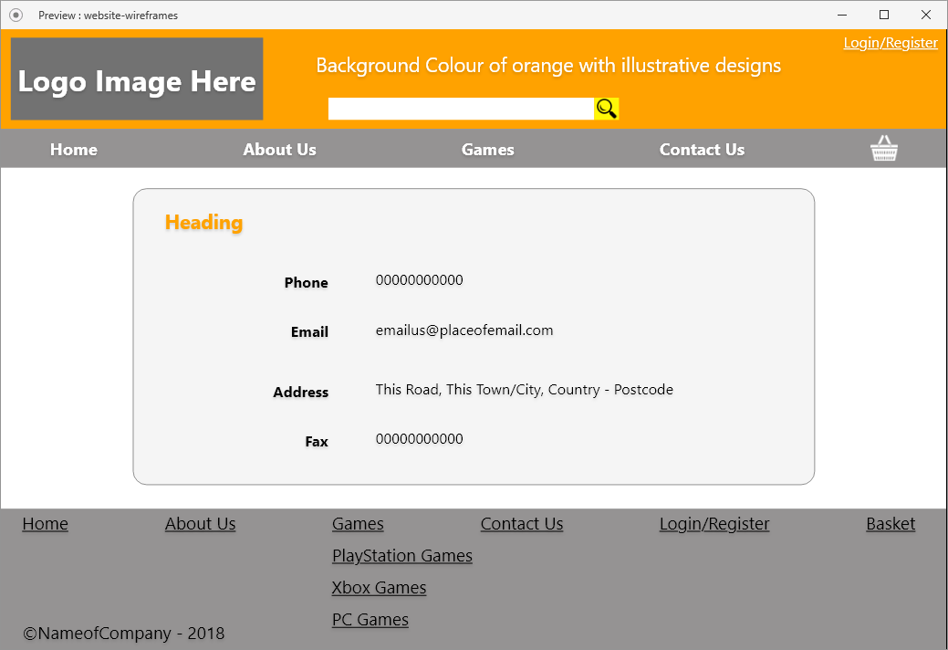

Games Page
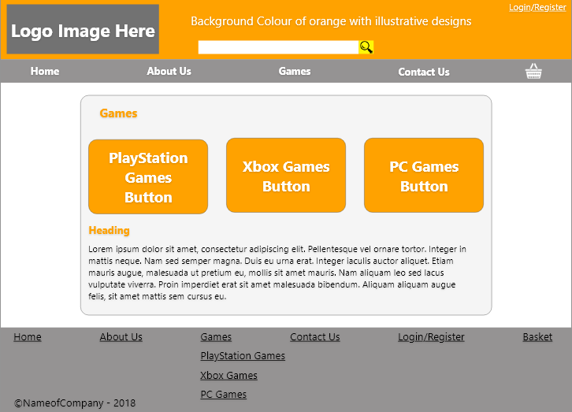

Product List Page
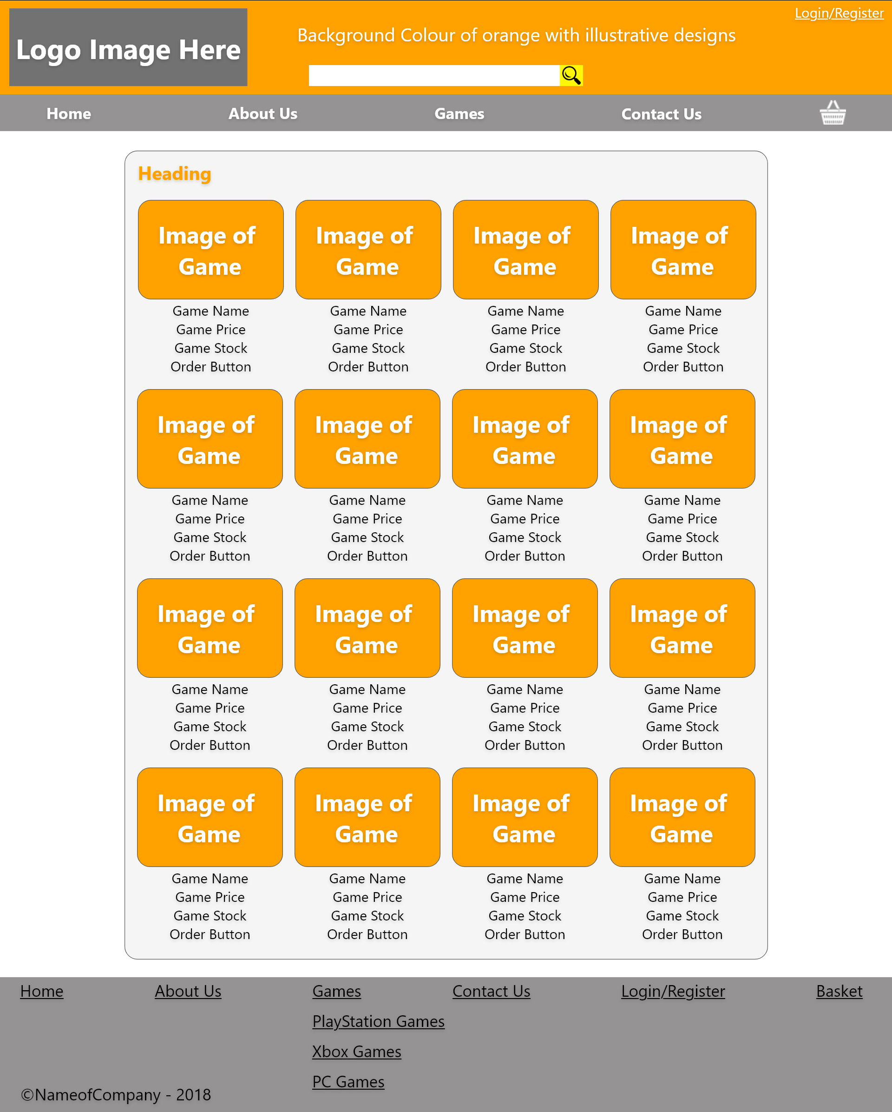

Product Page
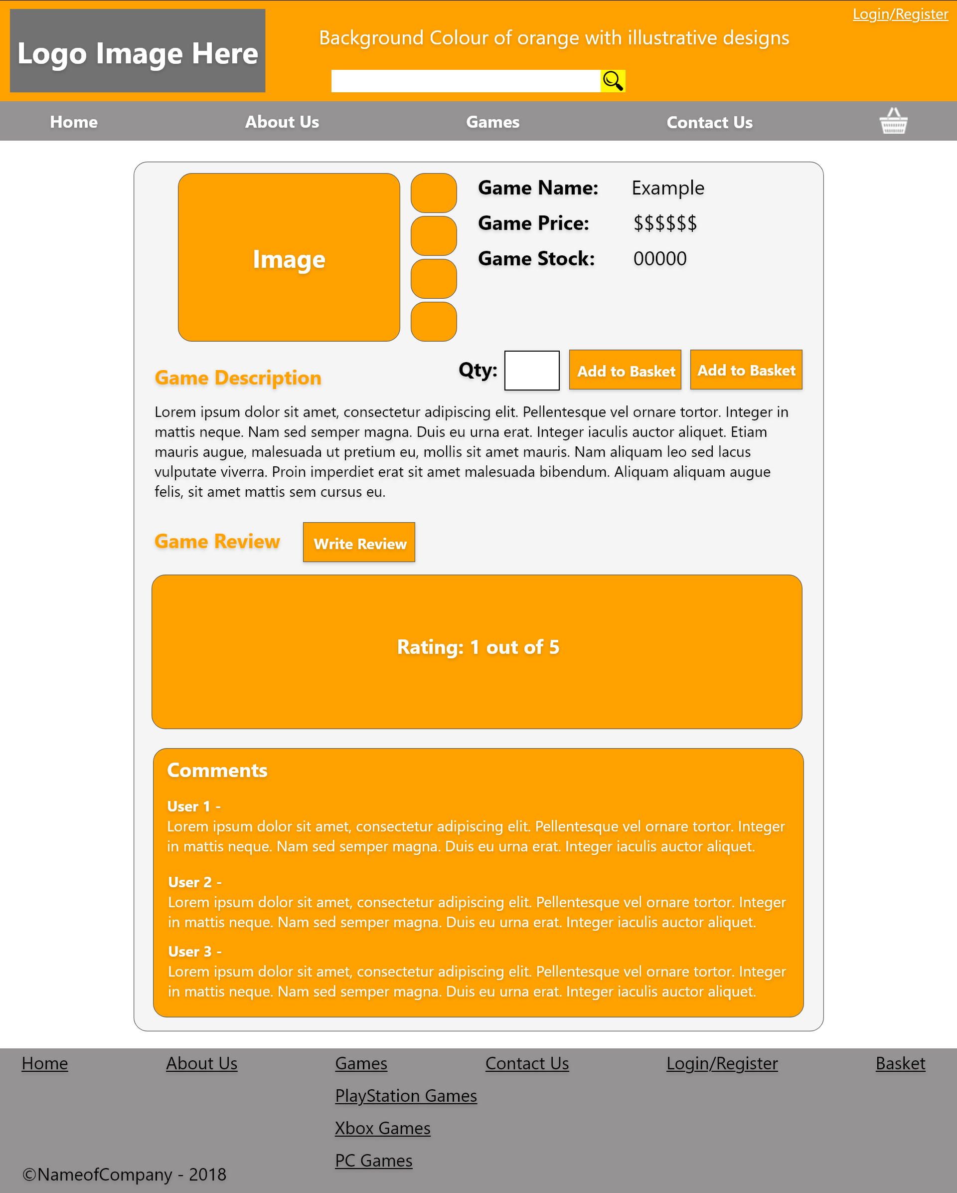

Basket Page
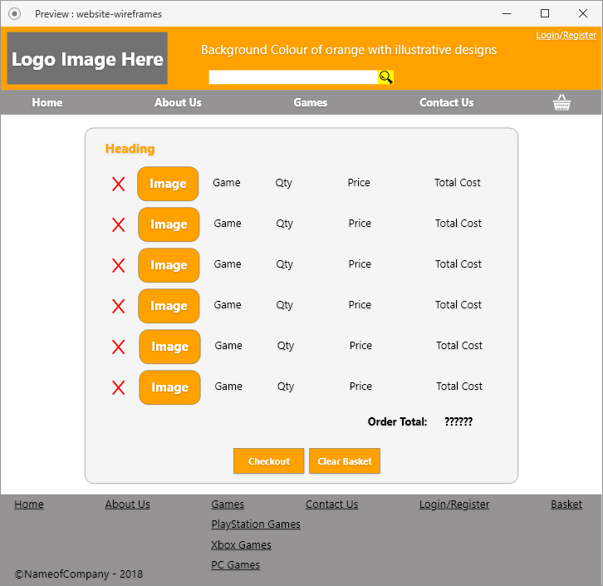

Review Page
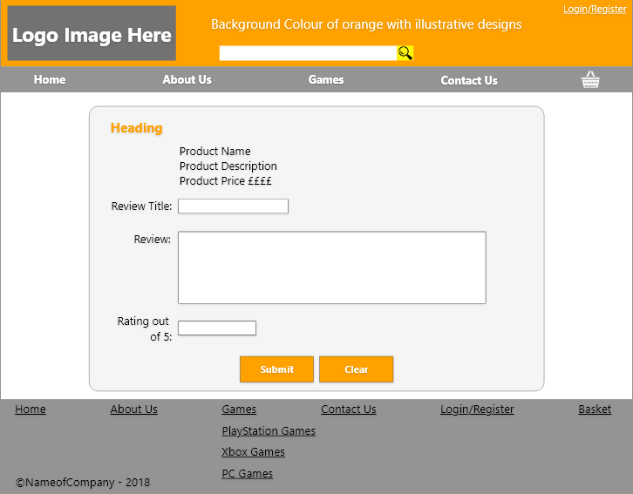

Login Page
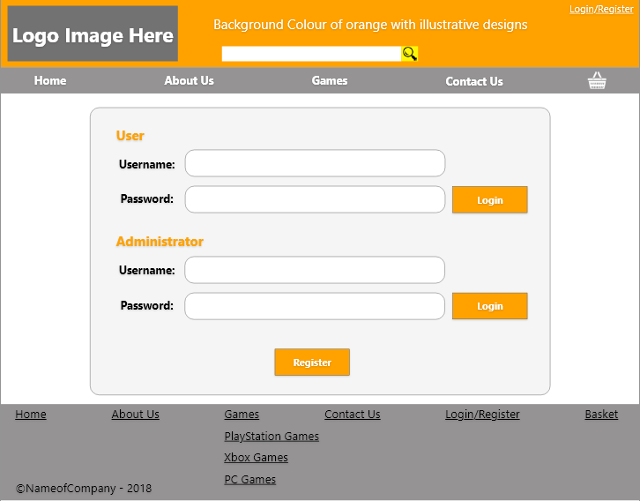

Management Page
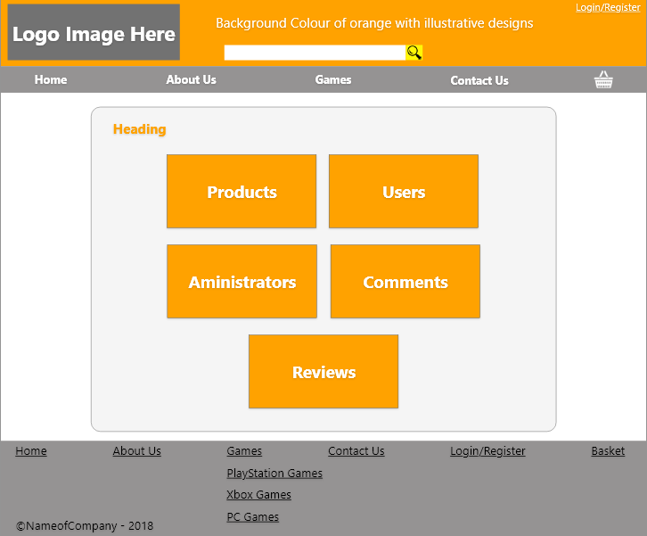

Database Page
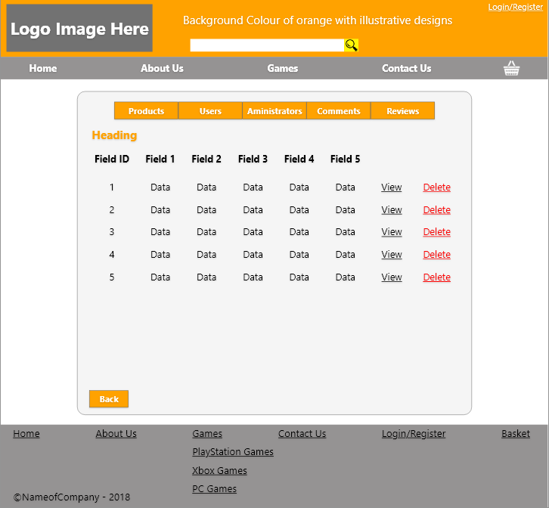

Record Page
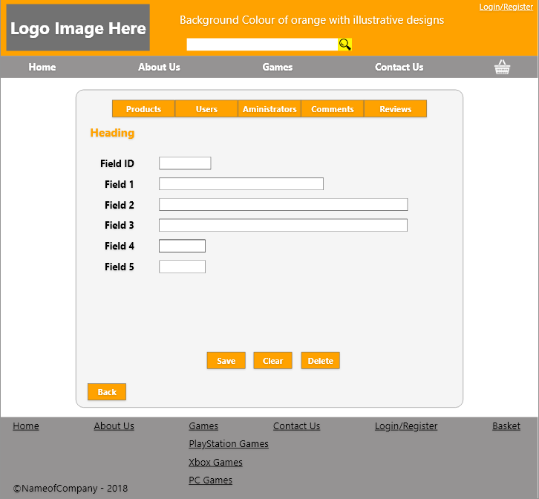

Register Page
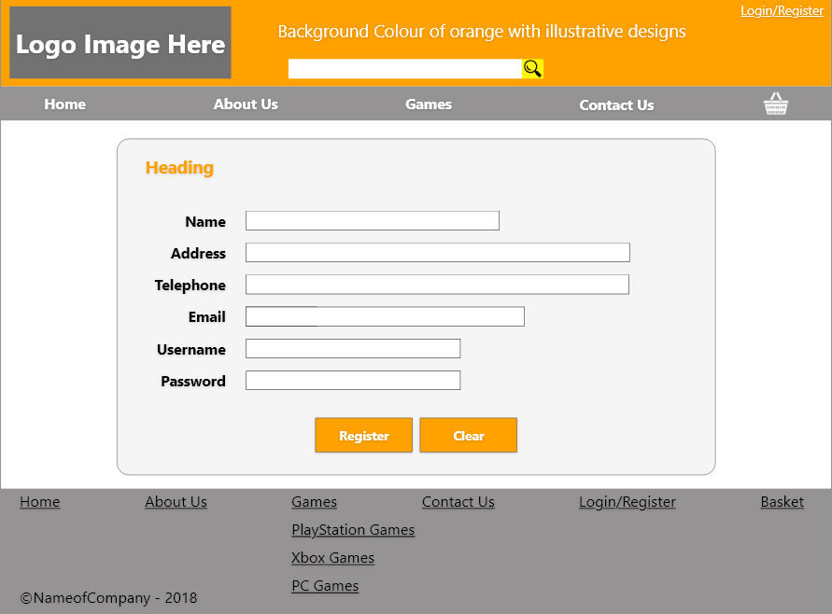

Wireframes
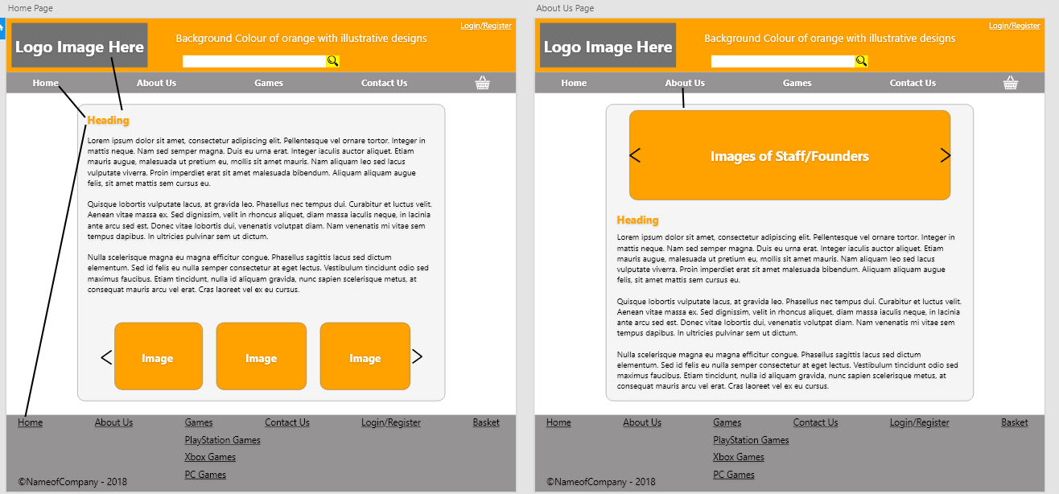

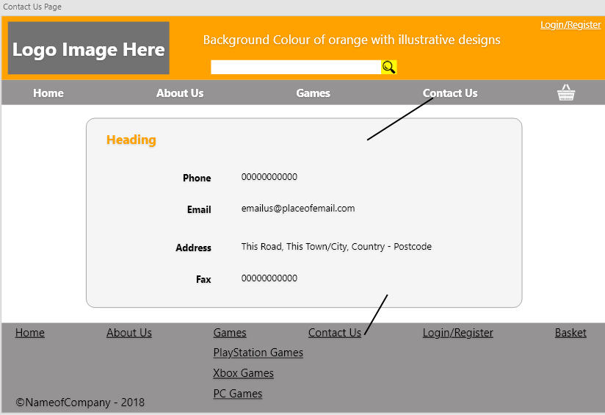

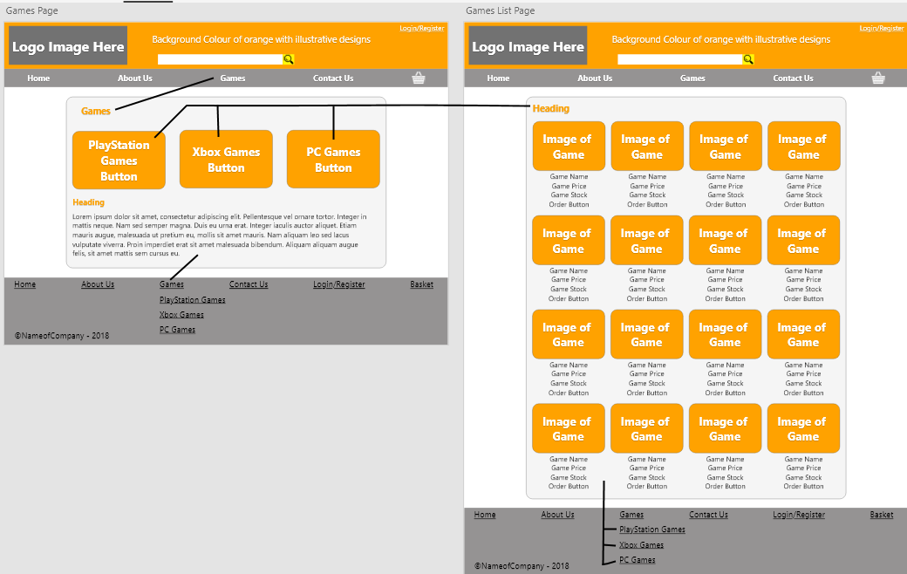

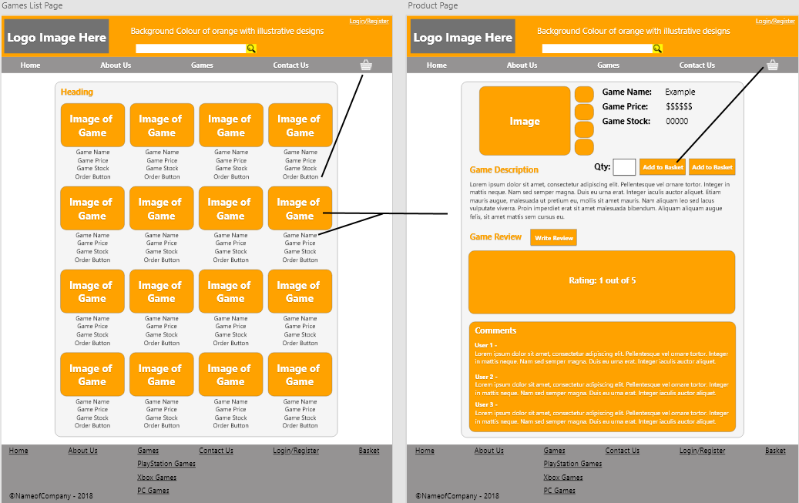

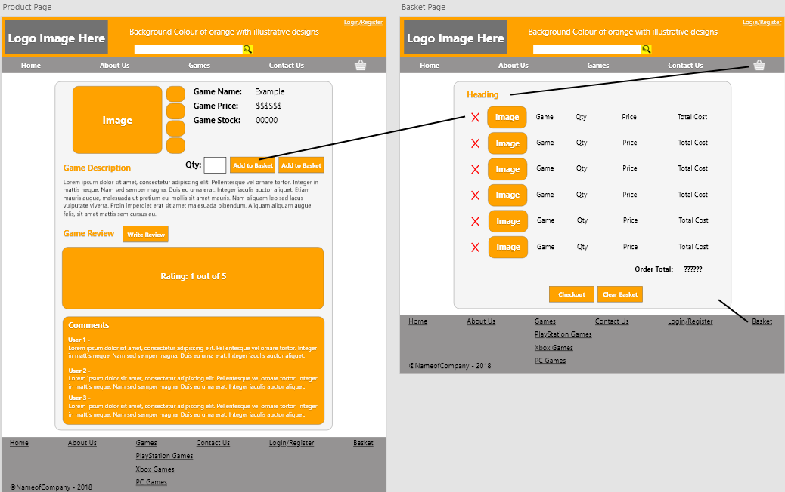

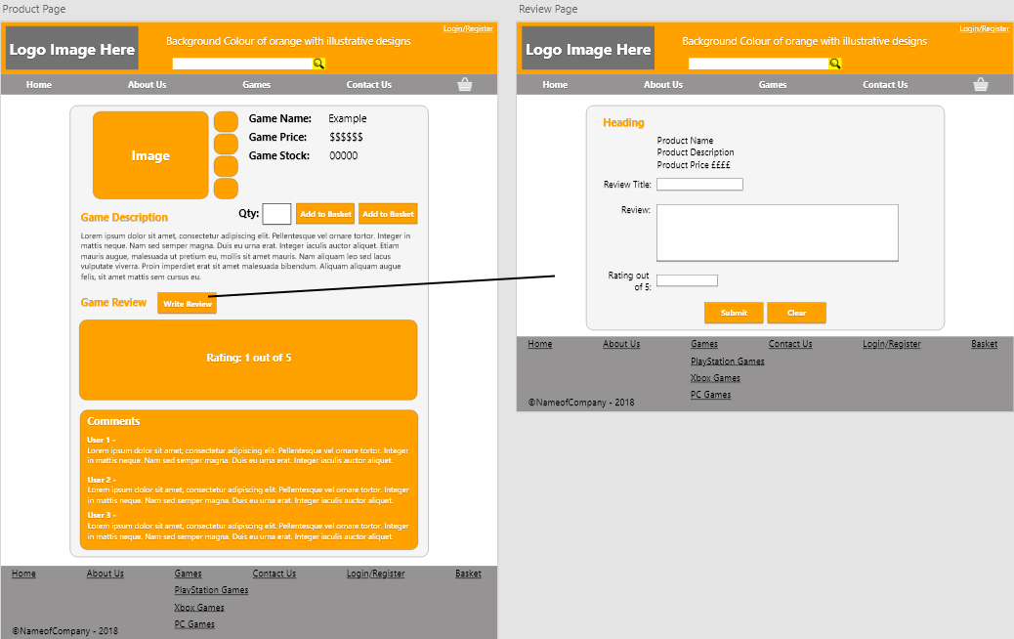

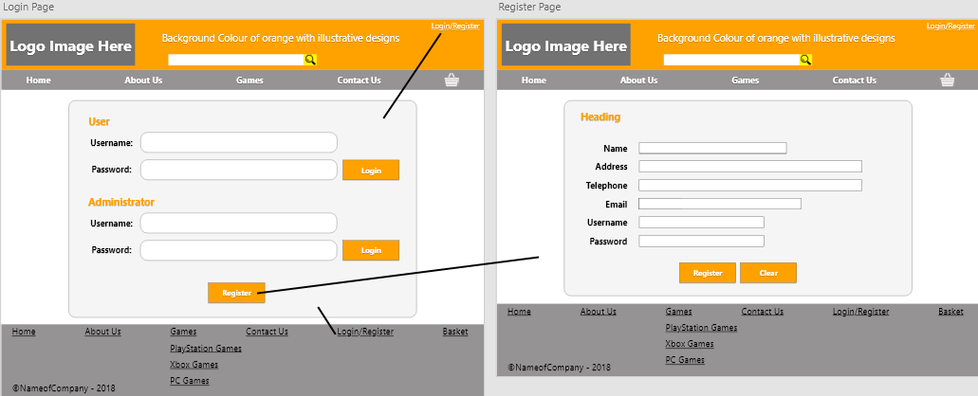

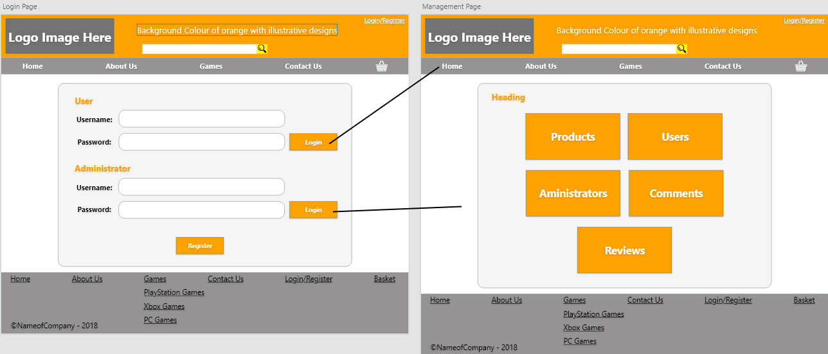

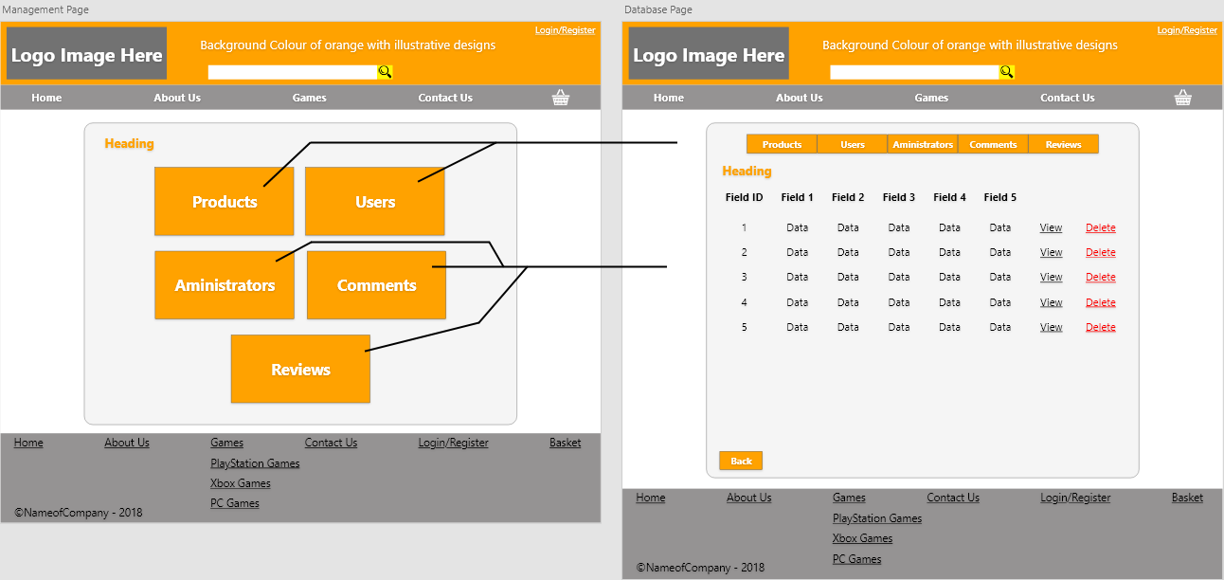

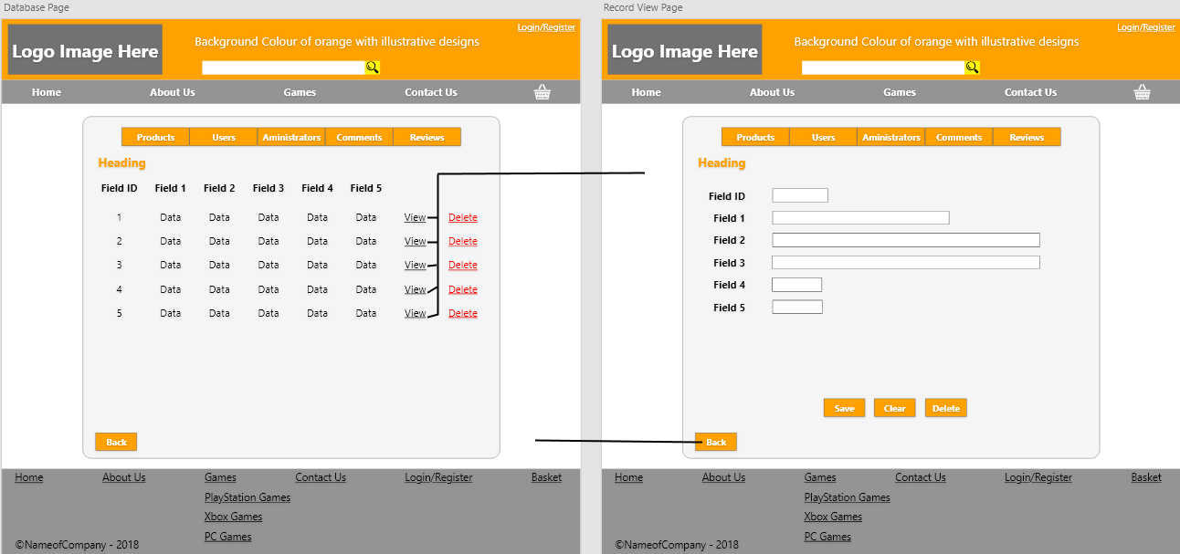

References

- Author(s): U.S. Department of Veterans Affairs
Title: Enterprise Design Patterns
URL: https://www.ea.oit.va.gov/EAOIT/VA_EA/ENTERPRISE_DESIGN_PATTERNS.asp
Access Date: 18/12/2018
Updated: 2017
- Author(s): Enterprise Integration Patterns
Title: Messaging Patterns
URL: https://www.enterpriseintegrationpatterns.com/patterns/messaging/Messaging.html?fbclid=IwAR3e7n0yyyVymuq-pDGAE-l6y_2-A27DU9qSYZXqeXRG_o0m4BgNIObAe_U
Access Date: 18/12/2018
Updated: 2017
- Author(s): Gregor Hohpe, Bobby Woolf
Title: Enterprise Integration Patterns Designing, Building, and Deploying Messaging Solutions
URL: https://github.com/vaquarkhan/vaquarkhan/raw/master/integration%20design%20pattern/Addison%20Wesley%20-%20Enterprise%20Integration%20Patterns%20-%20Designing%2C%20Building%20And%20Deploying%20Messaging%20Solutions%20-%20With%20Notes.pdf
Page(s): 18, 67
Access Date: 18/12/2018
Publish Date: 2004
- Author(s): GeekForGeeks
Title: MVC Design Pattern
URL: https://www.geeksforgeeks.org/mvc-design-pattern/
Access Date: 18/12/2018
Updated: 2018
- Author(s): Erich Gamma, Richard Helm, Ralph Johnson, John Vlissides
Title: Design Patterns: Elements of Reusable Object-Oriented Software
URL: https://github.com/dieforfree/edsebooks/raw/master/ebooks/Design%20Patterns%2C%20Elements%20of%20Reusable%20Object-Oriented%20Software.pdf
Page(s): 18
Access Date: 18/12/2018
Publish Date: 1994
- Author(s): Nick Heidke, Joline Morrison, Mike Morrison
Title: Assessing the Effectiveness of the Model View Controller Architecture for Creating Web Applications
URL: http://micsymposium.org/mics_2009_proceedings/mics2009_submission_55.pdf
Access Date: 18/12/2018
Updated: 2009
- Author(s): Avraham Leff, James T. Rayfield
Title: Web-Application Development Using the ModelNiewlController Design Pattern
URL: https://pdfs.semanticscholar.org/9c1b/b39706724095d5eb1f988dc1d283472388d4.pdf
Page(s): 119
Access Date: 18/12/2018
Publish Date: 2001

- Author(s): Interaction Design Foundation
Title: User Interface (UI) Design Patterns
URL: https://www.interaction-design.org/literature/topics/ui-design-patterns
Access Date: 18/12/2018
Updated: 2018
- Author(s): Jenifer Tidwell
Title: Design Interfaces
URL: http://internativa.com.br/mobile/Livro%20-%20Designing%20Interfaces,%202nd%20Edition,%202010.pdf
Page(s): 29, 30
Access Date: 18/12/2018
Publish Date: 2011
- Author(s): Erik G. Nilsson
Title: Advances in Engineering Software
URL: https://brage.bibsys.no/xmlui/bitstream/handle/11250/2431617/SINTEF+S14803.pdf?sequence=1
Page(s): 1327
Access Date: 18/12/2018
Publish Date: 2009
- Author(s): courses.ischool.berkeley.edu
Title: Comparative Analysis
URL: http://courses.ischool.berkeley.edu/i213/s06/projects/uipatterns/a3/companalysis.html
Access Date: 18/12/2018
Updated: 2018
- Author(s): nodejs.org
Title: About Node.js
URL: https://nodejs.org/en/about/
Access Date: 18/12/2018
Updated: 2018
- Author(s): GeekForGeeks
Title: PHP vs. Node.js
URL: https://www.geeksforgeeks.org/php-vs-node-js/
Access Date: 18/12/2018
Updated: 2018
- Author(s): EDUCBA
Title: Node.js vs Asp.net
URL: https://www.educba.com/node-js-vs-asp-net/
Access Date: 18/12/2018
Updated: 2018
- Author(s): tutorialspoint
Title: CakePHP Tutorial
URL: https://www.tutorialspoint.com/cakephp/
Access Date: 18/12/2018
Updated: 2018

- Author(s): David A. Botwe, Joseph G. Davis
Title: A Comparative Study of Web Development Technologies Using Open Source and Proprietary Software
URL: https://www.ijcsmc.com/docs/papers/February2015/V4I2201534.pdf
Page(s): 164
Access Date: 18/12/2018
Publish Date: 2015
- Author(s): Daniel Roth, Rick Anderson, Shaun Luttin
Title: Introduction to ASP.NET Core
URL: https://docs.microsoft.com/en-us/aspnet/core/?view=aspnetcore-2.2
Access Date: 18/12/2018
Updated: 2018
- Author(s): Roy Thomas Fielding
Title: Representational State Transfer (REST)
URL: https://www.ics.uci.edu/~fielding/pubs/dissertation/rest_arch_style.htm
Access Date: 18/12/2018
Updated: 2000
- Author(s): Thomas Fielding
Title: Architectural Styles and the Design of Network-based Software Architectures
URL: https://www.ijcsmc.com/docs/papers/February2015/V4I2201534.pdf
Page(s): 87
Access Date: 18/12/2018
Publish Date: 2000
- Author(s): smartbear
Title: What is Microservices Architecture?
URL: https://smartbear.com/learn/api-design/what-are-microservices/
Access Date: 18/12/2018
Updated: 2018
- Author(s): Sam Newman
Title: Building Microservices: Designing Fine-Grained Systems
URL: http://index-of.es/Varios/Sam%20Newman-Building%20Microservices-O'Reilly%20Media%20(2015).pdf
Page(s): 17, 20, 22
Access Date: 18/12/2018
Publish Date: 2015
- Author(s): Chris Ullman
Title: What is Ajax?
URL: http://www.wrox.com/WileyCDA/Section/id-303217.html
Access Date: 18/12/2018
Updated: 2007
- Author(s): Daniel Zucker
Title: What does AJAX mean for you?
URL: http://interactions.acm.org/archive/view/september-october-2007/what-does-ajax-mean-for-you1
Access Date: 18/12/2018
Updated: 2007

- Author(s): Douglas Crockford
Title: Introducing JSON
URL: https://www.json.org/
Access Date: 18/12/2018
Updated: 2018
- Author(s): Peter-Paul Koch
Title: The AJAX response: XML, HTML, or JSON?
URL: https://www.quirksmode.org/blog/archives/2005/12/the_ajax_respon.html
Access Date: 18/12/2018
Updated: 2005
- Author(s): johnnyagerard
Title: XML introduction
URL: https://developer.mozilla.org/en-US/docs/XML_introduction
Access Date: 18/12/2018
Updated: 2018
- Author(s): MongoDB
Title: The MongoDB 4.0 Manual
URL: https://docs.mongodb.com/manual/
Access Date: 18/12/2018
Updated: 2008
- Author(s): João Ricardo Lourenço, Veronika Abramova, Marco Vieira, Bruno Cabral, Jorge Bernardino
Title: NoSQL Databases: A Software Engineering Perspective
URL: https://www.researchgate.net/profile/Bruno_Cabral/publication/282296714_NoSQL_Databases_A_Software_Engineering_Perspective/links/5612594008ae0fc513f335c6.pdf
Page(s): 9
Access Date: 18/12/2018
Publish Date: 2015
- Author(s): Yishan Li, Sathiamoorthy Manoharan
Title: A performance comparison of SQL and NoSQL databases
URL: https://www.researchgate.net/profile/Yishan_Li/publication/261079289_A_performance_comparison_of_SQL_and_NoSQL_databases/links/564fbcf708aeafc2aab3ff73.pdf
Page(s): 18
Access Date: 18/12/2018
Publish Date: 2015
- Author(s): tutorialspoint
Title: Neo4j Tutorial
URL: https://www.tutorialspoint.com/neo4j/
Access Date: 18/12/2018
Updated: 2018
- Author(s): Salim Jouili, Valentin Vansteenberghe
Title: An empirical comparison of graph databases
URL: http://www.odbms.org/wp-content/uploads/2014/05/an-empirical-comparison-of-graph-databases.pdf
Page(s): 4, 5
Access Date: 18/12/2018
Publish Date: 2014

- Author(s): tutorialspoint
Title: Cassandra Tutorial
URL: https://www.tutorialspoint.com/cassandra/
Access Date: 18/12/2018
Updated: 2018
- Author(s): GeekForGeeks
Title: An introduction to Machine Learning
URL: https://www.geeksforgeeks.org/introduction-machine-learning/
Access Date: 18/12/2018
Publish Date: 2018
- Author(s): Mandeep Kaur
Title: Top 10 real-life examples of Machine Learning
URL: https://bigdata-madesimple.com/top-10-real-life-examples-of-machine-learning/
Access Date: 21/12/2018
Updated: 2018
- Author(s): Bernard Marr
Title: 27 Incredible Examples Of AI And Machine Learning In Practice
URL: https://www.forbes.com/sites/bernardmarr/2018/04/30/27-incredible-examples-of-ai-and-machine-learning-in-practice/#1044eb8e7502
Access Date: 21/12/2018
Updated: 2018
- Author(s): tv tropes
Title: Follow Colour-Coded Emotions
URL: https://tvtropes.org/pmwiki/pmwiki.php/Main/ColourCodedEmotions
Access Date: 21/12/2018
Updated: 2018
- Author(s): tv tropes
Title: Color-Coded Elements
URL: https://tvtropes.org/pmwiki/pmwiki.php/Main/ColorCodedElements
Access Date: 21/12/2018
Updated: 2018
- Author(s): Color Psychology
Title: Orange Color Psychology and Meaning
URL: https://www.colorpsychology.org/orange/
Access Date: 21/12/2018
Updated: 2018
- Author(s): Interaction Design Foundation
Title: Color Theory
URL: https://www.interaction-design.org/literature/topics/color-theory
Access Date: 21/12/2018
Updated: 2018
- Author(s): Usability Body of Knowledge
Title: Principles for Usable Design
URL: https://www.usabilitybok.org/principles-for-usable-design
Access Date: 21/12/2018
Updated: 2010
- Author(s): GCF Global
Title: What is typography?
URL: https://edu.gcfglobal.org/en/beginning-graphic-design/typography/1/
Access Date: 21/12/2018
Updated: 2018
- Author(s): Mads Soegaard
Title: The power of white space
URL: https://www.interaction-design.org/literature/article/the-power-of-white-space
Access Date: 21/12/2018
Updated: 2018

