Assessment of Practical Tasks
Menu Engineering

Name: Andreea Ionelia Girboiu
Student Id: 2119260

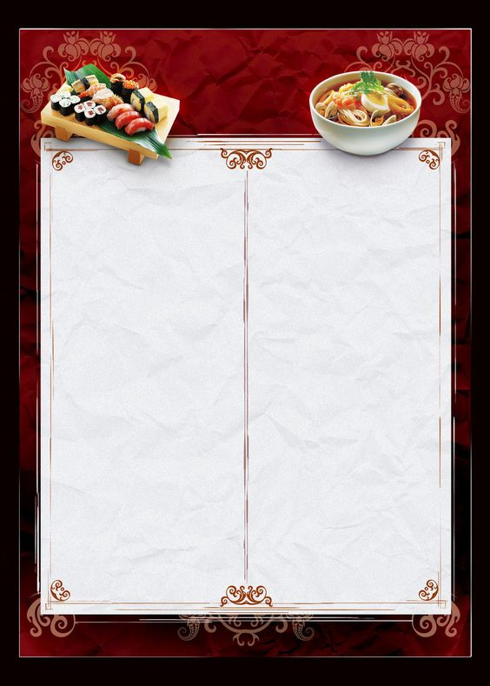
Hotel Trinity
Swansea, South Wales region

MAIN COURSE
Chicken pave mushroom (goes excellent with the elegant Chardonnay Wine) 10.00
Sliced and Roasted chicken cooked with mushroom and vegetables stew
Thai green spices and onion puree curried goat with mint and green peas 15.10
Caribbean’s iconic dish, cooked with the creamy and spicy flavour of coconut, is majorly served with the peace and rise and perfectly topped with the coriander and mint leaves.
Grilled Hake 15.78
Soft and Delicious hake filets with some black pepper, olive oil and roasted nuts ideally served with the butter crunch Croute and garlic potatoes.
Braised mustard beef with carrots puree 15.28
Cooked Braised Beef with red wine and vegetable oil and stock of chicken with best and fresh chopped carrots and specifically served with the delicious cream (fresh), garnished with the culinary tarragon herbs.
Potatoes (Creamy) mash specifically served with red wine sauce 16.15
Potatoes (Mashed) specifically baked with Gouda, cheddar and mozzarella cheese topped with the delicious cream, cool and coriander and served with the sauces reduction of red wine.
Grilled platter of meat with potato ravioli (goes perfect with Syrah wine) 20.00
The Grilled chops of lamb, sausages, and chicken with the sauce and red flakes are specifically served with the ravioli of cheesy potato, vegetables and a huge variety of dips.
Creamy Corn with lime your gut-specific seasoning 18.95
The cod is specifically cooked in the olive oil with the flavours garlic, perfectly served with the sauté of sweet corn with the delicious butter, black salt and red chilli and served with the lime wedges and spring onion.

DESSERTS
Cheese Strawberry pannacotta €8
A creamy and delicious dessert made of gelatine, cream, sugar, milk and strawberry with the leaves of mint.
Vanilla and cream catalane (1pc)
5.12
Baked with vanilla, cinnamon, whole milk, sugar, egg yolks, and gluten-free flour.
Cheesecake (1pc) 3.2
The cheesecake is made with heavy cream, crease cheese, butter, and crumbs specifically topped with the raspberry sauce garnished and reduced with the ripped cream and raspberry.
Butter crust cups and Orange bliss (3pc) 4.50
The flaky crust of butter and zest of orange specifically filled with the thick sauce of caramel, topped with the orange wedge and whipped cream...
Blondie pave vanilla/chocolate ice cream (2pc) 3.00
Blondie is perfectly filled with finely chopped white sugar, flour (gluten-free), chocolate and is specifically served with the chocolate or vanilla ice cream.

COFFEE  Filter Coffee Range 2.30  Espresso Classic 2.40  Double Espresso Classic 2.50  Cafe Latte 2.60 | TEA  Green Tea 2.90  Black Tea 2.20  Herbal Tea 2.10 |  | MOCK TAILS  Mocktail Punch 2.10  Margarita (Virgin) 2.05  Mojito (Virgin) 3.00  Still water 1L 2.00  Sparkling water 11 2.00  wate | FRUIT JUICES  Grape Juice 3.30  Mango Juice 2.30  Cranberry Juice 1.30

STARTERS
Squash soup and Croute 10.30
It is specifically blended with the baked peanuts (spicy), alongside topped with the butter crunch toast and fresh cream.
Baked Ravioli with creamy Mushroom 9.30
It is specifically baked with the flour (gluten-free) and the mushroom (button) that is perfectly seasoned with the chilly, pepper and sale and also cooked in the delicious cream.
Cheesy Rigatoni 10.00
The delicious gluten-free pasta is specifically cooked with corns, traditional Japanese miso and white sauce.
Miso Rigatoni 12.45
Pasta (gluten-free) is specifically cooked with delicious sweet corn, traditional Japanese miso and white sauce.
Fried potatoes with flavorous green spices 4.80
Saute potatoes is specifically seasoned in the delicious cheese and green species with the red chilli and tasty coriander.

TAKEAWAY
Specifically considering the factor of COVID 19, the Hotel Trinity is specifically focusing on the option of the takeaway and all of its major customers require collecting their entity of parcels from the factor of the reception counter.

RED WINES
Garnacha 9.15
Lighter and perfect red colour wine with the major aromas of the red and black barriers, ideally paired with the roasted meats and spied vegetables.
Syrah 3.15
Perfect for lamb and Meaty red wine, tandoori meats and gyros dishes; primary flavours- black plum, green peppercorn, blueberry.
Tempranillo 6.30
Spanish ideally loved red wine, specific flavours such as Dried fig, dill, cedar, cheesy and ideally goes with the tomato-based dishes, ravioli and baked pasta.
Merlot 5.78
Ideally known for its fruity flavours and the refined texture form of tannin, matches with a specific variety of the foods such as bbq chicken, mushrooms, short rib and many more.
Cabernet Sauvignon 6.00
The Cabernet Sauvignon is currently the world's most popular wine and it is specifically loved for its effective concentration, it is highly recommended for combination with the grilled meats, high flavours and dishes and peppery sauces because of its ideal flavour and high tannin content.

SPECIFIC GUIDELINES FOR THE TAKEAWAY FACILITY
All the specific customers require for getting screened at the important gate before specifically entering the factor of premises.
The temperature of the body of all the major customers must not be more than around 98.9 F.
The customers are specifically directed to sanitising their hands just before the process of entering the area of reception and after specifically taking the premises of the hotel.
It is necessary as well as compulsory for the customers to properly cover their faces with the mask and usage of the hand gloves would be specifically appreciated for ensuring the safety of themselves, customers, and staff.
At one time only 2 major customers could enter the part of reception premises for takeaway and other requirements and needs for being seated in the designated waiting area and the requirements for following the norms of the factor of social distancing (Zhang et al., 2020).

Allergens Statement
Dishes/food prepared in the hotel might contain specific ingredients such as shellfish, fish, eggs, peanuts, tree nuts, and milk. If one has any type of allergy to food, then please once specifically read the ingredients mentioned in the food or dish please specifically notify the same kind of server. Thank You.

DETAILS OF CONTACT
Details regarding order placing
Call on: 017924545455
Email to contact: HotelTrinity@Gmail.com

WHITE WINES
TrebbianoToscano 6.00
Italy Originated wine specifically makes the ideal pair with the Roasted chicken, pesto, pasta, and cheese, primary flavours are the lemon, basil, green apple, white peach and lemon.
Airen 7.40
Viura with Blended and verdejo grapes
Chardonnay 9.25
Oaked form of Chardonnay perfectly paired with the mushrooms, corn and carb. Unoaked Chardonnay makes the ideal pair with sauted fish, vegetable risotto, chicken and sushi.
Sauvignon Blanc 6.55
Ideally loved white wine and specifically paired with the sauces (herb driven), fish and chicken dishes. Primary flavours are grapefruit, passion fruit, white peach and Honeydew.
Size- The size of the serving of the white and red wine is 5 oz. = 150 ml.

TIMING
All the significant desserts and different foods of the course would be specifically accessible from 10:30 am at the time of daybreak till the time of 10:00 pm at the Night (Monday-Sunday). The starters would be specifically accessible from 9:30 in the timing of morning and that would specifically accessible till 7:00 am (From Monday-Sunday).

COVID 19
All the major norms of the government are specifically being followed, we generally follow the guidelines of social distancing, wearing the masks properly and the gloves daily and keeping the places majorly clean, disinfect and healthy as well as the specific temperature of the employees is specifically checked thrice in a day (Le and Phi, 2021).
The physical distancing of around 6 feet must be followed as far as the factor of feasible. The part of practising the frequent hand washing and soap (for around 40-60 seconds) even when the hands are not specifically visibly dirty. Using the alcohol-based hand sanitizers (for around 20 seconds) could be specifically made where the part is feasible. The factor of respiratory etiquettes must be strictly followed (Sharma et al., 2021). It will include the compulsion and strict factor to cover one's nose and mouth while sneezing/covering with the flexed elbow/handkerchief/trusses and disposing of the used tissues specifically.
The entrance of the hotel will be mandatory hand hygiene, and the management of the hotel will also provide the service of thermal screening specifically (Spanaki et al., 2021). Only the factor of asymptomatic guests and staff will be allowed in the hotel. All the major guests and staff for being allowed entry only if specifically using the face masks/cover The masks/cover has for being worn at all times inside the area of the hotel. The factor of adequate manpower would be specifically deployed at the management of the hotel to ensure the distancing (physical) norms.

References
Le, D. and Phi, G. (2021). Strategic responses of the hotel sector to COVID-19: Toward a refined pandemic crisis management framework. International Journal of Hospitality Management, 94, p.102808.
Ruffolo, I. and Jimenez, J.M. (2021). Promoting Hotels in the Covid-19 Era: An Exploratory Review of UK Hotels’ New Challenges. Iperstoria, (18).
Sharma, A., Shin, H., Santa-María, M.J. and Nicolau, J.L. (2021). Hotels' COVID-19 innovation and performance. Annals of Tourism Research, 88, p.103180.
Spanaki, M.Z., Papatheodorou, A. and Pappas, N. (2021). Tourism in the Post (?) Covid-19 Era: evidence from the hotel sector in the North East of England. Worldwide Hospitality and Tourism Themes.
Zhang, J., Xie, C., Wang, J., Morrison, A.M. and Coca-Stefaniak, J.A. (2020). Responding to a major global crisis: the effects of hotel safety leadership on employee safety behaviour during COVID-19. International Journal of Contemporary Hospitality Management.

