Dissertation

‘A Critical Analysis into Whether Current South Wales Police Officers Believe that all Serving Police Officers Should be Educated to a Degree Level’.

Connor Lewis
April 2025
Word Count: 7342
Declaration
This work has not previously been accepted in substance for any degree and is not being concurrently submitted in candidature for any degree.
Signed: CJlewis
Date: 07/04/2025
Statement 1:
This dissertation is being submitted in partial fulfilment of the requirements for the degree of BSc Policing and Criminology.
Signed: CJlewis
Date: 07/04/2025
Statement 2:
This dissertation is the result of my own independent work/investigation, except where otherwise stated.
Other sources are acknowledged by footnotes giving explicit references. A bibliography is appended.
Signed: CJlewis
Date: 07/04/205
Statement 3:
I hereby give consent for my dissertation, if accepted, to be available for photocopying and for interlibrary loan, and for the title and summary to be made available to outside organisations.
Signed: CJlewis
Date: 07/04/2025
Statement 4:
I hereby give consent for my dissertation, if accepted, to be available on the university’s IT system to those who have consent to use the system.
Signed: CJlewis
Date: 07/04/205

Acknowledgments

I would like to take this opportunity to thanks all staff members of UWTSD who have assisted me in the completion of this dissertation. I would also like to thank my employers for providing me with protected learn days in order to be available to have the time to complete this research.

Abstraction
This academic project aim is to conduct a critical analysis into the views of current Police Officers working for South Wales Police. This will be done by looking at relevant and current literature surrounding the topic area of education in Policing.
In order to assist in analysing this a primary questionnaire was completed a distributed to 23 participants who were all serving South Wales Police Officers.
The finding of this questionnaire showed that the majority of participants believed that there were some benefits to be had from undertaking a degree of any type, with particular emphasis on a degree in Professional Policing. Despite these participants still on the hole believed that not all Police Officers should have to undertake and be trained to a degree level.
Introduction
This dissertation will look to critically analyse the views of current serving South Wales Police Officers on whether all Police Officers should be educated to a degree level. This chapter will look to introduce the above topic and provide context surrounding the topic area being discussed.
The aims and objectives of this research study are:

To ascertain what are the current serving South Wales Police Officers views are on the current level of training new Police Officers are receiving.

To understand what is the current academic training being delivered to South Wales Police Officers.

To ascertain quantitative and qualitative data form current South Wales Police Officers, of differing lengths of services, on the effectiveness of academic training/learning.

To ascertain the effect, if any, academic work has had on South Wales Police Officers currently undergoing the training.

When discussing a degree level qualification, it is important to identify what is meant by this. When discussing levels of qualification these are broken down into Levels 1 to 8 in the United Kingdom. There are a number of different qualifications that come under each level, but the generally excepted traditional qualifications of a GCSE grade A* to C would be a level 2 qualification. An A Level qualification would be a Level 3 qualification, with a degree with honours (BA/BSc) being a Level 6 qualification (GOV 2025).

Polcie Forces from around the world have differing approaches when it come to the training and academic training of their Police Officers. For example, Police Officers in South Australia Police do not have a current requirement to join with a degree or equivalent qualification. They do however require all applicant who do not hold a degree to undertake a further test to ensure their general literacy and numeracy skills are up to the required standards. This shows that although they do not mandate the need for a degree, they do see it as a desirable qualification (South Australia Police 2025).

To ensure that this research project covers all the objectives stated above whilst being easy to read and understanding the information being presented within it. The research project will be separated into a number of different chapters with this being the first chapter. Chapter two will comprise of the Literature Review this will look to provide to reader with any background information necessary to understand before looking at any data collected and the analysis of that data. It will also look to give the reader an understanding of the volume of current literature on the stated topic to both inform the reader and possibly highlight a gap in the current research that could highlight a need for the current research. Chapter three will look at different methods for how to conduct research and untimely come to a conclusion on how best to conduct this research to meet the stated objectives whilst staying in the limitations that are set by the researchers’ circumstances. Chapter four will look at the results of the data collected during this research and look to present this data in a clearly understandable format. Chapter five will look to form a conclusion that can be gathered from the data collected and potentially provide any recommendations. This research will also contain a bibliography to highlight all sources used throughout the research.

The chapter has displayed the aims and objectives of this research project and has provided the reader with an overview of the contents and format of the research.

Literature review

This literature review will look to see what current research and literature is present surrounding the topic of ‘A Critical Analysis into Whether Current South Wales Police Officers Believe that all Serving Police Officers Should be Educated to a Degree Level.’ It will also look to answer objective two namely ‘ To understand what is the current academic training being delivered to South Wales Police Officers.’ This will be done by researching a number of academic and reliable sources which will look to answer the research objectives. It will also look at other related research topics which although may not directly assist in this research it may highlight areas to focus on and help explained on specific questions to put to the participants.

In order for this to be discussed effectively it requires that the reader has an understanding of the recruitment process of South Wales Police and what different entry routes are available. As well as what the academic requirements are for the different entry routes.
Firstly, there is the Professional Policing Degree Route (PPD), This route requires the applicant to have already attended higher education and achieved a degree in Professional Policing before joining. After passing the application and an initial streamlined training the applicant will have no academic assessments to complete in order to pass their probation. The applicant will only need to prove that they are competent in a number of areas before the end of their two-year probationary period in order to pass their probation.

The next entry route is the Police Constable Degree Apprenticeship (PCDA) entry route. This entry route requires all applicants to have obtained at least a level three qualification or complete an assessment demonstrating that the applicant have the required proficiency in English and Maths to perform the role of a Police Officer. Once the Officer begins training, they will have to complete a number of academic assessments over a three-year probation period including their six months initial training. The academic assessments consist of academic reflective workbooks, academic essays as well as a portfolio evidencing the Officers proficiency in a number of areas of Policing. These assessments will need to be completed in a number of protected learning days that the officer will receive depending on the entry route and any specific learning needs the Officer may have. On completion of these three years the Officers will not only pass their probationary period but will be awarded a Degree in Professional Policing.

The final entry route available is the Degree Holder Entry Programme (DHEP) this route requires that the applicant has attended higher education and received a degree level qualification. However, in contract to the PPD entry route this qualification does not need to be a Professional Police Degree or any related degree. Any degree level qualification is sufficient. The Officers utilising this route will be required to complete both academic essays, Reflective workbooks and Professional Portfolios in their two-year probationary period before they will pass their probation and be awarded a Graduate Diploma in Professional Policing. (South Wales Police 2024)

With these current entry routes that are available to prospective Police Officers wanting to join South Wales Police, all Police Officers by the completion of their probationary period will have a degree level qualification in Policing.

These entry routes are not only utilised by South Wales Police but are standardised entry routes used by all Police Forces in England and Wales. There is however another entry route that is utilised by other forces but not by South Wales Police, Initial Police Learning and Development Programme (IPLDP) is an entry route which consists of a two-year probationary period with no requirement for the applicant to have a degree. Where this differs from the PCDA entry route is that at the end of the probation period the Officer will not obtain any qualification with the officer only having to achieve operational competency to pass probation. (Surrey Police 2024)
In order to understand the impact that having degree level educated officers will or is having on the Police Service it is important to understand the makeup of what entry routes are being used. According to statistics released by the Home Office in May 2024, between November 2019 and March 2023 there were 46,504 Police Officers recruited throughout England and Wales. Of these 66% joined utilising entry routes which do not require the Officer to have a degree before applying. With 32% using the PCDA route and 33% using the IPLDP route. 34 % of the new officers joined using entry routes which required them to have already obtained a degree before applying. 31 % of the Police Officers applied using the DHEP entry route, this includes direct to detective officers who undertake the same academic requirements but upon the completion of their probation will be placed in investigative roles. Only 1% of all newly recruited Police Officers utilised the PPD entry route to join Police Forces in England and Wales. The current figures show that only 33% of newly recruited Police Officers will not achieve a degree level qualification, this is not however truly representative of all Police Officers as this only shows officers required in since November 2019. It is unclear what level of Education is achieved on average by officers who joined before this date. These figures also do not take into account any officers how joined during the timeframe but have since left the Police Service. (Home Office 2024) These statistics do not provide a breakdown of South Wales Police Officers specifically, with South Wales Police not providing a IPLDP entry route at this time all Officers would receive a qualification either before or on completing their probation.

These entry route have been established by the College of Policing. The College of Policing was formed in December 2012, its goal when it was formed was to be a professional body that would develop Police Officers professionalism leadership knowledge and their professional conduct. The College of Policing took over from the National Policing Improvement Agency the College of Policing sets you the policy around the training and development of new and existing Police Officers and Police Staff. (House of Commons 2017)
The College of Policing is operationally independent from the Police and is a publicly funded body. This was done to try and ensure that the College of Policing is a non-biased entity that would strive to make improvement for the Police to serve the wider public better. (College of Policing 2024)

Due to the specificity of the research proposal, there is little to no research on the views and opinions of South Wales Police Officers specifically however there are similar research such as the research conducted by M, Lee and M, Punch which looked at Essex Police and officers who attend Essex University and its effect on their policing carriers . This study looks at the effect that having higher education graduates has on Essex Police. The study suggests that Essex Police Service has become a more sophisticated institution and believes that having well educated leader in a contributing factor to this. (M, Lee & M, Punch 2007).

C. TELEP 2010, has also conducted research on the views and opinions of Police Officers, this research does not look that the officers’ views of higher education but how the views of officers who have received a high education differs to the views of officers who have not. The study ascertained the views of officers on abuse of authority. The study showed a corelation between the educated level of the officers and their views on abuse of authority. It showed a small but noticeable correlation that showed that officers with a higher education were less supportive of abuse of authority. This correlation appeared apparent irrespective of when the officers received their education. This helps remove generational divides as a possible explanation for the difference in opinions. This research although not directly related to this studies research area highlight the need to ascertain the level of education received from officers taking part in this research. Officers who have undertaken a higher level of education may have differing opinions on whether Police Officers should receive a degree level higher education.

There is also current research on other persons other than Police Officers opinions. S Wadley and Phillips in 2024 conducted a study to determine the views of students on obtaining a university degree and if it would benefit policing. This was done utilising an online questionnaire. These studies finding showed that under half of the students polled believed that Police Offices should be educated to a degree level in order to perform their role properly and effectively. This although a large potion of the participants does show that most of the participants did not believe that having a university degree would be beneficial for Police Officers. On the other hand, over half of the participants polled stated that they believed that having a higher level of education would be beneficial for career development within the Police. This perhaps shows that the students taking part in the study does see the value in a higher education in policing for the development of leadership roles within the police rather than Police Constables. However further research would need to be undertaken to ascertain if these students believed that they believed higher education of higher-ranking officers would be beneficial for the Police Service or if that the education would just be beneficial for, the officer in achieving the promotion.
T Andrews in 2024 conducted research whereby 520 members of the Public passed on their views on whether Police Officers need to have a degree to do the role. This research highlighted some interesting results with two-thirds of the people asked stated that they did not believe that a Police Officer needs a degree to do their role. Which on the surface appears to be a significant portion of the public do not want Officers to be educated to a degree level. However, the participants were asked if they expect Police Officers to have a Police specific higher education qualification. 90% of the participants did expect Officers to have a Police Specific higher education with most participants stating that they would also be more confident if a Police Officer had a policing related degree. This at first appears to be a contradiction and potentially questions the rational of the participants. However, Andrews postulates that the public may have a negative view of degrees as they see them not necessarily the idea of Police Officers receiving further training or learning on their role. This could either show that the public participating does not believe that an academic basic degree would be beneficial for Police Officers, but a more vocational Police based learning curriculum would only increase their confidence in Police Officers. In the light of this research, the questions compiled for this study will look to be specific in what a person believes is meant by Higher Education and whether they are open to further learning for Officer but have queries with the academic style that this being currently used.
Nugmanova et al in 2020 states that professionalisation of the Police is a vital area that should be improved for Policing the development of modern Police Forces. Numanova states that one of the most crucial ways of doing this is by the introduction of Higher education for all Police Officers. Nugmanova states that due to the increased complexity of Policing in the modern day requires more knowledgeable and effective Police Officers. Nugmanova states that by Police Officers undertaking higher education officers’ knowledge, appreciation of cultures in particular that of minority groups. Dispute this work highlighting their view that higher education is vital it does highlight what it believes to be potential incompatibilities between the Police and Universities. The writer believes that Police Forces are hereditary conservative organisations that are reluctant to change and are not open to new ideas and differing viewpoints. It also highlights that Universities are designed not to teach one correct ideology but to be focused on challenging viewpoints and having open discussions in order to continuously develop. This could make it difficult for Police Forces to help their linked Universities to deliver the Education that is needed which in turn could affect the possible benefits of having Higher Educated Officers.

In conclusion, due to the specificity of the research question and objectives there is not a great deal of relevant literature with none found specifically discussing the topic of South Wales Police. The lack of research on the topic shows that there is a clear gap that this research proposal looks to fill. It is also clear by the related research already conducted that the question of how educated Police Officers should be and the effects of this on Policing is an area which academics and the wider public is both interested and divided.

Methodology

There are two main methods for undertaking research the first being primary research and the second being secondary research. Primary research is defined by Glass (1976) as the first original analysis of any data being used to conduct research on a topic. Secondary research is where a researcher uses data that was collected by another party in order to answer their own research questions (Wickham 2019). A subcategory of secondary research which has increasingly been used in research id Meta-analysis which is where a researcher will look and compile data from multiple studies which the same subject matter, before drawing a conclusion from the total collected data. This can have elements of primary research if the research uses one or more of their own studies in the meta-analysis but generally consists of secondary research (Guzzo Et al 1987). These two forms of research have advantages and drawbacks. Primary research allows the researcher to collect specific data that directly relates to their topic area or research hypothesis this ensures that there is no wasted or unnecessary data collection. Primary research is also beneficial if researching a new, or specific topic which does not have a large amount of previous research. This would limit the number of potential secondary research studies which could be used to answer the research question (Driscoll 2011). Primary research does have the possibility of introducing biased data gathering as the researcher collecting the data knowns the objective and or hypothesis of the study which could increase the likelihood of biased questions designed to prove or disprove the hypothesis (Sica 2006). Secondary research has the benefit

There are two types of data that can be collected qualitative data and quantitative data. Quantitative data is numerical data that once collected is analysed for collections in order to help the researcher form a conclusion on a research topic (Albers 2017). This differs from qualitative which is data that cannot be simply broken down into numerical data, it often looks at the thoughts and feelings of individuals involved in a study. This is often collected by the use of open-ended questions (Tenny 2022).
This data can be collected by a number of different methods, a questionnaire can be created this has a number of benefits as a questionnaire can be created and disseminated out to a far gather number of people allowing them to complete the question in their own time. It does have the negative of being ridged as once this is sent questions cannot be changed or adapted to probe deeper into an answer given by a participant. This is in contras to an interview which could be used more fluidly to tapper or add further questions to gather a greater understanding of a participant’s answers. This method can be very time consuming and would require participants to be interviewed one at a time or necessitate multiple interviewers. Information gather would also be less comparative if different participants had different questions. A focus group provides some of the benefits of an interview but allows multiple participants to discuss a matter simultaneously. This will reduce the time taken but result in some participants providing more to a discussion than others (Oluwatosin 2023).

In order to best answer this research question Secondary Data would not be feasible as the research question looks to gather the views of a very specific set of people, namely current South Wales Police Officers. It also looks to gather their views on a very specific topic, that being the education level of themselves and their colleagues. There were no secondary studies that covered these areas leave primary research as the only feasible method of collecting usable data. This data will be collected by means of an electronic questionnaire which can be shared to officers on their internal Ethernet and in between individual officers. A mixture of both quantitative data and qualitative data will be collected to try and strike a balance between easily interpretable and detailed data.

The data that’s obtained from the primary research questionnaire will be collected on a Google Forms document which will automatically collect and organise the data into a number of graphs. This will allow the data to be more easily analysed by the researcher to see if there are any correlations than can be gathered or if the data helps form a conclusion to the research topic.

Due to the limited time available as well as other work-related commitments of potential participants it will not be possible to collect a complete set of data as expecting all current South Wales Police Officers to be willing and have to time to complete a questionnaire would not be reasonable.

It is vital that data is collected ethically throughout a research project this is especially important when conducting primary research. Prior to completing this research an Ethics Proposal form was sent to The University OF Wales Trinity Saint David outlining the proposed research project and its methodology for collecting data by means of a primary research questionnaire. Only after approval was granted was research conducted. All participants were made aware prior to starting the questionnaire that the results were intended to be used in a research project and that even though now sensitive information was to be retained the participants could choose to withdraw at any time prior to the completion of the research project. All data that has been store has been stored on a secure program which is password protected.

This chapter of work has provided an overview of the different types of research available as well as the types of data that differing research can gather. The work has evidenced why this specific methodology was used to conduct this research and what limitations were preventing a more effective approach from being utilised.
Data Analysis and Findings
In this chapter the primary research data that had been collected utilising the method outlined in the previous chapter will be displayed and an attempt will be made to analyse the collected data.
An uncompleted copy of the questionnaire can be found in Appendix A and will show all questions asked, whether those question were marked as compulsory and the instructions given to all participants prior to them completing the questionnaire.
The questionnaire was created on a Google Docs Form which created a link for any willing participants. This link was shared by a number of means to current South Wales Police Officers, this includes being shared on a chat box located on he home page of South Wales’s ethernet page and by being sent to individual officers with the instruction to forward the link on to others. 23 participants completed the questionnaire which although is a very small sample size out of the just under 3000 Police Officers in South Wales Police, was expected due to the fact that officers are often busy, and the questionnaire was voluntary (South Wales Police 2025).

Each questions responses have been organised into a chart to allow the responses to be easily and visually seen and understood. This allowed for the data to be analysed in a timely manner. To analyse data is to break the data down into its component parts and reorganise the data in order to see how each component relates to the topic area being discussed and to help identify any themes, patters or a clear conscience. In this research all the data will need to be viewed as it pertains to the research question of the views of South Wales Police Officers on the education level that should be mandated (Empire State University 2025).

Its clear from the first question that the questionnaire was not only disseminated out to the correct target audience but that all participants read and understood to instructions prior to the completion of the questionnaire. All participants are service South Wales Polcie Officers which can ensure that all the data collected from them will be relevant to this research project.
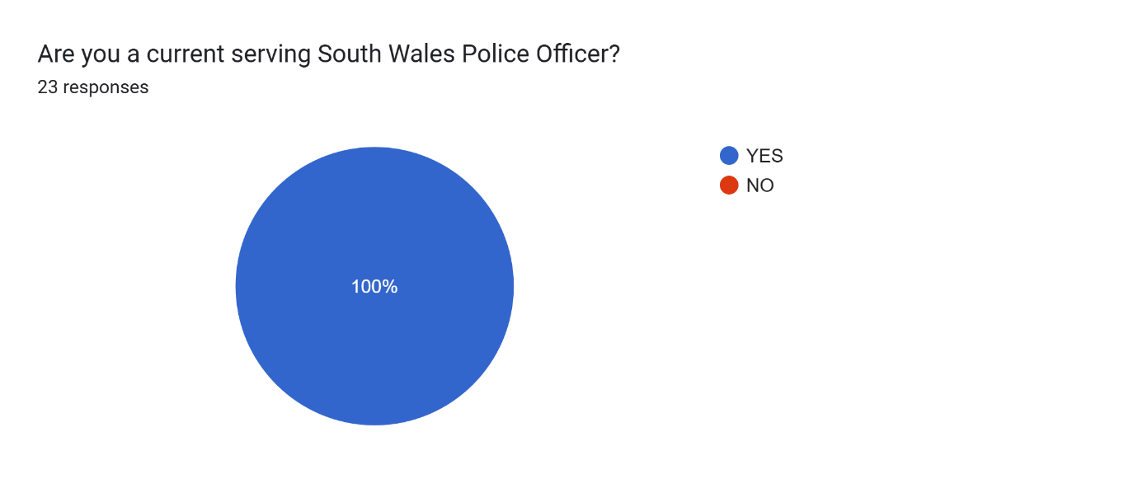
Figure 1 – Chart showing number of responses and answers to question 1.

There was a good variety in the length of service from all participants with at least 1 participant from all 6 different service lengths. Although the lowest number of participants were from 1-2 years and 0-1 years these will have included participants who have not completed their academic studies and therefor may be less likely to understand or witness the effects that academic work would have on their or their colleague’s professional development.
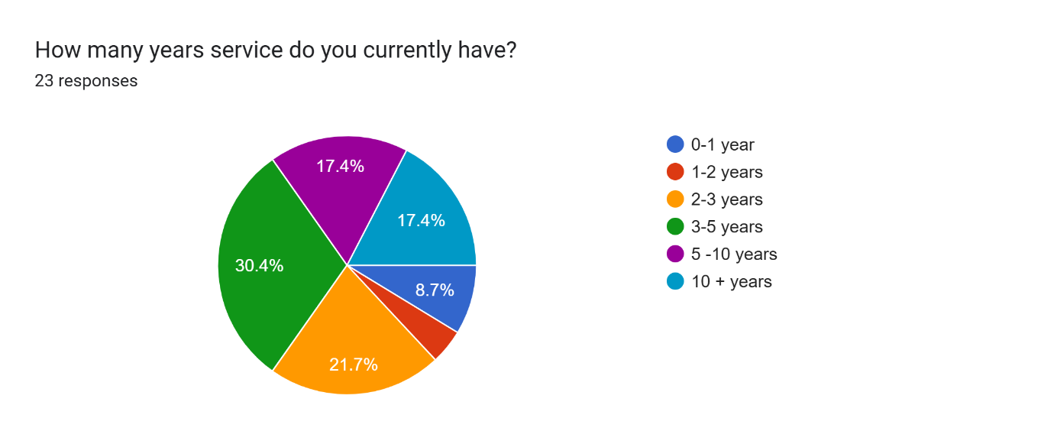
Figure 2 – Chart showing breakdown of length of service for participants.

Participants were asked to say whether they were required to either complete a degree whilst working or already have a degree prior to joining. 65% of all participants stated that they were required to either complete or already have a degree. Although not directly related to the research question this question could help identify any potential bias in participants answers. This shoed that the majority of officers had either completed or were part way through completing their degree and would be best placed to determine its effects on their policing carrier. Although some participants had through their own accord complete a degree prior to it being mandated there is a possibility that as this was a concision and voluntary decision made by them the likelihood of them believe that it had a positive effect would be high. Whereas is an officer who would not have necessary completed a degree if no required still sees a positive benefit could hold more weight.
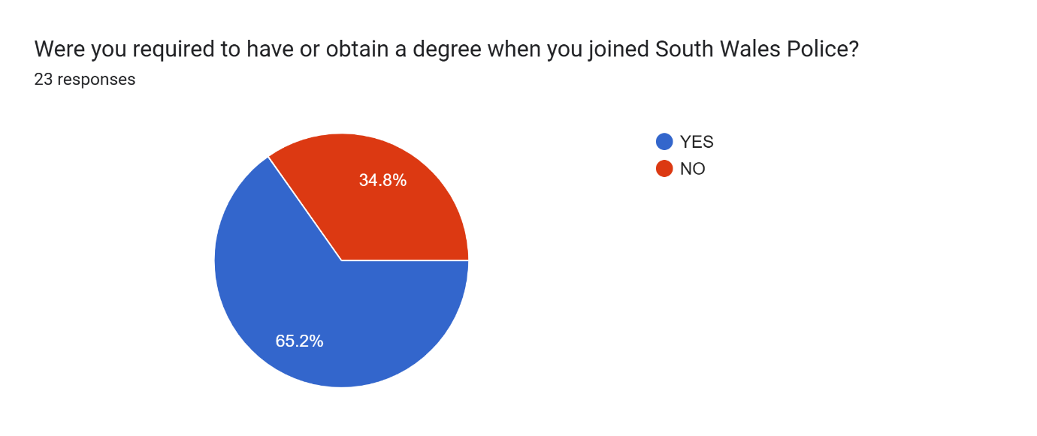
Figure 3 – Chart outlining the percentage of participants who were required to complete a degree.

The following question looked to highlight a similar bias by following on to see how many officers, out of the officers who answered YES to the previous question completed a degree prior to joining or whilst working for South Wales Police. The majority 66% of the participants were or are undertaking the degree whilst being employed full time. These participants should be able to best identify the effect academic education had on them throughout their professional development.

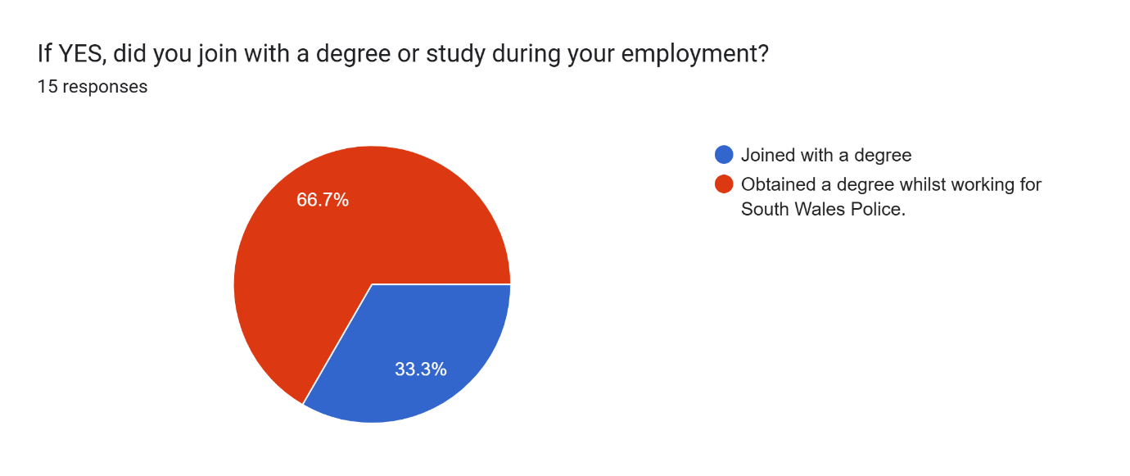
Figure 4 – Chart outlining when participants completed their degree.

Participants who completed degrees prior to joining South Wales Police were given to opportunity to identify their degree subject. The majority of the participants had not completed a Degree in Professional Policing with only 2 participants stating that they did this degree. There was however a related degree with one participant stating that they had achieved a degree in Law which would have undoubtedly provided some transfer in knowledge. The majority of participants undertook degrees that were unrelated to Policing.

After ascertaining a basic understanding of the participants educational background, the following question looked to ascertain whether participants believed that having any form of degree was necessary to perform the role of a Police Officer. It is clear from the consensus from the participants that having a degree is not a necessity for being able to perform the role. Although necessary is a high threshold set following questions lower the bar in an attempt to see how beneficial, if at all participant’s believed degrees were to Policing.
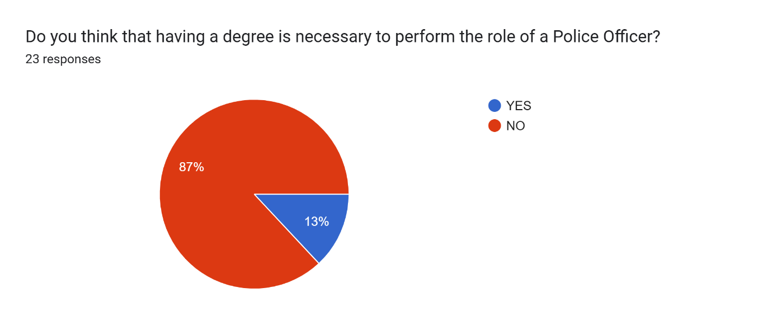

Figure 5- Chart outlining whether participants believe that a degree is a necessary qualification in order to be a police officer.

The following question asked participants to say if they believed that having a degree in any field would be beneficial to performing the role of a Polcie Officer. With the majority of participants believing that having degree would provide a positive and beneficial effect on an officer’s ability to perform their role. 60% of participants identified this beneficial effect which although is a clear majority is not the resounding consensus identified on the previous question.
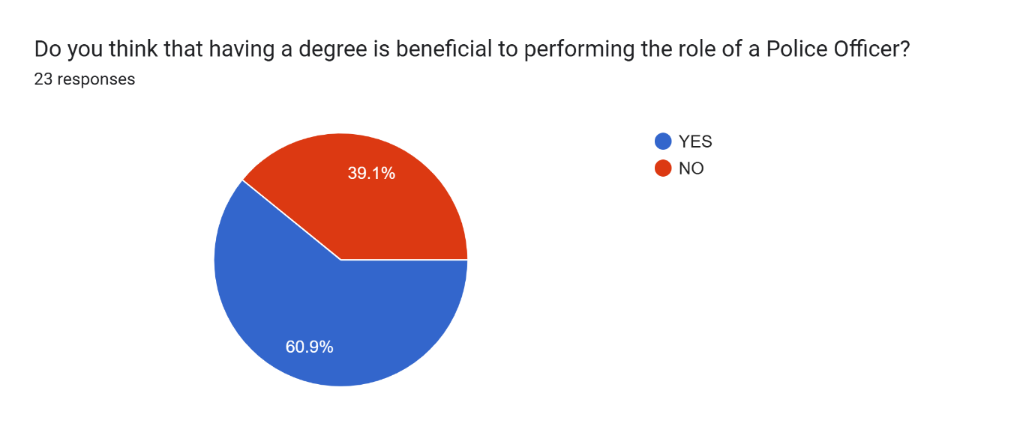
Figure 6 – Chart outlining the number of participants who believed that having a degree has some form of beneficial effect on a police officers ability.

In order to determine whether the type and relevance of the degree would impact the participants views, the following question asked participants to look specifically at the Policing Degree and whether it is a necessary qualification to have to perform the role of a Police Officer. Although this did have a very minor change from the results shown in Figure 5 there is still a clear consensus that even if the degree is the Policing degree it still is not a qualification that is absolutely necessary in order to perform as a Polcie Officer. The 4% increase does however show a small corelation between the relevance of the degree and the participants views on its necessity.
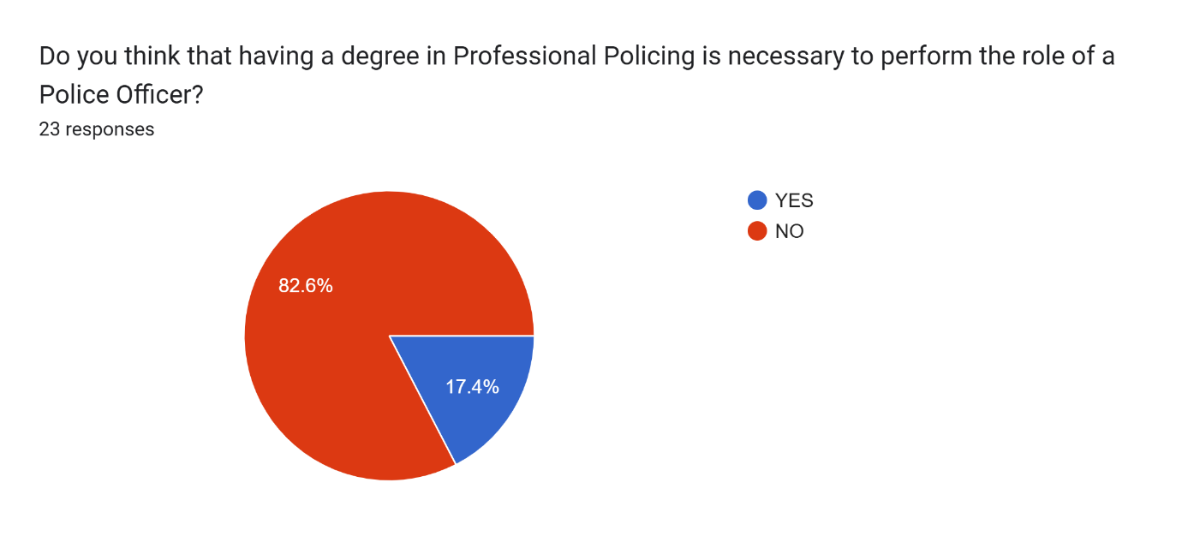
Figure 7 – Chart showing the number of participants that believe that having a degree in Professional Policing is necessary.

The following question looks to again reduce the threshold for the impact having a degree has on an Officers ability to perform their role but looks specifically on the views of Offices surrounding the Professional Policing Degree. The results follow the pattern outlined in the previous questions, again it shows that when ascertaining if officers believe that having a degree provides a benefit when performing their role. Which was clearly shown in Figure 6, it also reiterates that the relevance of the degree has a compounding effect on its perceived benefit as 69% of participants believed that having a degree in Professional Policing is beneficial to performing their role. The increase show between Figure 6 and this question clear highlights officers’ views on the Professional Policing Degree when compared to other degrees.
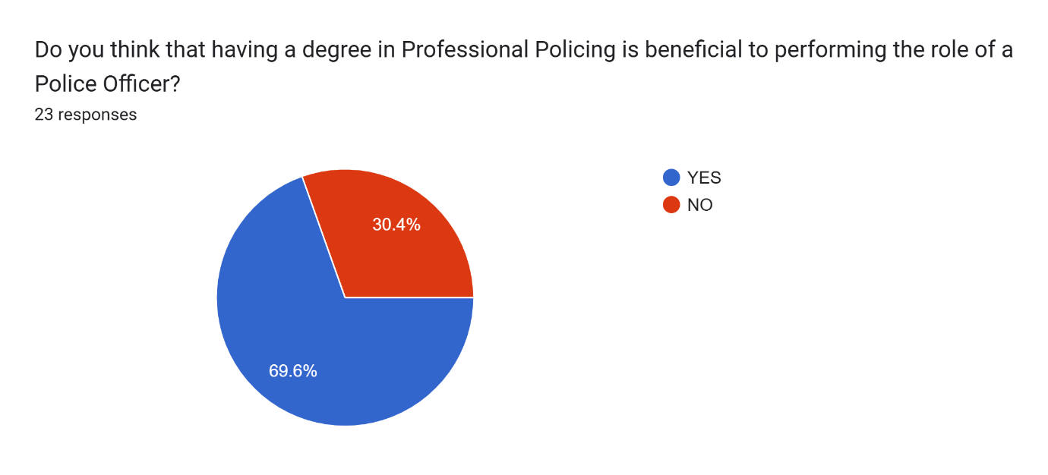

Figure 8 – Chart Outlining participants views on if the Professional Policing Degree benefits officers when performing their role.

The following question taking a different approach with all the previous questions around the perceived positive effect of the degree being its general effect on all perosns undertaking a degree. This question looks to have the participant honestly assess their degree and whether it has helped them in their current role. With the question being directed at each participant personally the result is far more divided with 52% of participants believing that their degree has not helped them.
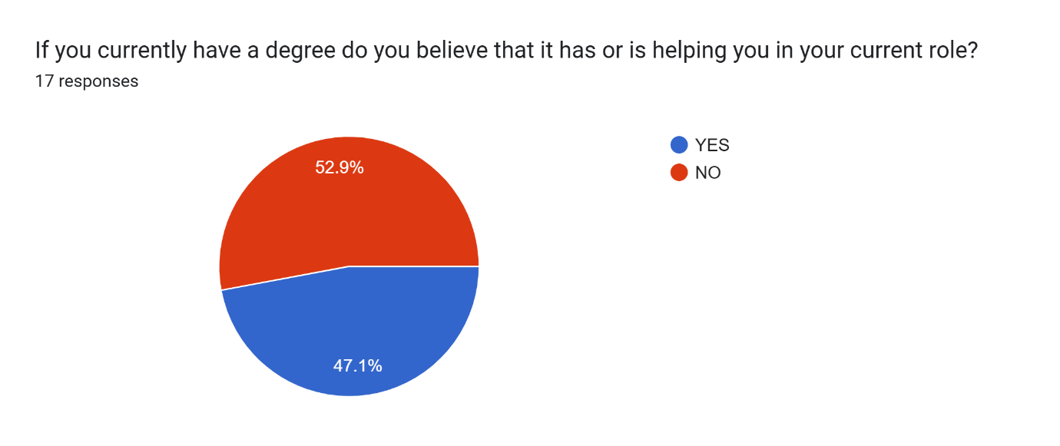
Figure 9 – Chart outlining participants views on if their person degree has had positive effects.

A question is posed asking if participants believe that the role of a Police Officer is a complex one. This question had the vast majority of participants confirming that they believe that the role of a Police Officer is a complex one.

The following question looks to gain a greater understanding on what specific training they believe is beneficial for Police Officers. This question shows that Academic Essays are perceived to be the leaves beneficial when compared with other more traditional methods of Police Training such as the learning of legal definitions, Practical Scenarios or Statement taking exercises. This was a clear and fast negative opinion on academic learning with only 34% percent of participants believing that it would be beneficial. The next closest being Examples of written incident updates at 73%.
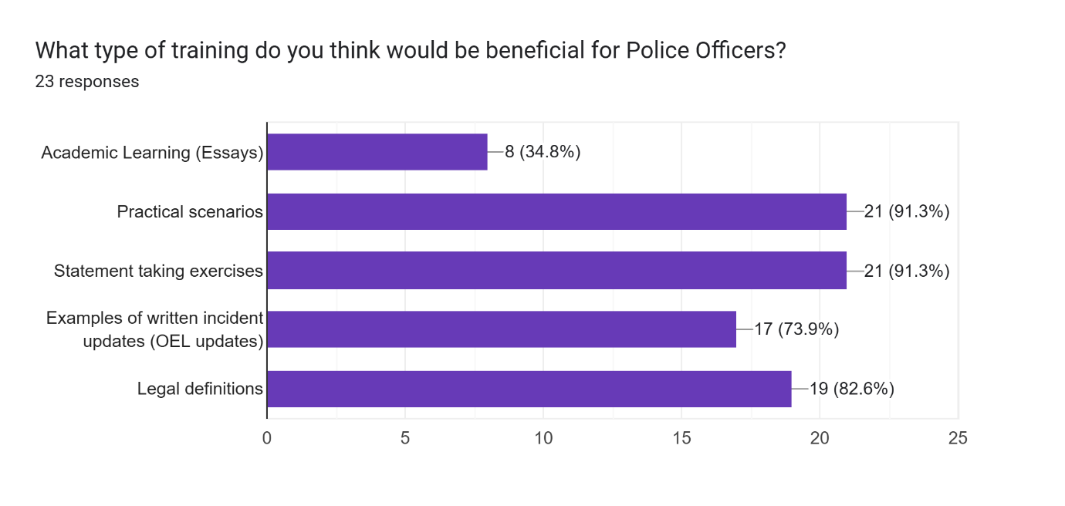
Figure 10 – Chart outlining what training participants believe are useful to Police Officers.

Finally, the question that most directly looks to answer the stated research question ‘Do you think that all serving South Wales Police Officers should be trained to a degree level?’ 65% of participants did not believe that serving South Wales Police Officers should be trained to a degree level. This whilst by no means being a clear conscious does show a majority of the participants that took part in this questionnaire dispute most of them undertaking a degree do not believe that Officers should be mandated to undertake a degree in order to complete their role effectively.
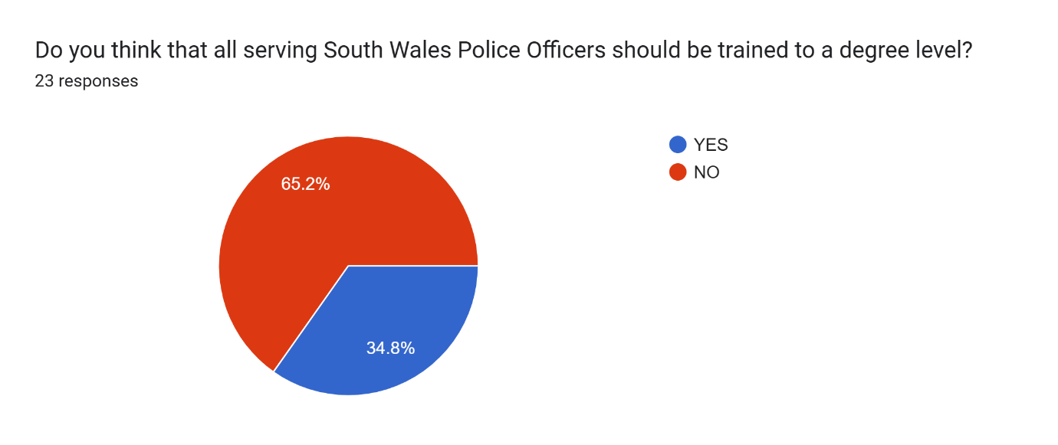
Figure 11 – Chart Outlining if participants believe that all South Wales Polcie Officers should be trained to a degree level.

This chapter has both clearly presented its finding form the primary data collected during the research studies questionnaire, with use a visual chart to better and clearly display the data. The next and final chapter will use this data to attempt to form a conclusion on the research question as well as possible recommendations that can be presented.
Conclusion and Recommendations
This final chapter will look to provide a conclusion to the finding of this research project and ascertain whether Current South Wales Police Officers Believe that all Serving Police Officers Should be Educated to a Degree Level.
The following aims and objective were meet-
To ascertain what are the current serving South Wales Police Officers views are on the current level of training new Police Officers are receiving.
This was shown in chapter 4 and can be clearly seen in the data.

To understand what is the current academic training being delivered to South Wales Police Officers.
This was evidenced in chapter 2 where the current training is outlined.

To ascertain quantitative and qualitative data form current South Wales Police Officers, of differing lengths of services, on the effectiveness of academic training/learning.
This was evidenced during the collection and displaying of data in chapter 4.

To ascertain the effect, if any, academic work has had on South Wales Police Officers currently undergoing the training.

This although not directly address could be evidenced in the differing opinions from Participants views on whether they think that degrees are beneficial compared to how they directly believe that their degree has helped them.

A number of interesting findings as be seen in the data that has been collected. Firstly, this research will look to identify any themes and patters and can show a clear collective response. It will then look to identify any apparent inconsistencies and analyse them to both understand what might be causing them and also if any information can be interpretated from them.
In general, the data has three main elements firstly is the information gathering around participants such as the length of service, what entry route was used and what degree was used. In this study not much information can be gathered from this section as the information was automatically collected and organised into a chart. This did not allow the researcher to view what one participant answered to all questions. This could have provided the opportunity to see if there were any correlation between length of service, views on degrees or if peoples views on degrees would be impacted by whether they had been mandated to undertake the training or voluntarily undertook it prior to joining South Wales Police.

The second aspect of the data looked at the participants views on if they believed that a degree had a perceived benefit. This data showed that by no means did participants believe that a degree had such an important and beneficial impact that the role could not be effectively performed without it. This is evidenced by the fact that the majority of participants believed that neither the Policing Degree nor any other degree would be necessary to perform the role. However, they did identify that it would benefit an officer if they did have it. Due to the limited data it is not possible to ascertain how much of a benefit the participants believed this to be from these questions alone, but the further questions asked could possibly highlight this. This data also can show that the participants believe that the Policing Degree is somewhat relevant to their role, this can be seen in the high percentage of participants that believed that the Professional Policing Degree had a beneficial effect on an officer’s ability to perform their role. It is, however noted that when asked what training would be beneficial for Officers the majority of participants believed that Academic Learning would not be beneficial. At first glance this appears to contradict the previous answers given, however it is possible that the formatting of the question lead participants to click on items that they believed to be the most beneficial instead of the stated question of just what are beneficial. This could be interpreted as participants believing that although academic learn may have some small benefit it an outweighed but all other traditional Police Training methods.
The third aspect of the data looks at how specifically the participants believe that their degrees have helped them. Participants were almost split with a small majority of stating that they did not believe that their degree helped them. There are a number of potential reasons for this, this could show that a disproportionate number of the participants in this study are learners who do not respond well or like to perform academic studies, however they are self- aware enough to believe that the majority of other general would benefit. Or possible the question of is a degree beneficial was too binary leading to participants to answer yes as any level of training or learning will have some form of benefit. When participants looked at their own experience and whether it had been helpful, they may have looked at the emotional strain or extra mental load and compared that to the benefits which overall resulted in a net negative effect. Without further research or more qualitative question this cannot be determined from the above data collected.

The final question of ‘Do you think that all serving South Wales Police Officers should be trained to a degree level?’ is perhaps he most telling as despite their views previously the majority of participants did not believe that a degree was necessary. Although the exact reason for this cannot be determined from these subsets of questions and a complete judgment cannot be determined from such a small subset of officers. Based solely on this data it is clear that current serving South Wales Police Officers do not believe that all Police Officers should be trained to a degree level.

After conducting this research, a number of recommendations can be made regarding the current training of South Wales Police Officers especially regarding use of Academic Learning.
Firstly, in is clear that from the subsection of officers who participated in this research study that they do not believe that a University Degree should be a necessary and mandated component of Police Training. However, it is clear that they believe that some element of further training can only be beneficial. Although this research conducted did not go far enough it determine exactly what level of further training would be beneficial and however benefits that would be.

The use of academic learning or essays are clearly identified as the least important element of training which highlights the need for a new approach to a Policing Degree. A Policing Degree should focus on providing a gold standard for Police Specific elements. A focus on improved and detailed statement taking, or the ability to clearly explain the events of an incident as providing a clear rational for the action taken by an attending officer are far more useful skills. Not only this but they are skills that can be effectively taught and developed in the same way that an academic writing style is. It is clear that developing a Police Officers academic writing and general written language skills will have knock on effects into any other element of writing, however by focusing on learning a new unused writing skill in everyday policing Officers would be better applying that time specifically of Policing written formats. Whilst it is appreciated that academic universities may not wish to replace or contradict initial training conducted by forces by utilising practical scenarios this would allow officers to improve their skills whilst receiving feedback in a relatively calm and safe environment without having to solely rely on debriefs from live incidents. This is a format used effectively by other organisations such as the fire service and military branches.

This research project suffered from a number of limitations. Due to is specificity there was not a lot of other research conducted on the same area. This would have necessitated any primary research to receive a large response from a large portion of South Wales Police Offices in order to truly ascertained their believes and views on the level and type of education provided. This research would have also greatly benefited from a broader range of question with the edition of short answer questions. This would have allowed a better understanding of the views of the participants especially around difficult questions that in this research project forced participants to stick to a binary yes or no answer to most question.

This topic area would benefit from further research, this could include a similar study in the hopes of gathering more participants in order have a better sample size of participants. This in turn could confirm the finding of this project. As stated previously a more in-depth qualitative study could also better understand the nuanced views of the participants. There is also a need for further expansion on the topic area for example this may have identified that most officers believe that a degree is beneficial, however without looking at exactly how beneficial this impact is and compering that to the structurally difficulties of implementing this method of further training it would be impossible to determine whether this approach is ultimately successful.

In conclusion this project identified that on the hole serving South Wales Police Officers do not believe that all Police Officers should be trained to a degree level, this is despite also believing that any and specifically the Policing Degree does have a beneficial impact on an Officers ability to perform their role. Possibly hinting to the fact that although there is some benefit it is not deemed to be enough to warrant the intense effect that such an undertaking has on the officers completing the learning.

References
Albers, M. (2017) Quantitative Data Analysis – In the Graduate Curriculum https://journals.sagepub.com/doi/abs/10.1177/0047281617692067 (Accessed 07/03/25)

Andrews, T. (2024) Public Expectations of the Police Education in England and Wales. Available at: Public expectations of police education in England and Wales | Policing: A Journal of Policy and Practice | Oxford Academic (Accessed 02/11/24)

Empire State University (2025) Analysis in Research Papers https://sunyempire.edu/online-writing-support/resources/research/research-paper/analysis-research-papers/#:~:text=To%20analyze%20means%20to%20break%20a%20topic,of%20the%20topic%20from%20your%20own%20perspective. (Accessed 02/04/25)

Glass , G. (1976) Primary, Secondary, and Meta-analysis of Research. https://journals.sagepub.com/doi/abs/10.3102/0013189x005010003 (Accessed 04/03/25)

Guzzo, R. Et Al (1987) Meta-Analysis Analysis. https://smlr.rutgers.edu/sites/default/files/Documents/Faculty-Staff-Docs/MetaAnalysisAnalysis.pdf (Accessed 05/03/25)

Home Office (2024) Police Uplift Programme: entry routes of officer recruits Available at: Police Uplift Programme: entry routes of officer recruits - GOV.UK (Accessed 01/11/24)

House of Commons (2017) College of Policing three years on Available at : https://publications.parliament.uk/pa/cm201617/cmselect/cmhaff/23/23.pdf (Accessed 24/08/24)

Lee, M., & Punch, M. (2004). Policing by Degrees: Police Officers’ Experience of University Education. Policing and Society, 14(3),233–249. Available at: https://doi.org/10.1080/1043946042000241820 (Accessed 24/08/24)

Nugmanova, M. Et Al. (2020) Education, Human Rights and Peace in Sustainable Development. Education, Human Rights and Peace in Sustainable Development - Google Books (Accessed 03/11/24)

Oluwatosin, V (2023) A review of Primary Sources of Data and Secondary Sources of Data. https://www.researchgate.net/publication/370608670_A_Review_on_Primary_Sources_of_Data_and_Secondary_Sources_of_Data (Accessed 05/04/25)

Sica, G. (2006) Bias in Research Studies https://pubs.rsna.org/doi/abs/10.1148/radiol.2383041109 (Accessed 08/03/25)

South Australia Police (2025) Recruitment Process https://www.police.sa.gov.au/join-us/achievemore/police-officer-careers/recruitment-process (Accessed 17/03/25)

South Wales Police (2024) Entry Routes Available at: https://www.south-wales.police.uk/police-forces/south-wales-police/areas/careers/careers/uniformed/police-officer-role/entry-routes/ (Accessed 25/08/24)

South Wales Police (2025) Overview https://www.south-wales.police.uk/police-forces/south-wales-police/areas/about-us/about-us/overview/ (Accessed 01/04/25).

Surrey Police (2024) Initial Police Learning and Development Program Available at:Initial Police Learning and Development Programme - (IPLDP+) | Surrey Police (Accessed 01/11/24)
Telep, C. (2010) The impact of Higher Education on Police Officer Attitudes Towards Abuse of Authority. Available at: The Impact of Higher Education on Police Officer Attitudes toward Abuse of Authority: Journal of Criminal Justice Education: Vol 22 , No 3 - Get Access (Accessed 01/11/24)

Tenny, S. Et Al (2022) Qualitative Study https://europepmc.org/article/NBK/nbk470395 (Accessed 07/03/25).

Wadley, S. and Phillips, M. (2024) Uniforms and Degrees: investigating student experiences of higher education and policing Available at: Uniforms and degrees: investigating student experiences of higher education and policing | Emerald Insight (Accessed 01/11/24)

Wickham, R. (2019) Secondary Analysis Research. https://pmc.ncbi.nlm.nih.gov/articles/PMC7520737/ (Accessed 04/03/25)

Appendix A



