Name :Alfred Ojekere
Student ID 2226760
BA Business Management
Module Academic Skills
Module code: LCBB4006
Lecturer: Dr Hoang Nguyen
Assignment Title: Component 1

Skills Development for Enhancing Employability
Introduction
In the contemporary Job market's competitive vortex, the matrix of success extends beyond mere technical acumen, necessitating a rich competence of soft skills. The importance of technical expertise is unquestionable in context of employability. However, soft skills such as effective communication, teamwork, problem-solving ability, adaptability, perseverance, leadership, and emotional intelligence, are also equally important in context of employability (Poláková et al, 2023). These soft skills, which include interpersonal communication, leadership with high emotional fraction are greatly valued when viewed from an employer perspective. Understanding their complex nature and developing strategies to enhance them can significantly enhance career prospects in the global competitive landscape. Within the dynamism that characterizes today's vocational job domains, adapting a multifaceted skill set is paramount. The book by Stella Cottrell deals with the necessary skill set required for enhancing employability and making a successful career (Cottrell, 2019). This report will focus on chapter three of the book to discuss various traits required to enhance employability. As suggested by the author, a person can plan and train themselves to prepare for the future with these skills. Besides gaining knowledge about different desirable skill sets at the workplace, one can learn about preparation for the future in the context of employment and career progression, enhancing one's own value in the job market, learning about the relevance of gained skills at the workplace, and identifying weak areas to work upon and develop prospects.
Other researchers suggest that skills are necessary to enhance employability and become a successful employee (Meeks, 2017; Poláková et al, 2023). These skill sets are summarized in Figure 1 for an easy grasp. Out of these skill sets, we have emphasized three key areas for this report: interpersonal, critical thinking, problem-solving, and leadership skills.
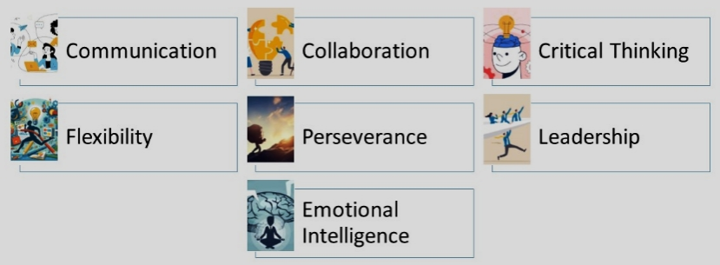
Figure 1: Desirable skills set for succeed in career
Interpersonal Skills
Soft competencies, also known as interpersonal skills, are crucial in driving collective creativity, promoting innovation, and maximizing operational effectiveness alongside technical expertise (Hargie, 2021). These include communication and collaboration among the employees of an organization or collaborating organizations. This discussion emphasizes the importance of soft skills in professional growth, outlining critical areas for improvement and providing practical advice for their use in diverse professional settings. Effective communication is of utmost importance in business relationships, requiring the development of a robust set of communication skills. This undertaking goes beyond simple expression, including perceptive listening, empathetic understanding, and the ability to adapt communication to a range of audiences.
Enhancing communication skills have very positive consequence at workplace. It can create a company culture of honesty and transparency, strengthen relationships, reduce communication errors and conflicts, and improve outcomes of collaborative efforts. Currently at a professional workplace setup, it is essential to have a good communication skill. Because employees with good interpersonal relationships with colleagues, stakeholders, and multifunctional teams is essential to achieve larger corporate goals. Cooperation and collaboration are based on mutual respect, trust, and a shared dedication to common goals. Teams that welcome diversity in perspectives and utilize unique skills unlock the potential for collaborative discoveries, ignite innovation, and ultimately achieve fantastic success. Furthermore, effective collaboration fosters a shared identity and inclusiveness, enhancing employee involvement and overall job satisfaction.

As per the books under consideration, the students are advised to start early on developing these skill sets, as it takes time to sharpen these skills. Early starting and self-monitoring or self-evaluating from time to time show the student's progress in that area, which can aid in accelerating the pace of reaching the goal. Also, self-monitoring can let the candidate know about their weaknesses (Cottrell, 2019).

Problem-Solving and Critical Thinking Skills
The ability to overcome hurdles and coming up with innovative strategies are challenging situations. For overcoming such situations, the proficiencies in problem-solving and critical-thinking skills are essential (Xu et al, 2024). Individuals who excel in these areas demonstrate cognitive flexibility, creative talent, and the capacity to identify fundamental problems, assess practical solutions, and make decisions based on experimental evidence. Developing a mindset focused on solving problems and supporting a culture of inquisitiveness enables employees to effectively overcome complications, drive ongoing progress, and contribute substantially to an organization's successes. Successfully steering through the rapidly changing dynamics of modern workplaces requires the ability to adjust and recoil from challenging situations. People who demonstrate adaptability, agility, and openness to new ways of thinking thrive in overseeing change. Resilient individuals quickly recover from difficulties, absorb knowledge from their experiences, and become more robust in facing future obstacles. Promoting flexibility and resilience can drive an organization towards a culture infused with innovation, swiftness, and a dedication to continuous learning, assuring its success in the face of constant change. Stella Cottrell argues that critical thinking skills can be acquired directly from classroom lectures (Cottrell, 2019). However, a person must practice a lot to achieve the objective and critical thinking level necessary for corporate jobs.
Leadership
A leader’s role it to foresee future challenges and accordingly prepare the team to overcome the challenge. It can be done by inspiring a group to work together towards common goals with the leader’s vision. Here, emotional intelligence is a vital for effective leadership, providing leaders with self-awareness, self-regulation, compassion, and social skills (Saha et al, 2023). These qualities promote strong team dynamics based on trust and collaborative effort. Organizational leaders who demonstrate integrity, honesty, and empathy can instil confidence, drive employee motivation, and improve performance metrics. Emotional intelligence enhances leaders' ability to effectively traverse intricate interpersonal dynamics, resolve disagreements, and foster an inclusive and psychologically secure professional atmosphere. As per the author, a student can gain substantial leadership skills by leading group projects at the school level or acting as a coach or supervisor in relevant areas.
Conclusion
The importance of soft skills in achieving professional success in today's highly competitive job market cannot be denied. Skills such as effective communication, collaboration, critical thinking, flexibility, perseverance, leadership, and emotional intelligence are essential for an individual to advance their careers and succeed in various work environments. In another perspective, if an organization gives importance to enhance the soft skills of their workforce can gain a competitive advantage by encouraging a culture of creativity, collaboration, and complete involvement of employees. Therefore, individuals and businesses need to highlight the improvement of soft skills. Organizational investment in soft skill development can lead to growth, success and can create a favourable environment for long-term prosperity and professional satisfaction.
Reference List
Cottrell, S. (2019) The study skills handbook, 30Bloomsbury Publishing.
Hargie, O. (2021) Skilled interpersonal communication: Research, theory and practiceRoutledge.
Meeks, G. A. (2017) Critical soft skills to achieve success in the workplaceWalden University.
Poláková, M., Suleimanová, J. H., Madzík, P., Copuš, L., Molnárová, I. & Polednová, J. (2023) Soft skills and their importance in the labour market under the conditions of Industry 5.0. Heliyon, 9(8).
Saha, S., Das, R., Lim, W. M., Kumar, S., Malik, A. & Chillakuri, B. (2023) Emotional intelligence and leadership: insights for leading by feeling in the future of work. International Journal of Manpower, 44(4), 671-701.
Xu, T., Deeprasert, J. & Kanchanapoom, K. (2024) Employability Strategy by Focusing on Soft Skill Development of Animation Students in the Metaverse Job Market. Educational Administration: Theory and Practice, 30(2).

