

Module Name: Computer Architecture
& Operating System
Module Code: ACCA 4022
Student Name: Adiba Shabbir
Student ID: 2513924
Lecturer Name: Md Shantanu Islam

Submission date: 27-03-2026

Contents
Introduction 4
Key functions of general Operating Systems 4
Task Management: 4
Application/Program Management: 5
File/Directory Management: 6
Device Management: 7
Security Management: 8
Use of Windows OS CLI commands 8
Example 1: 9
Example 2: 9
Example 3: 10
Example 4: 10
Example 5: 10
Example 6: 11
Example 7: 11
Example 8: 12
Example 9: 12
Example 10: 13
Example 11: 13
Use of Linux OS CLI commands 14
Example 1: 14
Example 2: 15
Example 3: 15
Example 4: 16
Example 5: 16
Example 6: 17
Example 7: 17
Example 8: 18
Example 9: 18
Example 10: 19
Use of Windows OS scripts 19
Example 1: 19
Example 2: 20
Use of Linux OS scripts 21
Example 1: 21
Example 2: 22
Conclusion 23
References: 24
Appendices 25

Introduction
This coursework provides an overview of operating systems and their key functions, including process, file, user, and network management. It covers the practical use of Windows and Linux command-line interfaces by demonstrating various commands with appropriate options and outputs. The report also includes the development of Batch and BASH scripts to automate tasks using variables, loops, and conditionals. Screenshots are used to support command execution and script results. Additionally, it includes a conclusion, properly formatted IEEE references, and appendices containing learning activities and evidence of engagement with an online course related to operating systems.

Key functions of general Operating Systems
The Windows operating system, developed by Microsoft, was first released in 1985, providing a graphical user interface for personal computers. It is widely used for its ease of use, system management, and application support, performing key functions such as process, file, memory, and device management [1].

Task Management:
Task management in Windows is a key function that allows the operating system to control running programs and background processes efficiently. Users typically interact with it through Task Manager, which displays active applications, CPU and memory usage and system performance. If a program becomes unresponsive, Task Manager lets users end the task to restore stability.
Beyond this interface, Windows uses a priority-based, pre-emptive scheduling system to allocate CPU time among processes. This ensures multitasking works smoothly and prevents slowdowns. According to Russinovich, Solomon, and Ionescu, the Windows kernel manages threads and processes systematically to maintain performance and reliability [1], making multitasking possible and keeping the system responsive under varying workloads.
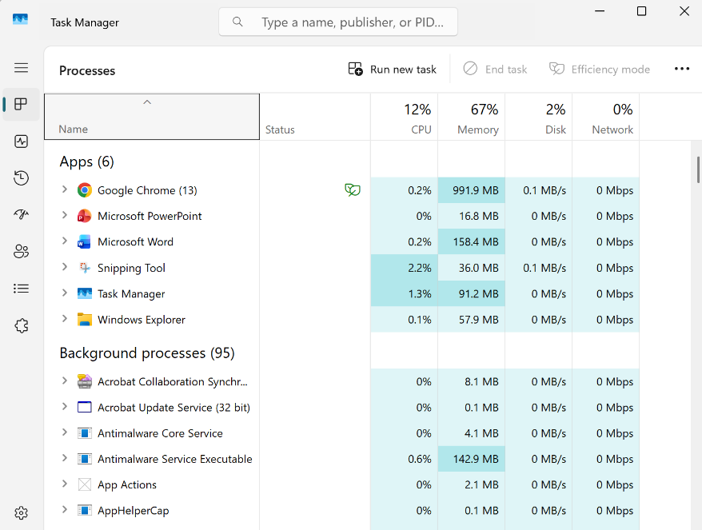
Figure 1: Task Manager

Application/Program Management:
Application management in Windows refers to how the operating system handles the installation, execution, updating, and closure of software programs so that they function reliably and efficiently. When a user opens a program, the operating system loads necessary files, allocates system resources such as memory and processor time, and ensures the program interacts correctly with the hardware and other software. Effective management of applications helps prevent conflicts, optimises performance, and maintains system stability. In computing research, monitoring and controlling applications is defined as a critical part of managing software performance, availability, and security to meet system requirements and service goals [2].
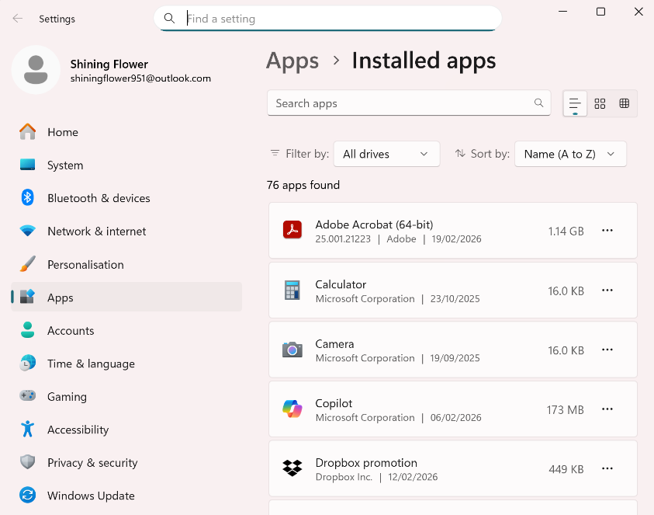
Figure 2: Application Management

File/Directory Management:
File and directory management in Windows is the organisation and handling of files and folders so users can store, locate, access, and manipulate data effectively. The Windows operating system organises files in a hierarchical folder structure, where directories (also called folders) contain files and sub-folders arranged in a tree-like system that represents the logical organisation of data on storage devices. Users interact with this structure through tools like File Explorer, which allow creation, renaming, moving, copying, and deletion of files and folders.
Research shows that digital file management, including organising, retrieving, and sharing files and directories, remains a fundamental human–computer interaction task that influences system usability and user satisfaction [3].

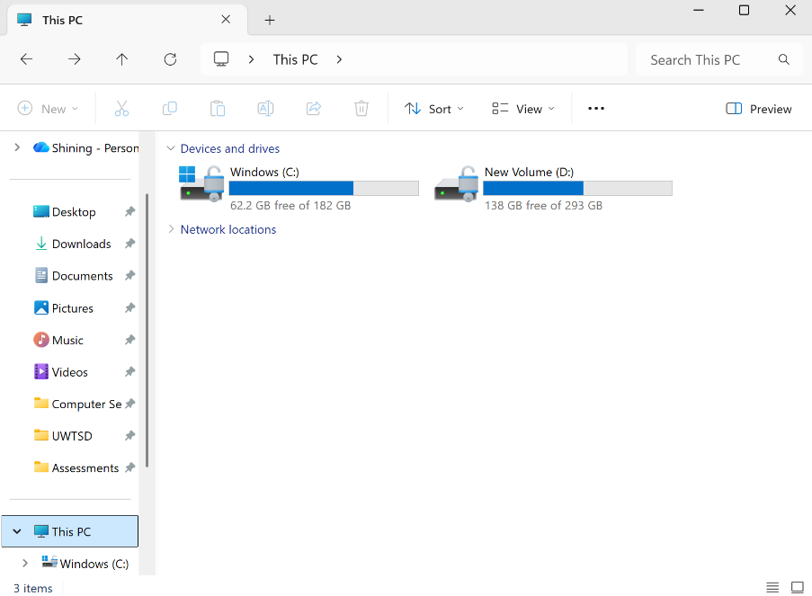
Figure 3: File Manager

Device Management:
Device management in Windows is a critical component of the operating system, responsible for ensuring that hardware devices, such as printers, network adapters, and storage drives, operate correctly. This is primarily achieved through device drivers, which act as intermediaries between the OS and hardware, translating system commands into instructions the hardware can execute.
Windows provides tools like Device Manager to let users view connected devices, install or update drivers, and troubleshoot hardware issues. Research shows that proper device driver management is essential for system stability and performance, as poorly managed drivers can cause failures or slowdowns [4], [5].
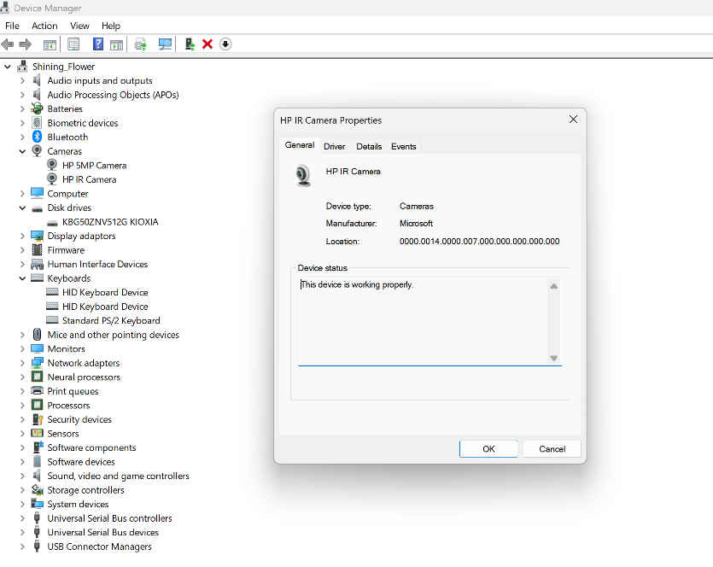
Figure 4: Device Manager

Security Management:
Security management in Windows involves the policies, controls, and mechanisms that protect the operating system and its resources against unauthorized access, threats, and vulnerabilities. It includes managing user authentication, access permissions, and enforcement of security policies such as limiting administrative privileges and controlling application behaviour. An important aspect is access control, which determines who can access what within the system and how resources are protected from misuse, forming a core part of system security architecture [6].
Effective security management helps maintain confidentiality, integrity, and availability of data on Windows devices, ensuring that only authorized users and processes can perform sensitive actions.
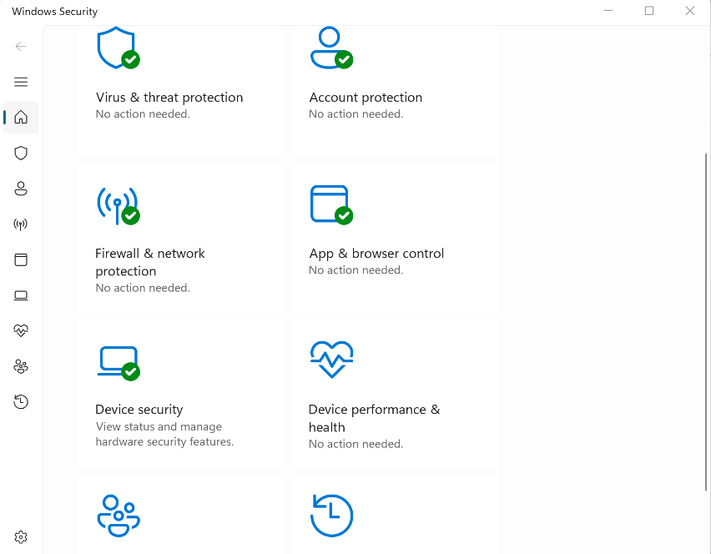
Figure 5: Window’s Security Manager

Use of Windows OS CLI commands
Windows Command Line Interface (CLI) enables users to execute administrative and automation tasks through textual commands. Utilities such as CMD and PowerShell support file management, process control, networking diagnostics and scripting, offering enhanced efficiency and system-level configuration capabilities [7], [8].

Example 1:
The dir command is used to display all the files and subdirectories within a specified directory.
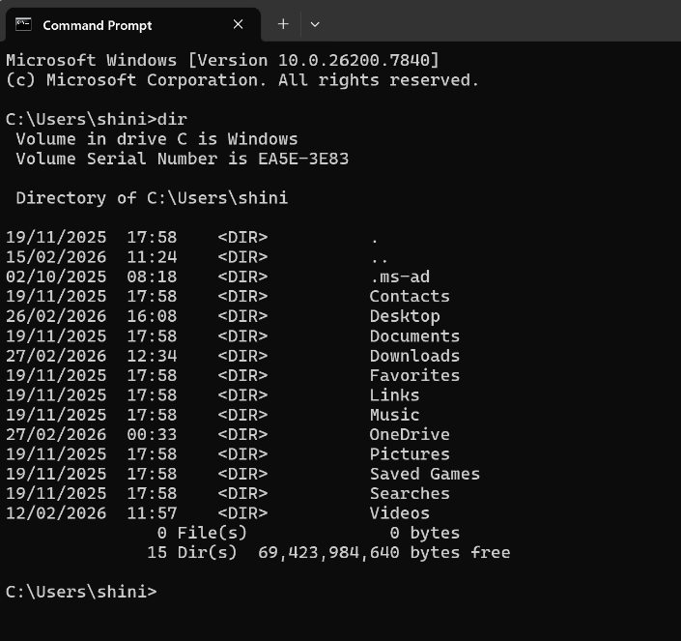
Figure 6: Command dir

Example 2:
The cd command then space ,followed by the directory name (shortcut: type first letter and press TAB), takes you inside that directory. Use \ for a subdirectory. For going back to the previous directory , type cd then space, followed by two dots. For example: cd ..
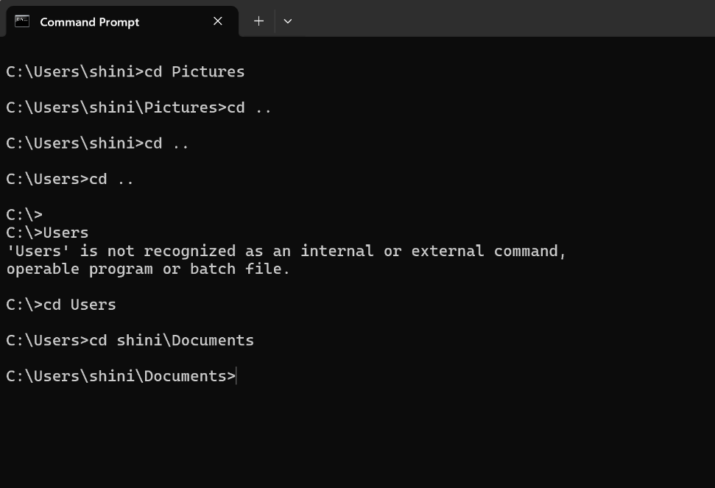
Figure 7: Command cd

Example 3:
The mkdir command then space followed by the name of the folder will create a new folder. Putting a space while naming a folder will create a separate new folder. Use dir to see if the folder has been created.
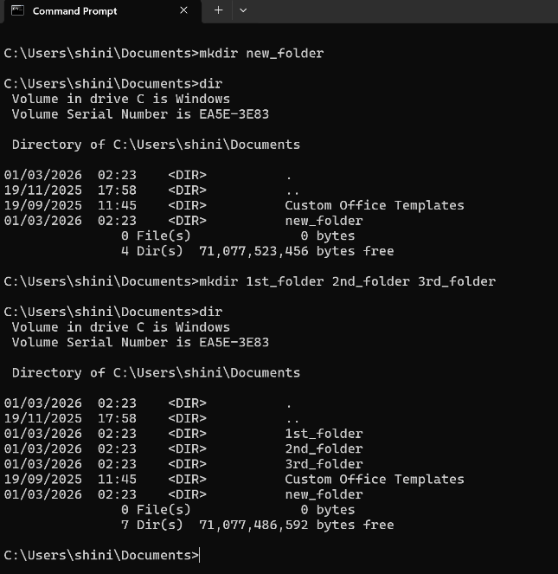
Figure 8: Command mkdir

Example 4:
The rmdir command then space, followed by the name of the folder will delete that folder (directory). Then use dir to check if the directory has been removed successfully.
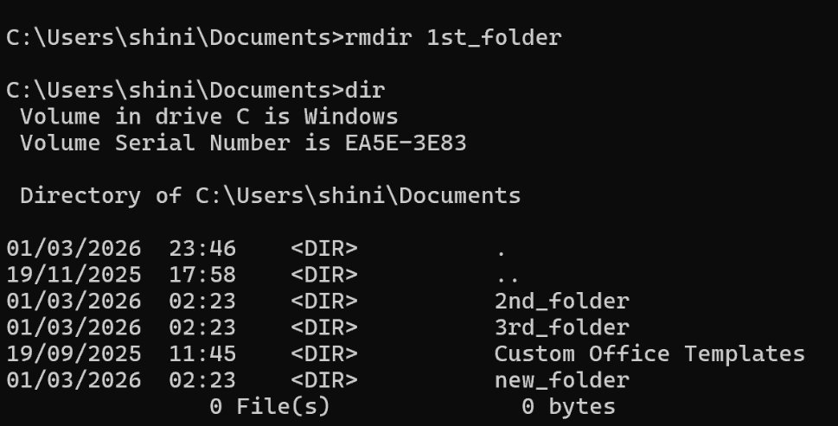
Figure 9: Command rmdir

Example 5:
The echo command is used to write something into a file. General syntax is, type echo then whatever you want (any information) then this sign > which will specify the location of the text. After that the name of the file with extension .txt
To open that file , just put the name of the file with the extension in the next command and the file will open.
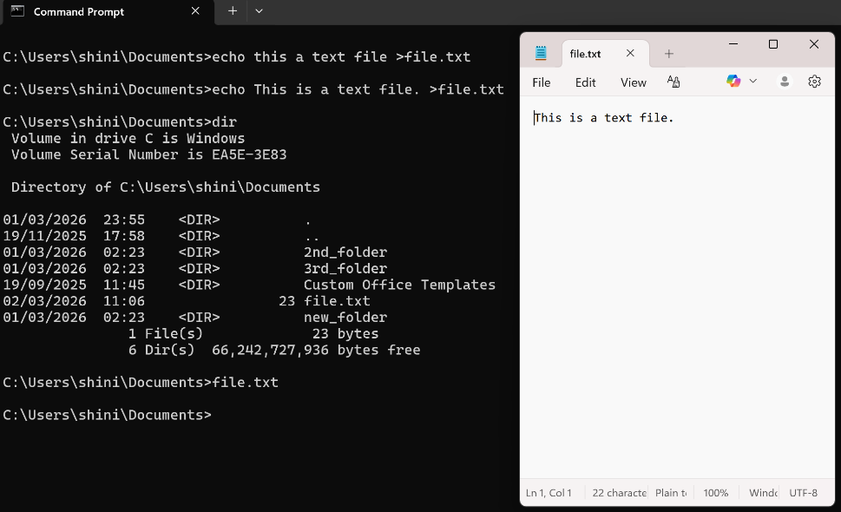
Figure 10: Command echo

Example 6:
The tasklist command is used to display detailed information of all the processes currently running on the system. It works same as task manager but presents the information in a structured , command-line interface.
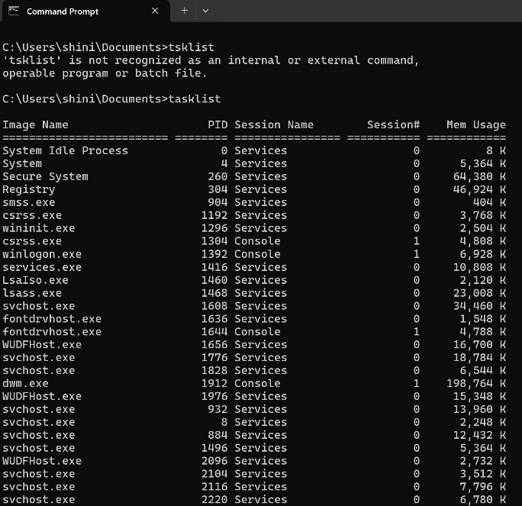
Figure 11: Command tasklist

Example 7:
The systeminfo command is used to display detailed information about the system. This includes operating system version, system manufacturer, memory status, network details, and installed updates, etc.
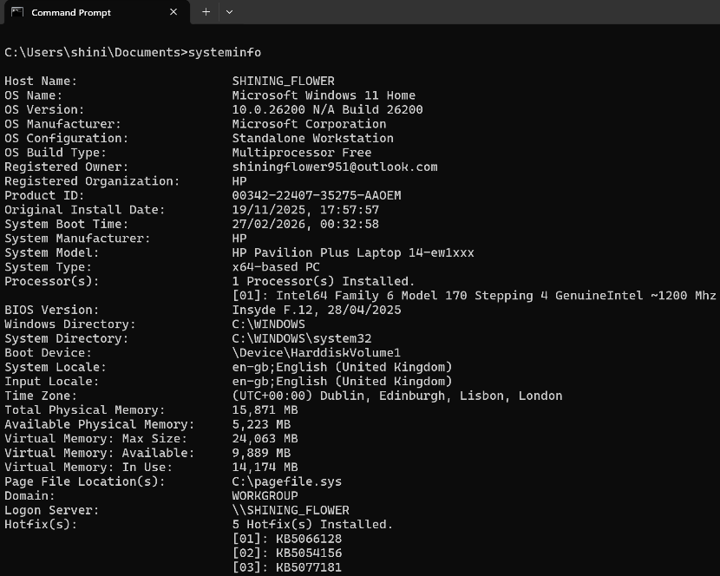
Figure 12: Command systeminfo

Example 8:
The ipconfig command displays network configuration details for a Windows system, including IP address, subnet mask, default gateway, and DNS information. It helps in troubleshooting and managing network settings. General syntax is ipconfig then space /all .
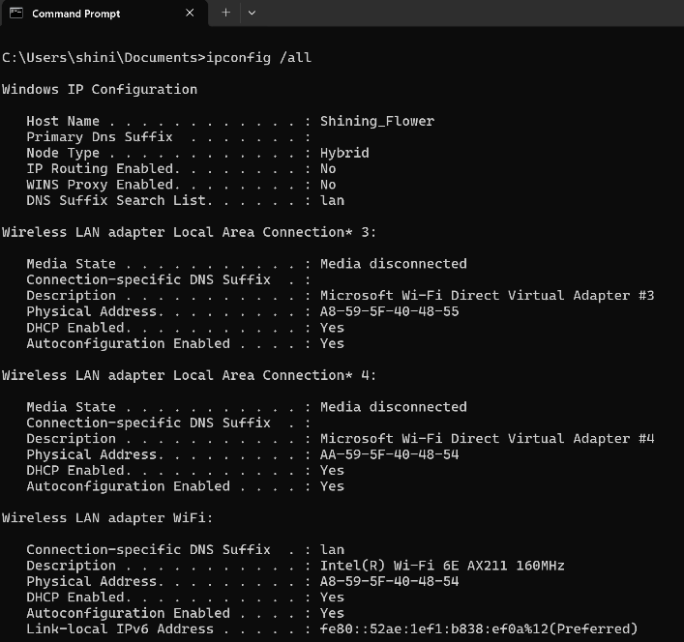
Figure 13: Command ipconfig

Example 9:
The ping command is used to check internet connectivity. General syntax is ping , space and then the address of any website. Reply from followed by an IP address, time in milliseconds, TTL , 0% packet loss in summary, all this means that the device is connected to the internet.
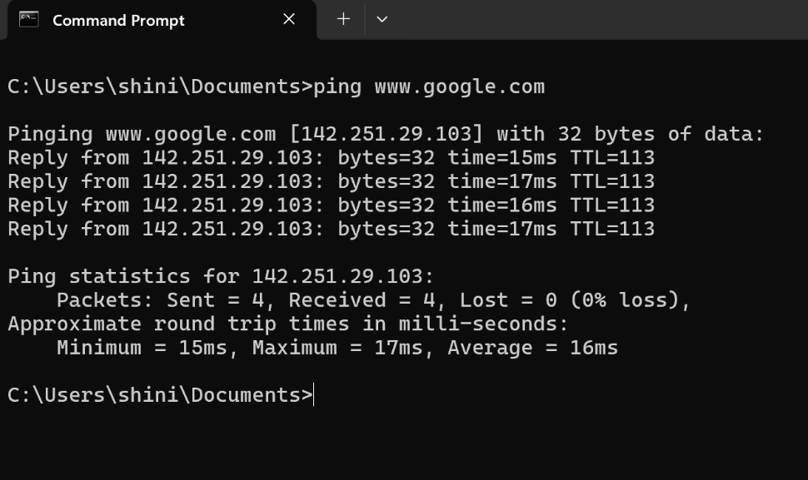
Figure 14: Command ping

Example 10:
The tracert (trace root) command is used to see the path your internet connection takes to reach a website or server. It shows each stop (called a hop) along the way and how long it takes to reach each one. This helps to get where a network problem might be happening.
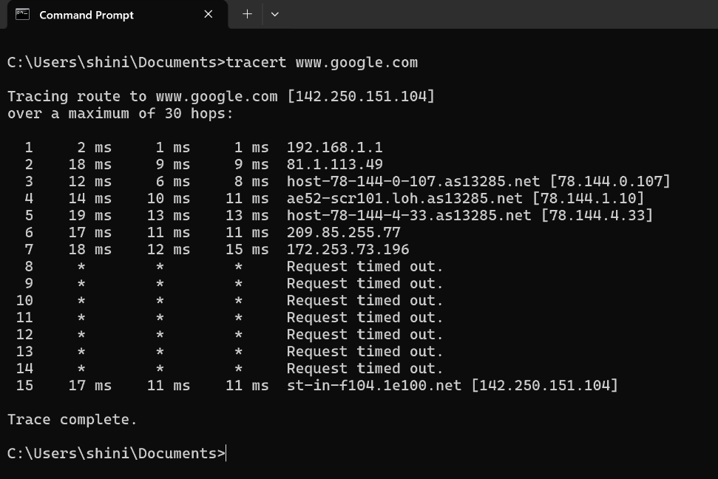
Figure 15: Command tracert

Example 11:
The del command is used to permanently delete one or more files from a specified directory. General syntax to delete a single file is del space, then the name of the file with extension which you want to delete. del *.* to delete all files in that directory.
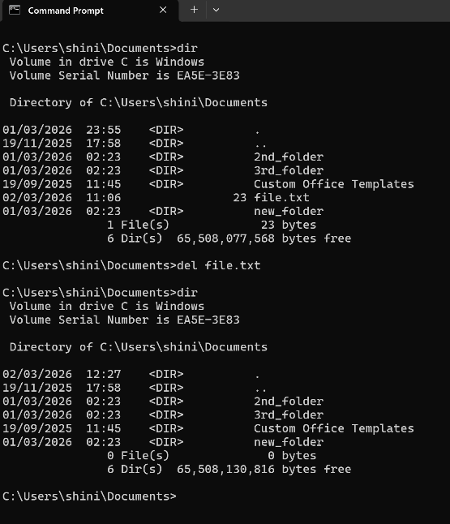
Figure 16: Command del

Use of Linux OS CLI commands
The Linux Command Line Interface (CLI) allows users to interact with the operating system by typing textual commands for file navigation, management, scripting, and system control. It provides efficient control over operating system functions without relying on graphical interfaces [9], [10].

Example 1:
The command su root logs in as the root user in Linux. Typing su (swiss user) alone also switches to root. After becoming root, you can switch to another account by running su but this time with the username.
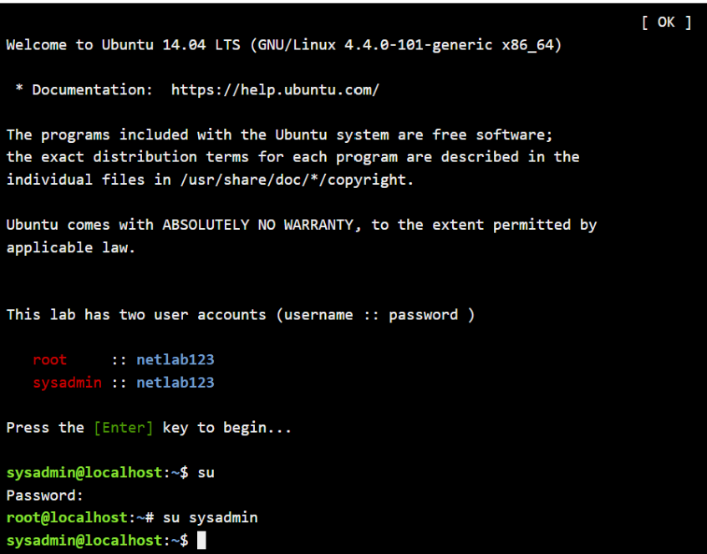
Figure 16: su (swiss user)

Example 2:
The pwd (present working directory) command displays the current directory. Its output shows the absolute path of the directory where the user is currently working in a CLI environment.

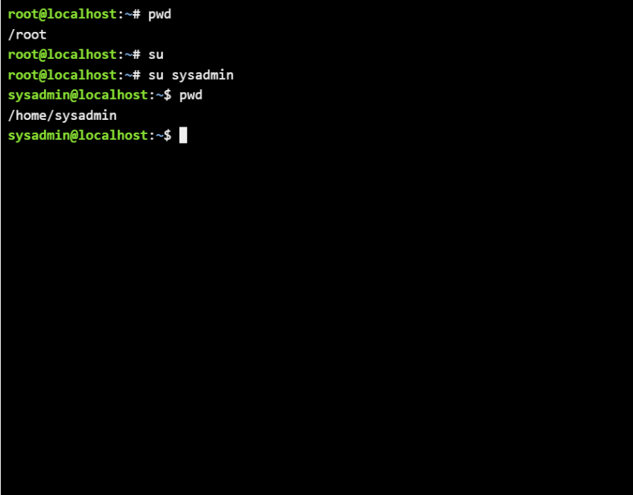
Figure 17: pwd

Example 3:
The ls command lists directory contents. ls -l shows detailed file info, and ls -a displays all files, including hidden ones, providing a complete directory overview.
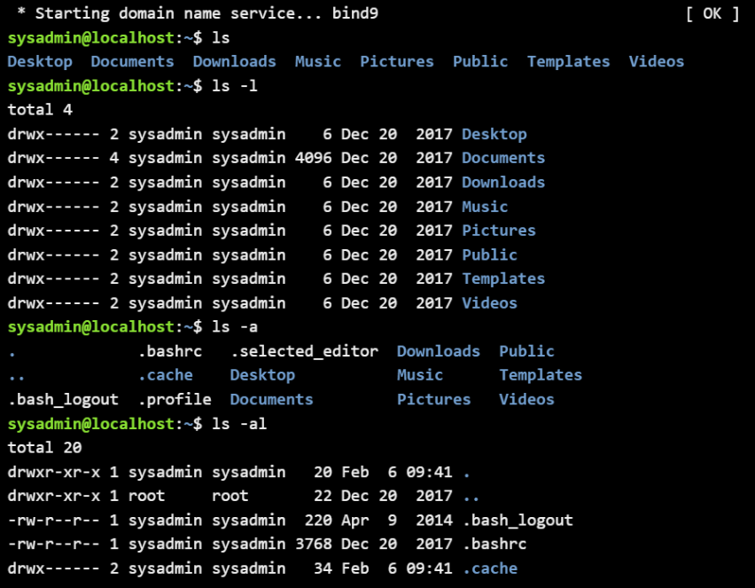
Figure 18: ls

Example 4:
The cd (change directory) command navigates between directories in a CLI environment. Its output updates the current working directory, moving the user to the specified folder path within the file system.
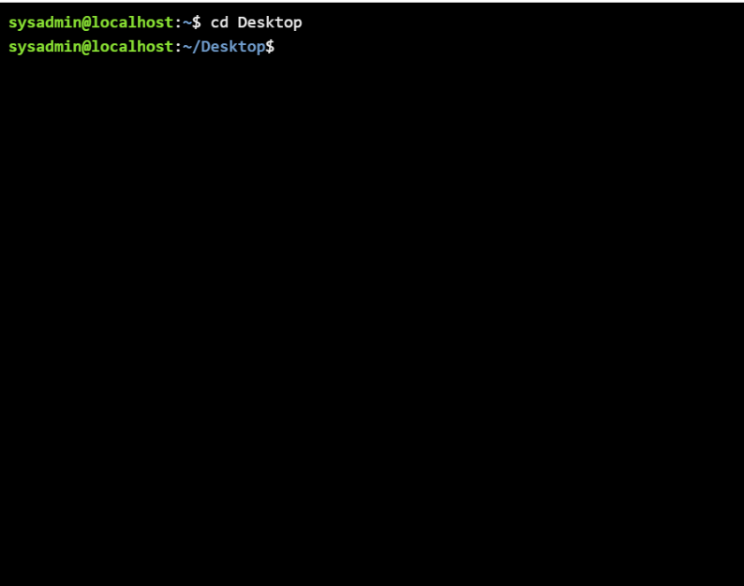
Figure 19: cd

Example 5:
The mkdir (make directory) command creates a new folder in the specified location. Its output confirms successful creation, adding the directory to the file system at the given path.
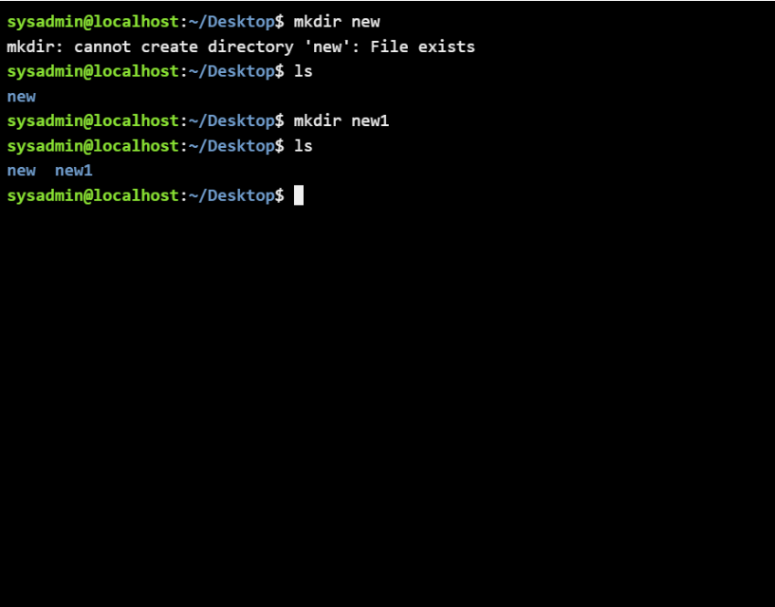
Figure 20: mkdir

Example 6:
The rmdir (remove directory) command deletes an empty directory. Its output confirms successful removal, but it fails if the directory contains files or subdirectories, as only empty folders can be deleted.
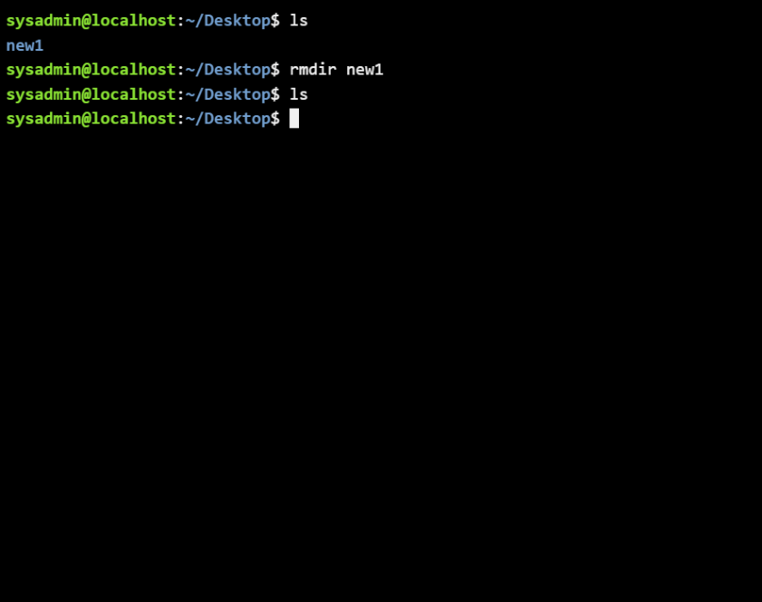
Figure 21: rmdir

Example 7:
The touch command creates a new empty file, such as file.txt, or updates the modification timestamp if it already exists. Its output does not display text but confirms file creation.
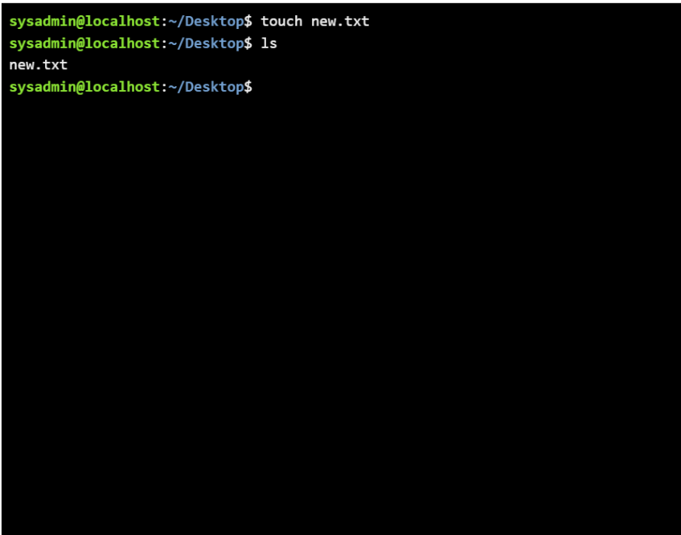
Figure 22: touch

Example 8:
The echo command displays text and can write or append content to a file using >. The cat command reads and outputs file contents in the terminal.
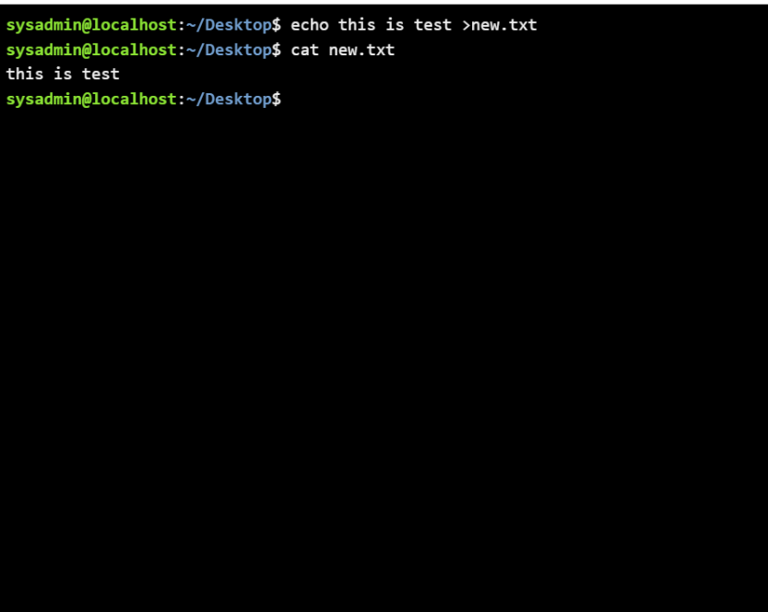
Figure 23: echo & cat

Example 9:
The ifconfig (interface configuration) command displays and manages network interfaces in Linux. Its output shows IP addresses, subnet masks, MAC addresses, and interface status, helping monitor and configure networking settings.
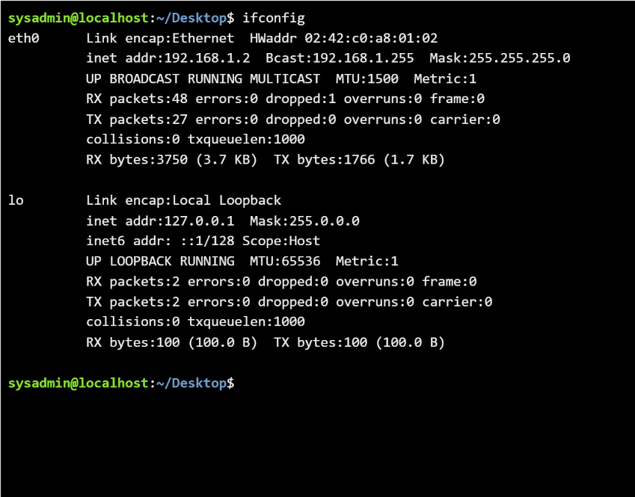
Figure 24: ifconfig

Example 10:
The whoami command shows the current logged-in user. date displays the system date and time. rm with filename deletes the specified file, confirming its removal in the CLI environment.
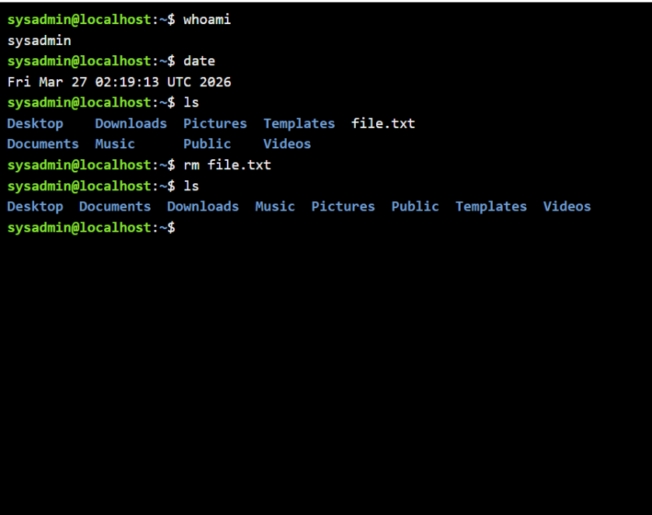
Figure 25: whoami , date , rm

Use of Windows OS scripts
Batch scripting is the process of writing a series of commands in a .bat or .cmd file to automate tasks in Windows. It enables execution of multiple commands sequentially, simplifying repetitive operations like file management, system maintenance, and software execution, improving efficiency and reducing manual effort [11], [12].

Example 1:
This batch file calculates the area of a rectangle in a Windows Command Prompt. It starts with @echo off, which hides the commands as they run, so only relevant output appears. The lines set /p length=Enter the length of the rectangle: and set /p width=Enter the width of the rectangle: use the /p switch to prompt the user to enter values for length and width, storing them in variables. The line set /a area=length * width uses the /a switch to perform arithmetic, multiplying the two inputs to calculate the rectangle’s area and storing it in the variable area. The %area% syntax retrieves the variable’s value for display. Finally, echo The area of the rectangle is %area%. prints the result and pause keeps the window open so the user can see the output before closing the script.
The output displays the area of rectangle 6000 when length 120 and width 50 is entered by the user.
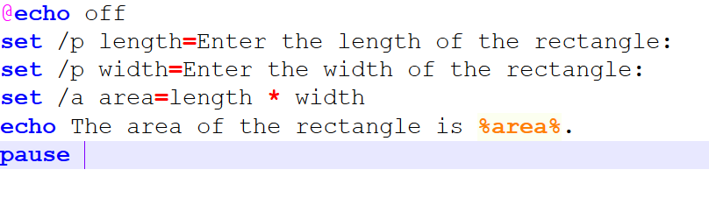
Figure 26: Script for area of rectangle
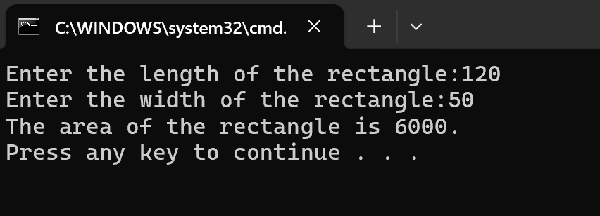
Figure 27: Output

Example 2:
This batch file script checks whether a number entered by the user is even or odd. It begins with @echo off, which hides the commands themselves in the console, showing only the output for clarity. The line set /p num=Enter a number: uses the /p switch to prompt the user to input a number, storing it in the variable num. The line set /a remainder=num %% 2 uses the /a switch to perform arithmetic, calculating the remainder when the number is divided by 2. The script then uses an if-else statement: if %remainder% equ 0, it executes echo The number is even., otherwise it executes echo The number is odd.. The percentage signs around remainder reference the variable’s value. Finally, pause keeps the window open until the user presses a key, allowing them to see the result. The outputs display appropriate statement when two numbers 25 and 26 are entered separately.
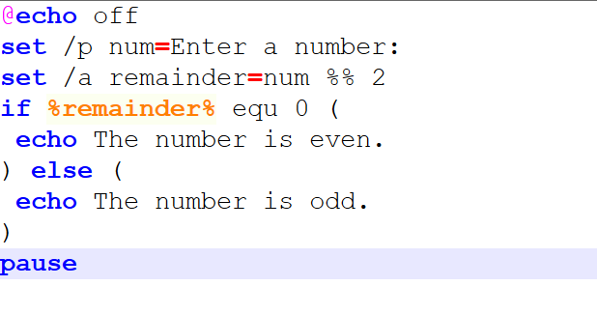
Figure 28: Script to find even or odd number
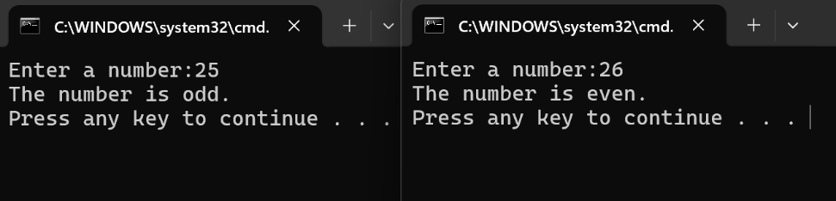
Figure 29: Output

Use of Linux OS scripts
BASH scripting involves writing sequences of commands in a text editor, such as Nano, and running them in the Unix/Linux terminal. It automates tasks like file handling, process management, and system maintenance, reducing manual effort and improving efficiency for administrators and developers [13], [14].

Example 1:
This BASH script calculates the sum of two numbers entered by the user. It starts by displaying a prompt using echo "Enter the first number:", asking the user to input a value. The read num1 command then stores this input in the variable num1. Similarly, echo "Enter the second number:" prompts for the second value and read num2 stores it in num2. The line sum=$((num1 + num2)) performs arithmetic using double parentheses, calculating the sum of num1 and num2, and stores the result in the variable sum. Finally, echo "The sum is: $sum" outputs the computed sum to the terminal, clearly showing the result to the user. When executed in a terminal or GUI editor like Nano, the script first asks for inputs, then displays the sum. For example, entering 78 and 90 will give the output: “The sum is: 13.”
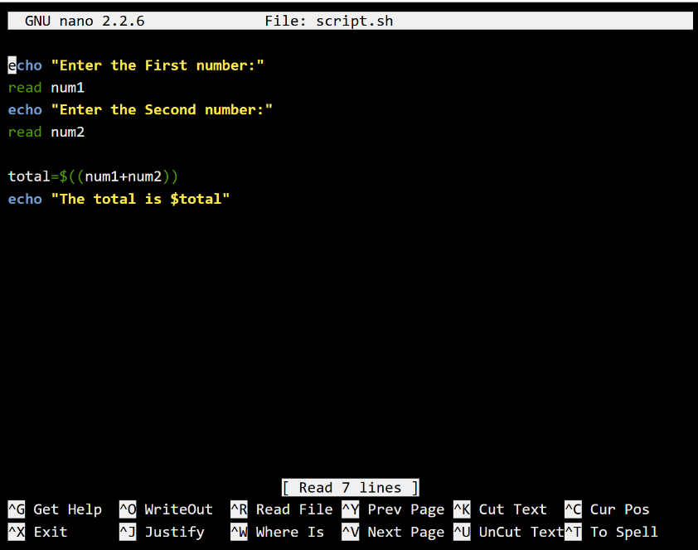
Figure 30: Bash Script
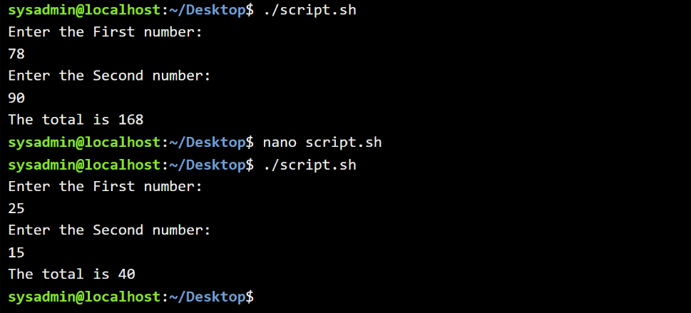
Figure 31: Output

Example 2:
This BASH script prints numbers sequentially from 1 up to a user-defined limit, which in this case is 10. It starts with echo "Enter the final value:", prompting the user to input the maximum number. The read final command stores this input in the variable final. The script then uses a for loop: for ((i=1; i<=final; i=i+1)), where i starts at 1 and increases by 1 on each iteration until it reaches 10. Inside the loop, echo "$i" prints the current value of i to the terminal. The do…done block ensures that the print command executes repeatedly for each iteration. When executed in a terminal or GUI editor like Nano, the script first prompts the user, then outputs numbers 1 through 10, each on a new line. This demonstrates basic input handling, looping, and output in BASH scripting, ideal for automating sequential tasks.
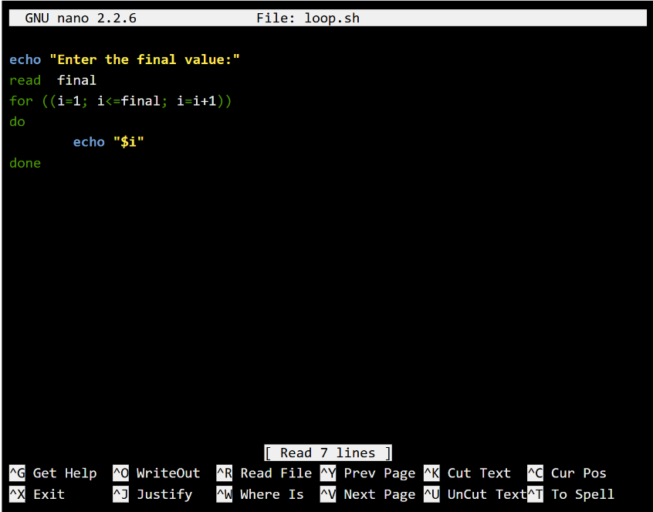
Figure 32: Loop Bash
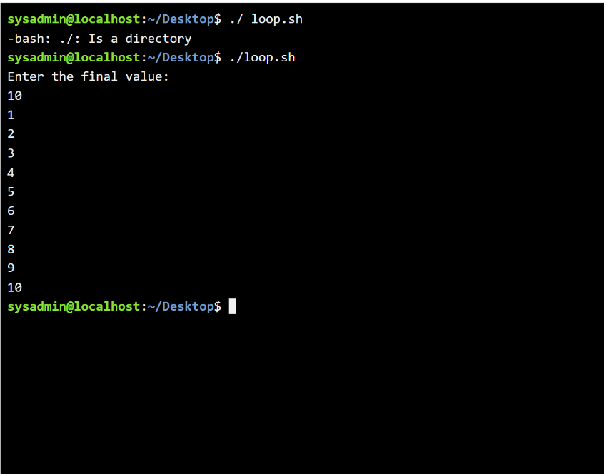
Figure 33: Output of loop

Conclusion
This report explored operating system functions, focusing on process, file, user, and network management. It demonstrated practical use of Windows and Linux CLI commands and scripting. Tasks enhanced understanding of automation, command-line operations, and system control, supported by screenshots, references, and additional learning through course engagement and activities.

References:
[1] M. E. Russinovich, D. A. Solomon, and A. Ionescu, Windows Internals, Part 1: System Architecture, Processes, Threads, Memory Management, and More, 7th ed. Redmond, WA, USA: Microsoft Press, 2017.
[2] R. Sturm and J. Craig, Application Performance Management (APM) in the Digital Enterprise. Cambridge, MA, USA: Academic Press, 2017.
[3] J. D. Dinneen and C. A. Julien, “The ubiquitous digital file: A review of file management research,” J. Assoc. Inf. Sci. Technol., vol. 71, no. 1, pp. E1–E32, 2020.
[4] S. Checkoway and H. Shacham, “Iago attacks: Why the system call API is a bad untrusted RPC interface,” in Proc. 18th Int. Conf. Architectural Support for Programming Languages and Operating Systems (ASPLOS), 2013, pp. 253–264.
[5] M. Satyanarayana, Operating Systems: Concepts and Design, 3rd ed. New York, NY, USA: McGraw-Hill, 2019.
[6] C. Cho, Y. Seong, and Y. Won, “Mandatory access control method for Windows embedded OS security,” Electronics, vol. 10, no. 20, p. 2478, 2021.
[7] W. R. Stanek, Windows Command-Line Administration Instant Reference, 2nd ed. Indianapolis, IN, USA: Wiley, 2015.
[8] B. Payette and R. Siddaway, Windows PowerShell in Action, 3rd ed. Shelter Island, NY, USA: Manning, 2017.
[9] M. Schröder and J. Cito, “An empirical investigation of command line customization,” Empirical Software Engineering, vol. 27, art. 30, 2022.
[10] M. Kappelman Fenzl, “Introduction to command line (Linux/Unix),” in Next Generation Sequencing and Data Analysis. Cham, Switzerland: Springer, 2021.
[11] R. Awati, “What is a batch file?,” TechTarget, Feb. 21, 2025. [Online]. Available: https://www.techtarget.com/searchwindowsserver/definition/batch-file
[12] “Writing a Windows batch script,” GeeksforGeeks, Feb. 2, 2026. [Online]. Available: https://www.geeksforgeeks.org/techtips/writing-windows-batch-script
[13] “Bash scripting – working of Bash scripting,” GeeksforGeeks, Jul. 23, 2025. Available: https://www.geeksforgeeks.org/linux-unix/bash-scripting-working-of-bash-scripting/
[14] “What is Bash scripting?” LinuxSimply, Jan. 2, 2024. Available: https://linuxsimply.com/bash-scripting-tutorial/introduction/what-is-bash-scripting/

Appendices
Cisco Network Academy: Linux Unhatched
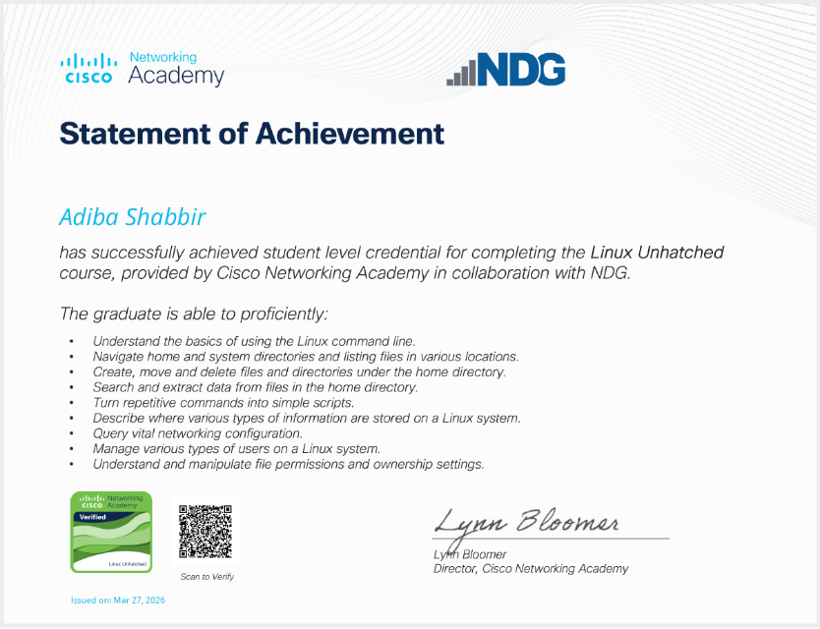
Figure 34: Certificate of completion

