
An investigation in to “What impact does the Wales Police Schools Programme have on building trust and confidence in policing amongst schools in South Wales?”
Catherine Lewis
Student number: 2116818
MSc Policing (Operational & Strategic Leadership)
July 2024
15,292 words

Declarations

This work has not previously been accepted in substance for any degree and is not being concurrently submitted in candidature for any degree.
Catherine Lewis
27th June 2024

This dissertation is being submitted in partial fulfilment of the requirements for the degree of MSc Policing (Operational & Strategic Leadership).
Catherine Lewis
27th June 2024

This dissertation is the result of my own independent work/investigation, except where otherwise stated. Other sources are acknowledged by footnotes giving explicit references. A bibliography/ reference list is appended.
Catherine Lewis
27th June 2024

I hereby give consent for my dissertation, if accepted, to be available for photocopying and for library loan, and for the title and summary to be made available to outside organisations.
Catherine Lewis
27th June 2024

I hereby consent for my dissertation, if accepted, to be available on the University’s IT system to those who have consent to use the system.
Catherine Lewis
27th June

Acknowledgements
I would like to express my gratitude to South Wales Police for investing in my leadership development and funding the undertaking of this degree of MSc Policing (Operational & Strategic Leadership). I am encouraged that police staff managers in my force are accorded equal opportunities to develop as leaders alongside our ranked police colleagues.
This endeavour would not have been possible without the schools that took part in this research. A special recognition therefore goes to school staff who participated directly in this work and gave their time and enthusiasm to assist with answering the research question. Without their cooperation there would not have been an opportunity to understand the impact of the Wales Police Schools Programme on creating trust and confidence in policing within school communities.
As a person of faith, I am also indebted to my relationship with God, upon whom I rely for strength and wisdom daily.
Special thanks to Alison Cooke my supervisor for her support and insight throughout the process of producing this dissertation. I cannot thank her enough for her sunshiny Microsoft Teams calls and emails that allayed fears and encouraged me towards the finish line.
I am also grateful to my husband David, who listened to my many thoughts, ideas and ramblings throughout the process. His willingness to pick up the slack in the home and tireless positivity in encouraging my abilities to succeed in this endeavour have not gone overlooked. David made it so much easier to balance work, study and home life.
It would be remiss of me not to mention important family members, close friends and other colleagues who have been a constant supply of support and have cared for my wellbeing along the way. Where would we be without such connections.
I could not also fail to mention my dear mum, who because of my commitment to this academic process has had to endure fewer visits from me. Despite being very conflicted personally with this reality, I have received nothing but understanding and empathy from her, which has been immensely humbling. Thank you, Joy Williams, for making it easier for me not to feel so guilty for having to focus on this leviathan task.
Finally, I acknowledge the countless hours that my German Shepherd has laid by my side, faithfully keeping me company when he would much rather have been chasing a ball. He was the silent partner that let me know I was not alone during this otherwise isolating pursuit.

Abstract
Shaping future attitudes of young people towards policing is essentially challenging according to all the literature. Policing must, however, find ways to build legitimacy and trust with the young to secure its continuation as a service that is dependent upon its communities’ consent, whilst preventing criminalisation and perpetuation of crime amongst children within schools and wider communities. The research addressed the lack of understanding around the impact of socially engineered policing engagement, through the Wales Police Schools Programme (WPSP), with regard to building trust and confidence in policing, amongst school communities in South Wales. School Police Officers (SPOs) were identified as essential and effective providers of crime prevention and safety education and supportive school policing services. There was a predilection by respondents to view SPO interactions and engagement activities in a very positive light. However, the timing of the research coincided with a period of uncertainty regarding the continuation of these policing services and it was inconclusive whether this had any effect on inflating the positivity in the data, considering the urgency expressed by schools in not losing these services. Significantly, themes that emerged from the data indicated a positive correlation between the creation of trust and confidence in policing and the methods and approaches being employed by SPOs. The data revealed that school relationships with policing partners were highly valued and that immersion in school communities was viewed as the most effective school policing approach and essential to creating and maintaining trust and confidence. This grounded theory approach allowed a hypothesis to emerge that indicated that the WPSP creates trust and confidence in policing amongst schools. The research captured primary and secondary school staff voices and filled a gap in the literature. The data revealed in both primary and secondary school settings that staff demonstrated trust and confidence in their SPO; nevertheless, research was not carried out directly with the young and should be undertaken in South Wales schools with children and young people, to understand their perspectives first hand. With the end of the WPSP in Wales from July 2024, policing in South Wales should consider prioritising the retention of dedicated police officers in schools, to ensure continuity in the effectiveness of providing school-based policing services that are procedurally just. There is a risk that the range of services will contract without Welsh Government funding, and that the impact of future policing school services will diminish in relationship to creating trust and confidence in policing amongst schools. This appears to be in direct conflict with the aims of child-centred policing according to the literature and requires further consideration at high levels in Welsh Government, Education and South Wales Police.

Contents Page

Chapter 1 Introduction 6 – 12

Chapter 2 Literature Review 13 – 27

Chapter 3 Methodology 28 – 38

Chapter 4 Analysis 39 – 65

Chapter 5 Conclusions & Recommendations 66 – 71

Bibliography 72 – 81

Appendices 82 – 93

List of Figures and Tables

Figure 1 The questions asked during the semi-structured interviews 41
Figure 2 Codes emerging from transcripts 44
Figure 3 SWP questionnaire results responses collated (from Appendix 6) 45
Figure 4 Table shows the letter code designated to each school, identifying whether a primary, secondary or independent school setting 45
Figure 5 Table shows the letter code designated to each school and letter codes for each participant 46
Figure 6 Table shows the key to understanding the code designated to each participant 46
Figure 7 Participant responses to questionnaire 48
Figure 8 The schools that participated in the online schools’ questionnaire 49
Figure 9 The Welsh-medium schools that participated in the online schools’ questionnaire 50
Figure 10 Key characteristics identified from research survey questions 51
Figure 11 How these themes evolved from the initial coding 53
Figure 12 Emergent themes 54
Figure 13 Schools satisfaction with services 57
Figure 14 Data from Q.18 from the school survey 59

Chapter 1 - Introduction

The British model of policing relies on the common consent and cooperation of the public rather than force (Jackson et al., 2012). Brown and Hobbs (2023) assert that high public trust enables this “policing by consent” to function effectively. They also note that public trust encourages people to report crimes and provide information to the police, which is essential for investigating and solving crime. When the public trusts the police, they are more likely to comply with laws and cooperate with officers, facilitating law enforcement efforts due to a sense of legitimacy (Jackson and Bradford, 2010). Trust allows the police to work closely with local communities to identify and address their specific concerns and problems (Independent Office for Police Conduct, 2024). The literature suggests that trust, therefore, is central to the effective policing of all communities, including those where children and young people are represented in larger numbers, as is the case in school communities.
Inescapably, police leaders should ensure that policing inherently has effective approaches to engaging with children and young people. A priority stated in the National Police Chiefs’ Council’s (2015) youth strategy is the relationship between the police and children and young people. The strategy outlines the importance of identifying best practice approaches to engaging with children and young people that successfully dismantle barriers whilst building relationships with them. It also acknowledges that improved services to children and young people require better listening to and incorporating the voice of the child when formulating policy and practice. Tantamount to improving the trust and confidence of children and young people in the police service is improved communication and relations with them (Sindall et al., 2017). Like adults, children want to be treated fairly by police, but much of the time this is not the case (Bradford and Jackson, 2018). Sindall et al. emphasise that children and young people’s inclination to follow laws correlates with procedural justice and legitimacy in policing.
The literature indicates that the frangibility of young people’s trust and confidence in the police exceeds that of adults (Flexon, Lurigio and Greenleaf, 2009; Hinds, 2007), which results from an increased frequency in them encountering the police, giving rise to opportunities for conflict (McAra and McVie, 2010). Therefore, socially engineered encounters between police and young people are critical to creating trust and confidence in policing amongst young communities.
Until March 2024, policing engagement with children and young people in Welsh schools had been jointly funded by the four Welsh forces and Welsh Government, with a 50/50 financial commitment by both partners (Appendix 1). Funding was allocated through the substance misuse aspect of the health budget; however, fiscal restraints resulted in funding being redirected to frontline health services (Welsh Government, 2023). The services known as the Wales Police Schools Programme (WPSP) are delivered by specially trained School Police Officers. These officers spend 50% of their time delivering crime prevention and safety education and 50% dedicated to supportive policing. This incorporates managing school-based crime and antisocial behaviour incidents, facilitating restorative justice meetings and safeguarding the young in partnership with others. There is an emphasis on decriminalising offences committed by young people wherever possible, using the School Crime Beat Protocol (Wales Police Schools Programme, 2023), which is a strategy to reduce early entrance into the criminal justice system. A police schools programme has been in existence for around 20 years and has gone through several professional reviews, with subsequent recommendations for its improvement and continuation. The decision to withdraw funding had not been anticipated by policing, and the four forces have committed to continuing servicing schools in the current format until the end of the academic year (Appendix 2). Beyond this date there is no clear directive for future services. As an impact report was not commissioned by Welsh Government prior to the decision to stop the funding, there has been no formal opportunity for any stakeholders to share their concerns regarding the decision.
Against this backdrop, the main aim of this research is to explore the question, “What impact does the Wales Police Schools Programme have on building trust and confidence in policing amongst schools in South Wales?” Research as to the impact the current WPSP has on trust and confidence in policing has never been conducted, and although there is strong anecdotal evidence to suggest that it does, in fact, create significant trust and confidence in policing, there has been no reliable empirical evidence to conclude this is the case. This study aims to address this deficit in knowledge and, based on the research findings, proposes that policing ensures that any future iteration of police schools services considers incorporating the elements of the WPSP that bolster trust and confidence in policing.
Given the longevity of the WPSP services in Wales, the research offers policing an invaluable perspective on engineered police engagement with schools, as there is a long, well-established relationship with schools upon which to base the evidence. The WPSP is an example of a child-centred policing engagement approach to schools services and offers a perspective that might differ from other models of police schools engagement. The Welsh model is distinct from other national models such as the Safer School model in England (Youth Justice Board, 2009) and the enforcement-style approach in the USA. The WPSP is like only one other model, which is found in New Zealand (New Zealand Police).
To explore “What impact does the Wales Police Schools Programme have on building trust and confidence in policing amongst schools in South Wales?”, the research objectives were to:
- Determine through the literature review how trust and confidence in policing are defined and evidenced.
- Examine the literature to identify what approaches are prevalent amongst police schools services in the UK or other countries and how these compare with the WPSP approach.
- Identify what engagement approaches are used by the WPSP and whether these approaches are commensurate with building school communities’ trust and confidence in policing.
- Understand schools’ perceptions about the WPSP, using a survey, semi-structured interviews and a South Wales Police questionnaire to capture their experience of their School Police Officer services.
- Analyse the data to establish the impact of the WPSP on the school communities’ trust and confidence in policing, its strengths and any shortcomings.
- Evaluate the findings, sharing any learning with the four Welsh police forces, proposing any changes in policy or practices that may support any future police schools services in Wales to better understand how to build trust and confidence in policing amongst school communities.
A cross section of schools was chosen from across the South Wales area, representing urban and semi-rural communities. The researcher, utilising a cross-sectional timeframe, conducted eleven semi-structured interviews with fifteen adult participants. These participants were selected based on their regular contact with police schools services, which qualified them to have a significant perspective on the WPSP impact. In addition, participants each completed a survey. The original research proposal had intended to also survey and hold focus groups with children and young people, to directly find out their perspectives on the WPSP’s effectiveness in creating trust and confidence amongst the young. Due to a lack of consent by the ethics committee, however, the research was reconfigured to engage solely with adult school community participants, with questions designed to ascertain the views of young people based on adult perceptions and observations. The research, therefore, is limited in representing young people’s direct perspectives, and this might be addressed through future research undertaken with children and young people.
Following the introduction, the research is presented in four chapters, commencing with a literature review. The literature review is arranged thematically, starting with a critical analysis of the existing research around trust and confidence in policing in general terms and then as it pertains to the young in the widest context and specifically in relationship to police schools services. This is followed by an investigation of Schools Policing Services across the UK and beyond, critically analysing the approaches prevalent in these services and how they compare with the WPSP approach. The literature review informs the research by critically analysing and synthesising the key theories, concepts, methodologies and findings from the literature to identify gaps that the research intends to address, as well as any inconsistencies in the current state of knowledge, offering a clear rationale for the research undertaken.
Following this chapter is one on the methodology undertaken in the research. The chapter presents a justification for the choice of research philosophy and for the adoption of a mixed-method approach to the research design. A cross-sectional approach to data sampling is explained, and the choice of participants is rationalised. Research methods are described, and mitigation for any challenges and limitations is offered. Techniques for data analysis are defined in context to the reliability and validity of the approaches. A clear rationale illustrates how the research design aligns with the overall research objectives and question.
A chapter on the research analysis follows next. This chapter supplies key information about the demographic of the participants within the research and their suitability for contributing to answering the research question. It describes the qualitative analysis techniques used to analyse the data and presents the results in a clear, organised manner with excerpts from the qualitative data. Results are interpreted in relation to the research question and the findings discussed in comparison with previous research in the literature. Where the research has extended knowledge around the key concepts, this is made clear.
The final chapter offers a conclusion to the research. This includes a clear and concise summary of the main results and conclusions drawn from the analysis and presents an explanation of how the findings address the original research question.
The significance and implications of the research findings are discussed, and how they contribute to or extend the current knowledge in the field is highlighted. Any limitations to the research design and methodology are acknowledged, and future research recommendations are suggested that can build on the research or address the limitations of the study.
Chapter 2 - Literature Review

Introduction
This literature review is arranged thematically and opens with a critical analysis of the current research around trust and confidence in policing, defining what they are in general terms and the complexities inherent in building trust and confidence with children and young people. The following part focuses on better understanding police engagement with children and young people in school settings in the USA, England and Wales, critically analysing and synthesising the key theories, concepts, methodologies and findings from the literature to identify gaps that this research intends to address and any inconsistencies in the current position of knowledge, offering a clear rationale for the research undertaken.
Defining Trust and Confidence in Policing
It is essential to establish a clear understanding of what trust and confidence in policing are and why they are of such importance for this study. The literature proposes that trust and confidence in policing are fundamental pillars of effective law enforcement in society (Jackson and Bradford, 2010; Myhill and Bradford, 2012; Brown and Hobbs, 2023). This is challenging, however, as the relationship between law enforcement agencies and their communities is inherently complex, influenced by an array of factors including historical context, socio-economic conditions and individual experiences (Merry et al., 2012; Albrecht, 2019; Jackson et al., 2023). This section of the literature review explores the definitions, determinants and implications of trust and confidence in policing, shedding light on the key factors that shape these perceptions and their impact on law enforcement effectiveness.
Hanway and Hambly (2023), having reviewed the current research around trust and confidence in policing, establish that trust and confidence are not explained unequivocally, which makes comparing studies one against another difficult. They note that broadly, confidence is associated more with ‘evaluations of the policing institution’, whilst trust is personal in nature, informed by direct experiences, and represents individuals’ own appraisals of and perspectives on local police and individual police officers. They uncover, furthermore, through the research of Skogan (2009), the mutuality in the relationship between trust and confidence, with one impacting on the other. Citing Cao (2015), they note that definitions of trust and confidence are often used interchangeably with each other. Cao, citing Hart (1988), suggests that the challenge in distinguishing between confidence and trust is down to modern English vernacular, which does not satisfactorily distinguish people from inanimate objects, so that “trust” is equally accorded to “persons”, “things” or “ideas” (2015, p242).
Trust, as demonstrated in the literature, can be defined as the belief or confidence that individuals have in the integrity, reliability and competence of the police force (Jackson and Bradford, 2010; Merry et al., 2012). Confidence, on the other hand, arguably refers to the level of assurance or faith that individuals have in the ability of law enforcement agencies to uphold justice, maintain order and protect their rights and safety (Cao, 2015). While these terms are often used interchangeably, they do, according to the research, show two distinct dimensions of the relationship between the police and the public.
Determinants of Trust and Confidence
Evidence suggests that perceptions of procedural fairness significantly influence trust and confidence in policing. When individuals perceive that the police treat them with dignity, respect and transparency, trust in law enforcement institutions results (Hinds and Murphy, 2007).
The literature indicates that transparency in police operations, including openness about decision-making processes and accountability mechanisms for officer conduct, fosters trust among community members. Contrariwise, evidence suggests instances of misconduct or corruption can erode trust and confidence in law enforcement (Mulligan, 2018).
Research by Hanway and Hambly (2023) indicates that strong community–police relationships, built through regular interactions, collaboration on problem-solving initiatives and community policing efforts, contribute to increased trust and confidence. When police officers are seen as accessible and responsive to community needs, residents are more likely to trust their intentions and actions (Jackson et al., 2012). They go on to argue that the perceived legitimacy of policing practices, including perceptions of the legality and fairness of law enforcement actions, influences trust and confidence. The literature agrees that there is greater frequency in people’s compliance with laws where perceptions of procedurally just behaviour by police are deemed commonplace.
Procedural Justice
Sunshine and Tyler’s (2003) research highlight the central role of procedural justice in building police legitimacy and securing public collaboration and compliance, regardless of the community’s demographic. According to their research, procedural justice is the notion of fairness in the methods used to resolve disputes and assign resources, the fairness of the procedures used by authorities having greater importance than just the outcomes themselves. Hough, Jackson and Bradford (2013) note that Tyler (2003), credited with having defined and developed the concept of procedural justice in the context of policing, describes procedural justice theory as having four key components:
- Voice: giving people a chance to explain their side and be heard
- Neutrality: ensuring decisions are fact based and not biased

- Respect: treating people with dignity and respect

- Trustworthiness: demonstrating that the authorities have benevolent motives.
It is the presence of these four key characteristics of procedural justice that gives rise to trust and confidence, according to the literature.
The Challenge of Creating Trust and Confidence
According to research, there is substantial evidence that demographic features such as race, ethnicity, socio-economic status and previous experience of law enforcement act to shape perceptions of trust and confidence in policing (Brown and Hobbs, 2023; Davies et al., 2023; Hanway and Hambly, 2023). Research consistently shows disparities in trust levels among different demographic groups, highlighting the need for inclusive and equitable policing practices (Hough, Jackson and Bradford, 2013). The Lammy Review (2017) reflects upon how Black, Asian and Minority Ethnic (BAME) people are treated and what the outcomes are for them from encountering the criminal justice system. Carr (2017) notes in an article about this report that it uncovered a considerable rise in offending, reoffending and young people being incarcerated over a ten-year period. HMICFRS (2021) revealed that during the Covid pandemic, a “disproportionate” number of fines and stop and searches happened to BAME citizens. Their report argues that during the Covid pandemic, such drug-oriented policing searches often revealed nothing but disproportionality, negatively impacting on relations with communities. An ongoing inquiry by the Home Affairs Select Committee commissioned in 2020 to look at the Macpherson report 21 years on is in the process of considering improvements since the Stephen Lawrence Inquiry (Macpherson, 1999), which identified a ‘lack of confidence in the police’ amongst BAME people, significantly among the young. This legacy of distrust amongst BAME communities is compounded by the underrepresentation of BAME people within policing, as outlined in the Police Race Action Plan (2022), where only 1.3% of officers are black compared with other public service areas, which are 3.5%. Included in this research are participants from schools with high percentages of young people from BAME backgrounds, to ensure that there is representation from ethnically diverse communities.
A Case for Research on Trust and Confidence in School Settings
The literature concludes that trust and confidence in policing are multifaceted constructs, shaped by a complex interplay of factors ranging from procedural fairness and transparency to community engagement and demographic characteristics. Of particular importance in this research is the inclusion of young people’s perspectives on trust and confidence in policing. The reasons for this will be explored next. Arguably, police leaders must ensure that policing inherently adopts effective approaches to engaging with children and young people. The National Police Chiefs’ Council’s (2015) youth strategy identifies the urgency for policing to focus on the relationship between them and young people. The strategy outlines the importance of identifying best practice approaches to engaging with children and young people that successfully dismantle barriers whilst building relationships with them. It also acknowledges that improved services to the young require better listening to and incorporating the voice of the child when formulating policy and practice.
According to Sindall, McCarthy and Brunton-Smith (2017), improving the trust and confidence of children and young people in policing relies on improved communication and relationships with them. Like adults, children want to be treated fairly by police, but the literature indicates that often this is not the case (Bradford and Jackson, 2018). Sindall, McCarthy and Brunton-Smith emphasise that children and young people’s inclination to follow laws correlates with procedural justice and legitimacy in policing. However, the literature shows that adolescents are less inclined to have trust and confidence in policing, which is harder to secure and sustain compared with adults (Hinds, 2007; Flexon, Lurigio and Greenleaf, 2009); this is most likely the consequence of them having more frequent encounters with the police, which generates more numerous opportunities for conflict (McAra and McVie, 2010). The All-Parliamentary Group for Children recommended in their report that “first contact with the police is important in shaping children and young people’s attitudes, yet for a significant number of children and young people this experience is a negative one” (2014, p6).
In a groundbreaking piece of research, Pósch and Jackson (2021) discovered that just approaches that demonstrate respectful engagement with young people through contact with them in the classroom “significantly improved attitudes towards the police both short term and long term” (p5). This randomised control test, being the first of its kind, reliably evidenced that police interventions supplied by police officers trained to deliver specific lessons not only helped young people learn key knowledge about drugs and substances but helped create trust and build relationships with the police. However, very little research has been conducted to better understand how police intervention in school settings impacts on children and young people’s perspectives on policing. No similar research has been conducted in primary schools. Research that has been undertaken in primary school settings has produced limited results. The “Getting it Right” programme, which involved regular police engagement with primary school pupils, was described as helping “break down barriers between police and community and improving community relations” (Wincup and Downey, 2003, p37). However, it is not possible to form any secure hypothesis for the positive impact of policing on creating trust and confidence amongst primary school-age pupils, as so little research has been undertaken and not in recent years. The author suggests that the research undertaken in South Wales schools is therefore of particular importance in providing perspectives from primary school settings.
Some important sources of literature report that children and young people are often subject to “adultification” (Davies and Marsh, 2020; Children’s Society, 2022), where their vulnerabilities and rights as children are not being recognised by police, and conversely, they are treated as though they are mini adults. This compounds the problem of children and young people developing trust and confidence in policing. This is especially the case according to reports by young people from BAME backgrounds and amongst young people identified with mental health issues (Murphy, 2015).
The Case for Research in Schools Across Phases
Contextual safeguarding issues across Wales are giving rise to deep concerns about the exploitation of children and young people regarding County Lines, blurred lines, and localised drug-dealing threats and gang-related harms (Maxwell and Wallace, 2021). Their research shows that:
Transition from primary to secondary education and secondary education to further education, and managed school moves, emerged as critical periods where children were groomed as they strived to form new friendships (p6).
In a 2019 review, Maxwell et al. note that “there has been an increase in the numbers of 10- to 17-year-olds arrested for possession with the intent to supply class A drugs since 2015” (p10). The association of increased risks to children and young people as they cross educational phases, therefore, solidified the decision to focus this research on both primary and secondary educational settings. Maxwell and Wallace (2021) propose that the transitional period when children move phase from year six to year seven is identified as a critical period and, therefore, their relationship with policing is essential in the safeguarding process. Maxwell et al. also identify in their review that “children who are at risk of, or who are being criminally exploited require strengths-based, relationship driven approaches” (2019, p12). According to Cavadino, Dignan and Mair (2013), these approaches recognise that individuals have human rights despite the presence of any offending behaviour and promote the inclusion of all stakeholders’ perspectives in response to the criminal behaviour. This method acknowledges that there is a range of factors that contribute to crime which extend further than the offender, identifying that “social and economic injustices are not only root-causes of crime but are potential solutions also” (Kewley, 2017). Therefore, this research is of particular importance as it provides an opportunity to ascertain the effectiveness of such an approach. It will establish the impact of the WPSP in building relationships with school communities that signify a feature of trust and confidence in policing, which are strengths and relationship based and which, research indicates, can help to prevent child exploitation.
Finally, the Violence Prevention Unit Wales (2023), in their National Framework to Prevent Violence amongst Children and Young People, highlight the duty schools have to utilise education as an important protective factor to prevent violence. Given that over the last five years much crime in schools is down in South Wales according to niche police systems, it is expedient to note that violence in schools has significantly increased in that time (Appendix 3). The Wellbeing of Future Generations (Wales) Act 2015 emphasises the importance of collaboration, prevention and a long-term approach to addressing issues like violence. This legislative framework indicates the need for policing to partner with schools and other community stakeholders, utilising the right policies and practices when building relationships to safeguard children and young people.
The Approaches to Police Engagement in Schools
Gaffney, Farrington and White (2021) note that there are three main reasons for police in schools programmes:
(1) enforcement and safety (e.g., tackling crime, discipline and behaviour in school) (2) supporting improvements to young people’s lives (e.g., involvement in extra-curricular activities or providing pastoral support); and (3) strategic and multi-agency preventative work (e.g., sharing intelligence, police presence and profile). Police in schools also educate students and staff, especially on local issues. (p3)

Police Schools Services Model in the USA
Bradford and Yesberg (2020) report that in the USA, the police schools model tends to emphasise enforcement and surveillance, with mentoring and prevention work taking a back seat. Gleit (2022) argues that in American schools there is a disparity in the approaches taken with schools with differing demographic makeup. She notes that schools with a greater prevalence of BAME pupils encountering policing in these schools frequently receive services that are more oriented towards disciplinary approaches, whilst schools with a greater presence of white pupils regularly encounter policing through teaching sessions. Police officers known as School Resource Officers, designated to work with schools, have, according to Fisher and Hennessy (2016), had an impact on increasing the school exclusion rate, law enforcement referrals and arrests, disproportionately affecting black pupils and pupils with disabilities.
The USA model is shown to have less impact on building trust and confidence in policing amongst young BAME people. The literature indicates that amongst these schools in areas of socio-economic deprivation, school relationship building has a lower profile amongst police than in more affluent, predominantly white environments (Bell, 2021). A systematic literature review by Fisher et al. (2023) into school-based policing interventions in primary and secondary schools in the USA indicates that crime recording increased and behavioural challenges were more significant in these schools than in schools without these interventions. There were higher exclusion rates and, although children and young people in these school settings reported feeling safer, findings were often deemed unreliable. These results correlate with other research that indicates that a stronger enforcement-style approach can do more harm than good, compared with a more supportive and preventative type of approach. Stoltzfus (2020) notes that critics of the American Police Schools Programme approach view it as a “school-to-prison pipeline”. This pipeline denotes a “pipeline of youth on the brink of becoming serious offenders” (McGrew, 2016, p343). Research uncovers that a combination of “zero-tolerance” behaviour policies and the incorporation in American schools of police officers has resulted in the early criminalisation of far too many young people of colour (Stoltzfus, 2020). Largely in the USA, the approach is not strengths and relationship based.
Police Schools Services Model in England
Since 2002, Safer School Partnerships (SSP) has been the key schools’ approach in policing in England. The approach aims to improve partnership working between police and schools and improve safety inside schools and in the surrounding environment (Bowles, Reyes and Pradiptyo, 2005). The Police Foundation (2011) presents the SSP model as involving assigning designated police officers to work with one or more schools, either based on school premises or at the local police station. The role of these officers is intended to balance law enforcement duties with understanding and supporting the needs of pupils. The main approach of the SSP model is to improve safety in the school environment, prevent crime and disorder, and support positive outcomes for pupils. This is achieved through a combination of enforcement, information sharing, pastoral support and delivering educational programmes on topics like personal safety. The SSP model relies on close partnership and collaboration between the police, schools and other partners such as social workers. This includes establishing shared aims, protocols and governance structures to coordinate the work of the designated police officer. The implementation of the SSP is tailored to the needs and context of each school and local area. Factors like the presence of crime and antisocial behaviour, available resources and the preferences of school leadership influence the intensity and focus of the police officer’s role.
Evaluations have found that well-implemented SSPs can lead to improvements in student safety, reductions in crime and antisocial behaviour, and better educational outcomes (Bowles, Reyes and Pradiptyo, 2005). However, the overall evidence on effectiveness is mixed, and some have suggested that there are worryingly adverse effects to a police presence in schools. Critics have argued that this enforcement-focused approach may have harmful effects such as criminalising pupil behaviour that would otherwise be handled internally. In the research conducted by the Runnymede Trust into the impact of Safer School Officers in schools, they stated, “By bringing the criminal justice system into schools, the placement of Safer School Officers can facilitate the school-to-prison pipeline for many black and ethnic minority young people” (2023, p2). This concern is shared in an article by Nijjar (2021) that not only questions the effectiveness of Safer School Officers in schools, but also states that such strategies disproportionately impact black pupils.
However, research by Pósch and Jackson counterbalances this perspective in their randomised controlled tests, showing value for a ‘police-in-the-classroom’ approach, where robust evidence was present to indicate that police-led educational inputs significantly increased “young people’s trust in police fairness” (2021, p4). Notably, the research showed that the results were the same regardless of the young person’s personal characteristics, socio-economic background or previous police-related experiences. This positive intervention has a short- and long-term impact. However, their work was undertaken only with secondary schools, and there is a need for research to be conducted also with primary schools if the right conclusions are to be drawn for work being undertaken in this educational setting too. Given that the age of responsibility in law in the UK is ten years old, the author suggests research should also be undertaken with primary schools to close the gap in knowledge about the impact of police school interventions in primary schools. This research offers a perspective from primary schools that is missing from the literature.
Police Schools Services in Wales
The WPSP, formerly known as The All-Wales Schools Liaison Core Programme (AWSLCP), was a partnership approach between policing and schools, funded in part by the Welsh Government; however, the 50% Welsh Government funding ended in March 2024. The four Welsh police forces have committed to continue to deliver the existing services to schools until the end of July 2024 (Appendix 2). The WPSP, unlike the Safer School Partnership in England, is a nationally designed programme that supports all schools in Wales – through crime prevention, safety education inputs and supportive policing services – to decriminalise young people’s behaviour wherever possible. This is achieved using the School Crime Beat Protocol (WPSP). The School Crime Beat Protocol is a set of procedures and guidelines that outlines how the police and schools should work together to address incidents involving young people that occur in schools. The protocol aims to achieve a consistent and collaborative approach between the police and schools in dealing with incidents that happen there; it emphasises that schools should deal with incidents under their normal disciplinary procedures in the first instance, before involving the police; it advises police officers not to automatically register incidents occurring on school premises, provided the school has recorded it appropriately; it lists ‘serious incidents’ that schools should report to the police, such as criminal offences, serious assaults and sexual offences; and it emphasises the need to balance the likelihood of an offence with the risk of infringing on individual privacy. The policy is part of the wider WPSP services, which aim to work with schools to reduce crime and disorder through education. Stead et al. (2011) discovered in their research of the AWPSLCP that three-quarters of primary-age children and one-third of secondary-age young people who participated in their survey offered to give examples of the positive impact the police lessons had had on their behaviour, indicating an improvement in children’s behaviours. However, the effectiveness of police schools programmes in reducing crime is unclear, as research is weak with regard to such outcomes (Gaffney, Farrington and White, 2021).
Like the New Zealand model, the Welsh model has dedicated police officers attached to every school in the country. Both partnerships are relationship lead and focus on safeguarding and preventing crime. The Welsh model, like the New Zealand one, has a collaborative approach to solving problems that affect children and young people, with an emphasis on decriminalising the young. However, there is little empirical research published on the impact of the New Zealand Police School Services, with most reviews being conducted internally by the New Zealand Police. Stewart-Withers and Greener (2022) note in their research on gender balance within policing that the New Zealand Police workforce includes a significant number of women, which they propose helps to build trust and better relationships with pupils in school settings.
Working with schools, the WPSP aims to safeguard children living in Wales by providing them with relevant information about safety, social behaviour and the risks associated with issues such as drugs. Specially trained SPOs deliver classroom inputs to ensure children are empowered to make better decisions, resulting in avoiding criminalisation. Research indicates that it is valuable for young people to receive inputs from police officers instead of teachers around topics that relate to crime and antisocial behaviour (Pósch and Jackson, 2021).
According to Stead et al. (2011), the AWSLCP was considered effective at improving children and young people’s ‘knowledge, understanding and skills development’, particularly in areas like drugs, social behaviour and personal safety. They comment that school communities find the presence of dedicated School Police Officers helps their pupils feel safer. Notably, their research identifies a correlation between the positive relationship between the school and their SPO and enhanced relationships with neighbourhood police officers, who may have found engagement with some schools challenging. Largely, the research evidences many positive outcomes from the former Welsh model of police school services, however, this research is now 13 years old, and more recent studies are not available to corroborate these findings, which strengthens the rationale for undertaking further research.

Chapter 3 - Methodology

Introduction
This chapter aims to rationalise the methods chosen in this research as they relate to better understanding the impact of the WPSP on building trust and confidence. It will present an argument for the philosophical choices in the research approaches, explain the specific research approaches, justify why this design is a suitable approach to meeting the research brief and describe the techniques and procedures used to collect and analyse the data and how these methods were implemented. The chapter will also explain how the key constructs were measured, including any scales or coding schemes used and their appropriateness to the research objectives. Contained in this chapter additionally will be an explanation of who the target population was, the sampling strategy, and how participants were selected, justifying the sampling approach. Clarity about how the data was collected, including the timeline, locations, and the role of the researcher will be set out. An account will be given as to how the collected data was analysed, such as the statistical techniques or qualitative coding procedures. Any limitations and challenges faced in the methodology will be acknowledged, and an explanation of how their impact was mitigated will be supplied.
Research Design
To establish reliability and validity in the research, three main elements were important to consider, namely the objective of the research question, the availability of data and the timeframe for the study (Saunders, Lewis and Thornhill, 2016).
The question essentially drove the approach to the research being conducted. Trust and confidence are abstract emotional states, directed by an assortment of elements; these include perceptions of trust and confidence, personal experiences and environmental factors (Saunders, Lewis and Thornhill, 2016). Such factors require approaches that capture qualitative data. The research question is not endeavouring to test a hypothesis, given the lack of literature surrounding the current picture. So, a positivist approach that relies on deductive reasoning is not a good fit for this study. Such an approach reasons that there are links that support an already established theory (Gulati, 2009).
Positivism as a research philosophy, therefore, relies on measurable observations culminating in numerical interpretations. Saunders, Lewis and Thornhill describe the research philosophy of positivism as having its focus on working within a scientific approach towards an understanding with an “observable social reality” that produces “law-like generalisations” and emphasis being on “highly structured methodology to facilitate replication” (2016, p724). According to Hammersley, “understanding of phenomena in reality must be measured and supported by evidence” (2013, pp22–23).
Leavy (2017) goes on to qualify this kind of research as one where the perceptions of the world are objective, tangible and singular; where there is a rigid separation between the researcher and the research; where the intentions of the study are to explain something with a clear prediction and answer questions such as how many people think a certain way or do a specific thing? The purpose is to establish clear laws, patterns and absolutes, which are more black and white in nature and are value free. According to Hammersley (2013), a limitation inherent in this approach relates to the key objective of positivism, which largely aims to generalise the result of the research. This results in neglecting to represent individuals’ understanding and interpretation associated with any events, phenomena or issues, therefore neglects the more nuanced meaning evident in the research results.
Although the research will include a quantitative element in the form of a survey with multiple choice answers, this would not be adequate to fully answer the question and would only contribute in part to understanding how effective the WPSP is at creating trust and confidence. The detail of why this quantitative method was included and how it will be implemented is further explored later.
Substantially, answering the research question favours an approach that embraces a philosophical perspective of interpretivism that views reality differently and can embrace a perspective which reveals subtle distinctions; it is defined by the Oxford Reference (n.d.) as “A sociological approach that emphasizes the need to understand or interpret the beliefs, motives, and reasons of social actors in order to understand social reality”. Saunders, Lewis and Thornhill describe interpretivism as a “philosophical stance that advocates humans are different from physical phenomena because they create meanings.” They argue that people and the “social worlds” they inhabit, therefore, “cannot be studied in the same way as physical phenomena due to the need to take account of complexity.” (2016, pp718–719).
An interpretivist researcher, therefore, concentrates on the values and perspectives conveyed by situations and behaviour as understood by people, and how this helps them interpret the world. The researcher’s perspective is that reality and the person who observes it are indivisible, as their view of the world is intrinsically linked to their experiences.
This approach offers the opportunity to go beyond simply recognising patterns that may exist amongst opinions generated by a cohort of participants, aiming to elicit a detailed understanding of the impact of the WPSP on trust and confidence in policing. A qualitative method became a clear pathway as it would allow for a more rigorous process of understanding schools’ perspectives around trust. A survey was included as it would offer an additional insight that could effectively evidence some important factors that might be common or different in the experience of schools around the services they received from their SPO. Therefore, a mixed-method approach was adopted to ensure that the limitations of either approach alone might be mitigated. There are important considerations when incorporating a mixed-method approach (Creswell, 2014; Tashakkori and Teddlie, 2003). Bryman (2006) notes that there are a few ways mixed-method might be utilised. Considerations should be given as to whether quantitative and qualitative data are collected simultaneously or sequentially, which one has priority and when to use both, such as for triangulation or serving to corroborate findings (Creswell, 2003). Greene et al. (1989) suggest that justification for combining methods could be to corroborate data findings in both methods, to clarify or elaborate on one through the other, to look for contradictions between the results or to expand on the results. It was clear, therefore, that adopting a mixed-method approach could offer greater validity and reliability to the research for the reasons suggested in the literature.
Research Strategy
The research was undertaken in line with Bickman and Rog’s (2009) depiction of applied research, with the intention of improving the understanding of the problem of creating trust and confidence in policing amongst school communities, specifically evaluating the contribution made by the WPSP. The literature indicates a limited amount of research has been undertaken around the theme of the question and, therefore, the research would be better conducted in line with an inductive approach. This would allow for the gathering of relevant data, followed by an analysis of any possible similarities or patterns in responses, which in turn would allow for developing theories about the themes in the research and any possible application.
The quantitative primary data approach consisted of a survey with a range of questions to establish a measurement for the level of satisfaction experienced by participants with their SPO services. This was combined with collecting primary data using semi-structured individual and group interviews to find out the thoughts and opinions of school communities about the WPSP in relation to how effective it is at building their trust and confidence in policing. Saunders, Lewis and Thornhill (2016) describe this method as being especially relevant where data is then analysed qualitatively to discover ’why’ in addition to ‘what’ and ‘how’. In carrying out several structured interviews, the intention was to assist with a Grounded Theory approach to formulating a hypothesis around the impact of the Wales Police Schools Programme on school communities’ trust and confidence in policing. The characteristic of Grounded Theory is an attempt to offer a theory based on research data (Chun, Birks and Francis, 2019). Glaser and Holton (2004) define Grounded Theory as both a research approach and a resultant product of that inquiry. Strauss and Corbin (2008) define Grounded Theory as a theory systematically acquired through data-driven research and analysis. The idea is that a researcher devises a focus of study and permits the theory to present itself based on the data. This differs from the understanding of Birks and Mills (2015), who present Grounded Theory as a method by which theory is produced from the analysis of data. They argue that theory is not uncovered but is formed by the researcher, who views the world through their own distinct perspective. There is a risk inherent in this approach to the reliability of the theory, should any bias be present in how the data is interpreted by the researcher. The presence of a mixed-method approach mitigates this risk by offering a quantitative approach with a qualitative one, which assists in clarifying and corroborating data and identifying contradictions should they arise, which serves to improve the reliability of either data set alone.
Research Methods
The researcher secured authorisation from the WPSP lead in South Wales Police to access all school-based contacts on the WPSP database. A range of schools from across the South Wales Police area were then contacted by email and invited to participate in the research. The purpose of the research, how it would be conducted and by whom were clearly explained, and the terms of the research were clarified. Once the invite was accepted, a second email was provided with an invitation to complete an electronic survey that would take approximately 15–20 minutes to complete. A log of all the schools, participants, communications, responses and a record of each school’s participation was kept in a central document.
The survey comprised 17 questions, using a five-point Likert scale to determine how strongly the participants agreed or disagreed with 17 statements designed to measure satisfaction with the WPSP services. The questions were designed to incorporate key characteristics associated with the presence of trust and confidence, allowing for a measurement of participants’ perspectives of the services supplied by SPOs against this framework (Appendix 4).
In almost every case, the survey was undertaken first by the participants and returned before the structured interviews. Surveys were returned electronically, where data was saved in a designated file. Also electronically, arrangements to carry out the structured interviews were made with a key contact person at the school, and a time was agreed upon for the interview using the Teams app to facilitate the meeting. In several instances, there was more than one participant online at a time. The researcher used a script to explain what the objectives of the interview were and reiterate the intentions of the research (Appendix 5). Each of the five questions was asked by the researcher, who also displayed a PowerPoint slide with the question for focus sequentially displayed. A transcript of the meeting was created and stored in a designated file. Interviews took between 25 and 50 minutes each to conduct. Following the online meeting, the electronic transcription accuracy was checked against the recording of the meeting to ensure that all responses were clearly captured. Where there was a lack of clarity in the written transcript, this was corrected in line with the recording made of the meeting by the researcher.
Measurements
The survey questions were designed to determine to what extent the participants agreed with a range of statements that aimed to elicit the presence of trust by participants in their SPO and their services. Establishing trust is a challenge in surveys, therefore the researcher needs to offer participants the opportunity to identify, to a greater or lesser extent, their position as it relates to key characteristics valued in policing services that indicate the presence of trust. For example, asking a participant to what extent they agree with the statement ‘Our School Officer is trustworthy’ predisposes that the researcher and the participant share an identical understanding of the characteristic of trustworthiness, which may not be the case. Therefore, a positive response by the participant to this statement might produce unreliable data, as there may not be a common understanding of what trustworthiness is. Interestingly, based on research around trust and confidence, an indicator of the presence of trust correlates with characteristics such as reliability, impartiality, transparency, professionalism, etc. Therefore, the questions aim to test for the presence of these characteristics as experienced by the participants in their relationship with SPOs. Using a deductive method and a priori codes, the researcher organised and categorised the survey data according to pre-defined criteria indicated by the questions. This allowed the researcher to focus the analysis on specific aspects of interest based on the research questions.
The structured interview questions were intended to build on the participants’ earlier responses in the survey and create the opportunity to extend, further clarify and develop the responses by allowing participants the freedom to say much more than the survey would permit. A base of open coding established a broad categorisation of data with descriptive labels assigned to emerging themes within the structured interviews. This was followed by a process of inductive coding to better understand the data; this is a method that correlates with a Grounded Theory approach as it allows the researcher to identify and group the themes within the data into clear categories for consideration (Saldana, 2015; Bingham and Vanover, 2021; Vanover, Mihas and Salanda, 2022). Codes from both approaches were then used to explore the research question from multiple angles, allowing the researcher to make ‘meta-inferences’ that combine both methods.
Sampling
The sample incorporated participants from primary and secondary schools from across South Wales, from both urban and semi-rural settings. Of particular interest to the research were members of school staff who had regular contact with SPOs, such as headteachers, deputy or assistant headteachers, designated safeguarding persons, behaviour or wellbeing managers or Personal and Social Education leads. These people were most qualified to have an opinion of the police school services as they came into contact most frequently with SPOs during their role and could be relied upon to have expert opinions. It was also important that the sample represented schools where children and young people come from a range of backgrounds, including BAME heritage, to ensure that if there were disparities in the research findings that could possibly be related to specific school communities, then this could be identified. A total of five secondary schools, six primary schools and one Independent special school were involved in the research. This represented 15 participants in total.
Data Collection Process
To facilitate ease of collection, data gathering was carried out using electronic methods, and all meetings were conducted through the Microsoft Teams app. This ensured that the researcher could best accommodate the needs of the participants, who could more efficiently manage the survey requirements electronically. Using Teams to conduct interviews meant that a transcript could be generated easily for use by the researcher. Clear guidelines were supplied to the participants concerning the storage and future deletion of the raw data, to reassure all participants that their responses would be handled with full regard to data protection laws.
Research began in March and was concluded by the first week of June 2024.
Ethical Issues
All participants were advised from the initial correspondence and following communications that participation was entirely voluntary and that they had the option to withdraw at any stage of the research. Clear information about the research was provided in electronic communications and again before the start of the structured interview by the researcher directly. Consent to use any participants’ comments was established by the researcher before and after the interview commenced, with the researcher assuring all participants that their anonymity would be observed and no identifying information about any individual or the school they worked at would feature in the research. Any names used by participants in their responses would be redacted.
The researcher’s relationship with the WPSP was clearly identified to ensure transparency throughout the data collection process. The conflict of interest, due to the researcher also being the WPSP manager, was mitigated by using Teams to record and transcribe the meetings. These transcriptions are available should they be required for scrutiny purposes.
Limitations
There was a risk to the quality of data generated through structured interviews due to interviewer bias. The interviews being conducted and recorded through Teams captured not only the content of the conversations but also the tone and way the researcher carried out the research, ensuring quality control of the interview process, maintaining partiality and avoiding bias. Preparation for the structured interviews was carefully undertaken, with the creation of several slides to help participants remain focused on each question and available on request. The interviewer was perceived as being a credible person to discuss the Police Schools Programme due to being the current programme manager and having an expert knowledge of the programme services.
Having a mixed-method approach takes significantly more time and resources compared to a single-method approach, and therefore a very rigid timeframe was applied to ensure the research stayed on track. Integrating qualitative and quantitative data can be complex, especially when transforming one type of data into the other. Due to the relatively recent emergence of mixed-method as a research approach, there are still challenges in establishing clear standards for evaluating the quality, validity and reliability of the “meta-inferences” drawn from the combined results (Tashakkori, Johnson and Teddlie, 2020). Ensuring proper interpretation and synthesis of the combined results is crucial and will be explored in the chapter on analysis.
Chapter 4 – Analysis

Introduction to the Research Findings
The research undertaken with schools across South Wales seeks to understand what the impact of the WPSP is upon the school communities’ trust and confidence in policing. This chapter sets out to:
- Understand schools’ perceptions about the WPSP, based on responses from a survey, semi-structured interviews and the South Wales Police schools questionnaire, with the intention of capturing their experience of their School Police Officer services.
- Analyse the data to establish the impact of the WPSP on the school communities’ trust and confidence in policing, its strengths and any shortcomings.
Introducing the School Surveys
Schools were offered the opportunity to submit surveys (Appendix 4) from as many participants as they wanted to, provided they had personal experience of the WPSP services. One primary school chose to submit four individual surveys from different contributors, and one secondary school had two respondents, a headteacher and an assistant headteacher. All other schools opted to submit one survey, often completed by a headteacher, with one instance of a Wellbeing lead submitting the survey, two Personal Social Education leads and three classroom teachers. This meant a range of respondents were able to contribute to the research and gave a broader context to the experiences provided. This was evident with respect to the schools who submitted more than one survey, where there was some variation in the responses to the questions in primary School J.
The survey findings were universally positive as regards how strongly participants agreed with the first 17 statements. The 18th question allowed participants to identify, from a wide range, the top five most suitable words or phrases with which they might describe their SPO. There was scope for them to add any original words or phrases of their own choosing. This question was designed to inform the research about the personal characteristics identifiable in SPOs’ services attributed to them by participants in the schools and aimed to indicate the presence of positive or negative traits. It allowed for a comparison across schools to be made and between primary and secondary school settings, where any differences in responses might be noted and consideration given as to what this data might be revealing about SPO services. There were, however, few differences in the primary and secondary school data sets.
Introducing the Semi-structured Interviews
The semi-structured interviews were facilitated through the Microsoft Teams app with the same schools that had responded to the survey. The interviews allowed schools the freedom to respond to open-ended questions and to communicate their experiences and opinions in more detailed ways. During these interviews, participants were asked specific questions by the researcher (Fig. 1).

Fig. 1: The questions asked during the semi-structured interviews.
These questions elicited a range of personal responses captured in interview transcriptions, which are available upon request. Upon better familiarisation with the transcripts, it became clearer that the researcher could identify codes to describe a “semantic or conceptual meaning in the data” (Campbell et al., 2021, p2014). Initially using a range of colours to highlight key words or phrases, language was identified in the scripts that correlated with a wide range of descriptors associated with trust and confidence. This assiduous process ensured that the most suitable and reliable terms were attributed to specific comments made by those interviewed. According to Braun and Clarke (2006), ‘Reflexive Thematic Analysis’ offers the researcher the flexibility to utilise an approach that allows for personal decisions as to what can be considered as a theme and the most effective method of analysis. They note that the relevance of a theme is best determined by how vital it is to meet the requirements of the research question.
It was necessary to go beyond the limitations of merely a semantic level of understanding of what was said and to utilise a latent or interpretive level of coding of themes, which uncovers the fundamental notions, inferences and conceptualisations within the data to help make sense of, understand and interpret it (Braun et al., 2019). According to Elliott, Fischer and Rennie (1999), reflexivity is essential to high-quality analysis. They assert that researchers must endeavour to comprehend and ‘own’ their perceptions. It is a deliberate thoughtful process that, according to Braun and Clarke (2022), demands vigour and creativity.
Therefore, the themes that developed evolved directly from the researcher’s judgement by scrutinising the language used to identify the underlying meaning inherent in the transcripts. Reflexive thematic analysis enhances the rigour and trustworthiness of the research by requiring the researcher to critically examine and account for their own assumptions, values and experiences that may influence the analysis and interpretation of data. This self-reflection and transparency strengthen the validity of the findings. This approach did not come without essential challenges due to the risk of bias, given the researcher’s close alignment with the WPSP services. However, the strength of this approach to analysing qualitative data is the subjectivity employed in this method, as endorsed by Braun and Clarke (2022), who acknowledge that personal biases are always present in research. They describe a reflexive researcher as subjective, poised with an awareness of this reality, rigorous with questioning, and maintaining an attitude that embraces openness in the process and self-awareness in their studies. They contend that reflexivity does not create a problem to circumnavigate but is a valid approach to inductive thematic analysis that creates greater insight and legitimacy to the findings. An inductive thematic approach allows for a bottom-up method to research where data-driven discoveries can be made, upon which a hypothesis can be founded (Lamba et al., 2022; Naeem et al., 2023). The inherent challenge in this approach, however, is that it is time-intensive concerning immersion in the data and then interpreting it.
Codes or labels were assigned to data segments that captured a single idea, concept or piece of relevant information, such as perceptions of fairness, reassurance, delivering on safety, perceived effectiveness and competence (Fig. 2). They are specific and descriptive, identifying discrete topics or meanings (Byrne, 2022). Byrne further notes that codes represent the investigator’s initial understandings as derived from patterns in the data. These codes often reappeared, many times, which resulted in a rich picture of the commonality or patterns of codes occurring in the data. The presence of repeated codes helped strengthen the value of these codes in better understanding the emerging themes from the data. Some portions of the interview transcripts were open to representing more than one code, and in these situations, a decision was made by the researcher to tease apart the meaning of the wording to arrive at the most reliable code for interpreting data. This required revisiting some sections of the transcripts more than once and with fresh eyes.

Fig. 2: Codes emerging from transcripts.
Introducing the South Wales Police Schools Questionnaire
Additionally, data from a South Wales Police questionnaire for headteachers was incorporated into the research. This questionnaire was commissioned by a South Wales Police task-and-finish group responsible for the WPSP consultation with key stakeholders and sent to all schools across South Wales. It required headteachers to rank a list of 15 services supplied by SPOs to schools in order of importance regarding the schools’ needs.
Responses were submitted by participants from 85 English-medium schools and 14 Welsh-medium schools, or a total of 17% of South Wales schools. The 15 statements from English-medium schools’ respondents were ranked in order of importance (Fig. 2).
Fig. 3: SWP questionnaire results responses collated (from Appendix 6).
Interestingly, the same top ten preferences were ranked by respondents from Welsh-medium schools. The top four scoring answers were identically ranked as the highest scoring choices by Welsh- and English-medium respondents, along with the same choice in sixth position. This questionnaire would prove useful when it was compared with the mixed-method approach undertaken in the research and will be interpreted later.
Learning from the School Surveys
Secondary School | Primary School | Independent Special School
A, B, C, D, E, F | G, H, I, J | K
Fig.4: Table shows the letter code designated to each school, identifying whether a primary, secondary or independent school setting.
School Code | Participant Codes | School Code | Participant Codes
A | Ht1 | G | Ht6
B | Ht2 | H | Ht7
C | PSEL1  (WBL1, AHt1) (did not contribute to survey but did to the semi-structured interviews) | I | Ht8
D | Ht3 | J | Ht9 Ct1, Ct2, Ct3
E | Ht4, AHt2 | K | PSEL2
F | Ht5
Fig. 5: Table above shows the letter code designated to each school and letter codes for each participant.
Code | Respondent/participant school role
AHt | Assistant Headteacher
Ht | Headteacher
PSEL | Personal Social Educational Lead
Ct | Class Teacher
WL | Wellbeing Lead
Fig. 6: Table above shows the key to understanding the code designated to each participant.
There were 15 respondents from 11 schools. School E had two respondents and School J four, whilst all others had one. The respondents, in answering the school surveys, made ‘a. strongly agree’ the response to almost all the statements.
This was not the case with Schools H and J – incidentally both primary schools – where for questions 8, 9, and 10, they indicated they ‘neither agree nor disagree’. The schools clarified these neutral responses by explaining they had not made use of the SPO supportive policing services. The most likely reason for this is that the questions were related to crime happening in schools, and both schools were primary settings and less likely to utilise police to manage pupil-related issues.
Of the 255 questions answered by respondents, 237 respondents ‘strongly agreed’ with the statement with choice ‘a’. Less frequently, eight answers were choice ‘b’, which indicated they ‘tend to agree’. Only five answers were ‘c’ or neutral. School G did not respond to five of the questions and this data was void (DV) (Fig 7). The timing of this research corresponded with a period of uncertainty for schools regarding the future of the WPSP services. It is impossible to know, based on the survey alone, if this had any impact on the results in the data generated by respondents. There was a possible risk of positive bias from schools, who may have inflated the positive responses to the answers about the WPSP services and positively skewed the survey, due to fear of losing any services, thus creating an unreliable result. A comparison with the data from the semi-structured interviews showed a similar pattern of positivity among participants, whose responses to the WPSP were similarly positive with respect to the range of SPO services. The triangulation of data therefore, did not help to interpret the results with regards to the reliability or unreliability of the data, based on the timing of the research. Although there was a need to consider whether the impending loss of the services had any effect on the data, for example, conflating the positivity from the two data sets, or if the potential loss of services, alternatively, increased the honesty in the appraisals made by the respondents, who wished to register more urgently their perspective and opinion of the services and which so happened to be very positive. It is inconclusive as to whether the timing of the research had any significant impact on the resulting data sets. What is clear is that both primary and secondary school staff recorded similar levels of positivity, to all aspects of WPSP services. The presence of positivity being comparative across all schools sampled whether primary or secondary school settings.
Fig. 7: Participant responses to questionnaire.

The Role of our SPO is Important!
In Q.1, all strongly agreed with the statement, “The role of the School Police Officer is important to our school”. This was further qualified with the opportunity for respondents to use a free-text box to explain their answers. Of the 11 school surveys completed, 14 free-text responses included reference to positive experiences of the services. Only School A did not make any use of the opportunity to use free text.
Respondent Ht9 from School J, when describing their SPO’s impact in school, noted their SPO:
has a positive relationship with all stakeholders – pupils, teachers, support staff and parents, who all value her input. Seeing a police officer in uniform engaging so positively and respectfully with our young people is hugely important with the challenges facing society. This cannot be replicated and would not have the same impact if this service was unavailable to our school.
The survey revealed that the role of the SPO is similarly important to both primary and secondary schools. This correlates with the results from the South Wales Police questionnaire (Appendix 6), where over half of the respondents represented primary schools (Fig. 8 & 9). The service ranked most frequently as ‘most important’ was “Single point of contact”, which revealed that schools valued a dedicated SPO above all aspects of the role.
Fig. 8: The schools that participated in the online schools’ questionnaire.

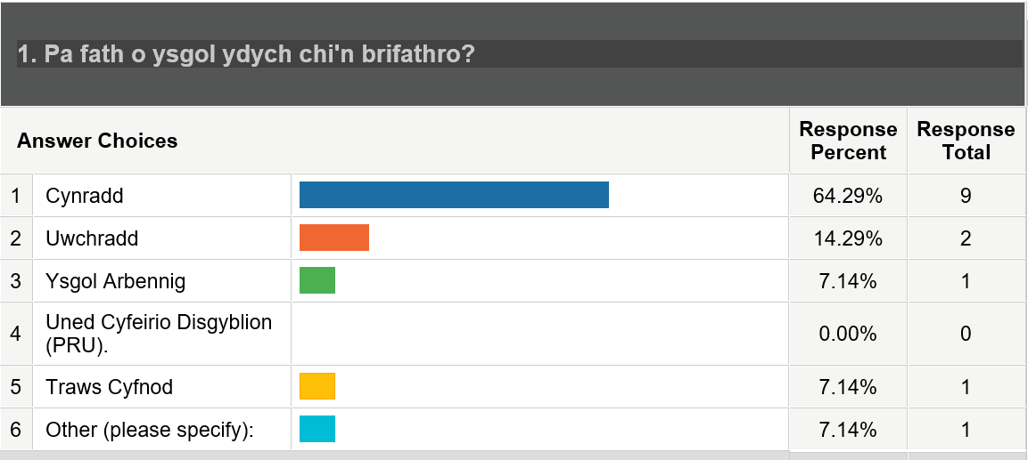
Fig. 9: The Welsh-medium schools that participated in the online schools’ questionnaire.
The qualitative elements of the survey allowed for a more detailed understanding of why this was the case and suggested that a positive relationship with policing was highly valued by schools.
The survey questions identified several key characteristics of school staff’s positive personal experiences of their SPOs (Fig. 10).

Fig. 10: Key characteristics identified from research survey questions.

Insight from the Free-Text Boxes in the Survey
Regarding a loss of SPO services, schools indicated unanimously that they would be negatively impacted by the removal of the dual aspects of services. However, there was variation in the quality of the responses in the survey’s free-text sections. Of the respondents who answered Q.11, Q.13 and Q.17, not all explained their responses to these questions. In Q.11, eleven out of fifteen respondents gave explanations for their answer. In Q.13, eleven out of fifteen also offered explanations in the free-text boxes. For Q.17, the lowest number of respondents used the free-text box, with nine out of fifteen respondents including further explanation. Where additional text facilities were accommodated to indicate concerns about the impact of the loss of WPSP services in Q.11 and Q.17, respondents described how they might be affected negatively should these services no longer exist. There were comments around the expertise of SPOs and the gravitas they possessed which was extremely effective in helping schools manage low-level offending behaviours. Much was made of the positive nature of the relationship the SPO had forged with the school. Schools indicated other kinds of policing services
“could never match the quality of the long-standing SPO as he had built up very strong relationships with pupils and staff and was well known around the school. There is no substitute for the … supportive role played by the SPO. He has developed a degree of trust with pupils and parents and far from being a threatening presence in school is a reassuring figure for all” (respondent Ht5 from School F).
There was genuine concern that without the WPSP, there might be an escalation in the criminalising of children. Ht4 from School D said, “One of the greatest benefits of having a police liaison officer is the de-escalation and accurate recording of events that prevents children from being criminalised. I am extremely concerned that more children will now be involved in criminal behaviour without intervention”.
Schools spoke about how crucial they believed it was for SPOs to deliver classroom-based curricula and that the withdrawal of such inputs would “undoubtedly have an adverse impact … if withdrawn” (Ht9, School J). This headteacher went on to describe that during these sessions around sensitive topics, children were more open and honest about their experiences than they were with school staff. She said this positive classroom intervention “facilitates the delivery of really strong messages, coming from the SPO”.
These initial surveys carried out ahead of the semi-structured interviews established the positive nature of the feeling towards the WPSP services; however, without a deeper understanding of schools’ perspectives, it would not be possible to conclude
that the WPSP created trust and confidence in policing beyond its intrinsic value as a service to meet school-based needs.
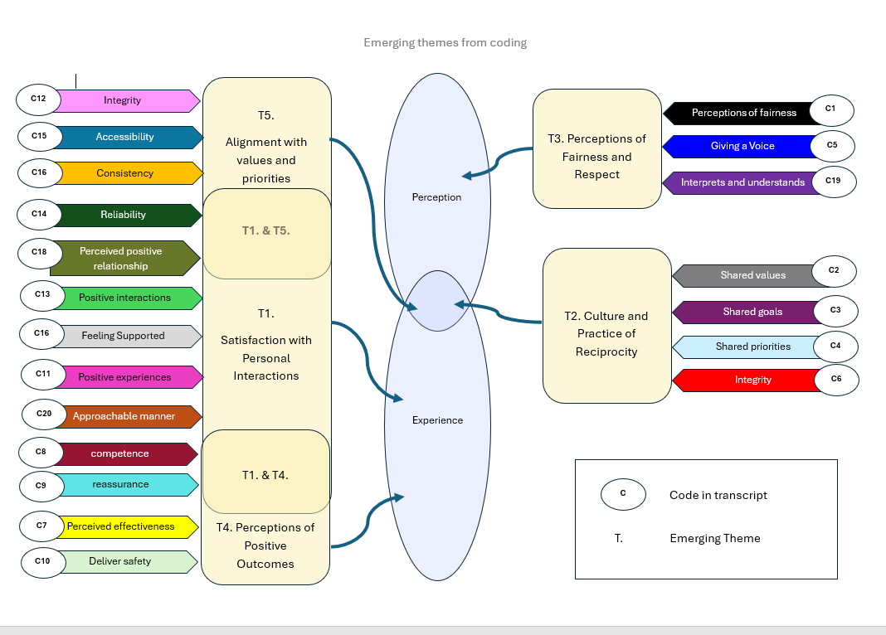
Learning from the Semi-structured Interviews
Fig. 11: How these themes evolved from the initial coding.

Twenty codes emerged from the data, and the frequency of their use was noted in a chart to establish any patterns across the questions, across the schools and amongst the participants. These codes were further categorised thematically where there was an emerging idea presenting as an effective way of classifying a group of codes (Fig. 11 & 12).
.

Fig. 12: Emergent themes

The Importance to Schools of Crime Prevention Education
Respondents spoke about the effectiveness of both the classroom-based educational engagement and the supportive policing services. Respondent Ht3 from School D noted in respect of their SPO’s services that “All of our students get the same consistent message regarding crime prevention … It’s completely inclusive”. There was concern expressed about the possible withdrawal of the educational services, as respondents viewed schools as less able to deliver police-themed lessons. Respondent Ht9 from School J said, “staff … would be reluctant to approach the more sensitive topics that are dealt with by our police officer, they feel that they would skirt around those more pertinent points that are delivered so expertly by our police officer”. The data suggests that a large contributing factor to the positivity around the WPSP relates to the classroom deliveries. The prominence in the value of these services was prevalent in the SWP Schools Questionnaire too, which showed them ranked amongst the top four SPO services.
Participant Ht2 from School B clarified that what the SPO brought to class inputs that a teacher cannot deliver is “authenticity … he has the knowledge that is far more relevant than any of our staff in delivering on those areas”. They spoke about their reliance on SPOs to deliver what they considered were highly impactful inputs. Participant PSEL1 from School C emphasised the importance of “a different voice giving the same message in a different way” as being invaluable to schools.
What about Negative Feedback?
Wherever anything negative was expressed by respondents, it was in the context of describing the overwhelming concerns schools were experiencing regarding the loss of the current WPSP services, post-July 2024. This was difficult to code in a negative context as it was not a criticism of the services per se but worries about how schools would move forward without these services. Q. 3 and Q.5 uncovered these concerns. Speaking about his apprehensions at losing his SPO school services, respondent Ht5 from School F explained that several officers in place of one SPO impacts on the relationship with the police and on an ability to rely on them when he said, “You lose the relationship, you lose the faith”. This school had experienced the loss of their SPO for almost a year when he was taken seriously ill and therefore had a recent experience to draw upon regarding a replacement police service that he suggested was inconsistent, unreliable and less effective.
The Power of Strong Relationships and Collaboration in Procedurally Just Policing Approaches
Bradford and Yesberg (2020) note that in research into police school services, there is an absence of a rigorous understanding of the types of police interactions that can create positive benefits, in particular clarity about police behaviours that generate trust and confidence in policing.
Murray et al. (2021) note that an essential period for people to develop moral codes and compliance with social norms is during puberty. However, the research indicates that procedural justice is only starting to be explored amongst adolescents. The literature suggests that little has been carried out in the UK, and that which has been undertaken only establishes a positive correlation between engineered police encounters and the impact of procedural justice in the classroom between police officers and young people of secondary school age (Pósch and Jackson, 2021). It does not incorporate an understanding of procedural justice across wider policing services within schools and amongst school staff in both primary and secondary school settings.
The findings in this new research, therefore, importantly captured the voice of our schools. Through the surveys and interviews, key policing partners were given the opportunity to indicate whether or not WPSP School Police Officers behave in ways that might indicate the presence of procedurally just practices that ultimately create trust and confidence in policing.
The themes that emerged from the semi-structured interviews support the view that there is a presence of trust and confidence in policing through the WPSP. Words commensurate with behaviours associated with procedural justice appeared in the codes used to interpret the conversations with schools – ‘positive interactions’, ‘interprets and understands needs’, ‘perceptions of fairness’, ‘giving a voice’, ‘integrity’, ‘approachable manner’, ‘competence’ and ‘positive experiences’.
Additionally in the school survey, schools reported satisfaction with aspects of services associated with procedural justice (Fig. 13):

Fig. 13: Schools satisfaction with services.

What the Data shows from Question 18 in the Survey
Figure 14 shows the data from Q.18 of the school survey, which allowed respondents to identify five key words that best describe their SPO. None of the respondents selected any words that were not of a positive orientation. The most frequently chosen word used to describe their SPO, being used on 12 occasions by over half of the schools, was ‘supportive’, which correlates with data from the semi-structured interviews and appears in T1. This indicates a satisfaction with ‘personal interactions’ with their SPO. ‘Competent’, ‘approachable’ and ‘reliable’ were also used frequently to describe SPOs; these also correlate with T1 in the data. T1 assists in interpreting the data as an indication that schools use language to describe their SPOs which, according to literature, signifies the presence of procedurally just behaviours by these police officers.

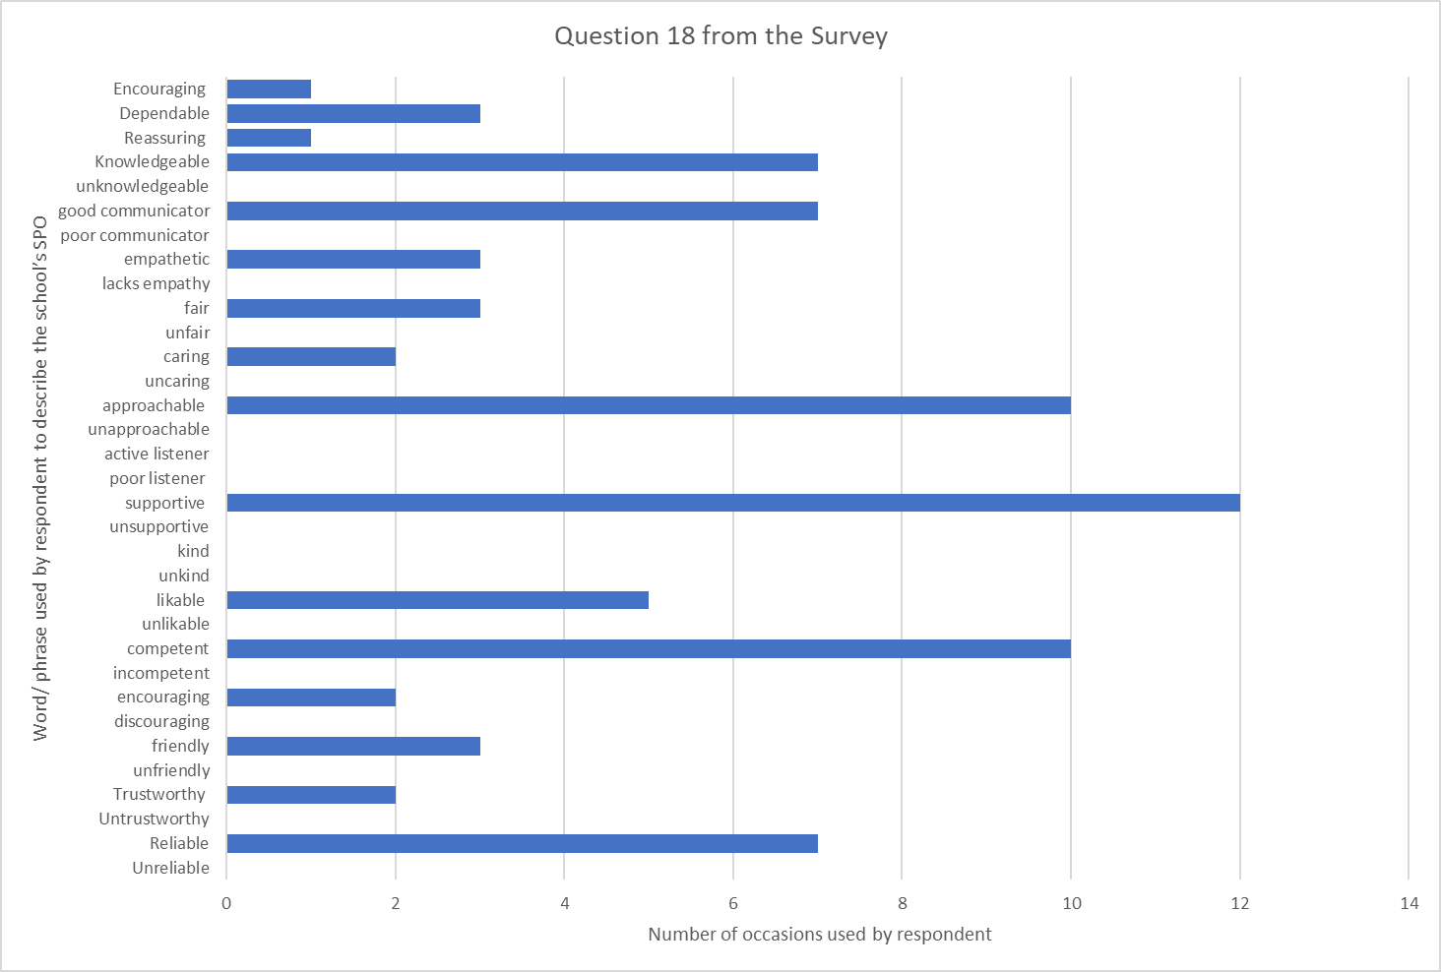

Fig. 14: Data from Q.18 from the school survey.

Implications from Theme One – ‘Satisfaction with Personal Interactions’
Theme one emerged from the most numerous codes. This theme represented respondents’ satisfaction with their personal interactions and was experiential. The literature review suggested that how officers interact with citizens, such as demonstrating interest and treating them with fairness and respect, positively impacts satisfaction and confidence in the police (Myhill and Beak, 2008). Likewise, Brown and Hobbs (2023) note that trust correlates notably more with how justly the public feels police interact with them than how police manage crime. Myhill and Beak (2008) also propose that satisfactory police-initiated contact is associated with higher public confidence, while unsatisfactory contact, whether public or police initiated, is linked to lower confidence levels.
What came through strongly in the semi-structured interviews was that school staff had high levels of trust and confidence in their SPO and their police school services in school settings where they had regular contact with their SPO. Where sickness had impacted on the availability of an SPO service, a school had struggled to engage as effectively with police services. In such instances, they spoke in terms of being in contact with a very different police service. Respondent Ht5 from School F said:
… if you take away that face to face – that immediate contact with the police officer, who’s attached to our school that we know well, with the best will in the world, if you’re ringing in on 101, it’s not the same kind of service. I’m not going to say level of service. I’m going to say kind of service.
This headteacher expanded on what made a difference to policing interactions in his school; he emphasised the importance of “being present. You’ve got to be in the school, you’ve got to get to know the staff and the children, because for me that’s the important aspect of what they do”.
Schools indicated that policing must be immersive in school settings and build relationships with school staff and pupils to create trust and confidence. The relationships described as satisfactory or positive are demarked by schools experiencing reassurance, feeling supported and having confidence in their SPO’s abilities and skills, which correspondingly affects their perceptions of the relationship, and trust and confidence in the police officer and the service they represent.
Implications from Theme Two – ‘Culture and Practice of Reciprocity and Collaboration’
Increasingly, policing works in a partnership environment, and collaboration is regarded as essential to effective policing (McCarthy and O’Neil, 2014). Collaborating with others is a standard practice in policing, and this appeared in the semi-structured interviews as shared values, goals, priorities and a professional bond. An example of this can be found when respondent Ht5 from School F was speaking about the value of restorative justice as facilitated by the SPO. He noted that it was a mutual goal with policing not to criminalise a young person. He stated, “We’ve kept it to a restorative practice approach because we don’t want to criminalise children unnecessarily. That’s always been the message from the service [WPSP] and that’s something I’ve always agreed with to be quite honest”.
Another interesting aspect of collaboration in T2 emerged from the data regarding mutual benefits. Respondent Ht5 from School F described a sense of reciprocity working with his SPO collaboratively. “There’s been tricky situations in the past where I’ve obviously spoken to [Name of SPO] … and just said, what do you think and actually had a conversation about what we think will be the best way forward … we’ve been able to bounce those ideas. It’s not a one-way relationship.”
The implication is that according to some participants, both policing and schools mutually benefit from aspects of the WPSP services, and it is important to understand the further benefits of the collaboration resulting from a service which has created an opportunity for reciprocity – which, according to the literature, fosters police legitimacy. Bradford, Murphy and Jackson (2014) argue that procedurally just approaches help reproduce a reciprocal role relationship of being an “upstanding citizen” where the police are viewed as a legitimate authority, thus creating confidence in policing services as indicated in the data.
Participant Ht4 at School D, in promoting the positive experience of developing a relationship with her SPO, commented on the value of gaining “an understanding of what each other does. So, we have that great understanding”. This understanding appears to create a positive professional bond and builds a culture of collaboration based on valuing each other’s organisational needs. What was surprising from the data was the presence of reciprocity between partners that creates a complementary coupling of partners, occasioning trust.
Implications for Theme Three – ‘Perceptions of Fairness and Respect’
Central within the literature review was the presence of fairness and respect, characteristics of procedural justice which, when found in communities, indicate the presence of trust and confidence in policing (Brown and Hobbs, 2023). This theme emerged from coding that identified in the transcripts instances where there were perceptions of fairness, where the participant felt that policing had given others a voice, and instances where the SPOs interpreted and understood the school’s needs. An example of this is when an SPO had acted as a conduit for the voice of the community within a school environment. Respondent Ht3 from School D noted that the relationship with her SPO helped with receiving “feedback of what the community needs as well, from a voice that you trust, and you can actually speak one to one without it being very formal”. Trust here is also being generated with the wider community as the police and partners problem-solve together, the wider community’s voice being effectively heard through the conduit of a trusted policing partner.
Youth justice also featured in several interview responses. Schools value the School Crime Beat protocol utilised by SPOs to manage school-based offending as it aims, wherever possible, to decriminalise children’s inappropriate behaviours. Participant PSEL2 from School K was asked about what impact the removal of the programme might have on the school, and she asserted, “We don’t want to criminalise our children, we want to use preventative measures, restorative measures … where I think if we didn’t have that service, we are going to then have no option but to criminalise kids, you know, to call 999”. She went on to affirm that they were unlikely to make such reports. The inference from this dialogue is that schools perceive the services of the SPO as being fair and respectful of their pupils’ needs, and in the absence of these services, schools might less frequently report school-based incidents to the police because they envisage less procedurally just services might be supplied to them.
Implications from Theme Four – ‘Perceptions of Positive Outcomes’
This theme helped categorise many elements of schools’ experiences as they appeared in the transcripts. Frequently, respondents perceived effective elements in the WPSP services. Participant Ht9 from School J spoke about a task she set a group of her pupils, which was to write down on a whiteboard “the things in our school that we do that are successful with anti-bullying that ensure that our children are safe … The first thing they’ve written in their own handwriting is [Name of SPO]”. This headteacher related that the work undertaken by their SPO and her presence in their school had been effective in helping these pupils to identify a trusted adult who could help in relation to bullying in the school. This is a strong indicator of a positive relationship and trust demonstrated by pupils in their SPO.
Describing the effectiveness of the SPO services in School E, participant Ht4 stated that without their SPO, there would be “a huge hole in our provision” and described that they would be working in the dark regarding what was happening in the community.
The SPO’s competence was cited along with the quality of the relationship as the strength of the service. This correlates with the literature, which views effective relationships as a precursor to positive outcomes (Mastoras, 2022).
Implications from Theme Five – ‘Alignment with Values and Priorities’
Two codes from this theme also appeared to align within ‘satisfaction with personal interactions’, as relationships stood out from the transcripts as a priority aspect of the services. Reliability presented just as much as a value as it did part of positive personal interactions. This alignment with values, according to Jackson and Bradford, exists based on the notion that the key actors concerned have “shared social bonds” that enable one actor to gain insight and “influence the interests of the other” (2010, p6). This research agrees with this discovery in the literature in that trust in this context becomes a “moral connection” between communities, in this instance schools and law enforcers. The idea being conveyed is that the police are working on behalf of schools to meet their requirement of safe communities, protecting their “values” and ensuring “a sense of justice which represents the rights and dignity of citizens” (Jackson and Bradford, 2010, p6).
Participant Ht5 from School F spoke about trust as it relates to the reality of a relationship, where the school managers believe their police resource can be directly influenced by them through “professional discussions” and simultaneously, the school feels that their SPO is a reliable person and worthy of trust. Where there was an alignment of policing with the values and priorities of schools, trust appears to be formed, as indicated in the literature.
Chapter 5 - Conclusions and Recommendations

Key Headline
The mixed-method research, using reflexive thematic analysis and a triangulation of data sets, offered a grounded theory approach to derive a theoretical framework, which proposes that the WPSP does, in both primary and secondary schools and within one independent special school setting, have a positive impact on creating trust and confidence in policing amongst schools in South Wales.
The Strengths of the WPSP Model
The data shows according to school leaders and teaching staff that the WPSP helps to positively shape children and young people’s attitudes to the police, in line with the literature around procedural justice and policing. Schools attested in the research data that the relationship between the SPO and the school was invaluable in support of them as a community, and that collaboration was at the heart of the effectiveness of what they perceived was being achieved through these services. The themes that emerged from the data aligned with a picture of procedurally just approaches to policing being a common feature of the WPSP services. Schools reported satisfaction with services performed by competent police officers regarding both crime prevention education engagement and supportive policing activities. SPOs were credited for their collaborative approach to working with schools, and reciprocity was recognised as an important feature of the relationship between the partners. Schools recognised a raft of positive outcomes that were generated by the involvement of SPOs in their schools, and they experienced an alignment from these police services with their values and priorities, which they also recognised they often shared with policing.
Unlike previous studies, this research captures the views of adults in school settings who work closely with children. It supplies insights where there is currently a gap in the literature. Importantly, it shows that there is a need for police educational deliveries and supportive policing services within school settings. These services were often viewed with equal importance from school perspectives. Considerable concerns were being expressed by schools as regards the loss of police schools services in the academic year 2024–25, and anticipation of gaps in school provision for children and young people should police interventions be withdrawn. The data affirmed that, 13 years on since the last research into the impact of the police schools services in Wales, SPOs still contribute to helping schools feel safer (Stead et al., 2011).
The Gaps in the Data and Weaknesses
It is notable that the research was conducted directly only with school adults. Children and young people were not surveyed, nor were focus groups held with them to ascertain what they think, perceive or believe about the WPSP. Their voice was represented by proxy. This essentially was the key weakness in this research. Gathering from the adults who represented the pupils’ perspectives, some of the elements of the service that help create trust and confidence for children and young people are dependent upon the contact SPOs have with them in classroom settings. Schools describe this engagement as impactful. School staff spoke about the trust that is generated from these encounters and indicated from their observations that young people had positive encounters and built positive relationships with SPOs, and this created trust and confidence in policing.
Nevertheless, the data in this research does not conclusively inform us whether the WPSP has the same impact on creating trust and confidence in policing amongst children as it does school-based staff. The research implies that there is a strong indication that it is perceived as being a procedurally just approach by children and young people, but without the empirical evidence from research that is conducted directly with them, it is not conclusive.
Whether the timing of this research had any impact on the study and the data results are not conclusive. The degree of positivity expressed by participants about the WPSP services may have been inflated because of the impending loss of the current services, however, it is not possible to ascertain this was the case. It would be useful to commission research of future police schools services, to establish the impact it has on trust and confidence in policing amongst schools and compare the findings with this research.
With the withdrawal of Welsh Government funding, these WPSP services appear under threat, and how they will look in the future is unclear. Sustainability is a core weakness of this model, which has relied upon Welsh Government funding throughout its existence. The uncertainty for schools in how services might change and the impact this would have on them came through strongly in the data, with schools implying they have no contingency for the loss of these services. How this will affect schools’ future trust and confidence in the police is yet to be seen.

Recommendations
The first recommendation is that an ethical, mixed-method research approach should be undertaken with children and young people, asking very similar questions through surveys and focus groups. These focus groups could be conducted by school-based staff to reduce any potential risks to the participants because of the research. The benefit of undertaking such research would be to make a comparative analysis of the responses between the results from the research with school staff and the young participants to establish whether there were similarities and/or differences in the results and what that means with regard to understanding the impact of the WPSP in creating trust and confidence in policing amongst children and young people. The results of this would contribute to guiding future police school services. It would also help frame how policing can learn from this research and improve its interactions with young people in the context of the wider community, to create a more procedurally just approach that makes effective use of child-centred policing practices. According to the literature, using evidence-based approaches in policing is increasingly favoured in the partnership arena.
The second recommendation for policing is to raise awareness with senior police leaders around the efficacy of South Wales Police’s current engineered police engagement in creating trust and confidence in policing. In the future development of services for schools, dedicated SPOs should continue to work with children in all school settings. The contact with schools should extend beyond the parameters of traditional enforcement-style policing and remain “strengths-based and relationship driven”, as recommended in the literature (Maxwell et al., 2019). This would require a commitment to strong relationships and collaborative solutions, also positively identified in this research and the literature as contributing to building trust and confidence in policing. In line with the Police Chiefs’ Council’s (2015) youth strategy, there must be a continued priority to develop the relationship between the police and young people. The research indicates that the WPSP is an effective way to engage with children and young people and successfully dismantles barriers whilst forging relationships with them. South Wales Police should continue to support child-centred policing practices, recognising that building effective strategies with young people always requires listening to and integrating the voice of the child when formulating policy and practice. To move further away from regular engineered contact with children, according to schools, would be a retrograde move.

Overall Conclusion
In the National Strategy for the Policing of Children and Young People, Olivia Pinkney emphasised that children are not “mini-adults” and should, therefore, not be treated as such. Getting policing right with them today, she suggested, may mean they will have less need of policing tomorrow. She described every interaction with policing “leaves a mark and we need to think carefully about what sort of mark that is” (NPCC, 2015, p2). As the fiscal restraints in policing ever tighten, as is the case with the loss of Welsh Government funding for the WPSP, it is essential that policing does not retreat too far away from the path it has been navigating in partnership with schools over the last 20 years in South Wales – one where dedicated police officers remain a regular feature of school life, and contact with children and young people does not simply occur at the point of being a victim or perpetrator of crime. Schools highly value and have trust and confidence in their SPOs, and foremost for them too is the special relationship they establish with a dedicated police contact. Clearly, when it comes to creating trust and confidence, the quality of the relationship is king.
Bibliography
Albrecht, J. (2019). ‘In Evaluating Police-Community Relations Globally’. Policing and Minority Communities, 3–10.
All Party Parliamentary Group For Children. (2014). “It’s all about trust”: Building good relationships between children and the police. London: All Parliamentary Group For Children. Retrieved April 4, 2024, from: basw_20117-10_0.pdf
Bell, C. (2021). Punishment, Violence, and the Failure of School Safety. Baltimore. JHU Press.
Bickman, L. & Rog, C. (2009). The SAGE Handbook of Applied Social Research Methods. SAGE.
Bingham, A. J. & Vanover, C. (2021). Qualitative research design & data analysis: Deductive & inductive approaches. Retrieved March 30, 2024, from: YouTube: https://youtu.be/e1OCkH21NdE
Birks, M. & Mills, J. (2015). Grounded theory: a practical guide. (2nd ed.) London: SAGE.
Bowles, R., Reyes, M. G. & Pradiptyo, R. (2005). National evaluation of the Safer Schools. London: Youth Justice Board. Retrieved April 3, 2024, from: https://dera.ioe.ac.uk/id/eprint/7759/1/Safer%20Schools%20Partnerships%20-%20Full%20Report.pdf
Bradford, B. & Jackson, J. (2018). Police legitimacy among immigrants in Europe: Institutional frames and group position. European Journal of Criminology, 15(5), 567–588. https://doi.org/10.1177/1477370817749496
Bradford, B., Murphy, K. & Jackson, B. (2014). Officers as mirrors: Policing, Procedural Justice and the (Re)Production of Social Identity. The British Journal of Criminology, 54(4), 527–550. Retrieved June 15, 2024, from: OFFICERS AS MIRRORS: Policing, Procedural Justice and the (Re)Production of Social Identity on JSTOR
Bradford, B. & Myhill, A. (2015). Triggers of change to public confidence in the police and criminal justice system: Findings from the Crime Survey for England and Wales panel experiment. Criminology & Criminal Justice, 15(1), 23–43 https://doi.org/10.1177/1748895814521825
Bradford, B. & Yesberg, J. (2020). Police in schools – An evidence review. London: UCL Jill Dando Institute for Security and Crime Science. Retrieved April 3, 2024, from: https://fs.hubspotusercontent00.net/hubfs/20248256/Vision/Police%20in%20schools%20Evidence%20Review%20FINAL.pdf

Braun, V. & Clarke, V. (2006). Using thematic analysis in psychology. Qualitative Research in Psychology, 3(2), 77–101. Retrieved June 1, 2024, from: http://doi.org/10.1191/1478088706qp063oa
Braun, V. & Clarke, V. (2022). Thematic analysis: A practical guide. SAGE. Retrieved May 28, 2024, from: Thematic Analysis: A Practical Guide - Virginia Braun, Victoria Clarke - Google Books
Braun, V., Clarke, V., Hayfield, N., Terry, G. (2019). Thematic Analysis. In: Liamputtong, P. (eds) Handbook of Research Methods in Health Social Sciences. Springer, Singapore. https://doi.org/10.1007/978-981-10-5251-4_103
Brown, R. & Hobbs, A. (2023). Trust in the police. London: UK Parliament Post. Retrieved April 2, 2024, from: https://researchbriefings.files.parliament.uk/documents/POST-PN-0693/POST-PN-0693.pdf
Bryman, A. (2006). Integrating quantitative and qualitative research: how is it done? Qualitative Research, 6(1), 97–113. doi:10.1177/1468794106058877
Byrne, D. (2022). A worked example of Braun and Clarke’s approach to reflexive thematic analysis. Quality & Quantity, 56(2), 1391–1412. Retrieved May 4, 2024, from: https://doi.org/10.1007/s11135-021-01182-y
Campbell, K. A., Orr, E., Durepos, P., Nguyen, L., Li, L., Whitmore, C., Gehrke, P., Graham, L. & Jack, S. M. (2021). Reflexive Thematic Analysis for Applied Qualitative Health Research. The Qualitative Report, 26(6), 2011–2028. https://doi.org/10.46743/2160-3715/2021.5010
Cao, L. (2015). Differentiating confidence in the police, trust in the police, and satisfaction with the police. Policing: An International Journal of Police Strategies & Management, 38(2), 239–249. doi:10.1108/PIJPSM-12-2014-0127
Carr, N. (2017). The Lammy Review and race and bias in the criminal justice system. Probation Journal, 64(4), 333–336. https://doi.org/10.1177/0264550517740461
Cavadino, M., Dignan J., & Mair, G. (2013). The penal system: An introduction (5th ed.). London: SAGE.
Chun Tie Y, Birks M, Francis K. (2019). Grounded theory research: A design framework for novice researchers. SAGE Open Medicine. 7. doi:10.1177/2050312118822927
Coghlan, D. & Coughlan, P. (2010). Notes toward a Philosophy of Action Learning Research. Action Learning: Research and Practice, 7(2), 193–203. doi:10.1080/14767333.2010.488330
Creswell, J. W. (2003). Research design: Qualitative, quantitative, and mixed methods approaches (2nd ed.). Thousand Oaks, CA: SAGE.
Creswell, J. W. (2014). Research design: Qualitative, quantitative, and mixed methods approaches (4th ed.). Thousand Oaks, CA: SAGE.
Creswell, J. W. & Poth, C. N. (2016) Qualitative Inquiry and Research Design: Choosing Among Five Approaches (4th ed.). London: SAGE.
Davies, N., Hoddinott, S., Fright, M., Nye, P., Shepley, P. & Richards, G. (2023). Performance Tracker 2022/23: Spring update. Institute for Government. Retrieved April 3, 2024, from: Performance Tracker 2022-23 Spring Update.pdf (instituteforgovernment.org.uk)
Davis, J. & Marsh, N. (2020). Boys to men: the cost of “adultification” in safeguarding responses to Black boys. Critical and Radical Social Work, 8(2), 255–259. https://doi.org/10.1332/204986020X15945756023543
Elliott, R., Fischer, C. T. & Rennie, D. L. (1999). Evolving guidelines for publication of qualitative research studies in psychology and related fields. The British journal of clinical psychology, 38(3), 215–229. https://doi.org/10.1348/014466599162782
Fisher, B. W., Petrosino, A., Sutherland, H., Guckenburg, S., Fronius, T., Benitez, I. & Earl, K. (2023). School‐based law enforcement strategies to reduce crime, increase perceptions of safety, and improve learning outcomes in primary and secondary schools: A systematic review. Campbell Systematic Review, 19(4), e1360-n/a. https://doi.org/10.1002/cl2.1360
Fisher, B. W. & Hennessy, E. A. (2016). School Resource Officers and Exclusionary Discipline in U.S. High Schools: A Systematic Review and Meta-analysis. Adolescent Research Review, 1(3), 217–233. doi:10.1007/s40894-015-0006-8
Flexon, J. L., Lurigio, A. J. & Greenleaf, R. G. (2009). Exploring the dimensions of trust in the police among Chicago juveniles. Journal of Criminal Justice, 37(2), 180–189. https://doi.org/10.1016/j.jcrimjus.2009.02.006
Gaffney, H., Farrington, D. & White, H. (2021). Police in schools toolkit technical report. Youth Endowment Fund. Retrieved April 2, 2024, from: Police-in-Schools-technical-report.pdf (youthendowmentfund.org.uk)
Glaser, B. G. & Holton, J. (2004). Remodeling Grounded Theory. Qualitative Social Research Forum, 5(2), 1–23. Retrieved April 1, 2024, from: https://www.proquest.com/docview/869223799/fulltextPDF?pq-origsite=primo&sourcetype=Scholarly%20Journals
Gleit, R. D. (2022). Cops on Campus: The Racial Patterning of Police in Schools. Socius, 8. https://doi.org/10.1177/23780231221108037
Glenn, J. W. (2019). Understanding school-based policing: recommendations for improving School Resource Officer programs and promoting safer schools. Safer Communities, 18(3/4), 132–142. doi:10.1108/SC-05-2019-0015
Greene, J. C., Caracelli, V. J. & Graham, W. F. (1989). Toward a conceptual framework for mixed-method evaluation designs. Educational Evaluation and Policy Analysis, 11(3), 255–274.
Gulati, P. M. (2009). Research Management: Fundamental and Applied Research. New Delhi: Global India Publications.
Hammersley, M. (2013). What is qualitative research? Bloomsbury Academic. Retrieved June 3, 2024 from: What is Qualitative Research?: : The 'What is?' Research Methods Series Martyn Hammersley Bloomsbury Academic
Hanway, P. & Hambly, O. (2023). Home Office Research and Analysis Public perceptions of policing: A review of research and literature. Retrieved May 11, 2024, from: Gov.uk: https://www.gov.uk/government/publications/public-perceptions-of-policing-a-review-of-research-and-literature/public-perceptions-of-policing-a-review-of-research-and-literature
Hart, K. (1988 ). “Kinship, contract, and trust”, in Gambetta, D. (Ed.),Trust: Making and Breaking of Cooperative Relations, Oxford: Basil Blackwell, , 176–193.
Her Majesty’s Inspectorate of Constabulary and Fire and Rescue Services. (2021). Disproportionate use of police powers: A spotlight on stop and search and the use of force. HMICFRS. Retrieved March 30, 2024, from: Disproportionate use of police powers: A spotlight on stop and search and the use of force (justiceinspectorates.gov.uk)
Hinds, L. (2007). Building Police—Youth Relationships: The Importance of Procedural Justice. Youth Justice, 7(3), 195–209. https://doi.org/10.1177/1473225407082510
Hinds, L. & Murphy, K. (2007). Public satisfaction with police: using procedural justice to improve police legitimacy. Australian & New Zealand Journal of Criminology, 40(1), 27–42. doi:10.1375/acri.40.1.27
Hohl, K., Johnson, K. & Molisso, S. (2022). A Procedural Justice Theory Approach to Police Engagement with Victim-Survivors of Rape and Sexual Assault: Initial Findings of the ‘Project Bluestone’ Pilot Study. International Criminology, 2(3), 253–261. https://doi.org/10.1007/s43576-022-00056-z
Hough, M., Jackson, J. & Bradford, B. (2013). ‘Legitimacy, Trust and Compliance: An Empirical Test of Procedural Justice Theory Using the European Social Survey’, in Tankebe, J. and Liebling, A. (eds.) Legitimacy and Criminal Justice: An International Exploration, Oxford: Oxford University Press.
House of Commons Home Affairs Committee. (2021). The Macpherson Report: Twenty-two years on. House of Commons. Retrieved May 22, 2024, from: The Macpherson Report: twenty-two years on - Committees - UK Parliament
Independent Office for Police Conduct. (2023). IOPC-public-perceptions-tracker-report-2022-23. London: Yonder. Retrieved April 3, 2024, from: https://www.policeconduct.gov.uk/sites/default/files/documents/IOPC-public-perceptions-tracker-report-2022-23.pdf
Independent Office for Police Conduct. (2024). Independent Office for Police Conduct. Retrieved May 11, 2024, from: Building Trust and Confidence in Policing: https://www.policeconduct.gov.uk/about-us/our-strategy-and-performance/building-trust-and-confidence-in-policing
Jackson, J. (2020) Trust and confidence in policing: a British perspective. [PowerPoint presentation]. NSW Bureau of Crime Statistics and Research. Trust and confidence in policing: a British perspective. Retrieved June 9, 2024, from: Sydney_NSW_seminar
Jackson, J. & Bradford, B. (2010). What is trust and confidence in the police? Policing: a journal of policy and practice, 4(3), 241–248. doi:10.1093/police/paq020
Jackson, J., Bradford, B., Giacomantonio, C. & Mugford, R. (2023). Developing core national indicators of public attitudes towards the police in Canada. Policing & Society, 33(3), 276–295. doi:10.1080/10439463.2022.2102757
Jackson, J., Hough, M., Bradford, B., Hohl, K. & Kuha, J. (2012). Policing by consent: understanding the dynamics of police power and legitimacy. European Commission.
Javdani, S. (2019). Policing Education: An Empirical Review of the Challenges and Impact of the Work of School Police Officers. American journal of community psychology, 63(3–4), 253–269. https://doi.org/10.1002/ajcp.12306
Johnson, B., Teddlie, C. & Tashakkori, A. (2009). Foundations of mixed methods research: Integrating quantitative and qualitative approaches in the social and behavioral sciences. Thousand Oaks. SAGE.
Kewley, S. (2017). Strength based approaches and protective factors from a criminological perspective. Aggression and Violent Behavior, 32, 11–18. doi:10.1016/j.avb.2016.11.010
Lamba, N., Van Tonder, A. & Raghavan, A. (2022). Unpacking qualitative methodology to explore experiences of mothers with children with autism spectrum disorder in the UAE: A thematic analysis inquiry. International Journal of Qualitative Methods, 21(1), 16094069221110295. https://doi.org/10.1177/16094069221110295
Lammy, D. (2017). The Lammy Review: An independent review into the treatment of, and outcomes for, Black, Asian and Minority Ethnic individuals in the Criminal Justice System. UK Gov. Retrieved May 20, 2024, from: The Lammy Review (publishing.service.gov.uk)
Leavy, P. (2017). Research Design: Quantitative, Qualitative, Mixed Methods, Arts-Based, and Community-Based Participatory Research Approaches. New York, NY: The Guilford Press.
Lind, E. A. & Tyler, T. R. (1988). The Social Psychology of Procedural Justice: Critical Issues in Social Justice. New York, NY: Springer. Retrieved June 9, 2024, from: LindTyler-1988-SelectedChapters.pdf
Macpherson, W. (1999). The Stephen Lawrence Enquiry. Home Office. Retrieved April 6, 2024, from: 4262.pdf (publishing.service.gov.uk)
Madon, N. S., Murphy, K. & Sargeant, E. (2017). Promoting police legitimacy among disengaged minority groups: Does procedural justice matter more? Criminology & Criminal Justice, 17(5), 624–642. https://doi.org/10.1177/1748895817692849
Mastoras, M. C. (2022). Proactive Alliance: Combining Policing and Counselling Psychology. Arizona State University Center for Problem-Oriented Policing Retrieved June 14, 2024, from: https://popcenter.asu.edu/sites/default/files/proactive_alliance_mastoras.pdf
Maxwell, N. (2023). I’m Trying to Save My Family: Parent Experiences of Child Criminal Exploitation. Youth Justice, 23(2), 243–258. https://doi.org/10.1177/14732254221122559
Maxwell, N. & Wallace, C. (2021). Child Criminal Exploitation in Wales. Cardiff University. Retrieved April 22, 2024, from: CCE-Interim-report-Final-04.10.21.pdf (cascadewales.org)
Maxwell, N., Wallace, C., Cummings, A., Bayfield, H. & Morgan, H. (2019). A systematic map and synthesis review of Child Criminal Exploitation October 2019. Cascade Wales. Retrieved April 22, 2024, from: A-systematic-map-and-synthesis-review-of-Child-Criminal-Exploitation-October-2019-1.pdf (cascadewales.org)
Mazerolle, L., Bennett, S., Davis, J., Sargeant, E., & Manning, M. (2013). Procedural justice and police legitimacy: a systematic review of the research evidence. Journal of Experimental Criminology, 9(3), 245–274. doi:10.1007/s11292-013-9175-2
McAra, L. & McVie, S. (2010). Youth crime and justice: Key messages from the Edinburgh Study of Youth Transitions and Crime. Criminology & Criminal Justice, 10(2), 179–209. https://doi.org/10.1177/1748895809360971
McCarthy, D. & O’Neill, M. (2014). The Police and Partnership Working: Reflections on Recent Research. Policing: A Journal of Policy and Practice, 8(3), 243–253. https://doi.org/10.1093/police/pau022
McGrew, K. (2016). The dangers of pipeline thinking: How the school-to-prison pipeline metaphor squeezes out complexity. Educational Theory, 66(3), 341–367.
Merry, S., Power, N., McManus, M. & Alison, L.. (2012). Drivers of public trust and confidence in police in the UK. International Journal of Police Science and Management, 14(2), 118–135.
Morgan, M. M. & Higginson, A. (2023). Police and procedural justice: perceptions of young people with mental illness. Policing and Society, 33(7), 841–860. https://doi.org/10.1080/10439463.2023.2207714
Mulligan, J. (2018, February 27). Building trust with openness and transparency. Policing Insight. Retrieved April 2, 2024, from: https://policinginsight.com/feature/opinion/building-trust-openness-transparency/
Murphy, K. (2015). Does procedural justice matter to youth? Comparing adults’ and youths’ willingness to collaborate with police. Policing & Society, 25(1), 53–76. https://doi.org/10.1080/10439463.2013.802786
Murray, K., McVie, S., Farren, D., Herlitz, L., Hough, M. & Norris, P. (2021). Procedural justice, compliance with the law and police stop-and-search: a study of young people in England and Scotland. Policing and Society, 31(3), 263–282. ISSN 1043-9463. Retrieved June 9, 2024, from: 30714.pdf (bbk.ac.uk)
Myhill, A. & Beak, K. (2008). Public confidence in the police: Research, Analysis and Information (RAI). National Policing Improvement Agency. Retrieved May 9, 2024, from: Microsoft Word - Public Confidence in the Police.doc (college.police.uk)
Myhill, A. & Bradford, B. (2012). Can police enhance public confidence by improving quality of service? Results from two surveys in England and Wales. Policing and Society, 22(4), 397–425. doi:10.1080/10439463.2011.641551
Naeem, M., Ozuem, W., Howell, K. & Ranfagni, S. (2023). A Step-by-Step Process of Thematic Analysis to Develop a Conceptual Model in Qualitative Research. International Journal of Qualitative Methods, 1(18). DOI:10.1177/16094069231205789
National Police Chiefs’ Council. (2015). National Strategy for the Policing of Children & Young People. NPCC. Retrieved May 21, June 13, 2024, from: national-strategy-for-the-policing-of-children-young-people.pdf (npcc.police.uk)
National Police Chiefs’ Council. (2021). Child Centred Policing. Police in the classroom: A handbook for the police and PSHE teachers. London. Retrieved April 2, 2024, from: https://fs.hubspotusercontent00.net/hubfs/20248256/Guidance/Documents/CYP%20police%20in%20the%20classroom%20handbook.pdf?hsCtaTracking=6ce13dde-24b4-4d20-a9db-0434c410f569%7C5f1fa8b7-7d5b-4fdf-876c-52b26d594116
National Police Chiefs’ Council and College of Policing. (2022). Police Race Action Plan: Improving policing for black people. College of Policing. Retrieved April 8, 2024, from: Police Race Action Plan: Improving policing for Black people (college.police.uk)
New Zealand Police. (n.d.). Police School Partnerships. Retrieved May 12, 2024, from: New Zealand Police: https://www.police.govt.nz/advice-services/personal-community-safety/school-portal/information-and-guidelines/police-school
Nijjar, J. (2021). Police–school partnerships and the war on black youth. Critical Social Policy, 41(3), 491–501. https://doi.org/10.1177/0261018320964655
Oxford Reference. (n.d.). Interpretivism. Retrieved April 5, 2024, from: Oxford Reference: Interpretivism - Oxford Reference.
Ping Li, P. (2012). When trust matters the most: The imperatives for contextualising trust research. Journal of Trust Research, 2(2), 101–106. doi:10.1080/21515581.2012.708494
Police Foundation. (2011). The Briefing: Safer Schools Partnership. Police Foundation series 2 (2nd ed.). Retrieved April 2, 2024, from: Police Foundation Safer Schools Briefing.qxd (police-foundation.org.uk)
Police Professional. (2024). Police Professional, 705. London, United Kingdom. Retrieved April 16, 2024, from: Police Professional (pagesuite-professional.co.uk)
Pósch, K. & Jackson, J. (2021). Police in the classroom: Evaluation of a three-wave cluster-randomised controlled trial. London: The London School of Economics and Political Science. Retrieved April 3, 2024, from: https://eprin ts.lse.ac.uk/108632/1/Posch_police_in_the_classroom_published.pdfril
Runnymede Trust. (2023). Over-policed and under-protected: The Road to Safer Schools. Runnymede Trust. Retrieved April 23, 2024, from: https://assets-global.website-files.com/61488f992b58e687f1108c7c/63c027251c4ddb3581daa9fb_Safer%20Schools%20Officers%20Briefing%20-%20FINAL.pdf
Saldana, J. (2015). The Coding Manual for Qualitative Researchers (3rd ed.). Thousand Oaks. SAGE.
Saunders, M., Lewis, P. & Thornhill, A. (2016). Research methods for business students (7th ed.). Harlow. Pearson Education.
Sherman, L. (1998). Evidence Based Policing: Ideas in American Policing. Police Foundation, 1–16. Retrieved June 12, 2024, from: Ideas-Sherman (policinginstitute.org)
Sindall, K., McCarthy, D. J. & Brunton-Smith, I. (2017). Young people and the formation of attitudes towards the police. European Journal of Criminology, 14(3), 344–364. https://doi.org/10.1177/1477370816661739
Skogan, W. G. (2009). Concern About Crime and Confidence in the Police: Reassurance or Accountability? Police Quarterly, 12(3), 301–318. https://doi-org.ezproxy.uwtsd.ac.uk/10.1177/1098611109339893
Stead, J., Lloyd, G., Baird, A., Brown, J., Riddell, S., Weedon, E. & Laugharne, J. (2011). All Wales School Liaison Core Programme (AWSLCP) Evaluation Report. University of Wales Cardiff and Edinburgh University. Retrieved April 22, 2024, from: https://www.gov.wales/sites/default/files/statistics-and-research/2019-08/110314-all-wales-school-liaison-core-programme-en.pdf
Stewart-Withers, R. & Greener, B. K. (2022). New Zealand’s Policing Efforts in the Pacific: Gender Programs, Practices, and Performances. Journal of Contemporary Criminal Justice, 38(3), 346–363. https://doi.org/10.1177/10439862221096959
Stoltzfus, C. (2020). Public-school systems are criminalizing our young people: Giving voice to the marginalized. Scholar Works at Arcadia, 1–140. Retrieved April 3, 2024, from: https://scholarworks.arcadia.edu/cgi/viewcontent.cgi?article=1027&context=grad_etd
Strauss A. L. & Corbin, J. M. (2008). Basics of qualitative research: techniques and procedures for developing grounded theory. (3rd ed.). Thousand Oaks, CA: SAGE.
Sunshine, J. & Tyler, T. (2003). The Role of Procedural Justice and Legitimacy in Shaping Public Support for Policing. Law & Society Review, 37(3), 513–548. https://doi.org/10.1111/1540-5893.3703002
Tan, J. (2010). Grounded theory in practice: issues and discussion for new qualitative researchers. Journal of Documentation, 66(1), 93–112. doi:10.1108/00220411011016380
Tashakkori, A., Johnson, R. & Teddlie, C. (2020). Foundations of Mixed Methods Research: Integrating Quantitative and Qualitative Approaches in the Social and Behavioral Sciences (Applied Social Research Methods). SAGE.
Tashakkori, A. & Teddlie, C. (2003). Handbook of Mixed Methods in Social & Behavioral Research. Thousand Oaks. SAGE.
Teddlie, C. & Tashakkori, A. (2012). Common “Core” Characteristics of Mixed Methods Research: A Review of Critical Issues and Call for Greater Convergence. The American Behavioral Scientist (Beverly Hills), 56(6), 774–788. https://doi.org/10.1177/0002764211433795
The Children’s Society. (2022). The Good Childhood Report. Children’s Society. Retrieved April 22, 2024, from: childrenssociety.org.uk/sites/default/files/2022-09/GCR-2022-Full-Report.pdf
The Children’s Society (2022). Written evidence submitted by The Children’s Society to UK Parliament (POP0078). Children’s Society. Retrieved May 13, 2024, from: committees.parliament.uk/writtenevidence/113778/pdf/
The Police Foundation. (2011). The Briefing: Safer Schools Partnership. Police Foundation Series 2 edition 2. Police Foundation. Retrieved April 2, 2024, from: https://www.police-foundation.org.uk/wp-content/uploads/2017/08/safer_schools_briefing.pdf
Tyler, T. R. (2003). Procedural Justice, Legitimacy, and the Effective Rule of Law. Crime and Justice (Chicago, Ill.), 30, 283–357. https://doi.org/10.1086/652233
Vanover, C., Mihas, P. & Salanda, J. (2021). Analyzing & Interpreting Qualitative Research. Thousand Oaks. SAGE.
Violence Prevention Unit. (n.d.). Wales Without Violence Framework. Retrieved April 22, 2024, from: Wales Without Violence: https://waleswithoutviolence.com/wp-content/uploads/2023/04/WWV-Framework-Digital-English.pdf
Wales Police Schools Programme (2023). School Crime Beat Protocol: A Protocol for Police Supporting Schools with Incidents of Crime & Disorder. Wales Police Schools Programme. Retrieved June 22, 2024, from: WPSP_School_Crime_Beat_Protocol_ENG_wpsp_scbp_20230222 (7).pdf
Welsh Government. (2015). Wellbeing of Future Generations Act (Wales) 2015: Essential Guidance on our law to improve social, economic, environmental and cultural well-being. Welsh Government. Retrieved April 22, 2024, from: Well-being of Future Generations (Wales) Act 2015: the essentials | GOV.WALES.
Welsh Government. (2023). Welsh Government Draft Budget 2023-2024: A budget to protect the services that matter to you. Cardiff: Welsh Government. Retrieved April 10, 2024, from: https://www.gov.wales/sites/default/files/publications/2023-12/2024-2025-draft-budget-narrative.pdf
Wincup, E. & Downey, S. (2003). ‘Getting it Right?’: Police in primary schools. Crime and Justice. Retrieved April 4, 2024, from: https://www.crimeandjustice.org.uk/sites/crimeandjustice.org.uk/files/09627250308553553.pdf
Youth Justice Board/Department for Education/Association of Chief Police Officers/ National Police Chiefs’ Council. (2009). Safer Schools Partnerships Guidance. London: YJB/ DfE/ ACPO/ NPCC. Retrieved April 10, 2024, from: http://data.parliament.uk/DepositedPapers/Files/DEP2009-1366/DEP2009-1366.pdf

List of Appendices

Appendix 1 The Wales Police Schools Programme 81
Appendix 2 Letter from Chief Constable and PCC 82
Appendix 3 Five Year Comparison of Occurrences on School Premises 83
Appendix 4 School Survey 84
Appendix 5 Script for Semi-structured Interviews 89
Appendix 6 South Wales Police Schools Questionnaire 89


Appendix 1: The Wales Police Schools Programme

What is the Wales Police Schools Programme - also known as SchoolBeat?

The WPSP is an example of Partnership Working between the Welsh Government and the four Welsh Police Forces and consists of a series of Crime Prevention lesson deliveries and Supportive School Policing initiatives that aim to:
- educate children and young people about the harm substance misuse can cause to their health, their families and the wider community
- promote the principles of positive citizenship through the medium of education
- achieve a reduction in the levels of crime and disorder within our young communities.
The WPSP provides a wrap-around service to all schools and educational settings in Wales offering crime prevention education and supportive policing services captured in the Programme’s strap line,

‘Police safeguarding the children of Wales through crime prevention education’

There are 68 School Police Officers (SPO) who in addition to their professional training as Police Officers take a child centred approach and are trained to deliver lessons on the themes of substance misuse, personal safety, safeguarding and behaviour and community to a best practice educational standard that is warmly welcomed by schools.
They are also able to offer a wide variety of assembly presentations. The assemblies offer flexibility and ensure the WPSP keeps pace with emerging threats, trends and issues. A series of vlogs and other materials are also available on our dedicated www.SchoolBeat.cymru website.

The SPOs work closely with Pastoral, Behaviour and Safeguarding leads in schools to support the newly developing Health and Well-being curriculum.
The Programme has a corporate approach to ensure that all children, 5 to 16 years old across Wales receive the same accurate and up to date information.
SPOs also support schools through supportive policing practices; dealing with incidents using the School Crime Beat policy and offering restorative resolutions including restorative conferencing when required.

Why was the Wales Police Schools Programme developed?
The WPSP was developed to educate young people about some of the challenges that affect our society today. The intention of the Programme is to work with schools to safeguard all children and young people living in Wales by providing them with current information about the dangers associated with issues such as substance use and misuse, County Lines, domestic abuse, exploitation, bullying, anti-social behaviour, internet safety, weapons, radicalisation and community cohesion.
It is important that children are provided with accurate up to date information by specialists to ensure they are able to make correctly informed decisions and hopefully avoid entry into the Criminal Justice System as well as signposting them to help and support.
The Programme encourages positive citizenship and through prevention seeks to protect vulnerable children and young people who may become victims of criminal activity.
Appendix 2: Letter from the Chief Constable and PCC
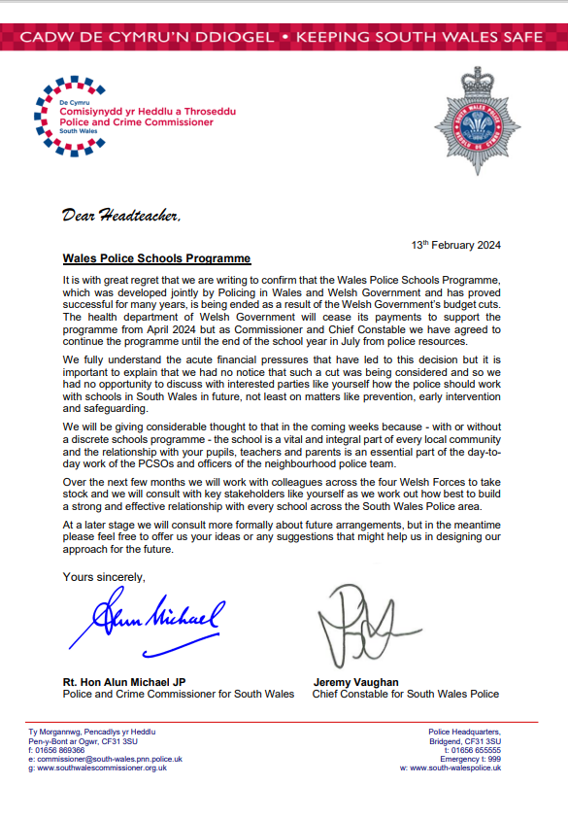

Appendix 3: Five Year Comparison of Occurrences on School Premises
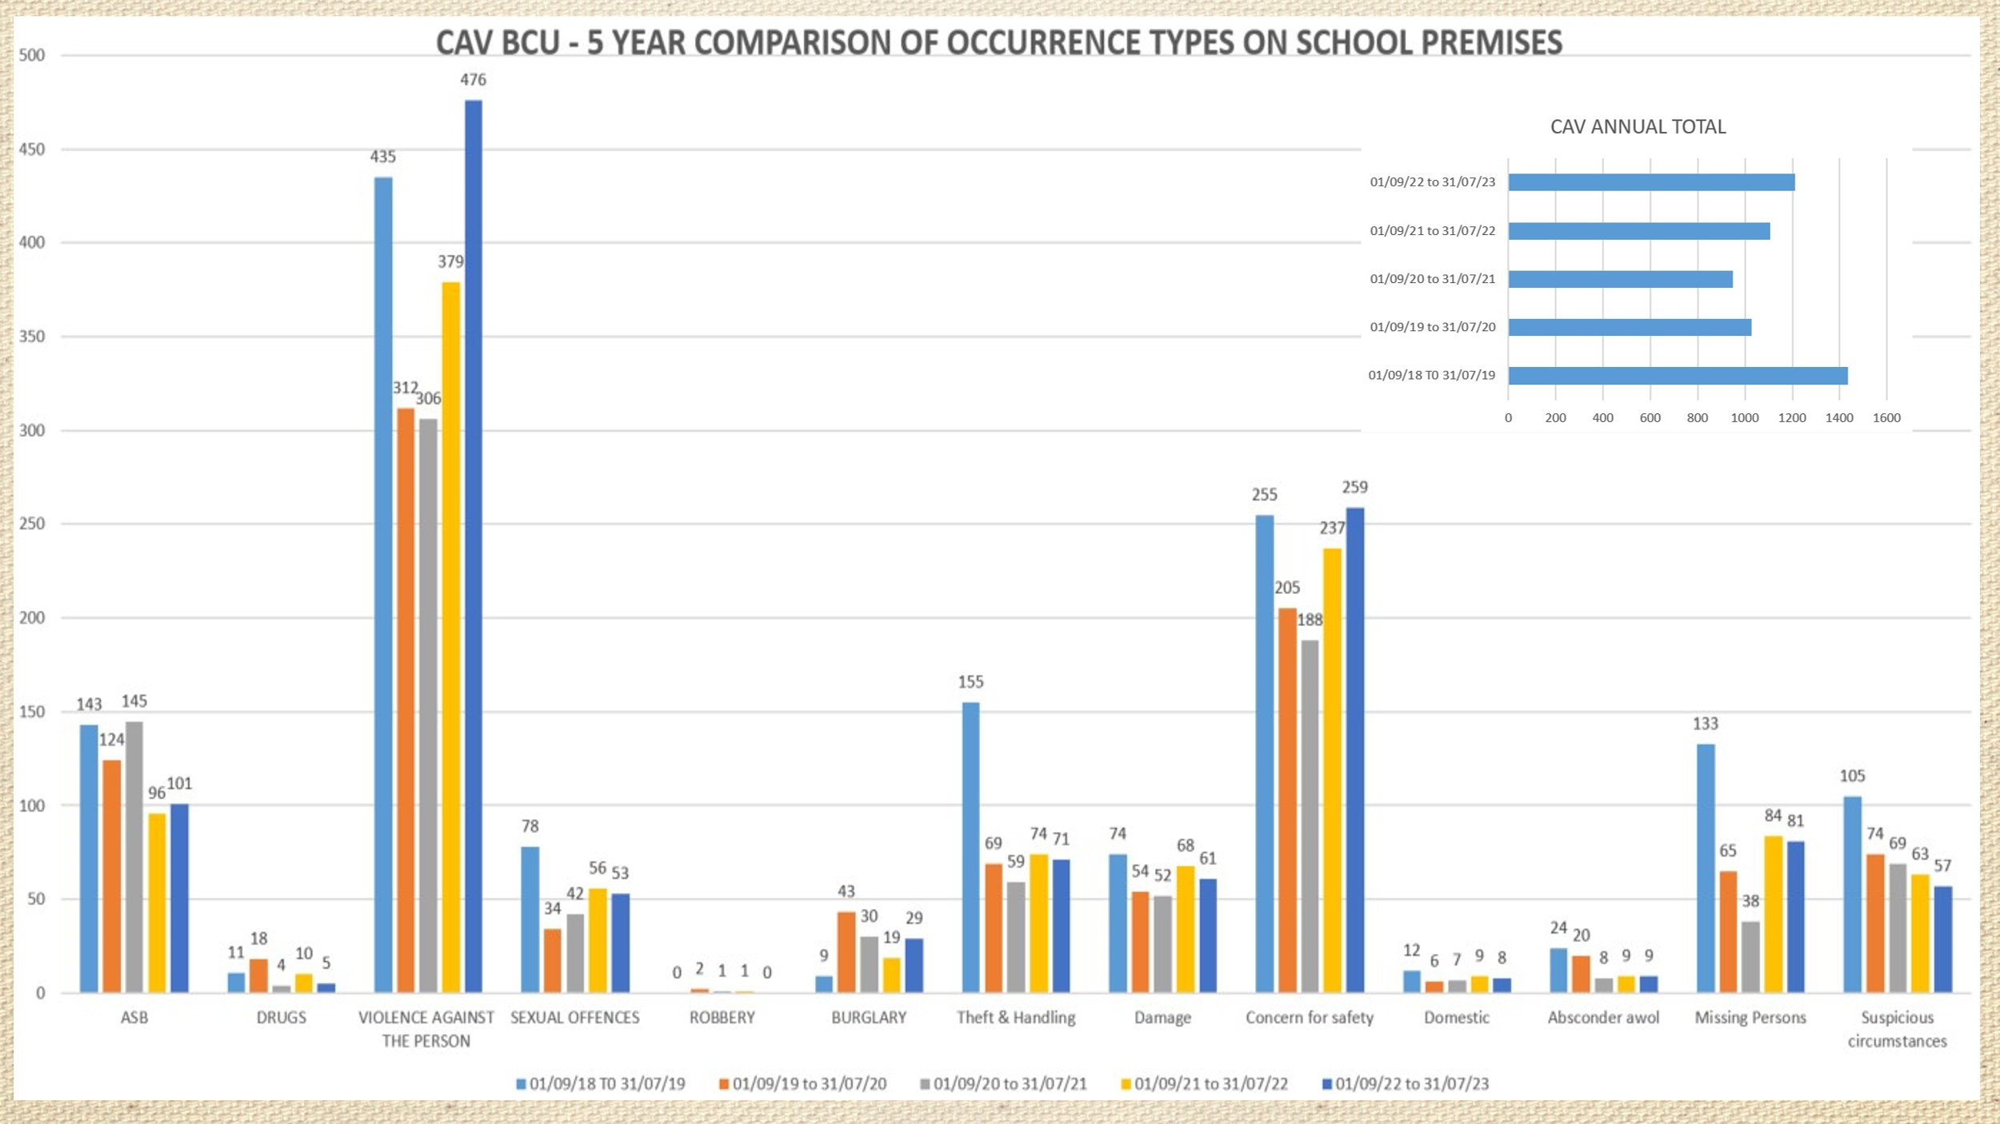
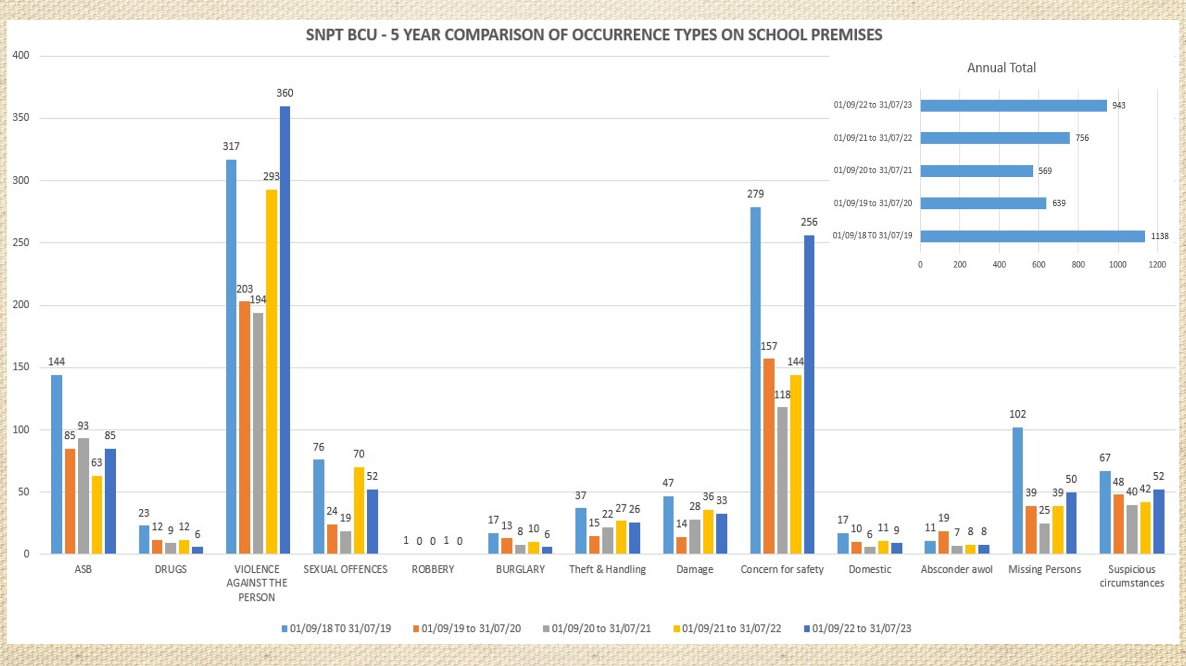
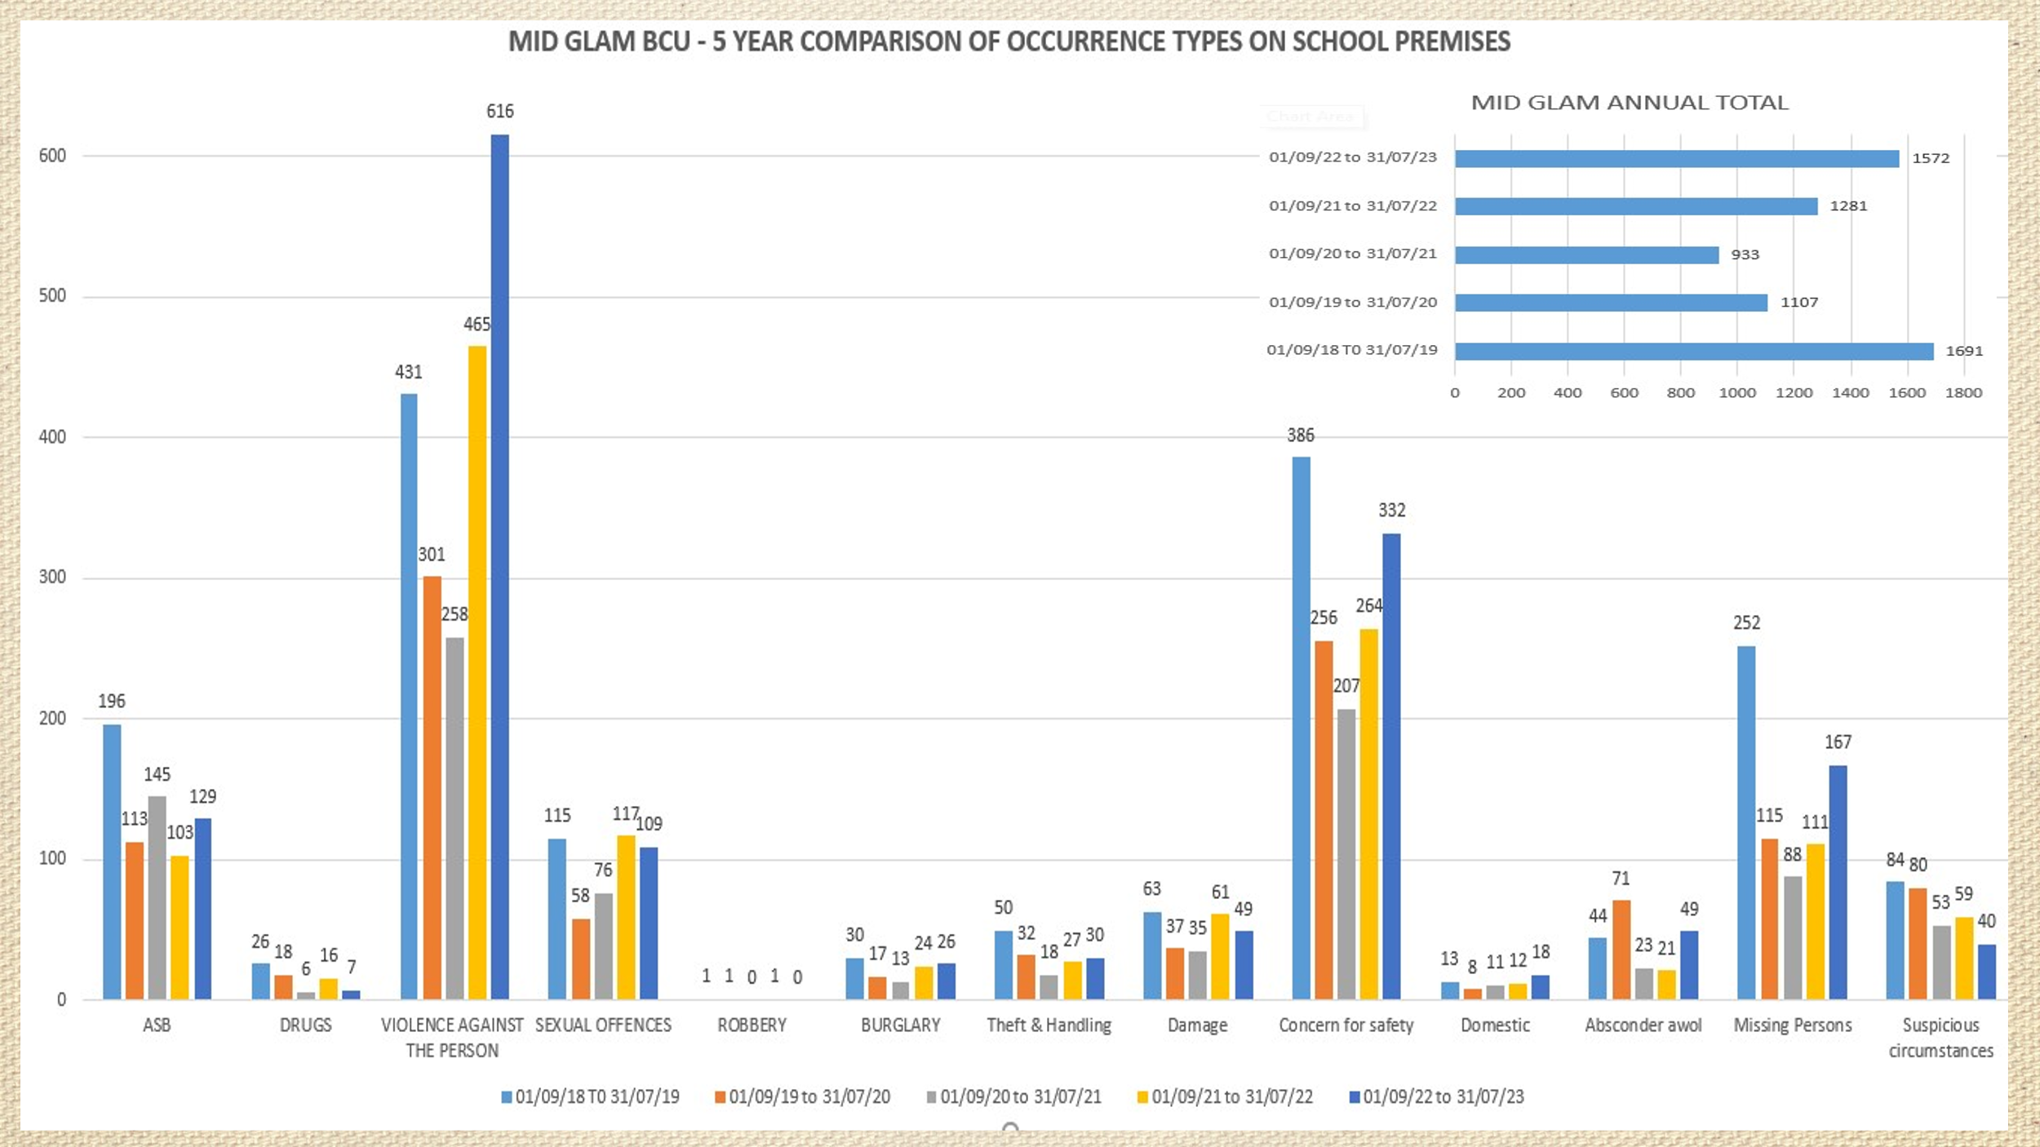

Appendix 4: School Survey

Name of School . Date Participant

Participant Job Role …………………………………………… LA
Questionnaire
Please indicate how much you agree or disagree with the following statements. (Circle the letter of the most appropriate answer to each statement).

- The role of the School Police Officer is important to our school. (This question is to ascertain how important a designated police contact is for schools, one designated to offer both supportive policing and educational inputs).
- Strongly agree
- Tend to agree
- Neither agree nor disagree
- Tend to disagree
- Strongly disagree
Please briefly explain your choice of answer.

- My overall opinion of our School Police Officer is a good one.
- Strongly agree
- Tend to agree
- Neither agree nor disagree
- Tend to disagree
- Strongly disagree

- Our School Police Officer is reliable in keeping in communication with me.
- Strongly agree
- Tend to agree
- Neither agree nor disagree
- Tend to disagree
- Strongly disagree

- Our School Police Officer is well received by our pupils in the school environment.
- Strongly agree
- Tend to agree
- Neither agree nor disagree
- Tend to disagree
- Strongly disagree

- Our School Police Officer listens well to our needs as a school.
- Strongly agree
- Tend to agree
- Neither agree nor disagree
- Tend to disagree
- Strongly disagree

- I am satisfied with the way our School Policer Officer manages school-based incidents.
- Strongly agree
- Tend to agree
- Neither agree nor disagree
- Tend to disagree
- Strongly disagree

- I am reassured by the support of our School Police Officer in managing school-based incidents?
- Strongly agree
- Tend to agree
- Neither agree nor disagree
- Tend to disagree
- Strongly disagree

- Our School Police Officer’s practices are impartial in the management of incidents that happen in a school environment. (This question aims to understand if the services by the SPO are equitable and fair regardless of pupils’ protective characteristics).
- Strongly agree
- Tend to agree
- Neither agree nor disagree
- Tend to disagree
- Strongly disagree

- I am satisfied with how our School Police Officer supports perpetrators of harm within our school.
- Strongly agree
- Tend to agree
- Neither agree nor disagree
- Tend to disagree
- Strongly disagree

- I am satisfied with how our School Police Officer supports victims of harm within our school.
- Strongly agree
- Tend to disagree
- Neither agree nor disagree
- Tend to disagree
- Strongly disagree

- Our school would be impacted if our School Police Officer supportive policing services were withdrawn?
- Strongly agree
- Tend to agree
- Neither agree nor disagree
- Tend to disagree
- Strongly disagree
Please briefly explain your choice of answer.

- School Police Officers are best placed to deliver crime prevention and law-based inputs as they have knowledge and expertise that our teachers may not have.
- Strongly agree
- Tend to agree
- Neither agree nor disagree
- Tend to disagree
- Strongly disagree.
- The educational inputs delivered by our School Police Officer to our pupils are important.
- Strongly agree
- Tend to agree
- Neither agree nor disagree
- Tend to disagree
- Strongly agree
Please briefly explain your choice of answer.

- I am satisfied with the educational inputs delivered to our pupils by our School Police Officer.
- Strongly agree
- Tend to agree
- Neither agree nor disagree
- Tend to disagree
- Strongly disagree

- The engagement our School Police Officer has with our pupils in the classroom is positive.
- Strongly agree
- Tend to agree
- Neither agree nor disagree
- Tend to disagree
- Strongly disagree

- Our pupils are comfortable in speaking with our School Police Officer in the classroom.
- Strongly agree
- Tend to agree
- Neither agree nor disagree
- Tend to disagree
- Strongly disagree

- Our school would be adversely impacted if our School Police Officer’s educational inputs were withdrawn.
- Strongly agree
- Tend to agree
- Neither agree nor disagree
- Tend to disagree
- Strongly disagree

- Please briefly explain your choice of answer. Circle the top 5 words that best describe your School Police Officer, number them one to five. You may add your own words in the choice of 5.
unfriendly
reliable
caring
Poor listener
unreliable

unapproachable
empathetic
dependable
incompetent
trustworthy
discouraging
Active listener
likable
competent
supportive
poor communicator
unfriendly
encouraging
unlikable
unknowledgeable
fair
kind
approachable
friendly
knowledgeable
unfair
uncaring
unkind
undependable
Thank-you for your participation
Catherine Lewis (Researcher)
unsupportive
incompetent
Good communicator
untrustworthy
Lacks empathy
Appendix 5: Script for Semi-structured Interviews
Thank-you for agreeing to participate in is research that aims to explore, “What impact does the Wales Police Schools Programme have on creating trust and confidence in policing within our schools”.
Although as you are aware I am the Wales Police Schools Programme manager, I am undertaking a MSC in Operational and Policing Leadership and separately from my role, I am interested as a researcher to examine the impact of the programme on creating trust and confidence in policing.
Your contribution to this work will give valuable insight into the impact of the programme. All contributions will be anonymised, your schools name nor your name will not be used in the research. You may choose to answer all, some or none of the questions today. You can withdraw from the process at any point as your involvement is entirely voluntary.
In order to make it easier to capture your views, I would like to record the meeting today using the Microsoft teams transcription tool. I hope this is agreeable to you.
The semi-structured interview should take about 30-40 minutes to conduct. I will ask 5 questions using slides to display each question. I will let you know when I am starting and finishing the recording. If after this interview you should wish to withdraw from the research, you are able to withdraw your contribution at any time up to the submission of the dissertation on the 3rd of July.

Appendix 6: South Wales Police Schools Questionnaire
1. Page 1

1. Are you a Primary Headteacher or Secondary Headteacher?
Answer Choices |  |  | Response Percent | Response Total
1 | Primary |  | 58.82% | 50
2 | Secondary |  | 15.29% | 13
3 | Special school |  | 9.41% | 8
4 | Pupil Referral Unit (PRU). |  | 3.53% | 3
5 | Cross phase |  | 0.00% | 0
6 | Other (please specify): |  | 12.94% | 11
 |  |  | answered | 85
 |  |  | skipped | 1
Other (please specify): (11)
1 | 09/04/2024 10:53 AM  ID: 241940269 | Pastoral lead and Safeguarding officer
2 | 09/04/2024 11:06 AM  ID: 241941510 | PRIMARY SCHOOL OFFICE MANAGER
3 | 10/04/2024 08:06 AM  ID: 242006077 | primary teacher
4 | 11/04/2024 08:24 AM  ID: 242081516 | Head of Year
5 | 11/04/2024 09:27 AM  ID: 242085352 | Special school deputy headteacher
6 | 15/04/2024 12:03 PM  ID: 242293694 | All Age School (3-16 years old)
7 | 16/04/2024 10:00 AM  ID: 242366946 | Head of Year - Secondary
8 | 23/04/2024 16:16 PM  ID: 242941074 | Head of Year
9 | 23/04/2024 18:54 PM  ID: 242956616 | Head of Year
10 | 24/04/2024 08:53 AM  ID: 242998414 | Through School
11 | 26/04/2024 16:44 PM  ID: 243265052 | All through school

2. How many pupils attend your school?
Answer Choices |  |  | Response Percent | Response Total
1 | 0-100 |  | 11.90% | 10
2 | 101-500 |  | 60.71% | 51
3 | 501-1000 |  | 9.52% | 8
4 | 1000+ |  | 17.86% | 15
 |  |  | answered | 84
 |  |  | skipped | 2

3. Please consider the below activities and please arrange them in order of importance to you
Item | Total Score ¹ | Overall Rank
Single point of contact for schools with policing, (designated PC) currently the role of the School Police Officer | 1173 | 1
Delivery of crime prevention inputs to pupils | 1103 | 2
Targeted lesson inputs for most vulnerable pupils | 925 | 3
Delivery of crime prevention school assemblies | 912 | 4
Decriminalising of young people - using the School Crime Beat protocol for managing school-based incidents, preventing early entry into CJS | 762 | 5
Facilitation of Restorative Justice with pupils | 744 | 6
Advice and guidance for school SMT | 729 | 7
Mentoring of young people in support of wellbeing | 712 | 8
Working collaboratively with partners to coproduce sustainable solutions to the many issues facing children and young people | 583 | 9
Signposting schools/children/parents to most appropriate services | 570 | 10
Support for victims of crime | 565 | 11
Supporting schools with interventions at a family level | 508 | 12
Helping identify vulnerability with the aim of preventing ACEs or helping young people build resilience in the face of challenges | 507 | 13
Assist in making referrals to YOT, Prevent and other channels in support of safeguarding young people and initiating early intervention approaches | 404 | 14
Other activity (please specify in the below comment box) | 123 | 15
¹ Score is a weighted calculation. Items ranked first are valued higher than the following ranks, the score is a sum of all weighted rank counts. | answered | 86
 | skipped | 0
Other activity (5)
1 | 09/04/2024 10:53 AM  ID: 241940269 | Some of our students talk to our designated PC instead of teachers as he is so approachable and provides confidentiality.
2 | 15/04/2024 13:09 PM  ID: 242301408 | It is very difficult to rank these as they are all so important to us and our school community
3 | 15/04/2024 15:12 PM  ID: 242315628 | Police presence on the yard at the end of the day.
4 | 23/04/2024 15:51 PM  ID: 242937344 | This is a hugely important service to us and one we need more than ever.
5 | 23/04/2024 16:22 PM  ID: 242941735 | Variety of lessons that are delivered to wide range of pupils

