Student Name: Joshua Ward
P Number: 2004000
Programme of Study: Product and Furniture Design
Module: ADAD4018
Ways of Thinking Lecturer’s Name: Julia Lockheart

Tasks in the order I received them:
Task 1: Observational Writing = 573 words
Task 2: Manifesto Writing = 620 words
Task 3: Practice-based Writing = 326 words

Task 1: Observational Writing
When you look around the world, you see a world full of many products, whether its your phone, kitchen equipment or maybe just your furniture. We are always using products and design in our day to day lives (The Design of Everyday Things, 2013). Studies have shown that the design of our surroundings can impact human behaviour (Heywood, 2017), could this suggest that human behaviour adapts as design does?

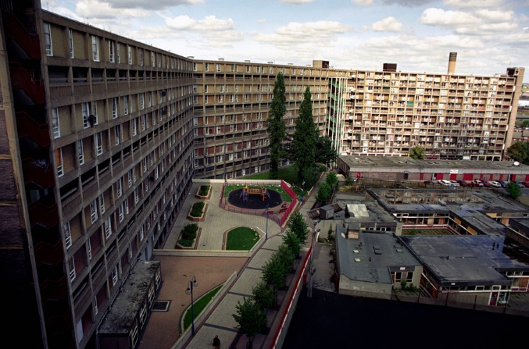
Image 1. Park Hill estate before it was renovated
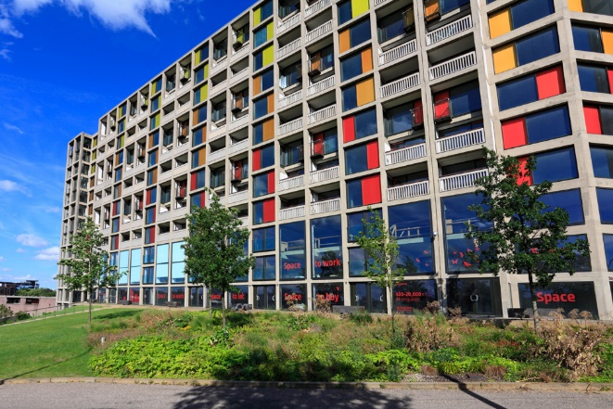
Image 1. Park Hill estate after it was renovated
Studies have suggested a link between brutalist, poorly built council estates and crime. I believe personally that the brutalist architecture creates a gloomy mood for everyone there, potentially increasing crime. After the Park hill estate was renovated, crime saw a noticeable drop. Rachel Fisher, head of policy at the national housing federation hails it as “Designing out crime”.
The issue is, after World War II, Britain needed a lot of homes and fast, so instead of focussing on design and making everything look nice, it was rushed for the sake of “quality over quantity”. At the time this worked, and nobody really minded, but I now feel we are seeing the consequences at a lack of planning of a long-term design and is costing us more money as we are having to redevelop buildings to look better when they could have just been planned and designed nicely in the first place. If they were designed with thought, perhaps we would be saving a lot of money now.

We also rely on design for more complex ideas like safety. Often you see designs in everyday life and do not even realise some lesser-known features added in, potentially for people with disabilities. For example, the tactile pavement has different patterns, it is not for looks, each pattern on the tactile pavement tells you why it is warning you, whether it is at a road crossing, a train station platform, or the top of a staircase.

I believe it is very difficult however to determine whether you can actually “Design out crime”. It could just be that if someone is poorer; and as a result, live in a poorer, less affluent looking area, they are more likely to be sucked into a life of crime. There are some who like the Brutalist style of design and want it kept. I wholeheartedly disagree. I find brutalism almost hard to look at, it just is not pleasant. I have visited council estates and the older ones do have a cold feeling to them; it made me not want to be there compared to the newer built council estates (Modernist Estates — Europe: The Buildings and the People who Live in Them Today, 2019).

There could also be a link between how people perceive brutalist architecture and its links to communist countries. Many communist countries to this day have brutalist architecture all throughout. A society that associates the word “communist” with negativity would likely see anything involved with it in a negative light and therefore have the brutalist architecture used extensively in Britain in the 60’s in a negative light. In general, I do believe there is a link between design and how people behave, but I do believe there are many other factors to people’s behaviour too, we don’t just base our behaviour of what design looks like around us or we would be all over the place whenever we moved around.

Bibliography:
Heywood, I (2017) Sensory Arts and Design Routledge; 1st edition
Norman, D. (2013) The Design Of Everyday Things. Revised and Expanded Edition.
Devlin, K. (2016) What makes estates 'brutal'?
Adil, S. (2017) Tactile Paving. Available at: https://medium.com/five-guys-facts/tactile-paving-8038ffd80ab7 (Accessed: 19 April 2021).
Orazi, S. (2013) Modernist Estates – Europe: The buildings and the people who live in them today

Task 2: Manifesto Writing
- Always go into a conversation or debate with an open mind.
- The sky isn’t the limit if man made it to the moon.
- Freedom of speech, expression, assembly are the most important rights we have and shouldn’t be infringed.
- The news and media often portray who they dislike in a negative way and distort and mislead people into believing it.
- Design is subjective on what makes it successful.
- Often the more radical or crazy ideas turn out to be the way forward.
- Form vs function, often people buy products just because they look good even if they don’t work as well.
- Wealth isn’t measured by money but with happiness.
Open-mindedness is often key to progress and without realising it people may be inhibiting themselves by not approaching life with an accepting attitude. In art if you look at something and immediately dismiss it, you may miss the point of what the art is trying to portray, it is not always obvious or clear. Research has shown that non-judgemental people often have a different view of the world and are “happier, healthier and more creative” (Oppong, 2019). A lot of this stems from the fact that when you open your mind up, you start to realise the possibilities of the world, you may think the world is dark but if you open your mind more you may find new wonders you never thought of. This is how some of the more radical ideas come to exist, people being open-minded to approaching design problems.
Often, I have also thought that form can often be just as important if not sometimes more important than function. A prime example I have researched into is the idea of “Designing out crime”. Often when housing estates and other buildings are built, historically the actual look and feel of them have been neglected. Research has shown that when an area looks depressing and dull, it can have a huge impact on the people who live there, it can alter their mood (Colquhoun, 2003). This isn’t done as often anymore as decades ago there was a huge demand for housing, so buildings were rushed as fast as possible with no care for how they looked. A lot of the stigma against how things look has to do with how people are brought up and raised. Seeing darker colours like Grey are moody and dull and brighter colours are often happier.
This also relates to the media and how they portray certain things. If the media started portraying Grey as the best and brightest colour all the time, it would start gradually having an impact. My grandparents and anyone from the older generations in general typically prefer an older looking style in their homes, it is just because that is what they grew up with and are used to, they are comfortable with it, a common conception is that older people do not like change, this is shown through their hesitance of changing the style of their home.
I have always said to myself that I would rather have a job that I enjoy than one that pays well, I could be wealthy but miserable at my job and that does seem to be the consensus among people. Not only can design bring joy to the designer but it can also bring joy to the people you are designing for, this also links back to designing out crime where if you design a new estate that makes the residents happy, that is bringing joy to other people’s lives. That is what I believe designers should strive to do, this relates to my other points that certain designs can bring people joy.
Bibliography
Oppong, T (2019). “Research shows that open-minded individuals see the world differently — and as a result are happier, healthier, and more creative” [Online] Available at: https://www.businessinsider.com/personality-traits-open-minded-benefits-2019-10?r=US&IR=T [Accessed on: 19th April 2021]
Colquhoun , I. (2003). Design Out Crime, Routledge; 1st edition

Task 3: Practice-based Writing:
Frank Lloyd Wright is an interesting designer, although he is an architect, I still find his style interesting and I do actually believe you can incorporate a lot of architecture into product design. I would say it is not the fact he designs architecture that I like him, its his style. He likes to incorporate nature and organicism in his designs (Wright, 2017). His designs are almost “in harmony with humanity and its environment” which helps educate and make people realise what the natural world is really like. I know for a fact that his style of organic architecture can be adapted into product design where we can design organic looking products or furniture. Perhaps a chair that merges into its natural surroundings. Frank Lloyd Wright was a strong believer in individualism but did take inspiration from many sources including Japanese art and buildings, Nature and music.
Not all of Frank Lloyd Wright’s work was buildings either, he did work on furniture such as the “Peacock chair” which he designed for the Imperial hotel in Tokyo. I believe in general; Frank Lloyd Wright was trying to encourage more design thinking at a time when buildings and products were often rushed to favour quantity over quality. This in turn made for not very good products. His nod to organic designs and using nature more in his ideas could also be a show of support for the climate change movement which at the time of his designs wouldn’t have been very big. A lot of Japanese architecture is considered pretty and in keeping with the natural world, this could be why he used Japanese art and buildings for inspiration for a lot of his work.
Frank Lloyd Wright links back to my point about new radical ideas are not always that bad, as long as we look at his designs and anyone else’s designs with an open mind, we might discover something that turns out to be amazing.

Bibliography
Wright, F.L. (2017). An Organic Architecture: The Architecture of Democracy, Lund Humphries Publishers Ltd; New edition

