COURSEWORK PORTFOLIO
Pharmacy Services and
Community Mental Health Services
Student name | Gillian Gibbs
Student ID | 2508019
Module name | Introduction to Health and Social Care
Module code | LCHS4003
Lecturer name | Muhammed Aliyu

Contents
Task 1: Pharmacy Services – Poster | 3-4
Task 2: Community Mental Health Services -- Essay | 5-6
References | 7-8

Acknowledgement of AI
Artificial intelligence was not used in the preparation of this portfolio, only for proofreading.
All research, analysis, arguments, and conclusions presented in this report are my own.

Pharmacy Services

What are pharmacy services?  Pharmacy services are accessible, and person-centred healthcare services delivered by pharmacists and pharmacy teams in community, hospital and primary-care settings. Their role extends beyond supplying medicines to include clinical assessment, prevention, health screening, vaccination, medicines optimisation and referral. In England, NHS community pharmacy services operate within a contractual and clinical-governance framework intended to support safe, effective care (Cunha Leal et al., 2025; DHSC and NHS England, 2025).  Accessible without an appointment  Scope note: the contractual framework described here applies to community pharmacy in England. | How NHS community pharmacy is commissioned  Sources: DHSC and NHS England (2025); House of Commons Library (2026a).
  ESSENTIAL | Required services include dispensing, repeat dispensing, disposal of unwanted medicines, public health promotion, signposting and support for self-care.
  ADVANCED | Nationally specified services that pharmacies may provide when accreditation and service requirements are met, including Pharmacy First, vaccinations and the New Medicine Service.
  ENHANCED | Services commissioned by NHS England where additional provision is needed beyond the national essential and advanced offer.
  LOCAL | Services commissioned according to local need by integrated care boards or local authorities, such as locally designed prevention and treatment schemes.

A brief history: from apothecaries to clinical pharmacy
1180 | 1617 | 1841 | 1852/1868 | 1948 | 2003/2006 | 2010 | Today
Guild of Peppers helped regulate the trade in medicinal substances. | A royal charter created the Society of Apothecaries, separating apothecaries from grocers. | The Pharmaceutical Society of Great Britain promoted education and professional standards. | Pharmacy Acts created registration and restricted the sale of scheduled poisons. | The NHS integrated community and hospital medicine supply into universal healthcare. | Pharmacists gained supplementary, then independent, prescribing rights. | The GPhC became the regulator; the RPS became the professional leadership body. | Pharmacy combines medicine supply with clinical care, prevention and public health services.

Sources: Holloway (1991); Anderson (2007); Department of Health (2008); GPhC (2010).

How pharmacy services function today
1 ACCESS | 2 ASSESS | 3 ACT | 4 REFER | 5 RECORD
A person attends directly or is referred by a GP, NHS 111 or another service. | The pharmacist gathers information, checks symptoms, medicines and clinical risk. | Advice, treatment, dispensing, vaccination or another commissioned service is provided. | Urgent, complex or out-of-scope needs are referred to an appropriate professional. | Care is documented, and relevant information is securely shared with the GP or NHS.

Sources: GPhC (2018); DHSC and NHS England (2025).

Challenge 1: funding and financial sustainability  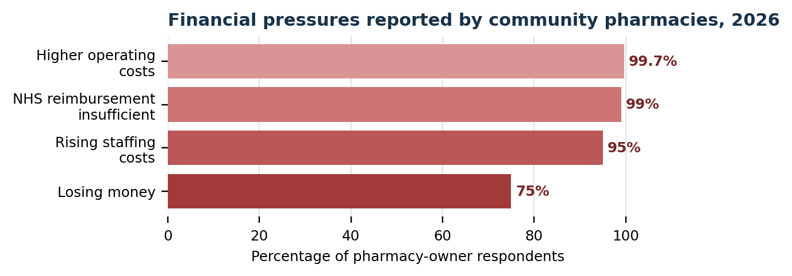  The 2026 survey indicates that funding and reimbursement remain misaligned with operating and medicine costs. Although the 2026/27 settlement increased funding, continued losses can restrict investment, opening hours and capacity to expand clinical care.  Chart recreated from original data—source: Community Pharmacy England (2026a; 2026b). | Challenge 2: operational capacity and patient access  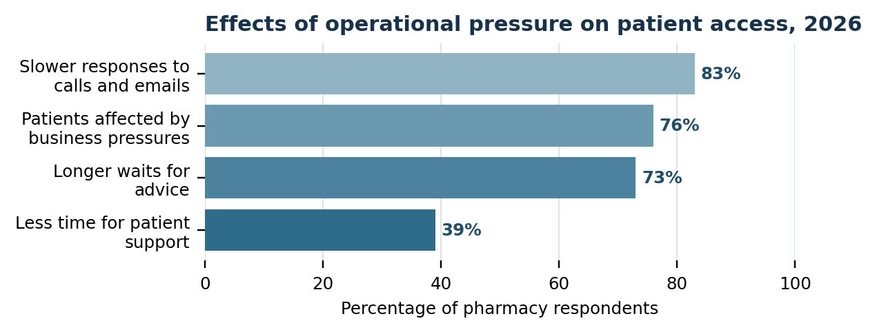  Growing clinical responsibilities compete with time spent sourcing medicines and managing cost pressures. The consequences are visible to patients through delayed responses, longer waits and less time for advice, weakening pharmacy’s role as an accessible first point of care.  Chart recreated from original data—source: Community Pharmacy England (2026b).
KEY MESSAGE | Pharmacy has developed from a medicine-supply profession into an accessible clinical service. Its contribution to prevention and NHS capacity depends on funding and staffing to keep pace with its expanded role.

Community Mental Health Services
Community mental health services provide assessment, treatment and social support while enabling people to remain in their homes and communities. This essay examines their historical development in England, evaluates contemporary delivery and considers their contribution to quality of life.
Before community provision became dominant, people with severe mental illness were commonly treated in large, long-stay psychiatric hospitals. Although these institutions offered shelter and specialist care, segregation could restrict autonomy and separate people from family and community life (Wright, Bartlett and Callaghan, 2008). Post-war changes in treatment and social attitudes encouraged deinstitutionalisation, but the transition was neither automatic nor consistently progressive (Calabria and Cullen, 2024). The development of effective psychiatric medications and growing criticism of long-term institutional care also supported the shift towards treating people in less restrictive, community-based settings (Calabria and Cullen, 2024; Wright, Bartlett and Callaghan, 2008). The Mental Health Act 1959 supported informal treatment and a movement towards community provision (Mental Health Act 1959; Wright, Bartlett and Callaghan, 2008). Powell’s 1961 ‘Water Tower’ speech then anticipated closure of much of the asylum system and greater use of local and general hospital services (Nuffield Trust, n.d.). Implementation was slow as financial constraints meant community services remained limited even after national policy had changed (Calabria and Cullen, 2024).
The 1989 white paper Caring for People sought clearer assessment, care management and local accountability, and these principles were later reinforced through the National Health Service and Community Care Act 1990 (Department of Health, 1989; Langan, 1990; National Health Service and Community Care Act 1990). The reforms created a mixed system involving the NHS, local authorities, voluntary organisations and informal carers. However, closing hospital beds without equivalent investment in housing, social care and continuing treatment exposed gaps between policy ambitions and service users’ experiences (Jones, 1993; Calabria and Cullen, 2024). Modern community services therefore emerged not simply as a replacement for hospitals but as a means of coordinating clinical and social support within everyday life.
Today, community provision includes Community Mental Health Teams (CMHTs), Crisis Resolution and Home Treatment Teams, Early Intervention in Psychosis services and NHS Talking Therapies for anxiety and depression. Referral may occur through primary care, self-referral or urgent pathways. Multidisciplinary teams can combine psychiatry, nursing, psychology, occupational therapy, social work, medicines management and peer support. NHS England (2019) argues that this place-based model should provide personalised, trauma-informed care alongside physical health, employment and social support. NHS Talking Therapies also offers evidence-based interventions for common anxiety and depression, often through self-referral (NHS England, 2024). These arrangements can be more accessible and holistic than care organised solely around hospital treatment.
Nevertheless, provision remains uneven. Thresholds between primary care, Talking Therapies and specialist CMHTs can leave people with substantial needs in a ‘missing middle’, while workforce vacancies, demand and waiting times restrict continuity and preventive work (House of Commons Library, 2024a; 2026b). A nominally community-based system may therefore become reactive, offering intensive help only after deterioration. Local variation also challenges equitable access, and repeated assessments or transfers can undermine therapeutic relationships. Community location alone does not guarantee timely, coordinated or person-centred care.
When adequately resourced, these services can improve quality of life by supporting autonomy, housing, family relationships, education and employment. Care in familiar surroundings may reduce disruption, while shared planning can increase choice and control (NHS England, 2019). Crisis and early-intervention services may prevent avoidable admission, but delayed access and fragmented follow-up can increase distress and carer pressure (House of Commons Library, 2024a). Quality of life, therefore, depends on continuity, cultural responsiveness, and integration across health, social care, housing and voluntary services. Overall, deinstitutionalisation enabled a more recovery-focused approach, but its promise is fulfilled only when community support is available before needs escalate into crisis.

References
Anderson, S. (2007) ‘Community pharmacy and public health in Great Britain, 1936 to 2006: how the phoenix rose from the ashes’, Journal of Epidemiology and Community Health, 61(10), pp. 844–848. Available at: https://doi.org/10.1136/jech.2006.055442 (Accessed: 30 July 2026).
Calabria, V. and Cullen, L.T. (2024) ‘Deinstitutionalisation and the move to community care: comparing the changing dimensions of mental healthcare after 1922 in the Republic of Ireland and England’, History of Psychiatry, 35(2), pp. 141–157. Available at: https://doi.org/10.1177/0957154X241231057 (Accessed: 3 August 2026).
Community Pharmacy England (2026a). CPE secures 10% funding rise but pushes for reform. Available at: https://cpe.org.uk/our-news/cpe-secures-10-funding-rise-but-pushes-for-reform/ (Accessed: 3 August 2026).
Community Pharmacy England (2026b). Pharmacy pressures hitting patients. Available at: https://cpe.org.uk/pharmacy-pressures-hitting-patients/ (Accessed: 3 August 2026).
Cunha Leal, M.L.G., Rodrigues, A.R., Bell, V. and Forrester, M. (2025) ‘Exploring the evolving role of pharmaceutical services in community pharmacies: insights from the USA, England, and Portugal’, Healthcare, 13(15), 1786. Available at: https://doi.org/10.3390/healthcare13151786 (Accessed: 30 July 2026).
Department of Health (1989). Caring for People: Community Care in the Next Decade and Beyond. London: HMSO.
Department of Health (2008). Pharmacy in England: Building on Strengths – Delivering the Future. London: Department of Health. Available at: https://assets.publishing.service.gov.uk/media/5a7bff2340f0b645 (Accessed: 30 July 2026).
Department of Health and Social Care and NHS England (2025). Community Pharmacy Contractual Framework: 2024 to 2025 and 2025 to 2026. Available at: https://www.gov.uk/government/publications/community-pharmacy-contractual-framework-2024-to-2025-and-2025-to-2026 (Accessed: 30 July 2026).
General Pharmaceutical Council (2010). The Pharmacy Order 2010: The Establishment of the General Pharmaceutical Council. Available at: https://www.legislation.gov.uk/uksi/2010/231/contents (Accessed: 30 July 2026).
General Pharmaceutical Council (2018). Standards for Registered Pharmacies. Revised June 2018. Available at: https://assets.pharmacyregulation.org/files/document/standards_for_registered_pharmacies_june_2018_0.pdf (Accessed: 30 July 2026).
Holloway, S.W.F. (1991). The Royal Pharmaceutical Society of Great Britain 1841–1991: A Political and Social History. London: Pharmaceutical Press.
House of Commons Library (2024a). Mental Health Policy and Services in England. Research Briefing CBP-7547. Available at: https://commonslibrary.parliament.uk/research-briefings/cbp-7547/ (Accessed: 30 July 2026).
House of Commons Library (2026a). Community Pharmacy in England. Research Briefing CBP-9854. Available at: https://commonslibrary.parliament.uk/research-briefings/cbp-9854/ (Accessed: 30 July 2026).
House of Commons Library (2026b) Mental Health Statistics: Prevalence, Services and Funding in England. Research Briefing SN06988. Available at: https://commonslibrary.parliament.uk/research-briefings/sn06988/ (Accessed: 30 July 2026).
Jones, K. (1993) Asylums and After: A Revised History of Mental Health Services. London: Athlone Press.
Langan, M. (1990). ‘Community care in the 1990s: the community care White Paper: Caring for People’, Critical Social Policy, 10(29), pp. 58–70. Available at: https://doi.org/10.1177/026101839001002904 (Accessed: 3 August 2026).
Mental Health Act 1959 (1959). c.72. Available at: https://www.legislation.gov.uk/ukpga/Eliz2/7-8/72/contents (Accessed: 3 August 2026).
National Health Service and Community Care Act 1990 (1990) c.19. Available at: https://www.legislation.gov.uk/ukpga/1990/19/contents (Accessed: 30 July 2026).
NHS England (2019). The Community Mental Health Framework for Adults and Older Adults. Available at: https://www.england.nhs.uk/wp-content/uploads/2019/09/community-mental-health-framework-for-adults.pdf (Accessed: 30 July 2026).
NHS England (2024). NHS Talking Therapies for Anxiety and Depression Manual. Version 7.1. Available at: https://www.england.nhs.uk/wp-content/uploads/2018/06/nhs-talking-therapies-manual-v7.1-updated.pdf (Accessed: 30 July 2026).
Nuffield Trust (n.d.). NHS Reform Timeline. Available at: https://www.nuffieldrust.org.uk/features/nhs-reform-timeline (Accessed: 3 August 2026);
Wright, N., Bartlett, P. and Callaghan, P. (20080. ‘A review of the literature on the historical development of community mental health services in the United Kingdom’, Journal of Psychiatric and Mental Health Nursing, 15(3), pp. 229-237. Available at: https://doi.org/10.1111/j.1365-2850.2007.01218.x (Accessed: 3 August 2026).

