

Program: MSC Data and Artificial Intelligence
Student ID: 2431449
Student Name: Prexakumari Maganbhai Ahir
Module Code: ACCA7028
Module: Data Security, Governance and Compliance
Lecturer: Dr Muhammad A. Abbas

Contents
1. Introduction 3
2. Literature Review 4
2.1 ISO/IEC 27000 Family 4
2.2 NIST Cybersecurity Framework (CSF) 4
2.3 ITIL Framework for IT Service Management 6
2.4 COBIT (Control Objectives for Information and Related Technology) 7
2.5 Synthesis and Comparison of Frameworks 8
3. Proposed Security Governance Framework for NatureGreen 11
4. Critical Discussion of Regulations and Standards 14
4.1 Dynamic Nature of Cyber Threats 14
4.2 Regulatory Evolution and Compliance Pressure 14
4.3 Business Continuity and Reputation Management 15
4.4 Continuous Improvement Philosophy 15
5. Recommendations 15
6. Conclusion 17

1. Introduction
The growth of worldwide reliance on web-related activities has increased the vulnerability to cybercrime, which requires strong cybersecurity control and adherence. Digital systems and cloud infrastructure play a critical role in modern enterprises, making them susceptible to data breaches, unauthorized intrusion, and violation of compliance. NatureGreen (NG) is a multinational health and wellness corporation and experiences tremendous information security concerns with typical of its typical large cloud-based network, operation on a global scale, and an increasing trend of demand for Bring Your Own Devices (BYOD). A lack of a formal security policy increases the vulnerabilities to data confidentiality, customer privacy, and intellectual property security. This report focusses on investigating established data security frameworks and models (ISO/IEC 27001, NIST, and ITIL) to develop an effective governance and compliance strategy towards NG. This aims at establishing an organized, safe, and flexible information management system, which fosters resilience, security of digital resources, and complying and following international data protection models.

2. Literature Review

2.1 ISO/IEC 27000 Family
The ISO/IEC 27000 family (particularly the ISO 27001 and IS 27002) provides a close-up guideline on the development and maintenance of an Information Security Management System (ISMS). It offers a methodological framework for taking care of information property protection to the sub-thrusters of Confidentiality, Integrity, and Availability (CIA) triad [15]. The implementation of the security controls is specified under the ISO 2700,1, and a new document is the best practices associated with the selection and implementation of controls under the ISO 27002. The most important attribute of the framework is the Plan-Do-Check-Act (PDCA) cycle that improves the constant improvement of risk management and the effectiveness of policies. However, ISO/IEC 27001 is resource-intensive to implement, and the workload for documentation often is extensive for most organizations to get certified. This makes it less flexible for fast-changing environments such as cloud-based businesses[11].

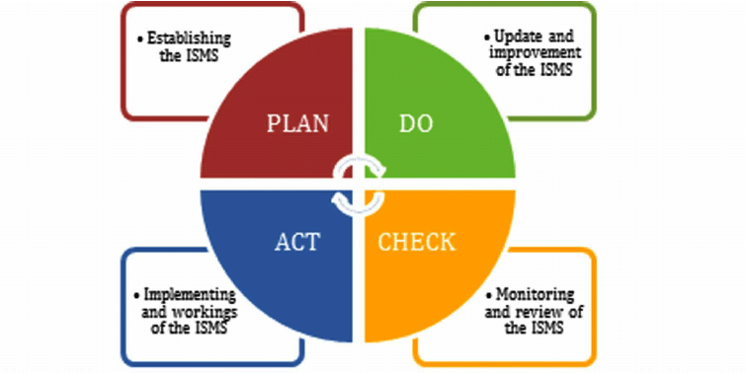
Figure 1: ISMS PDCA process

It is a cyclical model, and it helps organizations readjust in line with the evolving threats and remain within the frame of reference. The advantages of the ISO 27001 certification are its adherence to the international standards, a sign of faith in the stakeholders, and the legal and reputational guarantee [2]. NatureGreen used to adopt the ISO 27001 in case would establish formalized security governance, cloud and wireless infrastructure risk-based controls, and an auditable compliance route.

2.2 NIST Cybersecurity Framework (CSF)
NIST Cybersecurity Framework (CSF) is a framework of cyber risk management that brings a detailed but flexible approach to the framework through five functions that are conducted, including Identify, Protect, Detect, Respond, and Recover[15]. It is through these functions that a holistic life-cycle-based approach to managing cybersecurity is created. The NIST CSF assists the organizations in assessing the current security position and in scaling up risk-based, scale security according to business objectives. Its adaptability makes it applicable in diverse contexts, which include cloud-based applications and BYOD (Bring Your Own Device) systems such as NatureGreen. NIST CSF provides practical real-world guidance on cyber defence, is not certifiable, and is fundamentally based upon self-assessment, which often leads to variable implementation within departments[12].

Aspect | ISO 27001 | NIST CSF
Focus | Formal ISMS for managing information security. | Risk-based framework for cyber resilience.
Structure | Follows the PDCA (Plan–Do–Check–Act) cycle. | Built on five functions: Identify, Protect, Detect, Respond, Recover.
Scope | Organization-wide, certifiable standard. | Flexible, non-certifiable guidance.
Risk Approach | Formal risk assessment (ISO 27005). | Tiered, scalable risk management.
Use for NG | Best for governance and compliance. | Best for detection and incident response.
Table 1: Comparison between ISO 27001 and NIST CSF
The mitigation strategy prioritization framework has a risk-tier approach, which allows organizations to prioritize mitigation strategies and allocate resources efficiently. In addition, an appendix of ISO 27001 is focused on actual practice threat detection and response operations [4]. The NIST functional structure used in the case of NatureGreen would help in constant monitoring, vulnerability detection over time, and immediate restoration of the circumstances. NIST principles can be applied to make the operations more resilient and offer some data confidentiality to distributed and mobile-enabled networks[4].

2.3 ITIL Framework for IT Service Management
The Information Technology Infrastructure Library (ITIL) framework is focused on the provision of optimal IT services by aligning the work of technology with a business strategic purpose [5]. It outlines a structured approach to service management throughout its life cycle, encompassing Service Strategy, Service Design, Service Transition, Service Operation, and Continual Service Improvement. Under the framework of security governance, the Service Operation and Service Transition phases of ITIL become instrumental in the context of sustaining the incident response processes, configuration management, and changes.

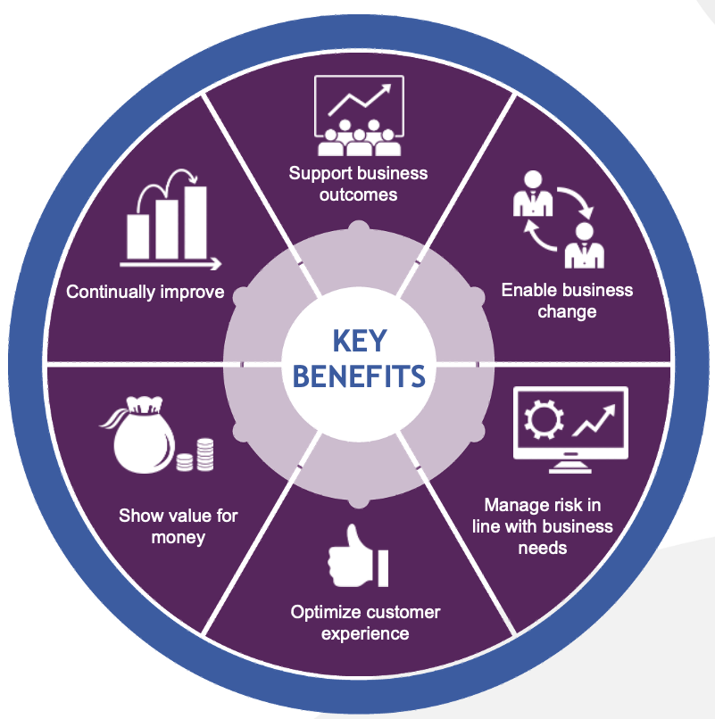
Figure 2: Benefits of the ITIL framework
These levels allow all service changes to be assessed in terms of risks and within accepted policies. ITIL also strengthens accountability, consistency of the processes, and transparency of governance, as part of the duties have security responsibilities that are obviously distributed between teams. ITIL enables NatureGreen to efficiently manage its cloud and wireless environment by defining standard procedures for user access, service downtimes, and problem prioritization.

2.4 COBIT (Control Objectives for Information and Related Technology)
A management and governance system designed by ISACA to ensure that the IT of an enterprise is utilized in supporting strategic business objectives and proper control and compliance. COBIT 2019 organizes its processes into Governance and Management domains, emphasizing Align, Plan, and Organize; Build, Acquire, and
Implement; Deliver, Service, and Support; and Monitor, Evaluate, and Assess [8]. COBIT can be used in combination with ISO 27001 and ITIL and offers a more detailed layer of governance based on value creation, compliance ratings, and accountability. An adequate introduction of COBIT in NatureGreen provide the governance structure that enhance the performance assessment and adherence to the data protection requirements, resulting in higher transparency, less inefficiency, and control maturity.

2.5 Synthesis and Comparison of Frameworks
The comparative study of the four models, such as “ISO 27001, NIST CSF, ITIL, and COBIT”, it is possible to note that each of them has its own advantages to the information security and governance landscape of an organization [5]. Information Security Management System (ISMS) offered by ISO 27001, offers a solid basis for the governance and compliance of the system and improvement on a continuous basis through the PDCA cycle. In comparison, NIST CSF provides a practical, risk-based model that is aimed at improving the detection, response, and recovery capabilities, and it is reflected more so in the cloud and BYOD setting, like that of NatureGreen. ITIL assists in the operation governance, as it standardizes the process of service management, provides service continuity, and efficient handling of incidents. COBIT provides IT governance and performance measures at an enterprise level, and this achievement aligns strategic goals of technology and business [8][15].
Framework | Focus Area | Strengths | Limitations
ISO 27001 | Information Security Management System | Strong compliance, auditability, PDCA-driven continual improvement | Rigid, resource-intensive implementation
NIST CSF | Cybersecurity Risk Management | Flexible, risk-based, enhances detection and recovery | Non-certifiable, high reliance on self-assessment
ITIL | IT Service Management | Improves operational efficiency and service continuity | Limited coverage of strategic governance
COBIT | IT Governance and Control | Strategic alignment, performance monitoring, and accountability | A complex structure requires extensive maturity
Table 2: Comparison table
When ISO compliance, NIST flexibility, ITIL operational orientation, and COBIT governance are properly integrated. NatureGreen can establish an effective and robust security governance system that can efficiently deal with its complex cloud and wireless threats.

3. Proposed Security Governance Framework for NatureGreen
This multilayered architecture is suitable for NatureGreen since it separates strategic governance from technical controls, thus facilitating the management of its complex environment composed of cloud services, wireless networks, and BYOD devices. In each of the layers, specific attention is paid to different security needs, thereby reducing the chances that a single weakness could compromise the entire organization. This structure provides stronger protection against both internal and external threats. The Governance and Compliance Layer align with ISO 27001 by providing policies, roles, risk management processes, and continuous improvement by means of the PDCA cycle.
The Security Management Layer supports the NIST CSF functions: Identify, Protect, Detect, Respond, and Recover by means of monitoring, incident response, and SOC activities. The User and Device Layer reflects ITIL's service-oriented approach through the assurance that user access, authentication, and device management are done in controlled, standardized processes[7]. The Technical Control Layer connects to the ISO 27001 Annex A controls and NIST cloud security practices, therefore giving strong protection for network, applications, and endpoints. Thus, by combining these layers, NatureGreen achieves a model of defence-in-depth that is critical for the protection of its intellectual property, customer data, and global digital services.
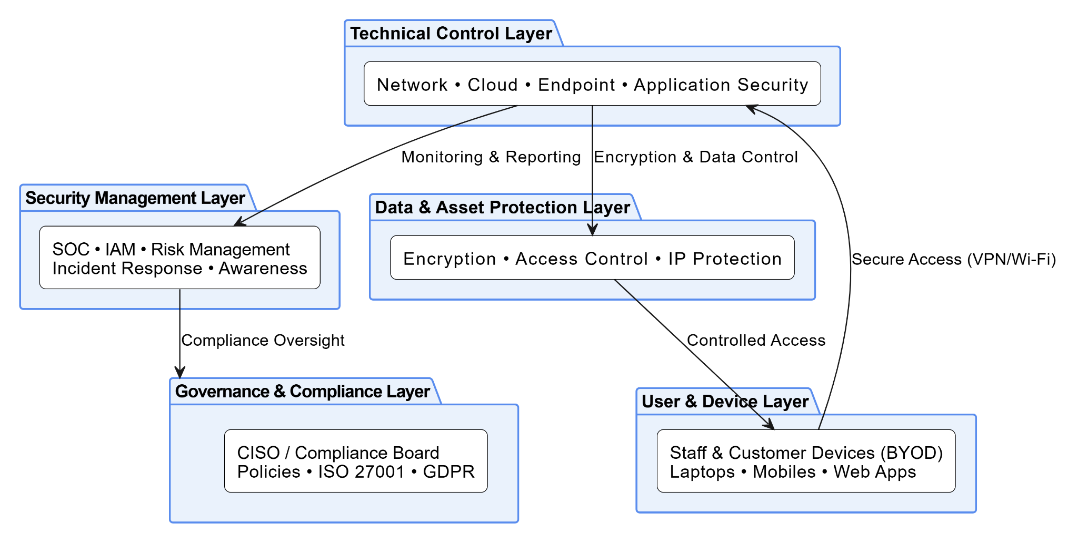
Figure 3: Architecture diagram of Information Security & Governance of NatureGreen
The Information Security and Governance Architecture of NatureGreen (NG) presented is crafted as a multi-layered structure to create a resilient yet structured and policy-based security environment. This architecture aligns the strategic oversight with the technical implementation to safeguard NG data, assets, and intellectual property. It has five related layers: Technical Control, User and Device, Data and Asset Protection, Security Management and Governance, and Compliance. These layers in combination create a holistic ecosystem to enable proactive risk management, regulatory compliance, and overall cybersecurity governance improvement.

Technical Control Layer:
The nature of the information security architecture of NatureGreen (NG) is based on the Technical Control Layer, which is the central unit of operation for implementing and enforcing security control in all systems. This layer carries out a real-time defence mechanism, which helps the organization to guard against cyber threats. It has several elements in it, including network security controls, firewalls, intrusion detection and prevention systems (IDS/IPS), and network segmentation to avoid unauthorized access. Cloud security is aimed at protecting cloud-based resources via secure configurations, access controls, and vulnerability testing [10]. End-point security guards protect the user devices, such as laptops, mobile phones with antivirus, endpoint detection and response (EDR), and host-based firewalls. This application security is the addition of protection in the software development life cycle through secure code and web application firewalls.
User and Device Layer:
The User and Device Layer is an interface mostly used between people and the information systems of NatureGreen. Being the most frequently targeted of cyber-attacks, this layer requires a strong security control, especially following the “Bring-Your-Own-Device (BYOD)” policy of the company. It includes both the staff and customer equipment, personal and corporate, which are connected to the organization's network. This must be intensively controlled by means of access, devices, and data segregation [11]. Constant configuration standards, mobile device management (MDM), and advanced endpoint protection are used to lock up laptops and mobile devices. Also, web applications serve as major points of entry to employees and customers and should require intensive authentication and session maintenance standards. The operations of the layer rely on the Technical Control Layer with efficient access and encryption, and the Data and Asset Protection Layer with compliance and approved data interaction.
Data and Asset Protection Layer:
Data and Asset Protection Layer is the key pivot of the Information Security and Governance Architecture of NatureGreen that works on protecting the critical data and intellectual property of the organization. It could be making a certain confidentiality, integrity, and availability principles could be maintained periodically across all the information assets and storage environments. Such a layer has embedded advanced encryption to guarantee the security of data in transit and rest to forestall the illicit access or data leakage [12]. It makes use of Role-Based Access Control (RBAC) as well in that the authorized personnel can merely access or enter sensitive information. To get additional protection of the intellectual property, the layer uses Data Loss Prevention (DLP) and Digital Rights Management (DRM) systems to track, limit and manage the usage of the data. This layer works together with the Technical Control Layer about the application of encryption, and anomalies or attacks reporting[11].
Security Management Layer:
Security Management Layer is the main working and analysis centre of the information security of NatureGreen. It manages daily security activities, check organizational risks and remain within due time in reacting to occurrences with a perspective of maintaining integrity in the system. The “Security Operations Centre (SOC)” is not an exception, and it is one of the large seamless components in this layer to keep a track and detect any threats. “Access and Identity Management” to regulate the procedure of authentication and authorization by the means of minimum of privilege provisions[10]. It also involves risk management initiatives to detect, analyse and suppress all the areas of weaknesses. Well-planned incident response systems also help it by allowing it to contain and recover within the shortest time possible in the case of cyber-attacks. Besides this, security awareness and training programmes will always be available which they practice in instilling a culture of vigilance in the employees. The layer shares the data of the Technical Control Layer with the Governance and Compliance Layer concerning compliance and risk performance.

Governance and Compliance Layer:
The highest layer of the information security framework of NatureGreen is the Governance and Compliance Layer. It offers a strategic path, policymaking, and international standards and other legal adherence. The “Chief Information Security Officer (CISO)” and the Compliance Board, who are the two executives who handle security programs and regulatory compliance, manage this layer. It describes key organizational policy and procedure, including Acceptable Use, Data Classification and BYOD policy promoting accountability and security awareness [13]. The important aspect on this layer is the conformity to ISO/IEC 27001, which provides a systematic “Information Security Management System (ISMS)” to regulate risks, administration, and constant enhancement[1]. Besides, the legislation of GDPR and other Data Protection Acts implies that all personal and customer data should be legally processed, reasonably and openly.

4. Critical Discussion of Regulations and Standards

4.1 Dynamic Nature of Cyber Threats
There is a rapid development of the cyber threat environment and advanced attacks such as ransomware, phishing, and zero-day attacks, affecting organizations of any size. Automation, artificial intelligence, and social engineering are using which threat actors now bypass traditional defences and make the old and non-evolving policies ineffective. In the case of a digitally prone business such as NatureGreen that is based on cloud service and wireless networks, the lack of updated security standards leaves important vulnerabilities [9]. The presence of static structures does not respond to new threats or changes in attacker methods, which can cause a possible data leak and a loss in the functioning. Restricting actions and internal policies to be frequently updated make defence mechanisms proactive instead of reactive. Thus, cybersecurity standards should be constantly adapted to protect information assets in a constantly evolving digital ecosystem.

4.2 Regulatory Evolution and Compliance Pressure
The ongoing development of data protection legislation and protection criteria is an indicator of the necessity of organizations to stay in the realm of a shifting legal and ethical environment. Models like the ISO 27001 update (2022), the NIST Cybersecurity Framework update (2018), and the ITIL version 4 are task forces oriented on the current risks of the digital era. Similarly, GDPR and the UK Data Protection Act 2018 have very high requirements of personal data processing, consent, and responsibility [15]. NatureGreen, which is in the business of operating in various jurisdictions, must follow legal and ethical principles touching on the customer and employee data stored in the cloud to build trust among the stakeholders. The goal of NatureGreen is to improve its governance practices to address the new regulations, which are likely to foster transparency, enhance the privacy of its data, and reinforce its reputation.

4.3 Business Continuity and Reputation Management
The presence of old security standards and the insufficiency of new regulations could greatly endanger the continuity of business and the reputation of corporations. Organizations that lag in altering their controls are reporting augmented risks of breach, loss of money, and downtime. The Equifax data breach and the Colonial Pipeline ransomware are examples of the serious outcomes of the lack of compliance and risk management [12]. In the case of NatureGreen, whose success be anchored on trust and health-centred products, it is important to avoid interruptions in the way services are rendered and the protection of customer data. In addition, the approach of complying with the international regulations regularly demonstrate accountability to the regulators, associates, and customers. Lastly, a security policy revised frequently is important to protect the image of NatureGreen, in addition to the long-term sustainability of the business in the diversity of upcoming cyber threats.

4.4 Continuous Improvement Philosophy
The concept of continuous improvement also applies in information security governance. The Plan -Plan-Do-Check-Act (PDCA) cycle that occurs within the standards like ISO 27001 is intended to trigger the constant progress of the security processes, and the Service Improvement Plan (SIP) proposed by the ITIL is expected to trigger the constant evaluation and optimization of the IT services[11]. In the case of NatureGreen, governance mechanisms be adjusted to the change in technology and regulations with the introduction of these improvement philosophies. This constant enhancement ensures that the weak points are identified in advance, the corrective actions to counter them are organized, and the experience of the previous incidents is utilized. To improve efficiency and achieve international standards, NatureGreen can perform periodic reviews and audits, as well as receive feedback on stakeholders[15].

5. Recommendations
NG needs a systematic and progressive approach to enhance its governance, compliance, operational resilience to the information security challenges, it must deal with. The reliance on cloud-based systems, wireless networks, and BYOD environment expose the organization to great threats, including data breaches, access by unauthorized personnel, and loss of intellectual properties [10] Thus, policy formulation, technical empowerment, and cultural change should be integrated. The recommended measures are divided into the short, medium-term, and long-term priorities to guarantee immediate and long-term enhancement of the information security posture of NG.
Short-Term Recommendations:
In the short term, NG must develop an official Information Security Policy and a detailed BYOD Policy that contains access restrictions, device use, and encryption requirements. The critical information assets should be evaluated with respect and categorized into high-risk and low risk through immediate risk assessment workshops, and the risks with cloud and wireless systems should be given priority . Furthermore, starting a staff awareness and cybersecurity training programme can be very important in minimizing human error and creating a culture of security consciousness. These measures form the basis of a uniform set of governance, compliance awareness, and enhanced incident prevention[5].
Medium-Term Recommendations:
In the medium term, NG ought to have a system of Information Security Management Systems (ISMS) in line with ISO 27001 with a formal governance framework headed by a Chief Information Security Officer (CISO). Multi-layered protection should be built into the organization, such as next-generation firewalls, Intrusion Detection and Prevention System (IDS/IPS), and endpoint protection tools. The introduction of the third-party compliance audits should also occur after some time to ensure the policies are efficient and comply with the ISO and GDPR requirements. This step eliminates the lack of connection between the design of governance and the maturity of operational security.
Long-Term Recommendations:
In general, the possible use of NG to attain the ISO 27001 certification in the end can be the demonstration of its global avoidance with data security and regulatory policies. Towards measure the effectiveness of the corporate security policy, the corporation must engage in automated compliance monitoring policy to manage the performance metrics of security in a continuous manner and revise the governance structures and incident response plans.

6. Conclusion
The analysis indicates that NG needs to have a structured and detailed journey to improve its information security, model of governance and compliance. NG is under threat since it operates worldwide with cloud infrastructural reliance and wireless connectivity and encounters growing risks in data confidentiality, integrity, and availability. An established framework through the implementation of standardised tools like ISO/IEC 27001, NIST, and ITIL can enable the secure establishment of the risk management organization, regulatory adherence, and perpetual growth. The adoption of these frameworks is likely to enable NG to have well-defined governance policies, good risk management practices, and well-established incident response mechanisms. Moreover, it also promotes longer-term resilience by developing a culture of cybersecurity awareness amongst the staff and updating the framework on a regular basis.

References:
[1] Agarwal, A., Kumar, S., Chilakapati, P. and Abhichandani, S., 2023. Artificial intelligence in data governance: Enhancing security and compliance in enterprise environments. Nanotechnology Perceptions, 19, pp.235-252.
[2] Albarami, S., Al-Hijji, K.Z. and Anwar, R.W., 2024. Assessing Information Security Practices in Omani Ministries: Challenges and Pathways to International Standards Compliance. Journal of Arts and Social Sciences, 15(3), pp.3-17.
[3] Coppola, G., Varde, A.S. and Shang, J., 2023, October. Enhancing cloud security posture for ubiquitous data access with a cybersecurity framework-based management tool. In 2023 IEEE 14th Annual Ubiquitous Computing, Electronics & Mobile Communication Conference (UEMCON) (pp. 0590-0594). IEEE.
[4] Dopamu, O.M., 2024. Cloud-based ransomware attack on US financial institutions: an in-depth analysis of tactics and counter measures. Int J Sci Res (IJSR), 13(2), pp.1872-81.
[5] Ernawati, Y. and Wang, G., 2023. Assessing IT services management with ITIL framework V3: A case study. Journal of System and Management Sciences, 13(4), pp.152-164.
[6] Irsheid, A., Murad, A., AlNajdawi, M. and Qusef, A., 2022. Information security risk management models for cloud hosted systems: A comparative study. Procedia Computer Science, 204, pp.205-217.
[7] Kolade, T.M., Aideyan, N.T., Oyekunle, S.M., Ogungbemi, O.S., Dapo-Oyewole, D.L. and Olaniyi, O.O., 2024. Artificial intelligence and information governance: Strengthening global security, through compliance frameworks, and data security. Available at SSRN 5044032.
[8] Lambert, S.L., Agnew, K., Fezzey, T.N. and Batchelor, J.H., 2025. Delineating Responsibilities for COBIT 2019 IT Control Activities Between Cloud Service Providers and Cloud Service Users. Journal of Emerging Technologies in Accounting, pp.1-19.
[9] Lian, J.W., 2021. Understanding cloud-based BYOD information security protection behaviour in smart business: in perspective of perceived value. Enterprise Information Systems, 15(9), pp.1216-1237.
[10] Machaladze, O., 2025. IT infrastructure management in educational institutions using the ITIL framework. International Science Journal of Engineering & Agriculture, 4(2), pp.215-225.
[11] Naik, S., 2023. Cloud-Based Data Governance: Ensuring Security, Compliance, and Privacy. The Eastasouth Journal of Information System and Computer Science, 1(01), pp.69-87.
[12] Najana, M. and Ranjan, P., 2024. Compliance and regulatory challenges in cloud computing: a sector-wise analysis. International Journal of Global Innovations and Solutions (IJGIS), pp.1-21.
[13] Reddy, A.R.P., 2021. The role of artificial intelligence in proactive cyber threat detection in cloud environments. NeuroQuantology, 19(12), pp.764-773.
[14] Rusman, A., Nadlifatin, R. and Subriadi, A.P., 2022. Information system audit using COBIT and ITIL framework: literature review. Sinkron: jurnal dan penelitian teknik informatika, 6(3), pp.799-810.
[15] Salihu, A. and Dervishi, R., 2024, October. Evaluating the Impact of Risk Management Frameworks on IT Audits: A Comparative Analysis of COSO, COBIT, ISO/IEC 27001, and NIST CSF. In 2024 International Conference on Electrical, Communication and Computer Engineering (ICECCE) (pp. 1-8). IEEE.
[16] Simuni, G. and Atla, A., 2024. Hadoop in Enterprise Data Governance: Ensuring Compliance and Data Integrity. Available at SSRN 4982500.
[17] Srikrishna, H.V. and Murthy, J.S., 2024. Securing Mobile Workspaces in the Cloud: Navigating Bring Your Own Device Challenges with Cyber Resilience. In Cloud Security (pp. 238-262). Chapman and Hall/CRC

