ECAD5008 Emmie Porter
2206236
Leading the learning: what, how and why am I teaching?

Word Count (Not including the reference list or appendixes): 4336

Assessment for learning (AFL) can include several strategies that teachers enable to support learners’ progression in education. Ultimately, the decisions that enable that progression, lie in the hands of the learner, regardless of how effective the assessment strategy may be according to theory. Teachers must ensure understanding and encourage full engagement and determination from the learners’ towards their education, for them to succeed and continue to positively develop, thus including adapting their lessons, learning environment or resources (Berry, 2008). The main use of AFL is to evaluate learners’ knowledge prior to a topic, as well as assessing the effectiveness of teaching and learning after the introduction of the topic and assessing the needs, personalised to specific learners. Teachers can also use this strategy to reflect on their own teaching practices moving forward, analysing how it has positively, or negatively affected pupils learning (Coe et al. 2020, p. 57). Effective AFL is stated as “a vital ingredient to great teaching” (Ko and Sammons, 2013, p. 11), this statement emphasizes the importance of the use of effective AFL, suggesting that the involvement is essential to result in pupils succeeding.
Within this assignment, I will be examining the use of AFL, discussing how it is, and can be used in schools to aid pupil progression, and implementing it within my own teaching and learning experiences. I will be including relevant research and discussing my decision and use of specific AFL strategies, furthermore, reflecting on my personal experience and contributing my opinion on the effectiveness of AFL in supporting pupils learning. I had the opportunity to implement some AFL strategies while on my most current personal teaching experience, therefore, the class I was teaching will be the focus of this assignment. I was set in a year 4 classroom at an English medium school, comprising 28 pupils of the ages eight and nine years old. The classroom consisted of a range of abilities, alongside the Welsh Curriculum, whole class abilities varied from ‘progression step 2’ to ‘progression step 3’ (Welsh Government, 2021). As a whole class, the focus was ‘progression step 3’, nonetheless, lessons were still adapted to meet all learners needs. Those of the lower ability were given extra support when needed, and simplified versions of tasks they were struggling with, although still ensuring the outcome was consistent throughout the class.
Specifically, the class’s current focus theme was ‘Pirates’, alongside that terms theme of ‘Explorers’. Previously, the class had learnt about modern land explorers, such as explorers who would hike, climb, or drive on land. To begin the theme, the class were taken on a school trip to Cardiff Bay, immersing on a ‘pirate style’ boat trip, giving them an informative, enjoyable, and personal experience to enable their learning. Fortunately, the pupils experienced this trip prior to their focused pirate lessons, therefore, had the opportunity to recap and retrieve information of real-life context during their lessons back at school. As proposed by King and Markant (2022, p. 13), when given the experience of real-life contextual learning, pupils will have a baseline of knowledge, therefore, are far more likely to acknowledge, recall and memorise relevant information easier.
Throughout my personal teaching experience alongside this assignment, I created and taught three main lesson plans, working across three different areas of learning experience (AoLE). Each lesson incorporated different AFL strategies that I thought would be most effective and wanted to analyse in my own practice. The three relevant lessons taught, took place throughout two weeks, towards the end of the topic. During the time of my lesson, some other topic lessons were completed by the class teacher or as a shared lesson with myself. The aim of these three lessons were to over time enable pupil progression, by transpiring and effectively engaging with the strategies put forward to monitor, observe and enable progression. As a result of the class being a very lively classroom, their attention was very low and majority of them would find it difficult to focus and stay on task. From observing the class, I established that active lessons were more suitable for them. Pupils would focus better and present a higher standard of work when the learning was almost ‘disguised’ with lessons that consisted with a mix of practical work rather than solely writing. The first AoLE I focused on within lesson 1 was humanities, more specifically, history. Humanities is the ‘central to learners becoming ethical, informed citizens of Wales and the world’ (Welsh Government, 2020 B), thus working hand in hand with one of the four purposes within the Welsh curriculum. By focusing on this AoLE, the aim is for pupils to increase their depth of knowledge on the past through experience and research. Secondly, I focused on the Science and Technology AoLE. Within this AoLE, the focus will be the technological aspect, familiarising with the context of algorithms. According to Estyn (2017 A, P.1), technology supports pupils’ life-long learning through enabling them with skills, knowledge and understanding which can further support them across other AoLE’s, this shows that the different aspects can enable pupils to progress effectively across multiple subjects. Lastly, was Expressive Arts, incorporating disciplines such as drama and digital media. Expressive arts can enable many creative work skills for pupils’ and ‘engage learners physically, socially and emotionally, nurturing their well-being, self-esteem and resilience’ (Welsh Government, 2020 A). Personally, I believe this to be one of the most appropriate and positive AoLE’s to utilize with the relevant class, as I retained from the class teacher and observation, that many of the pupils suffered considerably with lack of self-confidence.
Overall, there are four elements of AFL, these include sharing the learning intention and success criteria, use and quality of feedback, quality of questioning and peer and self-assessment. These are only brief descriptions of what is expected to be implemented into Welsh schools, teachers should also be making a great effort to plan effectively understanding what influences learning, as well as supporting students through providing effective resources and encouragement (Donaldson, 2015, p. 76). The Northern Ireland Curriculum (2007, p. 6-7), also follow these AFL elements. It is explained that sharing the success criteria and learning intention with learners provides the opportunity for them to know what is expected, why and how to achieve it. Secondly, questioning is described as an element that creates an environment to discuss openly and share ideas. Questioning can occur between teachers and pupils, peers or even come into play when questioning their own ideas. Aswell as this, they discuss how the quality of feedback impacts learners, for example giving feedback to learners helps them establish what is needed to create a better standard of work. Receiving feedback can also give learners an insight to what positive or negative factors are needed to look for in their own work. This can work hand in hand the element of peer and self-assessing, they will begin to understand how to recognise successful work, enabling them to formulate their own positive changes to their work and support peers in doing the same. (Northen Ireland Curriculum, 2007, p-6-7).
As indicated by the Welsh Government (2022 A) within the Welsh curriculum assessment guidance, all parties involved in a learners learning must collectively establish where the learner is currently with their learning, where they need to develop to and how they can get there. Alongside this, a document by the Welsh Government (2013, p. 6), states that AFL can be used to gauge a better understanding to attain these establishments and determine what is best and most effective for the learners to succeed and progress. Previously, it has been expressed that there is a relative weakness within the practice of AFL across schools in Wales, stating that many schools were underdeveloped with the formality of using AFL in their teaching (Estyn, 2014, quoted in Estyn, 2022, p. 3). Arguably, this statement was made ahead of the current Welsh curriculum, which embraces a heavy emphasis on AFL and the use of active and positive assessment to support learners’ progression. Although, a similar reference was later made by Donaldson (2015, p. 73), where he declared that AFL approaches are ‘not well understood and embedded’, which raises a question of how and when schools are going to be frequently and effectively collaborating with AFL strategies. Personally, from my experience and observations at placement and bridging schools, I encountered multiple lessons where AFL strategies were used and reacted to effectively by the teachers, to me, this suggests a growth in the use and understanding of AFL over the past couple of years within Wales.
As explained by Wiliam and Black (1998, p. 2), AFL presents an opportunity to “provide information to be used as feedback to modify teaching and learning activities”. This demonstrates that teachers can respond to the information gathered through AFL to further adapt their teaching patterns and better support pupils, whether this be a whole class change, or for individuals who aren’t progressing as swiftly as others. We can see this pattern in Vygotsky’s Zone of Proximal Development, where it is considered that the teacher, as well as others involved in the pupils learning, have a duty to adapt learning to expand their knowledge through personalizing and making distinctive changes to tasks, based on what the learner already know and can do (Eun, 2019, p. 19-20). All in all, the theory of the ZPD and the intention of AFL, according to the Welsh Government (2013, p.6), correspond as a positive outlook on pupil progression. In order to use the ZPD theory within practice, teachers should observe all learners and assess their individual needs, as well as adapting their teaching to support and enable pupils effectively to get them where they need to be. Wiliam and Black (1998, p. 3-4) also voice that ‘strengthening the practice of formative assessment produce significant and often substantial learning gains’, this was their conclusion following studies of formative assessment. They believe that AFL can improve pupil progression, especially for lower achievers, and close the attainment gap for schools. It is suggested by Ellis and Todd (2018, p. 37-38), that a learners’ behaviour towards learning can be affected by social, emotional and cognitive factors. If a child feels they are of a lower ability to their peers, they may feel as though they are failing and not ‘good enough’. There is a high possibility of this affecting their self-esteem and attitude towards learning, therefore negatively impacting their educational achievement. With all of this considered, AFL’s importance is emphasized, as it can be used as a strategy to avoid setting learners up to fail. Teachers should focus on empowering pupils through adapting classroom environments to help all pupils succeed to their best ability and enable progression. Within my own practice, present and future I will use AFL as a formality within day-to-day lessons. I believe it gives teachers the opportunity to personalise lessons to suit the needs of their learners. As mentioned previously, elements of AFL can be used to positively to support the teacher in assessing their own practice, as well as the pupils when it comes to assessing, questioning and adapting. AFL can allow pupils to reflect on their work, constantly setting small challenges to help make beneficial changes and facilitate in making long-term improvements, which is a skill needed throughout life.
Moving onto my experience of implementing AFL into lessons to enable learners to progress, my first chosen AoLE was Humanities (See Appendix A). I believe Humanities was a strong focus of the class’s topic ‘pirates’, as they are a part of history from all around the world, therefore, this AoLE was essential to visit within lessons. The description of learning, and a statement of what matters relevant to this lesson fell under ‘Enquiry, exploration and investigation inspire curiosity about the world, its past, present and future’ (Welsh Government, 2022 B). As discussed earlier, the class worked towards ‘progression step 3’, the aim of progression for this lesson was ‘I have actively engaged with a range of stimuli, and had opportunities to participate in enquiries, both collaboratively and independently’ (Welsh Government, 2020 E). The reasoning of choice for this AoLE, was not only to extend pupils knowledge and understanding of the world and human experiences, but to also assist in developing an appreciation for historical significance. The task set would allow pupils to reflect and evaluate on information they have perceived and present their knowledge and findings creatively. A cross-curricular skill this lesson aimed to progress in was literacy competency. The learners would be focusing on developing their descriptive vocabulary through naming, describing and explaining. The context of the lesson was to create a poster, presenting information regarding pirates, that they had learnt about on their recent informative class trip.
An AFL strategy was used at the very beginning of this lesson, with the subject matter being on quality of questioning and talk. I started the lesson by giving each pupil a piece of paper and having them write their name on there before beginning. As a class, we revisited photos and videos from their class trip, this helped prompt their memory and remind them of the different factors they had learnt about. Working individually, the pupils then had ten minutes to recall and write down as many facts as they could remember about pirates, or related things they learnt on the trip. Following this, they then had a further ten minutes to work with a partner and share their facts with each other. I was able to oversee the pupils engagement by walking around the classroom, and monitored the discussions and detected who was actively engaging with prior knowledge. We then progressed into a whole class discussion, collectively sharing and contributing their points. This gave me the opportunity to ask some open-ended questions to pupils, to assess and extend their knowledge deeper and expose some misconceptions. The open-ended questioning resulted in more information being retold by the pupils, they just needed a small reminder within the questioning. ‘In a talking classroom, learners are actively involved and motivated to learn’ (Welsh Government, 2013, p. 29), this proves that the aspect of talk is important, it gives pupils the opportunity to openly discuss ideas and feel heard by both their peers and the teacher. The aspect of questioning is important when focusing on interpreting AFL in the classroom as it allows teachers to not only assess, but to promote discussion to extend further and deepen understanding for pupils. Something to be cautious with when asking questions is the wait time given to allow pupils to think before answering. On average, teachers give 0.9 seconds for pupils to answer after being asked a question, this is not efficient enough for them to comprehend, contemplate and then finally answer (Welsh Assembly Government, 2010, p. 25). Taking this into consideration, I was vigilant with my timing after asking a question, granting the pupil enough time to think before interrupting or moving onto a different pupil. In my opinion, this element was very effective within the lesson, it allowed me to cold call questions on pupils who would not usually answer, and I feel the quieter pupils were not as closed off as usual while answering, I believe this was a result of the class being open to discussion and everybody was engaged and contributing to the lesson. I was also able to keep the notes that each pupil had written at the start of the lesson for myself, giving me a clearer insight into their prior knowledge, and a document to refer to when assessing progression.
‘The importance of science and technology in our modern world cannot be overstated. Developments in these areas have always been drivers of change in society’ (Welsh Government, 2020 C). There is a heavy recognition on the impact and increase of technology today, so the use of it within schools is of all importance. It offers pupils a range of knowledge at their fingertips, allowing them to work at a faster pace, and contributing to a better standard and outcome of work (Centre for education in science and technology, n.d). This links to my second lesson to aid towards the pupils progression, this was a lesson based on the Science and Technology AoLE (See Appendix B). The what matters statement complying to this lesson is ‘computation is the foundation for our digital world’ (Welsh Government, 2020 D), with the description of learning and progression aims being ‘I can use conditional statements to add control and decision-making to algorithms’ this description was again taken from progression step 3. The pupils will be working on creating algorithms, by using distinctive language and questioning to research on the internet and investigating the correct wording to apply to receive accurate answers. The lesson aims were to enable pupils to become familiar with the approach of digital humanities, where they would effectively use technology to extend their knowledge, draw conclusions from online resources and support their answers with evidence. Aswell as this, the main lesson intention was to find conclusions to their questions and answer in full sentences. At the beginning of the lesson, pupils were writing questions about a pirates life that they were curious to know and finding the answers online, once they found the answers they were then writing them down using full sentences. Referring to the last lesson, I revised the pupils work and gave their posters back to them with a ‘feed forward’ included. This feedback included questions such as asking pupils to extend, find evidence to support or corrections to look up regarding the facts. Through providing a type of live feedback this way, I knew that pupils could react and act upon the feedback within the lesson. The Welsh Assembly Government (2010, p. 26) state that giving learners feedback in the form of a mark, or a certain attainment level could negatively affect their attitude towards learning, therefore masking the AFL and marking this way can look like positive advice to the pupil and make them feel more satisfied with their prior work. They also note that feedback comments rather than a grade allow the pupil to focus more on improving their work and focusing on the intention rather than feeling down about a low mark. According to Estyn (2017 B), live feedback has worked well within schools as it gives clear targets to the learners so that they understand what is needed to succeed. Live feedback allows an opportunity for the pupil to question further and have a deeper understanding of what is being asked of them. This again, provides prior evidence that this aspect of AFL works effectively for learners. On account of this lesson, I was impressed with the outcome that the AFL strategy aided towards, as every pupil reacted to the feedback, which resulted in a higher and more efficient level of work. As a result of their work, the pupils clearly progressively learnt more about pirates, while developing the understanding of methodology as they were researching effectively and answering correctly and in detail.
Lastly, I focused on the expressive arts AoLE to conclude the journey of progression (See Appendix C). Expressive arts is classified as an AoLE to ‘engage, motivate and encourage learners to develop their creative, artistic and performance skills to the full’ (Welsh Government, 2020 A). As mentioned previously, the class was very active and enthusiastic, and often struggled to focus on comprehensive tasks that entailed mostly written work, therefore I predicted that an innovative and creative lesson would be more suitable. The progression step relevant during this lesson was to ‘perform, produce, design, exhibit and share my creative work in formal and non-formal contexts, considering the impact of my creative work on the audience’ (Welsh Government, 2020 F), which falls under the statement of what matters stating that ‘creating combines skills and knowledge, drawing on the senses, inspiration and imagination’. The aim for development within this lesson, was again to develop the knowledge of pirates, but more specifically, progress in critiquing and thinking creatively when applying and presenting knowledge. An important element of humanities also strongly links to this lesson, as within the Welsh curriculum it is displayed that inquiring minds can lead to creative thinking, this links amazingly as creativity is what this lesson mainly aimed to progress.
The lesson began with a video of a ‘pirates skit’, an example of what the pupils will be doing further in the lesson. Following this, the pupils then collaboratively assessed the video pointing out strengths within the video that made it interesting and informative. Unknown to them, they were creating their own success criteria for their upcoming task. I noticed this worked well with the Austins butterfly model (EL Education, 2016), where pupils were able to critique a piece of work and point out the changes needed to make it better, and slowly build a success criteria to make ‘the perfect butterfly’. This succeeded within my lesson and pupils created a success criteria for a successful informative video, this consisted of: Including a lot of facts, including props and costumes and include ‘realistic pirates’. Pupils will have a far better understanding of what to include in their own work to achieve best, through warranting what makes it successful in the first place (Teachers TV, 2005, 06:30). The main activity consisted of creating a one-minute role play scenario of an event that would take place within a pirates day, I created a more specific version of the class’s success criteria for them to follow during this task, attempting to keep is short, simple and easy to follow, to avoid overwhelming and confusing the pupils. The new success criteria specified of: The role play scenario must be at least 1 minute long, to use at least 5 props from within the classroom, to include at least 5 facts regarding pirates and lastly, to realistically mimic a pirate. The class were set into groups of four or five for this task and began their planning. Meanwhile, I was holding random objects from the class and prompting what they could be used as for a prop, as well as displaying pirate voices and phrases on the digital board. At the end of the lesson, all groups had the opportunity to produce their role play scene to the class, following this, their peers then gave each group two positives and a wish, something they could have improved. This would relate to the element of peer and self-assessment. I wanted to trial this element, as I hadn’t yet examined the use within a classroom within my own teaching experience, there were also many benefits highlighted within research which I thought would be beneficial within this classroom, as the pupils seemed to value their peers and share a mutual respect. Through introducing peer-assessment into learning, teachers are involving learners with an active role that not only contributes to their learning, but also their peers, making them feel more valued within the classroom (Babaii and Adeh, 2019, p. 62). However, prior to the lesson, I knew to be cautious when implementing this strategy as it could potentially cause negative feelings due to interpersonal variables due to the class having built a relationship. It is suggested that some pupils may fear the disapproval of their peers and take their critiques personally (Rotsaert, Panadero and Schellens, 2018, p. 76). As a result of this statement, when using peer-assessment in the lesson, I was cautious that pupils were critically evaluating the actual outcome of the task, and not pointing out disadvantages of any specific pupil on a personal matter.
On a whole, I personally believe that AFL has a positive impact on learning, although there were some limitations along the way that I will be cautious when implementing the strategies within my future practice. I did not find it to be too time consuming, and once I had familiarised myself with the elements and some strategies it was easier to include within my routine of teaching. It helped me to enable pupil progression as it allowed me to assess which pupils understood, and which pupils needed more support during the following lessons. It made it clearer to pinpoint the pupils who kept quiet and avoided asking for support, even when they were struggling. During my first lesson, I found the pupils notes on paper useful to keep throughout the progression series, as I could follow their progress with more of an idea of their prior knowledge. However, I did receive some papers back that had no names on them. Moving on, in future practice, I could have the pupils hold their papers in the air when their name has been written and ensure everyone is ready before moving on with the lesson.
Within my second lesson, I did not pick up on any negatives or limitations, the lesson was successful, and the work was satisfactory. I liked that I could give the pupils their feedback face-to-face and observe their reaction, this helped me gauge whether they understood what was being asked of them, or if they needed an oral explanation to extend further on the feedback. It also gave me the opportunity to converse with them whether they agreed and could see where I was coming from, or if they disagreed and believed different to what I suggested, this gave pupils an element of independence with their learning.
Lastly, within the third lesson I did notice some negatives when allowing the pupils to peer-assess each other in groups. Although the aspect of peer-assessment is highlighted as positive and effective, I established that the feedback was not specific enough when pupils were reflecting on their peers’ work. For example, they were giving feedback on aspects such as where pupils where stood, or how one pupil spoke more than the other, rather than reflecting on the information shared or referring to the success criteria. Next time, I will remind pupils what was expected from them within the task, and prompt them to give efficient feedback that is specific to the success criteria.

References
Adeh, A. and Babaii, E. (2019) One, Two, ... , Many : The Outcomes of Paired Peer Assessment, Group Peer Assessment, and Teacher Assessment in EFL Writing. Journal of Asia TEFL, 16(1), pp. 53–66. Available at: One, Two, ... , Many: The Outcomes of Paired Peer Assessment, Group Peer Assessment, and Teacher Assessment in EFL Writing - ProQuest (Accessed 07/01/2024)
Berry, R. (2008) Assessment for learning. Hong Kong: Hong Kong University Press.
Black, P. and Wiliam, D. (1998) Inside the Black Box: Raising standards through classroom assessment [Online article]. Available at: Inside_the_Black_Box_Raising_Standards_Through_Cla (1).pdf (Accessed on 14/12/2023)
Centre for education in science and technology (n.d) Importance if technology in schools. Available at: Importance of technology in schools – Centre for Education in Science & Technology (cest.org.uk) (Accessed on: 04/01/2024)
Coe, Rob et al (2020) Great Teaching Toolkit: Evidence Review. Evidence based education: Cambridge Assessment International Education. Available at: 5ee9f507021911ae35ac6c4d_EBE_GTT_EVIDENCE REVIEW_DIGITAL.pdf (website-files.com) (Accessed on 14/12/2023)
Donaldson, G. (2015) Successful Futures: Independent review of curriculum and assessment arrangements in Wales. Available at: *successful-futures.pdf (gov.wales) (Accessed 30/12/2023)
EL Education (2016) Austin’s Butterfly: Models, critique and descriptive feedback. [Video] Available at: https://youtu.be/E_6PskE3zfQ?si=8ruw7r4GMk2G_2Gh (Accessed on 05/01/2024)
Ellis, S., & Tod, J. (2018). Behaviour for Learning: Promoting Positive Relationships in the Classroom (2nd ed.). Abingdon, Oxon: Routledge.
Estyn (2017 A) Science and Design and Technology at Key Stage 2. Cardiff: Estyn. Available at: Thematic survey report (gov.wales) (Accessed on: 29/12/2023)
Estyn (2017 B) Effective feedback to support independent learners. Cardiff: Estyn. Available at: Effective feedback to support independent learners | Estyn (gov.wales) (Accessed on 05/01/2024)
Estyn (2022) Effective approaches to assessment that improve teaching and learning. Cardiff: Estyn. Available at: https://www.estyn.gov.wales/system/files/2022-10/Effective%20approaches%20to%20assessment%20that%20improve%20teaching%20and%20learning.pdf (Accessed on 30/12/2023)
Eun, B. (2019) The zone of proximal development as an overarching concept: A framework for synthesizing Vygotsky’s theories. Educational philosophy and theory. 51(1) Available at: The zone of proximal development as an overarching concept: A framework for...: EBSCOhost (uwtsd.ac.uk) (Accessed on: 30/12/2023)
King, J and Markant, J. (2022) Selective attention to lesson‐relevant contextual information promotes 3‐ to 5‐year‐old children’s learning: Developmental science. 25(4) Available at: Selective attention to lesson‐relevant contextual information promotes 3‐ t...: EBSCOhost (uwtsd.ac.uk) (Accessed on: 29/12/2023)
Ko, J., Sammons P. (2013) Effective Teaching: A Review of Research and Evidence. Reading: CfBT Education Trust. Available at: https://files.eric.ed.gov/fulltext/ED546794.pdf (Accessed on: 15/12/2023)
Northern Ireland Curriculum (2007) Assessment for learning for KS3. CCEA, Belfast: PMB Available at: https://ccea.org.uk/downloads/docs/ccea-asset/Assessment/Assessment%20for%20Learning%20for%20Key%20Stage%203.pdf (Accessed on 30/12/2023)
Rotsaert, T., Panadero, E. and Schellens, T. (2018) Anonymity as an instructional scaffold in peer assessment: its effects on peer feedback quality and evolution in students’ perceptions about peer assessment skills. European journal of psychology of education, 33(1), pp. 75–99. Available at: Anonymity as an instructional scaffold in peer assessment: its effects on peer feedback quality and evolution in students’ perceptions about peer assessment skills - ProQuest (Accessed on: 06/01/2024)
Teachers TV (2005) Peer assessment. London: Teachers TV/UK Department of Education, [Video] Available at: https://video.alexanderstreet.com/p/28D6RD72K (Accessed on: 06/01/2024)

Welsh Assembly Government (2010) How to develop thinking and assessment for learning in the classroom. Cardiff: Welsh Assembly Government. Available at: https://hwb.gov.wales/api/storage/663d00fd-9c3b-4003-9a1f-0012bad39fad/how-to-develop-thinking-and-assessment-for-learning-in-the-classroom.pdf (Accessed on: 04/01/2024)
Welsh Government (2013) Assessment for learning and the national literacy and numeracy framework. Available at: assessment-for-learning-and-the-national-literacy-and-numeracy-framework.pdf (gov.wales) (Accessed on: 30/12/2023)
Welsh Government (2022 A) HWB: Curriculum For Wales: Assessment Guidance. Education Wales. Available at: Supporting learner progression assessment guidance - Hwb (gov.wales) (Accessed 30/12/2023)
Welsh Government (2021) HWB: Curriculum For Wales: Introduction to Curriculum for Wales guidance. Education Wales. Available at: Introduction to Curriculum for Wales guidance - Hwb (gov.wales) (Accessed on 15/12/2023)
Welsh Government (2020 A) HWB: Curriculum For Wales: Expressive Arts. Education Wales. Available at: Expressive Arts: Introduction - Hwb (gov.wales) (Accessed on 29/12/2023)
Welsh Government (2020 F) HWB: Curriculum For Wales: Expressive Arts: Descriptions of learning. Education Wales. Available at: Descriptions of learning - Hwb (gov.wales) (Accessed on: 07/01/2024)
Welsh Government (2020 B) HWB: Curriculum For Wales: Humanities. Education Wales. Available at: Humanities: Introduction - Hwb (gov.wales) (Accessed on 29/12/2023)
Welsh Government (2022 B) HWB: Curriculum For Wales: Humanities: Statement of what matters. Education Wales. Available at: Humanities: Statements of what matters - Hwb (gov.wales) (Accessed on: 04/01/2024)
Welsh Government (2020 E) HWB: Curriculum For Wales: Humanities: Descriptions of learning. Available at: Descriptions of learning - Hwb (gov.wales) (Accessed on:29/12/2023)
Welsh Government (2020 C) HWB: Curriculum For Wales: Science and Technology. Education Wales. Available at: Science and Technology: Introduction - Hwb (gov.wales) (Accessed on 29/12/2023)
Welsh Government (2020 D) HWB: Curriculum For Wales: Science and Technology: Descriptions of learning. Education Wales. Available at: Descriptions of learning - Hwb (gov.wales) (Accessed on 05/01/2024)

Appendixes
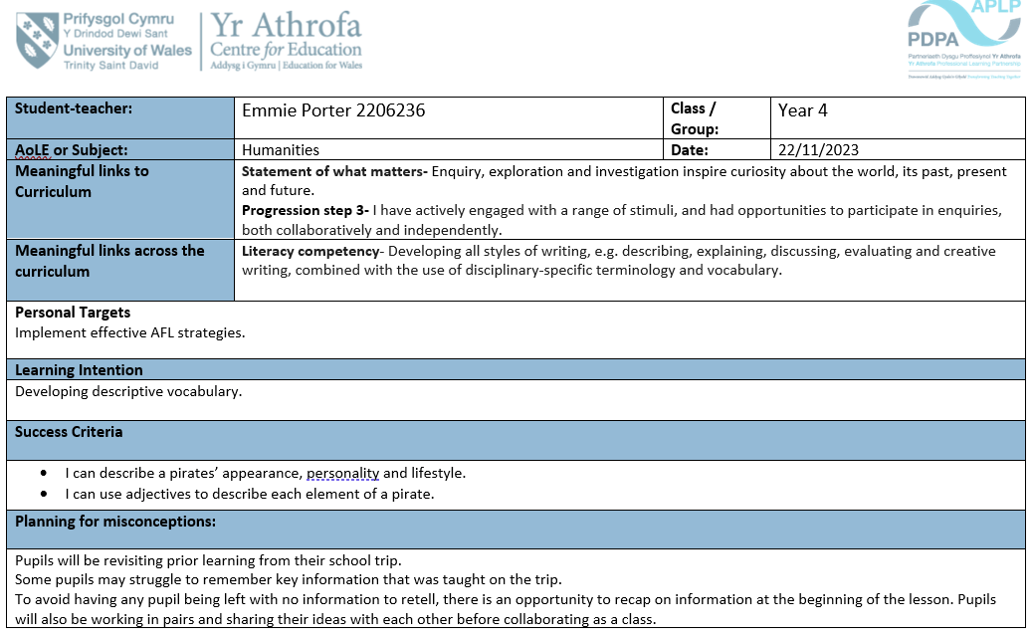
Appendix A- My lesson planning, including reasoning and a timetable for my Humanities lesson.

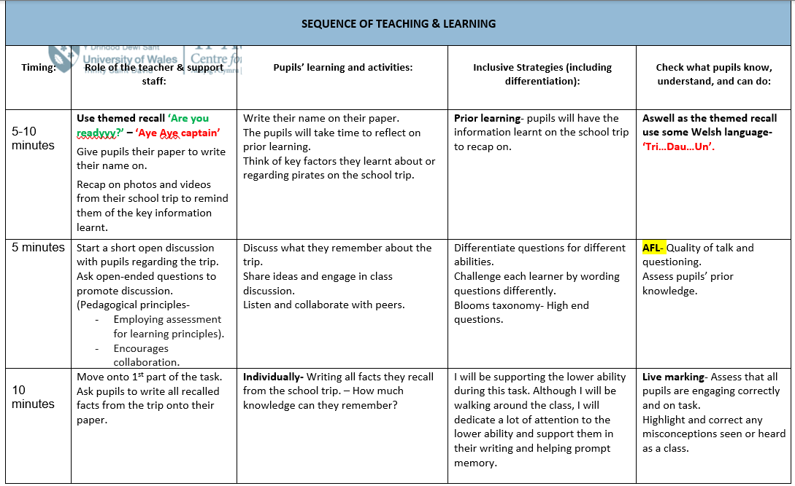
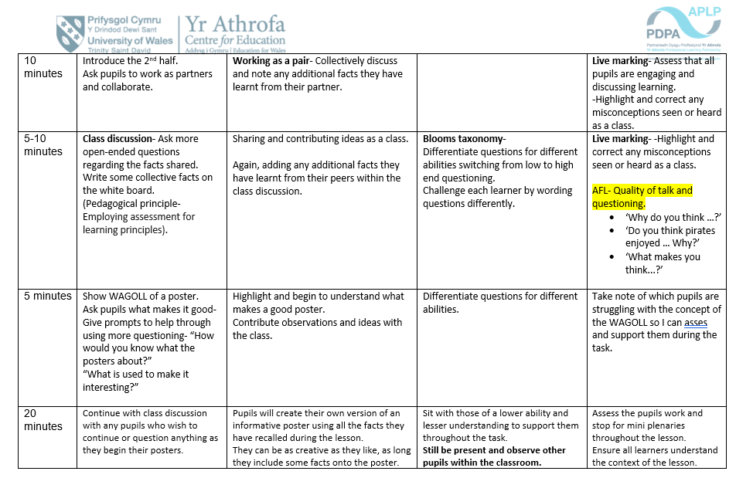
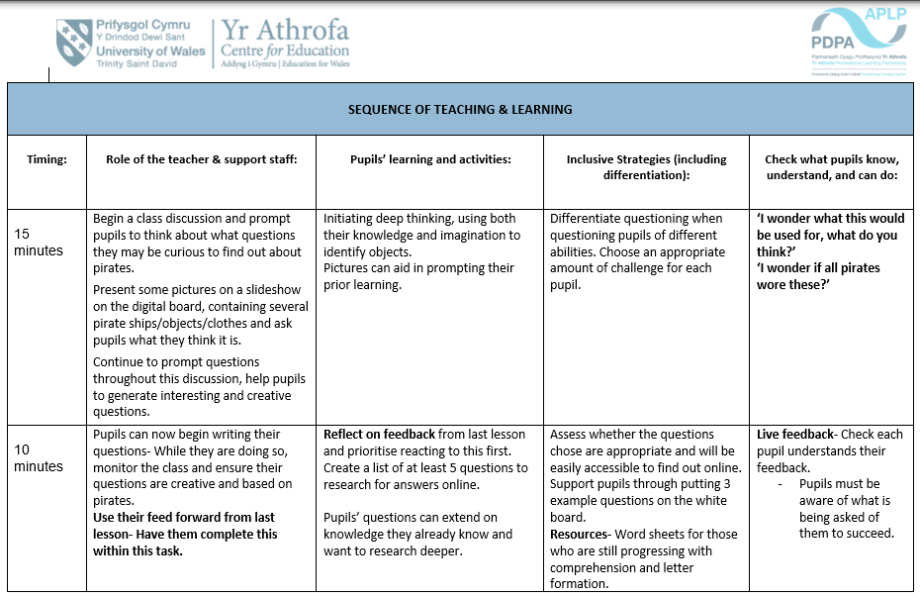
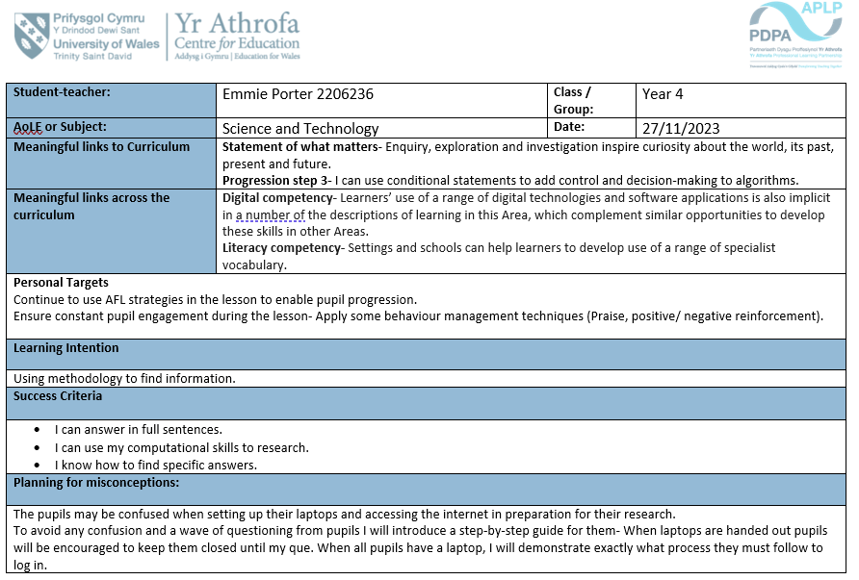
Appendix B- My lesson planning, including reasoning and a timetable for my Science and Technology lesson.
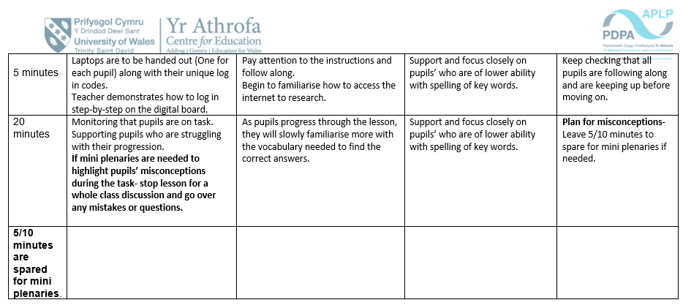

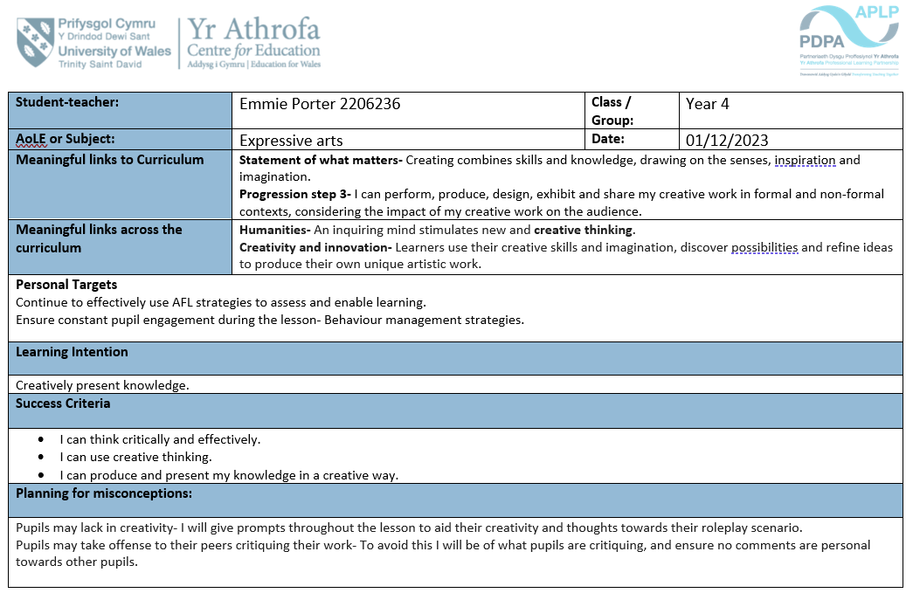
Appendix C- My lesson planning, including reasoning and a timetable for my Expressive Arts lesson.
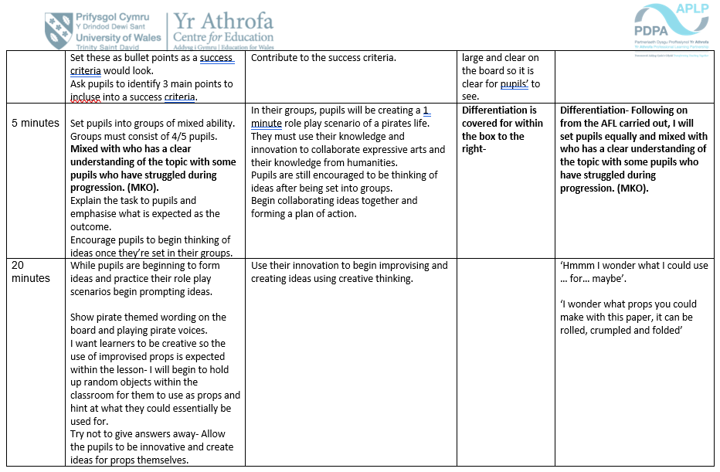
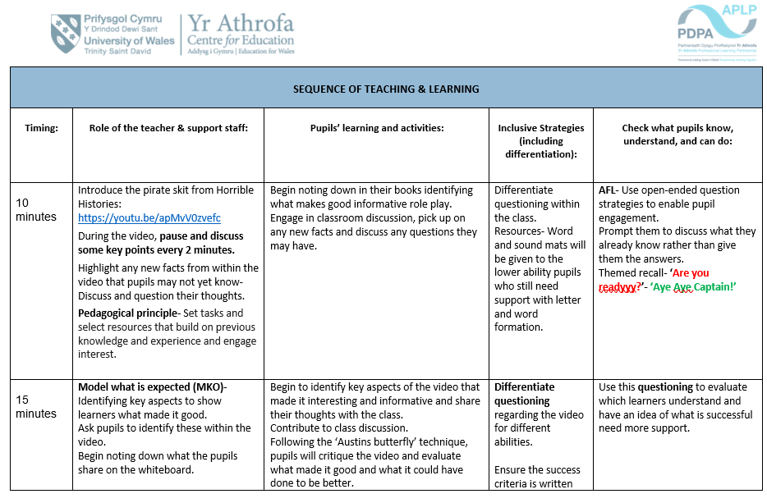
Pupils must follow the success criteria created within the lesson during this activity.


