Submerged Self Reflection

Introduction
For our Creative Practice 3 assignment we were tasked with developing a plan for a horror game project. This was a team project in which we individually presented our pitch for the given topic and as a team voted on the best concept and developed it. My pitch was for a survival horror game with the aim to escape a locked room in a life or death scenario. But the pitch that caught everyone’s interest was Submerged, which has a similar concept to my original idea but fit the premise better. Once we formed our group of 8, we had meetings together discussing how to take the project forward; from design ideas to actual game mechanics we discussed and gave our thoughts and opinions on what we want the game to be.
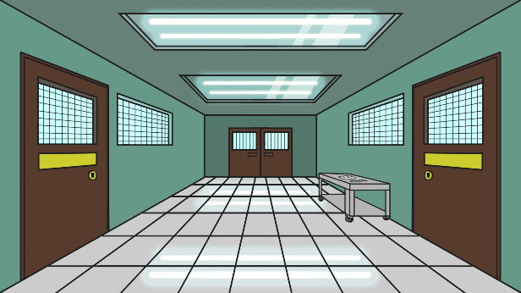
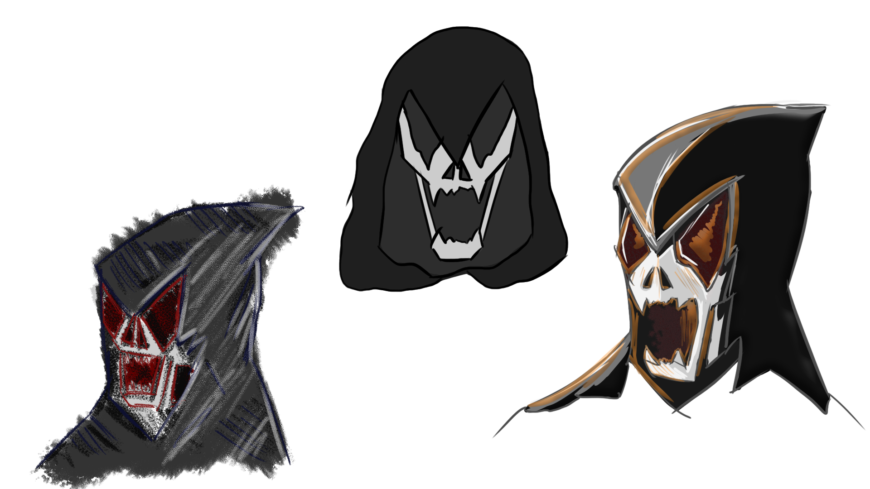

Research and inspiration
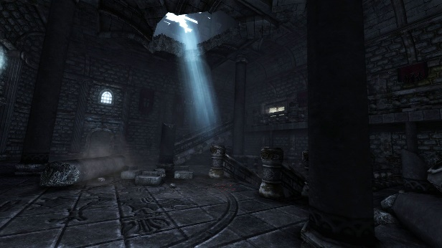
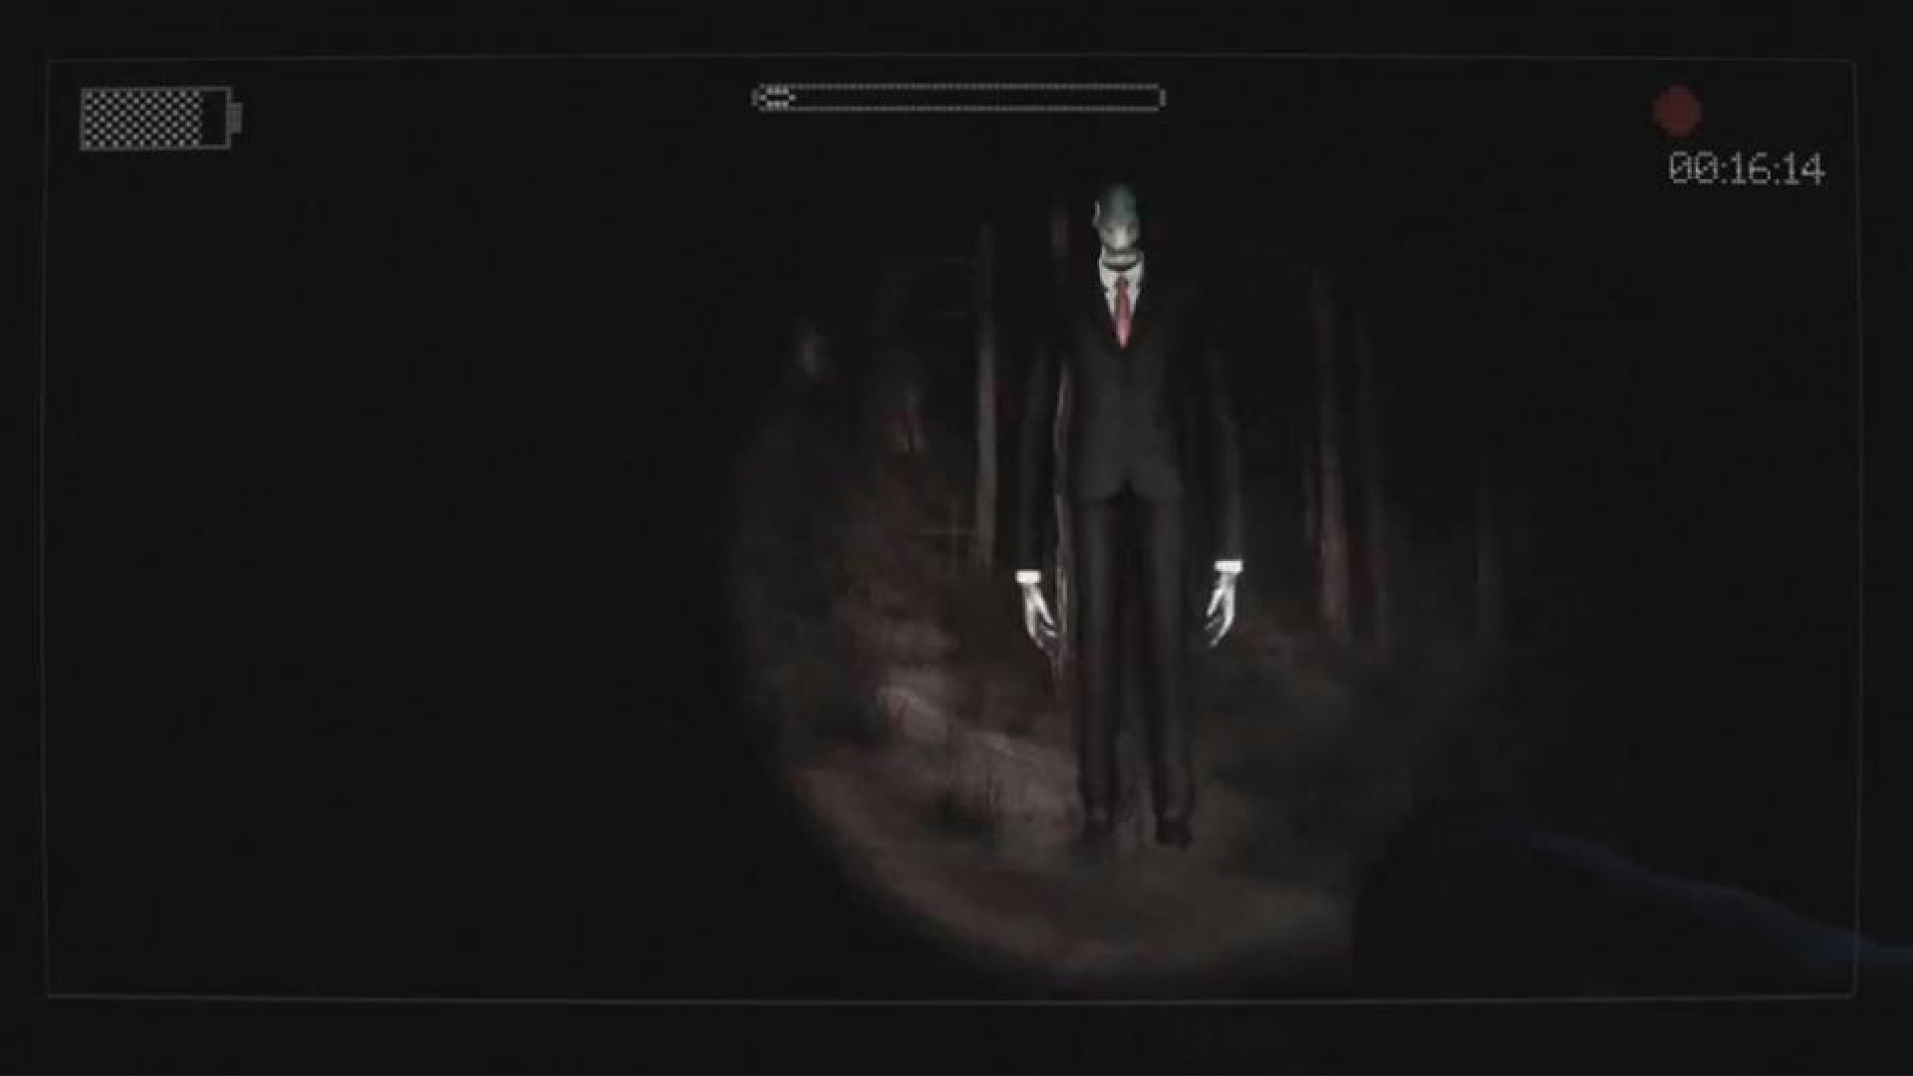When doing research for my original idea which was the abandoned hospital pitch, I looked at existing horror games which I have played before and am familiar with. The games I took inspiration from were Slenderman, Amnesia, Outlast and Resident Evil as I really enjoyed playing them and are some of the most memorable horror games I played. I looked at the story, style, characters/ monsters, colour theme and soundtrack when developing my original pitch and that research has helped me with Submerged. What stood out to me in those games was the dark contrast and the element of surprise which I tried to incorporate into my original pitch. Once I decided to work on Submerged, I had a different field of research to investigate, which was more natural and organic. My inspiration for the storyboards I have developed came from designs made by our team and my research of caves, mines and creeks.

Teamwork
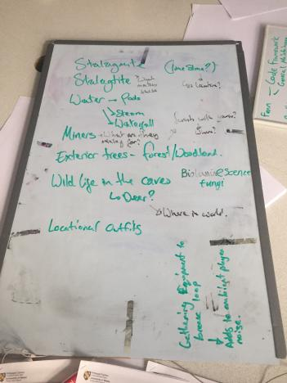
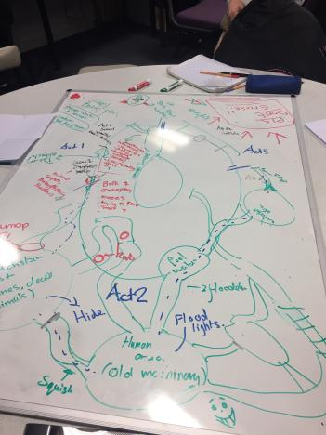
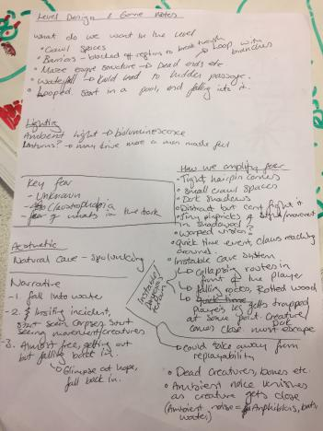
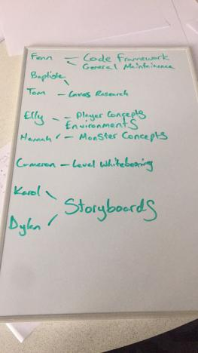Looking back on what we have accomplished as a team I am very pleased. From the start of the project we had decent communication which got better as the project went on and everyone was eager to put their ideas forward as we were introduced to each other at the start of this project through a games and animation class merge for this assignment. Throughout the first weeks of working on Submerged we focused on developing what we want it to be and spent most of that time discussing between the team, putting forward suggestions and ideas and deciding on the best approach to take. After processing all our ideas, we knew how we wanted Submerged to go forward and assigned team roles; 2D – Elly and Hannah, 3D – Baptiste and Tom, Animation – Dylan and Karol, Engine – Cameron and Fenn. In order to communicate outside of class, we used Discord and have our own server with different channels for different roles.
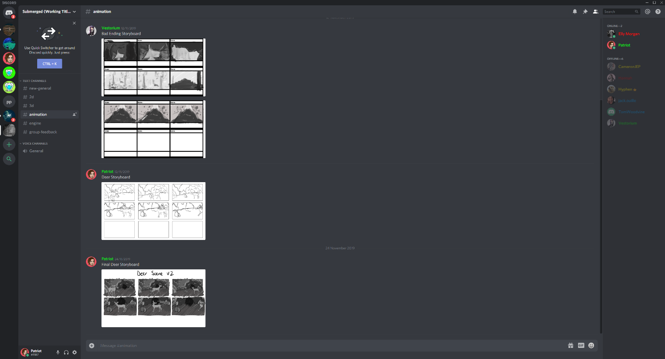

My role
My role for this project was ‘Animation’ which consisted of doing research and studying to better my animation skills, understanding movement and anatomy. I researched hands and different poses, did sketches, breakdowns and observational drawings to have reference when it came to drawing them in storyboards and future projects as they’ll play a big part in the game as we have decided it’s going to be first person. I used Photoshop for my drawings, sketches and breakdowns. I also did a thorough amount of research on deer’s, I watched videos I found on YouTube to analyse how they move and look from different angles. What I found studying the footage is that deer’s move in many ways such as walking, galloping and trotting, they tend to take steps followed by their opposite foot (example front left, back right, front right, back left) and when walking they almost kick their hoof. I also collected plenty of reference images and did multiple sketches to get a better understanding of them. All this research helped me make the storyboards I was assigned for. There are two people working on animation in this project, myself and Dylan split up the storyboards in half, I did the Introduction and Deer Storyboards which will help outline and construct the cutscenes/scripted sequences in the game. I decided to work on an animatic to better understand the motion of the scene. The animatic was challenging as I had to redraw a lot of the assets in higher quality as the storyboards were originally on a single layer, so I redrew the background, different poses of the deer and monster.
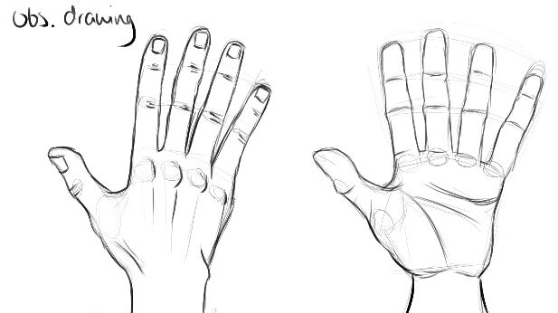
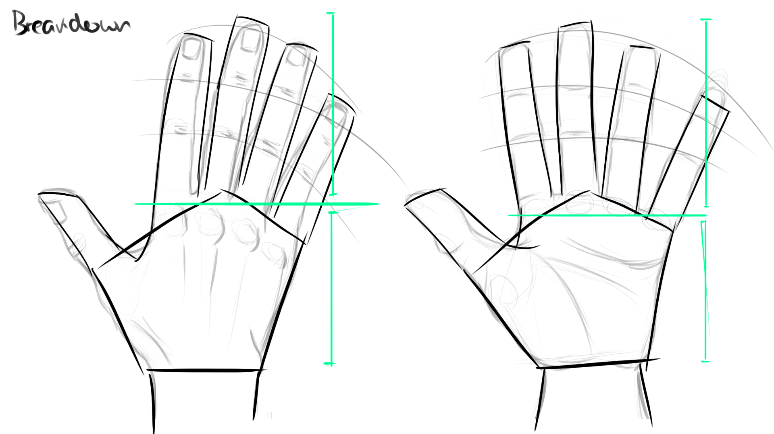

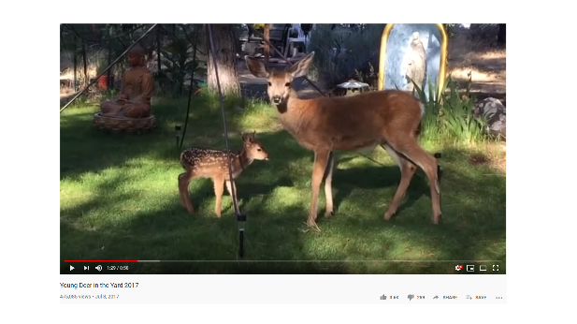
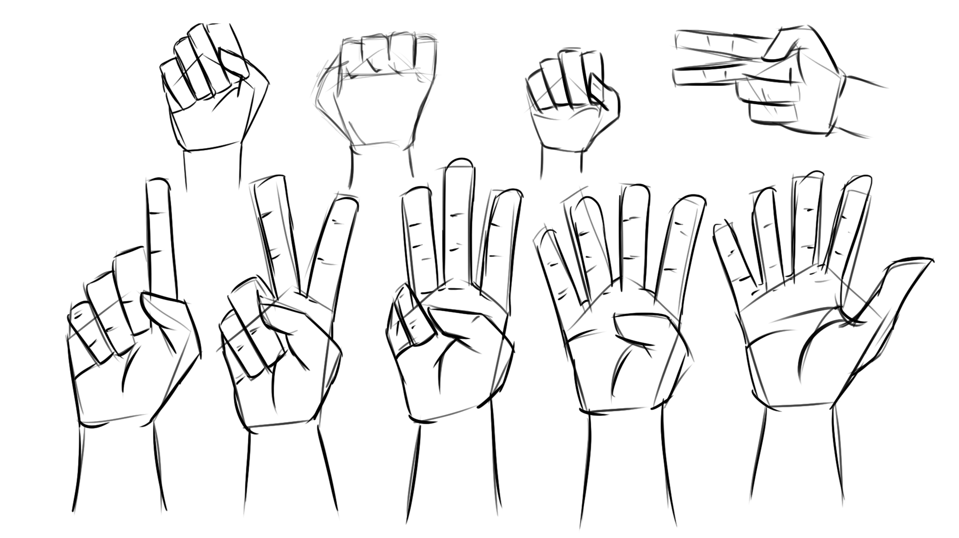

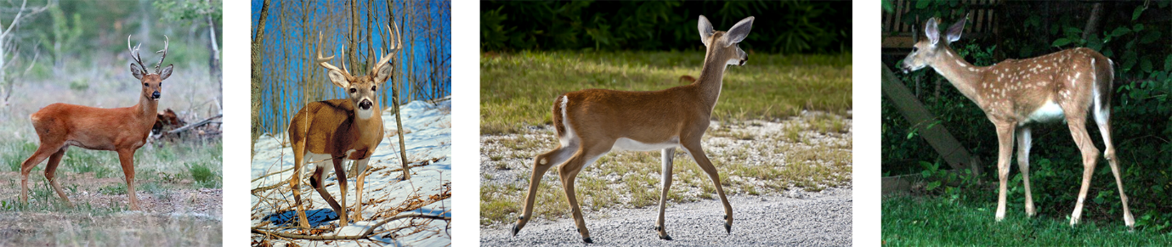
Designs and storyboards
I made the storyboards in Photoshop as it’s my software of choice as I am very comfortable using it and have been working with it consistently for over a year now since starting my first year in university. I used 1920x1080px canvas with an aspect ratio of 16:9 to fit a standard screen. I started doing sketches of the frames using a rough brush to give it a natural rigid look, using different tones of white, grey and black to add depth and shade. The reason I didn’t use colour on the storyboards was because the environment was overwhelmingly grey, and I didn’t want certain things to stand out too much such as the deer, the grey set the atmosphere and mood for the setting. I then tried out different hand poses to give the frame some emotion and motion. I went over my rough sketches in line and blended certain parts to give it a smoother look. For the storyboards that I worked on I realised that I needed two approaches as they are meant to convey different information. I went through different layers and designs. The intro storyboard had roughly three versions as the introduction plan kept changing and was lacking clarity at first. The Deer storyboard was fun to work on but also required changes, primarily the monster as at the time of me working on the storyboard there was no monster design meaning I had to go back and redraw the monster in the storyboard. This ultimately worked out as I spent some time doing different poses and sketches of the monster to better understand its design.
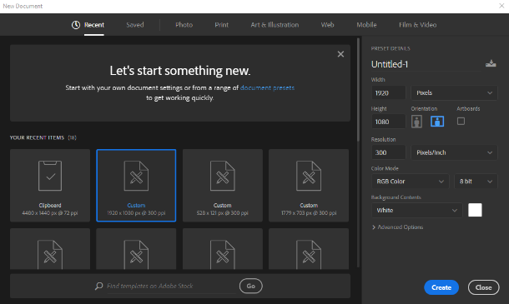
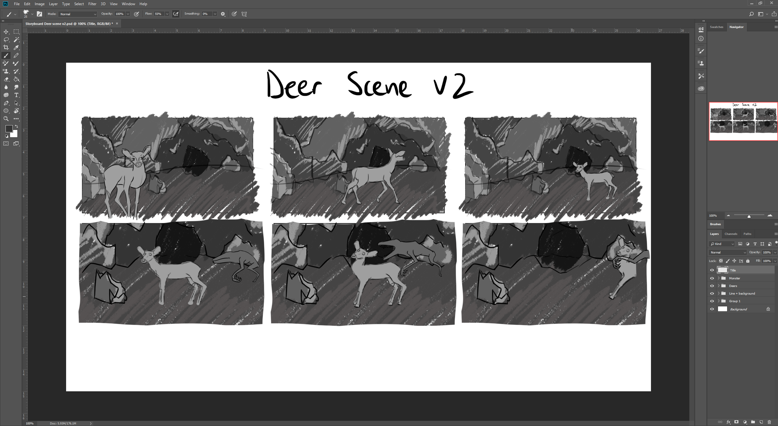

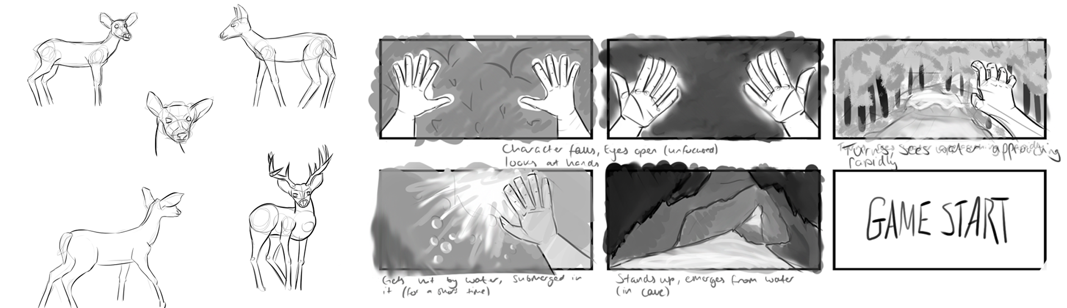

Animatic
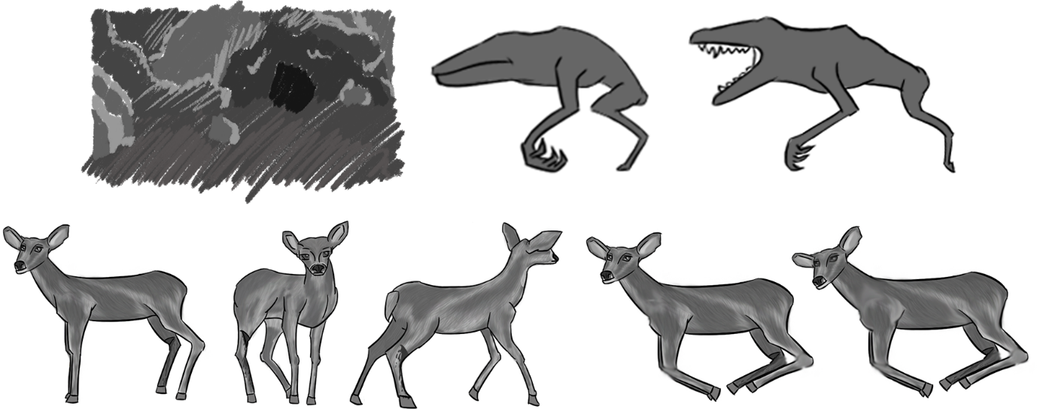
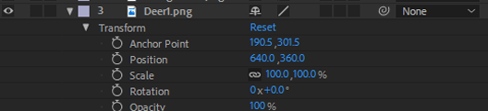Once I finished working on the storyboards I took it upon myself to make an animatic for the deer storyboard to give it more life, this scene was one of the focal scenes to the story as it introduced the player to the monster and demonstrates that noise attracts the monster. I had the assets (footage) from my designs and storyboards and used them in my After Effects composition. I used a 1280x720HD resolution as it was a good compromise between a full HD 1920x1080 and the original smaller scale of the storyboards which I had to redraw and upscale the background. I used a lot of effects on the assets to give them motion such as position, scale, rotation and opacity. This was all hand animated and took some trial and error but worked out in the end. I made this animatic to figure out the pacing and rhythm of the scene and get an idea of what the final animation could look like

Conclusion
Coming into this project I didn’t know what to expect, as we weren’t too familiar with the games group, but we developed good communication and teamwork skills. I am pleased with the roles we adopted and our general contribution. I feel everyone’s done their part which reflects how well we worked as team. Looking back at my contribution I am happy with the animatic which was challenging to make as this was my first time using After Effects, but developed a grasp of the software as its similar to Photoshop which I’m familiar with, overall the process took some trial and error but I managed to figure it out and improve my knowledge of After Effects. I also think that all the study and research I did will come in handy as I have plenty of examples and materials to base future animations on. One thing that I would change next time around is the role assignment, as I would’ve liked to contribute in other areas such as, 3D modelling the environments or characters and doing more concept designs. In conclusion I am pleased with the outcome of this project and happy that we worked so well as a group as well as my own contribution.
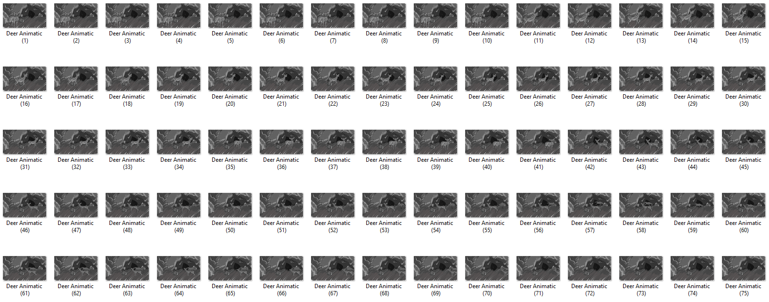

Word Count: 1374

Bibliography
(In order from start to end left to right)
Parsec Production (2012) Slender: The Eight Pages. [Online] PC. Unknown: Parsec Production.
Frictional Games (2010) Amnesia: The Dark Descent. [Steam] PC. Frictional Games.
Red Barrels (2013) Outlast. [Steam] PC. Red Barrels.
Capcom (2005) Resident Evil 4 [CD] Game Cube. Capcom.
Vignette.wikia.nocookie.net. (2019). [online] Available at: https://vignette.wikia.nocookie.net/theslenderman/images/2/2f/Slender-The-Arrival-Teaser-Trailer_9.jpg/revision/latest?cb=20130612205355 [Accessed 10 Dec. 2019].
Metro.co.uk. (2019). [online] Available at: https://metro.co.uk/wp-content/uploads/2016/11/210.jpg?quality=80&strip=all [Accessed 10 Dec. 2019].
Discord. (2019). Discord — Discord - Free Voice and Text Chat. [online] Available at: https://discordapp.com/ [Accessed 10 Dec. 2019].
Pelorian Pages (2019). Young Deer in the Yard 2017. [online] Youtube.com. Available at: https://www.youtube.com/watch?v=Vwvfd6tvN2c [Accessed 10 Dec. 2019].
En.wikipedia.org. (2019). Siberian roe deer. [online] Available at: https://en.wikipedia.org/wiki/Siberian_roe_deer#/media/File:Siberian_roe_deer.jpg [Accessed 10 Dec. 2019].
Encyclopedia Britannica. (2019). White-tailed deer | mammal. [online] Available at: https://www.britannica.com/animal/white-tailed-deer [Accessed 10 Dec. 2019].
Catcode.com. (2019). [online] Available at: https://catcode.com/dc2005/deer_6465.jpg [Accessed 10 Dec. 2019].
Etc.usf.edu. (2019). Key Deer Back Right Side | ClipPix ETC: Educational Photos for Students and Teachers. [online] Available at: https://etc.usf.edu/clippix/picture/key-deer-back-right-side.html [Accessed 10 Dec. 2019].

