Global Destination and Tourism Management
Rumen Grozdanov
Student N 1815102
UWTSD

Table of Contents

Introduction 3
Background 4
Discussion 7
Perceptions and Attitudes towards Tourism by the Host and Visitor 7
Globalisation of Tourism and its Demand 8
Tourism Impacts – Socio-Economic, Environmental and Political 9
Global Destination Marketing and Promotion 11
Global Tourism Trends and Issues 13
Logistic Development Issues in Global Tourism 15
Conclusion and Future Development 16
Reference 18

Global Destination and Tourism Management (GTDM)

Introduction
The aim of the assignment is to demonstrate “Global Destination and Tourism Management (GTDM)” which involve various trends in tourism management. However, it can be identified that the key element of the productive tourism industry is the ability to perceive and manage changes in many of the key elements and how they work together. The main driving forces of global changes in external conditions can be divided into “economic, political, environmental, technological, demographic and social” aspects. Studying these models allows operators to identify and investigate significant changes both from the side of grace and from the demand side in tourism. Thus, line managers and tourism managers can consider inventive methods to avoid a critical swimmer for their associations and create tourism in a smart way (Conrady and Buck, 2012).
Moreover, in order to overcome rapid changes, tourism partners must either move away from progress and their business recommendations, or focus on the toolbar. Since tourism is essentially coordinated with various sectors of the economy, tourism models cannot be seen as a separation of the key factors that will shape the universe of the future.

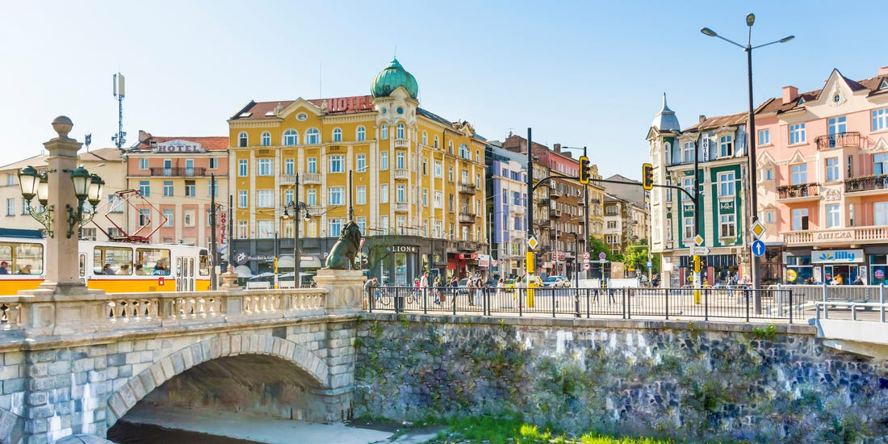
Figure 1 Bulgaria

Background
According to (Cooper and Hall, 2008) it can be determined that throughout the duration of evolution associated with independent market economy, whilst it has been observed that tourism within Bulgaria has developed itself as the vigorous and dynamic regions in Bulgarian national economy. Nonetheless, within the most unsettled times associated with the economy tourism, which is often engaged with the significant point along with it is emerged speedily after 1998.
However, the important part considering this could and ought to be played through the tourism of mountains. There are almost 16-17 ranges of mountains in Bulgaria that covers around 30 per cent of the area and it also covers an extensive areas within the southern, central and western regions of the country (Algieri et al., 2018).

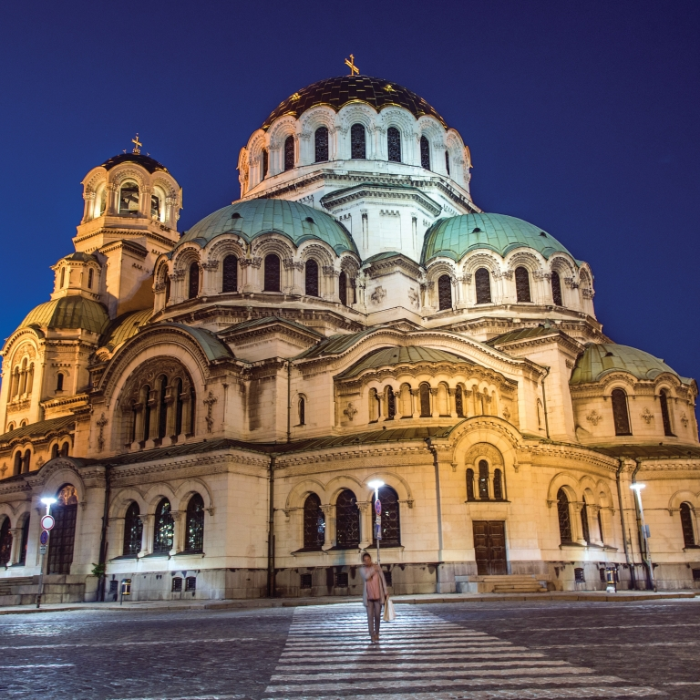
Figure 2 the Alexander Nevsky Cathedral, in Sofia, Bulgaria

Furthermore, mass tourism takes place in Bulgaria. It was raised in 1926 when the leader visited Varna, but World War II kept him in the development of tourism.

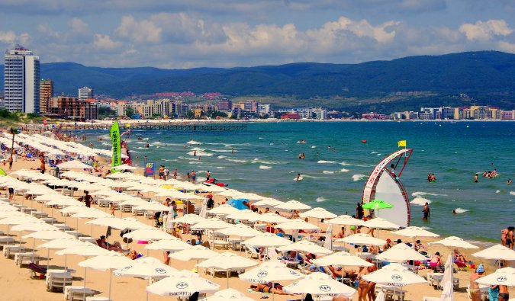
Figure 3 Mass Tourism

The post-socialist period in 1989 was interrupted by critical social, monetary and political changes. In the 1990s, the country began to move towards a market economy, but the changes were not yet ready. Travelers from the countries of Central and Eastern Europe underwent unexpected political, financial and social changes, while the number of tourists and recreation centers decreased significantly between 1990 and 1992. In fact, the number of beds in comfortable facilities fell from 302,890 in 1990 to 116,730 in 1999, and the number of international internships fell from 10 million in 1990 to 5.06 million in 1999 “(National Statistical Institute [NSI]” (Mill, 2008).

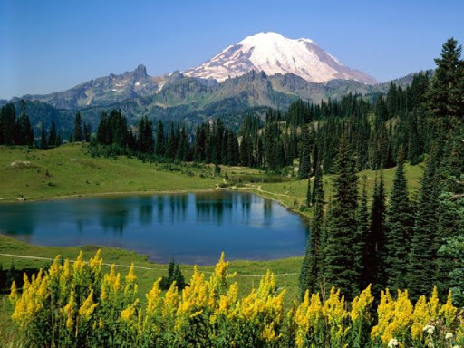
Figure 4 Mountains in Bulgaria

Discussion
It has been determined that traveling was considered to be the most fascinated by the people. However, traveling and the tourism industry have always been important social exercises for people. The desire to explore new places inside or outside the nation itself and to recognise differences in status and experience has been going on since ancient times. The tourism industry is one of the fastest growing companies in the world. Most of its development can be associated with higher allowable wages, more free time and lower mobility costs (Tribe and Liburd, 2016). As flight terminals become more popular, office mobility is gradually being computerised, and it is becoming easier for tourists to find location information.

Perceptions and Attitudes towards Tourism by the Host and Visitor
The observations and attitude of residents to tourism attract the attention of many scientists, and the main explanation is that they can affect the understanding and satisfaction of tourists, the implementation of tourism projects and strategies, as well as sustainability in general. Similarly, these changes reflect broader disciplinary concerns regarding support issues and the importance of addressing the needs of registration networks for tourism promotion. In any case, few people understand the developing countries, although researchers argue that the attitude of residents and tourism support are places created and created by peoples (Howie, 2003). Although inspections conducted in established countries may lead to significant hypothetical and functional reviews, they may not be relevant to the creation of countries that are truly isolated, are highly dependent on shared assets and are unable to change the environment. Such peaks indicate that state building may face greater difficulties than improving reliable tourism than its reliable partners. Benckendorff and Lund-Durlacher (2013) argued that the visible effects of tourism change over time, depending on further changes in business, as well as cooperation between local residents and tourists.
Benckendorff and Lund-Durlacher (2013) suggested that the scale of tourism improvement would have a direct impact on residents’ perceptions of the impact of tourism on network life. However, most previous studies have directly studied how the perceived tourist influence of residents differs from some levels/plans/scenarios designed to improve tourism.

Globalisation of Tourism and its Demand
Dowling and Newsome (2010) identified that globalisation encourages the development of trade blocs, global organisations and the global economy. The world is becoming a unique structure that makes the global market accessible to all. Financial globalisation offers numerous perspectives for countries around the world. However, these potential outcomes were quiet helpful as many nations in peripheral areas around the world have become exclusively created nations and can serve as real guidance for various nations that are just beginning to disappear market. Globalisation stimulates the location of commercial blocs, global organisations and the global economy. Thus, the world becomes a single structure in which the global market is open to all. Moreover, globalisation offers many opportunities for countries around the world (Morrison, 2018).
Consequently, globalisation is a large number of influential ties and similarities between nations and social orders that form the current structure in the world. Thus, globalisation is divided into two aspects: expansion and strength. This is illustrated by the expansion of efforts outside the periphery of the country with its central sovereignty, global capital flows, as well as the expansion of announced turnover and management (Hanlon, 2007). Globalisation is also a unique process, therefore, its completion and course can vary in different areas and can be applied to administrative markets and markets for products, production, industry, innovation and information just like mass culture is use and design.

Tourism Impacts – Socio-Economic, Environmental and Political
Social and monetary impacts in the Black Sea region were considered. The financial impact of tourism is highly appreciated and makes it possible to determine the logical mismatch existing in the Black Sea region between the need to meet the growing needs of tourists, which contributes to the rapid improvement of tourism. It is also associated with determining the amount of normal social assets. The monetary zone is in a state of decomposition. Therefore, it is important to ensure sustainable improvement of tourism does not depend on the various needs of the whole country and the Black Sea region (Mcleod, 2004). The tourism business is an important economic zone and a significant factor in the financial progress of the Black Sea region and the entire nation. Thus, a comprehensive study of the financial impact of tourism on the country’s economy is relevant, as it allows us to assess the role of tourism in terms of the progress of the country and individuals as a whole.
It has been analysed that improving sustainable tourism can rationally satisfy numerous financial, social needs without compromising social seriousness and biology. Like others, there are monetary, social, and natural views on the goals of improving tourism (Sustainable, 2005). In addition, successes in tourism have an impact on raising expectations for everyday comfort, helping to reduce needs and provide social assistance to the region. Thus, (Benvenuto et al., 2020) argue that a sustainable tourism industry requires long-term coordination of social and financial goals, which draws attention to the friendly relationship between these tourism development tips in the region. The impact of tourism on the financial cycle was also taken into account, as increased awareness of tourism contributes to changes in the use of leisure facilities to expand the district administration. Tourism affects the good distribution of financial assets in order to reduce the cost of over-financing in areas identified by tourism, which has a positive effect on the financial cycle of the areas (Mileva, 2018).
Therefore, maintaining the natural quality of your destination is one of the main standards of the World Code of Ethics for Tourism. For the EU, promoting the productive use of assets to develop a green economy means “green public procurement (GPP)” or “sustainable public procurement (SPP)” as “a process in which public experts try to protect products, administrations, and work with diminished natural effects during a cycle of intellectual times, unlike goods, administrations, and work with similar or otherwise inherent potential.” despite the fact that there is a “round disposition” in the industrialised countries of the EU, today it is being discussed in accordance with the ideas of a circular economy and green public procurement (Brondoni, 2016).

Global Destination Marketing and Promotion
The Ministry of Tourism promotes sustainable tourism in Bulgaria throughout the year to achieve social and monetary solidarity and maintain a strategic distance from the end of the impoverished areas of our country. Improving the tourism industry in Bulgaria strengthens the path to employment even in less successful and limited regions of the country - an approach that helps to increase personal satisfaction from networks of neighbours. The progress of social and registered tourism in Bulgaria is important to increase the intensity of the entire segment and the adequacy of local tourism assets through the rational and appropriate use of social and ordinary assets (Brondoni, 2017). A new emphasis on promoting social and chronic tourism in Bulgaria benefits neighbouring networks and contributes to the improvement of nearby products and enterprises, brands, nearby nutrients, music movements, imitation and administrative focus. Tourists are looking for such a promotion.
Thus, the ministry has created the latest register of online tourist attractions, which includes more than 3300 registered and social destinations throughout the country. Other parts of the program include festivals and social rehearsals, which are touted as a tourist item to improve the local financial situation. Festivals offer practical alternatives for improvement, as the segment is based on the innovations of neighbouring specialists and entrepreneurs and creates a higher level of neighbourhood, including profit. The Ministry of Tourism provides support to SMEs by providing institutional support to the executive organisations described in the Tourism Law and opening the door to subsidize most areas of tourism, including activities aimed at: restricting business operations to facilitate access and proximity nationally and internationally (Morrison, 2018). Markets create an integrated tourism information system at the national level as a springboard for the tourism administration, tourism organizations and tourism company facilities; ICT implementation support; Conduct research, research and company data; Creation of ideas, techniques, plans and advertising, commodity and corporate items; Settlement of commercial disputes at home and abroad, support for cooperation in events and presentations (territorial, national and international).


Figure 5 Global Destination

However, Inkson and Minnaert (2018) identified that the Ministry of Tourism is trying to track and respond to the latest trends. It can be determined that they have created an administrative structure for the “Integrated Tourism Information System (ESTI)”. It regulates the conditions for registration, maintenance, protection and access to information in the “National Tourism Program (NTP)”, as well as the measurement, management, compilation and presentation of tourism events in accordance with the recommendations of Eurostat and the “World Tourism Organisation”. Based on a centralised information system, our goal is to provide a large number of customers with open and accessible information. This integration phase will have several points of contact that can be accessed through a combination of widgets for end customers that improve real-time creation and facilitate travel contacts, as well as adapting travel assets on board through small destinations and upgrade levels to the full level.

Global Tourism Trends and Issues
Gössling et al. (2018) claims that more than 50 percent of Bulgarian hotels are located on the Black Sea, but attracts 80 and more percent of business, and the vast majority of ski resorts are located there. This falling market provides several different services, for example:
- The best price position in Bulgarian resorts and winter resorts is in front of the rest of the market, the cost of the industry is high and low in accordance with Western European standards.
- The image of Bulgaria as a travel option with minimal effort has a negative impact on other tariff segments.
- The dominance of almost all administrators of mass visits and the organization of mass tourist centers has weakened progress and speculation with dangers in various areas of the Bulgarian tourism industry, including Sofia, various mountains and lakes.
- Most of the arriving travel companies are full in July and August, and in winter during the snow season. The high season in the middle of the year is limited to 45 days. Methods for the shoulder season have not been tested.
- Due to speculation and market movement, the legislator was attractive in terms of progress, new products and new markets.
- There was practically no statistical survey. Whilst, domestic market is recognised to be huge, yet undistinguishable and indeterminate piece of the entire market.
Five key prospects have been identified that describe the progress of tourism in Bulgaria over the past decade, in particular (Dyankov et al., 2018):
- Sensory decline in development due to the huge life and universal challenges of that time,
- Segments of interest that determine the legacy of past systems and wasteful negligence (for example, limited use of available assets, consistency of tourism assets, spatial and convenient handling, low administrative nature and origin, lack of skills and errors of innovation);
- The transfer of property from the state to the private segment, a process that creates real difficulties for new owners and administrators who currently manage old organizations and maintain an outdated base;
- The rapid development of a large number of small and medium-sized measuring organizations led to fundamental changes in the unit, and the old external monopolies collapsed in the stomach and darkness as they solve problems in their articles it continue to promote.
- The striking gap between the available type of attribute and social wealth and the scale of a single, but unified management at a relatively useless level of structure and non-industrial administrations that clearly affect its presentation and results.

Logistic Development Issues in Global Tourism
According to Boycheva (2017) transport and coordination administrations contribute to the development of world trade and play an important role in the development of the neighbourhood economy. The quality and competence of a coordinated administrative unit can be important for universal trade, as a weak coordination structure and operational procedures can be a significant obstacle to global trade relations. Conversely, improved trade-related coordinates, combined with changing economic conditions, can increase trade volumes and economies of scale and scale in transfer and creation exercises.
Coordinated administrations establish sectoral relationships within the neighbourhood economy. It also links the family economy to the global economy. The coherence of differences between the tested subareas (including agricultural, manufacturing, food, tourism) of the national economy is supported by a fluid vehicle and agreed framework conditions, which is one of the intentions of manufacturers moving their products economically and with little delay for them (Stankova and Vasenska, 2017). They conducted a comprehensive investigation of the air traffic system with 1,060 air terminals in 175 countries. This is an important study that has helped to understand the internal and external relationships that can be seen in the field of transport. Also, the ability of local manufacturers to participate and receive rewards for the development of “global value chains (GVCs)” (systems that detect various stages using proven methods in the most competent areas and with the coordinated use of innovations (containerisation, air transport) (telecommunications) and information technology) rely on efficient and reliable structures for vehicles and coordination that can strengthen their global ties, and a subsequent report found that 67% of the global value was achieved in terms of GVC for countries in the “Organisation for Economic Co-operation and Development (OECD)” also noted an increase in the “Newly Industrialised Countries (NICs)” and five major economies “(Brazil, Russia, India, China and South Africa (BRICs))” were around 24 and9 percent respectively, thus, improving connectivity can contribute to direct or organisational development outcomes to achieve basic social development goals, for example, labour production; providing medicine and food, which is verified by “OECD/World Trade Organization (WTO, 2013)”; along with improving revenue (Kazandzhieva, 2019).
Although the coordinated contribution to achieving national results in a country may not be as competitive as in different segments, the task of coordinating support within the economy cannot be rejected or ignored (Aleksandrov and Kilimperov, 2018). An important link between transport and national coordination and development is universal trade assistance, which, under appropriate conditions, brings some other valuable economic and social results.

Conclusion and Future Development
By concluding the assignment, it can be examined that a general analysis of the selected markers for assessing the practical progress of tourism in Bulgaria showed that the improvement is very stable. The development of Bulgarian tourism in the last ten years has led to an expansion of tourism's commitment to promote the nation. Tourism accounts for about 13 per cent of the country’s GDP, 12 per cent of companies, including more than 30 per cent of its value and more than 7% of total speculation for the reporting period. This is a measure that the Tourism Section will use to demonstrate positive trends in terms of GDP, work and the country’s interests over the next ten years. This will contribute to the prospect of improving the everyday comfort of the population and financial development.
Furthermore, Bulgaria can build selective forms of tourism: economic, social, resort and environmental concerns, which reduces the unevenness of tourism and the use of low operating costs and leads to the expansion of the tourist facility. During the period under review, the country was built as a good tourist destination for meetings and conferences around the world and at the national level, since guests who stayed for fleeting reasons and also had a high proportion of all guests saw significant development from others.

Reference

Aleksandrov, K. and Kilimperov, I., 2018. The role of destination management organizations (DMOS) for sustainable rural tourism in Bulgaria. Scientific Papers Series Management, Economic Engineering in Agriculture and Rural Development, 18(2), pp.11-160.
Algieri, B., Aquino, A. and Succurro, M., 2018. Tourism Management Perspectives. Tourism Management, 25, pp.41-52.
Benckendorff, P. and Lund-Durlacher, D. eds., 2013. International cases in sustainable travel & tourism (pp. 57-113). Oxford: Goodfellow Publishers.
Benvenuto, M., Sambati, F.V. and Viola, C., 2020. A New Framework to Build a Touristic Strategy in Global Destination Management. International Journal of Business and Management, 15(5).
Boycheva, C., 2017. Innovation and competitiveness in the context of the Bulgarian tourism industry. Economic Alternatives, 1, pp.137-148.
Brondoni, S.M., 2016. Global Tourism Management. Mass, Experience and Sensations Tourism. Symphonya. Emerging Issues in Management, (1), pp.7-24.
Brondoni, S.M., 2017. Global tourism and terrorism. Safety and security management. Symphonya. Emerging Issues in Management, (2), pp.7-16.
Conrady, R. and Buck, M. eds., 2012. Trends and issues in global tourism 2012. Springer Science & Business Media.
Cooper, C. and Hall, C.M., 2008. Contemporary tourism: An international approach. Routledge.
Dowling, R.K. and Newsome, D., 2010. Global Geotourism Perspectives. Goodfellow Publischers Limited.
Dyankov, T., Krastev, V. and Yancheva, K., 2018. Evaluation of brand identity of Bulgaria as a tourist destination. Tourism: An International Interdisciplinary Journal, 66(1), pp.19-34.
Gössling, S., Scott, D. and Hall, C.M., 2018. Global trends in length of stay: Implications for destination management and climate change. Journal of sustainable tourism, 26(12), pp.2087-2101.
Hanlon, J.P., 2007. Global airlines: competition in a transnational industry. Routledge.
Howie, F., 2003. Managing the tourist destination. Cengage learning EMEA.
Inkson, C. and Minnaert, L., 2018. Tourism management: An introduction. Sage.
Kazandzhieva, V., 2019. Incentive programmes as a tool for promoting tourism in Bulgaria. Известия на Съюза на учените-Варна. Серия Икономически науки, 8(1), pp.27-35.
Mcleod, D (2004) Tourism, Globalisation and Cultural Change, Clevedon : Channel View
Mileva, S.V., 2018. Potential of development of dark tourism in Bulgaria. International Journal of Tourism Cities.
Mill, R.C., 2008. Resorts: management and operation. John Wiley & Sons.
Morrison, A.M., 2018. Marketing and managing tourism destinations. Routledge.
Morrison, A.M., 2018. Marketing and managing tourism destinations. Routledge.
Stankova, M. and Vasenska, I., 2017. Tourism destination competitiveness models. Tourism and Travelling, 1, pp.58-64.
Sustainable, M.T.M., 2005. A guide for Policy makers. UNWTO, UNEP, p.12.
Tribe, J. and Liburd, J.J., 2016. The tourism knowledge system. Annals of Tourism Research, 57, pp.44-61.

