Individual Report: Marketing Fundamentals

External Analysis & Evaluation

Name: Crina Mihut
Student ID: 2218982
Module name: Marketing Fundamentals (LCBB4004)
Lecturer: Piyumika Kithulgoda Gamage
University of Wales, Trinity Saint David

Table of Contents
Introduction 3
Analysis and Discussion 3
PESTLE Framework 4
PORTER’s Five Forces 7
SWOT Analysis 9
Recommendation 11
Conclusion 13
References 14

Introduction
The report's primary objectives are to analyze the political, economic, social, technological, environmental, and legal conditions that have an impact on the company's daily operations. As part of its analysis, it will look at the state of the industry as a whole, including the companies that compete with Shell, as well as the trends and developments that have shaped the market. The goal of this paper is to assess the strengths and weaknesses, opportunities, and dangers, facing Shell Plc from an outside perspective. The impetus for producing this report is rooted in the dynamic evolution of the energy sector, necessitating Shell's proactive measures to maintain its prosperity. Through external assessment and scrutiny, valuable perspectives pertaining to market dynamics, clientele preferences, rival companies, and various other extraneous factors are gained that impact business operations significantly. By pinpointing critical openings as well as challenges within this industry context; strategies can be formulated by Shell that capitalise on its strengths while mitigating any deficiencies it may have. In light of this, the following report presents a comprehensive analysis of Shell's current position in the energy sector and provides recommendations for future action. The report covers various aspects, such as the company's financial performance, market share, sustainability initiatives, and technological advancements. Additionally, the report examines Shell's competition in the market and highlights potential areas for growth (Shell Global, 2022). Moreover, the report discusses potential risks and threats that could affect Shell's operations in the energy sector. Based on the analysis, the report proposes a set of actionable recommendations that Shell can implement to ensure its continued success in this evolving energy landscape.

Analysis and Discussion
Shell Plc is a multinational energy company that operates in the oil and gas industry. As of 2021, the company has a market capitalization of approximately $160 billion and operates in over 70 countries worldwide (van Bylandtlaan, 2020). Shell has been investing heavily in renewable energy and low-carbon technologies in recent years, with a goal of becoming a net-zero emissions energy company by 2050. Despite challenges posed by the COVID-19 pandemic and the global shift towards renewable energy, Shell remains one of the world's largest energy companies with a strong presence in the industry.

PESTLE Framework
PESTLE analysis is a useful tool for understanding the macro-environmental factors that impact an organisation's operations (Issa, Chang and Issa, 2010). In this section, we will analyse Shell Plc using the PESTLE framework to identify the external factors that affect the company's business.
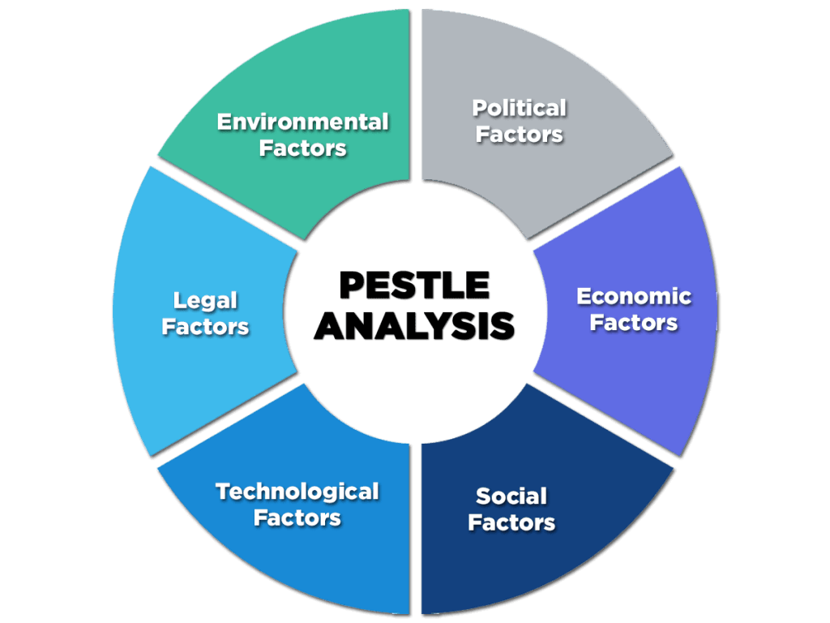
Figure 1: Pestle Framework
(Source: Perera, 2017)

Political Factors:
The political factors that affect Shell Plc include government policies, regulations, and laws that impact the energy industry. In recent years, governments around the world have been implementing policies to reduce greenhouse gas emissions and combat climate change. This has led to increased pressure on companies like Shell to reduce their carbon footprint and transition to cleaner sources of energy. Governments also play a significant role in regulating the oil and gas industry, particularly in areas such as safety, environmental protection, and taxation (Newell and Raimi, 2015). Changes in government policies and regulations can have a significant impact on the profitability and viability of Shell's operations.
Economic Factors:
The economic factors that affect Shell Plc include global economic trends, exchange rates, and energy prices. The company's financial performance is closely tied to the global economy, as economic growth drives demand for energy and affects energy prices. As of 2021, Shell Plc had a market capitalization of approximately $160 billion and generated revenue of $180 billion in 2020 (Silva, 2020). The COVID-19 pandemic had a significant impact on the global economy and the energy industry, causing a sharp decline in oil prices and reduced demand for energy. The company's net income was $4.8 billion in 2020, a significant decline from the $15.8 billion it earned in 2019, largely due to the impact of the pandemic on the energy industry. Despite these challenges, Shell remains one of the world's largest energy companies, with a strong presence in the industry and a commitment to transitioning to cleaner sources of energy.
Social Factors:
The social factors that affect Shell Plc include consumer attitudes and behaviours, demographic trends, and social norms. Consumers are increasingly concerned about the environmental impact of their energy consumption, leading to the growing demand for renewable energy and cleaner sources of energy. This trend has led to increased investment in renewable energy by companies like Shell. Demographic trends also play a role in Shell's operations, particularly in areas such as energy demand and workforce diversity. The company operates in diverse markets and must adapt to local cultural norms and customs to succeed in different regions. Moreover, social norms such as ethical and sustainable practices are becoming increasingly important to consumers, and Shell has responded by implementing policies and initiatives aimed at reducing carbon emissions and promoting sustainable practices across its operations (Duttagupta et al., 2021). As a responsible corporate citizen, Shell Plc recognizes the importance of engaging with local communities and stakeholders to understand their needs and concerns. This engagement helps the company to build positive relationships and maintain its social licence to operate. In conclusion, Shell Plc acknowledges the importance of balancing its commercial interests with social and environmental responsibilities. These factors are important considerations for Shell's long-term sustainability and growth strategy.
Technological Factors:
The technological factors that affect Shell Plc include advances in energy technology, digitalization, and automation. Technological advances are driving changes in the energy industry, leading to the development of new sources of energy and more efficient energy systems. Digitalization and automation are also transforming the energy industry, leading to increased efficiency and cost savings. Shell has been investing in digitalization and automation to streamline its operations and improve its competitive position. For instance, the company has implemented digital twin technology to simulate its oil and gas fields, enabling it to optimise production and reduce downtime. This technology has also enabled Shell to improve safety and reduce its environmental impact by identifying potential issues before they occur.
In addition, Shell has also been exploring new energy technologies such as renewable energy and electric vehicle charging to diversify its business and meet the growing demand for cleaner and more sustainable energy solutions (LaMonaca and Ryan, 2022). Moreover, Shell has been investing in research and development to improve its technological capabilities and stay ahead of the competition.
Legal Factors:
Shell Plc must contend with the same laws, rules, and legal issues that affect the entire energy sector in order to account for the legal elements that influence it. Regulatory uncertainty is a major risk for companies like Shell operating in the energy sector, which is highly regulated. Threats to a company's legal status, such as litigation or investigations by regulatory agencies, can have a major effect on its brand and bottom line. In recent years, Shell has been the target of numerous lawsuits, many of which have to do with the company's alleged role in causing climate change and environmental damage (Peel and Osofsky, 2018). In addition, Shell has collaborated with local and national organizations to advance low-carbon economic development and sustainable growth. Shell Plc takes ethical business practices and sustainability seriously, as seen by its proactive actions. Shell's social license to operate and stakeholder trust can both be strengthened through these efforts.
In conclusion, it is crucial for Shell Plc to continue monitoring and adapting to changes in legal factors affecting the energy industry. This will ensure that the company can navigate regulatory changes and legal challenges while maintaining its commitment to responsible business practices and sustainability. It is important for Shell Plc to prioritise legal compliance and ethical conduct in all its business operations. Shell Plc can set an example for other companies in the energy industry to follow, by prioritising legal compliance and ethical conduct in all its business operations and demonstrating that profitability can be achieved while also promoting sustainable development.
Environmental Factors:
The environmental factors that affect Shell Plc include climate change, pollution, and natural resource depletion. The energy industry is a significant contributor to greenhouse gas emissions and environmental degradation, leading to increased pressure on companies like Shell to reduce their environmental impact. These environmental factors have significant impacts on Shell's operations and reputation. Furthermore, pollution from Shell's operations can have detrimental effects on the environment and public health, leading to negative publicity and potential legal action against the company for not complying with environmental regulations or causing harm to local communities; such as the recent legal action taken against Shell by environmental groups for its failure to reduce emissions in line with the Paris Climate Agreement (Ermakova, 2020), which highlights the increasing pressure on companies to reduce their environmental impact and meet global emissions targets. This has significant implications for Shell's reputation and ability to attract investors who are increasingly interested in sustainable and socially responsible investments.
Shell has been investing heavily in renewable energy and low-carbon technologies to reduce its carbon footprint and transition to cleaner sources of energy. The company announced in April 2020 that it has set a goal of becoming a net-zero emission energy company by 2050 and has made significant progress in this area (Gudde et al., 2021). Shell Plc faces significant and multifaceted challenges in achieving its goal of becoming a net-zero emissions energy company by 2050 which are significant and multifaceted including technical, economic, and political challenges. Technical challenges include developing and scaling up new low-carbon technologies, such as carbon capture and storage (CCS), hydrogen production, and renewable energy, while also ensuring that these technologies are economically viable and can compete with traditional fossil fuels (Nurdiawati and Urban, 2022). Shell must navigate the complex political and regulatory landscape surrounding climate change policies and renewable energy incentives.
Overall, the PESTLE analysis reveals a number of external factors that impact Shell's operations. The company operates in a highly regulated industry that is undergoing significant changes as a result of technological advances, environmental concerns, and shifting consumer attitudes.

PORTER’s Five Forces
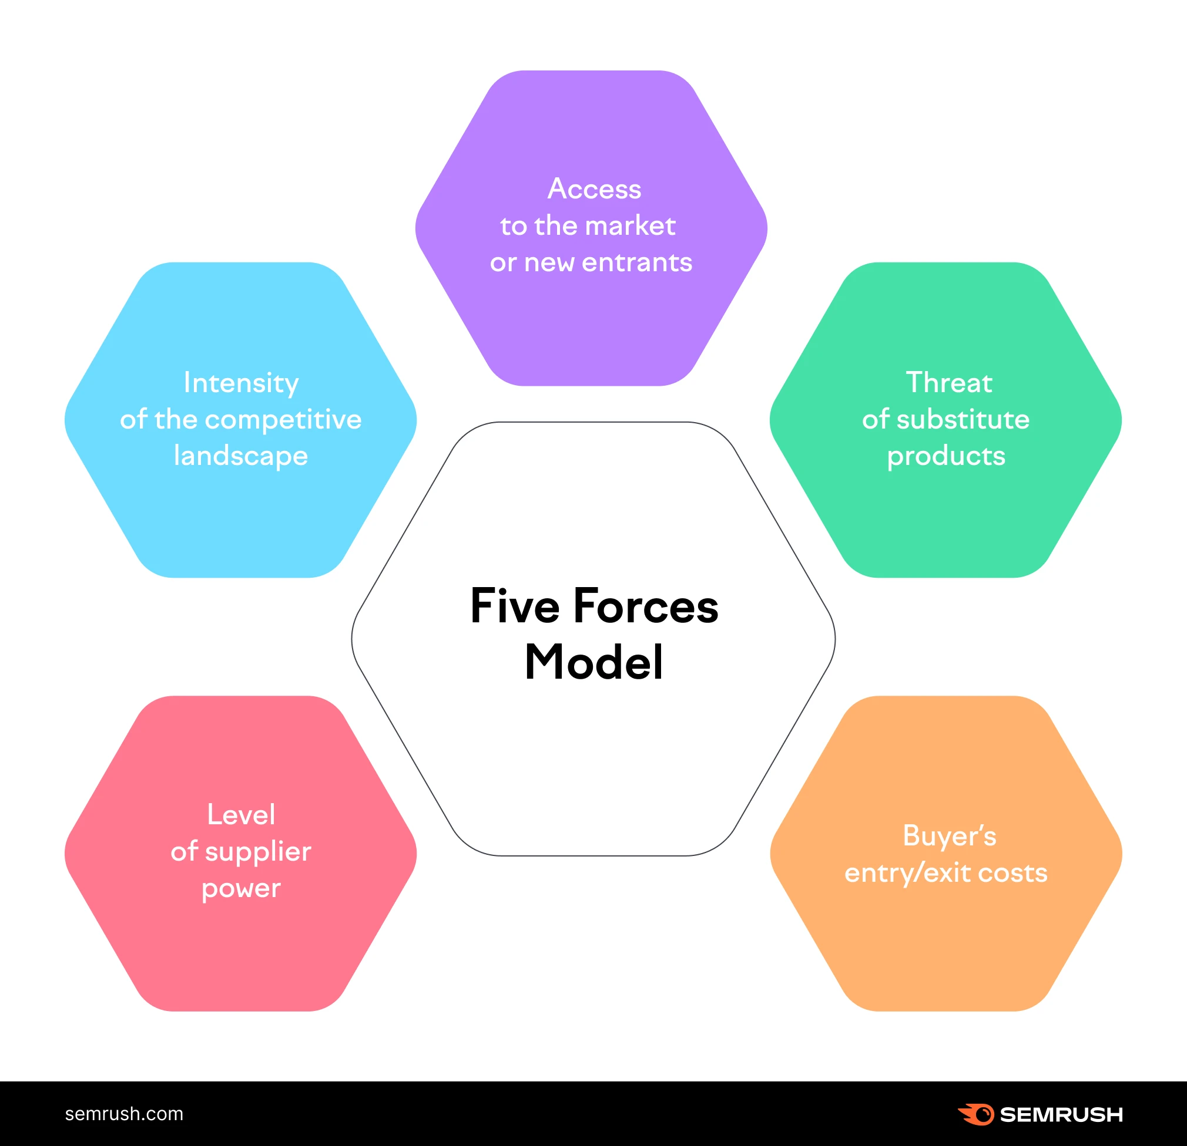
Figure 2: Porter’s Five Forces
(Source: Dobbs, 2014)
When analyzing the competitive factors that shape an industry's profitability and structure, strategists often turn to Porter's Five Forces. It breaks down what factors—new entrant risk, supplier negotiating power, buyer bargaining power, substitute product risk, and competitive rivalry intensity—make up an industry's competitive environment (Bruijl and Gerard, 2018). Companies can benefit from this analysis by learning more about the dynamics of their industry's competition and using that knowledge to devise strategies for survival in a highly competitive market.
In this section, we will analyse Shell Plc using Porter's Five Forces framework to identify the competitive forces that affect the company's business.
Threat of New Entrants:
Due to the high cost of oil and gas exploration, development, and production, the business is very difficult to break into. This makes it challenging for upstarts to enter the market and challenge incumbents like Shell Plc. Also, there are many hurdles to join because the industry is so strictly regulated, with stringent standards for things like environmental safety.
Bargaining Power of Suppliers:
As there are so many companies providing raw materials, equipment, and services to the oil and gas sector, suppliers have little leverage in negotiations. Yet, some suppliers have a disproportionate impact on the sector as a whole. OPEC, for example, owns a large share of the world's oil reserves and has the ability to affect oil prices through production decisions. Shell Plc has historically been a cost leader in the oil and gas industry, with a focus on operational efficiency and cost reduction (Li, Trencher and Asuka, 2022). However, the shift towards renewable energy and low-carbon technologies is changing the dynamics of the industry, requiring companies to invest in new technologies and capabilities.
The Bargaining Power of Buyers:
The bargaining power of buyers in the oil and gas industry is relatively low, as the products are essential commodities with few substitutes. However, buyers have some power to negotiate prices, particularly in the downstream market, where there are many retail outlets and competition is strong. Shell Plc has a diversified portfolio of products and services, with a presence in the upstream, midstream, and downstream markets (Al-Janabi, 2020). The company has a strong focus on safety, environmental protection, and social responsibility, which differentiates it from its competitors.
The threat of Substitutes:
Because there are so few practical competitors for oil and gas as energy and transportation fuels, the sector faces minimal competition. Yet, long-term alternatives are becoming more accessible due to the development of renewable energy and electric automobiles. Shell Plc stands out from the crowd because of its reputable name, extensive product line, and dedication to environmental responsibility (Sousa, 2020). The corporation has committed substantial resources to develop renewable energy and low-carbon technologies with the aim of being a zero-emissions energy provider by 2050.
The intensity of Competitive Rivalry:
The intensity of competitive rivalry in the oil and gas industry is high, as there are many large players in the market, each with significant resources and capabilities (Ahmad et al., 2017). The industry is characterised by strong competition for resources, market share, and profitability. Furthermore, the industry is cyclical, with periods of high profitability followed by downturns and consolidation.
Overall, Porter's Five Forces analysis reveals that Shell Plc operates in a highly competitive and regulated industry, with significant barriers to entry and strong competitive rivalry. To succeed in this environment, the company must continue to innovate and invest in new technologies and business models while maintaining its strong position in the market.

SWOT Analysis
SWOT analysis is a tool used in strategic planning to assess an entity's strengths, weaknesses, opportunities, and threats. It enables the identification of both internal and external factors that have effects on its business activities as well as devising effective strategies to exploit advantageous areas while addressing weak spots, seizing prospects, and curtailing risks (Sarsby, 2016). SWOT analysis finds extensive application across various domains such as commercial operations, marketing, or overall strategy development, which help organisations make informed decisions so they can maintain their competitive edge within the marketplace.
With the above analyses in hand, let's perform a SWOT analysis of Shell Plc. A SWOT analysis of Shell Plc reveals that the company has a strong position in the energy industry, with a strong brand, diversified portfolio, and global presence.
Strengths:
a. Strong brand and reputation: Shell Plc has a strong brand and reputation in the energy industry, built on decades of experience and a commitment to safety, environmental protection, and social responsibility.
b. Diversified portfolio: The company has a diversified portfolio of products and services, with a presence in the upstream, midstream, and downstream markets. This diversification helps to mitigate risks and balance the company's revenue streams.
c. Global presence: Shell Plc operates in more than 70 countries and has a strong global presence, giving it access to diverse markets and resources (Hamilton and Webster, 2018).
d. Strong research and development capabilities: Shell Plc has a strong research and development capability, allowing it to innovate and develop new technologies to stay ahead of the competition.
Weaknesses:
a. Dependence on oil and gas: Shell Plc's dependence on oil and gas for revenue and profits makes it vulnerable to changes in the market, including shifts towards renewable energy and low-carbon technologies (Kabeyi and Olanrewaju, 2022).
b. High debt levels: Shell Plc has a high debt level, which could limit its ability to invest in new technologies and business models.
c. Reputation risks: The energy industry is often criticised for its impact on the environment and society, which could damage Shell Plc's reputation and brand value.
Opportunities:
a. Renewable energy and low-carbon technologies: The shift towards renewable energy and low-carbon technologies presents a significant opportunity for Shell Plc to diversify its business and reduce its carbon footprint.
b. Growing demand for natural gas: The demand for natural gas is expected to grow significantly in the coming years, providing a significant opportunity for Shell Plc to expand its business (Pickl, 2019).
c. Emerging markets: Emerging markets, particularly in Asia, offer significant growth opportunities for Shell Plc, as energy demand is expected to increase in these markets in the coming years.
Threats:
a. Intense competition: The energy industry is highly competitive, with many large players vying for market share and profitability.
b. Price volatility: The oil and gas markets are highly volatile, with prices subject to fluctuation due to a range of factors, including supply and demand, geopolitical risks, and market speculation.
c. Regulatory risks: The energy industry is highly regulated, with complex environmental, safety, and social requirements that could impact Shell Plc's business operations and profitability (O’Faircheallaigh, 2015).

Recommendation
According to the SWOT analysis conducted on Shell plc, it is recommended that the company utilise its strengths and overcome weaknesses, capitalise on available opportunities, and minimise potential threats in order to foster future expansion. The following strategic recommendations can be made for Shell Plc’s growth.

Diversify into renewable energy and low-carbon technologies
The SWOT analysis highlighted the trend toward renewable energy and low-carbon technology as one of the most promising opportunities. If Shell Plc wants to lessen its reliance on the oil and gas industry while taking advantage of new market prospects, it could look at expanding into these other sectors. Investment in R&D could lead to the creation of novel technologies, or it could lead to the acquisition of businesses with experience in renewable energy and low-carbon technology.
Focus on safety, environmental protection, and social responsibility
Shell Plc's strong brand and reputation in the energy industry are built on its commitment to safety, environmental protection, and social responsibility (OBASA, 2022). The company should continue to prioritise these areas to maintain its strong position in the market and mitigate the risks associated with reputation damage. This could involve investing in new technologies and processes to reduce environmental impact and improve safety, as well as engaging with stakeholders to build trust and foster positive relationships.
Manage debt levels carefully
Shell Plc's high debt level could limit its ability to invest in new technologies and business models, which are crucial for future growth (Stevens, 2016). The company should manage its debt levels carefully to ensure it has the financial flexibility to invest in these areas while maintaining its strong position in the market. This could involve implementing cost-cutting measures, divesting non-core assets, or exploring alternative financing options.
Capitalise on growing demand for natural gas
The demand for natural gas is expected to grow significantly in the coming years, particularly in emerging markets (Sen and Ganguly, 2017). Shell Plc should capitalise on this opportunity by expanding its business in this area, investing in new infrastructure, and exploring new markets. This could involve partnerships with local companies or governments.
Invest in new technologies
Shell Plc should continue to invest in research and development to develop new technologies and business models that can help the company stay ahead of the competition and address the challenges posed by the shift towards renewable energy and low-carbon technologies. The company can explore partnerships with startups and other innovators to access cutting-edge technologies and accelerate its innovation efforts.
Maintain strong reputation
Shell Plc should continue to focus on safety, environmental protection, and social responsibility to maintain its strong brand and reputation in the industry and mitigate the risks associated with reputation damage (Leipziger, 2017). The company can implement initiatives to reduce its carbon footprint, improve its environmental and social performance, and engage with stakeholders to build trust and credibility.
Leverage digital technologies
Shell Plc can leverage digital technologies to optimise its operations, improve efficiency, and reduce costs. The company can invest in data analytics, artificial intelligence, and other digital tools to optimise its supply chain, improve its customer service, and streamline its operations.
Expand into emerging markets
Shell Plc can explore opportunities to expand into emerging markets, particularly in Asia, where energy demand is expected to increase significantly in the coming years. The company can leverage its global presence and expertise to access new markets and build strategic partnerships with local players.
The SWOT analysis conducted on Shell Plc concludes that the company possesses notable strengths, which can be utilised to counterbalance its weaknesses and confront potential threats. It is recommended that the organisation concentrate on diversifying its operations, investing in innovative technologies, controlling debt levels, sustaining an admirable image, exploiting digital platforms and penetrating into developing markets to establish a stable footing for future expansion and prosperity within the energy sector.

Conclusion
The assessment of Shell Plc's current business status, competitive position, and future growth prospects is effectively carried out through the external analysis, utilising the PESTLE and PORTER frameworks in conjunction with internal SWOT framework evaluation. This thorough examination reveals crucial obstacles that the company must address, including the transition to renewable energy, mounting regulatory demands and risk from new market players or alternatives. Nevertheless, by identifying key advantages and opportunities that can be capitalised on to surmount these hurdles while maintaining a strong edge over rivals also becomes apparent through this study.
The recommendations shared based on the SWOT analysis emphasise the need for Shell Plc to diversify its business, invest in new technologies, manage its debt levels, maintain its strong reputation, leverage digital technologies, and expand into emerging markets. By implementing these recommendations, Shell Plc can position itself for long-term growth and success in the energy industry. Overall, the comprehensive analysis of Shell Plc provides a clear understanding of its current position and the strategies that it needs to adopt in order to remain competitive in the ever-changing energy industry.

References
Ahmad, N.K.W., de Brito, M.P., Rezaei, J. and Tavasszy, L.A., 2017. An integrative framework for sustainable supply chain management practices in the oil and gas industry. Journal of Environmental Planning and Management, 60(4), pp.577-601.
Al-Janabi, Y.T., 2020. An overview of corrosion in oil and gas industry: upstream, midstream, and downstream sectors. Corrosion Inhibitors in the Oil and Gas Industry, pp.1-39.
Bruijl, D. and Gerard, H.T., 2018. The relevance of Porter's five forces in today's innovative and changing business environment. Available at SSRN 3192207.
Duttagupta, A., Islam, M., Hosseinabad, E.R. and Zaman, M.A.U., 2021. Corporate social responsibility and sustainability: a perspective from the oil and gas industry. Journal of Nature, Science & Technology, 2, pp.22-29.
Ermakova, E.P., 2020. Lawsuits against governments and private companies of european countries over climate protection under the Paris Agreement 2015 (UK, Netherlands, Germany and France). Perm U. Herald Jurid. Sci., 49, p.604.
Gudde, P., Oakes, J., Cochrane, P., Caldwell, N. and Bury, N., 2021. The role of UK local government in delivering on net zero carbon commitments: You've declared a Climate Emergency, so what's the plan?. Energy Policy, 154, p.112245.
Hamilton, L. and Webster, P., 2018. The international business environment. Oxford University Press.
Issa, T., Chang, V. and Issa, T., 2010. Sustainable business strategies and PESTEL framework. GSTF International Journal on Computing, 1(1), pp.73-80.
Kabeyi, M.J.B. and Olanrewaju, O.A., 2022. Sustainable energy transition for renewable and low carbon grid electricity generation and supply. Frontiers in Energy Research, 9, p.1032.
LaMonaca, S. and Ryan, L., 2022. The state of play in electric vehicle charging services–A review of infrastructure provision, players, and policies. Renewable and sustainable energy reviews, 154, p.111733.
Leipziger, D., 2017. The corporate responsibility code book. Routledge.
Li, M., Trencher, G. and Asuka, J., 2022. The clean energy claims of BP, Chevron, ExxonMobil and Shell: A mismatch between discourse, actions and investments. PloS one, 17(2), p.e0263596.
Newell, R.G. and Raimi, D., 2015. Oil and gas revenue allocation to local governments in eight states (No. w21615). National Bureau of Economic Research.
Nurdiawati, A. and Urban, F., 2022. Decarbonising the refinery sector: A socio-technical analysis of advanced biofuels, green hydrogen and carbon capture and storage developments in Sweden. Energy Research & Social Science, 84, p.102358.
OBASA, O., 2022. Corporate Social Responsibility Practices of Multinational Enterprises in the Developed and Developing Countries Context (Doctoral dissertation, School of Public Policy, University of Erfurt).
O’Faircheallaigh, C., 2015. Social equity and large mining projects: Voluntary industry initiatives, public regulation and community development agreements. Journal of business ethics, 132, pp.91-103.
Peel, J. and Osofsky, H.M., 2018. A rights turn in climate change litigation?. Transnational Environmental Law, 7(1), pp.37-67.
Pickl, M.J., 2019. The renewable energy strategies of oil majors–From oil to energy?. Energy Strategy Reviews, 26, p.100370.
Sarsby, A., 2016. SWOT analysis. Lulu. com.
Sen, S. and Ganguly, S., 2017. Opportunities, barriers and issues with renewable energy development–A discussion. Renewable and Sustainable Energy Reviews, 69, pp.1170-1181.
Shell Global., 2022. Shell Annual Report and Accounts 2022 - Shell plc Annual Report and Accounts 2022. [online] Available at: https://reports.shell.com/annual-report/2022/ [Accessed 16 March 2023].
Shell. 2023. Home. available at.https://www.shell.com/ / [Accessed 16 March 2023].
Silva, P.I.B., 2020. Royal Dutch Shell PLC balancing oil with energy transition (Doctoral dissertation).
Sousa, S., 2020. Equity Research-Royal Dutch Shell, PLC (Doctoral dissertation, Universidade de Lisboa (Portugal)).
Stevens, P., 2016. International Oil Companies. Chatham House. van Bylandtlaan, C., Royal Dutch Shell plc.
Perera, R., 2017. The PESTLE analysis. Nerdynaut.
Dobbs, M.E., 2014. Guidelines for applying Porter's five forces framework: a set of industry analysis templates. Competitiveness review, 24(1), pp.32-45.

