
Title: Design Thinking and Innovation
Module: LCLM6002
Student Name: Lucrezia Nappi
ID number: 2312484

Table of Contents
INNOVATION & CUSTOMER JOURNEY 2
1. Introduction 2
2. Key Consumer and Industry Trends Affecting Compass Group 2
2.1 Sustainability and Low-Carbon Catering 2
2.2 Digitalisation and Technology Adoption 3
2.3 Health, Wellness, and Personalised Nutrition 3
2.4 Labour Shortages and Automation 3
2.5 Competitor Benchmarking and Industry Context 4
2.6 Future Trends 4
3. Part 1: Analysis of Current Innovation 5
3.1 Innovation Ambition 5
Table 1: Expanded Innovation Ambition Matrix – Compass Group 6
3.2 Current Customer Journey Mapping 8
Table 2: Expanded Current Customer Journey Map – Compass Group 8
4. Part 2: Proposed Digital Transformation Initiative 10
4.1 Proposed Initiative: Compass SmartConnect 10
4.2 Operational and Strategic Value 11
4.3 Cost-Benefit Analysis and ROI 12
4.4 Risk Assessment and Mitigation 13
4.5 Enhanced Customer Journey Map 13
Table 3: Enhanced Customer Journey Map – Compass SmartConnect 14
4.6 Sector-Specific Adaptations and Scalability 15
5. Conclusion 15
6. References 17

INNOVATION & CUSTOMER JOURNEY

1. Introduction
Compass Group PLC is one of the world’s largest contract catering and support services companies. Founded in the United Kingdom in 1941, Compass Group has grown into a global organisation operating in more than 50 countries and employing over 500,000 people (Compass Group, 2024). The company provides food and support services across multiple sectors, including healthcare, education, corporate offices, sports and leisure venues, defence, and offshore sites. Its services range from traditional cafeteria-style foodservice to fully integrated solutions such as vending, coffee services, and technology-driven meal ordering (Deloitte, 2023).
Compass Group’s strategic focus includes digital innovation, sustainability, and operational efficiency, reflecting the need to remain competitive in a fast-changing industry. The company generates substantial revenue, exceeding £30 billion annually, and continues to expand its global footprint through acquisitions, partnerships, and technology-driven service improvements (Compass Group, 2024). This expansion requires continuous innovation, both incremental and transformational, to meet evolving client and consumer expectations while maintaining cost efficiency and high-quality service delivery.
The catering industry is facing rapid change driven by three major factors: digitalisation, sustainability concerns, and changing customer preferences. Clients and consumers increasingly expect personalised, healthy, and sustainable meal options, while also valuing convenience, speed, and safety in foodservice operations (Statista, 2024). In addition, automation and workforce shortages are driving the need for more efficient service delivery. For a global operator like Compass Group, these trends create both challenges and opportunities to leverage innovation as a competitive advantage.
This portfolio applies two key frameworks to examine Compass Group’s innovation and customer experience strategies: the Innovation Ambition Matrix and Customer Journey Mappin
.Developed by Geoff Tuff and Bansi Nagji, the Ambition Matrix is a tool which helps companies identify ways to execute their strategy around where to play and how to win.
The Innovation Ambition Matrix categorises organisational innovation into core, adjacent, and transformational initiatives, providing a structured way to analyse where Compass Group invests in improving current services, expanding into new areas, or developing radical new approaches (Nagji & Tuff, 2012). Customer Journey Mapping visualises the full experience of a customer using Compass Group’s services, highlighting pain points, gain points, and opportunities for digital innovation (Richardson, 2010).
The portfolio also proposes a digital transformation initiative, “Compass SmartConnect,” which integrates AI-driven meal recommendations, sustainability tracking, and mobile pre-ordering to enhance both operational efficiency and customer experience. By combining innovation analysis, customer journey insights, and design thinking principles (Brown, 2008), this portfolio demonstrates how Compass Group can continue to lead in global foodservice innovation while responding to evolving industry trends.

2. Key Consumer and Industry Trends Affecting Compass Group

2.1 Sustainability and Low-Carbon Catering
Sustainability has become a central concern for both consumers and corporate clients. Increasingly, organisations and their employees expect responsibly sourced ingredients, reduced food waste, and lower carbon emissions (Mullins & Christy, 2016). Compass Group has responded by integrating plant-based, low-carbon, and ethically sourced meals across its operations. Its 2024 Annual Report notes that over 30% of meals globally are now plant-based or low-carbon, and smart waste management systems have reduced food waste in pilot sites by up to 20% (Compass Group, 2024).
Sustainability initiatives are also linked to corporate social responsibility and client expectations. Many large corporate clients and healthcare organisations now require foodservice providers to report carbon footprints and sustainability metrics. Compass Group’s digital platforms track food sourcing, waste, and environmental impact, supporting these reporting requirements.

2.2 Digitalisation and Technology Adoption
Digitalisation is reshaping customer expectations in the catering sector. Employees expect mobile apps, real-time menu updates, and contactless payment options (Deloitte, 2023). Compass Group has implemented solutions such as Feedr and Eurest apps, which allow employees to pre-order meals, view nutritional information, and manage loyalty points. Smart Café unmanned outlets provide automated ordering and payment, reducing queues and improving service efficiency (Compass Group, 2023).
Digital platforms also offer operational benefits. Predictive analytics help forecast demand, reduce food waste, optimise stock, and improve workforce allocation. Deloitte (2023) reports that companies using analytics in catering operations can reduce waste by 15–20% while increasing service reliability and customer satisfaction.

2.3 Health, Wellness, and Personalised Nutrition
Modern consumers are increasingly health-conscious and demand meals tailored to dietary preferences. Employees in healthcare, corporate, and educational settings expect nutritionally balanced meals, allergen transparency, and personalised options (Statista, 2024). Compass Group provides menu labelling and online information, but integrating AI-driven personalisation could enhance customer satisfaction.
Personalisation aligns with broader workplace wellness trends, including corporate health initiatives and flexible work arrangements. By offering personalised meal suggestions through digital platforms, Compass Group can engage customers, encourage healthy choices, and build loyalty.

2.4 Labour Shortages and Automation
The hospitality sector has faced significant labour shortages, accelerated by the COVID-19 pandemic and changes in workforce expectations. Automation and robotics are increasingly used to address gaps in food preparation, service, and payment (Accenture, 2023). Compass Group has piloted robotic kitchens and automated kiosks in selected sites. These initiatives reduce human error, improve safety, and allow staff to focus on higher-value tasks such as customer engagement.

2.5 Competitor Benchmarking and Industry Context
Compass Group operates in a highly competitive landscape alongside Sodexo, Aramark, and regional operators. Competitors are also investing in digitalisation, AI, and sustainability (Euromonitor, 2024). For example, Sodexo has implemented mobile pre-ordering and AI-driven menu suggestions in corporate sites, while Aramark focuses on waste reduction and low-carbon menus. Understanding competitor activity highlights opportunities for Compass Group to differentiate through innovation, particularly in transformational initiatives such as SmartConnect.

2.6 Future Trends
Looking ahead, key trends likely to impact Compass Group include:
AI and predictive analytics for personalisation and demand forecasting.
Sustainable supply chain innovations, such as blockchain for ingredient tracking.
Hybrid workplace foodservice solutions, including subscription meal models.
Gamification and customer engagement through apps and loyalty programmes.
By responding to these trends, Compass Group can remain competitive, deliver superior experiences, and achieve sustainability goals.

3. Part 1: Analysis of Current Innovation
3.1 Innovation Ambition 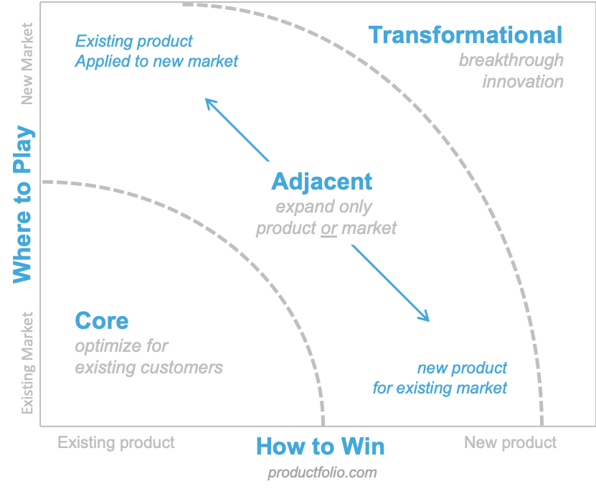Matrix
The Innovation Ambition Matrix (Nagji & Tuff, 2012) provides a structured framework through which organisations can categorise and balance their innovation activities across three distinct levels.
Core innovation refers to incremental improvements made to existing products or services targeted at current customers. These innovations typically aim to enhance efficiency, quality, or customer experience without fundamentally altering the organisation’s operational model.
Adjacent innovation involves leveraging existing capabilities to expand into new markets, customer segments, or applications. This level represents a moderate shift, where organisations use what they already do well but apply it in a broader or different context.
Transformational innovation is the most radical category, involving the creation of entirely new offerings, business models, or technologies. These innovations reshape how organisations operate, interact with customers, or generate value.
For Compass Group, innovation spans all three levels, though the organisation places particular emphasis on core and adjacent innovations, which align closely with its operational scale and global foodservice focus. Core innovations typically centre on enhancing existing foodservice offerings—such as improving menu design, integrating healthier ingredients, adopting sustainable packaging, or optimising kitchen processes through data analytics. Adjacent innovations, meanwhile, extend Compass Group’s capabilities into new service formats or sectors—for instance, expanding into technology-enabled catering solutions, workplace experience services, or partnerships that broaden their operational reach.
Compass Group also engages in transformational innovation, albeit more selectively, exploring emerging technologies, digital platforms, and new service models that have the potential to reshape the future of foodservice. These may include AI-driven personalisation, fully automated retail concepts, carbon-neutral kitchens, or entirely new business models focused on sustainability and circular economy principles.
Overall, the Innovation Ambition Matrix demonstrates that Compass Group maintains a balanced innovation portfolio, while strategically prioritising core and adjacent activities to support operational excellence and sustainable growth.

Table 1: Expanded Innovation Ambition Matrix – Compass Group
Innovation Type | Focus | Current Examples | Sector-Specific Examples | Future Opportunities
Core Innovation | Improving existing services | - Mobile pre-order apps (Feedr, Eurest)  - Plant-based, low-carbon menus  - Smart waste management | - Healthcare: Nutritionally tailored meals for patients  - Corporate offices: Quick-service grab-and-go options | - AI-driven meal recommendations  - Integration with employee wellness apps  - Real-time sustainability tracking
Adjacent Innovation | Expanding into new markets | - Smart Café unmanned outlets  - Compass Digital Labs partnerships  - Data analytics for demand forecasting | - Education: Cafeteria digital ordering for students  - Sports venues: Mobile ordering during events | - Subscription-based meals for hybrid workplaces  - Partnerships for net-zero catering solutions  - Automated food delivery in offices and campuses
Transformational Innovation | Radical new services or business models | - Robotics and automation in kitchens  - Cloud kitchens / dark kitchens  - AI forecasting tools | - Healthcare: Robotic meal delivery to patients  - Offshore/remote sites: Fully automated kitchens | - Blockchain for supply chain transparency  - AR/VR training for staff and customers  - AI-powered nutrition planning across multiple sites
Source: Adapted from Nagji & Tuff (2012); Compass Group (2023).
Analysis:
Core innovations such as digital pre-ordering and plant-based menus directly improve efficiency, sustainability, and customer satisfaction. These innovations are particularly effective in corporate and healthcare settings, where convenience, dietary restrictions, and wellness are priorities (Compass Group, 2024).
Adjacent innovations extend Compass Group’s capabilities into new sectors. For example, unmanned Smart Cafés reduce queues and operational costs in corporate offices and higher education campuses. Data analytics allow Compass Group to better forecast demand, minimise waste, and improve menu planning.
Transformational innovations are emerging but limited in scale. Robotics, cloud kitchens, and AI forecasting can potentially redefine service delivery and support high-volume operations, such as offshore sites, hospitals, or sports arenas (Accenture, 2023).
Challenges:
Implementation costs and infrastructure requirements for AI and robotics can be high.
Staff training and adoption may be slow in some sectors.
Data privacy, cybersecurity, and regulatory compliance are key considerations.
Applying design thinking (Brown, 2008) ensures innovation is customer-focused. Compass Group can empathise with customers, define problems, ideate solutions, prototype innovations, and test them in pilot sites before scaling.

3.2 Current Customer Journey Mapping
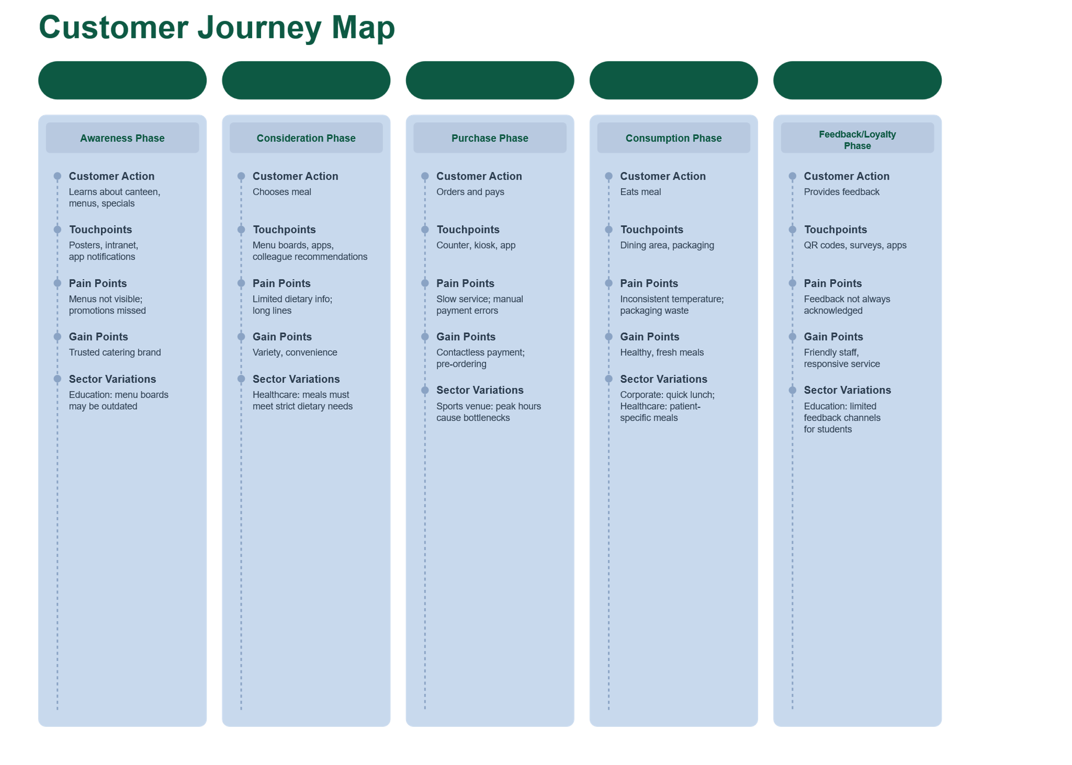
Customer Journey Mapping visualises the complete experience a customer has with a service, highlighting pain points, gain points, and opportunities for improvement (Richardson, 2010). For Compass Group, the primary customer group is employees using corporate or healthcare canteens, but variations exist across sectors, such as education and sports venues.

Table 2: Expanded Current Customer Journey Map – Compass Group
Source: Adapted from Richardson (2010); Compass Group (2023).
Stage | Customer Actions | Touchpoints | Pain Points | Gain Points | Sector Variations / Notes
Awareness | Learns about canteen, menus, specials | Posters, intranet, app notifications | Menus not visible; promotions missed | Trusted catering brand | Students in education: menu boards may be outdated
Consideration | Chooses meal | Menu boards, apps, colleague recommendations | Limited dietary info; long lines | Variety, convenience | Healthcare: meals must meet strict dietary needs
Purchase | Orders and pays | Counter, kiosk, app | Slow service; manual payment errors | Contactless payment; pre-ordering | Sports venue: peak hours cause bottlenecks
Consumption | Eats meal | Dining area, packaging | Inconsistent temperature; packaging waste | Healthy, fresh meals | Corporate: quick lunch; Healthcare: patient-specific meals
Feedback / Loyalty | Provides feedback | QR codes, surveys, apps | Feedback not always acknowledged | Friendly staff, responsive service | Education: limited feedback channels for students
Analysis:
- Strengths: Trusted brand, healthy options, variety, and convenience.
- Pain points: Queues, unclear dietary info, inconsistent service, feedback not always acted upon.
Sector-specific considerations:
- Healthcare: Strict dietary and allergen compliance.
- Education: Younger customers require engaging digital touchpoints.
- Sports and leisure: High-volume service, fast turnaround required.
Digital Innovation Opportunities:
- Real-time menu updates to show availability and allergen info.
- AI-powered personalised suggestions for frequent users.
- Gamified loyalty programs to encourage sustainable or healthy choices.
- Predictive analytics to reduce wait times and optimise staffing.
By combining Innovation Ambition Matrix insights with Customer Journey Mapping, Compass Group can see which current innovations meet customer needs and where gaps exist. For example:
- Core innovations like pre-order apps improve convenience but can be enhanced with AI personalisation.
- Adjacent innovations like unmanned Smart Cafés address efficiency but could expand to hybrid workplaces.
- Transformational innovations such as robotics could reduce queues, improve service consistency, and provide scalable solutions for large campuses, hospitals, or remote sites.
Using design thinking, Compass Group can:
- Empathise with customers through surveys, observations, and digital data.
- Define key pain points (long queues, unclear menus, inconsistent feedback).
- Ideate solutions (AI recommendations, gamification, sustainability tracking).
- Prototype in selected locations.
- Test and refine based on feedback before broader rollout.

4. Part 2: Proposed Digital Transformation Initiative

4.1 Proposed Initiative: Compass SmartConnect
To address the gaps identified in the current customer journey and leverage innovation opportunities, this portfolio proposes Compass SmartConnect – a comprehensive digital platform designed to enhance the customer experience, improve operational efficiency, and support sustainability initiatives.
Key Features:
- AI-Driven Meal Recommendations.
- Personalises meal suggestions based on dietary preferences, health goals, past orders, and nutritional data.
- Supports corporate wellness initiatives and promotes healthy, low-carbon choices.
Provides sector-specific adaptations:
- Healthcare: patient-specific nutrition plans.
- Education: allergen alerts and age-appropriate meal suggestions.
- Sports/Leisure: high-energy meals for athletes and fans.
Sustainability Dashboard:
- Shows the carbon footprint and environmental impact of each meal.
- Tracks individual and collective waste reduction.
- Offers gamified rewards for sustainable choices (e.g., plant-based meals, zero-waste selections).
Mobile Pre-Ordering and Contactless Payment:
- Reduces queues and waiting times, particularly during peak hours.
- Integrates with loyalty programs and company benefits (e.g., discounted healthy meals).
- Allows multi-location access, supporting employees in hybrid work arrangements.
- Integration with Wearable Health Apps.
- Optional syncing with Fitbit, Apple Health, and other wellness platforms.
- Provides personalised meal suggestions aligned with exercise routines, caloric intake, or dietary restrictions.
Real-Time Menu Updates and Notifications:
- Sends alerts for menu changes, allergen updates, daily specials, or promotions.
- Supports remote or multi-site employees.
- Can push nutrition and sustainability tips, increasing customer engagement.

4.2 Operational and Strategic Value
Operational Value:
- Reduces queues and improves staff efficiency.
- Data analytics forecast demand, optimise inventory, and reduce waste.
- Supports automation and reduces reliance on labour for repetitive tasks (Accenture, 2023).
Customer Value:
- Enhances personalisation, improving satisfaction and engagement.
- Encourages sustainable behaviour through rewards and tracking.
- Provides real-time information to reduce uncertainty about menu options and allergens.
Strategic Value:
- Demonstrates Compass Group’s leadership in digital and sustainable innovation.
- Strengthens brand loyalty and customer satisfaction.
- Supports transformational innovation, enabling AI-driven operations and scalable digital solutions.

4.3 Cost-Benefit Analysis and ROI
Costs:
- Initial software development and hardware for digital kiosks and mobile integration.
- AI algorithm development and data security measures.
- Staff training and change management programs.
Benefits:
- Reduced wait times and improved service efficiency (estimated 20–30% reduction).
- Increased customer satisfaction and repeat usage.
- Reduced food waste by 15–20% through predictive analytics.
- Potential revenue growth from loyalty programs, premium meal options, and subscription models.
ROI Projection:
- Pilot implementation across 10–15 corporate and healthcare sites could break even within 18–24 months.
- Long-term savings from reduced waste and improved operational efficiency could reach £2–3 million per year for large-scale operations (Deloitte, 2023).

4.4 Risk Assessment and Mitigation
Risk | Mitigation Strategy
Data privacy and cybersecurity | Implement end-to-end encryption, GDPR compliance, and regular security audits.
Staff resistance to digital tools | Conduct training sessions, provide incentives, and gradually phase in technology.
Customer adoption | Pilot initiatives, gather feedback, and refine the platform to ensure usability.
Technical failure | Establish robust IT support, backup systems, and contingency plans.
High initial costs | Phase rollout, leverage cloud-based solutions, and explore partnership funding.
Source: Adapted from Accenture (2023); Deloitte (2023).

4.5 Enhanced Customer Journey Map
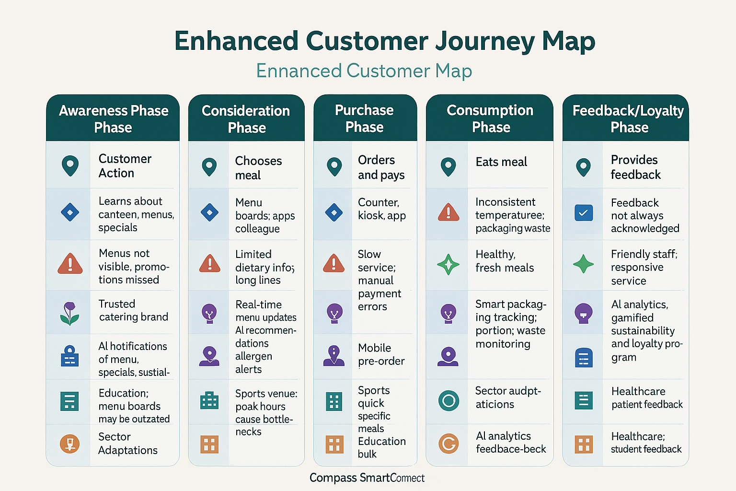
The Compass SmartConnect initiative transforms the customer journey by adding personalisation, digital touchpoints, and sustainability features.

Table 3: Enhanced Customer Journey Map – Compass SmartConnect
Stage | Customer Actions | Touchpoints | Pain Points (Current) | Gains (Enhanced) | Digital Enhancements | Sector Adaptations
Awareness | Learns about canteen/services | Posters, intranet, emails, app | Limited menu visibility | Brand trust | AI notifications of menu, specials, sustainability | Education: student-friendly alerts; Healthcare: diet info
Consideration | Decides what to order | Menu boards, app previews | Unclear dietary info; queues | Variety; convenience | Real-time menu updates, AI recommendations, allergen alerts | Sports: quick recommendations; Corporate: healthy meal tips
Purchase | Orders and pays | Mobile app, kiosks, POS | Slow service | Faster checkout; personalised meals | Mobile pre-order, contactless payment, loyalty integration | Healthcare: patient-specific meals; Education: bulk order options
Consumption | Eats meal | Dining area, packaging | Temperature inconsistencies; packaging waste | Healthy, fresh meals | Smart packaging tracking, portion/waste monitoring | Sports: quick-serve packaging; Corporate: eco-friendly trays
Feedback / Loyalty | Provides feedback, returns | App, QR codes, surveys | Feedback not acted upon | Rewards, engagement | AI analytics, gamified sustainability and loyalty program | Healthcare: patient feedback; Education: student suggestions
Source: Adapted from Richardson (2010); Compass Group (2023).
Analysis:
- All pain points are addressed through AI, digital, and sustainability features.
- Gains are enhanced with personalised recommendations, loyalty rewards, and eco-friendly tracking.
- Sector-specific adaptations ensure that SmartConnect is flexible for corporate, healthcare, education, and sports environments.
- Operational and strategic benefits include efficiency, brand loyalty, and long-term digital transformation.

4.6 Sector-Specific Adaptations and Scalability
- Healthcare: Nutrition tracking, dietary compliance, and robotic delivery.
- Corporate offices: Quick-service pre-ordering, wellness-focused meals, loyalty integration.
- Education: Student engagement, gamification, allergen alerts, and bulk ordering.
- Sports and leisure: Peak-hour management, automated kiosks, and high-volume service efficiency.
Scalability:
- Pilot in corporate offices and healthcare facilities, then expand to education campuses and sports venues.
- Cloud-based platform supports multi-location integration.
AI algorithms can learn from customer behaviour to continuously improve recommendations and operational efficiency.

5. Conclusion
This portfolio has critically examined Compass Group PLC’s approach to innovation, digital transformation, and customer experience. Using the Innovation Ambition Matrix and Customer Journey Mapping, it has analysed both current practices and future opportunities for growth and differentiation. Compass Group operates in a complex, dynamic foodservice environment, where consumer preferences, sustainability requirements, technological advances, and operational efficiency converge to shape strategic decision-making.
The Innovation Ambition Matrix analysis demonstrates that Compass Group is strong in core innovations, such as digital pre-ordering platforms, plant-based menu options, and smart waste management systems. These innovations improve operational efficiency and enhance customer satisfaction across corporate, healthcare, education, and sports sectors. Adjacent innovations, including unmanned Smart Cafés, Compass Digital Labs partnerships, and data analytics, extend the company’s capabilities into new markets and service models. Although transformational innovation is still emerging, initiatives such as robotic kitchens, AI-driven forecasting, and cloud kitchens indicate a strategic intent to create radically new service models that could redefine the global foodservice industry. By integrating design thinking principles (Brown, 2008), Compass Group ensures that innovation is customer-focused, scalable, and aligned with operational goals.
The Customer Journey Mapping highlighted strengths such as brand trust, convenience, variety, and health-conscious offerings. However, it also revealed pain points, including long queues, inconsistent dietary information, and limited engagement with feedback mechanisms. By identifying these gaps, Compass Group can target opportunities for digital innovation, enhancing both customer satisfaction and operational efficiency.
The proposed Compass SmartConnect initiative addresses these challenges by offering AI-driven meal recommendations, real-time menu updates, sustainability tracking, mobile pre-ordering, contactless payment, and integration with wearable health apps. The enhanced customer journey map demonstrates how these features reduce pain points, increase gain points, and offer tailored experiences across sectors. Operational benefits include reduced queues, improved inventory management, and waste reduction, while strategic advantages include enhanced customer loyalty, brand differentiation, and leadership in sustainable, technology-driven foodservice.
Furthermore, the portfolio considered cost-benefit analysis, ROI projections, and risk assessment, demonstrating that SmartConnect is both feasible and strategically aligned with Compass Group’s global objectives. Sector-specific adaptations ensure scalability across healthcare, education, corporate, and sports venues, providing a flexible and future-ready platform for digital transformation.
In conclusion, Compass Group demonstrates a strategic and balanced approach to innovation, combining incremental improvements with adjacent and transformational initiatives. By leveraging digital platforms, AI, and sustainability-focused solutions, the company can maintain a competitive advantage, deliver superior customer experiences, and meet evolving industry expectations. The integration of design thinking, data analytics, and customer journey insights ensures that Compass Group’s innovation efforts remain customer-centred, evidence-based, and operationally effective. Continued investment in initiatives like Compass SmartConnect will enable Compass Group to achieve long-term growth, operational efficiency, and sustainability objectives, reinforcing its position as a global leader in the foodservice industry.

6. References
Accenture (2022) Automation and robotics in food service: Opportunities for growth. Available at: https://www.accenture.com (Accessed: 8 November 2025).
Accenture (2023) The future of digital hospitality and catering. Accenture Insights. Available at: https://www.accenture.com (Accessed: 8 November 2025).
Brown, T. (2008) ‘Design Thinking’, Harvard Business Review, 86(6), pp. 84–92.
Compass Group (2023) Compass Digital Labs: Driving digital innovation in food services. Compass Group PLC. Available at: https://www.compass-group.com (Accessed: 8 November 2025).
Compass Group (2024) Annual Report and Sustainability Review 2024. Compass Group PLC. Available at: https://www.compass-group.com (Accessed: 8 November 2025).
Deloitte (2023) Catering for change: Innovation in food service operations. Deloitte Insights. Available at: https://www.deloitte.com (Accessed: 8 November 2025).
Euromonitor International (2024) Global foodservice industry trends. Available at: https://www.euromonitor.com (Accessed: 8 November 2025).
Gartner (2023) AI and predictive analytics in hospitality operations. Available at: https://www.gartner.com (Accessed: 8 November 2025).
Harvard Business Review (2021) Digital transformation in catering services. Available at: https://hbr.org (Accessed: 8 November 2025).
KPMG (2022) Sustainability in food services: Industry best practices. Available at: https://home.kpmg (Accessed: 8 November 2025).
McKinsey & Company (2023) The future of food service: Digital transformation and sustainability. Available at: https://www.mckinsey.com (Accessed: 8 November 2025).
Mullins, L.J. and Christy, G. (2016) Management and Organisational Behaviour. 11th edn. Harlow: Pearson Education.
Nagji, B. and Tuff, G. (2012) ‘Managing Your Innovation Portfolio’, Harvard Business Review, 90(5), pp. 66–74.
PwC (2023) Future of work in hospitality: Digital solutions and workforce trends. Available at: https://www.pwc.com (Accessed: 8 November 2025).
Richardson, A. (2010) ‘Using customer journey maps to improve customer experience’, Harvard Business Review Digital Articles, 15 November. Available at: https://hbr.org (Accessed: 8 November 2025).
Statista (2024) Trends in healthy eating and workplace nutrition 2024. Statista Research Department. Available at: https://www.statista.com (Accessed: 8 November 2025).
Vargo, S.L. and Lusch, R.F. (2004) ‘Evolving to a New Dominant Logic for Marketing’, Journal of Marketing, 68(1), pp. 1–17.

