BLANK FIRING HANDGUNS | DETAILS
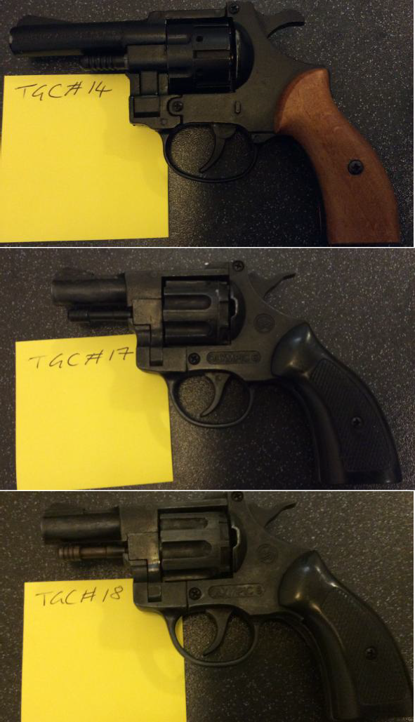
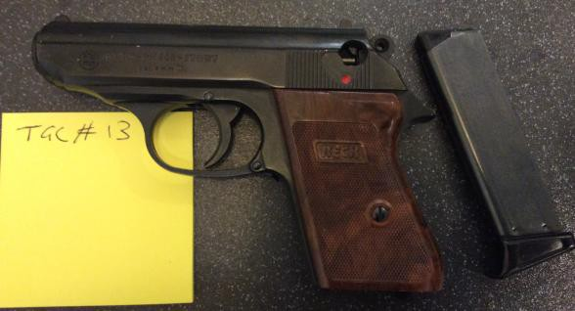 | Security Code: TGC#13  Item: RECK pk800. Blank Firer 8mm. Starter pistol with magazine. Description: Style of a Walther PPK.  Condition: Fine, slide racks, hammer cocks, trigger pulls. Lock lever missing. Repaired grip- screw not ideal but will do for now.  TESTED FIRED: Fires but not completely reliable, ensure that you fully release the trigger before second fire, always load the magazine with a least 5 rounds even if you only need one shot to prevent reduce jams and misfires.  Advice: Practical. Keep as blank firer or RIF.
Security Code: TGC#14
Item: Blank firing .22/6mm Revolver, double action Description: Smith and Wesson 22 style
Condition: Fine. Trigger pulls and Hammer cocks.
TEST FIRED: fairly reliable, single and double action work. Advice: Practical. Keep as blank firer or RIF.
Security Code: TGC#17
Item: Olympic 6, Starter pistol. Blank firing .22/6mm, double action. Description: In style of a snub nosed Smith and Wesson.
Condition: Fine, trigger pulls, hammer cocks, cylinder releases.
TEST FIRED: not that reliable as trigger can be hard to depress. It doesn’t like double action of cocking hammer first – this is quite difficult. Occasional miss fire.
Advice: Practical. Keep as blank firer/RIF
Security Code: TGC#18
Item: Olympic 6, Starter pistol. Blank firing .22/6mm, double action. Description: In style of a snub nosed Smith and Wesson.
Condition: Fine, trigger pulls, hammer cocks, cylinder releases. TEST FIRED: Occasionally jams, not very reliable firer.
Advice: Practical. Keep as blank firer/RIF
RIF (Realistic Imitation Firearms) | DETAILS
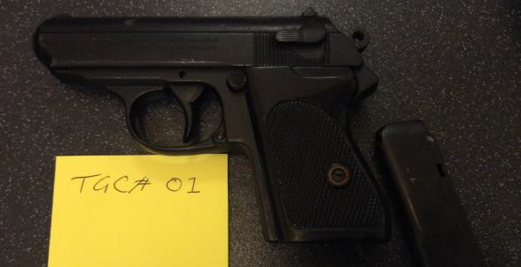 | Security Code: TGC#01  Item: RIF Walther PPK Style, with removable magazine. Description: Metal, weighty.  Condition: Good working order: trigger, slide can rack but won’t hold, hammer and magazine release all work. When fired slide doesn’t move. Advice: Prop.

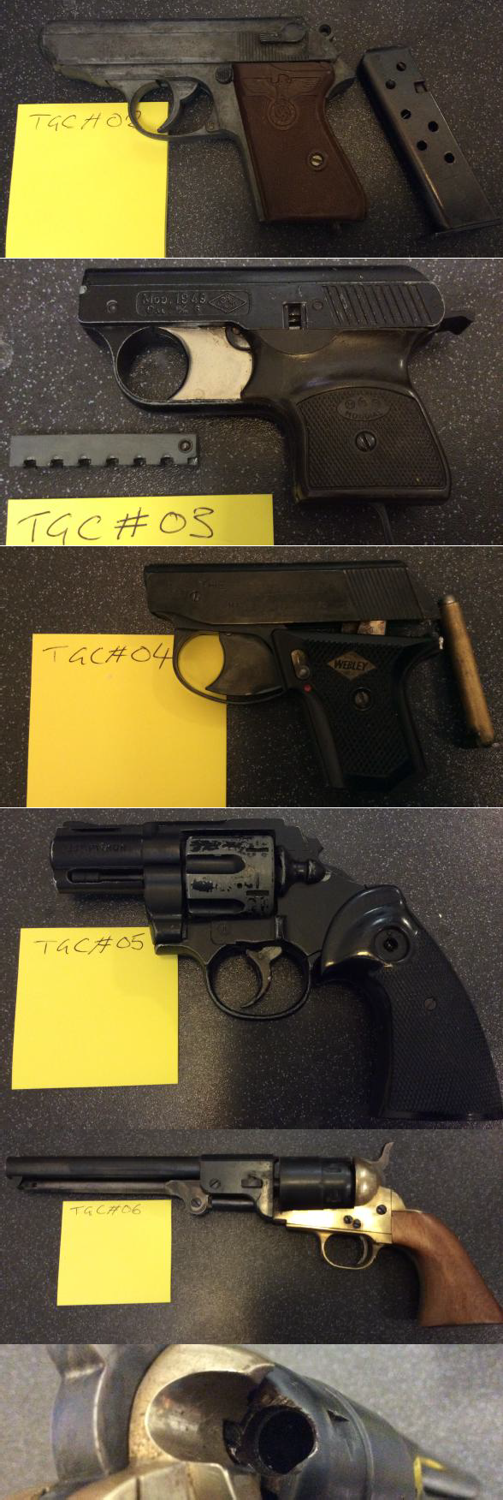
Security Code: TGC#02
Item: RIF Walther PPK Style, with removable magazine. Description: Metal and quite weighty
Condition: Good working order, trigger pulls, slide racks properly, hammer and magazine release all work. When triggered pulled the slide moves.
Advice: Prop
Security Code: TGC#03
Item: Mondial Starter Pistol 1949 Description: Blank Firer .22/6mm.
Condition: Poor, note that you feed the magazine with the ball end first. It feeds through unreliability on the trigger pulls.
Advice: Prop. DO NOT USE AS BLANK FIRER it will fail. Use as RIF
Security Code: TGC#04
Item: Sprint Webley starter pistol with magazine. Description: Blank firer .22 6mm.
Condition: poor, slide lose from frame
Advice: Prop. DO NOT ATTEMPT FIRE use as RIF
Security Code: TGC#05
Item: Snub nosed revolver, 9mm/.38. Description: Blank firer.
Condition: Poor. Hammer has snapped off, trigger doesn’t work, cylinder doesn’t release.
Advice: Prop. DO NOT ATTEMPT FIRE use as RIF
Security Code: TGC#06
Item: In style of 1851 Navy COLT revolver. Description: Blank Firer.
Condition: Dangerous. Was very dirty and in poor condition. Concerned over wear and chipped state surrounding the chambers in cylinder. We have cleaned up and removed carbon. NOTE: the trigger is very sensitive. Advice: Prop. It will probably fire HOWEVER we recommend that you DO NOT ATTEMPT FIRE and use as a RIF, this type are notorious for firing unexpectedly.

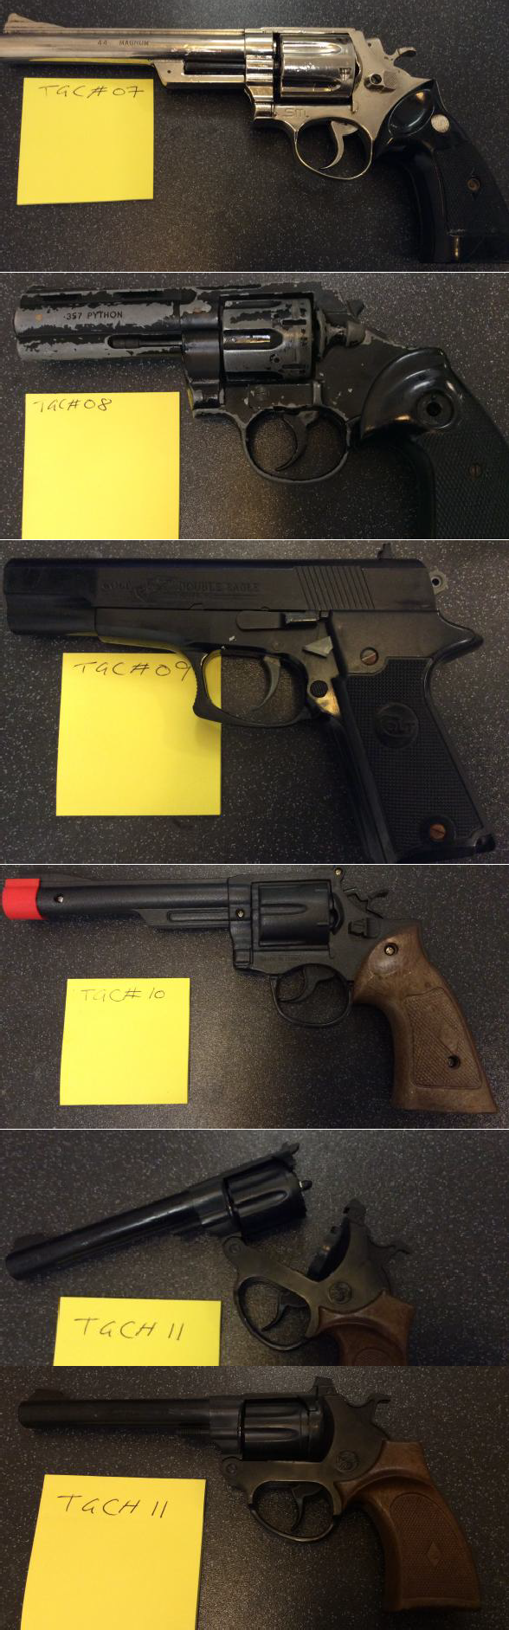
Security Code: TGC#07 Item: Silver Revolver.
Description: RIF. In a generic style of a Smith and Wesson .44.
Condition: Fine, trigger works and moves hammer, cylinder release is difficult, you could load cylinder with dummy bullets, hammer will not cock properly.
Advice: Prop. Keep as RIF.
Security Code: TGC#08 Item: Python Revolver. Description: Blank firer.
Condition: Poor. Cock hammer snapped off. Working trigger and cylinder release.
Advice: Prop. DO NOT ATTEMPT FIRE use as RIF
Security Code: TGC#09 Item: Desert Eagle BB. Description: RIF, plastic toy.
Condition: Fine. Working trigger, hammer bit loose and won’t locate, slide racks but stiff.
Advice: Prop.
Security Code: TGC#10 Item: Toy revolver
Description: Plastic with red muzzle, in the style of Colt police revolver. Condition: Good, pulling trigger moves hammer, cannot cock hammer separately.
Advice: Prop.
Security Code: TGC#11 Item: Cap gun.
Description: Plastic, in the style of a H&R .32 revolver.
Condition: Good, barrel breaks open, pulling trigger moves hammer and barrel, and hammer will not cock separately.
Advice: Prop.

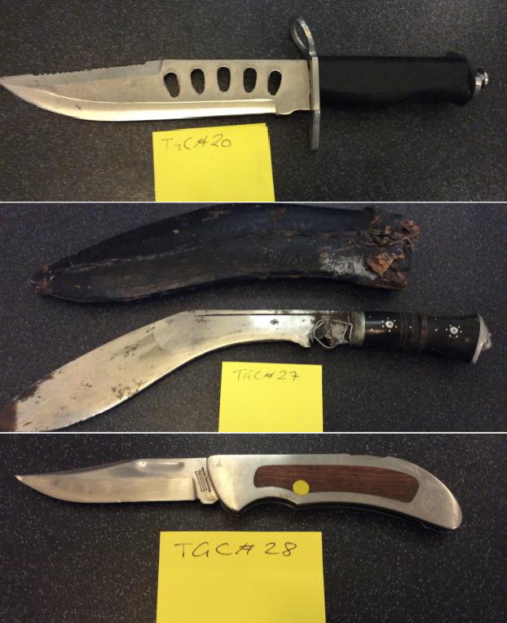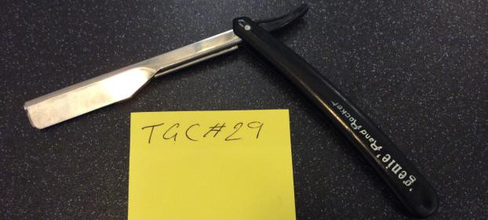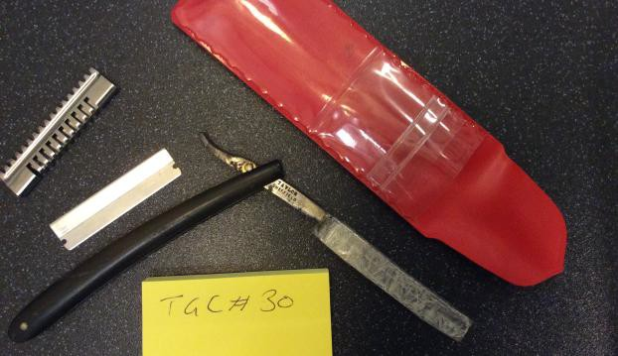
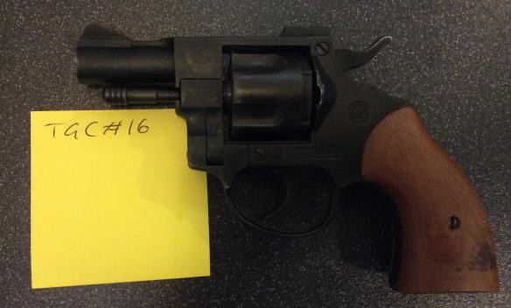 | Security Code: TGC#16  Item: Olympic 38, starter pistol.  Description: Blank firer.  Condition: Poor. Cylinder does not locate on firing, hammer cocks and trigger pulls, cylinder release works.  Advice: Prop. WARNING: This item, since 2010, is classified as a prohibited weapon under section 5 of the 1968 firearms act. (See legal info at end of document). I recommend that you swap this with TGC#14 or TGC#07 and, or once you have finished your run, simply unscrew the gun and dispose of the component parts separately.  DO NOT ATTEMPT FIRE and only use it as a RIF.
KNIVES | DETAILS
Security Code: TGC#20
Item: Large bowie style hunting knife. Description: Black plastic grip, steel blade.
Condition: Good. Blunted, note that pommel can easily work loose. Advice: Prop.
Security Code: TGC#27
Item: Kukri knife with sheath.
Description: Wooden grip, leather sheath, steel blade, heavy, wood grip. Condition: Poor. In grained rusty blade, needs cleaning on a grinder.
Advice: Prop.
Security Code: TGC#28 Item: Lock knife.
Description: Sharpe! Wood and steel grip, steel blade. Condition: Dangerous. A real knife.
Advice: Prop. NEEDS BLUNTING before use.
Security Code: TGC#29 Item: Cut throat razor.
Description: Fake, plastic grip, steel blade, blunt. Condition: Good.
Advice: Prop. RARE keep as safe usable prop, still do not draw against bare skin might scratch or cut.
Security Code: TGC#30 Item: Cut throat razor.
Description: REAL. Plastic grip is broken, complete with cover and 2 spare razors!!!!
Condition: DANGEROUS. Sellotape down blade to cover VERY sharp edge. Advice: Dispose. DO NOT USE. Remove from prop store.

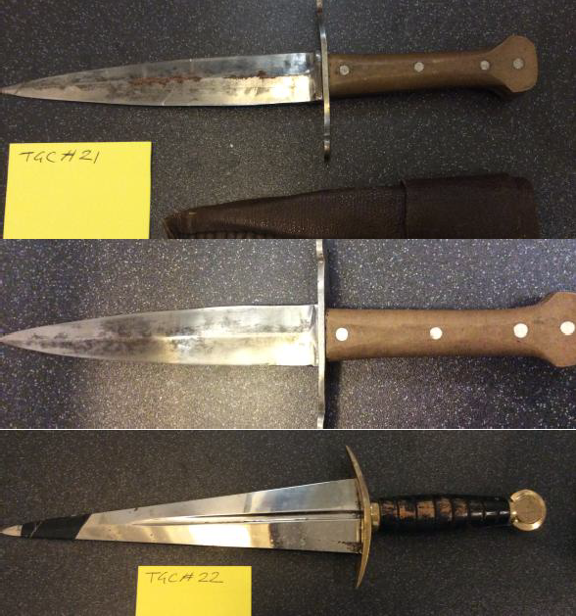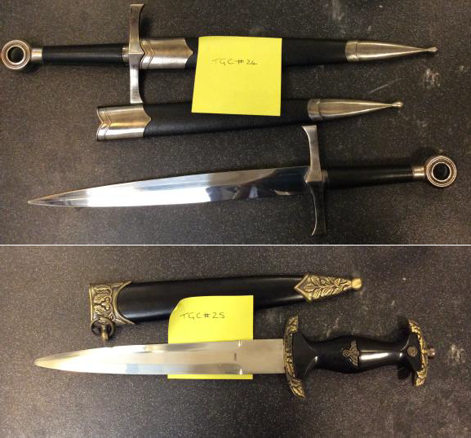
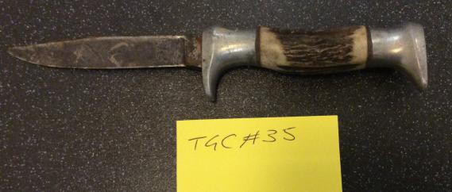 | Security Code: TGC#35 Item: Knife.  Description: Horn grip and steel blade.  Condition: Dangerous. SHARP. Very rusted blade.  Advice: Prop. SHARP NEEDS TO BLUNT BEFORE USE, needs ingrained rust removed on grinder.
DAGGERS
Security Code: TGC#21 Item: Medieval style Dagger.
Description: Metal, diamond cross section blade, leather sheath. Condition: Poor. SHARP. Rust alone centre.
Advice: Prop. NEEDS to be BLUNTED BEFORE USE and POINT taken off. Have removed rust and cleaned, however it still has black marks from old ingrained rust. Will need to clean and blunt on grinder.
Security Code: TGC#22
Item: Cinquedea. Italian 15th Century style dagger.
Description: Diamond blade with fuller, wooden grip, brass quillion and pommel, both scratched.
Condition: Fine. Blade needs cleaning, blade a little narrow may be hard to blunt. Have cleaned blade up.
Advice: Prop.
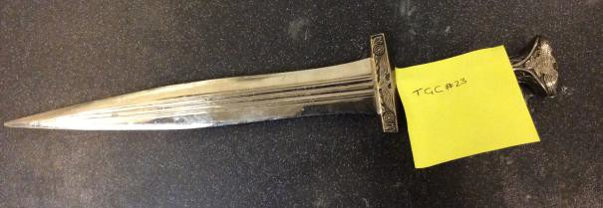 | Security Code: TGC#23 Item: Roman Style Dagger.  Description: Silver metal with cast grip, quillion and pommel, heavy. Condition: Good. Point needs grinding off.  Advice: Prop.
Security Code: TGC#24
Item: Crusader style daggers.
Description: Loop pommels, black plastic grip, cast quillions, scabbard of black plastic and cast resin.
Condition: Fine. They are blunted but a little pointy on the tips. Advice: Prop.
Security Code: TGC#25
Item: WWII style German Dagger.
Description: Black plastic grip, screwed on pommel nut, cast pommel and quillion, plastic and cast sheath.
Condition: Good. Steel blunt blade. Advice: Prop.

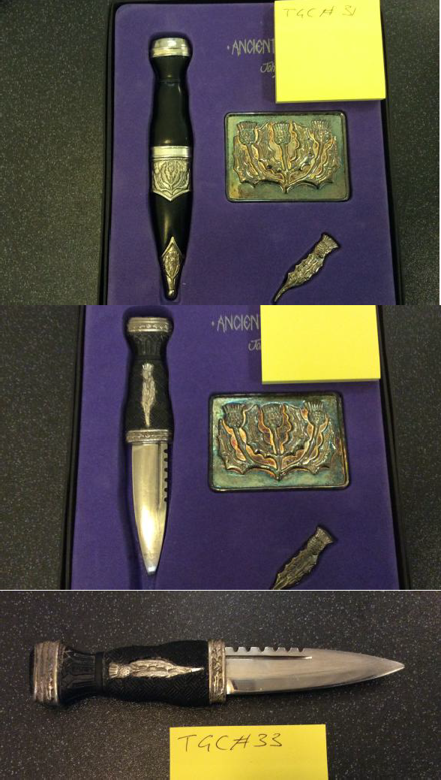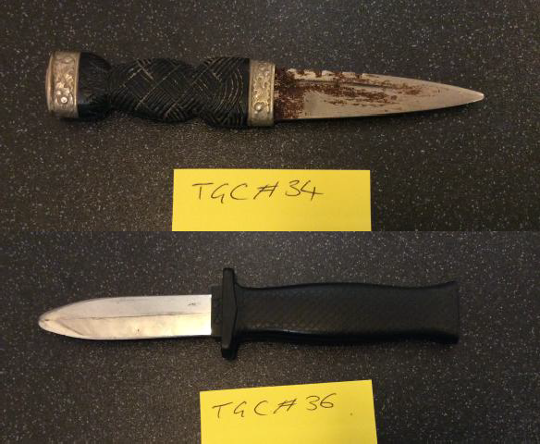
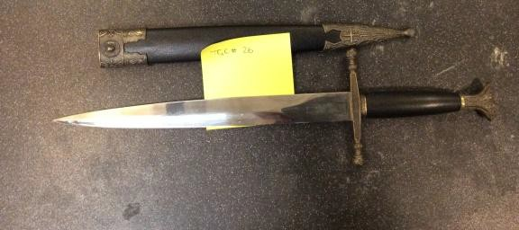 | Security Code: TGC#26  Item: Medieval styled Dagger.  Description: Black plastic grip, fake gold/brass cast pommel and quillion, plastic and cast sheath, steel blunt blade.  Condition: Fine. Bit POINTY, narrow blade, it may be hard to blunt. Advice: Prop. Needs tip blunting.
Security Code: TGC#31 Item: Sgian Dubh Set.
Description: Decorative case dirk with sheath, tie pin and buckle, steel blade, dirk has plastic and steel fake silver grip.
Condition: Good. Blunt. Advice: Prop.
Security Code: TGC#32 Item: Sgian Dubh Set.
Description: Decorative case dirk NO SHEATH, tie pin and buckle steel blade, plastic and steel fake silver grip.
Condition: Fine. Blunt Advice: Prop.
Security Code: TGC#33 Item: Dirk.
Description: Plastic and steel fake silver grip. NO SHEATH. Condition: Good.
Advice: Prop.
Security Code: TGC#34 Item: Dirk.
Description: Small dirk.
Condition: Poor. Very rusted and thin blade.
Advice: Dispose. As you have better examples either clean or dispose.
Security Code: TGC#36 Item: Retractable dagger.
Description: Plastic silver colour blade and black plastic grip. Condition: Good. Will snap easily.
Advice: Prop.

BRIEF LEGAL INFORMATION
Withdrawn: The Olympic BBM .380 caliber blank firing revolver (all variants) is a prohibited weapon due to forensic tests and their prevalence in crime. The Association of Chief Police Officers (ACPO) organised an amnesty which ran until 4th June 2010.

Extract taken from the Firearms Law Guidance to the Police, Restrictions on the Possession, Handling and Distribution of Firearms and Ammunition, 2012;
5.3 In some (very restricted) circumstances certain categories of people may be authorised by the Act to “have in their possession” firearms and/or ammunition without a certificate, but not to purchase or acquire. Such people might include licensed slaughterers, a person taking part in theatrical, television or film productions,

Extract taken from the Firearms act 1968 section 12
Theatre and cinema;
(1)A person taking part in a theatrical performance or a rehearsal thereof, or in the production of a cinematograph film, may, without holding a certificate, have a firearm in his possession during and for the purpose of the performance, rehearsal or production.

An extract taken from the VCRA
Section 37 Specific defenses applying to the offence under s. 36
- It shall be a defense for a person charged with an offence under section 36 in respect of any conduct to show that the conduct was for the purpose only of making the imitation firearm in question available for one or more of the purposes specified in subsection (2).
- Those purposes are—
  - the purposes of a museum or gallery;

(b) the purposes of theatrical performances and of rehearsals for such performances;
- the production of films (within the meaning of Part 1 of the Copyright, Designs and Patents Act 1988 (c. 48) - see section 5B of that Act);
- the production of television programmes (within the meaning of the Communications Act 2003 (c. 21) - see section 405(1) of that Act);
- the organisation and holding of historical re-enactments organised and held by persons specified or described for the purposes of this section by regulations made by the Secretary of State;

Knives that are illegal, (i.e. Section 141 of the Criminal Justice Act 1988)
  - flick knives (also called ‘switchblades’ or ‘automatic knives’) - where the blade is hidden inside the handle and shoots out when a button is pressed
  - butterfly knives - where the blade is hidden inside a handle that splits in two around it, like wings; the handles swing around the blade to open or close it
  - disguised knives – e.g. where the blade is hidden inside a belt buckle or fake mobile phone
  - gravity knives
  - sword-sticks
  - samurai swords (with some exceptions, including antiques and swords made to traditional methods before 1954)
  - hand or foot-claws
  - push daggers
  - hollow kubotan (cylinder-shaped keychain) holding spikes
  - shuriken (also known as ‘death stars’ or ‘throwing stars’)
  - kusari-gama (sickle attached to a rope, cord or wire)
  - kyoketsu-shoge (hook-knife attached to a rope, cord or wire)
  - kusari (weight attached to a rope, cord or wire)
This is not a complete list of banned knives. Contact your local police to check if a knife is illegal or not

Defence extract taken from the Violent Crime Reduction Act 2006 (c. 38) Part 2 — Weapons etc.
44
- In subsections (5), (8) and (9) of section 141 (defences relating to museums and galleries to offence of manufacture, sale etc. of prescribed weapons), for “prove” substitute “show”.
- After subsection (11) of that section insert—
“(11A) It shall be a defence for a person charged in respect of conduct of his relating to a weapon to which this section applies—
  - with an offence under subsection (1) above, or (b) with an offence under section 50(2) or (3) of the Customs and Excise Management Act 1979, to show that his conduct was for the purpose only of making the weapon in question available for one or more of the purposes specified in subsection (11B).
(11B) Those purposes are—
- the purposes of theatrical performances and of rehearsals for such performances;
- the production of films (within the meaning of Part 1 of the Copyright, Designs and Patents Act 1988 - see section 5B of that Act);
- the production of television programmes (within the meaning of the Communications Act 2003 - see section 405(1) of that Act).

