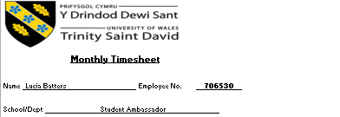

date | description | hours | Hourly rate | Cost centre | Post number
30/06/2026 | Answered students' questions on Unibuddy and put them in contact with a lecturer. | 0.5 | £12.60

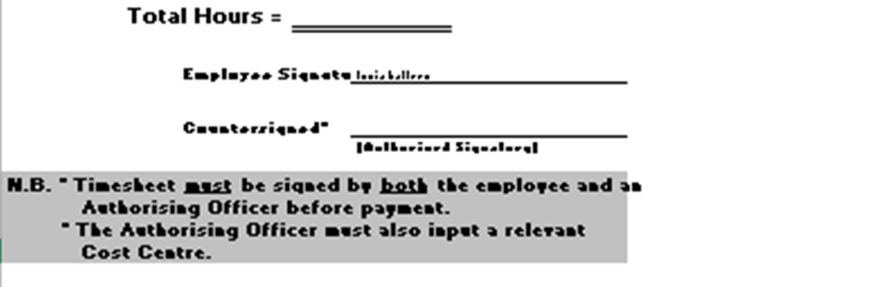
0.5

