8/10/2026
University of Wales Trinity Saint David
london campus
Assessment 1
Network and Cybersecurity Essentials
Module Name: Network and Cybersecurity Essentials
Module Code: (ACCA4024_LON)
Student Name: Dzhenifer Oleksandra Safutina
Student ID: 2514100
Group: 2
Lecturer’s Name: Amit Naik
Contents
Abstract……………………………………………………………..3
Introduction………………………………………………………..3
Identification of cybersecurity threats……………………..3
Security policies…………………………………………………..4
Mitigation measures……………………………………………..5
Monitoring and incident response……………………………6
Staff training and security awareness……………………….8
Data governance…………………………………………………..8
Conclusion…………………………………………………………..8
References……………………………………………………………9
Appendix…………………………………………………..………….9

Abstract
SteelForm Manufacturing Ltd (SFM) is a manufacturing business which uses IoT sensors, automation technology and a cloud-based production management system. While these technologies help boost efficiency and enhance manufacturing processes in today’s world, they also make the business susceptible to cyber threats. This is evidenced by recent cases of malware attacks, phishing emails and attempts of unauthorized access. The current report outlines the most significant internal and external threats that SFM faces and suggests the measures to lower such threats. Monitoring and incident response, as well as the staff awareness are also being considered. The CIA model, confidentiality, integrity and availability, is being used in order to assess the effect of such threats on the company. Suggestions made in the current report are being supported by the approaches used in the information security area, including ISO/IEC 27001, NIST and UK data protection standards.
Introduction
Modern digital technologies are crucial for contemporary manufacturing. SFM utilizes IoT sensors, automation and production management systems based in the cloud to perform its production activities. Though these technologies enable operation advantages, their integration into business and industrial processes increases cybersecurity risks. SFM has been exposed to malware, phishing attempts, as well as attacks on its systems trying to gain unauthorized access. An escalation of these events can lead to losses, interruptions in production, data stealing and harm the reputation of the company. Industrial espionage is another issue as manufacturing companies possess commercially sensitive information about their production process and products. This report aims to develop a cybersecurity and data governance policy for SFM. Such a policy will address issues related to identification of threats both from the inside and outside the company, development of the necessary security policies, mitigation strategies, monitoring of systems and incidents, as well as the enhancement of employees' knowledge in this sphere. The information security assures the confidentiality, integrity, and availability of the information. ISO/IEC gives the requirements for establishing, implementing, maintaining and improving information security management system.
Identification of cybersecurity threats
Internal Threats The internal threats come from the employees, contractors or any authorised user. One internal threat is the actions of the employee by accident. An employee might inadvertently open the malware attachment, click the phishing link or release the confidential information to an unauthorised person. Weak passwords and weak security can cause the attack on the employee's account. Another type of internal threat is insider threats. In this case, the employee with legitimate access may intentionally release the confidential. External threats arise from factors external to the organisation. Phishing presents itself as one of the largest threats since an attacker could use a legitimate-looking email to make the employees divulge their username, password, or other information. This stolen information could be used by the attacker to access cloud services and the corporate systems.
Malware and ransomware present themselves as another threat. While malware could cause harm to the system or steal information, ransomware could block access to files and systems. In the case of manufacturing organisation, a breach of the IT systems would interfere with production operations.
Another possible source of attacks is the IoT devices. An IoT device that is not secure enough can be targeted by the attacker who would use it as the source of entry into the system. Automated machinery and production systems need to be segregated from other devices.
Lastly, industrial espionage is a consideration for SFM. The attackers could try to gain access to sensitive information about the production process, designs, customers, and business plans.
Information, tamper with the data or even disclose the information to the outside party. The too many privileges of the users can lead to the insider threat as the user would access the information and system which are not required for the work.
Threat | Type | Potential impact | Principle
Phishing | External | Credential theft and account compromise | Confidentiality
Malware | External | System damage and loss data | Availability
Ransomware | External | Production and system failures | Availability
Insider threat | Internal | Data theft and misuse | Confidentiality
IoT attack | External | Network compromise | Availability
Industrial espionage | External | Loss or sensitive information | Confidentiality
Unauthorised access | External, internal | Access to system and data | Confidentiality

Security policies
SFM should establish clear security policies that define how employees and systems must be protected.
Access Control Policy It is crucial that SFM implements the principle of least privilege where users have access to the system only when necessary for the job function. User access should be re-evaluated periodically and terminated upon leaving the organisation and changing functions. MFA should be implemented where access to critical systems, especially cloud services, administrative accounts and remote access is needed as another level of security if the password is stolen.
Password Policy Employees should choose robust and unique passwords and not disclose the passwords to anyone else. Password manager applications may come in handy as a solution. MFA should be required for high-risk accounts.
Email and Phishing Policy Employees should be instructed on how to respond to suspicious emails and attachments. Staff should be encouraged to report suspicious messages rather than engaging with them. An email filtering solution should also be installed in order to identify malicious emails before they get delivered to employees. The combination of technical and human factors should be used since technological means do not protect against all social engineering attempts.
Data Protection Policy SFM should categorise information depending on its level of sensitivity. Sensitive production information, personal information and commercially sensitive information should be protected more than publicly accessible information. Organisations should process only personal information for legitimate reasons and take necessary security measures. According to the ICO, the UK GDPR contains such principles as lawfulness, purpose limitation, data minimisation, accuracy, storage limitation, integrity and confidentiality, accountability.
Remote access should only be permitted through approved secure methods. MFA should be required, and remote users should only receive the access necessary for their role. Unauthorised personal devices should not be permitted to connect directly to sensitive production systems.
Mitigation measures
Internet Firewall Corporate Network Controlled Gateway Production Network IoT and manufacturing devices
Production systems should not have unnecessary direct access to the public Internet.
Firewalls- firewalls should control traffic entering and leaving the corporate and production networks. Rules should be based on business requirements, and unnecessary services should be blocked.
Endpoint Detection and Protection- computers and servers should use endpoint protection capable of detecting malware and suspicious activity. Security software should be regularly updated
Patch Management- the operating systems, software and IoT devices need to be patched wherever possible. The vulnerabilities that go unpatched will enable the attackers to have the opportunity to access these systems.
Backup- here needs to be frequent backup of SFM's key business and production data. The backups must be secure from any unauthorised access and ransomware. Some backups must be kept isolated from the production environment so that it is not possible for the attacker to delete all the backups.
Encryption- sensitive information should be encrypted during storage and transmission where appropriate. The ICO notes that encryption can form part of the technical and organisational measures used to protect personal information under UK data protection requirements.
Network monitoring- should monitor the network activity of its system for any suspicious activity. There must be a logging of the security activities in order to detect any unauthorised authentication or malware activity
Monitoring and incident response
Security monitoring must give SFM advance notice regarding any possible attacks. The SIEM solution can be used for collection of logs from the server, endpoints, firewall, and authentication systems. The IDS/IPS solution can also be utilized for detection of any malicious network traffic. Incident Response should be developed as a proper process.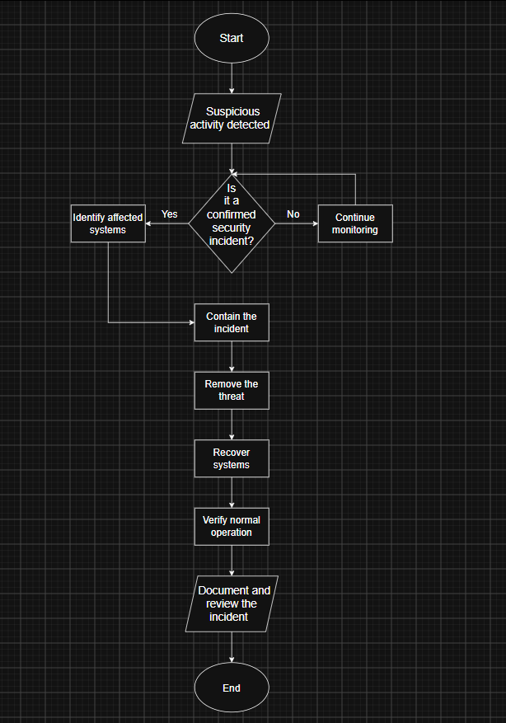
Detection is the first stage. It is important for security staff to examine warnings and see whether they indicate an actual incident. In case of confirmation of an incident, the devices or accounts which were under attack should be quarantined. Containment is the next step. For instance, the computer which became vulnerable can be disconnected from the network, while the account which was attacked will be disabled. Following this stage, the company should find the reason of the incident. Recovery requires restoring systems through backup. Before putting the system back in use, it should be examined. Documentation and analysis is the final stage of an incident response process. The company should learn about the incident, its causes and measures that should be taken to improve their current controls.
Staff training and security awareness
Employees are another component of SFM’s cyber security approach since a number of threats target human behaviour.
The new staff should be introduced to security awareness training at the beginning of their employment. The training should include password security, multi-factor authentication (MFA), phishing techniques, secure use of emails, data protection and incident reporting.
The refresher training should also take place regularly. SFM can organize phishing simulations to evaluate if the staff is able to recognize suspicious communications. The employees failing in simulations will require further training.
The staff should be aware of the procedures for incident reporting. If the employee accidentally clicks on suspicious link he/she should report it immediately and not hide the mistake. Reporting early allows to prevent further development of the incident.
The protection of the confidential production information should be explained in the training as well. The employees should understand the financial and competitive risks that the company faces due to leakage of the sensitive data.
Data governance
Data Governance should support cybersecurity. SFM needs to determine the data it has, where it resides, who will have access to it and for how long it should be retained. Confidential information needs to be classified and the access to it should be governed according to business needs. Duplicate copies of personal and confidential information need to be avoided. Data Protection should be taken into consideration when introducing new systems. According to ICO, data protection by design and by default means taking into consideration data protection and privacy right from the beginning of the development process of any project. SFM should take into account security and privacy when implementing IoT, Cloud or production systems.
Conclusion
As it makes use of connected technology and automated machinery and cloud-based computing technologies, there are cybersecurity threats that may affect SFM's information and operational processes in terms of confidentiality, integrity and availability of the data. An effective cybersecurity policy for the organisation must consist of the following elements: access control; MFA; network segmentation; firewalls; endpoint protection; backups; encryption and monitoring. All these technical measures are to be complemented by proper organisational policies and training for the personnel of the company. There has to be a structured incident response process that includes steps such as detection and containment of the threat followed by recovery and post-incident review. Data governance is another element that should be considered by the company as part of its cybersecurity strategy to ensure the protection of personal and business-sensitive data. On the whole, SFM has to take a risk-based approach to cybersecurity which can be based on the ISO/IEC 27001 standard and UK GDPR principles.
References
- https://nvlpubs.nist.gov/nistpubs/CSWP/NIST.CSWP.29.pdf
- https://nvlpubs.nist.gov/nistpubs/CSWP/NIST.CSWP.29.pdf
- https://www.techtarget.com/whatis/definition/information-security-management-system-ISMS
- https://www.cisa.gov/topics/cybersecurity-best-practices
- https://ico.org.uk/for-organisations/uk-gdpr-guidance-and-resources/security/encryption/encryption-and-data-protection/?utm_source=chatgpt.com
Appendix

