Encyclopaedia Entry: The London Mithraeum

Introduction
This encyclopaedia entry aims to look at the London Mithraeum located in the centre of the city of London. One of the primary focuses of this encyclopaedia entry is to look at both the historical aspects of the London Mithraeum as well as its role in the 21st century in the city of London. The first portion of the entry will discuss the historical background of Mithraism explaining its importance to those who were apart of the Cult of Mithras thousands of years ago. Hopefully this encyclopaedia entry will be able to give an informative understanding of the history and the importance of this historical site located in the City of London.
Background
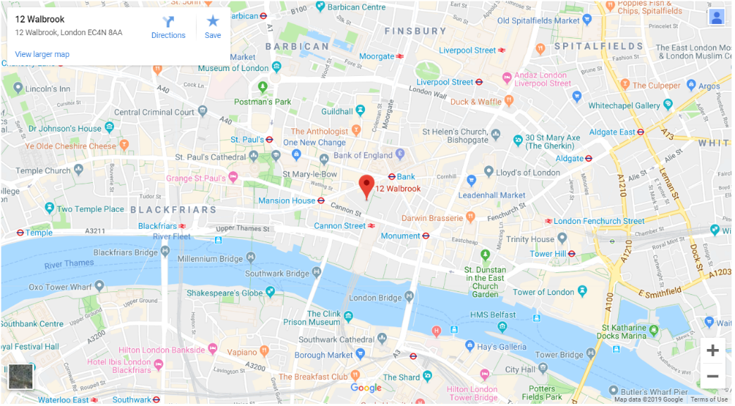
The London Mithraeum is a historical site dating back to the 3rd Century CE. This was a period in which the Roman Empire was in control of the city of Londinium (Now known as London). The historical site is located alongside the ancient Walbrook River which is known as one of London’s lost rivers.
Figure 1: Location of the London Mithraeum in the City of London
The site of the London Mithraeum was rediscovered on the 18th of September 1954. The site which held the ruins of the Temple of Mithras was discovered by a Welsh Archaeologist by the name of W.F. Grimes (1905 – 1988). Grimes was hired to excavate a number of different sites throughout the City of London which had been damaged from the events of the Blitz during the Second World War a decade prior. When excavating the site in Walbrook ready for the development of the new Bucklersbury house site, Grimes had uncovered an ancient Roman temple which was dedicated to the God known as Mithras.

Mithraism
Mithraism is a religion which can be traced back over two thousand years ago to a cult in the Roman Empire. This Roman cult dedicated their lives and worshiped a Roman Deity by the name of Mithras. The Cult can be traced back as early as the 1st Century CE throughout the ancient Roman Empire and then its existence seems to fade out of popularity and later disappears completely by the second half of the 4th Century CE. Temples dedicated to the deity known as Mithras can be located from the United Kingdom all the way to nations like Syria and Iran in the Middle East.
Figure 2: Artwork of the deity known as Mithras.
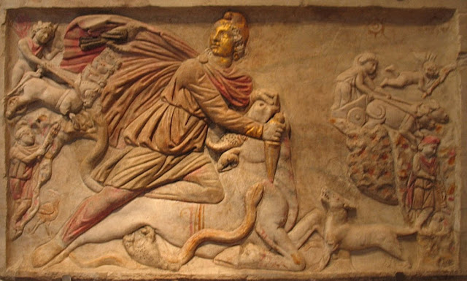
The Deity known as Mithras can actually find its origin to an old Indo-Iranian deity known as Mitra/Mithra. This ancient Persian deity known as Mithra was seen as the Persian god of both war and the sun in ancient Iranian civilization. This mention of the deity Mitra can be dated as far back to the 14th Century BCE in the capital city of the ancient Indo-European civilization known as the Hittites. There is an ancient treaty between the peoples of the Hittites and the Mitanni (Ancient Hurrian speaking people located in the North of Syria) that states that the deity known as Mitra was involved to help sanctify the treaty between these two groups of people.
It is suggested that the Roman Legionnaires who fought in the Middle East in the first Century BCE encountered the traditions and mention of the God known as Mitra from Persia and decided that they would bring back different components for their own use back In the Roman Empire. These Cults which were dedicated to the deity of Mithras in the Roman Empire were primarily full of Roman men of the upper classes, these ranged from both high ranking officials to the soliders stationed in the foreign lands occupied by Rome.

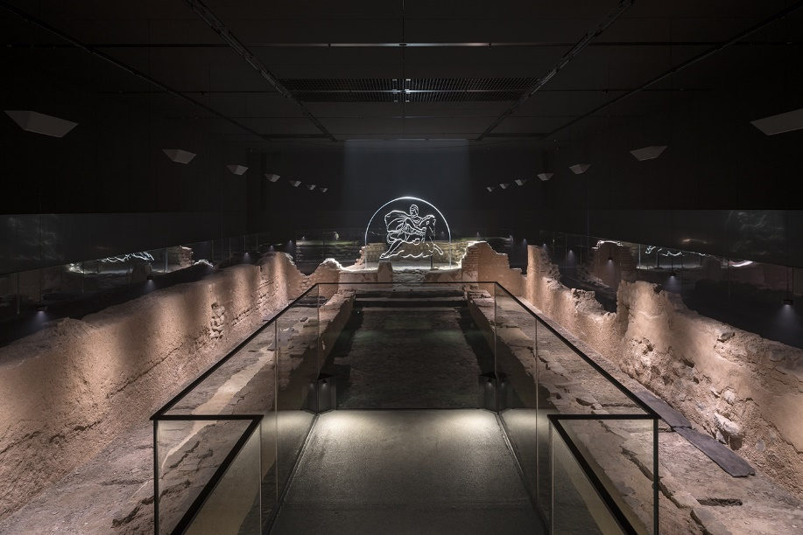
The Tauroctony
Figure 3: Inside the London Mithraeum
All of the Temples located across the Roman Empire which were dedicated to the deity Mithras all followed a very similar design. They seem to all be located in cave-like areas hidden away from the outside world of the ordinary public. There were two key reasons for its location being hidden away in these cave-like areas, the first being that the Cults dedicated to Mithras were primarily kept as a secret only for members of the group to discover and attend, the second key reasons relates to one of the origin stories believed by those inside of the Cult.
Inside of every Mithraeum is a monumental piece which symbolises the deity Mithras sacrificing a sacred Bull inside of a cave, this piece is known as the Tauroctony. This centrepiece inside of the Temple is meant to show an epic scene in which the character of Mithras is dressed in an outfit originating from Anatolia (Now located in Modern day Turkey) with his Phrygian styled hat; stabbing a large Bull in the neck with his knife. The image also contains a numerous amount of different animals alongside Mithras and the bull, this includes a dog and snake trying to reach towards the blood emerging from the dying animal.
This event taking place in the Tauroctony is supposedly taking place inside of a cavern in which Mithras has hunted down the Bull and carried it back to make a meal of it. It depicts the sun (also known as Sol in Latin) shining upon the character of Mithras in his triumph of hunting down the Bull creature. There are also some interpretations of this scene in which the character of Sol actually meets Mithras in person and bows to him as if he is a divine being just like him. This interpretation of Mithras’ relationship with the Sun can be traced back to the Persian origins of the Mithra being seen as the god of the sun.
Unfortunately there is not enough evidence regarding the practices of the cult of Mithras from the period in which they were active. Scholars are unable to confirm if those in the cult practised hunting bulls like the character of Mithras did in the images found in the Tauroctony.

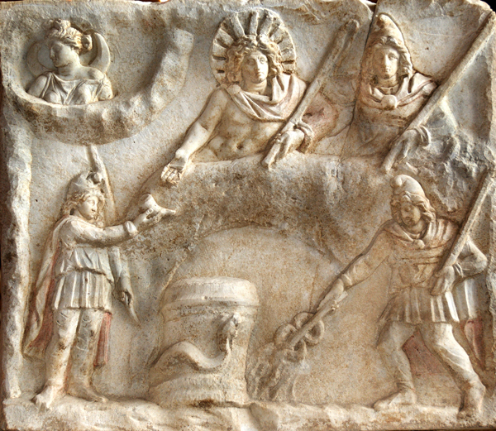
The Banquet of the Sun
Figure 4: Mithras and Sol feasting on the slain Bull.
Just like the image of Mithras slaying the Bull in the Tauroctony, the Banquet of the Sun is also seen as being one of the most important parts of the Cult of Mithras. This image tells the scene which follows after the death of the Bull in which the character of the Sun (known as Sol) and Mithras feast upon its dead carcass. It is stated that members of the Mithraic cult would enact their own version of this event in the Mithraeum once a week in honour of their god Mithras. These meetings places in which the members of the cult would meet would not be very large, meaning that only a small number of individuals would be able to meet and perform these ritual meals in dedication to Mithras.
The idea of ritual meals were in common place in the latter half of the Roman Empire, one of the most famous examples would the Christian Eucharist. The Eucharist is a Christian rite in which they will commemorate the events which took place with Jesus and the last supper prior to his death upon the Cross by Roman soldiers. This similarity between the two Ritual ceremonies regarding the meal sparked debate between Christian scholars, they believed that the Temple of Mithras were trying to parody their Eucharist. So in retaliation Early Church Fathers such as Tertullian (155 – 240 CE) apparently wrote letters to make Mithraism look demonic and evil compared to Christianity.
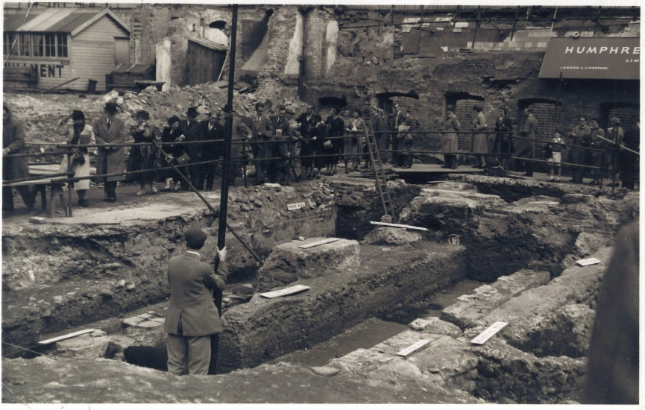
The London Mithraeum 20th Century
During the excavation led by the Welsh Archaeologist W.F. Grimes, the realisation that this was a Mithraeum was not actually realised until later when they discovered a carved piece of art in the shape of the god Mithras. After this realisation the Mithraeum became one of the most visited historical sites in London during the period of the 1950’s and onwards. This interest of the Mithraeum was not only just upheld by both historians and the general public, however it caught the eye of the Prime Minister of the time Winston Churchill who had formerly led Britain to victory during the Second World War. The site was originally going to be used as the foundations for an office block built by the British finance company ‘Legal & General’, however Winston Churchill used his power and influence to prevent this company from building upon the historical site of the Mithraeum.
Figure 5: Site of the rediscovered Temple of Mithras London in 1954.
Although the Mithraeum was supported by a number of influential parties, the company and the government came to an agreement that they would take apart the Mithraeum and move it over 100 meters down the road to an area called Temple Court on Queen Victoria Street. In 1962 they reassembled the site in an open environment for all of the public to be able to view it instead of entering a Cavern like it originally was built in. This reconstruction ran into a numerous amount of issues which drew a number of different criticisms from both the public and scholars alike. One of the key issues that they faced was that they used the wrong material of stone in the reconstruction.

London Mithraeum in the 21st Century
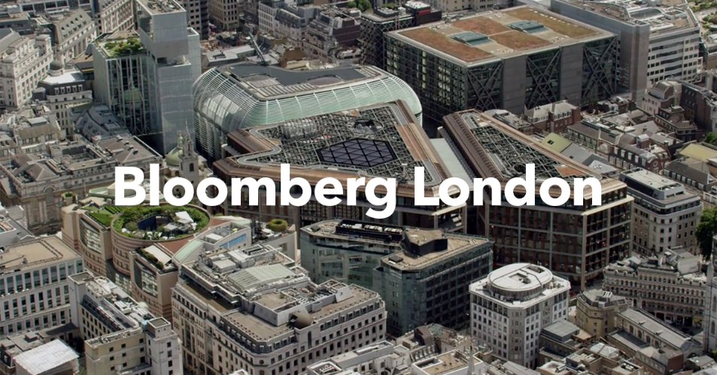
In 2007 there were reports that the London Mithraeum was going to be relocated back to its original location instead of its placement at Temple Court. There were a number of disputes with Legal & General regarding the site, however later in 2010 the international company known as Bloomberg L.P. bought the land and decided to build their new European headquarters. They also decided that they would in fact restore the Mithraeum back to its original site and allow the public to visit the historical site like they had been able to do in the past.
Figure 6: The Bloomberg Building which is built atop of the site of the London Mithraeum.
Bloomberg decided that they would build the Mithraeum underneath their headquarters by having it 7 meters below the London Street level. Alongside this this new rebuilt Mithraeum the Bloomberg Company decided to add a numerous amount of Roman artefacts as a part of the exhibition for the general public to view. These artefacts have been discovered to have belonged to the Roman citizens who lived in the city of Londinium. To provide information regarding the Mithraeum, the exhibition includes a number of different murals of key information located throughout the exhibit as well as providing audio transcripts from different scholars.
One of the benefits of the reconstruction of the London Mithraeum by the Bloomberg Company is that the site is completely free to the general public, according to their website they are open from Tuesday to Sunday every week (excluding a few public holidays). They also allow Schools to book visits to the Mithraeum via their website which allows pupils to have a first-hand account of an ancient religion from two thousand years ago. As a resource for schools they have also provided a KS2 teaching resource via their website which allows schools to both have relevant information about planning their visit as well as providing history regarding the site itself.

Bibliography

Britannica, Mithraism. [ONLINE] Available at: https://www.britannica.com/topic/Mithraism [Accessed 24 March 2019]
Icysedgwick, Temple of Mithras. [ONLINE] Available at: http://www.icysedgwick.com/temple-of-mithras/ [Accessed 28 March 2019]
Londonmithraeum, Learn. [ONLINE] Available at: https://www.londonmithraeum.com/learn/ [Accessed 29 March 2019]
Londonmithraeum. Temple of Mithras. [ONLINE] Available at: https://www.londonmithraeum.com/temple-of-mithras. [Accessed 24 March 2019]
Tertullian, Mithras. [ONLINE] Available at: http://www.tertullian.org/rpearse/mithras/display.php?page=main#History [Accessed 25 March 2019]
TheGuardian, Reconstructed Roman Temple Mithras. [ONLINE] Available at: https://www.theguardian.com/science/2017/nov/08/reconstructed-roman-temple-mithras-opens-public-bloomberg-hq [Accessed 27 March 2019]
TheWitchesAlmanac, Mithras. [ONLINE] Available at: https://thewitchesalmanac.com/mithras/ [Accessed 25 March 2019]
Images Used
Figure 1: Google Maps [ONLINE] Available at: https://www.londonmithraeum.com/visit/#getting-there [Accessed 24 March 2019]
Figure 2: Mithras [ONLINE] Available at: https://stravaganzastravaganza.blogspot.com/2018/01/mithras-and-aion.html [Accessed 25 March 2019]
Figure 3: Roman Temple [ONLINE] Available at: https://secretldn.com/roman-temple-london-mithraeum-bloomberg/ [Accessed 25 March 2019]
Figure 4: Banquet [ONLINE] Available at: http://www.jesusneverexisted.com/gospel-mithras.html [Accessed 26 March 2019]
Figure 5: Temple of Mithras Dig [ONLINE] Available at: https://www.bloomberg.com/company/announcements/new-digital-archive-preserves-memories-londons-greatest-archaeological-discovery/ [Accessed 27 March 2019]
Figure 6: Bloomberg [ONLINE] Available at: https://www.bloomberg.com/company/london [Accessed 28 March 2019]

https://www.londonmithraeum.com/temple-of-mithras/
https://www.britannica.com/topic/Mithraism
https://thewitchesalmanac.com/mithras/
https://thewitchesalmanac.com/mithras/
http://www.tertullian.org/rpearse/mithras/display.php?page=main#History
https://thewitchesalmanac.com/mithras/
https://thewitchesalmanac.com/mithras/
https://www.theguardian.com/science/2017/nov/08/reconstructed-roman-temple-mithras-opens-public-bloomberg-hq
http://www.icysedgwick.com/temple-of-mithras/
https://www.theguardian.com/science/2017/nov/08/reconstructed-roman-temple-mithras-opens-public-bloomberg-hq
https://www.londonmithraeum.com/learn/

