An Exemplar of Modern Architecture

Introduction

After looking into the development of architecture through the centuries I decided to look into the Schroder house. Designed in 1924 by Gerrit Rietveld and constructed in Utrecht, Netherlands this building was a residential home until 1985. The house is an architectural demonstration of the De Stijl era and according to rietveldschroderhuis it is a “iconic landmark in Utrecht”(Rietveld Schröder House – Unesco World Heritage in Utrecht, 2020).The De Stijl era originated from a Dutch modern art magazine which started in 1917 with Rietveld one of the key demonstrators.(Rietveld Schröder House – Unesco World Heritage in Utrecht, 2020). The De Stijl era has been a global encounter for over 100 years and still has an impact to date, however its impact is more digitally now more than architectural. As stated in wired’s article from 2017 the De Stijl era is a “simplified, minimalistic approach to composition” it consists of Clean lines filled by colour but kept simplistic. (Dujardin et al., 2017). As mentioned in the rietveldschroderhuis Gerald Rietveld desired to create the maximum space possible within the house, he did this by cooperating the three dimensions of the house in all features of the design process. Rietveld developed the three dimensional aspect from one of his most famous pieces of work, the Red and Blue Chair. This chair has become one of the most famous representations of the De Stijl era and is the perfect embodiment of functionality by consisting of only 15 wooden slats and only 2 rectangular panels.(Rietveld Schröder House – Unesco World Heritage in Utrecht, 2020) The Schroder house had one purpose and that was too live in, Truus Schroder jumped at this opportunity and she and her three children lived there until her death in 1985. Truus had a soft spot for the first floor as she loved the landscape outside.

Plan and Section

With the house being on the outskirts of the city it opened the the view of some landscape on one side this was a critical part of the design, critical enough for Mrs Schroder to purchase the landscape as soon as it entered the market in the early 1930s, according to rietveldschroderhuis herself and Rietveld later constructed two residential blocks which later become Erasmulaan. Also come the 1960s when a four lane motorway and viaduct was built across the front lawn the whole concept of the house was ruined and Rietveld stated “the house may as well be torn down now since what linked the exterior and interior had been destroyed”.(Rietveld Schröder House – Unesco World Heritage in Utrecht, 2020). As you can see in Sketch 1 the stairs are camouflaged behind a sliding door, this unveiled a quiet spot for a phone in the hallway and also kept the cold out. An iconic feature of the house was the corner window on the top floor that expressed the well known view as shown in sketch 2. There is one large window and one small window perpendicular so when both are open the corner spreads so you feel in more contact with the outdoors. As figure (1) shows the SouthEast elevation it really expresses the geometric shapes that De Stijl era is famously known for, there are no curves, just planes constructed to give a spacious yet simple and functional. The Schroder house has many windows to maximise the light intake during the days and is also fitted with sliding doors upstairs so during the days the house can be open planned however in the evening it can be sectioned off for rooms and personal space.(Rietveld Schröder House – Unesco World Heritage in Utrecht, 2020).

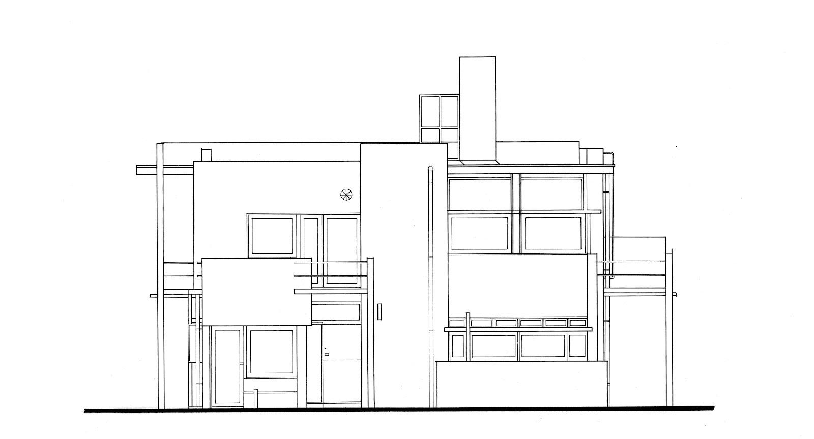

Figure (1) - South East Elevation.

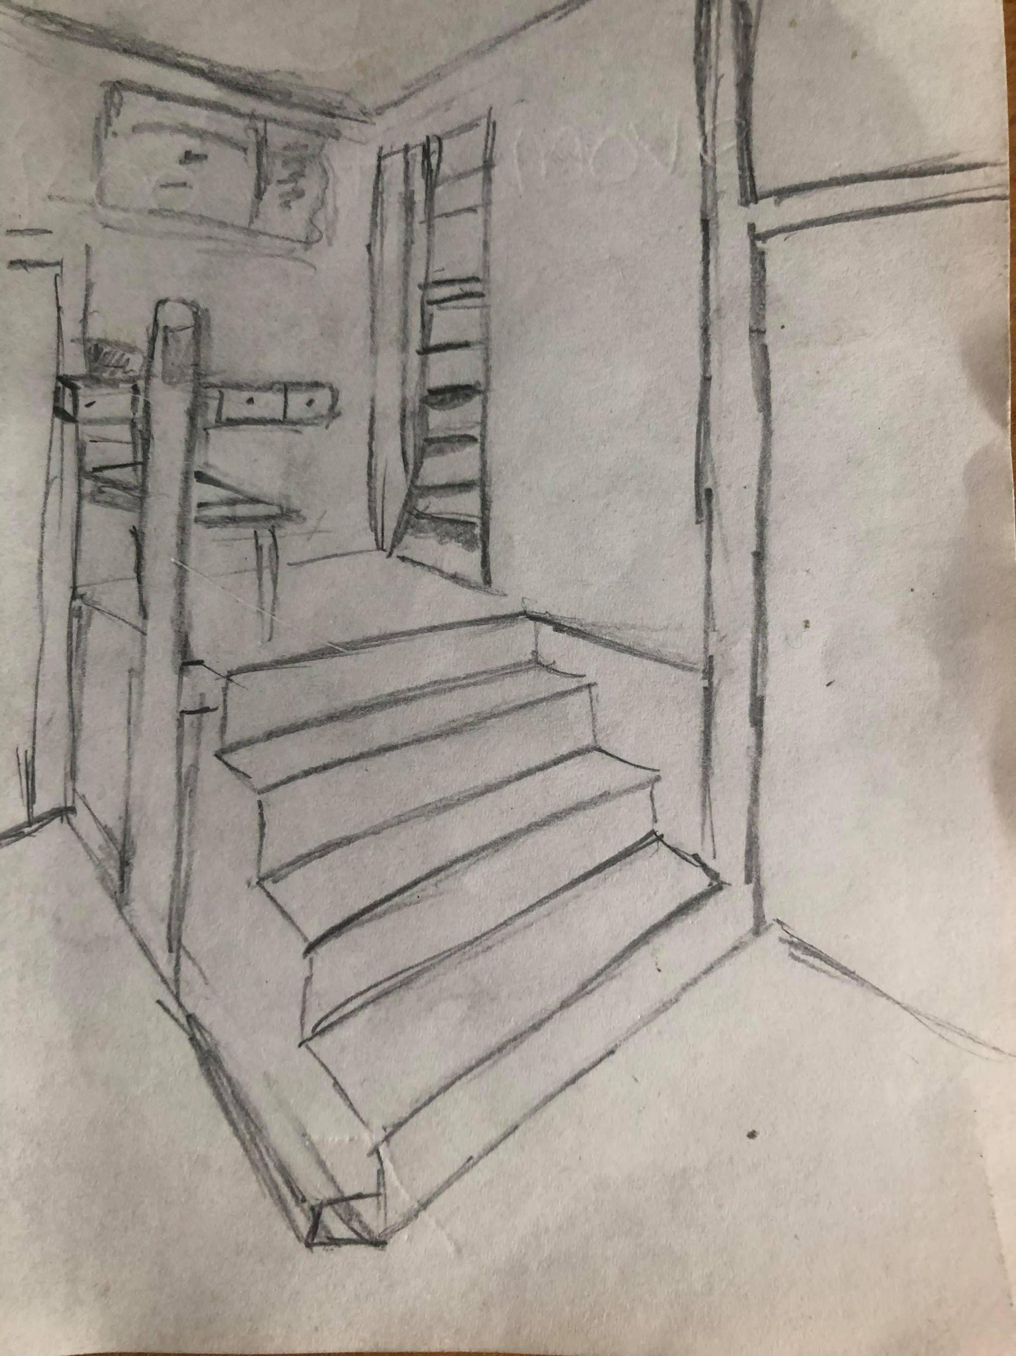

Sketch 1 - Sketch of the staircase of the

Schroder House.
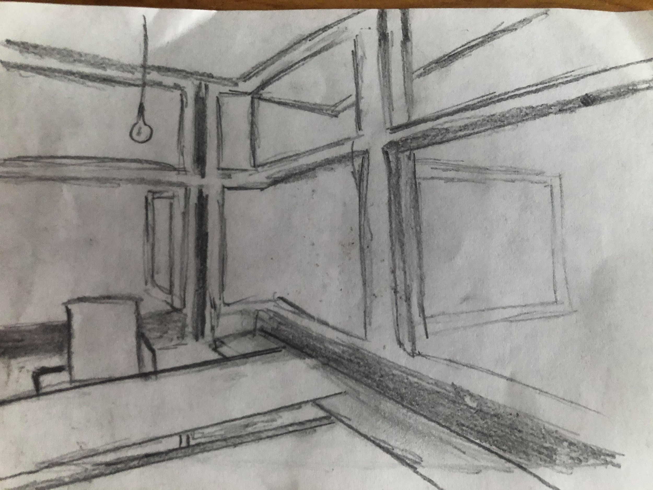

Sketch 2- Upstairs opening window sketch

Materials and Light

The structure of the house was supposed to consist of concrete because as you can see in the figure 1 above the big geometric planes that can be identified engaging with one another. However according to reports from THE RIETVELD-SCHRODER HOUSE the process and cost of concrete was too excessive for the budget so it was decided that the house would only have a concrete foundation and a reinforced concrete balcony. The structure of the house was then built with dutch brick and wood construction as that was a common structure during the era.(Dujardin et al., 2017). The flooring and roof was constructed by wooden joists with the lintels and columns consisting of steel I-beams. On the first floor they have moving partition walls which create a divide within the house, these were made of cork and beaverboard. The house is painted in primary colours throughout as these identify the planes. There were several problems within the construction, the odd form and shape of the building was very abnormal for that era and caused many problems, according to the CONSTRUCTION (CONSTRUCTION, 2012). article the team would often fit the windows upside down to try and catch Rietveld out, If Rietveld wasn't there things would normally go wrong. The lighting in the house is sourced from the massive pains of windows within the top floor, the sliding walls situated on the first floor would benefit this as during the sunlight period the light would project throughout the floor. As you can see form the section drawing of the Y axis below, Figure 2. The house consists of many windows allowing light to travel through the house at many different angles during the day, Rietveld thought thought the plan of the house out very well jeeping the goal of it being simplistic in mind and trying to make the most of the view available. The house consists of several geometric shapes windows at multiple sizes, This shows how Rietveld was inspired by the De Stijl era while making this house.
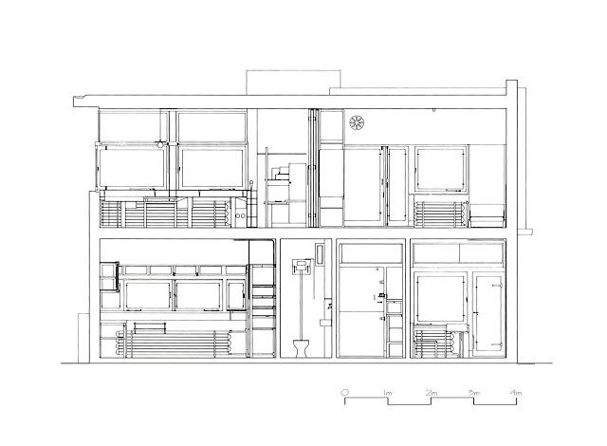

Figure 2 - (Y-Axis Section Drawing, 2012).

Ideas and Theories.

The main idea behind the Schroder house was for Rietveld to make a house that represents the De Stijl art movement era. There are several features within the house that reflect the era. For example, the primary colours consisting of red, blue and yellow are expressed in several ways around the house, these link into the composition piece of art by the famous artist Piet Mondrian. (Wolf, 2011). Rietveld related to the De Stijl aesthetic by keeping the structure geometric and including the colour scheme all throughout the house, even on the outside of the building as you look at it from that perspective you will still notice the colour scheme. Rietveld's Red and Blue chair attracted a lot of attention when he made that as stated by De Stijl Movement Overview it was a chair that “played and transformed the space around it”. Every component of the chair is defined and that's very similar to how the house looks to this day.(Wolf, 2011). De Stijl Movement Overview also stated the message behind the house was “a veritable manifesto for how an independent modern woman should live”. [5] It also reflects the art movement by its attention to the form, construction along with the function of the architecture and design. At the time of the schroder houses construction it had no interaction with any nearby surroundings, that includes buildings or roadways, this suggests that the isolated structure focusing internally instead of externally.

Summary

After considering the previous point Rietveld's aim was to create something new but reflecting the art movement era of De Stijl. His main message was to interact colour, form and space. He added distinctive features 3the house which were new during the time of construction. The sliding doors was a new thing of this era and this also created a lot more space during the day, another feature which made the house stand out was the way Rietveld used the geometric planes to build off, this gave the outwards form of the building which was completely different to other buildings and houses within the street, The Blue and Red chair reflected this and played a part in the design process. The chair is now displayed boldly within the top floor of the house. Rietveld considered the light reflection when deciding the construction as stated in an article in www.getty.edu “he always strove to achieve an even diffusion of light, over all spaces, at different times of day, indoors and out.”(van Thoor, Dubois, van Hees and Lubelli, 2019). Rietveld succeeded with this on the first floor, the corner window as shown in the sketch above, this window opened outwards and allowed a different aspect to the house but also allowed light to be projected in and light up the first floor. Downstairs the windows were geometric shapes but there were many of them as shown in figure 2. His overall aim was to produce a stand out house for Mrs Schroder and her family, Rietveld succeeded with this and the house was used up till 1985. He also lived in the house himself from 1957 up until his death in 1964. He remained part of the house after Mrs Scroder gave him a part of the downstairs too turn into a studio for himself to work on new design.(Rietveld Schröder House – Unesco World Heritage in Utrecht, 2020) The house is still on display and currently used as a museum and it attracts many people who love to see Rietveld's work of art.

Bibliography

[1] - Dujardin, A., Stirone, S., Allain, R., Galaxy, G., Barrett, B. and Adams, E., 2017. This 100-Year-Old Dutch Movement Shaped Web Design Today | Backchannel. [online] WIRED. Available at: <https://www.wired.com/2017/01/this-100-year-old-dutch-movement-shaped-web-design-today/> [Accessed 13 April 2020].

[2] - Rietveld Schröder House. 2020. Rietveld Schröder House – Unesco World Heritage In Utrecht. [online] Available at: <https://www.rietveldschroderhuis.nl/en> [Accessed 9 April 2020].

[3] - Rietveldschroderhouse.blogspot.com. 2012. CONSTRUCTION. [online] Available at: <http://rietveldschroderhouse.blogspot.com/2012/12/normal-0-false-false-false-en-ca-zh-cn.html> [Accessed 18 April 2020]. 3

[4] - van Thoor, M., Dubois, N., van Hees, R. and Lubelli, B., 2019. Colour, Form And Space. 1st ed. Utrecht: TU Delft, in collaboration with Centraal Museum, p.23.

[5] - Wolf, J., 2011. De Stijl Movement Overview. [online] The Art Story. Available at: <https://www.theartstory.org/movement/de-stijl/> [Accessed 18 April 2020].

Figure References
Figure 1- South East Elevation. JPG

Figure 2- 2012. Y-Axis Section Drawing. [image] Available at: <http://rietveldschroderhouse.blogspot.com/2012/12/hand-drawings.html> [Accessed 16 April 2020].

Sketch 1 - Schroder House Staircase. JPG

Sketch 2- Schroder House Corner Window. JPG

