

BAMB-LCBB5001- Entrepreneurship

Business plan – COTURNIX LAND LTD
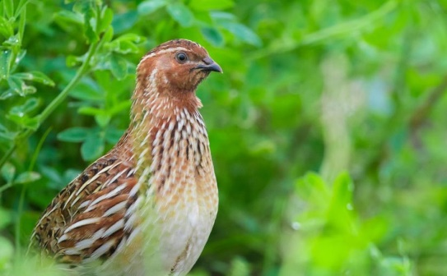
Source: Wikipedia

Word count: 1818

Student name: Vali-Daniela Pantazi
Student number: 2212835

Lecturer: Vasilios Tavlaridis

Table of contents

1. Overview of the business 3
2. Legal format of the startup company 5
3. SWOT and PESTLE analysis of the business 5
Strengths 5
Weaknesses 5
Opportunities 6
Threats 6
PESTLE analysis 6
4. The 4Ps of the marketing mix 7
Marketing segmentation 7
Marketing mix 7
5. Funding and cash flow forecast for the first 12 months. 8
Funding 8
6. References 10

Overview of the business

This business plan refers to opening a Coturnix quails mini farm in the West Midlands area.
Coturnix quails, known for their gentle nature and diverse breeds, are an excellent choice for small-scale farming. They are highly valued for their meat and egg production, and reach maturity by six weeks of age, with egg-laying beginning at eight weeks (Backyard Poultry, 2022).

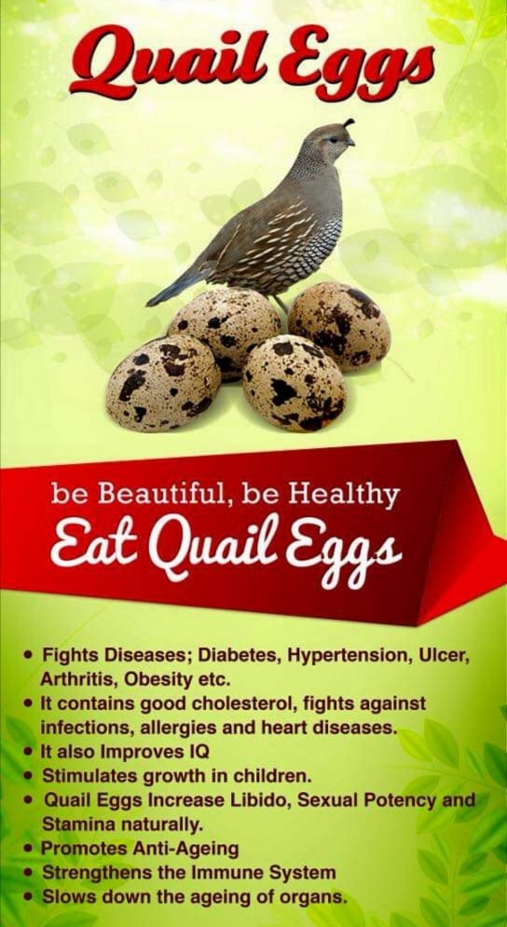
Source:MavernFarm
The farm will have its main activity selling quail eggs and living birds as pets. In the future, the farm will expand to sell quail meat. The statistics below show that in the West Midlands poultry farms occupy only 20% of the farmed area, which can make the Quail Farm a viable business idea (UKparliamentresearch, 2022).
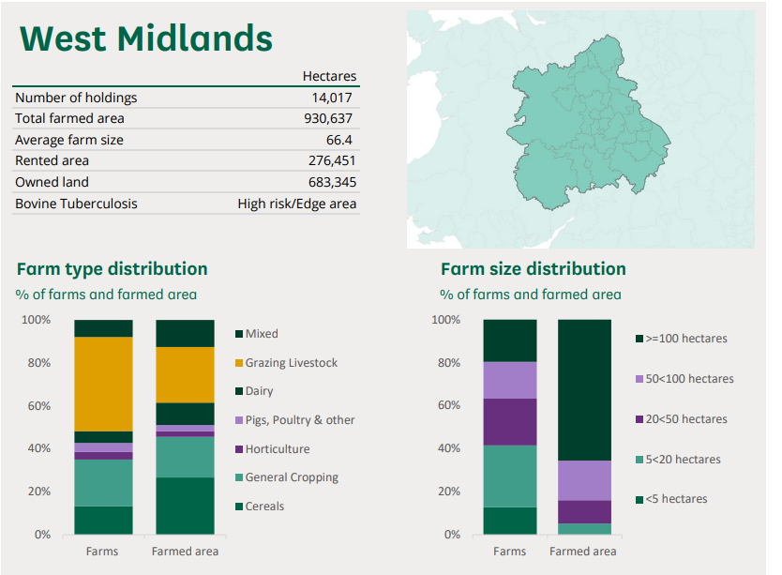
Source: Ukparliamentresearch
In large farms, quails are kept in cages as they do not require more than 1 square of space per adult bird, to maximize the space. At Coturnix Land, the birds will have access to an outdoor space and a shed for the day, where they can hide in grass and bathe in sandboxes when the weather is warm, and for the winter they will be kept in a heated barn, as they require heat and humidity conditions to remain healthy and lay eggs.
To hatch the eggs incubators will be required and these can be purchased or leased from a local producer. Some incubator manufacturers will provide new incubators to the farms to be used and tested, and that can help save money (brinsea.co.uk, 2023).
An adult quail requires around 15g of food in a day and the food should be always accessible to them. Very important in their diet are greens such as grass or vegetable leaves. The food can be purchased from local producers, in large quantities as the price is discounted (Haith’s Bird Food, 2024).
The land will be rented/leased from a landowner in the area and if it is not provided with a barn, this can be built or bought and adapted to the farm needs.
According to (GOV.UK, n.d.), to register as a keeper of 50 or more birds in captivity, the IRA81 registration form is compulsory to fill in; an environmental permit is required if you only have more than 40000 birds, and for the waste disposal you may not need a permit if there is a registered waste collector in the area.
To sell eggs, the business needs to be registered with APHA. This applies to all egg production sites, egg packing centers, incubators, and breeding sites. The registration process is free of charge (GOV.UK, 2023).

Legal format of the startup company

To start this business, the most suitable legal structure would be a Private Limited Company. This format provides several benefits, including reduced liability risk, easier access to funding for growth, company pension, lower taxation, protection for the business name, and a solid business profile. Furthermore, it enables future expansion opportunities (Accounts and Legal, 2023).
According to (Lawrence​, 2022), there are also disadvantages when opening a Private Limited Company: higher cost to set it up, lack of privacy due to the company being registered on Companies House, accountancy fees can vary, whether there is a limited company or not, time must be dedicated to paperwork. Regardless of the business type, it is crucial to maintain accurate and up-to-date records (Lawrence​, 2022). At the start, the business will only have a director and an accountancy firm to manage the accounts, as quails are easy to take care of and do not require much attention.
A local company will collect the birds' waste monthly and dispose of it legally.

SWOT and PESTLE analysis of the business

The SWOT analysis is a powerful tool for strategic planning that can contribute significantly to a company's growth and success by identifying its strengths, weaknesses, opportunities, and threats. Businesses can make informed decisions by understanding their strengths and weaknesses, driving growth, improving performance, and gaining a competitive edge (Bottrell, 2023).

Strengths

Healthy - Quail eggs are healthier than other poultry eggs, making quail farms stand out to health-conscious consumers.
Small-size farms – Quail farms require fewer resources and less space, making them ideal for small-scale farmers (finmodelslab.com, 2023).
Fast breeding and growth – Quails start laying eggs at a young age due to their shorter mature period.
Partnering with local grocery stores and restaurants can generate extra income, providing an opportunity to increase revenue.

Weaknesses

Limited market share - quail eggs are not as popular as chicken eggs.
High costs to start – Quail farming requires a considerable investment in infrastructure, such as cages, feeding systems, and incubators.
Short breeding – The breeding season of quails is known to be relatively short and requires specific environmental conditions such as temperature and lighting. These conditions can pose a significant challenge to farmers and breeders who aim to maximize the productivity of their quail farms.
Laws and regulations - The regulation of quail farms is subject to local and state laws, the variation of which can pose significant difficulties for farmers seeking to maintain compliance (finmodelslab.com, 2023)

Opportunities

Selling directly to consumers – Through the utilization of e-commerce platforms, farmers are empowered to retain authority over the pricing, quality, and distribution of their agricultural products, while concurrently establishing a devoted consumer base.
Selling at Farmer’s Markets – Offering customers the opportunity to see products before they make a purchase can boost their confidence in the product and increase their loyalty to the brand (finmodelslab.com, 2023)
By utilizing local deliveries, farmers can maintain the quality of their products. This allows them to ensure that their customers receive fresh, high-quality products that meet their expectations.

Threats

Competition –In the agricultural market, both existing farmers and new entrants are vying for a share, which has resulted in a limited market share for each player.
Changes in laws – increasing in tax, limitations in using certain techniques (finmodelslab.com, 2023).
Outbreaks – Quail farms are vulnerable to disease outbreaks that can result in the loss of birds and contaminated eggs.
Environmental factors – Climate change, natural disasters, and extreme temperatures can adversely affect egg production (finmodelslab.com, 2023).

PESTLE analysis

Political factors can influence the farm business through changes in laws and regulations, but at present the poultry market is well-regulated.
Economic factors may influence the business by new entrant entrepreneurs discovering newly identified profitable business niches, it is only natural for them to dedicate significant attention to these niches (www.thebigbookproject.org, 2019).
Social factors can influence the business through growing consumer awareness of chemical residue poisoning in food translates into increased demand for organic chicken meat and eggs. Following this newfound enthusiasm, the early organic convert will conduct research to learn about the various natural options and breeds available on the market (www.thebigbookproject.org, 2019).
Technological factors - organic food consumption has risen in direct proportion to internet usage - an increase in individuals using the internet for informational surfing connected to purchasing decisions has aided the organic trend in growing rapidly (www.thebigbookproject.org, 2019).
Legal factors - difficulties in obtaining the right licenses, and changes in laws that may affect the functionality of the farm.
Environmental factors – outbreaks of diseases such as Avian Flu.

The 4Ps of the marketing mix

Marketing segmentation

According to Martin (2011), marketing segmentation is a strategy employed by businesses to concentrate on the behaviors and purchasing patterns of their customers. When implemented efficiently, it helps organizations maximize their return on investment (ROI) for marketing and sales expenses. The rationale behind marketing segmentation is to allow businesses to focus on their consumers’ behaviors and purchasing patterns. If done effectively, marketing segmentation allows an organization to achieve its highest return on investment (ROI) for its marketing and sales expenses (Martin, 2011).
Geographic:
Local
All other regions

Demographic:
Children
Elderly
All ages

Market
Segmentation
Behavioural:
Groups shopping in supermarkets
Online shoppers
Birds lovers

Psychographic:
Vegetarians
People with healthy eating habits

Marketing mix
Price  Quail eggs will come in packs of 12 and the price will vary dependiging on the type of client and the quantity bought (between £2.50 and £3.50/ pack).  Price for a pair of adult birds (male and female) around £28  Price for quail chicks £4 |  | Promotion  Online by creating a website that details the products.  Farmer’s markets  Social media and online marketplaces (e.g. Amazon, Etsy)  Local supermarkets  Educational workshops  Partnerships (AVVALE, 2020)
  Product  Consumers can easily identify quail eggs through their appearance, such as the presence of cracks and the white base colour with black spots. (Putri and Daulay, 2023).  The Quail Eggs Market was valued at USD 54.16 million in 2020 and is projected to reach USD 81.97 million by the end of 2028, growing at a CAGR of 6.1% from 2021 to 2028 ((Verified Market Research, 2021). |  |  | Place  Restaurants and Hotels  Health-conscious consumers  Pet owners  Ethnic and cultural communities (quail eggs are very popular in cultures such as Asian and African cuisine)  Specific food shops
   |  | 4Ps

Funding and cash flow forecast for the first 12 months.

Funding

Starting a quail farm requires a significant amount of funding, and finding the right type of financing can often be a daunting task. It's important to carefully consider all available options before deciding, as the right funding can make all the difference in the success of the business.
Government funding can be an option and there are grants available for starting up a small business each year. Accessing those grants implies a series of conditions that need to be met and the application to be correctly filled in and in time (www.ukstartups.org, 2021).
Another funding option can be a government start-up loan which is a government-backed loan with a 6% interest rate per year. This type of loan can be repaid in between 1 to 5 years, and there are no application or early repayment fees (GOV.UK, 2024).


