Wine Tourism in Switzerland

Switzerland, beautiful at any time of the year, is the perfect place to relax. Such a unique diversity within a small area cannot be found anywhere else: mountains, lakes, glaciers, lively cities, and unspoiled landscapes. It is possible to easily and conveniently reach every location thanks to a unique public transportation network. Depending on the canton, one can feel like in Italy, France, or Germany. The coexistence of different cultures has resulted in many interesting monuments of architecture and art. Many people do not realise that this country is also famous for wine making. The neighboring countries such as France and Italy - the giants of wine making - certainly had an impact on this. Demanding tourists find the most seductive atmosphere of Switzerland precisely in wine. In the noble beverages served with local dishes. It is definitely possible to state that Swiss dishes are remarkable and the wine additionally emphasizes their taste. The local wines are produced with great care and solidity. With love and at the same time diligently. The Swiss are very respectful of their own products and it can be said that they regard them as being above all others. (Wallace, 2018) (Getz, 2000)
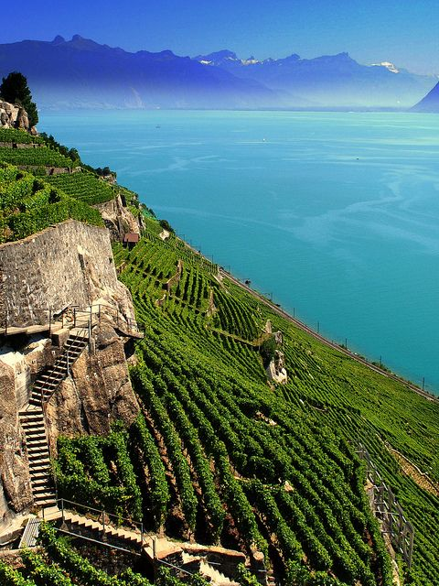
Although hard to believe, this small country is in many respects a great power of wine making. Despite that, Swiss wines are not widely known. And even more so, they are not widely available. Grapes are cultivated only in three cantons at the southern hillsides of the Alps and Jura. Mainly in the Rodan Valley and by the Geneva Lake, where vineyards stretch from Montreux-Vevey up to Geneva, and most in the French-speaking part of the Swiss federation. Vineyards are also located in the Italian-speaking part, in Ticino, although there are not many there. In total, the vineyards occupy only 15 thousand hectares. (Anon., 2017)
The Swiss love their wine and it is possible to find it in every restaurant and shop, with almost all of it being used on the spot. The more preventable consumers order a portion of their favorite beverages in advance. Therefore, the manufacturers are not worried about sales do not show as much interest in export as those from other countries. In recent times, the country began to promote itself more, and the wine-famous region by Lake Geneva - Lavaux - has entered the UNESCO list in 2007. (Anon., 2017)
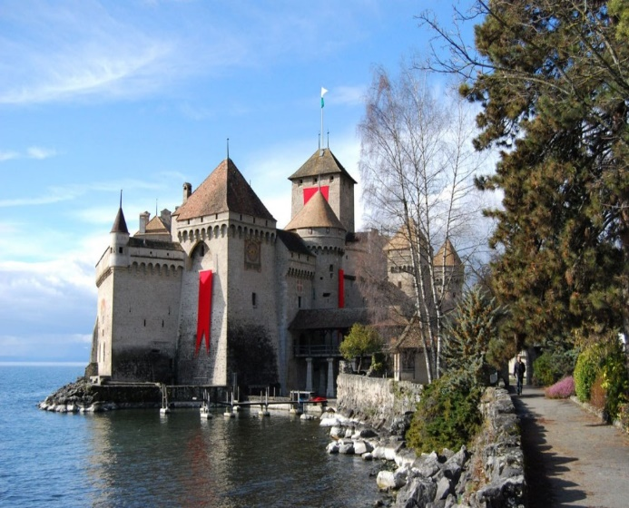
Viticulture has a long tradition here. Wine making developed during the times of the Roman Empire, and the first plantings took place 800 years before Christ. Today, as many as 240 different grape varieties are cultivated throughout the country, and as it was mentioned earlier, all of that on less than 15,000 hectares of land. Vineyards are small and scattered throughout the country's regions, although the winemakers can account for cultivating many indigenous wine varieties that cannot be found anywhere else. These include for example Chasselas, Gamaret, Arvine, or Amigne. The most wine (as much as one third of total production) is made in the alpine canton of Vallis, where the grapes grow at an altitude of over 1000 m above sea level. This is also the location of the highest vineyard in Europe - in Visperterminen - where the vine spreads on hills with their height from 650 m to 1150 m above sea level. Both Vallis and the adjacent Vaud canton are famous mainly for white wines. That is where the native variety of Chasselas comes from, which is tastefully paired with cheese fondue. Whereas, the most widespread grape variety in Switzerland is Pinot Noir, known here under the name of Blauburgunder. It is a so-called diva among vines, because due to the demanding conditions of its cultivation, it can be very capricious, and the quality of wines made from it depends heavily on weather, soil irrigation, etc. Pinot Noir is used to make both red and white wines. In Switzerland, it occupies over 4,000 hectares of land, or up to one-fifth of all plantations. (Gough, 2015)
The most pleasant activity associated with wine is, of course, drinking it. That is why when we look at what the Swiss usually drink, it turns out that almost half of the approx. 8 liters of pure alcohol consumed annually by a statistical Swiss, consists wine.
In this field, the Swiss are close to the world podium. The average annual consumption is 264 million liters, meaning 33 liters of the royal beverage per person. It results in over 3 bottles of wine per month and the fourth place in the world ranking for 2017. More wine is consumed only in Portugal, France and Italy. Of course, the Swiss drink not only their own products. Most wine is imported from Italy and Spain.
Why is there not much being said about Swiss wines in the world? Because the local winemakers do not send their products abroad (less than 1% of total production is exported). Although many of them in terms of quality could compete with German wines, they unfortunately lose due to a high price. (Wallace, 2018)
Wine tourism is one of a form of cultural tourism, and it is usually described along with culinary tourism, although the remarkable popularity of wine tourism allows it to be distinguished as a separate form. It is a fashionable and the fastest developing branch of the global tourism economy (Hall, et al., 2000) The main motive for a trip may consist in the desire to spend time in nature, outside the city - in this case, enotourism is a form of recreational tourism and also rural tourism. (Anon., 2016)
The tourism industry treats enotourism as a niche tourist market, but on the other hand, many wine producers around the world see opportunities for the development of their production concerning tourists (Getz & Carlsen, 2008)
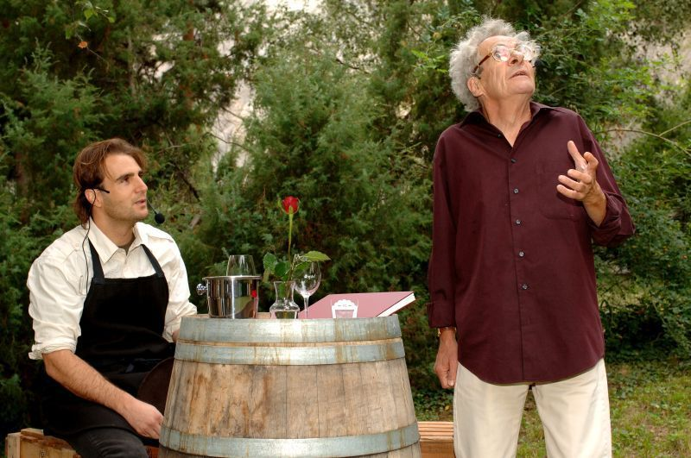
Therefore, enotourism is referred to trips to wine regions during which the tourist visits at least one place associated with the production of wine - depending on the choice it can be a vineyard, processing plant, or wine plantation - or the tourist can participate in wine-related events such as tastings, presentations, or wine festivals. Participants of such trips usually also buy a few bottles of wine "at the source" to take them home (Cohen & Ben-Nun, 2009)
The established fashion for wine travel was reflected in the offers of travel agencies, not only as an element complementing other types of trips. For "enotourism" entered in an online search engine, we receive offers of agencies specialising in organising such a form of tourism. They usually operate in the form of clubs bringing together aficionados interested in travels thematically related to wine (Getz, 2000)
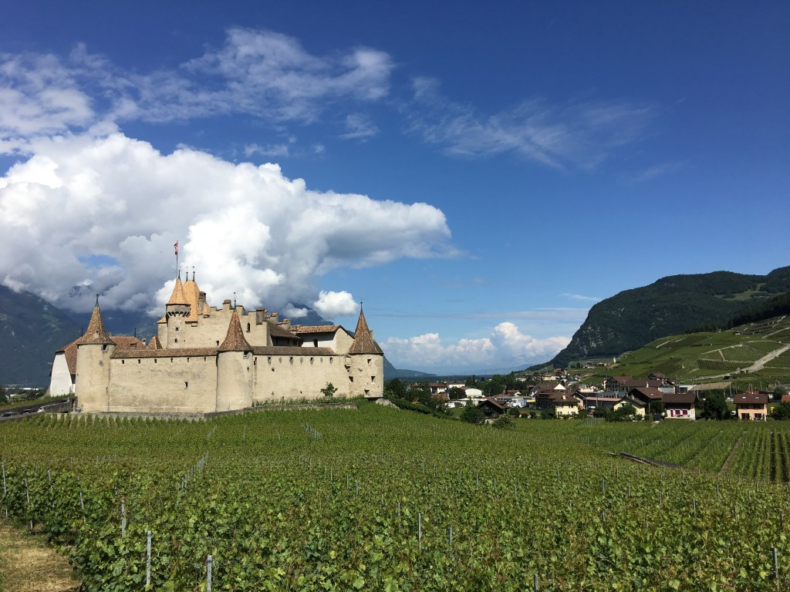
The contemporary enotourist is not only interested in wine, but also the entire context of its production. More and more wine producers also offer various educational programs, from a short guided tour up to specialized wine-related courses. The program of visiting such a farm includes a walk through the vineyard and a visit to the production cellar, with discussing issues related to viticulture and wine making. In such a case, tasting is also a standard. During the stay, an enotourist expects that the event will be conducted personally by the winemaker handling the process of making wine at that specific location. (Anon., 2017)
Wine production, especially in Europe has a centuries-old tradition, therefore, linking enotourism with cultural tourism. The beverage itself, being a product characterizing a given region, is associated with food, regional cuisine, which combines enotourism with culinary tourism.
Vineyards in Switzerland are an important direction of local tourism. There are six regions traditionally associated with wine: Vallis and Vaud, and in addition the Italian canton Ticino, surroundings of Geneva, the region of three lakes, namely the hills of Jura, and the German-speaking part of Switzerland. The most popular vineyards are located by the Geneva Lake between Lausanne and Montreaux. The sunny routes of Lavaux, entered on the UNESCO heritage list, constitute a route of over 30 kilometers going through 800 hectares of vineyards. What is interesting is the fact that it is possible to cover it by train, bicycle, or by foot. Along the way, we have the opportunity to visit many places where we can taste wines and local delicacies. The year 2018 was a breakthrough for Swiss wine. In March, Lausanne became one of the 10 largest wine capitals in the world and a part of the Best of Wine Tourism chain. (Bigar, 2018)
Switzerland is slowly creating a branch of wine tourism. This is partly related to the fact that the authority is in the hands of municipalities and cantons, which makes it more difficult to organize the joint establishment and financing of Swiss wine Promotion.
My Switzerland, the national tourist office, is also decentralized and therefore promotes tourism events and products designed at a local level, but does not create Swiss wine-tourist offers. Small Swiss vineyards are family businesses and many of them are not available to visitors. It is partly related to the fact that everyone is busy at the vineyard and there is no one to take care of the visitors. However, in larger ones, it is not always possible to talk to the winemaker or these are cooperatives, which do not always represent themselves in the area. Sometimes a language barrier also appears. One of the places in Switzerland where one can get to know the wine industry is Vinorama. Vinorama in Lavaux was opened in 2010. It brings together all of the local vineyards that sell their wines there. There are films, tastings, and hill treks available. In the Wallis Canton, the joint effort of vineyards from the Pfyn-Finges nature reserve and the nearby Valais wine museum with its wine routes, resulted in a number of interesting options for visitors and definitely helps to understand these special products (Anon., n.d.)
There are also various events including wine tasting and fairs being organised in Switzerland. (Wallace, 2018)
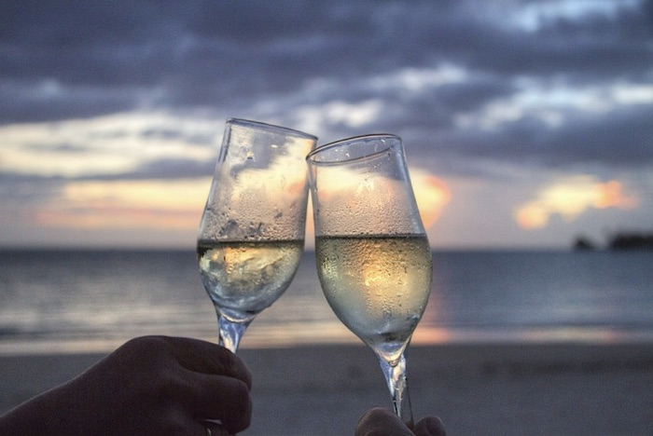
The most popular of them is Vinea (a vineyard initiative 25 years ago) in Valais, Arvinis (a private undertaking established more or less at the same time) in Vaud, and Expovina. Expovina is traditionally held in autumn in a rather unusual place, because on twelve ships moored at the Bürkliplatz on Lake Zurich. Four thousand wines from all around the world can be tasted, including many local products. It is the largest wine event open to the public in Europe. (Peregrine, 2018)
A small number of dynamic wineries in the Swiss wine world began to take advantage of more creative options about 10 years ago. A handful of private guided tours of vineyards of varying quality came into life. Recently, the Vaud Canton has developed a series of eight walking routes with apps. eBiketour in Geneva organized e-bike trips in 2015. Also in Geneva, the cantonal agriculture office opened a series of wine routes in the countryside, and in 2013 added what became a very popular wine rally on the open cellars' day. More wine boutiques include now an educational tasting session. Some vineyards organise regular tours (Cave Roduit in Fully, Valais) or music evenings (La Colombe in Féchy, Vaud with classical music, Cave Beetschen in the nearby Bursin with music, and Molokovs, as well as others with occasional jazz nights). Some (La Capitaine in Begnins, Vaud) offer evenings or markets with food and wine (Chateau d'Eclépens). (Wallace, 2018)
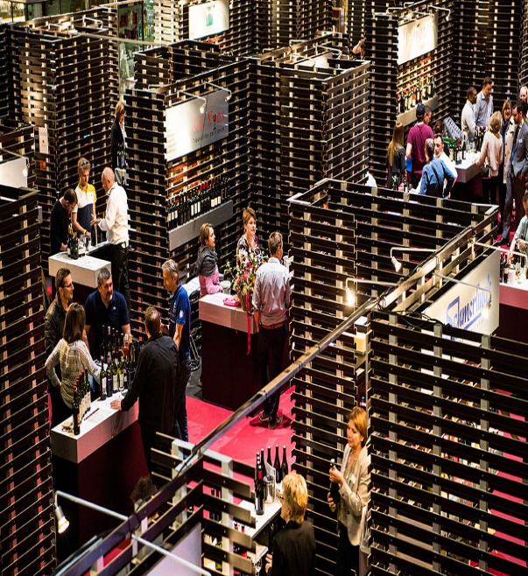
The public / private Vaud wine tourism project is now four years old and has been certified by 30 applicants, mainly wine cellars. The Swiss Wine Tourism 2017 Awards (September 2017) constitute a showpiece of great projects - not only the winners, but also the entire group of 60 entered people. (Anon., n.d.)
It is possible to observe an increase in the satisfaction of Swiss wineries due to the fact that the visitors appreciate their products in different contexts, learn to distinguish better wines and enjoy them. Wine tourism in Switzerland is a niche form of tourism. It is amazing that in order to fully enjoy the taste of these wines; one has to go to the source.
Only this way we would not lose a thing from the richness of the offered experiences.

References
Anon., 2016. UNWTO World Tourism Organisation. [Online]
Available at: http://media.unwto.org/press-release/2016-09-09/wine-tourism-growing-tourism-segment
[Accessed 15 03 2019].
Anon., 2017. Swiss Wine. [Online]
Available at: https://swisswine.ch/en/news/24th-edition-vinea-swiss-wine-fair-success?fbclid=IwAR2lSu8uWZkUB9kyuluKx0XePWbK8K65XPpzubTFiqWpb_v8syNv1m0zgeU
[Accessed 16 03 2019].
Anon., n.d. MySwitzerland. [Online]
Available at: https://www.myswitzerland.com/en-gb/home.html
[Accessed 18 03 2019].
Bigar, S., 2018. Forbes. [Online]
Available at: https://www.forbes.com/sites/sylviebigar/2018/08/02/your-next-favorite-wine-destination-switzerland/?fbclid=IwAR0nppquk94zf9UOkSExEuvL02gtKAmpNBdkZ4pxieNi3_2Ebl8WCpdjxto#55895c5c59ad
[Accessed 17 03 2019].
Cohen, E. & Ben-Nun, L., 2009. The important dimensions of wine tourism experience from potential visitors'perception. Tourism and Hospitality Research, 9(1).
Getz, D., 2000. Explore Wine Tourism: Management, Development and Destinations, Tourism dynamics. New York: Cognizant Comunication Corporation.
Getz, D. & Carlsen, J., 2008. Wine Tourism among generation X and Y. Tourism, 56(3).
Gough, D., 2015. Experience Transat. [Online]
Available at: https://www.airtransat.com/experiencetransat/wine-tourism-travel-perfect-switzerland-2/
[Accessed 12 03 2019].
Hall, C., Sharples, L., Cambourne, B. & Macionis, N., 2000. Wine Tourism Around The World: Development, Management and Markets. Oxford: Butterworth-Heinemann Ltd.
Peregrine, A., 2018. The Telegraph. [Online]
Available at: https://www.telegraph.co.uk/travel/food-and-wine-holidays/best-destinations-for-wine/
[Accessed 15 03 2019].
Wallace, E., 2018. Ellenworld wine. [Online]
Available at: https://ellenwine.com/swiss-wine-tourism-comes-of-age/?fbclid=IwAR0E7Zx5eu4zxHu3k4VxXzTuoqIamp7w03AB84q7AXqA3x75FkAYg2UVLNA
[Accessed 16 03 2019].

