JACOB REID

ID: 1809874

BMSK4003

DIGITAL SKILLS AND RESERCH METHODS

TEACHER: BALAN KANDASAMY

Task: Students will write a report of 2,000 words, on a relevant and appropriate workplace topic showing evidence of a use of a range of research methodologies and an understanding of effective and ethical data collection and interpretation

TABLE OF CONTENTS

Introduction – Page 3

Literature review – Page 4

Results – Page 6

Conclusion – Page 6/7

References – Page 8

Research Question: What factors have contributed towards a steady increase in employment in the UK

“Employment hits another record high and wages rise despite Brexit” (Wallace, 2019)

Introduction

In this research paper I will be talking about employment and what factors have been contributing to a steady increase of employment. I have decided to research this topic as I want to know more about what causes people to work and what factors contribute. Within the assignment I will research many factors including what causes unemployment, why it is going up and what this means for myself. The main areas of unemployment I will be talking about is structural, friction, cyclical and seasonal.

This topic suits my skills for the workplace course at university as after I finish the course I will go out and find employment.
Structural
“Structural unemployment is a longer-lasting form of unemployment caused by fundamental shifts in an economy and exacerbated by extraneous factors such as technology, competition and government policy. Reasons why structural unemployment occurs include workers' lack of requisite job skills or that workers live too far from regions where jobs are available and cannot move closer. Jobs are available, but there is a serious mismatch between what companies need and what workers can offer.” (Investopedia, 2019)
Friction
“Frictional unemployment is always present in the economy, resulting from temporary transitions made by workers and employers or from workers and employers having inconsistent or incomplete information. For example, a first-time job seeker may lack the resources or efficiency for finding the company that has the job that is available and suitable for him and as a result does not take other work, temporarily holding out for the better-paying job. Another example of when frictional employment occurs is when a company abstains from hiring because it believes there are not enough qualified individuals available for the job, when in actuality there is.” (Investopedia, 2019)
Cyclical
Cyclical unemployment is a factor of overall unemployment that relates to the regular ups and downs, or cyclical trends in growth and production, that occur within the business cycle. When business cycles are at their peak, cyclical unemployment will tend to be low because total economic output is being maximized. (Investopedia, 2019)
Seasonal
Seasonal unemployment occurs when people are unemployed at certain times of the year, because they work in industries where they are not needed all year round. Examples of industries where demand, production and employment are seasonal include tourism and leisure, farming, construction and retailing Anon, (2019)
Literature Review
Employment is “An individual who works part-time or full-time under a contract of employment, whether oral or written, express or implied, and has recognized rights and duties. Also called worker.” (BusinessDictionary.com, 2019). Currently in the UK unemployment is a record low since November 1974 with a rate of 3.9%.

People do not solely go work everyday for just money. There are many factors to why unemployment is low which I will cover in this research paper.
While money is essential for anyone I feel there are more factors into reasons why employment is going up and less people are being unemployed. I believe some addition factors of why this is because working can make people feel better and secondly employment gives us a chance to interact with people within the workplace, network and get out of our normal social life.
Firstly, employment gives us a sense that we are working towards something, a goal this makes our life feel a lot more meaningful which is important when discussing employment rates. People enjoy working towards long- and short-term goals that they would like to accomplish. If people where not working people often feel that they have no purpose or not gaining or working towards any goals.
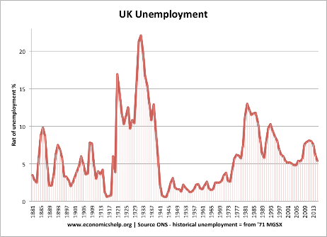
I have a personal experience of this when I stopped working for a short while. After holding down a job in a busy fast-paced working environment when I quit I felt quite down and depressed as I did not have anything to get up for and had no strive to do anything. I also felt as I wasn’t earning money I was not getting anywhere and wasn’t meeting personal goals.
Secondly having a job gives us opportunities to go out and work and meet new people regularly. This can improve personal life can make us happy. People who are unemployed rarely interact with new people and mostly interact with family and pre-existing friends, which can get boring over time.
I again experienced this when I was working in a fast food shop. Even tough it was not the best job in terms of pay. I enjoyed going in and meeting new people. This made my workplace a lot more enjoyable. I enjoyed chatting to different customers every day. It was also motivation to go into work as I would look forward to talking to people.
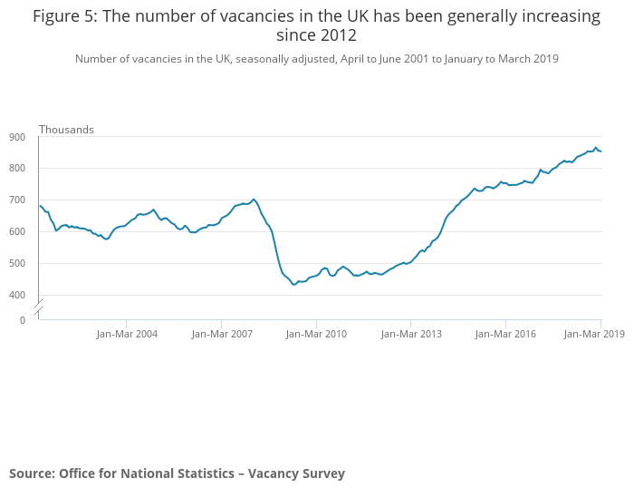
Employment has also increased due to the number of job vacancies increasing since 2012. This means there are more jobs available, so people can find a suitable job for themselves in a field of choice. More jobs also mean people can find work closer to their own homes making it easier for them to get to and from work. This would increase employment because people don’t want to spend a long time getting to work and back.
(Gov.uk, 2019)
Employment has also been improved because more people are working from home this is making jobs more appealing for certain people who never used to be able to get to work for what ever reasons. This saves the employers travel money as well as travel time if the work can be done at home. Working from home can also have many benefits by eliminating time wastage and also helps traffic congestion, furthermore reductions in commuting time can actually improve employee’s mental health, increase productiveness and even reduce tiredness.
The government has also given support to new and small businesses this encourages more businesses to be opened allowing more jobs, thus employment rate going up.
The government can assist small businesses in many ways such as financial help, start up loans, grants and government contracts. All these are to encourage businesses to grow and employ more people. These factors play a major role in why employment is rising. The government want to create more jobs for people to boost the economy.
The government also offer businesses grants for taking on apprenticeships, this has really encouraged businesses to take on apprenticeships getting the 16+ into work. This also effects the unemployment chart as it is from the age 16+ so by getting more young people into work it has improved the unemployment rate. This is another major factor as companies are now taking on younger staff and training them this can help the economy in many ways
Start up loans are also good as it allows people with little capital to start businesses creating jobs and improving statistics. With more people opening small businesses it drives local competition pushing work standards. It also creates more jobs for local people in the area which allows more people to get jobs. Start up loans can also allow budget for extra staff whilst boosting cash flow.
Employment contributes to economic growth. Higher employment rates means a greater number of goods can be produced and sold benefiting the economy. Businesses aim to make a workplace hospitable to employees for many reasons, mainly to save money. When employees appreciate spending time in the workplace, this in turn reduces employee turnover.

Many workplaces offer benefits to keep employment rates high such as offering free food and drink within the workplace, other benefits include company car, free/discounted travel, free company events, medical and even opportunities for extra learning such as sending employees on courses or to college/university.
These benefits that company offers is another contributing factor to why the employment levels within the UK have risen, people are much more happy to work when there are additional benefits, Many major companies such as Tesco, Google, Starbucks and other highstreet brands offer many benefits to their employees to keep them happy.
By also doing this it drives other companies and businesses to do the same this is because it improves employer productivity and keeps the staff happy. Even if you work part time there are still benefits you can receive within the workplace, such as gym pass and pension scheme. This encourages people to keep in employment and hold down jobs.
Rising wages is another contributing factor to why employment has remained to grow and a steady pace. If wages are going more people are willing to work as they get more for what they do.

Conclusion/Results

Overall there are many contributing factors to why employment has gradually increased. This ranges from personal reasons such as wanting to get up and do something to economical reasons, such as a growing economics. Other factors include increased people working from home, more job vacancies and government funding. All these factors have increased job openings allowing more people to work.

References

Wallace, T. (2019). Employment hits another record high and wages rise despite Brexit turmoil. The Telegraph, [online] p.4. Available at: https://www.telegraph.co.uk/business/2019/04/16/employment-hits-another-record-high-despite-brexit-turmoil/ [Accessed 2 May 2019].
BusinessDictionary.com. (2019). When was the last time you said this?. [online] Available at: http://www.businessdictionary.com/definition/employee.html [Accessed 2 May 2019].
Ons.gov.uk. (2019). Unemployment rate (aged 16 and over, seasonally adjusted) - Office for National Statistics. [online] Available at: https://www.ons.gov.uk/employmentandlabourmarket/peoplenotinwork/unemployment/timeseries/mgsx/lms [Accessed 2 May 2019].
Investopedia. (2019). Structural Unemployment. [online] Available at: https://www.investopedia.com/terms/s/structuralunemployment.asp [Accessed 2 May 2019].
Investopedia. (2019). Frictional Unemployment. [online] Available at: https://www.investopedia.com/terms/f/frictionalunemployment.asp [Accessed 2 May 2019].
Investopedia. (2019). Cyclical Unemployment. [online] Available at: https://www.investopedia.com/terms/c/cyclicalunemployment.asp [Accessed 2 May 2019].
Anon, (2019). [online] Available at: https://brainly.in/question/1338111 [Accessed 2 May 2019].

