Engineering design project

dpmsu
Luke Davies
Student Number: 1707263
Engineering Design
M4X01160

Contents
Introduction 3
Current Design 4
Functional Requirements 4
FMEA for Functional Requirements 5
Manufacturing Process 6
Injection Molding 6
Urethane Casting 7
Material Selection 9
Acrylonitrile Butadiene Styrene (ABS) 9
Polycarbonate (PC) 10
Design Concept 1 11
Design Concept 2 14
Design Concept 3 16
Tooling 17
Conclusion 18
Bibliography 19

Introduction

This report focused on the design development for a Drill Press Main Sliding Unit (DPMSU). The key components will include evaluating the existing design, highlighting features which are necessary for the finished design, justify material selection and an appropriate manufacturing process. The report will aim to highlight potential design changes to improve the manufacturing capabilities for the part, whilst aiming to reduce the manufacturing costs of the process.

Current Design

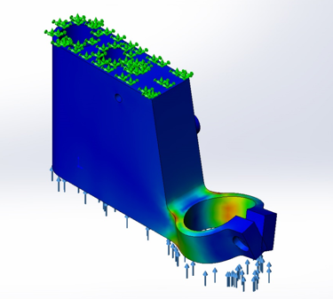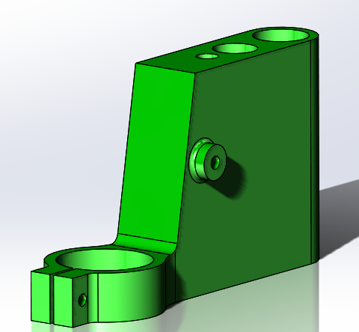

Functional Requirements

There are features of the current component which will need to be considered when generating a new design and manufacturing concept for the DPMSU.

- Sufficient clamping force of DPMSU to ensure the drill is secure during operation. Failure to generate enough clamping force on the drill head will result in poor manufacturing performance of the unit
- Linear movement of DPMSU in relation to the main shaft of assembly. This will ensure the drill head is square is situated correctly when in operation.
- Location of the pin holes for the lever arm to be secured to the DPMSU
- Position of the hole and spring clip to hold the top support clamp in place

fmea for functional requirements

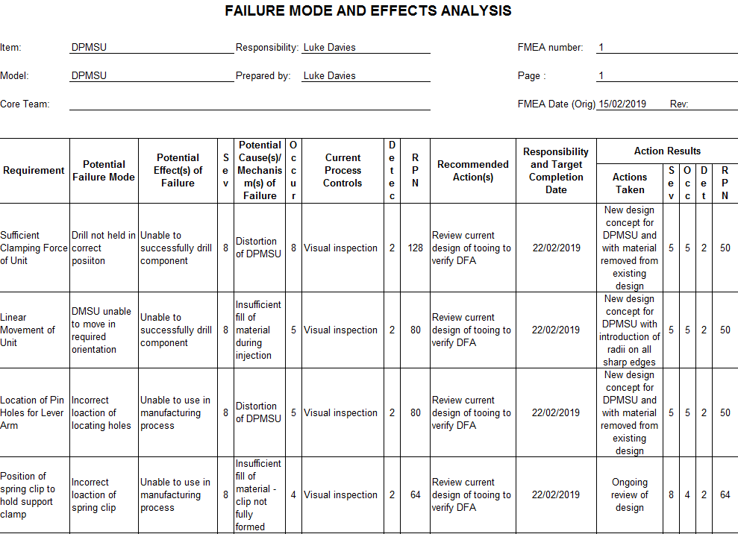
From the FMEA it is apparent that distortion of the DPMSU will impact not only the design of the DPMSU, but also the overall performance of the unit.

Manufacturing process

Two manufacturing processes have been reviewed during this report – Injection Molding and Urethane Casting

Injection molding

Injection molding has become a widely used method of manufacture for plastics. The process consists of a polymer being poured into a hopper, and fed through a barrel via a screw. The polymer is heated to a highly plastic state and forced to flow under high pressure into a mold cavity, where it then solidifies. The molded part is then ejected from the cavity (Groover, 2013).
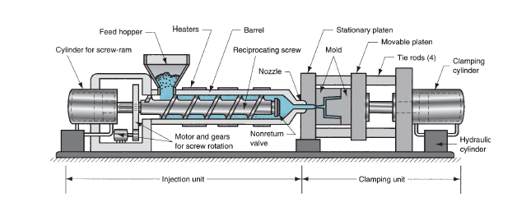
Injection molding has many advantages as a manufacturing process. The process allows for a production rate with cycle times of between 15-120 seconds depending on the complexity of the part manufactured (Worth, 2018), therefore a very efficient processing high volumes of parts. Additionally, enables parts to be processed with a high degree of dimensional accuracy, therefore removing any post processing machining operations.
One negative of this process is the initial tooling cost. Therefore, injection molding is only suitable and cost effective for high volume production.

Urethane Casting

Urethane Casting provides an alternative manufacturing process to that of injection molding. The process begins by creating a master pattern via CNC machining or a high resolution 3D printer. This pattern is then used to create a Urethane or Silicon mold, into which materials from rubbers to hard ABS plastics can be poured, with a production quality part being produced. (Outdesign, 2017)
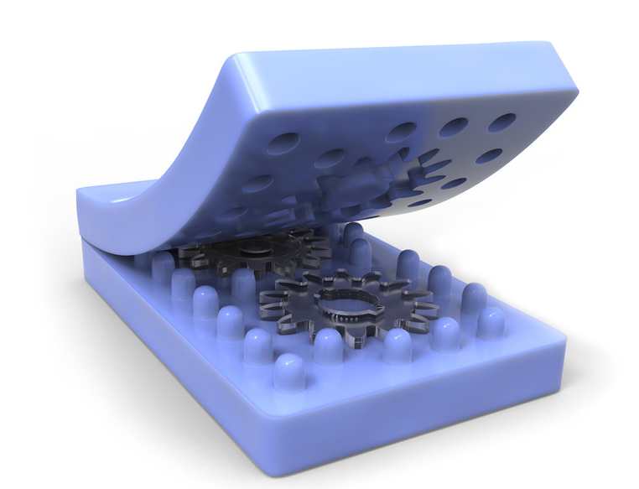
A benefit of this process is the high initial tooling costs of other manufacturing processes are removed, as the mold is created from the original master pattern. Additionally, the lack of a requirement for tooling means there are no lead times for the tooling to be manufactured, therefore reducing final delivery times. A negative of the use of this process is the restriction of batch sizes manufactured via the mold, with typical production runs ranging from 20-200 parts (Outdesign, 2017).

Material selection

There are a wide range of polymers available to select within the current market. This report focuses on two main types – ABS and PC.

ACRYLONITRILE BUTADIENE STYRENE (ABS)

Acrylonitrile Butadiene Stryene (ABS) is widely used within manufacturing process such as injection molding. The polymer is a thermoplastic, therefore allowing for gates, excess material or unfortunate reject parts to be melted and re-used. This will help by reducing costs, unlike with the use of thermoset polymers.
This material is structurally very sturdy and strong resulting in parts being able to withstand high impact. ABS possesses a low shrinkage rate (Typically 0.5-0.7%) in comparison to many other polymers, which will improve dimensionally accuracy of the finished part (Rogers, 2015). ABS provides a strong material type, given the low density 1.01e3 – 1.21e3 kg/m^, and low cost of the material £2.22-£2.25 per kg (CES, 2018).
However, a negative of ABS as a material is that it has a low service temperature for a plastic, typically between 88°C - 89°C (Unknown, 2019). This may cause issue during service with the heat generated from the drill, leading to issues such as distortion of the DPMSU.

Polycarbonate (Pc)

Polycarbonate polymers are used to produce a wide variety of material, and are predominantly used when materials require a high resistance to impact (Rogers, 2015). PC plastics like ABS are a Thermoplastic, therefore can be re-used to reduce waste and the volume of virgin material used, and are beneficial for cost saving. PC has a very good resistance to heat with a service temperature of 121°C (Unknown, 2019), so would be impacted less than the ABS material by the heat generated by the drill during the manufacturing process.
Although a light material compared with other polymers, PC has a high level of strength with a yield strength of 89.6MPa, therefore will with stand a greater load when compared with ABS at 68.9MPa.
Although PC has a far greater resistance to impact when compared with ABS, it has a slightly greater shrinkage rate of 0.6-0.9% (Rogers, 2015) when used to manufacture parts.

Design concept 1

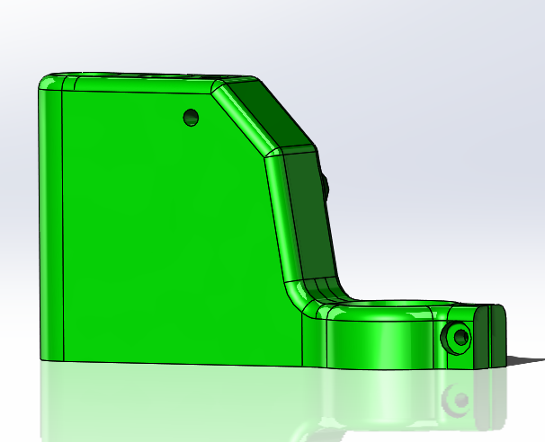

The initial design of the DPMSU had many sharp edges which would cause issues with repeatedly of molding a consistent part, potentially leading to defects such as short shot, and are unnecessary on the overall design. The introduction of the Radii on the component removes the difficulty of trying to form sharp edges.
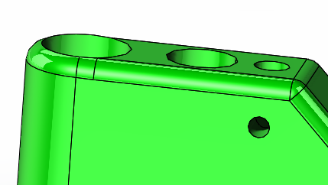

A consideration when creating a plastic injected component is to reduce, wherever possible the amount of material injected. This not only reduces the cycle time, but reduces the possibility of molding defects, such as sink marks on thicker sections (Rogers, 2015).

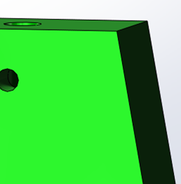
Before

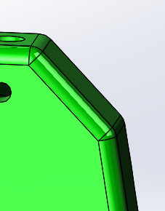
After

With 85% of the overall injection time consumed by the cooling of the polymer (Dray, 2019), reducing the volume of material in the mold will aid with reducing the overall cycle time, plus increasing output of parts manufactured and significantly reduce the costs for manufacture of the 1000 parts per week. To verify the changes to the initial design, an FEA study was conducted.

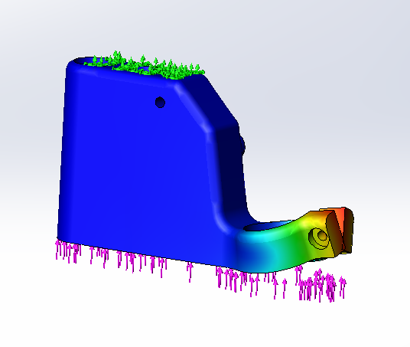
The changes to the design have reduced the displacement on the component in comparison with the results obtained from the initial design.

Design concept 2

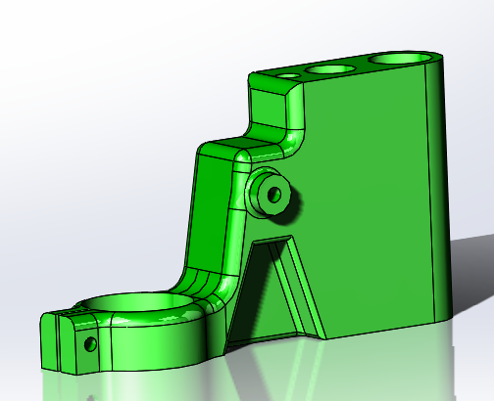
As discussed with the first design change proposed, the main area of improvement regarding cycle time within the injection molding process is reducing the volume of material injected to reduce the overall cooling time within a cycle. Therefore, using the information generated from the FEA for design 1, it was apparent there were no stresses present in the area at the front of the main body of the DPMSU.
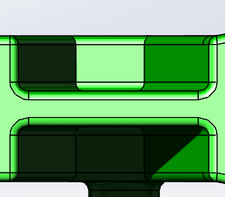

Additionally, there was a large volume of material at the front end of the main body that did not contain any special characteristics, or have an impact on the functional requirements of the unit. The inclusion of the undercuts on either side of the component will not only reduce the volume of material injected, which reduce the overall material cost, but again reduce cycle time. The FEA analysis demonstrates a reduced level of displacement on the front clamping end of the component. This will aid with the stability of the drill in service.

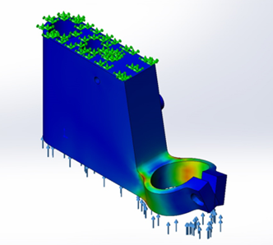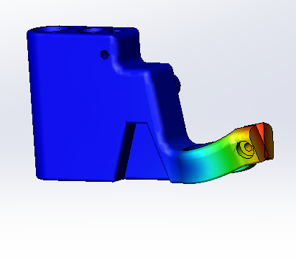
Initial Design Design Concept 2

design concept 3

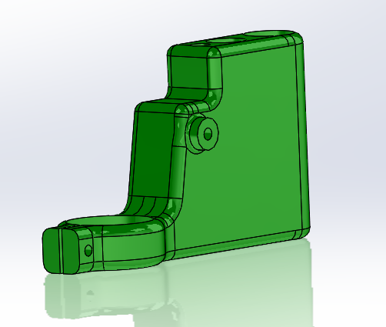

As discussed with design concept 2, the removal of material at the front end of the main body of the DPMSU, with reduce the volume of material required during the injection process, therefore reducing overall cycle times. However, design concept 2 would cause issues with cooling rates due to a reduced wall thickness in comparison the rest of the part. Therefore, design concept 3 has removed material by shelling the part, in an attempt to generate similar wall thicknesses in relation to the rest of the part.

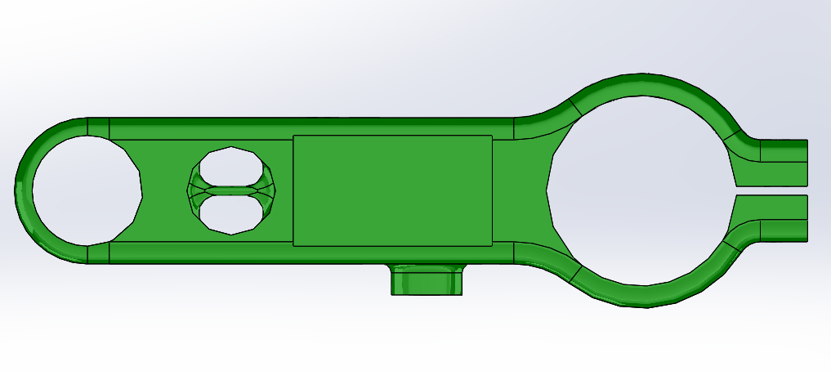

tooling

There are many areas to consider when designing and manufacturing tooling for manufacturing processes such as injection molding. The volume of parts required to be manufactured will impact the material used to produce the tooling. For low volume manufacturing runs up to 100,000 pieces, aluminum can be a suitable material. However, with 100 parts per week being produced, the tooling would likely need replacing within 2 years of manufacturing. Therefore, hardened tool steel would be the material of choice for the tooling, as this is the typical tooling used for high volume runs (Schwartz, 2017).
One area which must be considered is the ease of which the pattern is removed from the tooling, particularly for fully automated process. To aid with this, radii and draft angle must be included when designing the finished pattern, typically the draft angle used is between 1.5-2°, and is at the top of the mold (Schwartz, 2017).
Additionally, to allow for the removal of material from the part as proposed in the design concepts, slides would need to be included in the design of the tooling to create the undercuts and holes.

conclusion

The information reviewed and generated within the report suggest that design concept 3 is the most efficient design for the DPMSU. The removal of material from the main body will reduce the volume of material required to inject, therefore reducing overall cycle time and potentially reducing material costs. The most appropriate manufacturing route would be the injection molding process. Although this would incur an initial tooling cost which the Urethane casting process would not include, the production volume capacity of the mold at 20-200 runs would not be viable, with 1000 pieces per week.
The preferred material for manufacturing the part is the Polycarbonate. This is due to the higher resistance to impact and increased service temperature as opposed to ABS.

Bibliography

CES, 2018. CES EduPack. 2018 ed. Swansea: CES.
Dray, R. F., 2019. rdray.com. [Online]
Available at: https://www.rdray.com/injection-molding-cost-cutting-strategies
[Accessed 10 February 2019].
Groover, M., 2013. Principles of Modern Manufacturing. Fifth ed. Hoboken, NJ: John Wiley & Sons.
Outdesign, 2017. Outdesign.co. [Online]
Available at: https://www.outdesign.co/single-post/2017/11/16/Low-Volume-Cost-Effective-Alternatives-to-Injection-Molding
[Accessed 12 February 2019].
Rogers, T., 2015. Creative Mechanisms. [Online]
Available at: https://www.creativemechanisms.com/blog/what-cause-injection-molding-defects-and-how-to-fix-them
[Accessed 10 February 2019].
Rogers, T., 2015. Creative Mechanisms. [Online]
Available at: https://www.creativemechanisms.com/blog/everything-you-need-to-know-about-abs-plastic
[Accessed 12 February 2019].
Schwartz, J., 2017. Revpart. [Online]
Available at: https://revpart.com/impact-of-tools-on-injection-molding/
[Accessed 15 February 2019].
Unknown, 2019. Gplastics. [Online]
Available at: http://www.gplastics.com/pdf/polycarbonate.pdf
[Accessed 15 February 2019].
Unknown, 2019. teststandard. [Online]
Available at: http://www.teststandard.com/data_sheets/ABS_Data_sheet.pdf
[Accessed 20 February 2019].
Worth, J., 2018. Rodon Group. [Online]
Available at: https://www.rodongroup.com/blog/6-major-advantages-of-plastic-injection-molding
[Accessed 20 February 2019].

