Hotel Organisational Audit: Intercontinental Hotels Group (IHG)

Student name: Corina Elena Slujitoru
Student ID number: 2111320
Module title: Management & Organisational Behaviour (BMIH 5004)
Lecturer’s name: Julia Ault

Contents

Executive Summary: 3
Introduction: 3
Discussion/ Literature 4
Organization Structure 4
Organization Culture 6
Organization Goals 7
Organizational Change/ Kurt Lewin's Change Model 8
Strategic Management/ Strategic Direction 10
Conclusion and recommendation 12
References 13

Executive Summary:

While operating, the organisation focuses on building a network with the right partner and managing the market (Burgess et al., 1995). Managing hotel structure, as well as having a particular goal, is essential. The organisational structure is significant since it supports businesses in making efficient decisions (shrm.org, 2023). By providing specialised responsibilities to working-level employees, organisations can make the decision-making process more accurate. To adapt to the modern world's technologies, every company must alter, and knowledge is essential (Institute, 2022) as the change affects shareholders, workers, and customers; controlling it is crucial. Thus, handling change well may improve corporate performance. Also, strategic management is needed to operate, control, and organise work. This report will analyse all of these essential elements of the Intercontinental Hotel Group (IHG).

Introduction:

IHG (InterContinental Hotels Group) is a well-known British multinational hospitality corporation headquartered in Denham, United Kingdom (THE ORG, 2023) that owns, administers, franchises and manages a vast portfolio of hotel brands (6179 hotels and 914928 rooms globally), "with around 345,000 colleagues working across more than 100 countries to deliver True Hospitality for Good" (ihg.com, 2023). IHG was founded in 1777 and has developed to become one of the world's largest hotel companies. William Bass founded the Bass Brewery in Burton upon Trent, England, in 1777, marking the beginning of IHG's history. Over the years, the company diversified its operations and ventured into the hotel industry, transforming the hospitality industry by being the first to the franchise, the first in China market, launching the world's first reservation system, the first to take booking online, introducing the first application across all devices and pioneering the next generation technology through IHG Concerto (ihgplc.com, 2019).

Discussion/ Literature

Organization Structure

Organisation structure defines coordinating and supervising the work and communicating effectively to achieve the organisation's common goal (ccea.org.uk, 2018). It affects the function and action of an organisation, and with this, the organisation works (Pereira et al., 2014). IHG Hotels Group has a multi-brand structure, emphasised by the company vision as a "strategy focuses on value-creation by building preferred brands" (ihgolm.my.site.com, 2023) to serve varied markets (THE ORG, 2023). The organisational structure has several key components:
- Executive Leadership: The CEO leads the senior management team, which guides operations;

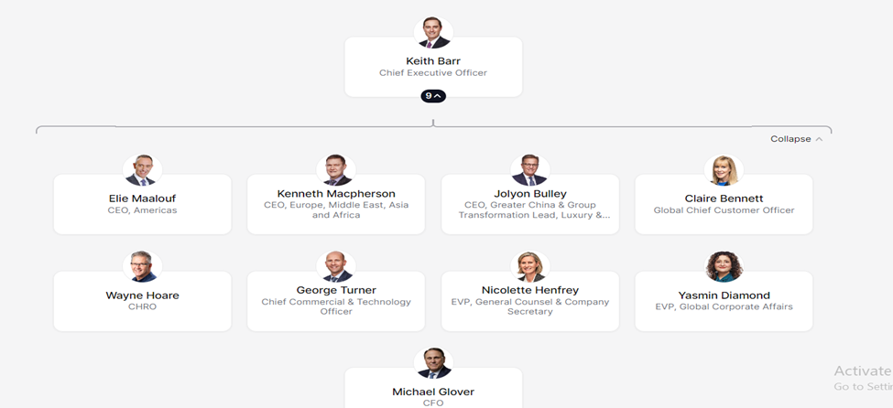
Figure 1: Executive Leadership Team
Source: (The Org, 2023)
- Regional operations: IHG maintains regional offices for operations, brand development, and franchise support. Europe, Middle East, Asia and Africa, and Greater China are these regions;
- Brand Divisions: IHG's hotel brands include InterContinental, Kimpton, Crowne Plaza, Holiday Inn, Holiday Inn Express, Staybridge Suites, and Candlewood Suites. Each brand division has a marketing, operations, and development staff.
Starting from Druker's affirmation, "Good organisation structure does not by itself produce good performance, but a poor organisation structure makes good performance impossible, no matter how good the individual managers may be", and considering the success of some of the hospitality industry's companies on the global market, there are some models that could bring good results for the organisations. In these terms, Marriott International is another global hospitality giant, one of the most important competitors for IHG. Both corporations are multi-brand; however, their organisational structures vary.
- Marriott's organisation matrix structure has clear lines of power and responsibility (marriott.com, 2019). In this matrix structure, employees report their activities to multiple leaders. Therefore, communication between group increases and it increases leadership skills. IHG's organisation structure is decentralised, involving a combination of centralisation and decentralisation, and allowing the company to control strategic choices while empowering regional offices and brand divisions to run day-to-day operations under this framework (IHG PLC, 2019);
- Structure Focus: Marriott's organisational structure is focused on business segments (cleverism.com, 2016), whereas IHG's is brand divisions;
- Geographical Segmentation: Marriott's regional operations span Asia Pacific, whereas IHG's incorporates AMEA (Asia, Middle East, and Africa) as a single area;
- Ownership vs Franchise Model: Marriott owns and franchises properties, whereas IHG primarily franchises.

Organization Culture

Culture is the values or beliefs that shape the organisation (shrm.org, 2023). Organisational culture, according to Schein (1990), "is a pattern of shared basic assumptions that the group learned as it solved its problems of external adaptation and internal integration". It tells others what an organisation produces and how it produces. It defines the behaviour of the people within an organisation. The critical success of an organisation is its culture. In these terms, IHG maintains a robust organisational culture in which employees know their actions and tell them how the organisation runs. IHG Hotels Group promotes a culture centred on providing exceptional visitor experiences (ihgplc.com, 2019). It maintains an environment which makes it unique. A strong organisational culture can be developed in three ways (Sawyers, 2021):
  - Hotel Teams must know what behaviour is expected in a specific situation: Hoteliers must be aware of their actions and know whether they are appropriate in a specific situation (Pierce and Delbecq, 2017). When a team is formed, they have to know their responsibilities and be honest regarding their actions. IHG provides value to its organisation and enhances its culture by encouraging teamwork at all levels and collaboration to accomplish objectives, as the company revealed in 2019's Strategic Report (ihgplc.com, 2019). IHG's online training platform (IHG Academy) and the forums and cross-functional project teams encourage staff engagement and information exchange.
  - Hoteliers should feel comfortable working in the hotel: IHG focuses on the comfortable environment in which employees work as well as IHG prioritises diversity and inclusion in its culture (ihgplc.com, 2019). Diversity improves decision-making and creativity, according to the firm. The corporation maintains employee resource groups that help underrepresented minorities and promote belonging.
  - A hotel manager should be working for their team: Management plays an important role here. The Hotel departments should know all their employees and keep track of customer preferences. Customers and employees are essential assets for a company (Pettigrew, 2019). Managers must manage their teams more effectively and ensure department communication goes smoothly. In the IHG organisation, all critical business and spending ideas come with a management review of how they will affect workers (ihgplc.com, 2019).
Regarding customer centricity, IHG maintains these cultures to make their service unique and rare by understanding and anticipating consumer wants and providing personalised services is the company's culture. IHG pushes staff to surpass visitor expectations. The "Room for You" programme lets staff recall visitors' preferences, including pillow varieties and room amenities.
IHG's culture also embraces environmental sustainability. Through strong governance, clear rules, and ambitious commitments in its "Journey to Tomorrow 2030" responsible business strategy, IHG fulfils its "True Hospitality for Good" objective (ihgplc.com, 2022). IHG's Green Engage system helps hotels reduce their environmental impact by offering energy saving, waste reduction, and water efficiency requirements.

Organization Goals

Having goals and working towards implementing them assists companies in knowing what they truly want (Simon, 1964). Having a goal also supports the company in prioritising what work should be done first. Goals give the organisation directions and keep them motivated. It also helps the organisation continue its operations in the long run. The organisation's primary goal is profit (Simon, 1964), so IHG is similar. The main goal of this organisation is to generate profits.
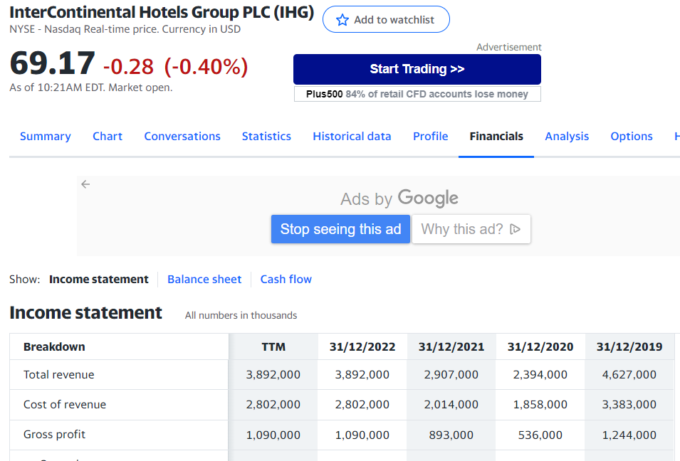
Figure 2: 2019-2022 IHG Turnover
Source: (uk.finance.yahoo.com)
IHG operates around 345,000 employees; at a first analysis of the listed figure, revenue is $11,281 per employee. The highest revenue of the hotel group was $4,627,000 in 2019 (before the Covid-19 pandemic). By comparison with 2019, it is reasonable to assume that IHG is on an upward trend in 2022 and that the objective of performing excellently again can only be achieved with a well-structured organisation that promotes a responsible and robust culture.

Organizational Change/ Kurt Lewin's Change Model

Organisational change is the framework for organising the process of new business functions, processes, technology, organisational structure or culture within an organisation (Oreg, 2016). It is an essential part of any business, so it should be managed successfully. It addresses three main areas in any business enterprise. These are organisational training, communication and change readiness. It manages the effect of any change occurring in the enterprise.
Managing change or change management is an approach that deals with transforming a firm's objectives and goals (Lewis, 2019). The goal is to establish a strategic position for managing and controlling change to help the people adopt the change. Preparing the team to implement change, designing a mission plan and change process, establishing and implementing the change, communicating with related groups, and evaluating the result and change process are the five steps to managing change.
In the 1940s, Kurt Lewin created a three-step change management model (mindtools.com, 2022). This framework describes change management methods. Lewin's three-step approach includes change, organisation, implementation, and common obstacles (Hussain et al., 2018).
- Step 1 - Unfreeze: defines weakening resistance to the idea of ​​change and accepting it through suitable communication;
- Step 2 - Change: accepting and learning new ideas, methodologies, and technology through the company's support; encouragement, optimism and enthusiasm should accompany this step;
- Step 3 - Refreeze: employees adopt the new method and the change becomes the norm through practice.
Over its history, IHG has continuously implemented many change initiatives to adapt to evolving market dynamics and maintain a competitive edge, such as:
Brand consolidation: IHG's plan of brand consolidation needed management adjustments to match the simplified brand portfolio (Doggrell, 2020). Evaluate performance, strategically judge divestments or discontinuations, and reallocate resources to support critical brands. IHG's management staff have managed these changes, smoothed transitions, and communicated the brand consolidation plan to internal and external stakeholders.
Global Extension and Acquisition: IHG's worldwide development and strategic acquisitions required management reforms to incorporate new brands and companies (Doggrell, 2020). This process entails analysing leadership and talent needs for managing acquired brands, integrating operational procedures and systems, and enabling cooperation and information sharing across regions and teams. IHG management has managed these integration efforts, driven synergies, and ensured post-acquisition success.
Digital Transformation: IHG's digital transformation requires management to adapt to new technology and client preferences. The management team had to promote innovation, build digital capabilities, and form strategic alliances with technology suppliers. They have led IHG's digital agenda, developing mobile applications and web platforms, and integrated digital solutions into marketing, reservations, and guest experiences (IHG Development, 2023).
Sustainability Initiatives: IHG's sustainability focus requires managers to include environmental considerations in strategy and operations (InterContinental Hotels Group PLC, 2023). IHG's management has set sustainability goals, review progress, and enforced sustainable hotel and business practices.
Organisational Restructuring: IHG restructured its management structure and responsibilities (InterContinental Hotels Group PLC, 2009). After the merger of regional divisions (such as Americas and Greater China), IHG's management has had to restructure reporting lines, clarify duties and responsibilities, and maintain good communication and coordination throughout the new territory.

Strategic Management/ Strategic Direction

Strategic management organises, monitors, and adapts organisational goals (University of York, 2023). It lets companies of all sizes assess their performance and change their operations to fulfil their goals. It entails analysing and studying the external competitive environment and internal organisational tactics to set firm objectives and assure management's success (Burnes, 2004). SWOT analysis is "a commonly used tool for strategic planning" used by business experts for strategic analysis (Phadermrod, Crowder and Wills, 2019).
IHG SWOT Analysis:
STRENGTHS:  Strong brand portofolio allow IHG to serve a variety of market sectors and consumer preferences;  With hotels in many countries, IHG can leverage economies of scale and attract a large consumer base;  IHG's loyalty program, IHG Rewards Club, fosters customer loyalty and repeat business;  IHG uses technology to improve guest experiences, simplify operations, and lead hospitality innovation. | WEAKNESSES:  IHG's franchise model may restrict control over quality and uniformity among hotels;  IHG's worldwide presence may need to be stronger in certain places than competitors;
OPPORTUNITIES:  Asia, the Middle East, and Latin America are expanding hospitality markets where IHG can expand;  IHG may capitalise on the growing focus on sustainability and responsible business by incorporating them into its operations and brand positioning. | THREATS:  Global and local hotels compete for market share, which might hurt IHG's profits;  Airbnb's growth threatens established hotel corporations like IHG.  Regulations, tariffs, and political instability in important markets might affect IHG's business.

The purpose of the SWOT analysis is to identify the strategic directions that the company may decide to pursue. In terms of strategic direction, the organisation's overall path to achieve long-term goals and objectives, IHG states on its website that the strategic aims and behaviours of the company focus on the growing brand portfolio as "the heart of our business" and the owners and visitors as "the heart of our thinking" as they appreciate the importance of an innovative, well-invested digital strategy in meeting the company's rising obligation to care for and invest in the organisation's people and to impact the company's communities and world positively (IHG PLC, 2019).

Conclusion and recommendation

Organisational framework, mindset, and goals are all linked and affect each other, influencing the organisation's strategic decision-making. It defines the understanding of essentials of the nature of management work, communicates the leadership role and builds a robust organisation. The report defines the organisational structure at Intercontinental Hotels Group (IHG), including the strategic management and direction process. The audit report shows the approaches to managing the organisational change that may affect the organisation's evolution. IHG can manage the change that Lewin's change model defines by taking the change initiatives. IHG can achieve its goals by analysing the strategic management and improving the current performance. IHG has several strategies to enhance overall performance by achieving the goals that are defined by the organisation's strategic management. The audit report recommends that IHG maintain the integrated relationship between the cultural structure and goals by functioning the change management through the change initiatives. It also evaluates its strategic management by analysing and defining the strategies the hotel group management wants to implement.

Word count: 2178

References:
Burgess, C. Hampton, A. Price, L. and Roper, A. (1995) International hotel groups. International Journal of Contemporary Hospitality Management, 7(2/3), pp.74–80. doi:https://doi.org/10.1108/09596119510080664;

Burnes, B. (2004) Kurt Lewin and the planned approach to change: a re‐appraisal. Journal of Management studies, 41(6), pp.977-1002;
Ccea.org.uk. (2018) UNIT AS 2: ORGANISATIONAL STRUCTURE AND CULTURE / FACTFILE: GCE PROFESSIONAL BUSINESS SERVICES. [online] Available at: https://ccea.org.uk/downloads/docs/Support/Fact%20File%3A%20AS/2019/AS%202%20Factfile%20Organisational%20Structure%20and%20Culture.pdf/ [Accessed on 16.06.2023];

cleverism.com (2016). Careers at Marriott / Mission. [online] Available at: https://www.cleverism.com/company/marriott/#:~:text=Under%20Marriott/ [Accessed on 16.06.2023];

Doggrell, K. (2020). Consolidation ‘over time,’ says IHG’s Barr. [online] hotelmanagement.net. Available at: https://www.hotelmanagement.net/ [Accessed 19 Jun. 2023];

Hussain, S.T. Lei, S., Akram, T. Haider, M.J. Hussain, S.H. and Ali, M. (2018) Kurt Lewin's change model: A critical review of the role of leadership and employee involvement in organizational change. Journal of Innovation & Knowledge, 3(3), pp.123-127;
IHG Development. (2023). Digital advantage. [online] Available at: https://development.ihg.com/hotel-development/owner-value/digital-advantage/ [Accessed 19 Jun. 2023];

ihg.com (2023). IHG Academy / IHG Hotels and Resorts [online] Available at: https://careers.ihg.com/en/early-careers/ihg-academy/ [Accessed on 16.06.2023];

ihgolm.my.site.com. (2023). About IHG / Legendary global leadership / IHG Strategic vision [online] Available at: https://ihgolm.my.site.com/s/amer-about#panel2/ [Accessed on 17.06.2023];

ihgplc.com (2019). Our Strategy. InterContinental Hotels Group PLC. [online] Available at: https://www.ihgplc.com/en/about-us/our-strategy/ [Accessed on 17.06.2023];
ihgplc.com. (2019) InterContinental Hotels Group PLC. Our history. [online] Available at: https://www.ihgplc.com/en/about-us/our-history#/ [Accessed on 15.06.2023];
ihgplc.com. (2022) InterContinental Hotels Group PLC. [online] Available at: https://www.ihgplc.com/en/ [Accessed on 15.06.2023];

Institute, T.C.M. (2022). The Effective Change Manager: The Change Management Body of Knowledge. [online] eBook. Vivid Publishing. Available at: https://www.google.co.uk/books/edition/The_Effective_Change_Manager/BeBsEAAAQBAJ?hl=en&gbpv=1&dq=about+management+of+change&printsec=frontcover [Accessed on 16.06.2023];

InterContinental Hotels Group PLC. (n.d.). IHG announces regional restructuring and cost saving programme. [online] Available at: https://www.ihgplc.com/en/news-and-media/news-releases/2009/ihg-announces-regional-restructuring-and-cost-saving-programme [Accessed 19 Jun. 2023];

Lawton, G. and Pratt, M. (2022). What is change management? / Tech Target. [online] Available at: https://www.techtarget.com/searchcio/definition/change-management/
[Accessed on 17.06.2023];

Lewis, L. (2019) Organizational change. In Origins and traditions of organizational communication (pp. 406-423). Routledge;
marriott.com (2019). Our Story of Innovation / Marriott International. [online] Available at: https://www.marriott.com/about/culture-and-values/history.mi/ [Accessed on 16.06.2023];

midtools.com (2022). Lewin’s Change Management Model / Mind Tools. [online] Available at: https://www.mindtools.com/ajm9l1e/lewins-change-management-model/ [Accessed on 18.06.2023];

O’Regan, N. and Ghobadian, A. (2014) The importance of capabilities for strategic direction and performance. Management decision, 42(2), pp.292-313;
Oreg, S. (2016) Personality, context, and resistance to organizational change. European journal of work and organizational psychology, 15(1), pp.73-101;
Pereira, L. and Almeida, P. (2014) Marketing and promotion in the hotel industry: A case study in family hotel and hotel group. [online] Available at: https://www.academia.edu/43048672/Marketing_and_Promotion_in_the_Hotel_Industry_A_case_study_in_Family_Hotel_and_Hotel_Group [Accessed on 14.06.2023];

Pettigrew, A.M. (2019) On studying organizational cultures. Administrative science quarterly, 24(4), pp.570-581;
Phadermrod, B., Crowder, R.M. and Wills, G.B. (2019). Importance-Performance analysis based SWOT analysis. International Journal of Information Management, [online] 44(12), pp.194–203. doi:https://doi.org/10.1016/j.ijinfomgt.2016.03.009;

Pierce, J.L. and Delbecq, A.L. (2017) Organization structure, individual attitudes and innovation. Academy of management review, 2(1), pp.27-37;
Sacheati, P. (2019). Organizational Structure: Meaning, Principles, Forms, Functions, Elements / Economics Discussion. [online] Available at: https://www.economicsdiscussion.net/organisational-structure/organizational-structure/32234/ [Accessed on 15.06.2023];

Sawyers, S. (2021) 3 Ways a Hotel Manager Develops their Culture / linkedin. [online] Available at: https://www.linkedin.com/pulse/hotel-manager-culture-strategy-more-important-stephen-sawyers/ [Accessed on 14.06.2023];

Schein, E.H. (1990) Organizational culture. American Psychologist, 45(2), pp.109–119. doi:https://doi.org/10.1037/0003-066x.45.2.109;
shrm.org. (2023). Understanding and Developing Organizational Culture / SHRM. [online] Available at: https://www.shrm.org/resourcesandtools/tools-and-samples/toolkits/pages/understanding-developing-organizational-culture.aspx/ [Accessed on 16.06.2023];

Simon, H.A. (1964) On the Concept of Organizational Goal. Administrative Science Quarterly, 9(1), p.1. doi:https://doi.org/10.2307/2391519;
THE ORG. (2023) InterContinental Hotels (IHG) Org Chart. [online] Available at: https://theorg.com/org/ihg/ [Accessed on 15.06.2023];

University of York. (2023). Strategic management theories: supporting leaders to achieve their business objectives. [online] Available at: https://online.york.ac.uk/strategic-management-theories-supporting-leaders-to-achieve-their-business-objectives/ [Accessed 18 Jun. 2023].

