Assessment for MA Heritage Practice

within AHHI7001

As the AHHI7001 will be marked by Dr Katharina Zinn and moderated by Dr Emma-Jayne Abbott, the case studies will be slightly adapted. The assessment structure will stay the same.

The assessment for the module will comprise a series of exercises, as follows:

1 1500 word bibliographical exercise (30%)
2 1000 word archival exercise (20%)
3 1500 word commentary on a visual image (30%)
4 1000 exercise museum’s primary sources (20%)

Criteria for Assessment

In your exercises you should show that you can:

● understand fully and evaluate questions of source provenance
- understand and apply, where appropriate, wider conceptual questions regarding source material and survival
- explain the source/document within its wider historical context
- critically evaluate and analyze the meaning and significance of source/ document
- make effective and insightful use of the relevant historiography, where appropriate
- write with structure, clarity and good grammar.

1 Bibliographical Exercise – annotated bibliography (1500 words)

Choose one of the following texts / artefacts / heritage sites and prepare a short bibliography identifying at least five key editions of or key monographic works on each text. You may include online editions if you wish.
You have to include after each entry two or three sentences explaining why you think this edition/monography is important or useful. Make sure your entries include all the key bibliographic components (title of the edition, date of publication, place of publication, publisher and printer, STC number if relevant, online access details if relevant). You should introduce your bibliography by briefly explaining the significance of the text and outlining the major resources you have used in compiling the bibliography.

- Text: Book of the Dead.
- Artefact: Rosetta Stone, BM EA24.
- Heritage Site: Amun temple – Karnak
- Heritage Site: Self chosen heritage site (world or national heritage site) indicate exactly the location and importance of this site.
.

2 Archival Exercise

Choose one of the following topics, and using all of the following archival websites: the National Archive (http://www.nationalarchives.gov.uk), the catalogues of the Egyptological Archive of the Griffith Institute (http://www.griffith.ox.ac.uk ) and the popular science Time Magazine Archive (http://www.time.com/time/archive) to compile a list of at least 15 sources related to your chosen topic. You should begin your report with a short statement explaining your methodology (the way how you find these sources). You should then list the sources you have been able to find, stating, on which of the upper 3 websites you found them, explaining the availability of the actual source (online or/and current location if they are both available online in a digitalised form and kept in original, state both) as well as their significance for the heritage of Egyptology and the Egyptian reception.

(A) People
George Herbert, 5th Earl of Carnarvon
Howard Carter
Seti (Sethos) I.

(B) Places and Institutions
Abydos
Giza

3 Write a commentary on the following image

The purpose of the commentary is for you to demonstrate that you understand the significance of a visual image and its relation to material culture, in preparation of an entry meant to be included in a museum’s catalogue. Please, set ONE of the following visual images in its literary, cultural or historical context.
- Pap. Harris I (The Great Papyrus Harris) BM EA 9999/43 – page showing Ramses III before the gods of Memphis
- This page can be also seen in the facsimile publication “Facsimile of an Egyptian hieratic papyrus of the reign of Rameses III, now in the British museum”, available in the Special Collection of the Roderic Bowen Library and Archives; Brit. M. 181 RBLA Reference
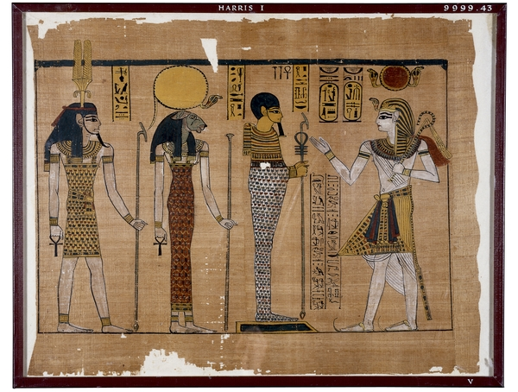

- The portico of the Temple of Hathor at Dendera, from Vivant Denon, Voyage dans la Basse et la Haute Égypte, (Paris 1802)
  - This sketch can also be seen in the publication “Voyage dans la Basse et la Haute Égypte”, available in the Special Collection of the Roderic Bowen Library and Archives; PHI 01320 RBLA - Founder's Library Vol. 2 [PHI 01320(2)]
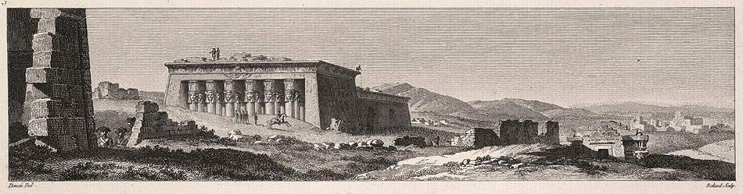

Examples, how to write catalogue entries are to be found in exhibition catalogues, two of them are especially recommended
Teeter, E. (ed.) (2011). Before the Pyramids: the Origins of Egyptian Civilization. Chicago: Oriental Institute. in library and online: http://oi.uchicago.edu/research/pubs/catalog/oimp/oimp33.html (free download)
Taylor, J. (ed.) (2010). Journey through the afterlife: Ancient Egyptian Book of the Dead. London: British Museum Pr. in library
The following museums provide a good online version of their catalogues (collection databases) and their websites are recommended and are therefore allowed to use (for general remarks concerning usage of website see below):
- British Museum (http://www.britishmuseum.org/research/search_the_collection_database.aspx )
- Metropolitan Museum of Art (http://www.metmuseum.org/collections)
- Petrie Museum (UCL) (http://petriecat.museums.ucl.ac.uk/ OR http://www.digitalegypt.ucl.ac.uk/Welcome.html)
- Brooklyn Museum (http://www.brooklynmuseum.org/opencollection/collections/)
- Ägyptisches Museum und Papyrussammlung Berlin (http://www.aegyptisches-museum-berlin-verein.de/index.php)
- The State Hermitage Museum, St. Petersburg (http://www.hermitagemuseum.org/fcgi-bin/db2www/browse.mac/category?selLang=English)
- Museo Egizio di Torino (http://collezioni.museoegizio.it/eMuseumPlus?service=ExternalInterface&module=collection)
- Fitzwilliam Museum Cambridge (http://www.fitzmuseum.cam.ac.uk/explorer/)
- The Global Egyptian Museum: over 2 million objects from ancient Egypt kept in about 850 public collections, dispersed over 69 countries around the world including objects from the Egyptian Museum Cairo (http://www.globalegyptianmuseum.org/)

4 Primary museum’s sources

This task is to prepare you for the handling of artefacts in museums. You have to take part in one handling session (offered at two occasions: 12/12/12 @ 3:30 or 17/01/13 @ 11am) in the Roderic Bowen.
You can choose any of the exhibited objects, coming from Cyfarthfa Castle Museums and Art Galleries.
Describe your object, search for comparative pieces, which could give you some indications about date, value and characteristics/nature of the chosen object.
These early research activities shall prepare the inclusion of these artefacts in the collection and should prepare/enable you to write a catalogue entry. (Please, be aware, that you have not to write a catalogue entry, but to collect enough material and facts to make it possible.)
Your task is to write a report about how you handled the objects to gain information, the information search in other museums catalogues, your found comparative pieces (at least 2, maximum 5) and state your found facts of these un-researched and un-catalogued pieces.

Egyptian Objects
Object number | Description | Image
280.004 | Vase with painted net and waved handle | 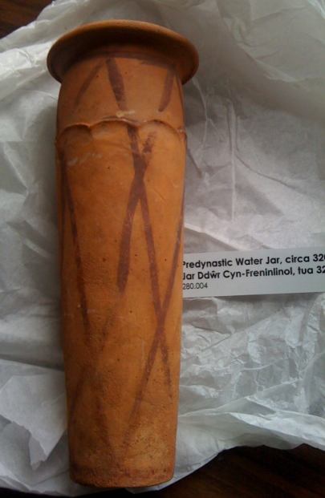
194. 996 | Plaque | 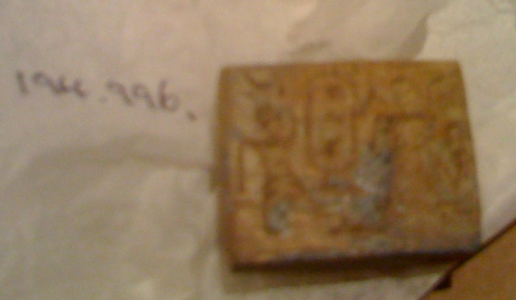
313.004 | Scarab mould | 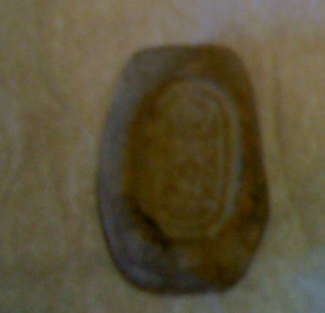
1715.004 | Steatite scarab | 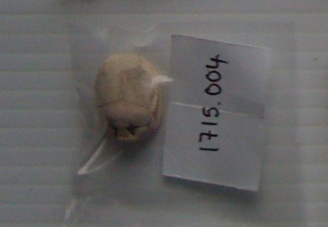
174.996 | Statue / Stelophor of Hwy | 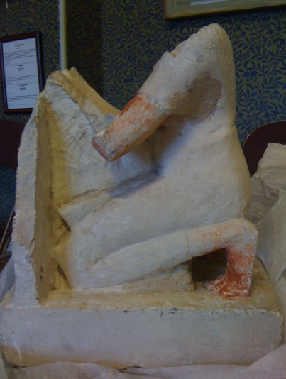
293.004 | Alabaster Vessel | 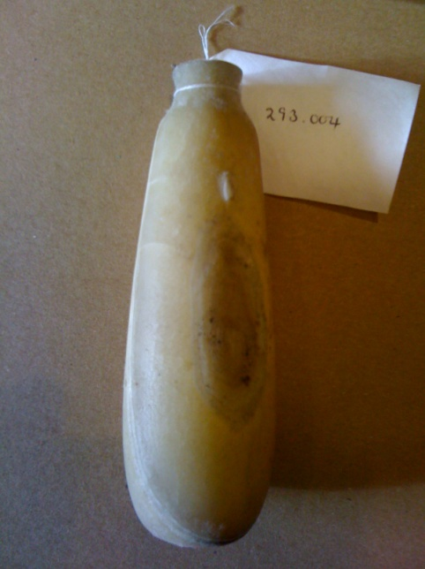

Egyptian objects – registered by museum as fakes

166.996 | Scribal Palette | 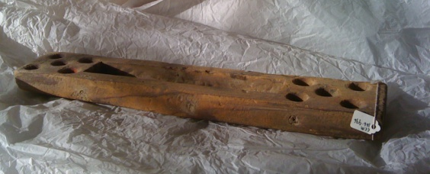
179.996 | Statue of Bastet | 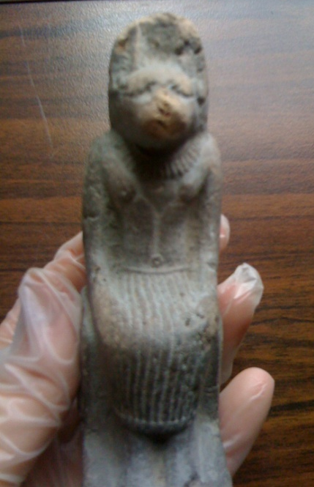

Chinese Objects
282.005 | Porcelain bowl | 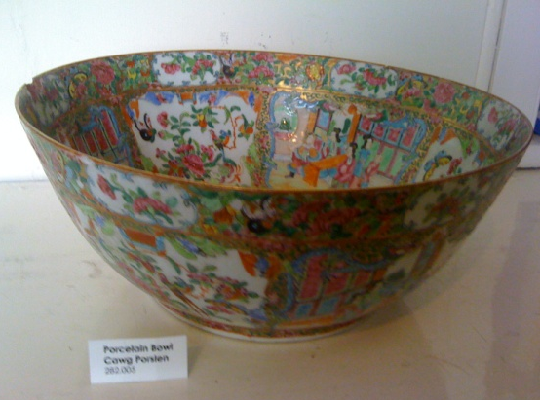
425.004 | Opium container ??? (coconut eyeshell) | 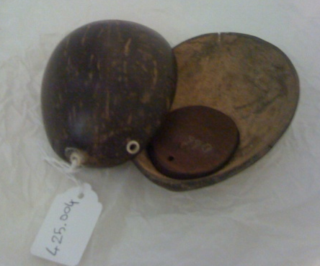
527.004 | Roof tile | 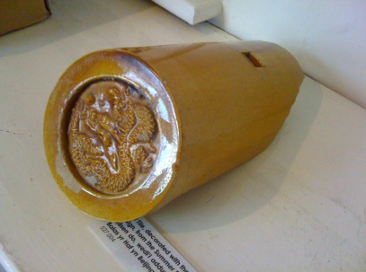
471.004.3, 477.004.3 AND 477.004.4 | Chess figurines (red Bishop, white bishop and queen) | 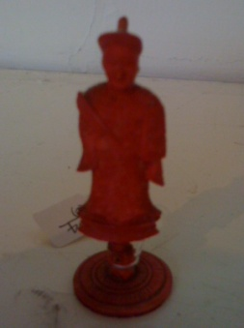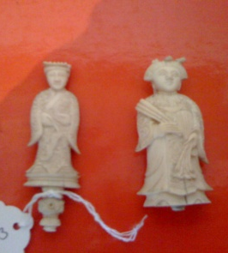
580.005 | Opium pipe | 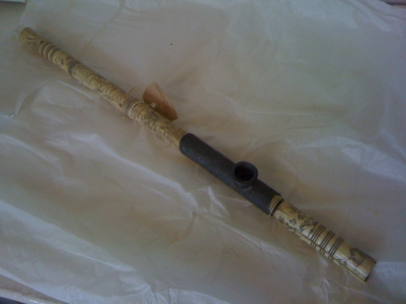
1890.004.1 AND 1890.004.4 | Seals | 

