

Predictive Modelling and Customer Segmentation for Telecom Churn
Student Name: Mohammed Nawaf
Student ID: 2541121

MSc Data and Artificial Intelligence

Module: Application of Machine Data Mining & Visualization
Module Code: ACCA7015
Lecturer: Dr Nouh Elmitwall

Table of Contents
1. Introduction 3
2. Critical Literature Review 4
3. Dataset Description and Analytical Methodology 6
4. Preparing Data and Feature Engineering 7
5. Classification Model Development 9
6. Clustering of Churned Customers 11
7. Results and Model Comparison 13
8. Discussion of Findings 16
9. Business Recommendations 16
10. Conclusion 17
11. References 17

Abstract
One important application of Data mining is unlocking the process of forecasting Customer churns; stop customers from leaving without giving any reason, and adopt these before they even depart so that it is not too late. After data preparation the data was analysed and used the dataset “Telecom Customer Churn” with 100,000 customer records for analysis and 98 predictive features. To build Logistic Regression and Random Forest classification models, there was a structured pipeline of preprocessing steps such as missing value imputation, feature selection and data transformation. A series of performance evaluation measures—including accuracy, precision, recall, f1-measure and roc-auc—were used for the model performance. Among all the discussed classifiers, Random Forest showed the best accuracy score at the same time having highest recall score of 0.6714 and AUC score of 0.6670 which clearly outshone the performance of Logistic regression. For complementing the classification, the churned customers underwent the process of K-means clustering, and two meaningful customer segments containing customers were identified to have targeted retention strategies. Among the findings, age of equipment, customer tenure since using the service, usage behaviour and recurring charges are some of the foundational variables that significantly drive customer churn and can help inform evidence-based churn decisions and retention.

1. Introduction
Communication services find themselves all in one market with mature services, low switching barriers, intermittent competitive offers at low price, and widespread price comparison. In this context, “customer churn” means the termination, non-renewal or transfer of a client’s relationship to another provider. Of course, churn is a concern for businesses as it strips away the repeat sales that are essential to their long-term sustainability, year-on-year and dynamic term value, and leaves businesses to invest on acquisition expenses to replace the widgets. In recent research, churn prediction is viewed as a problem of business intelligence, with churn signals generated from customer data, service information, billing information, device data, and behavioral data, in the form of early warning signals (Imani et al., 2025). Machine learning is especially germane since churn typically does not apply to just one rule, but happens because of several connected patterns featuring tenure, usage, fee, equipment, specific experience with the service, and changing engagement.
The present data assembles a complicated modelling problem. It carries details of 100,000 observations and 100 variables such as revenue, call activity, subscriptions, details about the handsets, accounts history, location, and demographic features. The outcome variable is the class 'churn' that indicates if the customer churned or not. Descriptive approach is useful to identify group differences, but not for estimating individual churn likelihoods and for non-linear combinations of predictors. A predictive workflow is then needed to differentiate between prospective churners and retained customers and assess the predictive classifications accuracy for operation.
The overall objective of the study is to formulate and test classification models for Telecom customer churn and to help in segmenting those customers who already churned to complement prediction. There are 4 objectives which guide the process of the analysis: to audit and preprocess the data with defensible imputation, encoding, scaling and feature selection, to build and tune the Logistic Regression and Random Forest classifiers, to compare classifiers using the accuracy, precision, recall, F1-score, ROC-AUC and behavior at threshold metrics, and to fit a K-means clustering model to the 'churned' customer population to enable the differentiation of retention responses by customer profile. The report first summarizes literature review, then explains the data set and methodology, presents the model development and the clustering results, compares and contrasts results, interprets the main churn drivers and lastly provides the business recommendations and limitations of the study.
This integrated design also distinguishes between three questions that often are confused: Would this customer probably be lost? What factors need to be considered in making this judgment? What would be a commercially appropriate step afterward?

2. Critical Literature Review
The predictability of customer churn has moved beyond the usual statistical approach into a wide spectrum of the machine-learning field featuring ensemble methods, feature selection, resampling, explainability, and business-oriented validation. Analyzing studies from 2020 to 2024, Imani et al. (2025) find that the three approaches (Random Forest, Logistic Regression and boosting) remain active with continued challenges in class imbalance, concept drift, opacity and insufficient profit-driven validation. These concerns are directly relevant in so far as a technically accurate churn model can be acceptable but not economically viable or not accurately described in terms that explains its function and provide stability, or have unstable predictions.
Behavioral, billing, accounting, and device characteristics have been shown consistently throughout telecommunications studies to capture useful "churn signals". Wagh et al. (2024) view churn prediction as a classification problem to be solved to intervene with the customers prior to their churn. Krishna et al. (2024) do a comparison of Random Forest with two other algorithms, namely the support vector machine and boosting that can capture the nonlinear customer behavior. But there are large variations in published accuracy. It is not possible to do simple comparisons due to the differences in definition of churn, window of observation, sample type, data leakage, class balance, and predictors. In the present study, it is only tested on the exclusive test set which is not tampered by external ones but not considering the accuracy in headlines as a target that may be achieved.
Logistic Regression is still significant as a baseline model because it makes probabilities at both extremes, regularizes the problem and provides interpretations of the sign of every coefficient. To emphasize the importance of the entire pipeline and not just the classifier, Lalwani et al. (2022) point out the need for preprocessing and feature analysis as part of a churn system. Logistic Regression is not suitable for nonlinear and highly interactive models. For some telecommunications data, equipment age could be affecting usage trends differently among tenure segments and increasing use downtrends could be more severe if charges are high. A linear log-odds specification may underfit the process unless relationships are deliberately created as such.
Random Forest models are combination of decision trees trained on bootstrap samples and a random subset of predictor variables. It can find thresholds and interactions without having to specify them explicitly in a mathematical form. Balancing, tuning and attribute reduction highlighted the promising performance of the Random Forest algorithm in the research by Bhatnagar and Srivastava (2025), and the research by Prabadevi et al. (2023) showed that using multiple algorithms instead of assuming one is superior can be useful. However, there are also some drawbacks to Random Forest: it is more computationally intensive than other methods, it is not as well-interpretable as other models in a direct sense, it can overfit on deep trees, and its direct sense of the interpretability of the impurity importance for a particular variable tends to favor the ones with more split points. Thus, depth constraints, minimum leaf sizes, permutation importance, and honest holdout validation are required.
Decisions should be incorporated into the evaluation. Overall correctness (accuracy) is no sign of poor churn detection. Churn estimates the reliability of churn alerts, recall estimates the percentage of churners detected and F1-score balances both. While precision-recall analysis is more about performance of the positive class, ROC-AUC studies the quality of the rankings at numerical thresholds. Identifying churners without too many false alerts is critical for churn management, so Wu et al. (2021) focus on its score in a framework of a single integration. The false positive results in an unnecessary use of campaign resources and the False Negative misses out a client that can be added.
Explainability is also key. Combining churn models with global/ local explanations is done by Poudel et al. (2024) and by integrating LIME with SHAP in a large ensemble of models built in a telecom service by Asif et al. (2025). Similarly, Rasool et al. (2025) demonstrate that explainable ensembles can uncover actionable usage and account drivers. In this study, coefficient analysis and impurity importance and permutation importance are three methods that should be used because of this finding as in the study, not all features have the equal weightage, and some important features are associated with other features and they share the credit.
Finally, classification indicates who may be keen to churn, but not whether they have different churners' profiles as customers. The advantages of fusion prediction and segmentation are demonstrated by Wu et al. (2021). While K-means can be scaled up numerically large data sets, it makes several assumptions, such as centroid based groups, it is sensitive to scale and outliers, and it needs a defensible number of clusters k. Therefore, these values should be interpreted in conjunction with the inertia, silhouette score, Davies Bouldin score, segment size and business profiles. The integrated design makes sense as risk will be the priority for supervised prediction and differentiated retention responses for clustering.

3. Dataset Description and Analytical Methodology
The research has used the Telecom Customer Churn dataset which comprises 100,000 customer records with 100 variables corresponding to customer demographics, usage variables, billing variables, handset variables and subscription variables. After dropping the target variable (churn) and dropping the unique customer identifier (Customer_ID), 98 predictor variables were selected for modelling: 77 numerical and 21 categorical. A binary target variable was used to classify the customer as retained (0) or churned (1). Exploratory analysis showed that the number of customers in each class was nearly equal (around 50%, 50%): synthetic resampling is not necessary in this case, but it can be included in the model's optimization.
A structured analytical method was executed to decrease information leaking and replicate the analysis. Have audited data initially for any data type, duplicated data, missing values/observations, and invalid observations. Values of the variable ‘equipdays’ that were negative were recognized as invalid and set as missing values before pre-processing. Categorical variables were one-hot encoded and numerical variables were robust-scaled or imputed with their median values. ANOVA F-statistics with Select Percentile then was used to reduce dimensionality of the data so only the most informative predictors expressed as percentages were retained.
This data set was split into two subsets; 80% of the data was used for training and 20% was used for testing, with the appropriate account for churn being maintained in both sets as well. To build the supervised classification algorithms, two algorithms Logistic Regression and Random Forest were developed with accuracy, precision, recall, F1-score and ROC-AUC. Two machine learning Algorithms, Logistic Regression and Random Forest were developed and tuned using RandomizedSearchCV to evaluate their performance using accuracy, precision, recall, F1-score and ROC-AUC. In addition to the predictive modelling, the clustering technique K-means was used only for customers who have churned to classify segments of these customers based on their behavior. To find the optimal number of the clusters, the elbow method, silhouette coefficient and Davies–Bouldin index were used.
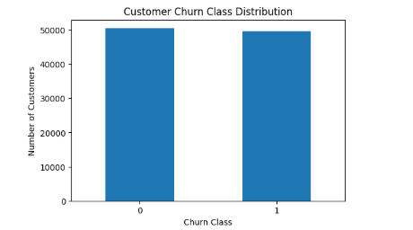
Figure 1. Customer Churn Class Distribution

4. Preparing Data and Feature Engineering
When the first audit was conducted there was no physical barrier to the modelling; the dataset had missed data and some quality issues. Could have also removed Customer_ID – an identifier can promote memorization – although not necessarily customer behaviour. The following was done for data processing: Infinite values were replaced by missing values; Equipment-age data from the equipment column, when negative, were discarded as days of equipment use must be positive. Negative recurring charges were not deleted based on policy because they could be a credit or a billing adjustment instead of an error, therefore the negative recurring charge would be unable to be derived from the data dictionary. Demographic and household characteristics were the areas with the most missing data. Approximately 49% of the time, Numbcars was missing; approximately 38% of the time, dwllsize and HHstatin were missing; approximately 34% of the time, ownrent was missing; approximately 32% of the time, dwlltype was missing; approximately 25% of the time, income was missing; approximately 23% of the time, adults was missing; approximately 22% of the time, infobase was missing; and approximately 10% of the time, hnd_webcap was missing. A large and possibly non-random share of customers should then be thrown out due to complete-case deletion. The median is used for numerical variables as it is less affected by skews in telecom usage and revenue values than the mean. The numerical imputer also produced imputed missing indicators, allowing for the potential of "missing" having predictive information. One-hot indicator encoding and the most frequent observed category of the categorical variables were used for imputation. Unseen test categories were not processed (said to be okay), and low-frequency categories were divided, by setting a minimum frequency. The numerical data had many measures with extreme values that necessitated the use of RobustScaler. Logistic regression, univariate feature scoring require scaling; robust-centring helps mitigate the impact of heavy users. Random Forest does not need scaling, but an identical data processing architecture helps to keep comparison easy and to ensure that the result is reproducible. Feature selection was performed by keeping 60% of the transformed predictors in the remaining efficient models, using SelectPercentile and F statistic (ANOVA). This was done to reduce dimensionality obtained by using one hot encoding and to reduce the computation time. It also gave clear and unambiguous examples of feature reduction, introduced into the model, which were being thoughtfully applied, and which recent research has acknowledged as beneficial in churn modelling (Bhatnagar & Srivastava, 2025). A limitation of univariate selection is that it overlooks predictive relationships among individual features and will exclude features which have little relationship with the outcome when considered individually but are important when viewed in conjunction with other features. Random Forest allows the modeling of interactions between only those features retained. Future comparisons should consider some of the following: mutual information selection, regularized selection, recursive elimination, and model-based selection. Most importantly, all the preprocessing and selection operations were placed within each pipeline. Each training round, the imputer, scaler, encoder, and selector were individually fitted—before validation—for the given fold. This design guarantees that there are no leaks and it will give the reported test metrics higher authenticity than preprocessing and splitting the dataset. The pipeline further saved the original test distribution and there were no synthetic examples since the target was already balanced.
The prepared pipeline can then contain leakage which is suppressed without losing potentially informative missingness or heterogeneous data types.
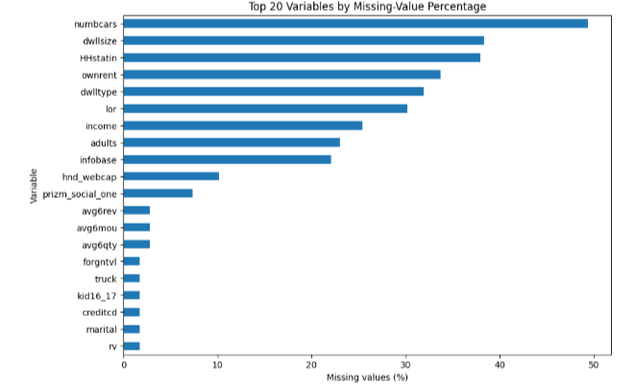
Figure 2. Top 20 Variables by Missing-Value Percentage

5. Classification Model Development
The data was broken down into 80,000 training data and 20,000 test data, based on the churn. The held-out test set was not used to tune hyperparameters. However, since pre-processing of the 98 predictors and large ones were costly, representative stratified samples utilized for tuning. Logistic Regression was based on 20,000 tuning observations, split into two halves of equal size, retained and churned. Random Forest employed a total of 10,000 balanced tuning observations. This approach not only saves time in execution but also retains class representations. All the training observations were further refitted with the best pipelines that were selected. The trade-off is that a smaller tuning sample may not lead to a set of parameters ideal for the larger population and the two-fold cross-validation has a greater variance in the estimates than five-fold cross validation. Logistic Regression was set up to do Logistic preprocessing, percentile Selection (60%) and Binary Classification with Regularization. Weighting for the classes and inverse regularization parameter C were compared in the search. Two-fold cross validation (CV) was performed on four sampled candidates yielding eight fits and optimizing for ROC-AUC. The optimal settings achieved C=10, balanced class weights and tuned with ROC-AUC of 0.6098. Larger C is equal to less coefficient shrinkage, which means the tuning data were benefiting from not being so restrictive on allowing predictor effects. Even the small folds in the full data set were almost equal so small differences in fold (or effects in the decision boundaries) did lead to improved rank discrimination, hence balanced weights were selected. Model was then refitted on all 80,000 training records. Random Forest adopted between 150 and 350 candidate trees, alternative maximum depth, minimum split and leaf sizes, square-root or logarithmic feature sampling and optional balanced weighting. The twelve fits were obtained by two-fold cross validation of six different random combinations. The best model employed 150 trees, a maximum depth of 10 trees, a minimum split size of 2, a minimum leaf size of 5, and it employed square-foot feature sampling and class weights which were balanced. The AUC of its tuning ROC was 0.6395. A depth ten curtails the complexity of individual trees, and five observations per terminal leaf provide smoother estimates locally and decreases the sensitivity to noise. Feature sampling is done randomly to increase tree diversity, and the ensemble average tree reduces variance. Accuracy, precision, recall, F1 score, roc-AUC, confusion matrix, ROC curve and precision-recall curve were used to evaluate both final models. The following measures are addressing different questions. Accuracy, precision estimate of the accuracy of churn alerts, and recall is an estimate of coverage for churn cases, and F1 score is a summary of precision and recall. ROC-AUC checks if the model performs better in the position where it considers churner as above all "other customers". A threshold analysis was also performed from 0.20–0.80 as there is no universally accepted decision threshold for a probability model. The cheaper the messaging option, the falser positives a telecom provider can afford to handle, and the lower the line that would be acceptable; the more costly the handset subsidy, the more "precision" that can be achieved. There are three dimensions in which interpretability was addressed: There are three dimensions that interpretability was treated: Logistic coefficients that were identified after preprocessing were both positive and negative. Random Forest impurity is a summary of the mean of the decreases in split impurity caused by each transformed feature. Permutation importance was then calculated as the drop in test ROC-AUC for each original feature when it was randomly perturbed. The agreement in impurity and permutation rankings provided an increase in trust of the most prominent predictors. Importance does not mean causality, however: if two (or more) variables are correlated, each may carry some of the contribution to prediction of the other. The practical design is based on the existing churn design procedure which includes preprocessing, model comparison, model tuning, and model validation (Prabadevi et al., 2023; Lalwani et al., 2022). It also captures recent findings that ensemble algorithms are more likely to outperform simple baselines on structured telecom data (Krishna et al., 2024; Imani et al., 2025). However, it was not a goal to duplicate a very high performance found elsewhere. The present results are obtained from a specific case study from the past, a stringent hold-out evaluation and a deliberately interpretable comparison of two models. These test results, therefore, should be the basis for any deployment judgment made and not external accuracy claims. Care needs to be taken with the interpretation of tuning samples. The sampling was stratified and reproducible but limited the diversity available when hyper-parameters were selected. Refit on the whole training set gave an improvement of the estimation of those parameters after selection but did not correct any of the estimation of those parameters which the smaller sample set had not corrected. An additional computationally intensive study should be conducted again with 5-fold cross validation, and expanded range of parameters and nested cross validation. It should also make comparisons between gradient boosting, calibrated ensembles, and cost-sensitive learners. Once again, this wasn't an add-on to the model; it was built in. The most appropriate estimators, tuning tables, classification reports, test probabilities and visualizations were exported. This facilitates the analysis during demonstration and lowers risk of unreproducible results being reported. Splitting, sampling, forests and clustering were controlled by a fixed seed. Reproducibility is not a guarantee of validity, but it can help identify, question and resolve any flaws in a study. The conversion of probability scores to an operational design question was called "threshold evaluation.

6. Clustering of Churned Customers
The analysis only considered records in which churn was equal to one and used K-means clustering. This limitation guaranteed that the complementary analysis would focus the analysis of variation, not on reproduced supervised target separation, but on departed customers. 10 business-relevant variables were taken into account: equipment age, handset price, tenure, average minutes of use, monthly recurring charge, overage minutes, overages occurring in a call, customer-care activity, blocked calls, dropped calls and recent average usage, and recent average revenue. Missing values were filled with the mode, and RobustScaler normalised the input to ensure that no one variable was influential based on usage and Euclidian. Inertia,Silhouette score,Davies-Bouldin score were used to compare the possible solutions vertices obtained from k ≥ 2. The silhouette score for the selected two-cluster solution was found to be 0.6331 which is considered as reasonable separation between customer and alternatives, respectively. Principal components analysis was only used to portray the high dimensional solution in two dimensions. The PCA plot revealed that there was one big compact cluster and another group which was more scattered with more extreme values. This geometry, in combination with the PCA change, may imply a main flow with some segment churning, and an atypical or high-intensity flow segment. PC coordinates alone, however, do not warrant commercial terminology. The cluster interpretation should therefore be made using the tables of means and medians exported. Prior to giving names or interventions, the cluster should do a comparison of equipment age, length of service, usage, cost, “overage” charges, handset values and measures of “service friction” for both clusters. When the disconnected group has high usage and high revenue proportion coupled with overage, priority recovery offers are essential. In the case that it reflects old equipment and less engagement, then upgrading and reactivation strategies would fit the bill. The disciplined order of this profile-first intentional strategy helps curb over interpretation of a good-looking story. The clustering part complements classification as it is suggested by Wu et al. (2021): prediction is used to identify customers who need attention; segmentation is used to see if they have different risk behaviour profiles which should be treated accordingly. Some of the limitations of K-means include the assumption of centroids, outliers, and the need to assign all cases. Future research should validate gaussian mixtures, hierarchical, density-based and stability under resampling approaches. The selected variables were intentionally just those that were not the classification features. The inclusion of all one-hot demographic categories would make it harder to understand the Euclidean distances and make some assignments disproportionately influenced by rare categories. Centering on the service uses, values, tenure, equipment, and friction generated segments can be divided for their manageability by using observable commercial measures. Stability is still a significant functionality or feature. If you have a good silhouette score, it does not mean the same groups will be present during a future period with your customer.
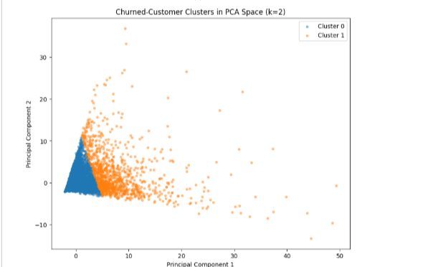
Figure 3. PCA Visualisation of Churned-Customer Clusters

7. Results and Model Comparison
The predictive performance was quite different for the two classification models. Logistic Regression achieved an accuracy of 0.5564, precision of 0.5464, recall of 0.6179, F1-score of 0.5800, and ROC-AUC of 0.5783. The results show that the model achieved only a quite average classification accuracy over random classification. Its precision is low, meaning that a high proportion of customers it predicts that churn would stay, despite the recall of a reasonable proportion of churners. This reduces its value in an operation that requires a retention fee to be high.
Random Forest outperformed significantly in all the performance metrics with accuracy of 0.6160, precision of 0.6007, recall of 0.6714, F1 score of 0.6341 and ROC AUC of 0.6670. This surpasses the results of Logistic Regression by around 5.96 percentage points in terms of accuracy and 5.43 points in terms of precision, which was 5.35 points and 8.87 points higher, respectively. In terms of accuracy, precision, recall, F1-score, and ROC-AUC it is around 5.96 percentage points, 5.43 points, 5.35 points, 5.41 points, and 8.87 points higher than Logistic Regression. Precision-recall curves also indicated that the classification threshold coverage for Random Forest was greater for the larger range of classification thresholds, demonstrating good discrimination strength across the range of classification thresholds.
The thresholds guarded the middle path between recall and precision on threshold analysis – higher thresholds boosted the precision of the endangered group while missing out more churners, and vice versa for lower thresholds. The F1-score had the highest values between the thresholds 0.40-0.45, so it is possible that the default 0.50 threshold is not ideal for retention initiatives. On average, random forest was the model of choice as it better captured nonlinear relationships and interactions than logistic regression. It is not a strong predictor however, therefore it should not be used as a standalone decision-making system, any more than it is a high predictive value, as seen by the ROC-AUC of 0.6670.
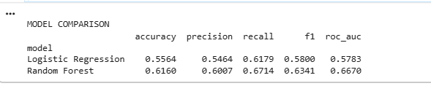
Figure 4: Classification Model Comparison
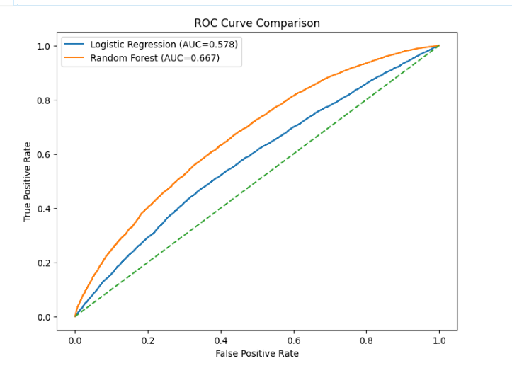
Figure 5. ROC Curve Comparison
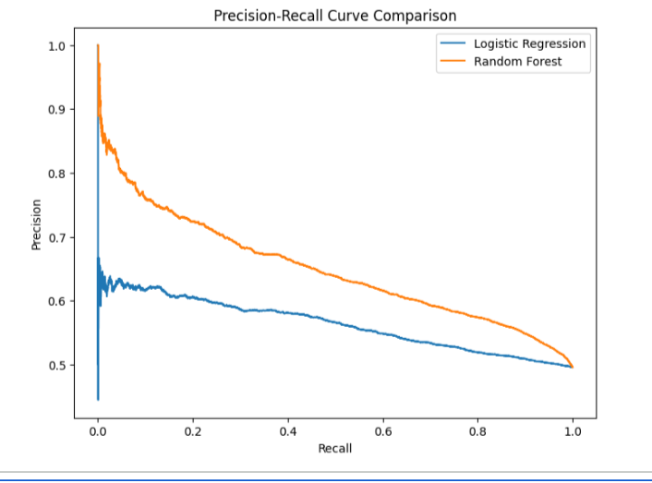
Figure 6. Precision–Recall Curve Comparison
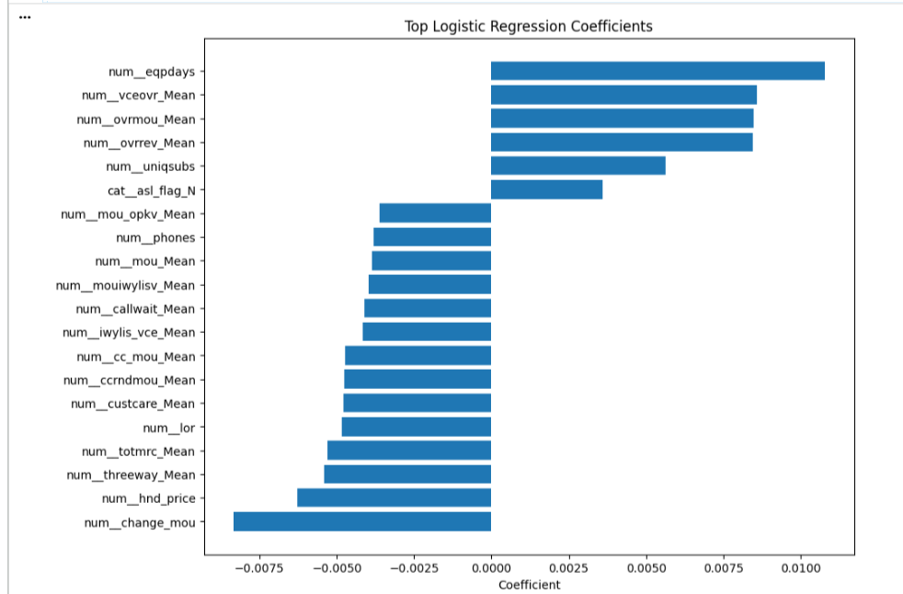
Figure 7. Top Logistic Regression Coefficients
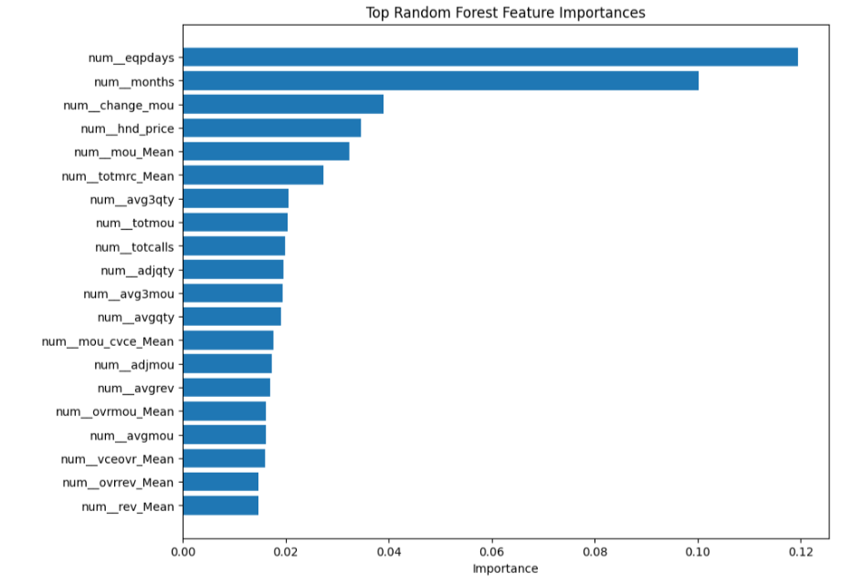
Figure 8. Random Forest Feature Importance

8. Discussion of Findings
It is found that customer tenure, equipment age, telecom usage behavior, recurring charges and recent changes on engagement have nonlinear interactions that affect telecom churn. The ability of the Random Forest algorithm to capture thresholds and interactions not modelled by a linear model was a reason for better performance than Logistic Regression. From the results, it is seen that the variables that have the strongest relationship with churn risk, especially eqpdays, months, change_mou, totmrc_Mean, mou_Mean and hnd_price indicate that the variables are related to the phenomenon of ageing of the device, changing usage patterns, the lifecycle stage of the customer, and the value customers perceive of the services.
The frequency of the occurrence of the event eqpdays suggests that customers with older equipment might get poorer service quality, have less functionality or greater motivation to vary providers. Likewise, declining usage could indicate disengagement prior to churn. The following variables have the potential to aid early-warning retention efforts. The Random Forest ROC-AUC value of 0.6670 shows moderate instead of high level of discrimination. Around one-third of churners may remain unreached, and there might be some ruined customers who will be targeted.
Additionally, the churned classification revealed that there is no homogeneity among churned customers. The two cluster solution proposes behavioural segments for which differentiated intervention(s) can be used. Despite that, results must be interpreted carefully due to the limited generalisability from the constraints of missing data, smaller tuning samples, two-fold cross validations and concept drift. The model's use is most suitable not as a retention system, but rather as a decision support mechanism.

9. Business Recommendations
The telecom would want to focus on customers who were identified highly by the Random Forest model, such as customers with older devices, decreasing usage, high recurring charges, and overage customers. Introduce targeted device-upgrade programme for customers with high eqpdays, based on subsidised handsets, incentives to renew and loyalty discounts to customers to minimize switching motivation. If customers do have significant drop-offs in change_mou, then there should be failures to interventions that trigger earlier interventions, such as personalized offers, service quality check, and proactive customer-care contact.
Retention threshold should be commensurate with the intervention cost. If an email or SMS campaign is not costly, then lower probability thresholds are acceptable, whereas if the campaign is costly, such as offering discounts or subsidizing devices, higher thresholds should be used. In addition, the two discovered churn clusters should also be targeted differently with retention strategy, according to their usage and value/usage/service friction profiles. Lastly, the model needs to be monitored monthly for drift, retrained from time to time and be updated for fairness. Operational decisions that impact sensitive demographic attributes must be handled with caution or avoided unless necessary for functional reasons and appropriately managed ethically.

10. Conclusion
This work proposes a reproducible and scalable classification and clustering pipeline for the task of telecom churn considering 100,000 customers and 98 predictors. The missing values, scaling, categorical encoding, and feature selection were addressed by applying the leakage-safe preprocessing. Random Forest showed highest accuracy of 0.6160, recall 0.6714, F1-score 0.6341 and best ROC-AUC 0.6670 values as compared with Logistic Regression classifier with accuracy 0.5997, recall 0.6157, F1-score 0.6174 and ROC-AUC 0.6097 values. The most significant factors were equipment age, equipment tenure, changes in equipment usage, recurring charges, average equipment usage and handset price. K-means additionally identified two groups of churned-customers of silhouette 0.6331, offering a foundation for tailored retention strategies. They show that there is added value from non-linear modelling – with the discrimination not being serious. Prioritisation, threshold based campaigning, and human judgment, not automatic consequential decisions should be supported by the model. The most defensible strategies are those that involve targeting the user for device renewal, tracking the decreasing usage of a device, retaining users based on cost and utilizing retention offers on a cluster basis. The workflow has, overall, a defensible base for churn management which can be monitored and gradually improved.

11. References
- Asif, D., Arif, M. S., & Mukheimer, A. (2025). A data-driven approach with explainable artificial intelligence for customer churn prediction in the telecommunications industry. Results in Engineering, 104629. https://doi.org/10.1016/j.rineng.2025.104629
- Bhatnagar, A., & Srivastava, S. (2025). Customer churn prediction: A machine learning approach with data balancing for telecom industry. International Journal of Computing, 24(1), 9–18. https://doi.org/10.47839/ijc.24.1.3873
- Imani, M., Joudaki, M., Beikmohammadi, A., & Arabnia, H. R. (2025). Customer churn prediction: A systematic review of recent advances, trends, and challenges in machine learning and deep learning. Machine Learning and Knowledge Extraction, 7(3), 105. https://doi.org/10.3390/make7030105
- Krishna, R., Jayanthi, D., Shylu Sam, D. S., Kavitha, K., Maurya, N. K., & Benil, T. (2024). Application of machine learning techniques for churn prediction in the telecom business. Results in Engineering, 24, 103165. https://doi.org/10.1016/j.rineng.2024.103165
- Lalwani, P., Mishra, M. K., Chadha, J. S., & Sethi, P. (2022). Customer churn prediction system: A machine learning approach. Computing, 104(2), 271–294. https://doi.org/10.1007/s00607-021-00908-y
- Poudel, S. S., Pokharel, S., & Timilsina, M. (2024). Explaining customer churn prediction in telecom industry using tabular machine learning models. Machine Learning with Applications, 17, 100567. https://doi.org/10.1016/j.mlwa.2024.100567
- Prabadevi, B., Shalini, R., & Kavitha, B. R. (2023). Customer churning analysis using machine learning algorithms. International Journal of Intelligent Networks, 4, 145–154. https://doi.org/10.1016/j.ijin.2023.05.005
- Rasool, H. A., Aljawaheri, K. K., & Karram, A. A. M. (2025). Explainable customer churn prediction in telecom using ensemble learning and SHAP analysis. Mathematical Modelling of Engineering Problems, 12(12), 4373–4386. https://doi.org/10.18280/mmep.121226
- Wagh, S. K., Andhale, A. A., Wagh, K. S., Pansare, J. R., Ambadekar, S. P., & Gawande, S. H. (2024). Customer churn prediction in telecom sector using machine learning techniques. Results in Control and Optimization, 14, 100342. https://doi.org/10.1016/j.rico.2023.100342
- Wu, S., Yau, W.-C., Ong, T.-S., & Chong, S.-C. (2021). Integrated churn prediction and customer segmentation framework for telco business. IEEE Access, 9, 62118–62136. https://doi.org/10.1109/ACCESS.2021.3073776

