Introduction to physiology
Ruhela Begum
1714382
BMHP 5003
Giridhar Khatti

Introduction
For the purposes of this study, the researchers wanted to find out what causes primary lung cancer in people and what their habits and perceptions were about it. They also wanted to find out why people get cancer and what kinds of activities and habits they had when they were diagnosed with primary lung cancer. A prospectively planned, national postal questionnaire survey in the United Kingdom with only one patient who had been doubted to be in the main stage of lung cancer and then a lay caregiver of their choosing. For those at higher risk of developing cancer, it is recommended that they have a CT scan conducted once a year to check for malignancies. Lung cancer is more common in elderly people who have smoked for a lengthy period of time and who have not smoked in the last 15 years, according to the American Cancer Society. Imaging tests, cytology, and tissue samples (biopsy) may all be used to aid in the diagnosis and evaluation of this scenario, among other things.

Case study
Jennifer Jason is the patient's given name. Her birthday is September 12th, 1980, and she was born in the year 1980. The patient is 41 years old at the time of the examination. The patient admits to being a nicotine addict and claims to do so on a daily basis. The patient claims to smoke fewer than nine cigarettes a day, according to the doctor. The patient has elevated blood pressure, as shown by a sphygmomanometer reading of 180/100. The patient states she has never had a heart attack, although she has claimed to have suffered from a stroke in the past. The patient's mother had never suffered a heart attack before the age of sixty-five. Another claim made by the patient was that her father did not suffer from any type of heart attack till he was 60 years old. Her height is 170.668 centimeters and her weight is 147.71 pounds, and she has never attempted to quit smoking. The health assessment report was made with the permission of the parties.

Assessment report
Known environmental risk factors for lung cancer include the use of tobacco products such as cigarettes and other tobacco products, as well as exposure to secondhand smoke, working lung carcinogens, irradiation, and indoor and outdoor air quality, among other things. Cigarettes smoking is the major risk factor for lung cancer and also the main cause of the disease death in the world, according to the World Health Organization. The prevalence rate in emerging countries has increased, resulting in the emergence of fresh lung cancer crises in these countries. A family history as well as developed lung illness are types of host variables that can be used as major clinical risk indicators in certain situations. Although risk simulations centered on lung disease risk variables have been created, further refining is required before they can be used to give clinically relevant risk stratification. Although several promising indicators of cancer incidence and early identification have been found, none of them is yet ready for widespread clinical implementation.
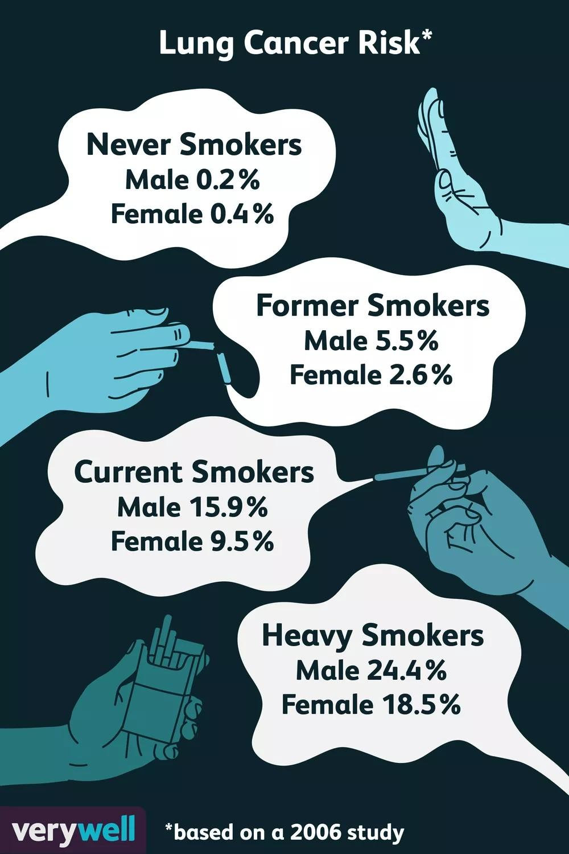
Figure 01: Lung cancer risk according to category
Source :
As a result, cigarette smoking is responsible for nearly all lung cancer fatalities, underlining the importance of continuing tobacco control efforts throughout the world. The reasons for lung cancer differences, the origins of malignancy in nonsmokers, the possible roles of HIV in tumor growth, and the creation of diagnostics are all areas that require further investigation.
Lung cancer has been the largest cause of the disease mortality in the United Kingdom, accounting for over one-third of all cancer deaths. Well over 1.6 million people were diagnosed with lung cancer in 2008, accounting for 13 percent of all cases cancer cases, and 1.4 million lives were lost from lung cancer, accounting for 18 percent among all cancer fatalities.
Smoking, which would include active cigarette smoking, released into the air cigarette smoke or passive smoking, pipe cigarettes, smoking cigars, workers exposed to silicosis, copper, metals, and arsenic; radiation exposure, which including radioactive particles in households and mines; and exposure to both air pollutants have all been distinguished as potential causes of lung cancer. Despite the classification of this constellation with some well causal adverse outcomes, the world disease of lung cancer is principally due to a single attribute: cigarette smoking. Despite the characterization of that kind of super cluster of some well causal risk factors, Smoking continues to be the most popular recreational activity in the world, thanks to clever advertising and promotion by multinational businesses of a highly addictive and lethal product.
Increased knowledge of either the pathogenesis and progression of lung disease continues to be an active research topic. Acknowledging the main causes of socioeconomic and racial disparities, explanation of the role of health factors other than smoking tobacco, for example, diet, physical exercise, a risk of inside and outside toxic elements, biological causes of risk, pharmacogenomics of risk, and early intervention are all possible facts which can be a cause of this.
Only a few studies have indicated that high blood pressure may be connected with an expanded danger, and that the strength of this relationship may differ depending on whether or not the person smokes. The purpose of this study was to examine the relationship between high blood pressure and lung cancer risk in hypertensive patients, as well as the possibility of a relationship between hypertension and nicotine. Lung cancer prevalence rate was defined for 7,908 people who were taken part in the high blood pressure register of the North Karelia Project between 1972 and 1988 by linking their records to the national Finland Cancer Institute. The study was conducted between 1972 and 1988. Lung cancer risk increased by 10 percent for every 10-mmHg increase in blood pressure, according to a Cox regression model. All these diastolic and systolic increased pressure were powerful determinants of lung cancer risk in the study. In smokers, overall maturity level hazard ratio related with a 10-mmHg increase in blood pressure was 1.17 (95 % confidence interval: 1.05, 1.29), whereas in nonsmokers, the excess risk was 0.98 (probability interval: 0.98, 0.98). (95 percent confidence interval: 0.80, 1.16). Cigarette smoking increased the risk of high systolic blood pressure by 11% (95 % confidence interval: 1.05, 1.17) while nonsmoking increased the risk by just 1.04 percent (95 percent confidence interval: 0.95, 1.14) Among this study, the researchers found that the high blood pressure concentrations are connected with an increased risk of heart disease in people who smoke and are hypertensive.
The study of the case shows that Jennifer Jason, the patient who is 41 years old. The patient smokes on a regular basis. Her daily cigarette intake is said to be under 9. The patient has a sphygmomanometer reading of 180/100. The patient states she has never had a heart attack but has had a stroke. The patient's mother had no heart attacks before age 60. The patient claims her father had no heart attacks before the age of 60. Her height is 170.668 cm and her weight is 147.71 lb.
Luckily she does not have any family history of lung cancer or heart issues to be reported but her habit of smoking is a health hazard. Her blood pressure is alarmingly high and it can be lethal anytime and absolutely increases the risk of lung cancer.

Recommendation
The inhalation of cigarette smoke and the use of certain chemicals can significantly raise your chance of developing lung cancer. As per the Center of Disease Control & Prevention, cigarette smoking is the most common Trusted Source of lung cancer, accounting for over 90 percent of all cases (CDC). Inhaling toxic, cancer-causing compounds, often known as carcinogens, causes damage to the cells that coat the lungs' inner lining. Smoking cigarettes, asbestos, and radon are just a few examples of carcinogens to be aware of. It is possible that a person's body will be able to fix itself at initially. Their cells, on the other hand, become more destroyed as a result of repeated exposure. With time, the cells continue to behave erratically and expand uncontrolled, resulting in cell death. This is the process via which cancer may develop.

The following recommendations for changing one's way of life can reduce the likelihood of hepatocellular carcinoma in the following ways:

Getting rid of a cigarette: In the United Kingdom, cigarette smoking is responsible for approximately 80 percent to 90 percent of all lung cancer deaths. The most significant thing a person can do to minimize liver cancer is to avoid starting to smoke, or to smoking if they already do.

Avoiding indirect or passive smoking is important: Passive smoking refers to smoke that has been inhaled from other person's cigarettes, cigars, or pipes. Creating a smoke-free environment in the house and car.

Having the house tested for radon: The Environmental Agency of the United Kingdom external symbol proposes that all dwellings be tested for radon before being built.

Keeping an eye out for any hazards at work: Workplace health and safety regulations can assist employees in eliminating carcinogens, which are toxic and can cause cancer.

Taking certain vitamins and supplements is not recommended: Studies that looked at the possibility of vitamin supplements playing a role in lowering the incidence of lung cancer have come up with disappointing results. It turns out that persons who smoke and take beta carotene supplements really have an increased risk of mortality, according to two big studies. Following the findings of these research, it is recommended that those who smoke refrain from using beta carotene supplements.

Arsenic in water supply is a problem: People living in high-arsenic areas where arsenic levels in their potable are high, have an increased risk of lung cancer, according to research. In the majority of these investigations, the levels of radiation in the water have been many times greater than those generally seen in United States, even in places where arsenic values are higher than normal in the United States. Drinking water is not a significant source of arsenic for the vast majority of Americans who rely on public water systems.

Obtaining a purification system for the air: Lung cancer appears to be slightly increased in the chance of developing in cities due to air pollution (particularly near heavily traveled roadways). However, although this risk is significantly less severe than the danger associated with smoking, some studies believe that smog may be responsible for approximately 5% of all lung cancer deaths globally. An air filtration system may be beneficial in this situation.

E-cigarettes: E-cigarettes are a sort of electronic smoking method that are becoming increasingly popular. Despite the fact that they do neither contain any tobacco, they are classified as "tobacco" products by the Food and Drug Administration (FDA). E-cigarettes are still in their infancy, and even more research is necessary to determine whether they have any long-term consequences, such as an increased chance of getting lung cancer. So avoiding them is necessary.

Talc & washing powder are two types of talc: Talc is a material that, when found in its natural state, may include trace amounts of asbestos. According to some research, talc miners and those who work in talc mills may be at an increased risk of developing the disease and other respiratory ailments as a result of being exposed to commercial grade talc. Many studies, on the other hand, have just not discovered a rise in the rate of lung cancer. So avoiding places with talc is necessary.
Along with all the avoiding, a proper diet and breathing exercise will also result into laws risk of lung cancer.

Conclusion

When it comes to illnesses such as cancer, a relative risk is something that raises a person's likelihood of contracting the disease. Different malignancies are associated with a variety of risk factors. Some risk factors, such as smoking, can be mitigated or eliminated. Others, such as a people's age of family background, are unaffected by their choices. However, simply because one has a vulnerability, or maybe even numerous risk factors, does not imply that you will develop the disease. Furthermore, some persons who contract the condition may have only a few or no identified risk factors for it. There are a number of risk factors that can increase the chances of developing lung cancer and these risk factors are associated with an increased risk of lung cancer in particular.

References

Horn L, Lovly CM (2018). "Chapter 74: Neoplasms of the lung". In Jameson JL, Fauci AS, Kasper DL, Hauser SL, Longo DL, Loscalzo J (eds.). Harrison's Principles of Internal Medicine (20th ed.). McGraw-Hill.

