
Skills for the Workplace
Module Assignment Submission
Student Name: | Charley Louise O’Sullivan
Student Number: | 2008694
Module No: | BMSK4002
Module Title: | Effective Team Working and Communication  Part 2

Statement of Confirmation of Authenticity
By the act of making this submission, the student declares that this is the work of the student named above. The work has not, in whole or in part, been knowingly presented elsewhere for assessment, or where assessment has been built on a previous assessment, this has been identified. Where materials have been used from other sources it has been properly acknowledged. If this statement is untrue, the student acknowledges that an assessment offence has been committed.
Attention is drawn to the plagiarism and unfair practice policies of both the University and of ILM.

Contents
Part 2 Communication 3
1.0 3
2.0 5
Assessing Own Communication Skills 5
References 8
Bibliography 9
Appendix A 10
Schramm Model of Communication 1948 10
10
Lasswell’s Model of Communication 1948 10
Appendix B 15
Interpersonal Skills Self-Assessment Results 15
Your overall score was: 74% 15

Part 2 Communication

1.0

What is Communication? In its simplest form, Communication is the exchanging of information in a method that both parties understand. There are many ways in which people can communicate and for success a clear communication cycle is needed to be adhered to for the intended message to reach the desired target market in its original form.
Many Communication Cycles have been developed and tested throughout the years. As a direct result of this, it is now established that there are three main models of communication: Linear, interactive, and Transactional.
The most documented developments occur in the 1940’s. It is during this period I have researched three theorists who demonstrate their truth-seeking theories and put them to the test. Who are they? What were the findings?
In 1948 both Schramm and Lasswell published a communication model. (See appendix A) Both these theorists had clear similarities within their models but equally there are differences also. Lasswell had approached communication via the use of a liner model. Schramm on the other hand approached his method with the use of an interactive model. Both models explain the communication processed however Lasswell’s approach is simplistic, only focusing on five main questions; the who, said what, through what channel, to who will be receiving and finally what effects. Schramm takes the view of Lasswell and goes deeper illuminating that communication needs to be both equal and reciprocal for success to be achieved. Neither theorist considers other potential affecting factors, and this was not challenged until Shannon and Weaver’s Model was developed.
During 1949 Shannon and Weaver (See Appendix A) took the above processes further and developed a Sixth step, with the introduction of “Noise”. Their linear model identified that interference could corrupt the deliverance of an accurate message. To have a ‘Fair test’ approach into the communication cycle theory I continued investigations and expanded my research to 1960, the Berlo’s SMCR Model OF Communication.
Constructed by David Berlo in 1960, this version takes the Shannon Weaver model a step further again and considers the different things that can affect each of the model’s components – Novak, MC (April 8th, 2019), (Everything you will need to know about communication theories), 20/05/2021. (See Appendix A, C.R.A.A.P). The most illuminating points to consider from the developed model is the consideration of Communication skills, Attitude, knowledge, social systems and cultures of the senders and receivers of the attended message. The model infers that these elements combined with both verbal and non-verbal communications will impact the quality and understanding of any message.
What is Verbal and Non-Verbal Communications? In a summarised overview Verbal communication is the exchanging of information via words. This simplistic method has an advantage of minimal miscommunication and prompts interchange of information.
Nonverbal communication is the transfer of information with the use of body language including eye contact, facial expressions, gestures and more. For example, smiling when you meet someone conveys friendliness, acceptance, and openness – Indeed Editorial Team, (November 25, 2020), (Non-Verbal communication Skills: Definition and Examples), 28/05/2021.
Now that a deep understanding of the origins, methods and developments of communication have been established, I have proceeded to apply these to the methods used within my working environment to determine their effectiveness. First step within the process I took was to identify the most frequent methods of communication in use. I proceeded by recording these in a pie chart (See Appendix A).
The method of ‘Emails’ was the first to be evaluated. The first example is that sent from a line manager reference my “Thrive” teaching lesson with a Nurture group of children who have severe behavioural needs, which sadly results in them being both physically and verbally violent for large proportions of the day, (See Appendix A).
The evaluation methods I am using for this are the “Rating scale method” and the “Checklist Method” (See Appendix A) Both allow the overall effectiveness needed to be reviewed and any flaws to be outlined.
The evaluation process illuminated that Email communication within this instance was 4/5 rating and over 90% successful by the checklist. Why? The method allowed effective feedback to be given, it was clear and outlined the positives, it is a recorded method therefore evidence for the receiver with details of the sender visual. The only downfall is that the email is ended in a format that does not infer opportunity for discussion further (For the purpose to ask if any development points) and furthermore due to be emailed the receiver would not know they have positive feedback until emails are reviewed which could be hours and/or days after the event. However overall, the negatives are small in reflection hence the high evaluation score.
After establishing email as effective it made me question whether there was an example where email is not the best form of communication. A Forbes investigation found that; it is not a terribly effective medium for clarifying complex information. Particularly when an issue is being discussed for the first time, some initial back and forth questions/clarifications are often necessary to get everyone on the same page – Brownlee, D (March 13, 2019), (3 Times when you really should not use email), 26/05/2021.
As a direct result of my research, I investigated further and found communications that reinforced Forbes findings. These findings were highlighted in this week’s “Daily Email” communication at work. The email had to have a clarification section (See Appendix A) as the previous email had caused large numbers of staff to email the head with the same question. Therefore, in this instance the best form of communication here would have been a “Teams Staff Meeting whole school” as this would have allowed for questions to be asked and answered then and there.
The next method of communication within the workforce I ‘Evaluated’ was internal intercom system. These systems are ideal for quick messages, such as asking someone to check their email for an important message. It takes seconds to get in touch with someone while it could take minutes or longer with phones – Carmack, N (August 2 , 2017), (6 Benefits of internal Intercom systems), 29/05/2021. However, working first-hand with these although I can confirm the positive is seen there is also a negative to the system within my education setting. Dependant on the noise level within the classroom depends on whether the message is heard and received by the receiver as intended. Exactly as both Shannon and Weaver and Berol’s models illuminate as an obstacle within communication. Therefore, this method on the Evaluation checklist achieved a rating of 3/5 stars.
As this wealth of knowledge has now been gained through hours of research via different methods, the next step would be to apply this to my own communication skills and understand how I could be interrupted and areas of improvement that I could work on within my personal development.

2.0

Assessing Own Communication Skills

According to Bento C. Leal, (2017 publication, pg. 26-27) “The more exposure we have to uplifting, thought-provoking information and testimonies from others that give us greater understanding and awareness of our own value, talents, and capacities the more we should take them and invest in them, we’ll be the better for it.”
I began the evaluation of my communication through personal research and continued with feedback from others on my deliverance of ‘Achieving effective teamwork’ PowerPoint via Teams. The first steps I took was the completion of ‘Skills you need’ development assessment. (See Appendix B).
Overall, the assessment rated my Interpersonal skills as ‘Above Average’, this was inclusive of Listening skills, Verbal communication and communicating in a group. Whilst this is fantastic result, it illuminated that my emotional Intelligence was Average at 66%. What is emotional intelligence?
Psychologists Peter Salovey and John D. Mayer, two of the leading researchers on the topic, define emotional intelligence as the ability to recognize and understand emotions in oneself and others. This ability also involves using this emotional understanding to make decisions, solve problems, and communicate with others – Cherry, k, (July 2019 published, Updated May 25th, 2020), (Utilizing Emotional Intelligence in the workplace) 28/05/2021.
As a direct result of the findings, I proceeded to create a SWOT. This enabled me to document my strengths Identified but equally my weaknesses and establish where the opportunities and potential threats would be within personal development in communication. (See Appendix B)
The SWOT highlighted that if I were not to develop my emotional intelligence it could lead to missed opportunities to promote further into the field of “ELSA” at work and to obtain a higher role within the deliverance of child psychology. Strengths that illuminated in the table where my skills to communicate in a variety of environments this allows me to tackle with ease situations that could occur without notice for example.
As a direct result of the SWOT, I then produced goals, short, med, and long term to address the working areas but also to continue the strength held in the “Above average” areas also. (See Appendix B) The short-term goal was to set weekly goals to improve my emotional intelligence.
The next logical step is to understand how others observe my communication skills. The process needed to ensure that the data obtained was a true reflection would need to involve several methods of collection.
The first step I took was to have a verbal meeting with the Head of Campus to gain feedback. (See Appendix B for typed notes during the meeting) From this I obtained that she was impressed with the way I can professionally communicate findings to all levels of colleagues, external agencies and then also able to adapt the information and inform students what is needed. Development point that was highlighted was wanting me to start to communicate my skill base and knowledge to my junior co-workers in a documented method, i.e., a recorded meeting. This is something I struggle with as its outside of my ‘Normal’ job profile and further due to low self-esteem. As a direct result I created a SMART Objective to work on to help aid this development area. (See Appendix B).
I then continued evidence gathering for this process with gaining others views on my communication skills. This was via their completed feedback evaluation sheets at the end of the “Achieving effective teamwork” presentation I delivered via Teams.
The last form of evidence to include for conclusion of my abilities is the feedback given from my lecturer and mentor Bob Wilson. (See Appendix B). This is important for two main reasons; Firstly, Bob has years of experience within the field of business management and has taught many students reference communication and achieving the best, therefore his knowledge is that of vital. Secondly, due to the fact Bob has been my Mentor for the academic year I believe that he understands my abilities, creating a ‘True reflection’ of my communication skills for me to analysis and improve on.
I then took the opportunity to collate my opinions of my communication skills and the view of others about this matter. Once they were all analysed, to review them in a useful method, I created a Johari’s Window. (See Appendix B).
The Johari window was important has it illustrated that from an external view I am perceived has having confidence in communication and both my Verbal and Non-Verbal communications reinforce this. According to Gibbons, P (2019, second edition, PP. 154-155) “Projecting confidence is a valued executive attribute.”
However, the Johari Window also highlighted a potential reason as to why my emotional intelligence could be only sitting at Average. Unknown to the ‘Arena’ due to suffering from C-PTSD this can affect how I process both mine and others around me emotions.
The final stage of my journey to assessing my own communication skills is to take all that has been learnt from the SWOT, SMART objectives, Johari Window and create a Personal development Plan, (See Appendix B).
The PDP allows a reflection to occur of what I what to learn after gaining all the valuable feedback when assessing own communication skills. What I must do for the goals to be achieved. Gives ways of measuring success and finally sets deadlines so targets are achieved in a timely manner.
In summary, this assignment has allowed a development of knowledge to occur in many forms within communication. It has allowed me to understand the humble stages that communication processes must go through to be successful. I have learnt the advantages and disadvantages of both verbal and Nonverbal communication. As a direct result of this understanding being illuminated it has resulted in a professional and personal development to occur.
Short term it has installed an element of self-confidence and assurance that as the communicator I can deliver the intended message/s with success, knowing that the message will be received as intended. Long term this will result in clear communication happening professionally as strengths are now highlighted and weakness have been analysed and a plan in place to develop these into a strength also with the aid of a Personal Development Plan.

References

Bento, C. Leal III, (2017), (4 Essential Keys to effective communication), Published in house at Bento.com.
Brownlee, D (March 13, 2019), (3 Times when you really should not use email), 3 Times When You Really Shouldn't Email (forbes.com) 26/05/2021.
Carmack, N (August 2 , 2017), (6 Benefits of internal Intercom systems), 6 Benefits of Internal Intercom Systems - BOS Security 29/05/2021.
Cherry, k, (July 2019 published, Updated May 25th, 2020), (Utilizing Emotional Intelligence in the workplace) Utilizing Emotional Intelligence in the Workplace (verywellmind.com) 28/05/2021.
Communication Theory, (Updated Jan 2021), (OSGOOD- SCHRAMM MODEL OF COMMUNICATION), OSGOOD- SCHRAMM MODEL OF COMMUNICATION (communicationtheory.org) 15/05/2021.
Gibbons, P (2019), (Impact), (2nd edn), Phronesis Media.
Indeed Editorial Team, (November 25, 2020), (Non-Verbal communication Skills: Definition and Examples), Nonverbal Communication Skills: Definition and Examples | Indeed.com, 28/05/2021.
McHarrie, L (August 13th, 2018) (Lasswell’s Model of Communication), Lasswell's model of communication - YouTube 26/05/2021
Novak, MC (April 8th 2019), (Everything you will need to know about communication theories), Everything You Need to Know About Communication Theory (g2.com) 20/05/2021.
Skills You Need (2019) Interpersonal Skills Self-Assessment. [online] Available at: https://www.skillsyouneed.com/ls/index.php/343479 Accessed: 15.05.19

Bibliography

Atstock Productions, (2003, Updated 2021), (Shutterstock Inc), Businesspeople Raising Their Hands Letters Showing Stock Photo (Edit Now) 453632293 (shutterstock.com) 10/05/2021

Blenkinsop, P. (2010) The Communication Cycle. [online] Available at: http://manyana-education.blogspot.com/2010/10/communication-cycle.html Accessed: 15.05.19.
Drucker, P (24th May 2007), The Practice of Management, Routledge.

Industrial Personnel Ltd, (updated Jan 2020), (Industrial Personnel Ltd Recruitment), Teamwork in the workplace - Job Search & Recruitment | Industrial Personnel 03/05/2021

Lumen Learning, (1998 published, updated July 2020), (Lumen), Reflective Learning | Professional Writing and Communication in Healthcare (lumenlearning.com) 12/05/2021.

Michael A. West, (Published 1994), (Effective Teamwork), Second Edition, Blackwell Publishing.

MindTools (2019) How good are your communication skills? [online] Available at: https://www.mindtools.com/pages/article/newCS_99.htm Accessed: 15.05.19.
Shannon, C. and Weaver, W. (1949) The Mathematical Theory of Communication. Urbana: University of Illinois Press.

Appendix A

Schramm Model of Communication 1948

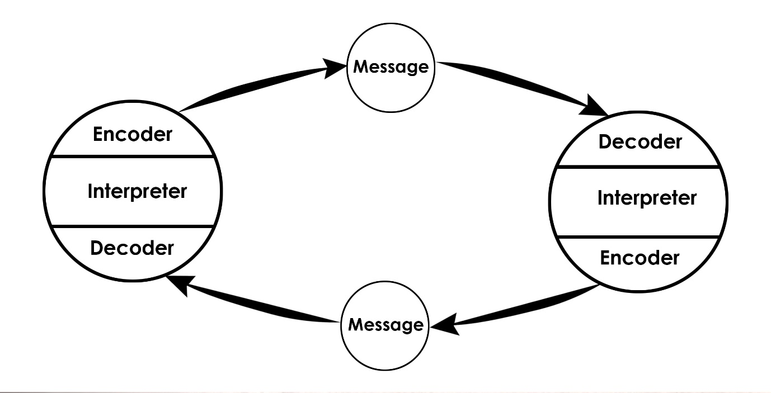

Lasswell’s Model of Communication 1948

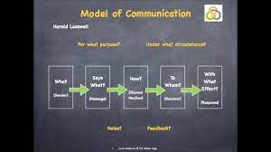

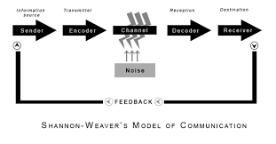



C.R.A.A.P Analysis on Reference Novak Mc.

Currency | First published 8th April 2019
Relevance | Covers communication Theories and illustrations of the models.  Written in a clear, easy to understand language with a professional but semi-formal language making it more attractive to the reader.
Authority | Degree level, including Drs of psychology. Knowledge and research quality evident.
Accuracy | All pages cited within the footer of each page.  Sources within the site are credited academic.
Purpose | Inform the work of Berlo SMCR Model and others within the period.  All information is Factual and based directly on the theory and reinforced by scientific research and data.

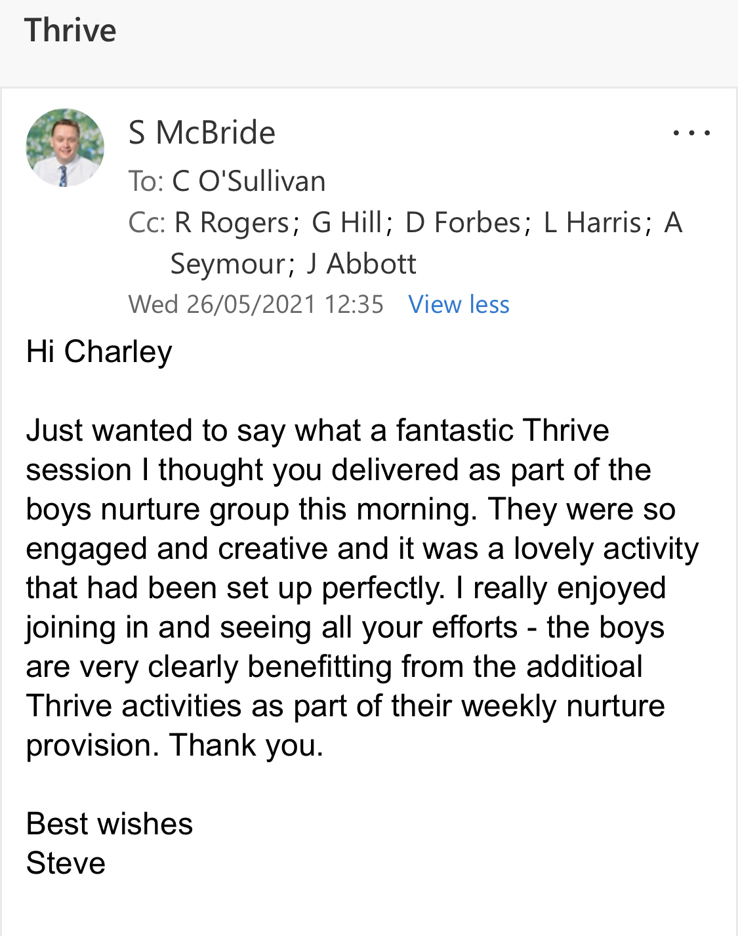

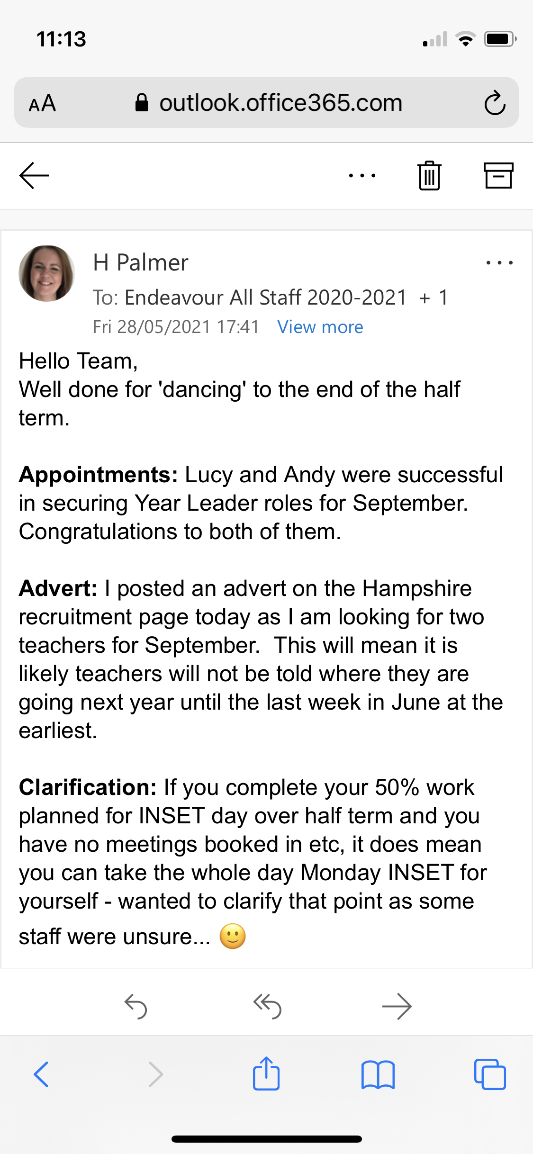

Appendix B

Interpersonal Skills Self-Assessment Results
Hello Charley
Thanks for completing the Skills You Need Interpersonal Skills Self-Assessment.

Your overall score was: 74%
Based on the answers you provided you have above average interpersonal skills. Although your interpersonal skills are good they can always be improved further, helping you to enjoy even more successful relationships with others, at home, socially and at work or school. Continue to practise your interpersonal skills and improve your understanding of yourself and others.
Listening Skills
Your score: 71% (Above Average)
(You rated your listening skills as: Above Average)
Based on the answers you provided your listening skills are classed as good, you are an above average listener. You are more likely to enjoy more meaningful relationships and are less likely to misunderstand what others are communicating – you don’t just hear what is being said, but bring together the verbal and non-verbal signals to gain an accurate interpretation of other people’s views and opinions. You should continue to practise your listening skills and try to avoid picking up any bad listening habits.
See our pages: Listening Skills and Active Listening for more on developing listening skills.
Emotional Intelligence
Your score: 66% (Average)
You achieved an average score for the emotional intelligence part of the assessment. Emotional intelligence is a measure of how well you understand and deal with your emotions and the emotions of others. Developing a better awareness of emotions and understanding why you and others behave in certain ways will enhance your interpersonal skills. It is worth taking some time to understand and improve your emotional intelligence as it could be the most important aspect of personal development. Research has shown that people with higher emotional intelligence enjoy more satisfying and successful careers and relationships.
See our pages: Emotional Intelligence and Counselling Skills for more information.
Verbal Communication
Your score: 84% (Above Average)
(You rated your verbal communication skills as: Above Average)
Your verbal or spoken communication is above average: you normally use appropriate language and know when to talk, and when not to talk. Having good verbal communication means that you can express yourself well to others – explaining your ideas and opinions in such a way that they are usually understood by others. Of course, you can always further improve your verbal communication.
See our pages: Verbal Communication and Effective Speaking for more information.
Communicating in Groups
Your score: 76% (Above Average)
You usually communicate well in a group situation and your skills in this area are above average. You are probably quite a confident person who feels comfortable making appropriate contributions in group settings. Although how you behave in a group situation is linked to your self-esteem, your ability to listen and process information and speak effectively are also important. You may find it useful to watch others the next time you are in a group situation for ideas on how you can improve your communication skills further.

SWOT – Interpersonal Skills
Strengths  - Listening Skills – Able to actively listen to all sides of communication before making decisions.  - Verbal Communication – Method of communicating verbally, am strong at and connote confidence whilst doing so.  - Communicating in Groups:- Overall able to respond well to carrying out this without issues. | Weaknesses  - Emotional Intelligence – If not developed, could lead to misinterpretations to occur. As well as the extent of the emotional importance of the message to be missed.
Opportunities  - Training – Opportunities could present due to good interpersonal skills. Resulting in promotion, career change and/or increase in pay.  - Research – Allows academic growth to occur. Expanding on knowledge. | Threats  - Career Development – Due to a “Average” knowledge of the emotional intelligence needed within communication could result in miss opportunities to expand within the child psychology field.  - Understanding of emotions not met – If not developed emotions to full extent could not be recognised resulting in upset and/or missed communication.

Charley Louise O'Sullivan – Goals
Short Term Goal (Next 12 Months)
- Create weekly focus goals to achieve in recognising Emotions of others during communications both verbal and nonverbal.
- Find a method that helps you to develop your emotional intelligence when talking to another.
- Keep a personal development log to enable reflection to occur.
Medium Term Goal (2-3 years)
- Continue to excel at verbal communications by ensuring a 70% and over percentage of both professional and personal communications happen verbally.
- Apply for further roles within my field where communication including emotional intelligence are critical
Long Term Goal (3-5 Years)
- Help others to develop their communication skills while ensuring mine stay sharp.
- Find new ways of communicating that allow all interpersonal skills to be tested regularly.
Meeting with R. Rogers (Head of King Campus) – 10/05/2021
Feedback requested on Communication Skills observed during Professional Performance.

Overview

Staff
- Good clear communications.
- Straight to the point.
- Not bias in anyway.
- Factual

Children
- Ability to adapt information to make it easier for them to understand and process.
- Able to attune to emotions and help them to understand.
- Patient and calm regardless of the situation.

External Agencies
- Confident and clear in delivering information.
- Facts always to hand and able to stand ground when needed in a professional manner to achieve outcome in the best interest of the child.

Development Point
- Would like as your employer to have you apply the skills, we see to help junior staff (Teaching Assistants/Supervisor Cover/Lego therapy) to be about communicate on site in the same professional manner as you. The method we would like you to deal this in the future when needed would be via Teams Meeting with a Senior team member present also.

S.M.A.R.T Objective
Monday 27th July 2021 by 5pm record an initial video on interpersonal skills and the importance of communication, including a link to the interpersonal skills quiz for junior staff at Endeavour Primary School.

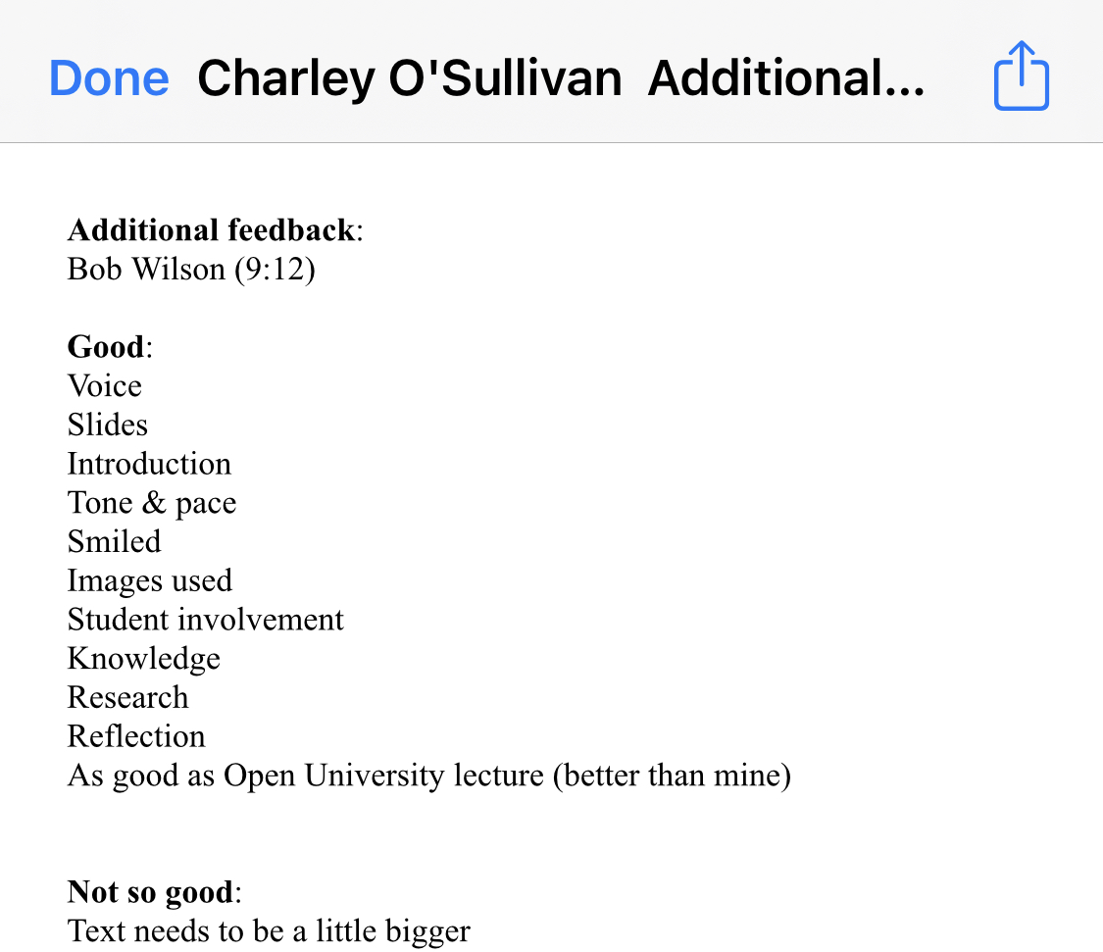

Johari Window – Communication Skills interrupted by self and others.

Arena  - I am qualified as a HLTA.  - I am based at the Endeavour Primary school  - I must communicate as a mediator daily between adults and children.  - I use both Verbal and Non-verbal Communications within my work.  - I communicate clearly | Blind Spot  - I am good at thinking on my feet.  - Tone and Pace when communicating is good.  - Portray as confident when communicate in all forms of communication.
Façade  - I am currently enrolled at University.  - Communicating to others I haven’t had to before or in a different environment to normal causes great anxiety.  - I have C-PTSD. | Unknown  - I will obtain a high-level role within education in behaviour and psychology due to my communication skills.

Personal Development Plan – Communication Skills
What do I want to learn? | What do I have to do? | What support and resources will I need? | How will I measure success? | Target Date for Review
Effective Ways to develop Emotional Intelligence within communication. | Research different methods to hep analysis others body language and tone of voice  Ask for regular feedback from Senior staff. | Peer support.  Weekly reviews. | Constructive Feedback – Negative and Positive.  Retake Interpersonal Skills quiz to see improvement. | 01/07/2021
Continue to develop Verbal Communication skills. | Attend Free webinars.  Ensure regularly Verbal communications for all matters occurs instead of a written form. | Publicise my needs and development goals. | Opportunities that are presented.  Feedback from senior Peers. | 10/09/2021
Continue to develop Non-Verbal Communication Skills. | Attend Lecture on the importance of body language.  Ask for regular feedback. | Family and Friends  Tutor with the course.  Colleagues and Line Mangers. | Completion of course.  Recognition within work performance review.  Feedback given. | 01/09/2023

Charley Louise O'Sullivan – Goals
Short Term Goal (Next 12 Months)
- Research methods and create action plan to aid development of emotional intelligence.
- Continue to have a balance of Verbal and Nonverbal communications within daily tasks to ensure communication skills stay polished.
- Keep a personal development log to enable reflection to occur.
Medium Term Goal (2-3 years)
- Continue to excel at verbal communications by ensuring a 70% and over percentage of both professional and personal communications happen verbally.
- Apply for further roles within my field where communication including emotional intelligence are critical
Long Term Goal (3-5 Years)
- Be able to achieve highest scores on the interpersonal skills quiz due to self-development being a long term focus.
- Find new ways of communicating that allow all interpersonal skills to be tested regularly.

