

LOCATION: Swansea | LLEOLIAD: abertawe
LEVEL 6 | LEFEL 6
EXAMINATION PERIOD | CYFNOD ARHOLIADAU
mAY 2022 | mAI 2022

MODULE CODE: ACMA6007
PLANT & ASSET ENGINEERING

TIME: 2 HOURS

answer THREE out of FOUR QUESTIONS

Equipment or materials required – None
Adnoddau neu ddefnyddiau sydd eu hangen – Dim

A formula sheet is provided for reference.

University approved calculators are permitted.

Assume ‘g’ = 9.81 m/s².

ONE
Ensuring assets are appropriately maintained is a huge task and a very costly. Individual assets frequently require multiple approaches to maintenance.

- With reference to Figures 1, 2 and 3 explain the various types of corrosion taking place and what causes them to happen.
(15 marks)

- Discuss what issues need to be considered when evaluating the ageing of electrical control equipment.
(10 marks)

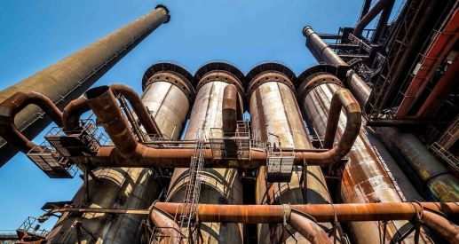

Figure 1

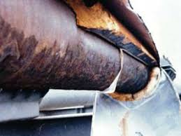
Figure 2

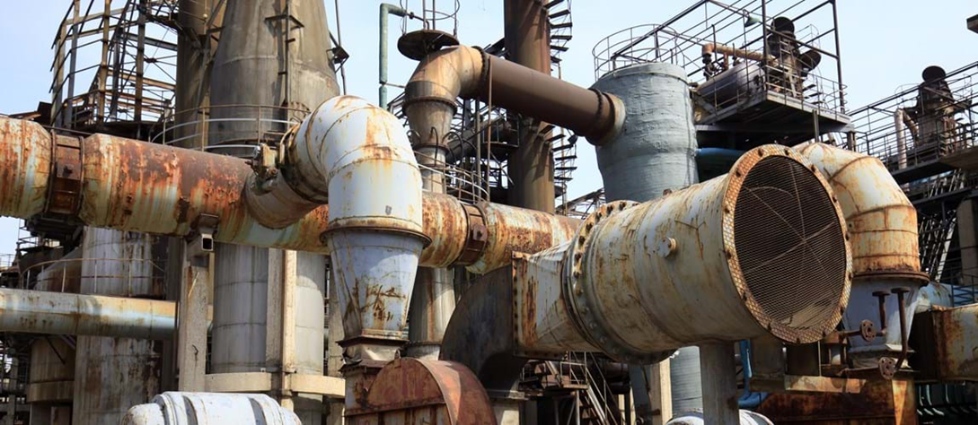

Figure 3
TWO

Energy monitoring and targeting has never been so important with energy costs at the highest levels ever.

- Evaluate what components must be in place to be able to implement an energy monitoring and targeting programme.
(13 marks)

- Explain what an energy audit is and how it can be used to help manage energy usage.

(12 marks)

THREE

Shell and tube heat exchangers are typically employed in oil refining and petrochemical industries to name but two. A significant issue affecting the operational performance of this plant is fouling.

- Consider the ‘shellside’ of a shell and tube heat exchanger which is fitted with conventional segmented baffle geometry. Suggest reasons why this design typically leads to higher fouling rates and also reasons for the consequential increased operating costs.

(5 marks)

- State four mechanisms that are considered significant factors in the development of fouling.

(2 marks)

- A design improvement on the conventional segmented baffle geometry for a shell and tube heat exchanger is one that employs helical baffles. How does the inclusion of helical baffles affect the shellside flow characteristics that are found to improve operational performance of this plant?
(4 marks)

- Oil is used to heat water from 15 °C to 60 °C using a simple single shell, two tube pass shell-and-tube heat exchanger. The hot oil flows through the shell at a rate of 0.95 kg/s, entering at a temperature of 165 °C and leaving at 135 °C. The shell and tube heat exchanger can be considered as operating in a counterflow configuration.

- Draw a simple schematic of this heat exchanger configuration, showing the relevant hot and cold stream inlet and outlet conditions as given.

(3 marks)
(ii) Determine the heat transfer rate (in kW).
(3 marks)
(iii) Determine the water flow rate (in kg/s) required to achieve a water exit temperature of 60 °C.
(3 marks)
(iv) Determine the required heat transfer area (in m²) of the heat exchanger.
(5 marks)

FOUR
- Other than the possibility of a single-phase AC motor having brushes making it similar in design to DC motor, what other similarity exists between these motors, and hence what is the main difference with that of a 3-phase AC motor?
(2 marks)

- Electronic AC drives are now prevalent in industrial applications. Briefly describe the fundamental operation of an electronic AC drive, and also the prime advantage of this drive as compared to an electronic DC drive.
(4 marks)
- Flexible mechanical power transmission has been achieved for many years by means of flat belt drive systems before the improved design of V-belts and associated pulleys. What mechanical property is relied upon in power transmission using belts and pulleys, and what inherent disadvantage do they suffer from? Give two examples of other flexible mechanical power transmission systems that overcome the disadvantage referred to above.
(4 marks)
- Positive mechanical power transmission is typically achieved by means of gear drive systems. Describe the relative differences of spur gears and helical spur gears, providing advantages and disadvantages of both designs and examples of industrial applications. Also, what critical aspect of the addendum and dedendum dimensions of two meshing gears must be observed?
(7 marks)
(e) (i) A compound gear train is shown in the following diagram, where gears B and D are attached to the same shaft. Given that the speed of gear A is 100 rpm, determine the speed of output gear C.
(3 marks)
(ii) Determine the overall gear ratio for the gear train shown.
(2 marks)
- If a further gear wheel (E) was to be added to the same shaft as gear C having 40 teeth, and this gear wheel was to mesh with an extra final output gear F, if gear F was to rotate at the same speed as gear A, how many teeth would gear F require?
(3 marks)
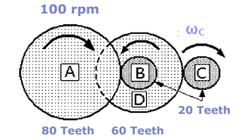
FORMULA SHEET

Steady Flow Energy Equation (SFEE):
Turbines & Compressors: $W=\dot{m}\left(h_{1}-h_{2}\right)$ = $\dot{m}c_{p}\left(T_{1}-T_{2}\right)$

Thermodynamic Processes:
Isentropic compression: $\frac{T_{2'}}{T_{1}}= {\left(\frac{p_{2}}{p_{1}}\right)}^{\frac{γ-1}{γ}}$

Isentropic efficiency: $η= \frac{T_{2'}-T_{1}}{T_{2}-T_{1}}$

Steam Power plant:
Dryness fraction of steam: $s_{x}= s_{f}+xs_{fg}$ and, $h_{x}= h_{f}+xh_{fg}$

Rankine efficiency: $η_{R}= \frac{h_{3} - h_{4}}{h_{3} - h_{1}}$

Heat Exchangers:
Rate of heat Transfer: $\dot{Q}= \dot{m}c_{p}∆T$ and, $\dot{Q}=UAF∆T_{LM}$

Log Mean Temp Diff: $∆T_{LM}= \frac{∆ T_{o}- ∆ T_{i}}{ln\left(\frac{∆ T_{o}}{ ∆ T_{i}}\right)}$
Parallel flow LMTD: $∆ T_{i}= T_{H,in}-T_{C,in}$ & $∆ T_{o }= T_{H,out}-T_{C,out}$
Counter flow LMTD: $∆ T_{i}= T_{H,in}- T_{C,out}$ & $∆ T_{o }= T_{H,out}- T_{C,in}$

Gear Drive Systems:
Gear ratio: $G= \frac{ω_{A}}{ω_{B}}= \frac{t_{B}}{t_{A}}= \frac{d_{B}}{d_{A}}$
Diwedd / End

