


Advanced Cyber Security (ACS)

Lab –

Faculty of Architecture, Computing & Engineering
School of Applied Computing
Mount Pleasant Campus
Swansea
SA1 6ED

Identify Running Processes
Objectives
In this lab, you will use TCP/UDP Endpoint Viewer, a tool in Sysinternals Suite, to identify any running processes on your computer.
Background / Scenario
In this lab, you will explore processes. Processes are programs or applications in execution. You will explore the processes using Process Explorer in the Windows Sysinternals Suite. You will also start and observe a new process.
Required Resources
- 1 Windows PC with Internet access
    - Download Windows Sysinternals Suite.
      - Navigate to the following link to download Windows Sysinternals Suite:
https://technet.microsoft.com/en-us/sysinternals/bb842062.aspx
      - After the download is completed, right+click the zip file, and choose Extract All…, to extract the files from the folder. Choose the default name and destination in the Downloads folder and click Extract.
      - Exit the web browser.
    - Start TCP/UDP Endpoint Viewer.
      - Navigate to the SysinternalsSuite folder with all the extracted files.
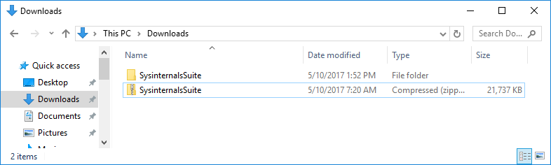
      - Open Tcpview.exe. Accept the Process Explorer License Agreement when prompted. Click Yes to allow this app to make changes to your device.
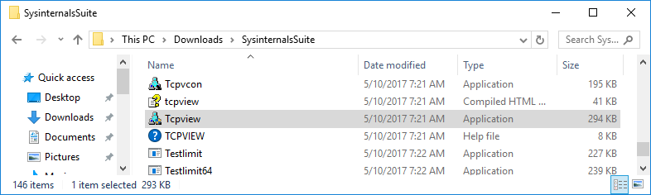
      - Exit the File Explorer and close all the currently running applications.
    - Explore the running processes.
      - TCPView lists the process that are currently on your Windows PC. At this time, only Windows processes are running.
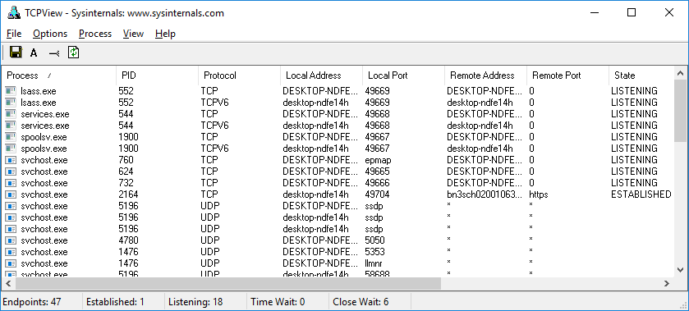
      - Double-click lsass.exe.
What is lsass.exe? In what folder is it located?
____________________________________________________________________________________
____________________________________________________________________________________
      - Close the properties window for lsass.exe when done.
      - View the properties for the other running processes.
Note: Not all processes can be queried for properties information.
    - Explore a user-started process.
      - Open a web browser, such as Microsoft Edge.
What did you observe in the TCPView window?
____________________________________________________________________________________
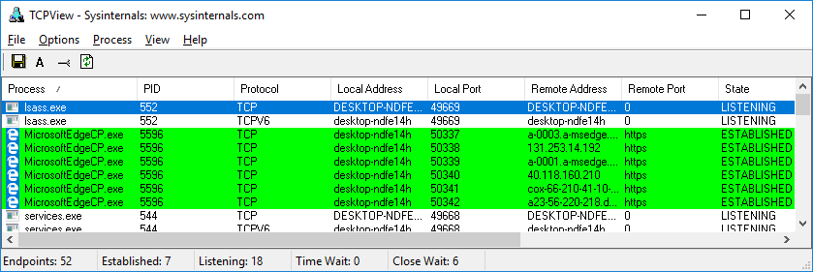
      - Close the web browser.
What did you observe in the TCPView window?
____________________________________________________________________________________
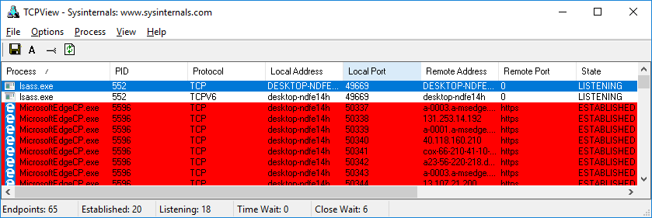
      - Reopen the web browser. Research some of the processes listed in TCPView. Record your findings.
____________________________________________________________________________________
____________________________________________________________________________________
____________________________________________________________________________________
____________________________________________________________________________________

Lab – Exploring Processes, Threads, Handles, and Windows Registry
Objectives
In this lab, you will explore the processes, threads, and handles using Process Explorer in the SysInternals Suite. You will also use the Windows Registry to change a setting.
Part 1: Exploring Processes
Part 2: Exploring Threads and Handles
Part 3: Exploring Windows Registry
Required Resources
- 1 Windows PC with Internet access
- Exploring Processes
In this part, you will explore processes. Processes are programs or applications in execution. You will explore the processes using Process Explorer in the Windows SysInternals Suite. You will also start and observe a new process.
    - Download Windows SysInternals Suite.
      - Navigate to the following link to download Windows SysInternals Suite:
https://technet.microsoft.com/en-us/sysinternals/bb842062.aspx
      - After the download is completed, extract the files from the folder.
      - Leave the web browser open for the following steps.
    - Explore an active process.
      - Navigate to the SysinternalsSuite folder with all the extracted files.
      - Open procexp.exe. Accept the Process Explorer License Agreement when prompted.
      - The Process Explorer displays a list of currently active processes.
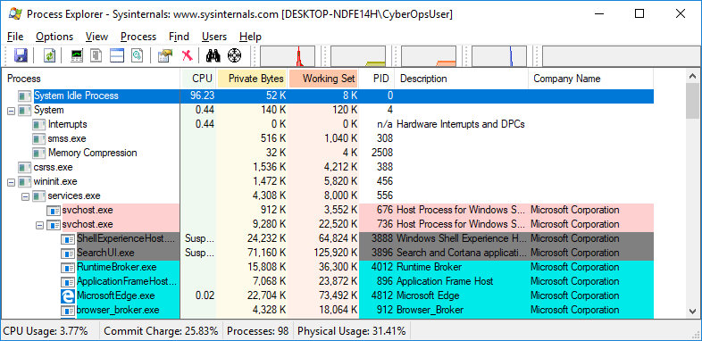
      - To locate the web browser process, drag the Find Window's Process icon () into the opened web browser window. Microsoft Edge was used in this example.
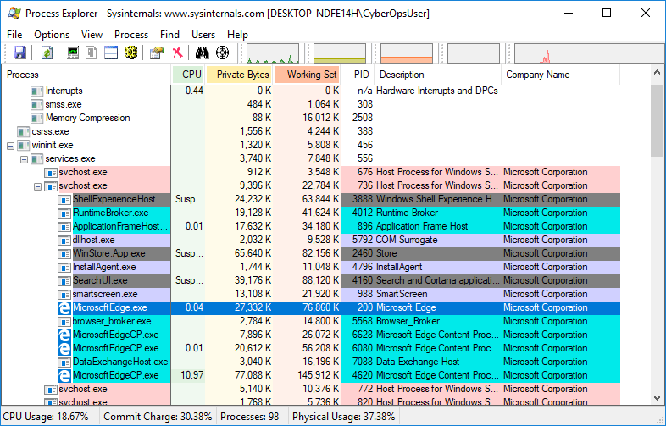
      - The Microsoft Edge process can be terminated in the Process Explorer. Right-click the selected process and select Kill Process.
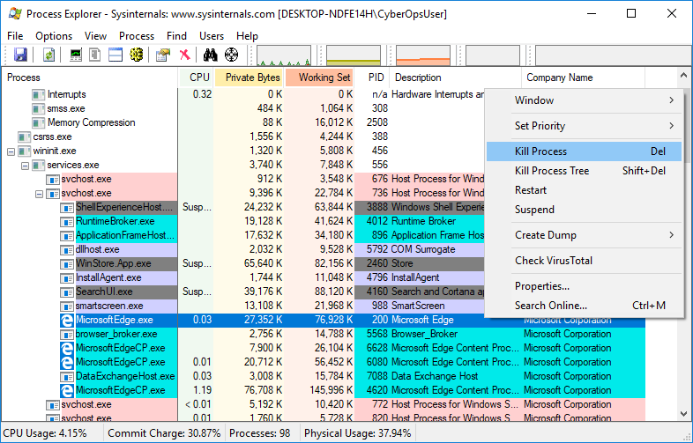
What happened to the web browser window when the process is killed?
____________________________________________________________________________________
    - Start another process.
      - Open a Command Prompt. (Start > search Command Prompt > select Command Prompt)
      - Drag the Find Window's Process icon () into the Command Prompt window and locate the highlighted Command Prompt process in Process Explorer.
      - The process for the Command Prompt is cmd.exe. Its parent process is explorer.exe process. The cmd.exe has a child process, conhost.exe.
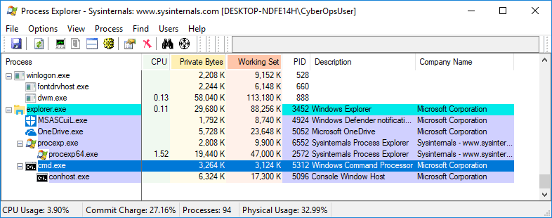
      - Navigate to the Command Prompt window. Start a ping at the prompt and observe the changes under the cmd.exe process.
What happened during the ping process?
____________________________________________________________________________________
      - As you review the list of active processes, you find that the child process conhost.exe may be suspicious. To check for malicious content, right-click conhost.exe and select Check VirusTotal. When prompted, click Yes to agree to VirusTotal Terms of Service. Then click OK for the next prompt.
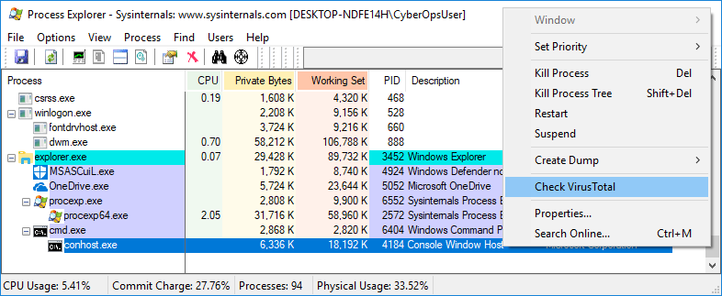
      - Expand the Process Explorer window or scroll to the right until you see the VirusTotal column. Click the link under the VirusTotal column. The default web browser opens with the results regarding the malicious content of conhost.exe.
      - Right-click the cmd.exe process and select Kill Process. What happened to the child process conhost.exe?
____________________________________________________________________________________
- Exploring Threads and Handles
In this part, you will explore threads and handles. Processes have one or more threads. A thread is a unit of execution in a process. A handle is an abstract reference to memory blocks or objects managed by an operating system. You will use Process Explorer (procexp.exe) in Windows SysInternals Suite to explore the threads and handles.
    - Explore threads.
      - Open a command prompt.
      - In Process Explorer window, right-click conhost.exe and Select Properties….. Click the Threads tab to view the active threads for the conhost.exe process.
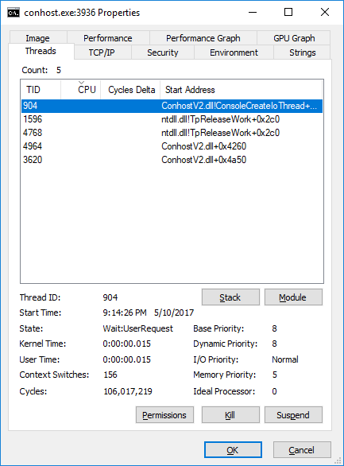
      - Examine the details of the thread. What type of information is available in the Properties window?
____________________________________________________________________________________
____________________________________________________________________________________
    - Explore handles.
In the Process Explorer, click View > select Show Lower Pane > Handles to view the handles associated with the conhost.exe process.
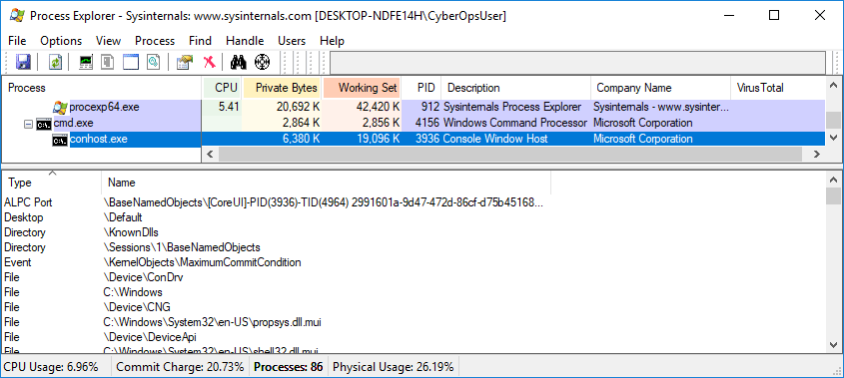
Examine the handles. What are the handles pointing to?
_______________________________________________________________________________________
- Exploring Windows Registry
The Windows Registry is a hierarchical database that stores most of the operating systems and desktop environment configuration settings. In this part, you will
      - To access the Windows Registry, click Start > Search for regedit and select Registry Editor. Click Yes when asked to allow this app to make changes.
The Registry Editor has five hives. These hives are at the top level of the registry.
- HKEY_CLASSES_ROOT is actually the Classes subkey of HKEY_LOCAL_MACHINE\Software\. It stores information used by registered applications like file extension association, as well as a programmatic identifier (ProgID), Class ID (CLSID), and Interface ID (IID) data.
- HKEY_CURRENT_USER contains the settings and configurations for the users who are currently logged in.
- HKEY_LOCAL_MACHINE stores configuration information specific to the local computer.
- HKEY_USERS contains the settings and configurations for all the users on the local computer. HKEY_CURRENT_USER is a subkey of HKEY_USERS.
- HKEY_CURRENT_CONFIG stores the hardware information that is used at bootup by the local computer.
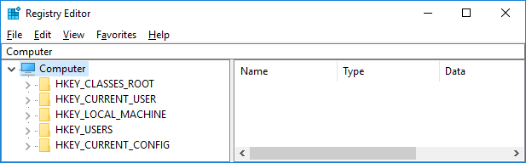
      - In a previous step, you had accepted the EULA for Process Explorer. Navigate to the EulaAccepted registry key for Process Explorer.
Click to select Process Explorer in HKEY_CURRENT_USER > Software > Sysinternals > Process Explorer. Scroll down to locate the key EulaAccepted. Currently, the value for the registry key EulaAccepted is 0x00000001(1).
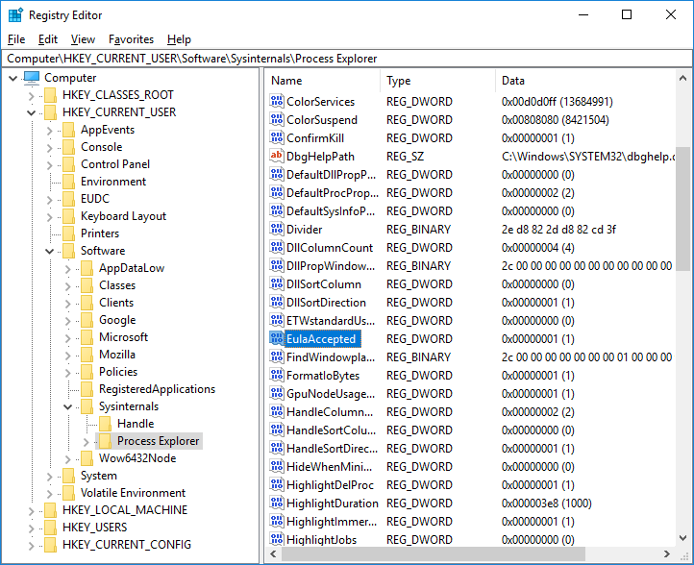
      - Double-click EulaAccepted registry key. Currently the value data is set to 1. The value of 1 indicates that the EULA has been accepted by the user.
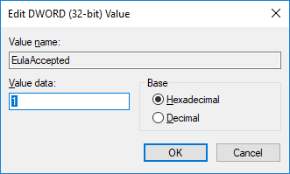
      - Change the 1 to 0 for Value data. The value of 0 indicates that the EULA was not accepted. Click OK to continue.
What is value for this registry key in the Data column?
____________________________________________________________________________________
      - Open the Process Explorer. Navigate to the folder where you have downloaded SysInternals. Open the folder SysInternalsSuite > Open procexp.exe.
When you open the Process Explorer, what did you see?
____________________________________________________________________________________

Lab - Create User Accounts

Introduction
In this lab, you will create and modify user accounts in Windows.
Part 1: Creating a New Local User Account
Part 2: Reviewing User Account Properties
Part 3: Modifying Local User Accounts

Required Resources
- A Windows PC
- Creating a New Local User Account
  - Open the User Account Tool.
    - Log on to the computer with an Administrator account. The account CyberOpsUser is used in this example.
    - Click Start > search Control Panel. Select User Accounts in the Small icons view. To change the view, select Small icons in the View by drop down list.
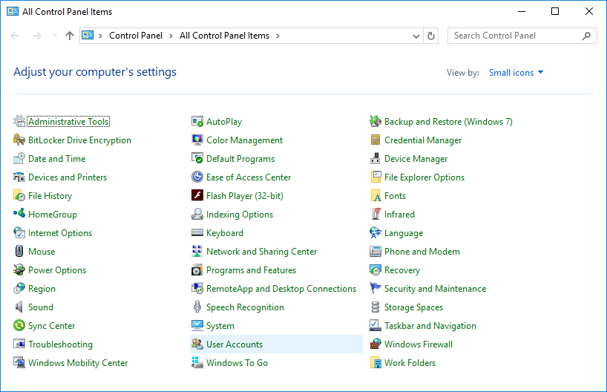
  - Create a user account.
    - The User Accounts window opens. Click Manage another account.
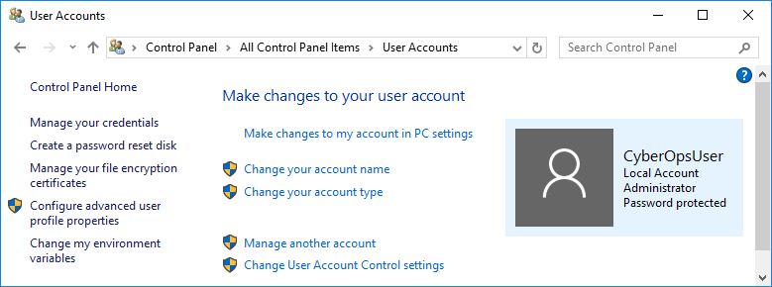
    - The Manage Accounts window opens. Click Add a new user in PC settings.
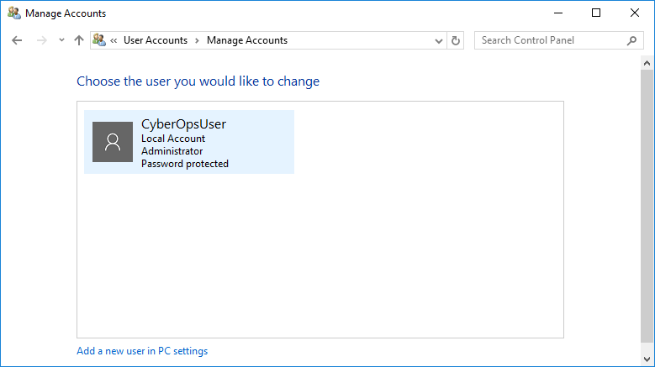
    - The Settings window opens. Click Add someone else to this PC.
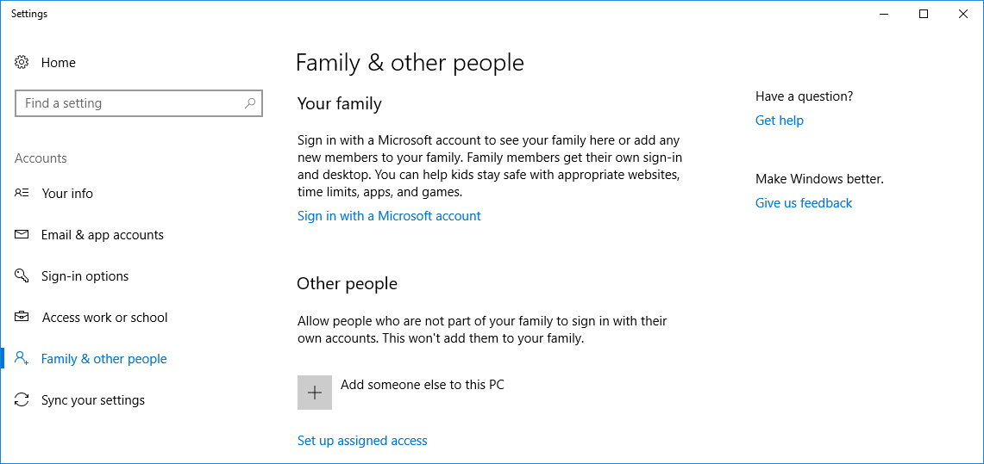
    - The How will this person sign in? window opens. Click I don't have this person's sign-in information.
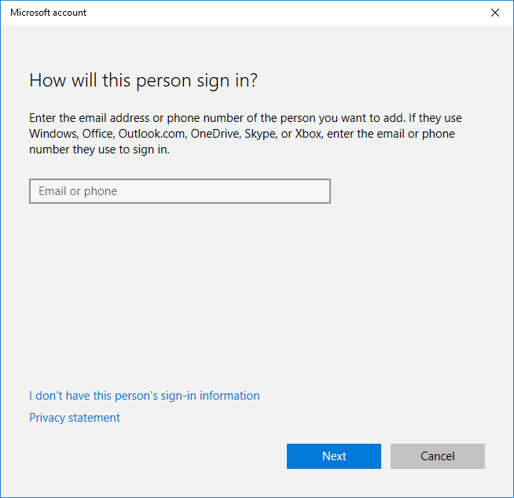
    - The Let's create your account window opens. Click Add a user without a Microsoft account.
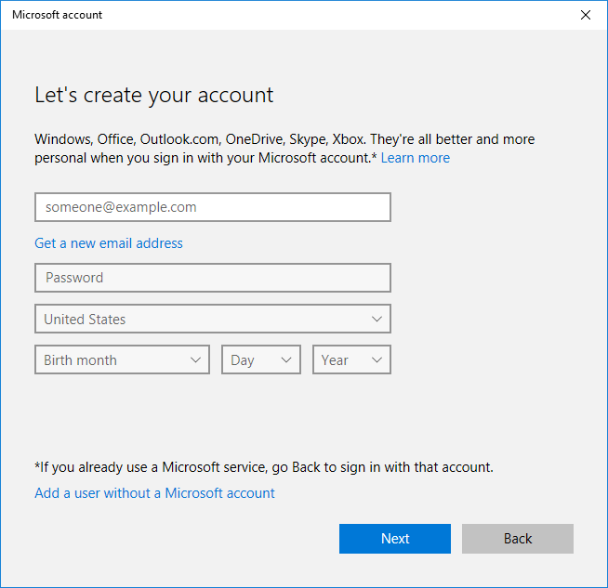
    - The Create an account for this PC window opens. Provide the necessary information to create the new user account named User1. Click Next to create the new user account.
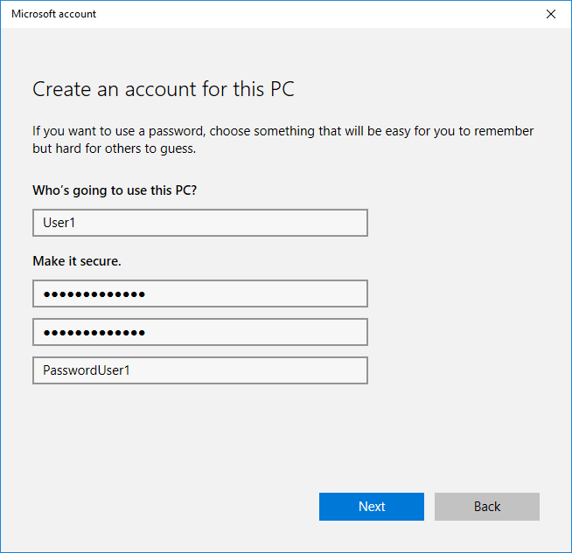
    - What type of user account did you just create?
____________________________________________________________________________________
    - Log into the newly created user account. It should be successful.
    - Navigate to C:\Users folder. Right-click the User1 folder and select Properties, and then the Security tab. Which groups or users have full control of this folder?
____________________________________________________________________________________
    - Open the folder that belongs to CyberOpsUser. Right-click the folder and click the Properties tab. Were you able to access the folder? Explain.
____________________________________________________________________________________
____________________________________________________________________________________
    - Log out of User1 account. Log back in as CyberOpsUser.
    - Navigate to C:\Users folder. Right-click the folder and select Properties. Click the Security tab. Which groups or users have full control of this folder?
____________________________________________________________________________________
- Reviewing User Account Properties
    - Click Start > Search for Control Panel > Select Administrative Tools > Select Computer Management.
    - Select Local Users and Groups. Click the Users folder.
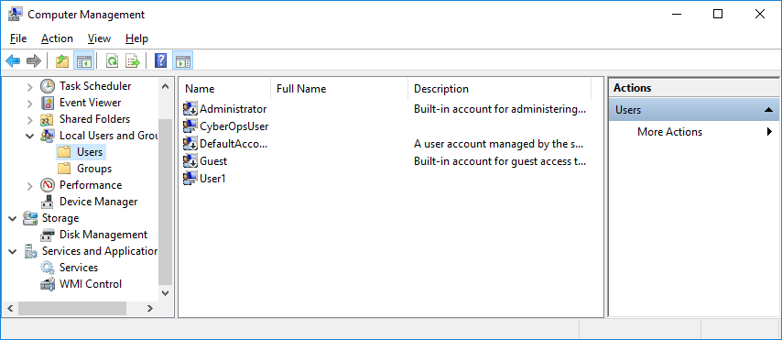
    - Right-click User1 and select Properties.
    - Click the Member Of tab.
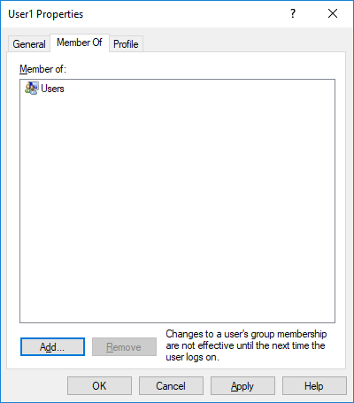
Which group is User1 is a member of? ________________________________
    - Right-click the account CyberOpsUser and select Properties.
Which group is this user a member of? ________________________________
- Modifying Local User Accounts
  - Change the account type.
    - Navigate to the Control Panel and select User Accounts. Click Manage another account. Select User1.
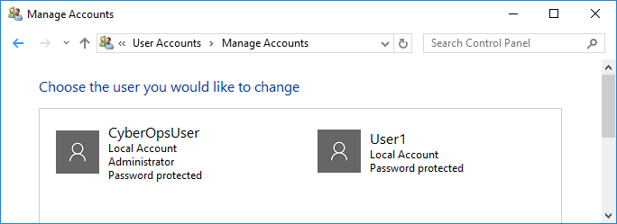
    - In the Change an Account window, click the User1 account. Click Change the account type.
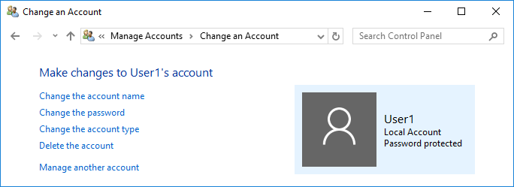
    - Select the Administrator radio button. Click Change Account Type.
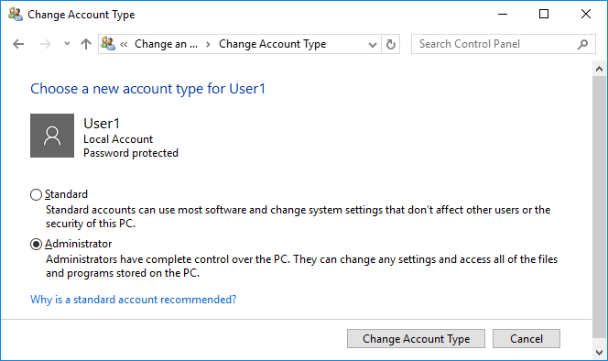
    - Now the account User1 has administrative rights.
    - Navigate to Control Panel > Administrative Tools > Computer Management. Click Local Users and Groups> Users.
    - Right-click User1 and select Properties. Click Member Of tab.
Which groups does User1 belong to?
____________________________________________________________________________________
    - Select Administrators and click Remove to remove User1 from the Administrative group. Click OK to continue.
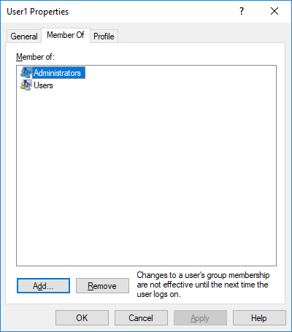
  - Delete the account.
    - To delete the account, right-click User1and select Delete.
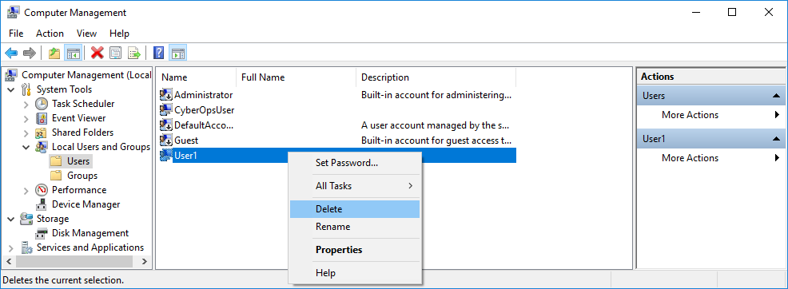
    - Click OK to confirm the deletion. What is another way to delete a user account?
____________________________________________________________________________________

Reflection
  - Why is it important to protect all accounts with strong passwords?
_______________________________________________________________________________________
_______________________________________________________________________________________
  - Why would you create a user with Standard privileges?
_______________________________________________________________________________________
_______________________________________________________________________________________
_______________________________________________________________________________________

Lab – Using Windows PowerShell

Objectives
The objective of the lab is to explore some of the functions of PowerShell.

Background / Scenario
PowerShell is a powerful automation tool. It is both a command console and a scripting language. In this lab, you will use the console to execute some of the commands that are available in both the command prompt and PowerShell. PowerShell also has functions that can create scripts to automate tasks and work together with the Windows Operating System.

Required Resources
- 1 Windows PC with PowerShell installed and Internet access
    - Access PowerShell console.
      - Click Start. Search and select powershell.
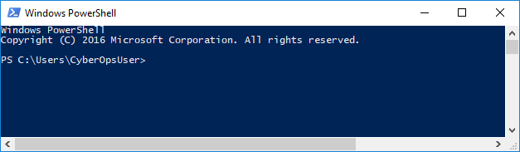
      - Click Start. Search and select command prompt.
    - Explore Command Prompt and PowerShell commands.
      - Enter dir at the prompt in both windows.
What are the outputs to the dir command?
____________________________________________________________________________________
____________________________________________________________________________________
      - Try another command that you have used in the command prompt, such as ping, cd, and ipconfig. What are the results?
____________________________________________________________________________________
    - Explore cmdlets.
      - PowerShell commands, cmdlets, are constructed in the form of verb-noun string. To identify the PowerShell command to list the subdirectories and files in a directory, enter Get-Alias dir at the PowerShell prompt.
PS C:\Users\CyberOpsUser> Get-Alias dir

CommandType Name Version Source
----------- ---- ------- ------
Alias dir -> Get-ChildItem
What is the PowerShell command for dir? ______________________________________
      - For more detailed information about cmdlets, navigate to https://technet.microsoft.com/en-us/library/ee332526.aspx.
      - Close the Command Prompt window when done.
    - Explore the netstat command using PowerShell.
      - At the PowerShell prompt, enter netstat -h to see the options available for the netstat command.
PS C:\Users\CyberOpsUser> netstat -h

Displays protocol statistics and current TCP/IP network connections.

NETSTAT [-a] [-b] [-e] [-f] [-n] [-o] [-p proto] [-r] [-s] [-x] [-t] [interval]

-a Displays all connections and listening ports.
-b Displays the executable involved in creating each connection or
listening port. In some cases well-known executables host
multiple independent components, and in these cases the
sequence of components involved in creating the connection
or listening port is displayed. In this case the executable
name is in [] at the bottom, on top is the component it called,
and so forth until TCP/IP was reached. Note that this option
can be time-consuming and will fail unless you have sufficient
permissions.
<some output omitted>
      - To display the routing table with the active routes, enter netstat -r at the prompt.
PS C:\Users\CyberOpsUser> netstat -r
===========================================================================
Interface List
3...08 00 27 a0 c3 53 ......Intel(R) PRO/1000 MT Desktop Adapter
10...08 00 27 26 c1 78 ......Intel(R) PRO/1000 MT Desktop Adapter #2
1...........................Software Loopback Interface 1
===========================================================================

IPv4 Route Table
===========================================================================
Active Routes:
Network Destination Netmask Gateway Interface Metric
0.0.0.0 0.0.0.0 192.168.1.1 192.168.1.5 25
127.0.0.0 255.0.0.0 On-link 127.0.0.1 331
127.0.0.1 255.255.255.255 On-link 127.0.0.1 331
127.255.255.255 255.255.255.255 On-link 127.0.0.1 331
169.254.0.0 255.255.0.0 On-link 169.254.181.151 281
169.254.181.151 255.255.255.255 On-link 169.254.181.151 281
169.254.255.255 255.255.255.255 On-link 169.254.181.151 281
192.168.1.0 255.255.255.0 On-link 192.168.1.5 281
192.168.1.5 255.255.255.255 On-link 192.168.1.5 281
192.168.1.255 255.255.255.255 On-link 192.168.1.5 281
224.0.0.0 240.0.0.0 On-link 127.0.0.1 331
224.0.0.0 240.0.0.0 On-link 192.168.1.5 281
224.0.0.0 240.0.0.0 On-link 169.254.181.151 281
255.255.255.255 255.255.255.255 On-link 127.0.0.1 331
255.255.255.255 255.255.255.255 On-link 192.168.1.5 281
255.255.255.255 255.255.255.255 On-link 169.254.181.151 281
===========================================================================
Persistent Routes:
None

IPv6 Route Table
===========================================================================
Active Routes:
If Metric Network Destination Gateway
1 331 ::1/128 On-link
3 281 fe80::/64 On-link
10 281 fe80::/64 On-link
10 281 fe80::408b:14a4:7b64:b597/128
On-link
3 281 fe80::dd67:9e98:9ce0:51e/128
On-link
1 331 ff00::/8 On-link
3 281 ff00::/8 On-link
10 281 ff00::/8 On-link
===========================================================================
Persistent Routes:
None
What is the IPv4 gateway?
____________________________________________________________________________________
      - Open and run a second PowerShell with elevated privileges. Click Start. Search for PowerShell and right-click Windows PowerShell and select Run as administrator. Click Yes to allow this app to make changes to your device.
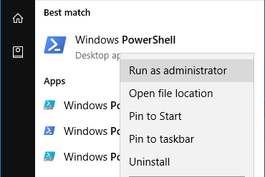
      - The netstat command can also display the processes associated with the active TCP connections. Enter the netstat -abno at the prompt.
PS C:\Windows\system32> netstat -abno

Active Connections

Proto Local Address Foreign Address State PID
TCP 0.0.0.0:135 0.0.0.0:0 LISTENING 756
RpcSs
[svchost.exe]
TCP 0.0.0.0:445 0.0.0.0:0 LISTENING 4
Can not obtain ownership information
TCP 0.0.0.0:49664 0.0.0.0:0 LISTENING 444
Can not obtain ownership information
TCP 0.0.0.0:49665 0.0.0.0:0 LISTENING 440
Schedule
[svchost.exe]
TCP 0.0.0.0:49666 0.0.0.0:0 LISTENING 304
EventLog
[svchost.exe]
TCP 0.0.0.0:49667 0.0.0.0:0 LISTENING 1856
[spoolsv.exe]
TCP 0.0.0.0:49668 0.0.0.0:0 LISTENING 544
<some output omitted>
      - Open the Task Manager. Navigate to the Details tab. Click the PID heading so the PID are in order.
      - Select one of the PIDs from the results of netstat -abno. PID 756 is used in this example.
      - Locate the selected PID in the Task Manager. Right-click the selected PID in the Task Manager to open the Properties dialog box for more information.
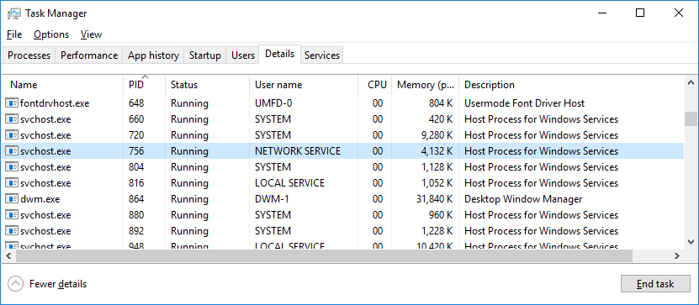
What information can you get from the Details tab and the Properties dialog box for your selected PID?
____________________________________________________________________________________
____________________________________________________________________________________
____________________________________________________________________________________
    - Empty recycle bin using PowerShell.
PowerShell commands can simplify management of a large computer network. For example, if you wanted to implement a new security solution on all servers in the network you could use a PowerShell command or script to implement and verify that the services are running. You can also run PowerShell commands to simplify actions that would take multiple steps to execute using Windows graphical desktop tools.
      - Open the Recycle Bin. Verify that there are items that can be deleted permanently from your PC. If not, restore those files.
      - If there are no files in the Recycle Bin, create a few files, such as text file using Notepad, and place them into the Recycle Bin.
      - In a PowerShell console, enter clear-recyclebin at the prompt.
PS C:\Users\CyberOpsUser> clear-recyclebin

Confirm
Are you sure you want to perform this action?
Performing the operation "Clear-RecycleBin" on target "All of the contents of the Recycle Bin".
[Y] Yes [A] Yes to All [N] No [L] No to All [S] Suspend [?] Help (default is "Y"): y
What happened to the files in the Recycle Bin?
____________________________________________________________________________________

Reflection
PowerShell was developed for task automation and configuration management. Using the Internet, research commands that you could use to simplify your tasks as a security analyst. Record your findings.
_______________________________________________________________________________________
_______________________________________________________________________________________
_______________________________________________________________________________________
_______________________________________________________________________________________
Lab – Windows Task Manager

Introduction
In this lab, you will explore Task Manager and manage processes from within Task Manager.
Part 1: Working in the Processes tab
Part 2: Working in the Services tab
Part 3: Working in the Performance tab
Background / Scenario
The Task Manager is a system monitor program that provides information about the processes and programs running on a computer. It also allows the termination of processes and programs and modification of process priority.
Required Resources
- A Windows PC with Internet access
- Working in the Processes tab
      - Open a command prompt and a web browser.
Microsoft Edge is used in this lab; however, any web browser will work. Just substitute your browser name whenever you see Microsoft Edge.
      - Right-click the Task bar to open Task Manager. Another way to open the Task Manager is to press Ctrl-Alt-Delete to access the Windows Security screen and select Task Manager.
      - Click More details to see all the processes that are listed in the Processes tab.
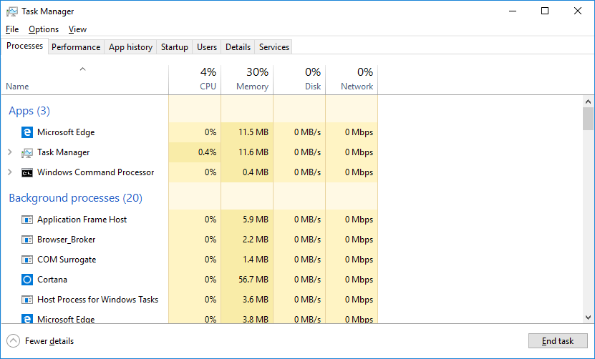
      - Expand the Windows Command Processor heading. What is listed under this heading?
____________________________________________________________________________________
      - There are three categories of processes listed in the Processes tab: Apps, Background processes, and Windows processes.
- The Apps are the applications that you have opened, such as Microsoft Edge, Task Manager, and Windows Command Processor, as shown in the figure above. Other applications that are opened by the users, such as web browsers and email clients, will also be listed here.
- The Background processes are executed in the background by applications that are currently open.
- The Windows processes are not shown in the figure. Scroll down to view them on your Windows PC. Windows processes are Microsoft Windows services that run in the background.
Some of the background processes or Windows processes may be associated with foreground processes. For example, if you open a command prompt window, the Console Window Host process will be started in the Windows process section, as shown below.
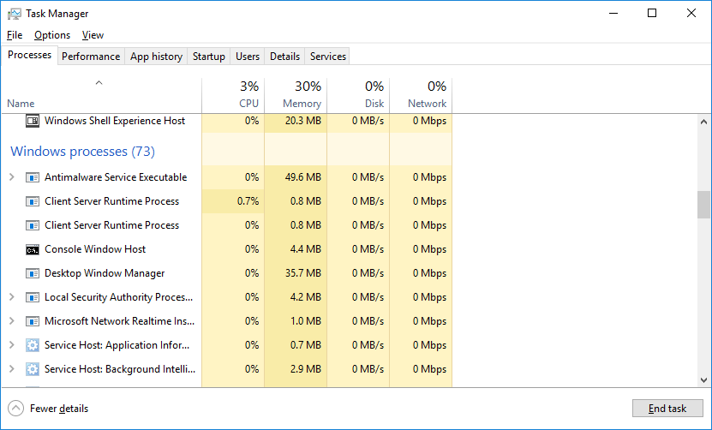
      - Right-click Console Window Host and select Properties. What is the location of this filename and location of this process?
____________________________________________________________________________________
      - Close the command prompt window. What happens to Windows Command Processor and Console Window Host when the command prompt window is closed?
____________________________________________________________________________________
    - Click the Memory heading. Click the Memory heading a second time.
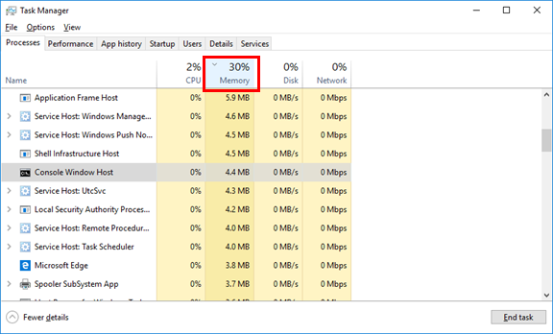
What effect does this have on the columns?
____________________________________________________________________________________
____________________________________________________________________________________
____________________________________________________________________________________
    - Right-click on the Memory heading, and then select Resource values > Memory > Percents.
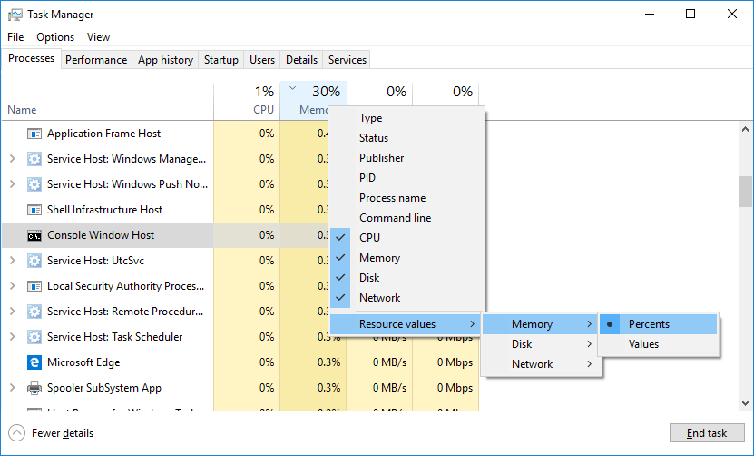
What affect does this have on the Memory column?
____________________________________________________________________________________
How could this be useful?
____________________________________________________________________________________
____________________________________________________________________________________
____________________________________________________________________________________
    - Return to the Task Manager. Click the Name heading.
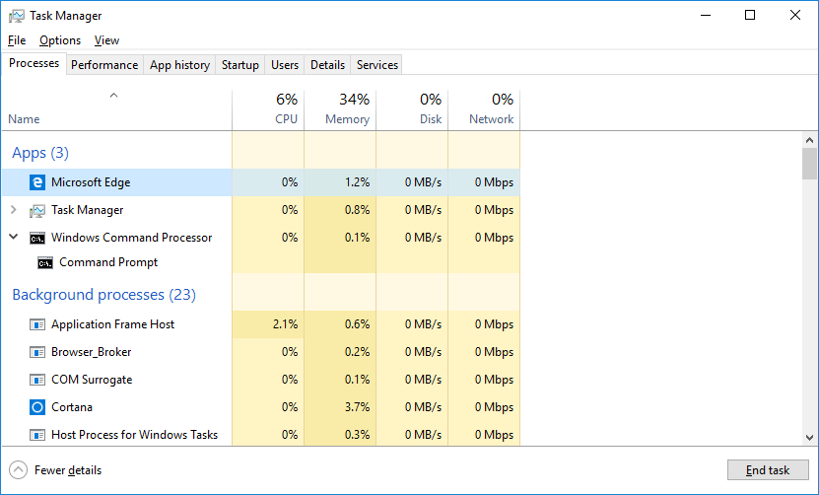
    - Double-click the Microsoft Edge. What happens?
____________________________________________________________________________________
    - Right-click Microsoft Edge, and select End task. What happens to the web browser windows?
____________________________________________________________________________________
- Working in the Services tab
    - Click the Services tab. Use the scroll bar on the right side of the Services window to view all the services listed.
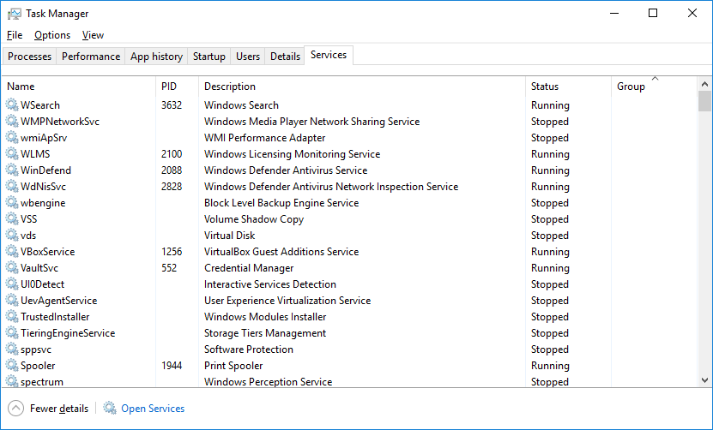
What statuses are listed?
____________________________________________________________________________________
- Working in the Performance tab
    - Click the Performance tab.
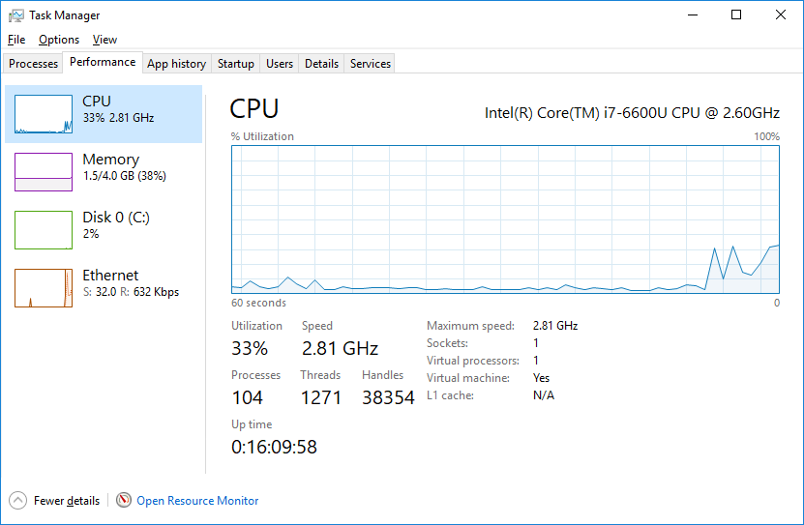
How many threads are running?
____________________________________________________________________________________
How many processes are running?
____________________________________________________________________________________
    - Click the Memory in the left panel of the Performance tab.
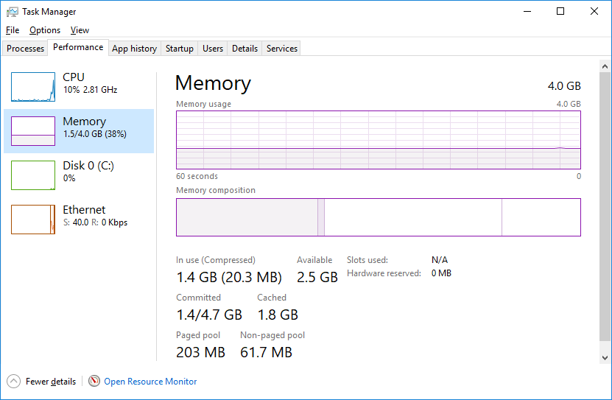
What is the total physical memory (MB)?
____________________________________________________________________________________
What is the available physical memory (MB)?
____________________________________________________________________________________
How much physical memory (MB) is being used by the computer?
____________________________________________________________________________________
    - Click the Ethernet Chart in the left panel of the Performance tab.
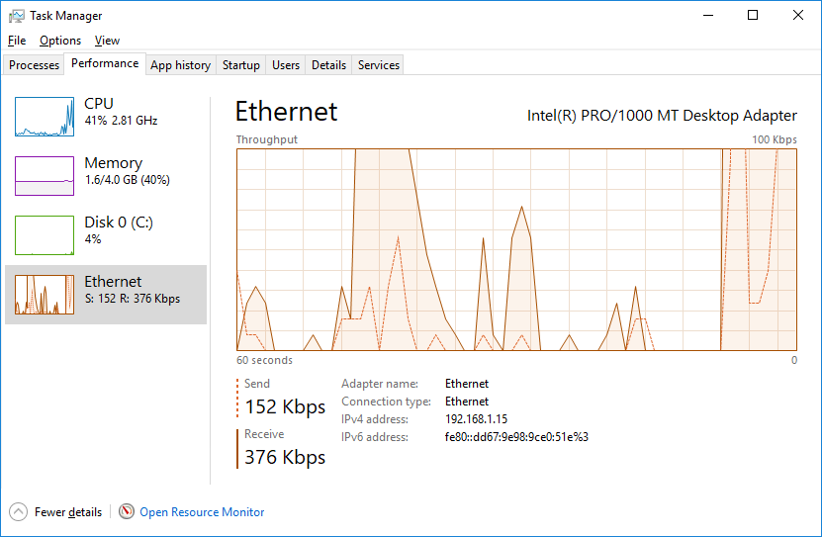
What is the link speed?
____________________________________________________________________________________
What is the IPv4 address of the PC?
____________________________________________________________________________________
    - Click Open Resource Monitor to open the Resource Monitor utility from the Performance tab in Task Manager.
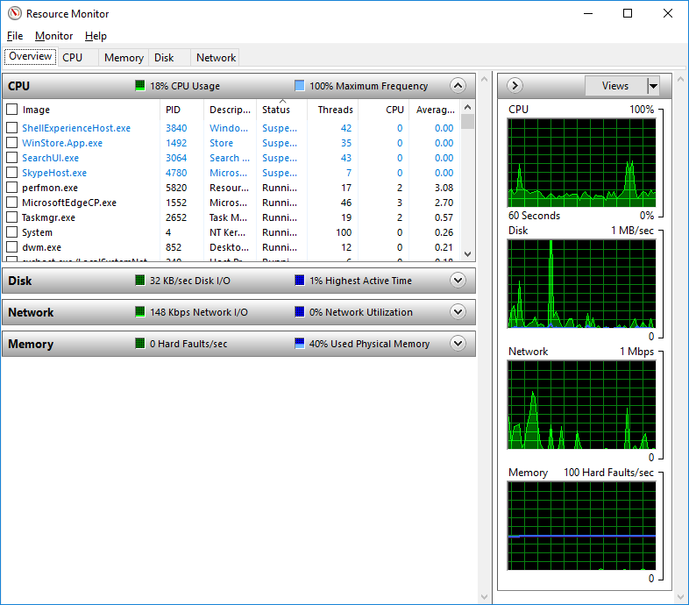

Reflection
Why is it important for an administrator to understand how to work within the Task Manager?
_______________________________________________________________________________________
_______________________________________________________________________________________
_______________________________________________________________________________________
_______________________________________________________________________________________

Lab - Monitor and Manage System Resources in Windows

Introduction
In this lab, you will use administrative tools to monitor and manage Windows system resources.

Recommended Equipment
- A Windows PC with Internet access
- Starting and Stopping the Routing and Remote Access service
You will explore what happens when a service is stopped and then started. In this part, you will use routing and remote access service as the example service. This service allows the local device to become a router or a remote access server.
    - Click Start > Search and select Control Panel > Click Network and Sharing Center.
Note: If your Control Panel is set to View by: Category, change it to View by: Large icons or View by: Small icons. This lab assumes that you are using one of these settings.
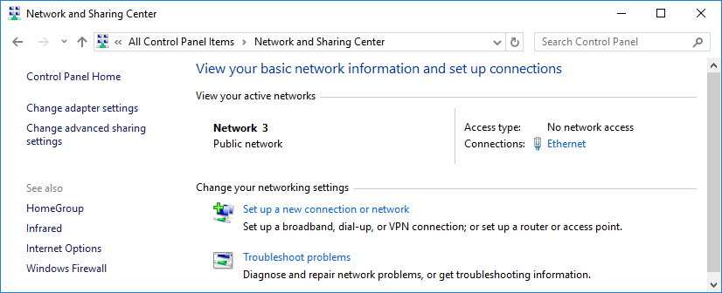
    - Click Change adapter settings in the left pane. Reduce the size of the Network Connections window and leave it open.
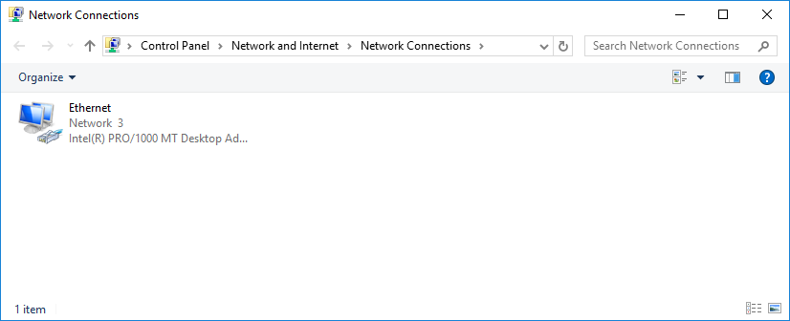
    - Navigate to the Administrative Tools. (Click Start > Search for and select Control Panel > Click Administrative Tools)
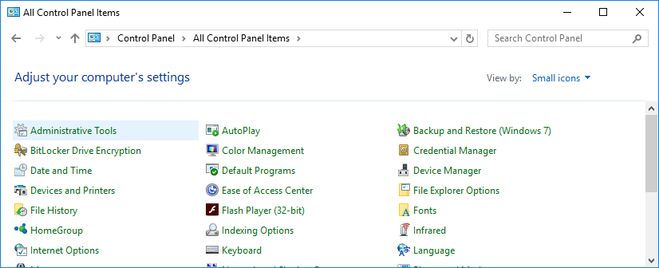
    - The Administrative Tools window opens. Double-click the Performance Monitor icon.
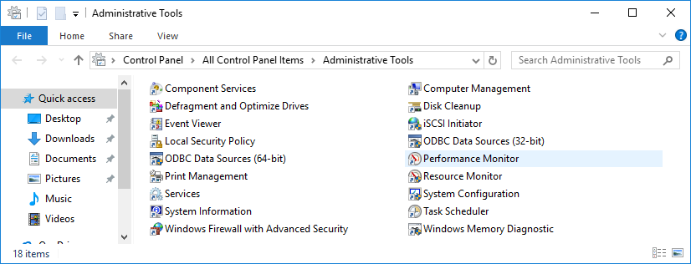
    - The Performance Monitor window opens. Make sure Performance Monitor in the left pane is highlighted. Click the Freeze Display icon (pause button) to stop the recording.
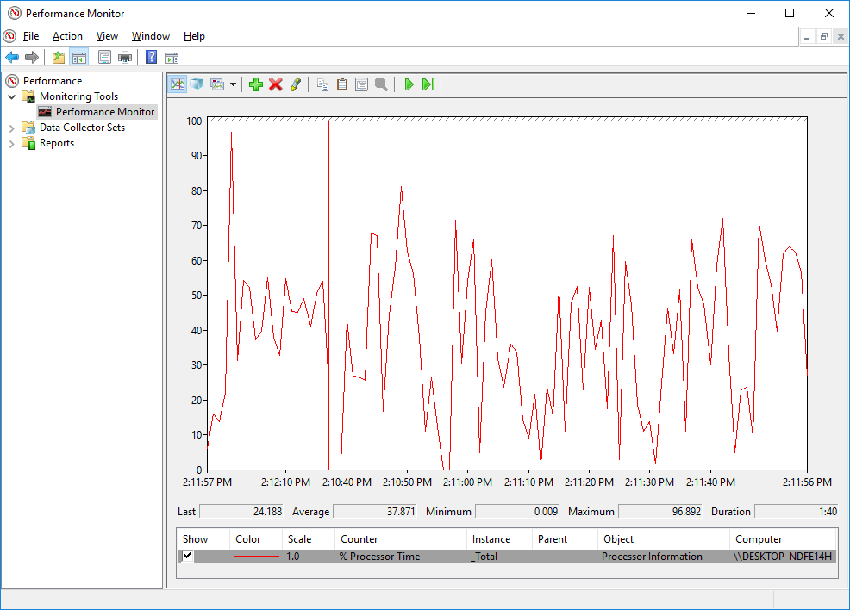
    - Right-click the Performance Monitor menu bar and select Clear to clear the graph. Leave this window open.
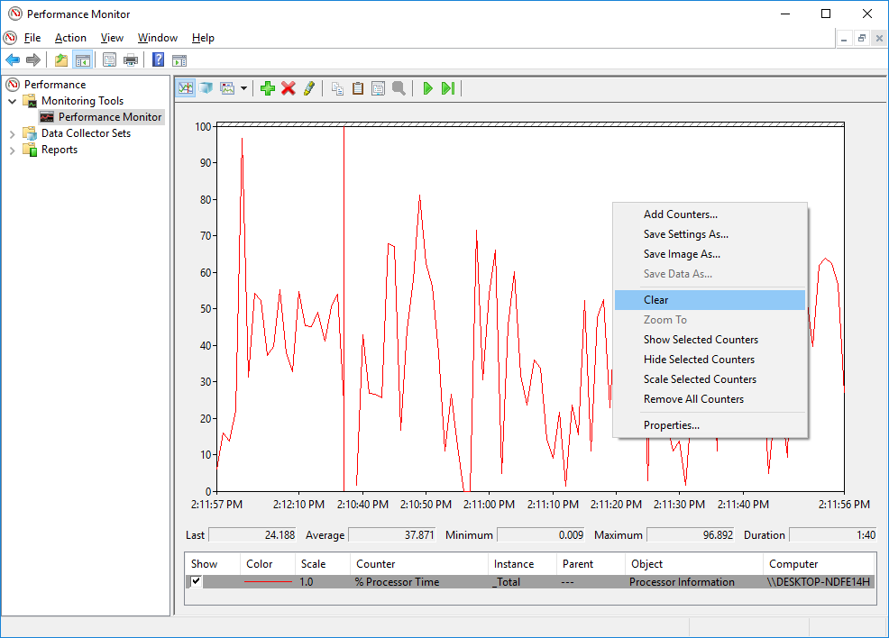
    - Navigate to the Administrative Tools window and select Services.
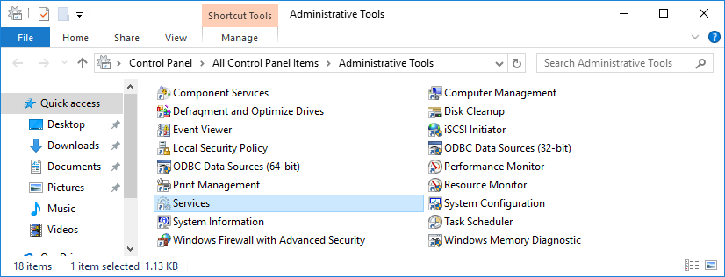
    - Expand the width of the Services window so you have a clear view of the content. Scroll down in the right pane until you see the service Routing and Remote Access. Double-click Routing and Remote Access.
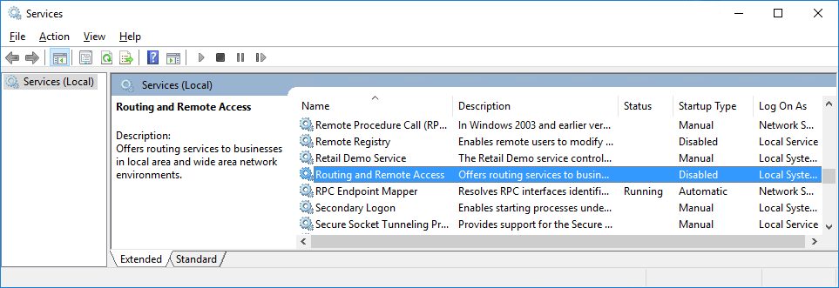
    - The Routing and Remote Access Properties (Local Computer) window opens. In the Startup type drop-down field, select Manual and then click Apply.
The Start button is now active. Do NOT click the Start button yet. Leave this window open.
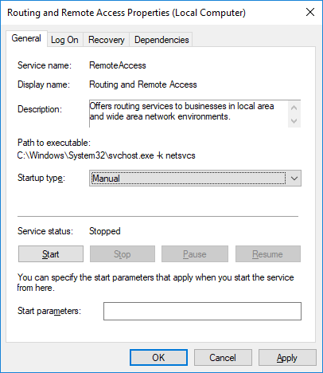
    - Navigate to Performance Monitor window. Click the Unfreeze Display icon to start the recording.
    - Click the Routing and Remote Access Properties (Local Computer) window. To start the service, click Start. A window with a progress bar opens.
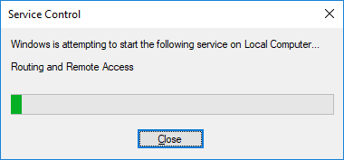
    - The Routing and Remote Access Properties (Local Computer) window now shows the Stop and Pause button active. Leave this window open
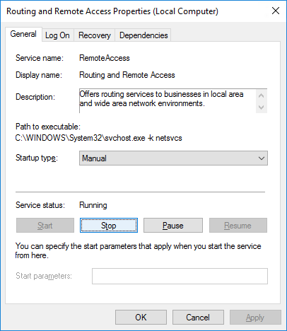
    - Navigate to Network Connections window. Press the function key F5 to refresh the content.
What changes appear in the window after starting the Routing and Remote Access service?
____________________________________________________________________________________
    - Navigate to Routing and Remote Access Properties (Local Computer) window and click Stop.
    - Navigate to Network Connections window.
What changes appear in the right pane after stopping the Routing and Remote Access service?
____________________________________________________________________________________
    - Navigate to Performance Monitor window and click the Freeze Display icon to stop the recording.
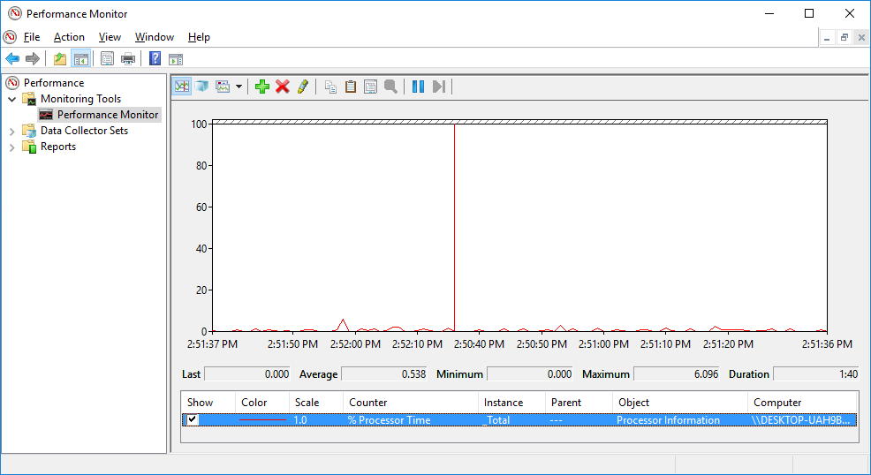
Which Counter is being recorded the most in the graph (hint: look at the graph color and Counter color)?
____________________________________________________________________________________
    - Click the Change graph type drop-down menu, select Report.
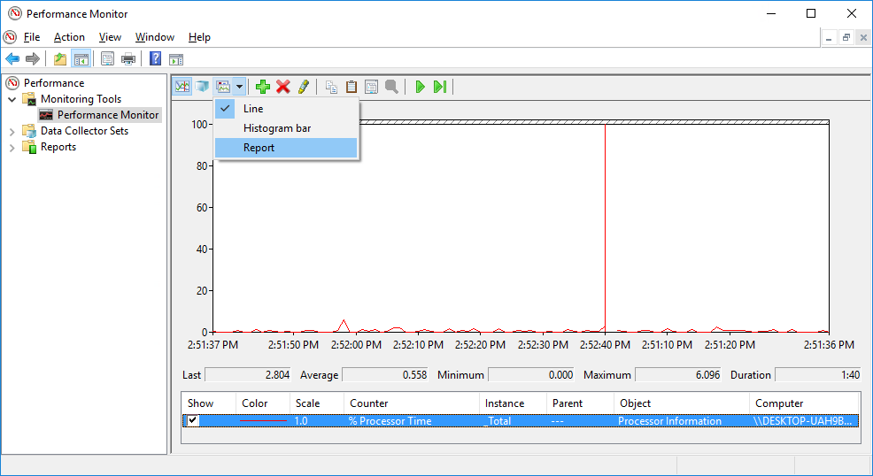
    - The display changes to report view.
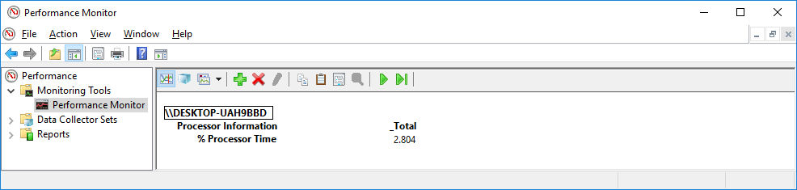
What values are displayed by the counter?
____________________________________________________________________________________
    - Click the Routing and Remote Access Properties (Local Computer) window. In the Startup type field, select Disabled and click OK.
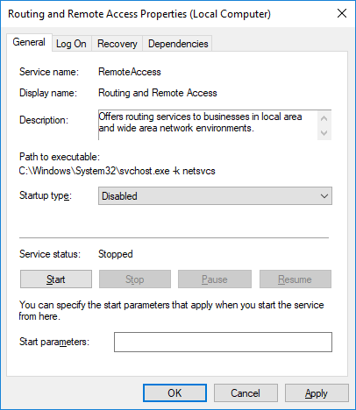
    - Click the Services window.
What is the Status and Startup Type for Routing and Remote Access?
____________________________________________________________________________________
    - Click the Performance Monitor window. Click the Unfreeze Display icon to start the recording.
    - Close all open windows you opened during Part 1 of this lab.

- Working in the Computer Management Utility
The Computer Management is used to manage a local or remote computer. The tools in this utility are grouped into three categories: system tools, storage, and services and applications.
    - Click Control Panel > Administrative Tools. Select Computer Management.
    - The Computer Management window opens. Expand the three categories by clicking on the arrow next to System Tools.
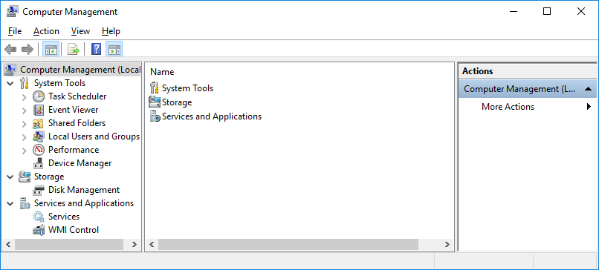
    - Click the arrow next to Event Viewer then click the arrow next to Windows Logs. Select System.
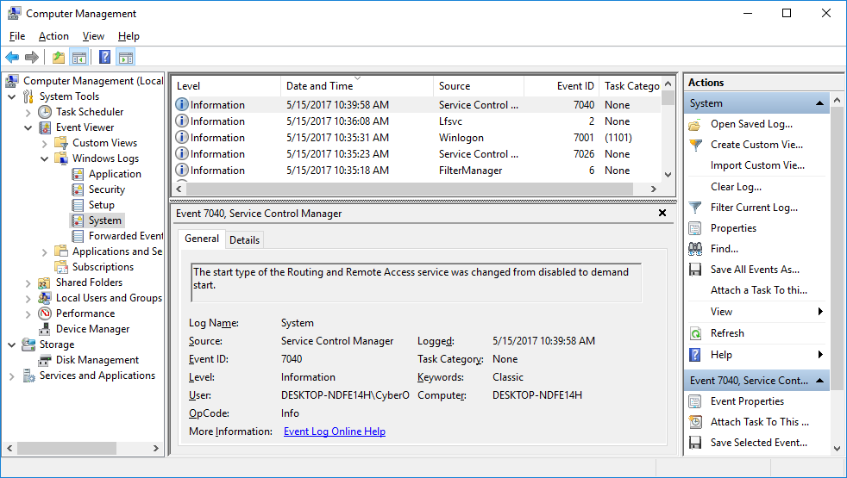
    - The Event Properties window opens for the first event. Click the down arrow key to locate an event for Routing and Remote Access. You should find four events that describe the order for starting and stopping the Routing and Remote Access service.
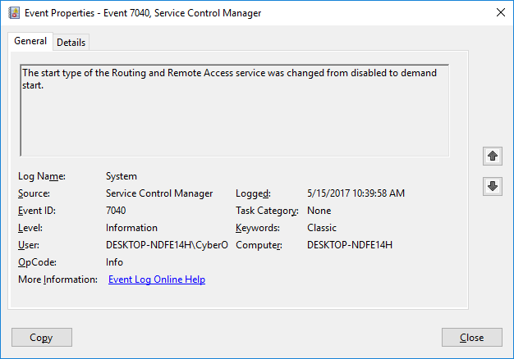
What are the descriptions for each of the four events?
____________________________________________________________________________________
____________________________________________________________________________________
____________________________________________________________________________________
____________________________________________________________________________________
    - Close all open windows.

- Configuring Administrative Tools
For the rest of this lab, you will configure Advanced Administrative Tool features and monitor how this affects the computer.
    - Click Control Panel > Administrative Tools > Performance Monitor. The Performance Monitor window opens. Expand Data Collector Sets. Right-click User Defined, and select New > Data Collector Set.
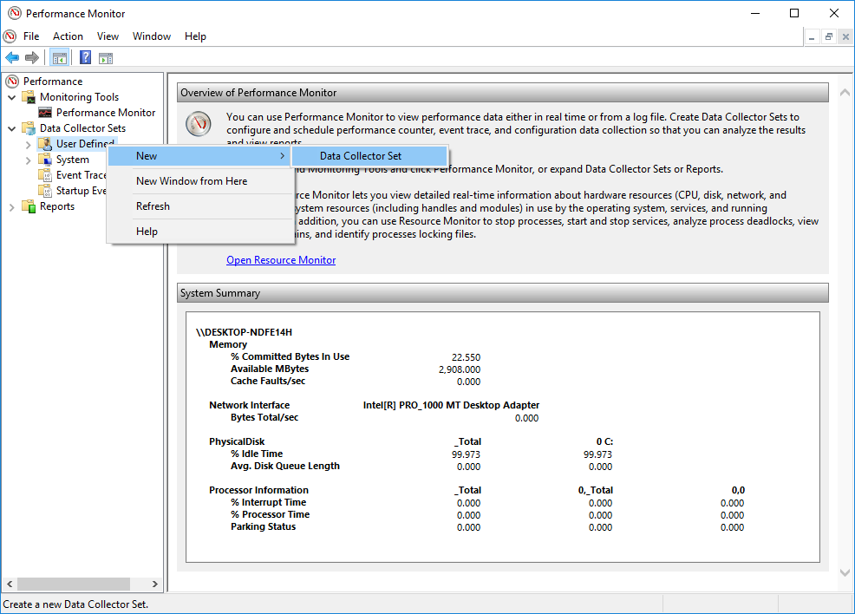
    - The Create new Data Collector Set window opens. In the Name field, type Memory Logs. Select the Create manually (Advanced) radio button, and click Next.
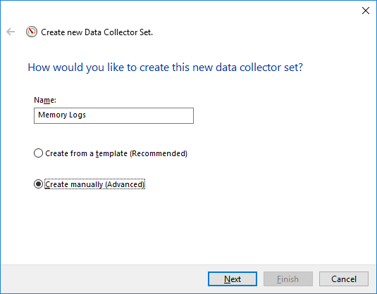
    - The What type of data do you want to include? screen opens. Check the Performance counter box then click Next.
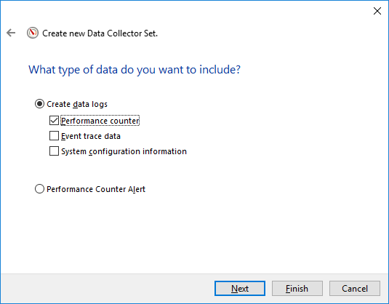
    - The Which performance counters would you like to log? screen opens. Click Add.
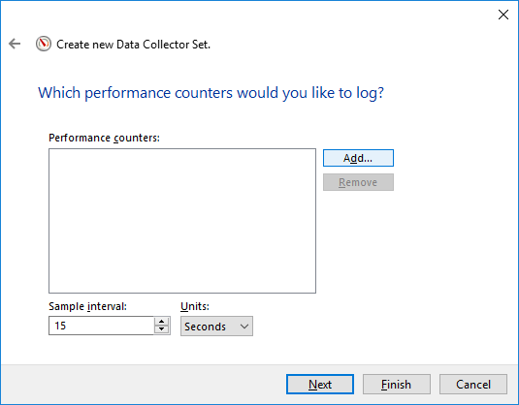
    - From the list of available counters, locate and expand Memory. Select Available MBytes and click Add>>.
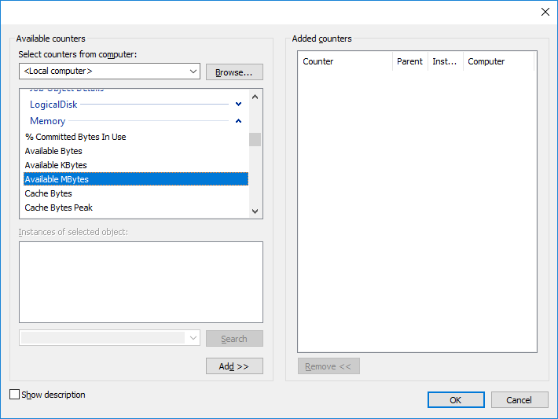
    - You should see the Available MBytes counter added in the right pane. Click OK.
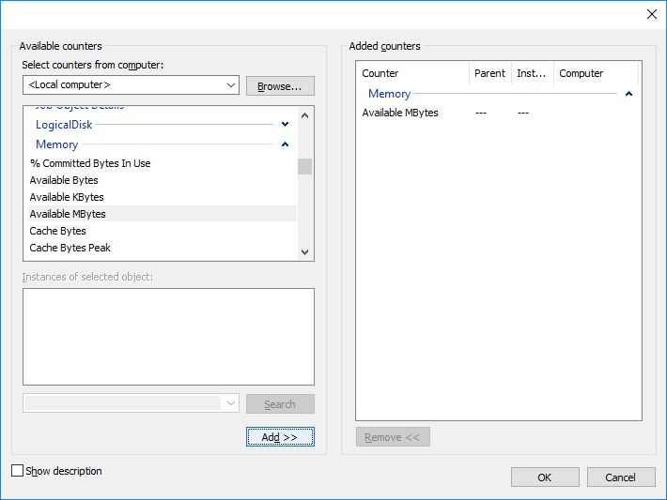
    - Set the Sample interval field to 4 seconds. Click Next.
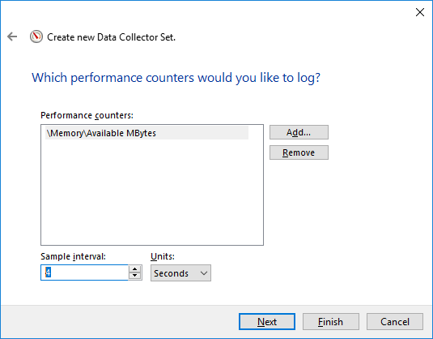
    - In the Where would you like the data to be saved? screen, click Browse.
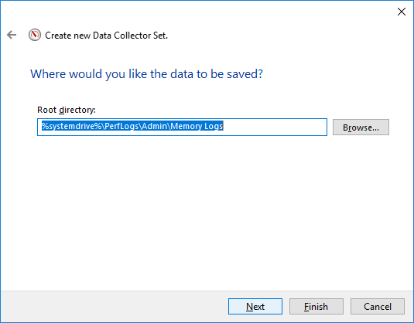
    - The Browse For Folder window opens. Select your (C:) drive which is Local Disk (C:) in the figure below. Select PerfLogs and click OK.
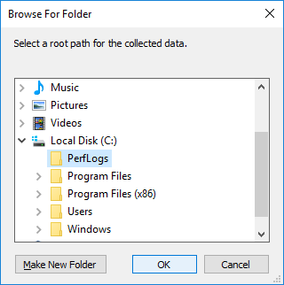
    - The Where would you like the data to be saved? window opens with the directory information that you selected in the previous step. Click Next.
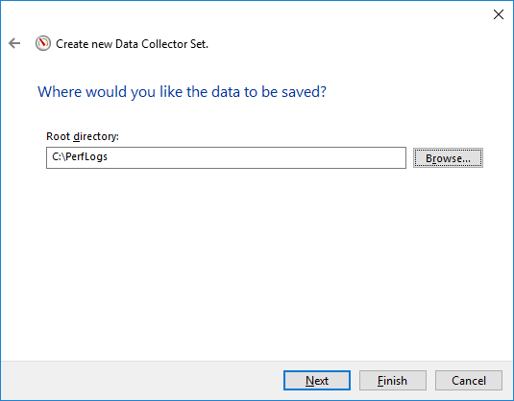
    - The Create the data collector set? screen opens. Click Finish.
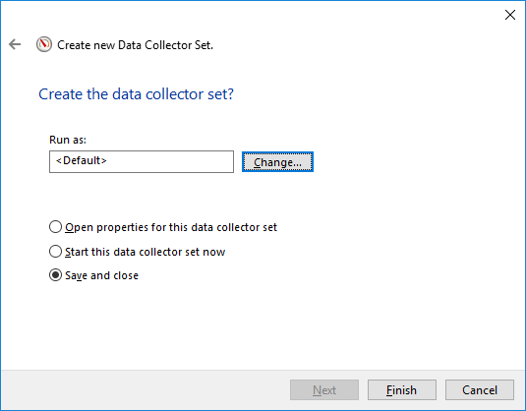
    - Expand User Defined, and select Memory Logs. Right-click Data Collector01and select Properties.
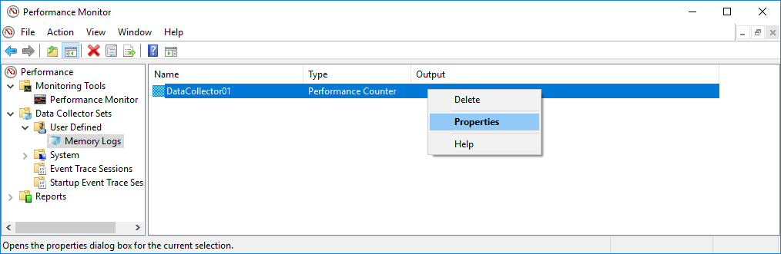
    - The DataCollector01 Properties window opens. Change the Log format: field to Comma Separated.
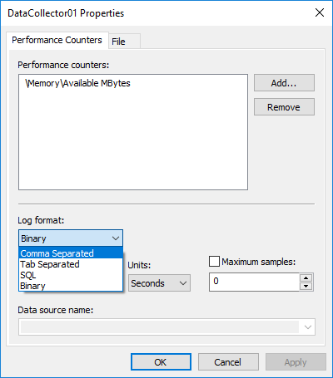
    - Click the File tab.
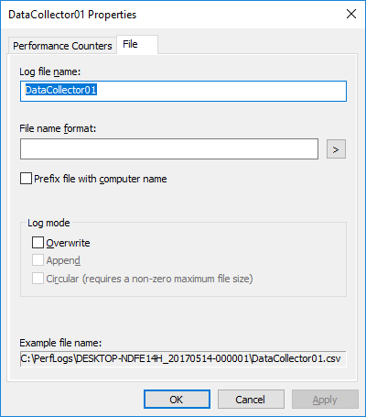
What is the full path name to the example file?
____________________________________________________________________________________
    - Click OK.
    - Select the Memory Logs icon in the left pane of the Performance Monitor window. Click the green arrow icon to start the data collection set. Notice a green arrow is placed on top of the Memory Logs icon.
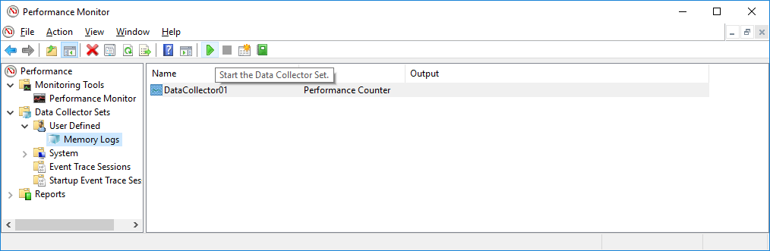
    - To force the computer to use some of the available memory, open and close a browser.
    - Click the black square icon to stop the data collection set.
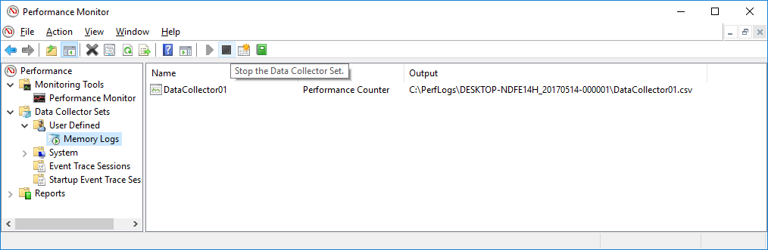
What change do you notice for the Memory Logs icon?
____________________________________________________________________________________
    - Click Start > Computer, and click drive C: > PerfLogs. Locate the folder that starts with your PC’s name followed by a timestamp, DESKTOP-NDFE14H_20170514-000001 in the example. Double-click the folder to open it, and then double-click the DataCollector01.csv file. If prompted, click Continue to permit access to the folder.
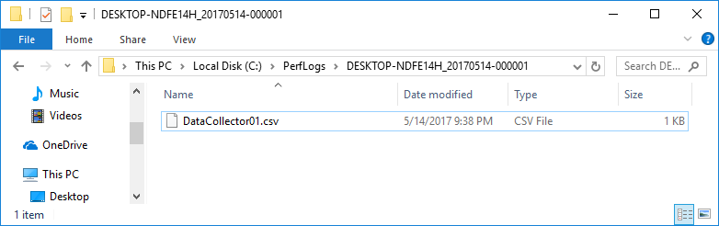
Note: If the Windows cannot open the file: message is displayed, select the radio button Select a program from a list of installed programs > OK > Notepad > OK.
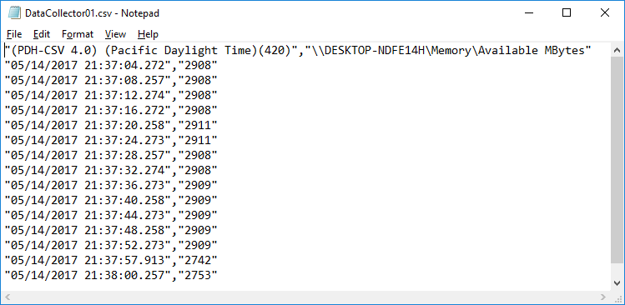
What does the column farthest to the right show?
____________________________________________________________________________________
    - Close the DataCollector01.csv file and the window with the PerfLogs folder.
    - Select the Performance Monitor window. Right-click Memory Logs > Delete.
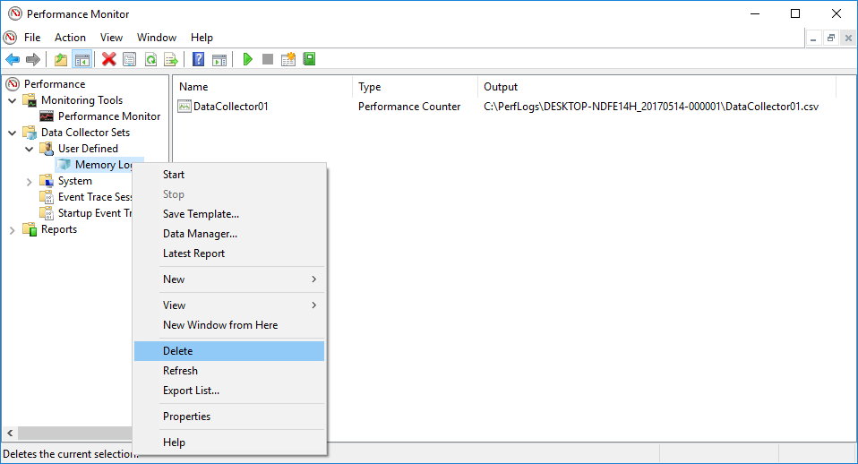
    - The Performance Monitor > Confirm Delete window opens. Click Yes.
    - Open drive C: > PerfLogs folder. Right-click on the folder that was created to hold the Memory log file, then click Delete.
    - The Delete Folder window opens. Click Yes.
    - Close all open windows.

